Bug Report: No bugs
Feature Report:
- A’s value: Fails to implement the condition where A can have a value of either 1 or 14 as needed.

Description of the data structures/classes:
- Storing Card: The program uses vector of strings to store individual card. The string contains two characters, first character for the suit and second for number value.
- Classes: Separate classes for table, deck and player. Game class uses these classes for composition. Human and Computer inherits from player class.

Log:
- Jan 3, 2019
  - Created classes for Deck, Table and Player and made sure their instances work perfectly. (1.5 hours)
- Jan 7, 2019
- Added the functions to the classes. Started with Deck, then Human and finally the Table. (1.5 hours)
- First decided to store a card as a vector of Struct but decided to use vector of strings since it was lot easier that way. (30 min)
- Deck:: shuffle() → Had trouble shuffling the deck but decided to use an algorithm from Internet. The algorithm works by swapping elements one by one starting from the last element. (40 min)
- Jan 10, 2019
- Still working on the functions of Player and Table. (1.5 hours)
- Player:: findCardHand() → Had problem deciding how to get a card from a players hand but later decided to use index. (30 min)
- Jan 14, 2019
- Tried to use and test all the classes in a new main class called Game. (1.5 hours)
- Game:: humanMove() → Had errors as was using size of vector as variable without converting to int . Later used static_cast<int>. (40 min)
- Jan 17, 2019
- Game: humanMove() → Had trouble handling the user input and decide whether to capture or build or trial. Solved the problem by asking the user himself to input whether he wants to capture, build or trial with a character as input (‘c’, ‘b’ and ‘t’) and use the input as parameter for required function call . (2.5 hours)
- Game:: optionCapture() → Worked on capturing one and multiple cards. Decided to work on capturing build cards for later. (1 hour)
- Jan 20, 2019
- Game:: optionTrial() → no issues (15 min)
- Game:: optionBuild() → Had problem restricting the user from building when he did not have the card with build value. In the end decided to ask user what the build value he wants before allowing him to build. If the build value (not including the card from his hand) is not in his hand then don’t allow him to build. (3 hours)
- Game:: optionCapture() → Worked on capturing build cards. Since I decided to store the build card information using “[ ]”, had problem parsing the string. (1.5 hours)
- Jan 21, 2019
- Worked on serialization, loading the file. Had problem reading the table section of the file just like capturing the build card. (4 hours)
- Jan 22, 2019
- Still working on loading file and still cannot figure out loading the table section of the file. Although I managed to run the program after loading the file ignoring the data of the table section. (5.5 hours)
- Jan 23, 2019
  - The program assumed that the user inputs the appropriate values and did not validate the input. Any incorrect user input would either crash the program or result in glitches. Therefore worked on fixing the problem
- Jan 26, 2019
  - The program failed to load the table section of the data. Although after loading the file, the program could continue the game, the table section is left empty since it is unable to read the data for table. Concluded that “Build Owner” section of the file would be a better alternative in reading the build info so decided to ignore builds in “Table: ” section of the file.
- Jan 27, 2019
  - Worked on implementing Help Mode. Finished the feature with the help of power set function that makes a list of all possible moves and recursion function that recursively checks if the given move is valid.
  - Also worked on calculating the score and number of cards for given move to make a list of valid moves and find the best move from the list
- Feb 16, 2019
  - Documentation (2 hours)

Screen Shots:
- Load Game:
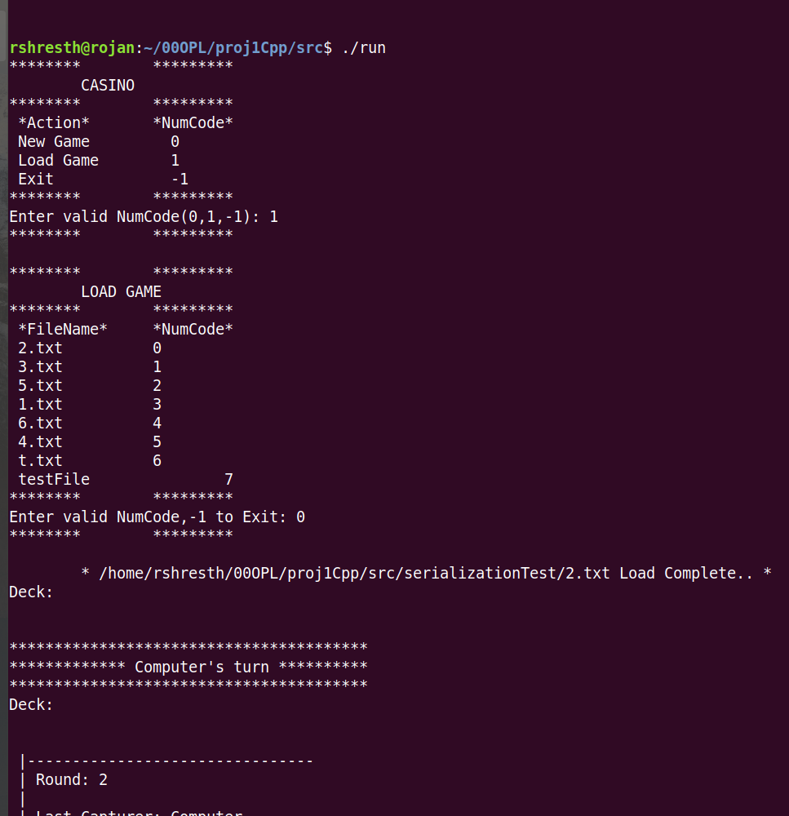
2. Help Mode:
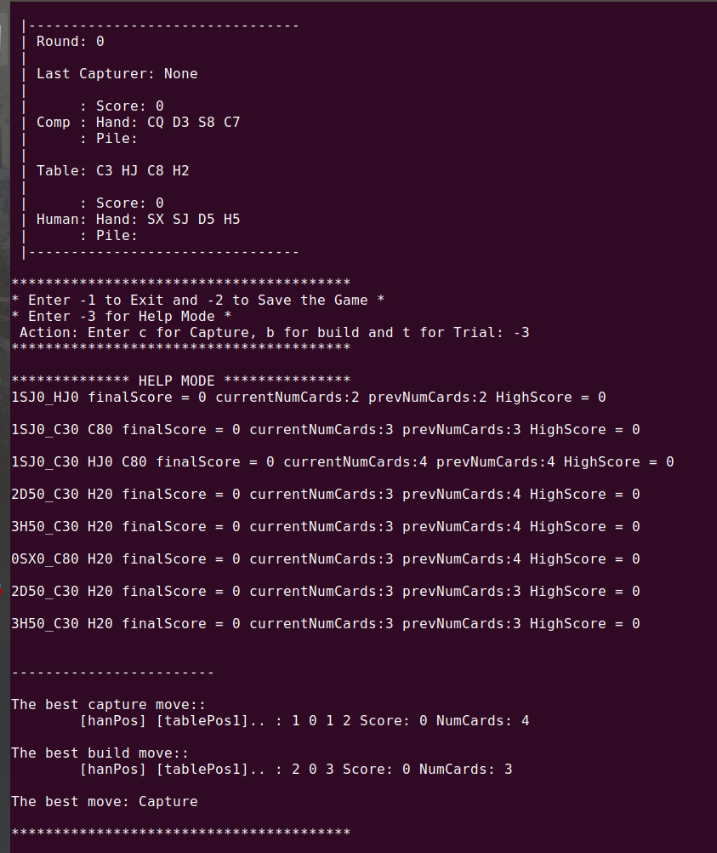
3. New Game, coin toss
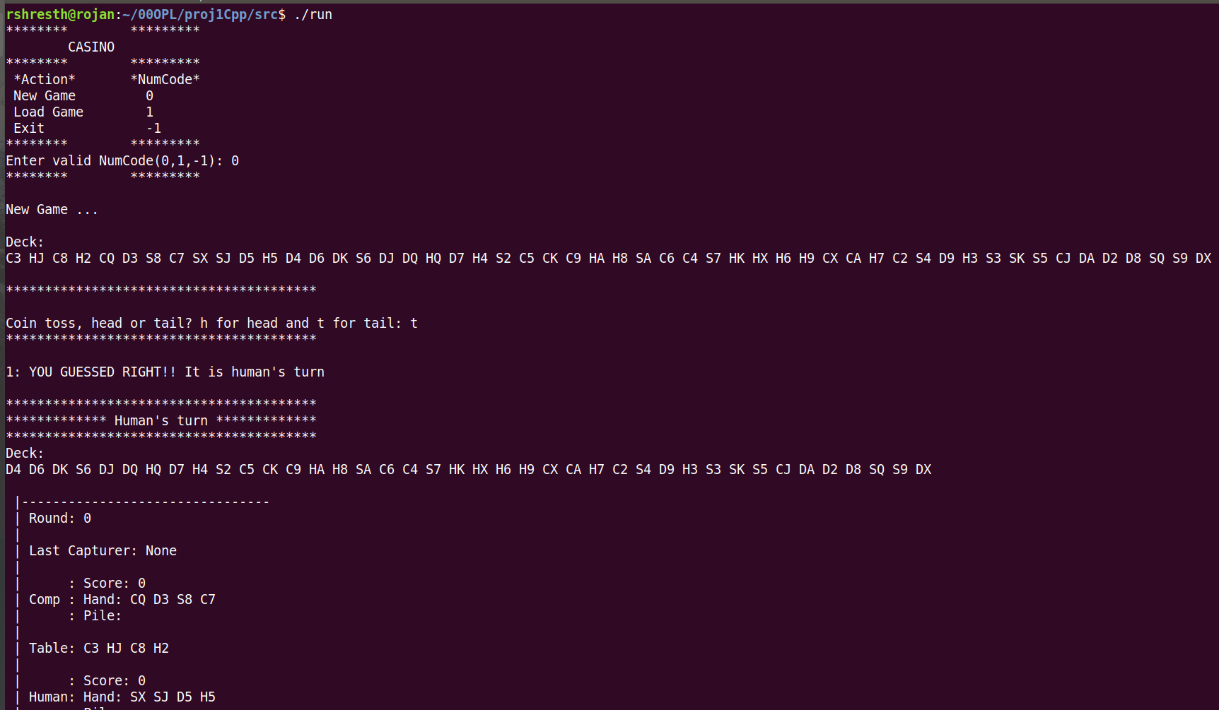
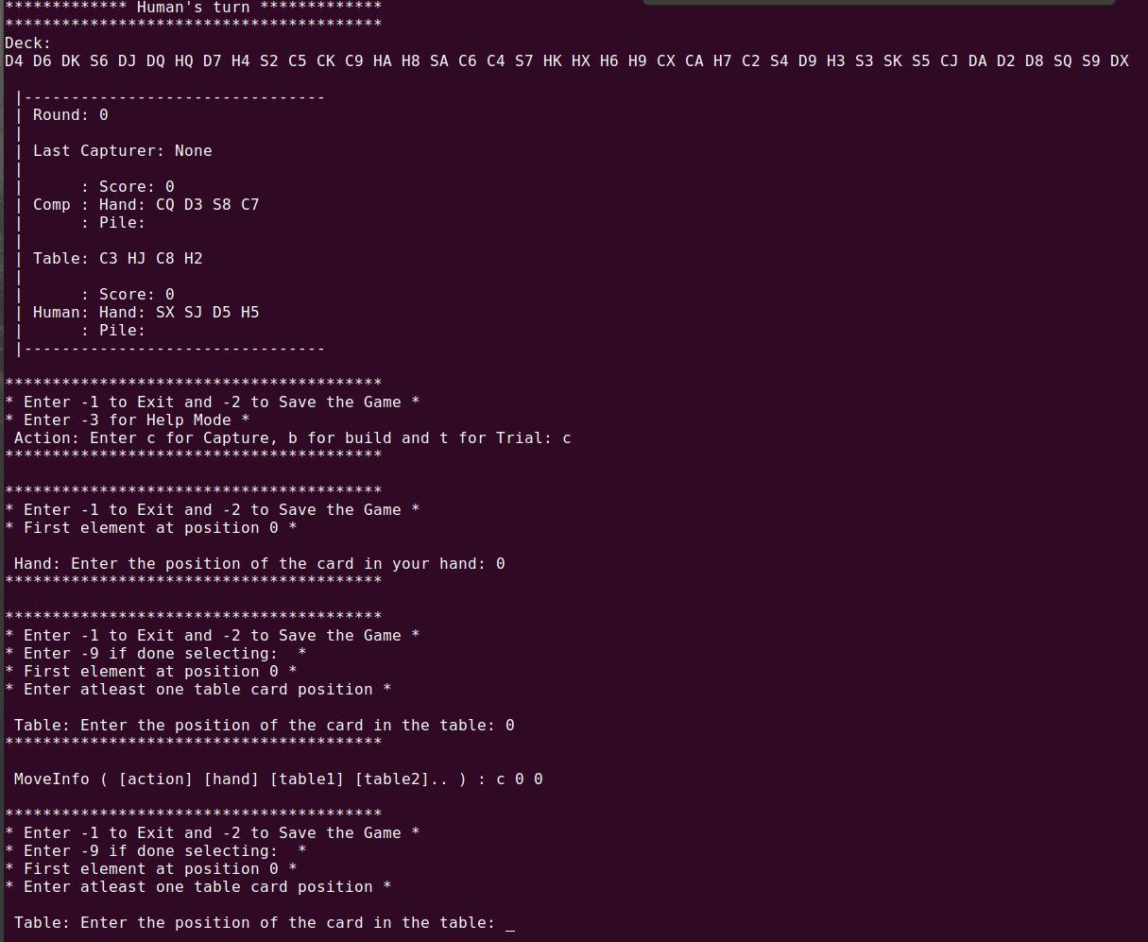
4. Components and making move

