Bug Report: No bugs
Feature Report:
- A’s value: Fails to implement the condition where A can have a value of either 1 or 14 as needed.

Description of the data structures/classes:
- Storing Card: The program uses list of strings to store individual card. The string contains two characters, first character for the suit and second for number value.
- Classes: Separate classes for table, deck and player. GameEngine class uses these classes for composition. Human and Computer inherits from player class.

Log:
- Feb 4, 2019
  - Since the project was already done in c++, worked to convert the logic part from c++ to python (3 hours)
  - Had problem getting used to change in syntax from c++ to python so lot of errors when running the program leading to loss of a lot of working time
- Feb 5, 2019
- There were many issues when converting the code. Since python had libraries that made it lot easier to implement many features like for example sorting was a lot easier in python compared to c++. There were many cut downs in code. (5 hours)
- Feb 6, 2019
- GameMoveCheck::captureBuildSumChecker () → Lot of semantic error cause of improper syntax implementation while converting code. Worked most of the time finding and solving the errors. (3.5 hours)
- Feb 8, 2019
- GameMoveCheck::recursiveSumChecker() → Tackled with lot of “out of bound ” errors since recursion was used in the function that checks the validity of the move. (2.5 hours)
- Feb 9, 2019
- Worked on wrapping up the logic part of the program by testing with multiple test cases. Small errors were noticed and resolved. (3 hours)
- Feb 10, 2019
- Learned to navigate and get used to the python interface called Tkinter for implementing the GUI part of the program. (5 hours)
- Feb 11, 2019
- Implemented 5 frames for each pages for loading game, new game, coin toss, save game and main page. (2 hours)
- Worked on figuring out how to make the frames communicate with each other. (2 hours)
- Feb 12, 2019
- Worked again on frames communication. Was able to finally solve the issue with the help of feature called container reference. (3 hours)
- Worked on editing each pages while adding buttons and labels to give a structure to the GUI. (2 hours)
- Feb 13, 2019
  - Worked on making the logic and GUI part of the game interact with each other. (5 hours)
- Feb 14, 2019
  - While testing the program which was mostly working with “mainGUI.py” file, laptop crashed that lead to loss of data. The file got corrupted so tried to recover the file. Although found out that the issue was with my IDE that replaced the file with an empty one when the laptop crashed. (4 hours)
  - Since the GUI part was a single file program, had to redo from scratch. Was unable to however to completely recover all the code. (8 hours)
- Feb 16, 2019
  - Completing the GUI and wrapping up with testing the game with several test cases. (5 hours)
  - Documentation (2 hours)

Screen Shots:
- Coin Toss:
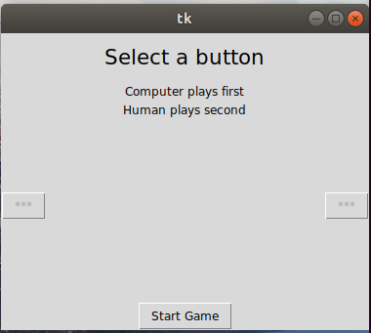

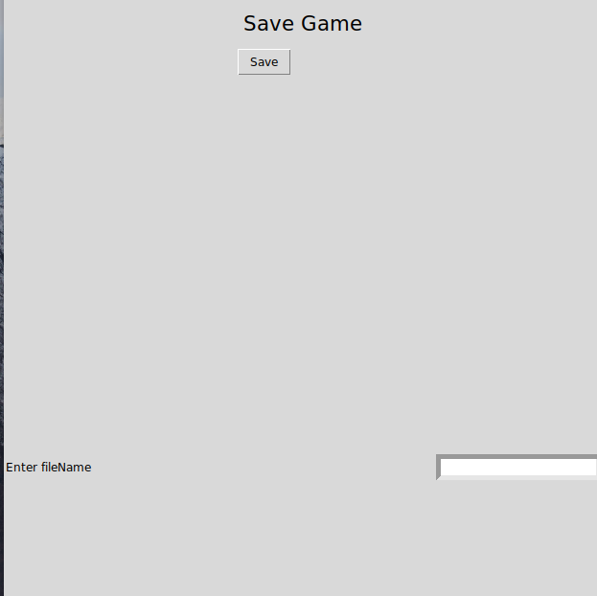
2. Save Game:
3. Load Game:
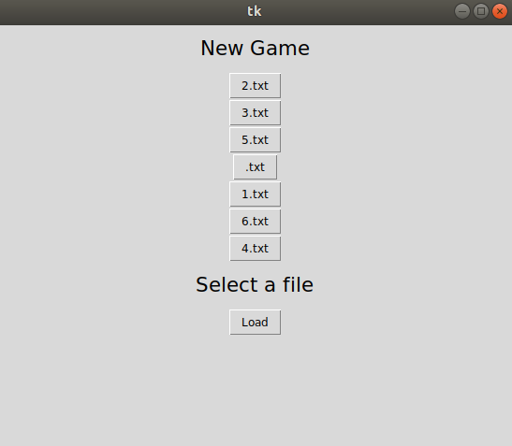
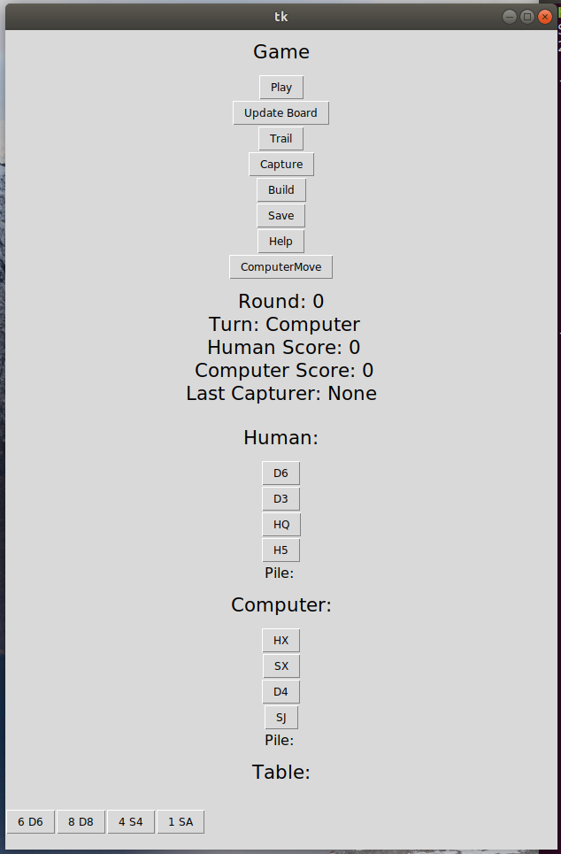
4. Components, making move:

