Hypothesis 1: Students with higher high school GPA and SAT reading have higher Cumulative GPA.
- Subsample :
  - all Non Science
  - 150
- Features :
  - high school gpa (out of 5)
  - SAT reading (out of 8; the acutal data was divided by 100 to match the range of both features)
- Outcome variable :
  - Cumuative GPA
  - The gpa was categorized into 4 groups. Initially I planned to have 3 groups however I observed that the concetration of data was high around GPAs 2.5 to 3.5. Therefore I had to subdivide the range to two categories for better distribution of the data.
  - Categories: 3(> 3.5), 2 (> 3.0) , 1 (> 2.7) and 0 (2.7 and less)
  - count (0,1,2,3) = [28 34 56 32]
- Test Size: 0.3
- Accuracy: 97.5%
- Result:
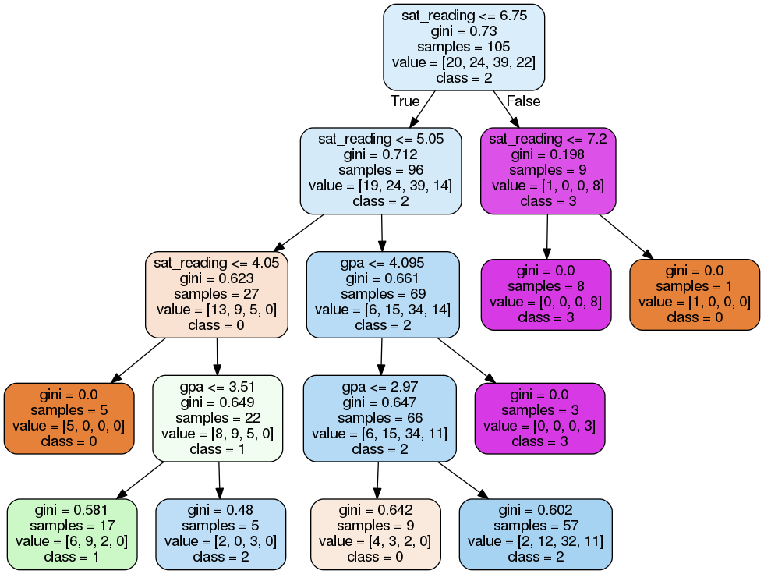
The hypothesis was more or less accurate with some anomalies. The range of gini values in leaf nodes of the decision tree either have a 0.0 gini value or it falls in range 0.48 and 0.642. However there are enough number of leaf nodes with 0.0 gini value to support the hypothesis. As observed in the diagram the students with higher high school GPA and SAT reading score are skewed on the right side. It is also true that these students are the one with high cumulative GPA. On the other hand, the left side have students with less high school GPA and SAT reading score and also fall in the category 0 and 1 (less cumulative GPA).
Hypothesis 2: Students with good GPA in intro, followup and fundamental courses graduate quicker.
- Subsample :
  - all Non Math ( Science, Non Science and CS )
  - 180
- Features :
  - Grade in Intro Course (0 - 4.0)
  - average of Grade in Followup Course and Grade in Fundamentals Course (0 – 4.0). I took the average of the grades cause the data was unevenly distributed when they were considered individually.
- Outcome variable :
  - Semesters taken to graduate
  - The variable was categorized into 3 groups. I considered 3 because it gave me an even distribution of the data. I observed that there were high number students that took 14 semester to graduate.
  - Categories: 2(> 17), 1 (> 15) and 0 (<= 15)
  - count (0,1,2) = [55 33 38]
- Test Size: 0.3
- Accuracy: 92.1%
- Result:
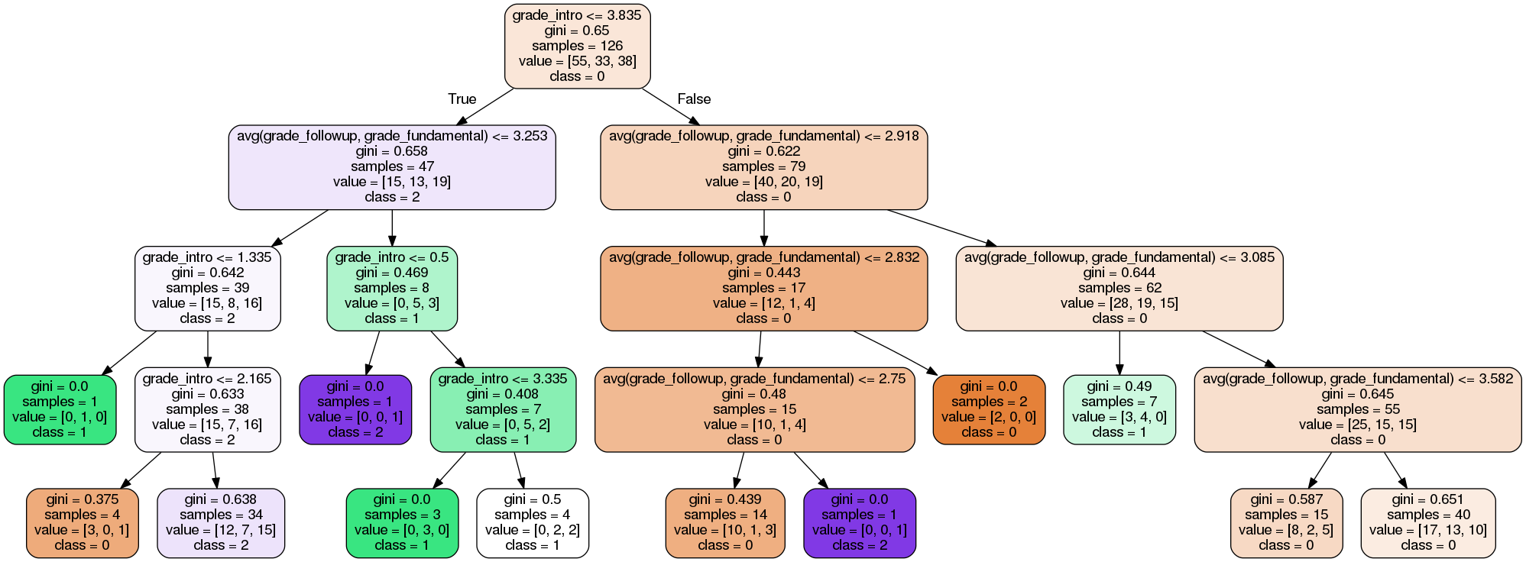
I observed that there were more data that supports the hypothesis compared to those which don’t but there are enough anamolies that prevent this hypothesis to be considered completely true. There were also few number of subdata set that had higher grade in Intro Course but low grade in followup and fundamental courses. Since there are more data in catergory 0 (lowest number of semester taken to graduate), 55 compared to 33 and 38 for catergory 1 and 2 respectively, the unequal data distribution of the dataset should also be considered. Ultimately these observations does not support hypothesis and therefore is false.
Hypothesis 3: The students with good high school GPA and good cumulative gpa graduate faster and have good grade in Intro Course
- Subsample :
  - first generation
  - 250
- Features :
  - Semesters taken to graduate (< 20), Althought the highest value is above 100, I put a limit to the semester taken to graduate since the hypothesis demands lower graduation time frame and 20 was an optimum number.
  - High School GPA (0 - 4.0)
  - Cumulative GPA (0 - 4.0)
- Outcome variable :
  - Grade in Intro Course
  - The variable was categorized into 3 groups.
  - Categories: 2(> 3.2), 1 (> 1.6) and 0 (<= 1.6)
  - count (0,1,2) = [61 92 97]
- Test Size: 0.4
Accuracy: 93.9%
- Result:
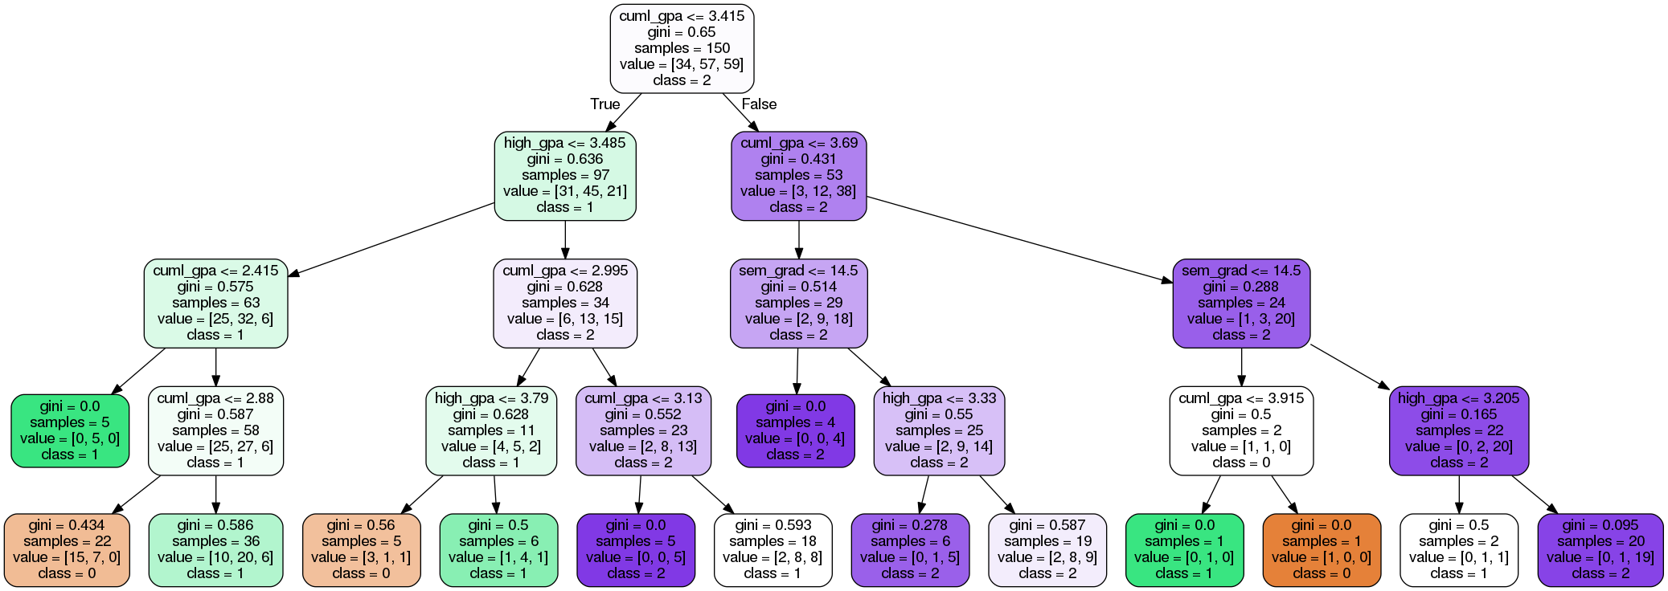
Compared to previous hypothesises, the data distrubtion for this hypothesis had a wider distribution of data because one more features was considered. It was true that students with good high school GPA and good cumulative gpa had good grades in Intro Course however it wasn’t necessarily true that they also graduate early. The students with low grade in Intro Course are skewed on the left side of the diagram but the semester taken to graduate had little to no effect on deciding if the student had good grades in Intro Course. The observation thus supports the previous statement. I think the semesters taken to graduate is not a good feature to be considered for the hypothesis. In the end if the semesters taken is ignored as the feature, the hypothesis is mostly true.
Hypothesis 4: Female students tend to do better in college (have higher cumulative GPA and better grades in different course)
- Subsample :
  - all possible data that have non empty input in all the feature and label columns.
  - 105, there were only 198 units of data in the given data sample with high number of students being male. Therefore I took a lower data size to accommodate as many female students as possible.
- Features :
  - Cumulative GPA (0 - 4.0)
  - Average grade of Intro, Followup and Fundamentals Courses (0 - 4.0). I also wanted to include Systems Course however inclusion of this feature heavly reduced the sample size.
- Outcome variable :
  - Sex (2 categories female as 0 and male as 1)
  - count (0,1) = [23 82]
- Test Size: 0.3
Accuracy: 71.9%
- Result:
As shown in the diagram, students with good cumulative GPA and good grade in the courses are skewed on the right side. However the students are mostly male which is a contradiction to the hypothesis. It is also important to note that the number of male students in the data set is almost four times the number of female students. This biased data set and plenty of anamloies in the diagram proves the hypothesis to be not true. However for similar reason we also cannot conclude that male students do better in college.
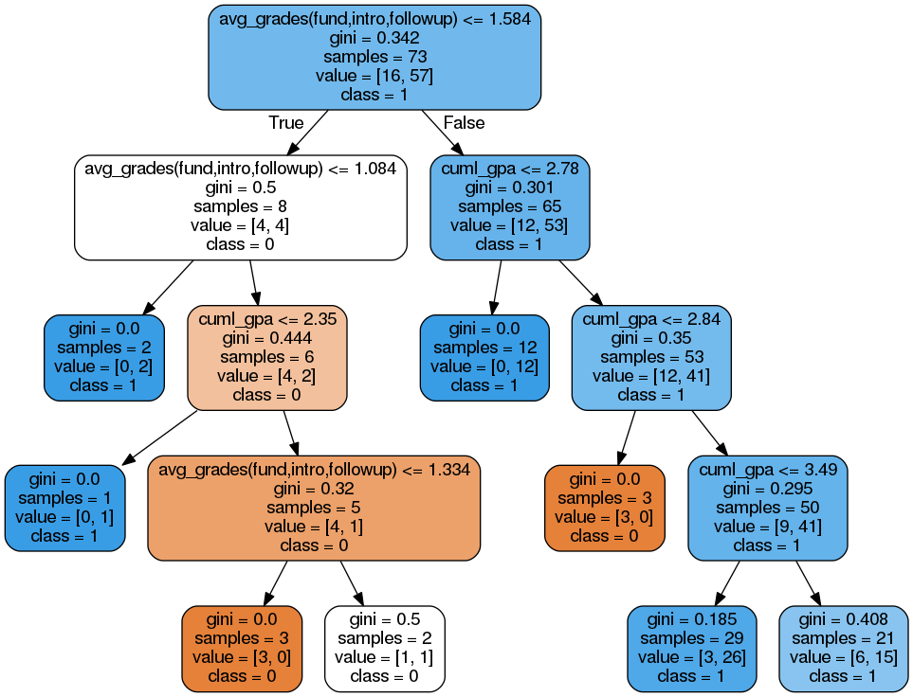
Hypothesis 5: Math major students have high SAT math score tend and good high school GPA and cumulative GPA.
- Subsample :
  - male students
  - 250
- Features :
  - SAT math score (out of 800)
  - High School GPA (0 - 4.0)
  - Cumulative GPA (0 - 4.0)
- Outcome variable :
  - Major
  - The variable was categorized into 2 groups, Math (0) and non Math (1)
  - count (0,1) = [76 174]
- Test Size: 0.4
Accuracy: 92.6%
- Result:
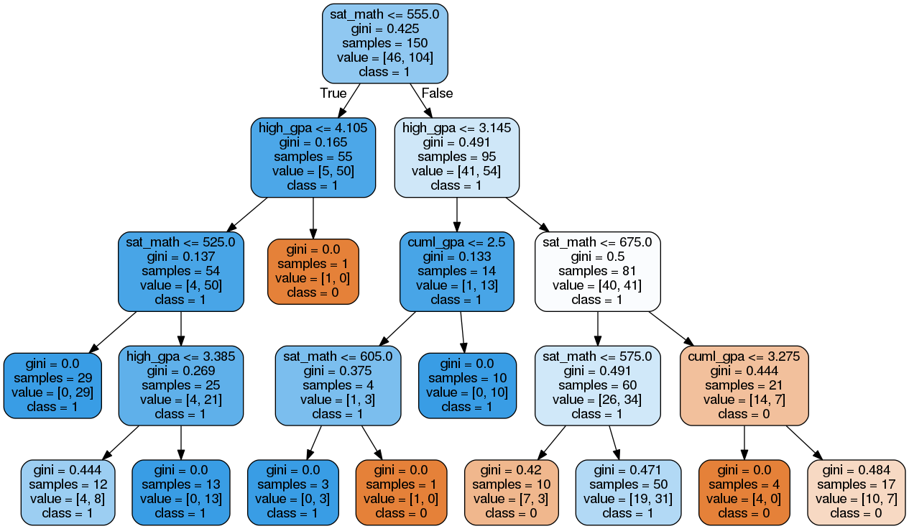
I observed that most math majors lies on the right side of the diagram (with high GPAs and high Math Score). Except for few anamolies most math major students have high SAT math score (> 555). It is however not correct to state that they also have good high school GPA, most having GPA of 3.15 or less. Therefore we can conclude that most math major male students had good SAT math score however they did not have goof GPAs.

