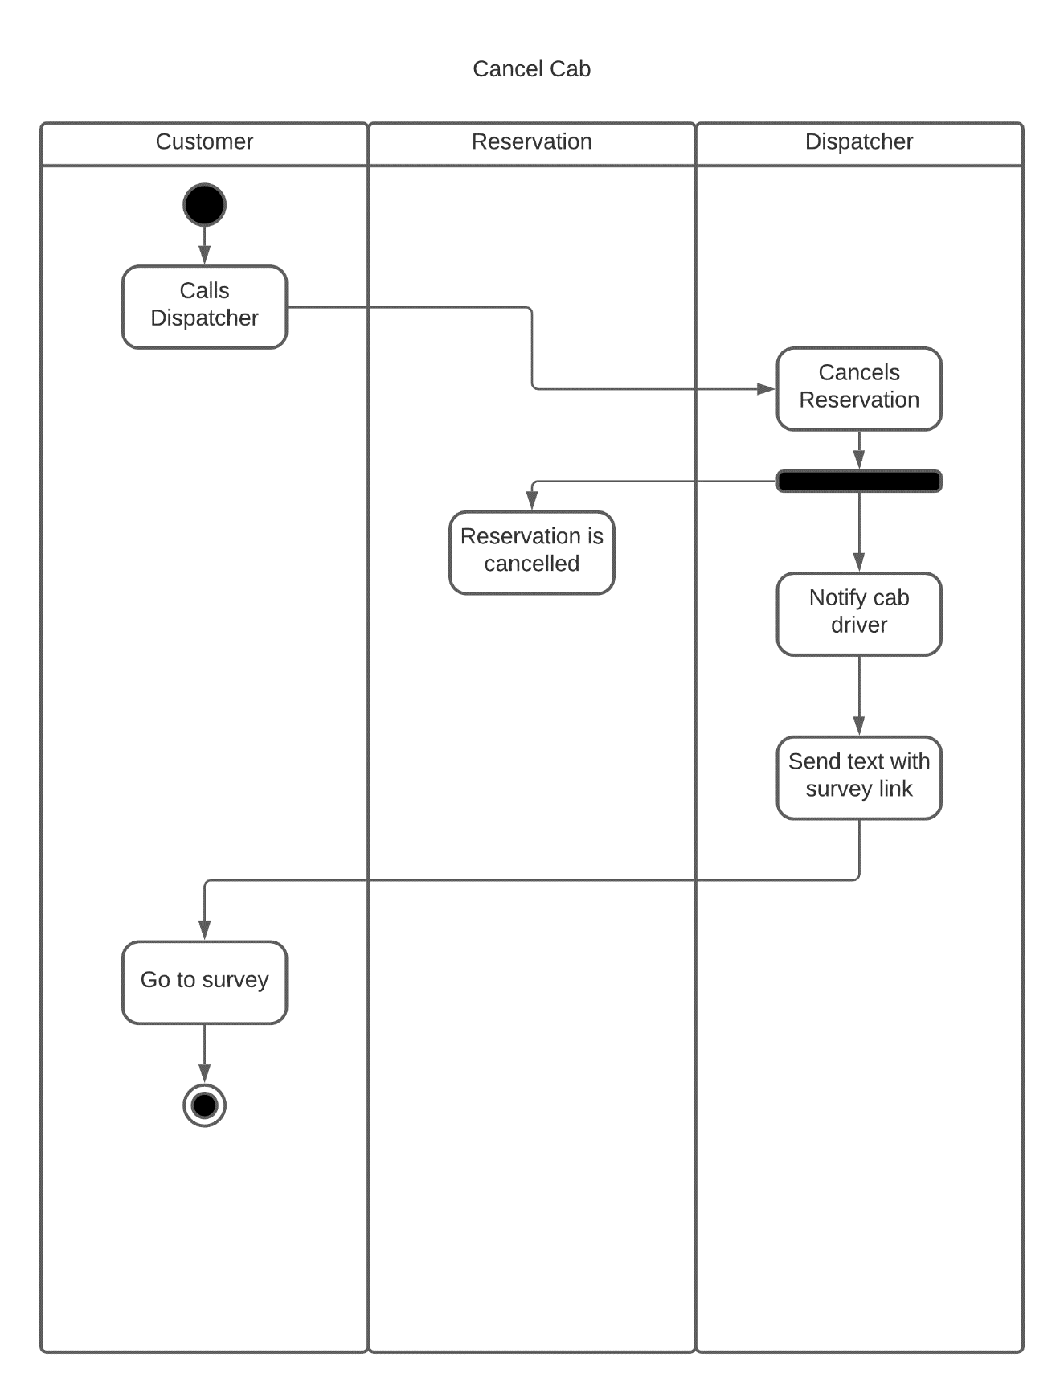

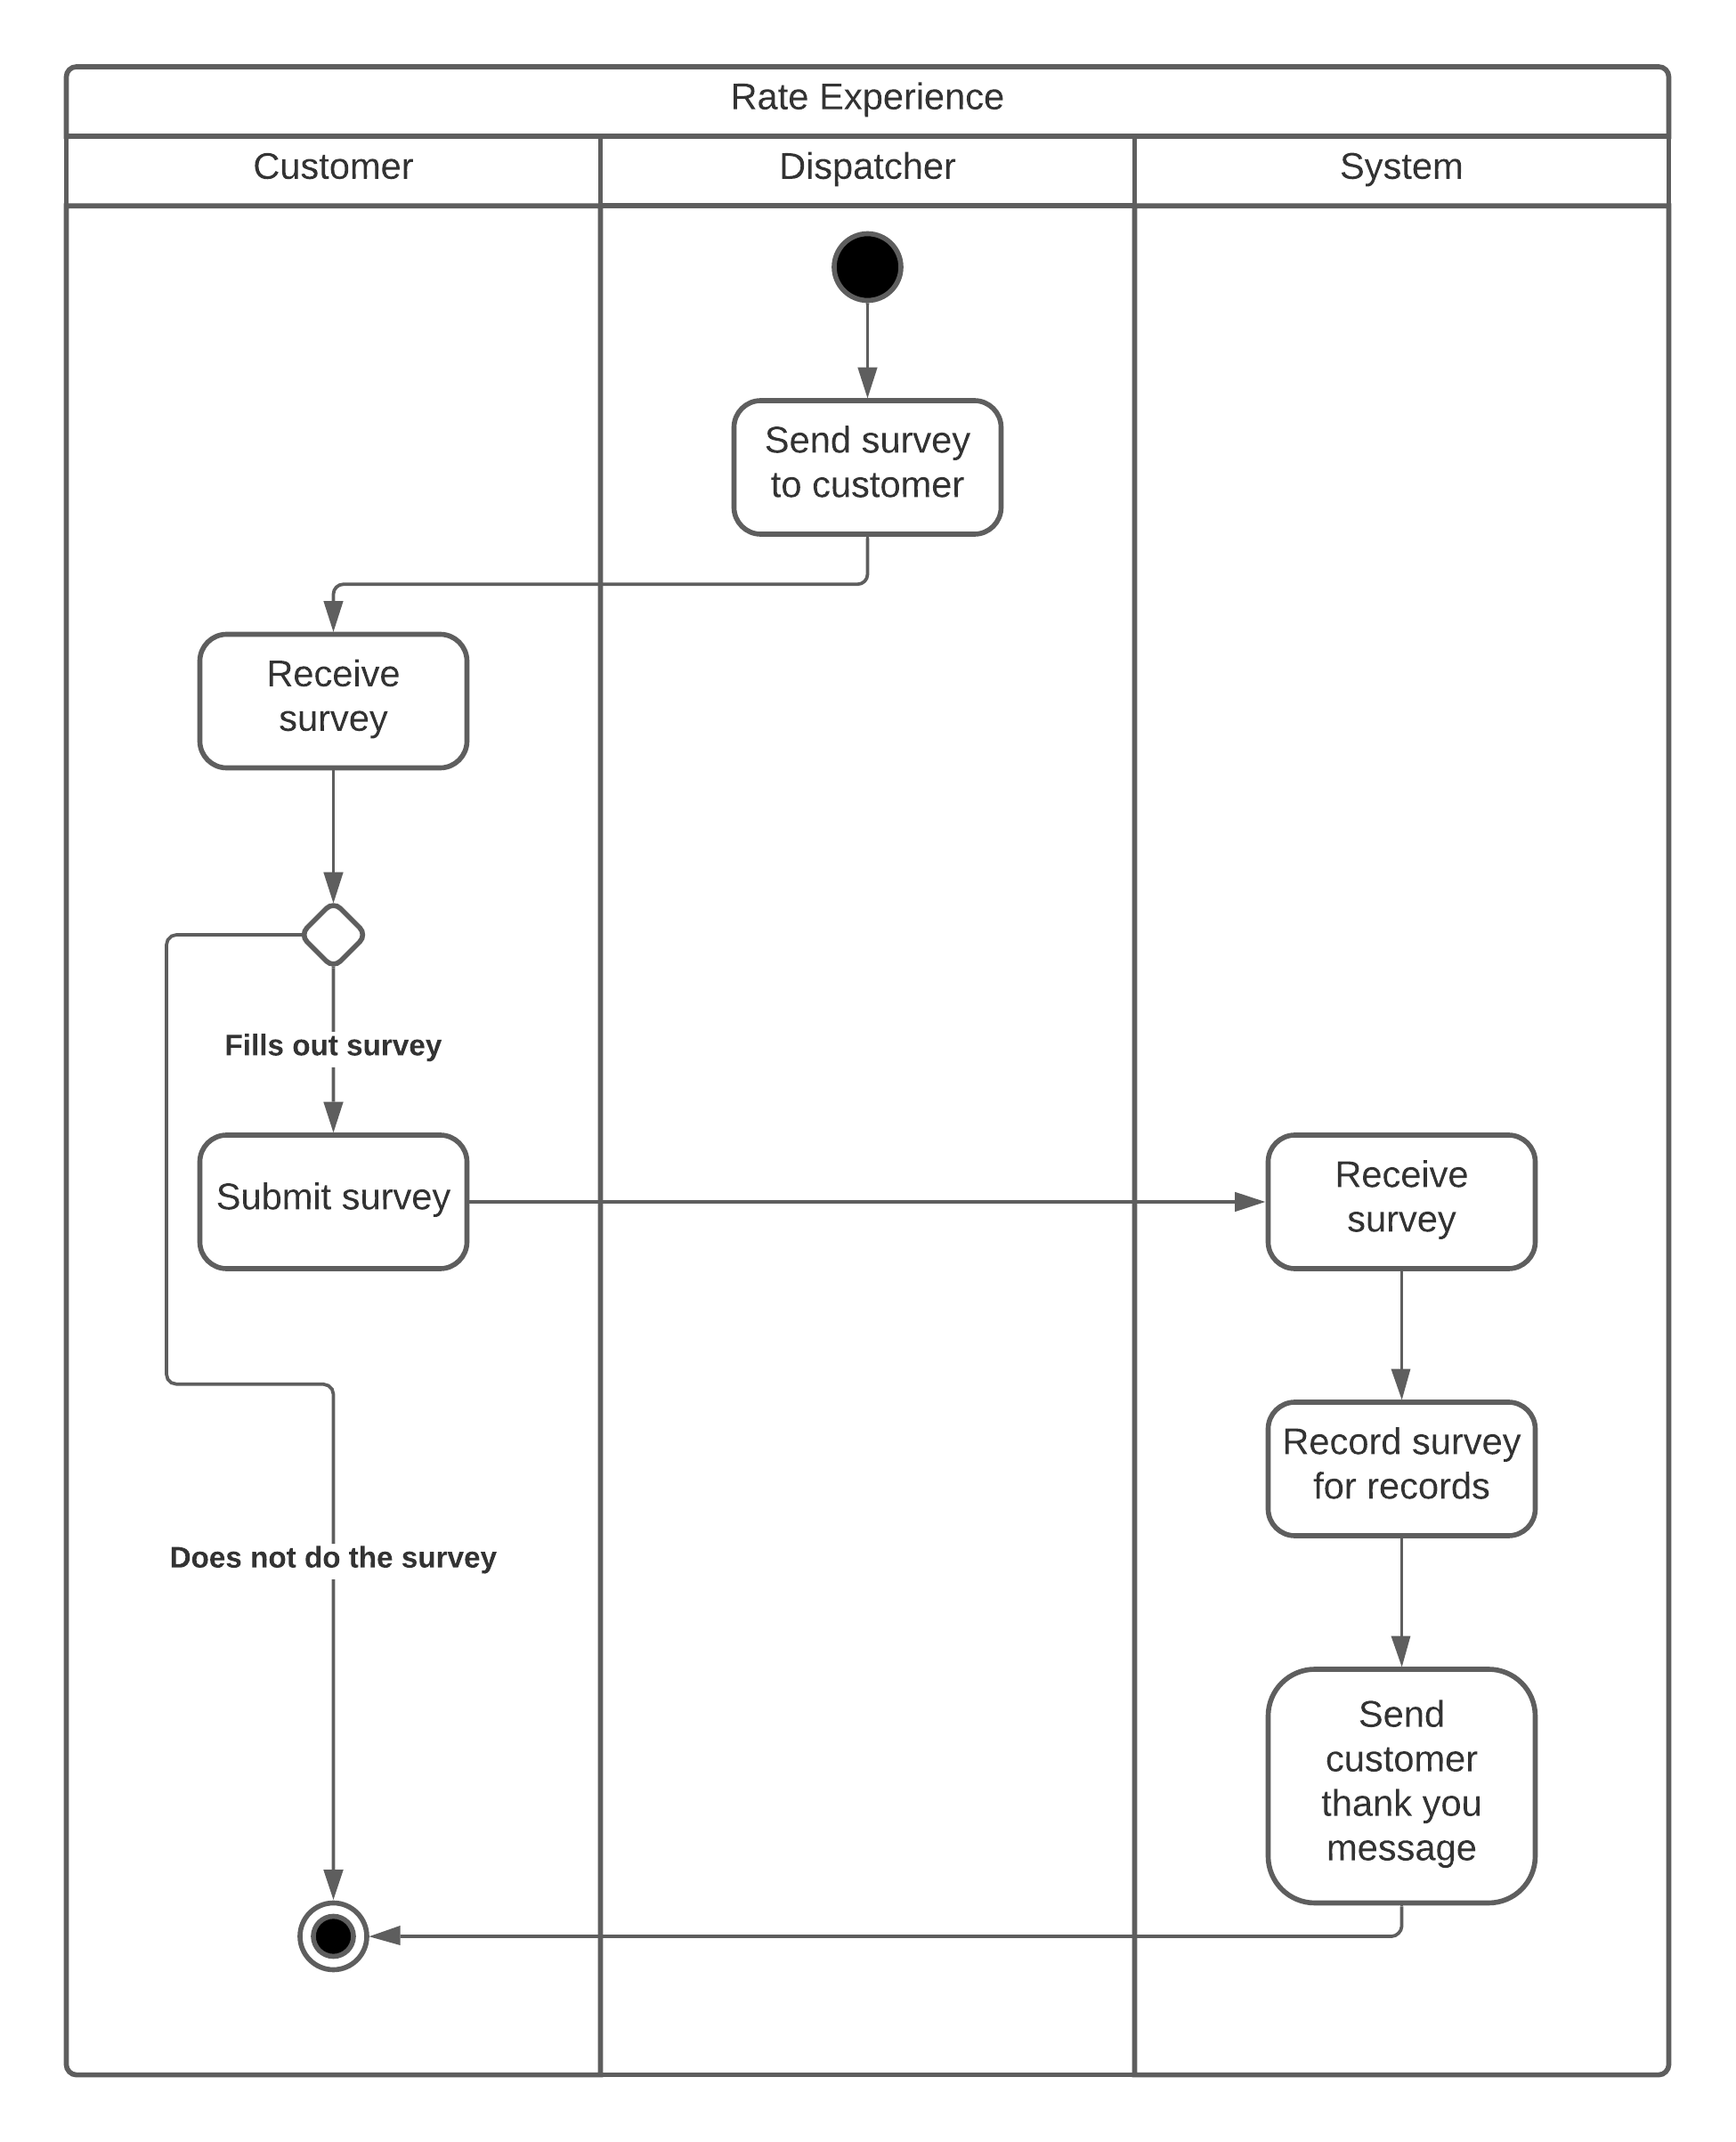

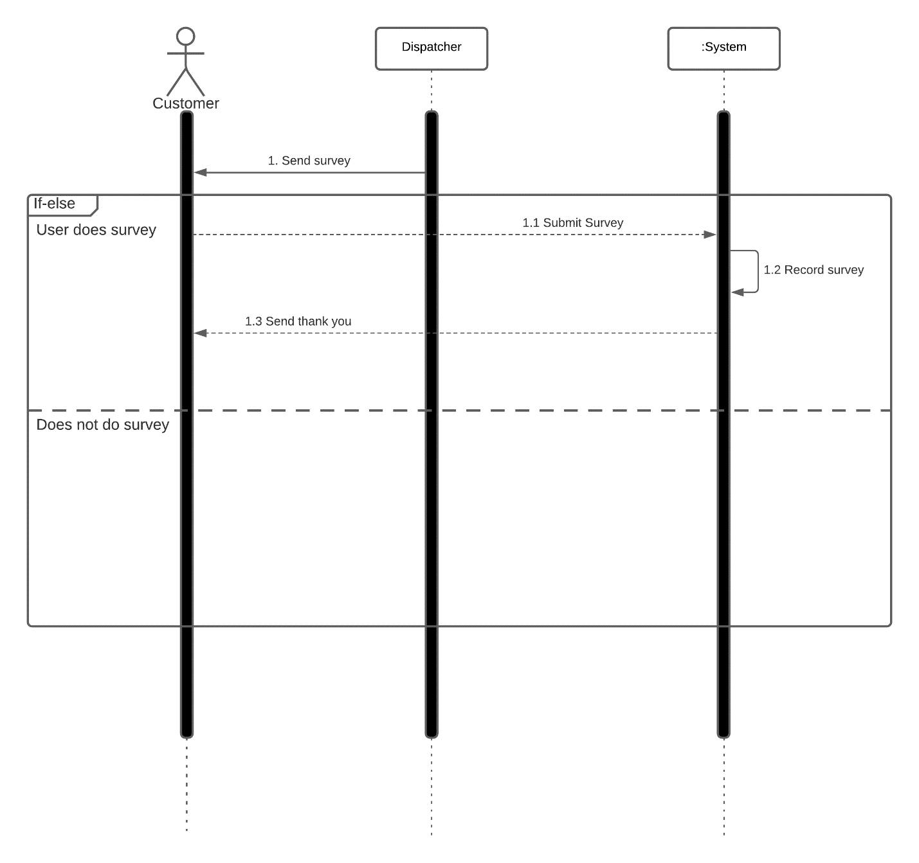

This activity diagram is for the “Cancel Cab” use case in the RazorCab system. The activity begins with the customer calling the dispatcher to cancel their cab reservation. The dispatcher takes the call from the customer and proceeds to cancel the reservation. The activity forks and the reservation is cancelled while the dispatcher notifies the cab driver of the cancellation. The dispatcher then sends a text with a survey link to the customer. The customer goes to the survey and the activity ends there.

The second activity diagram is for the “Rate Experience” use case in the RazorCab system. The diagram begins with the dispatcher sending the survey to the customer. Here, two things can happen: if the customer decides not to fill out the survey, the diagram ends. If they do decide to do the survey, once they submit it, that survey will be sent to the system. The system receives the survey and saves a record of the survey for record keeping. The system then sends the customer a thank you message and the activity ends.

The sequence diagram shown is for the fish-level use case, “Rate Experience”, in the RazorCab system. The sequence begins by the dispatcher sending the customer a text message with the link to a survey for the rental cab experience. If the user does the survey and submits it, the survey is sent to the system. The system then records that survey for safe keeping and to use in data analytics later on. The system then sends a thank you message to the customer and the sequence ends. However, if the user does not do the survey, nothing happens and the sequence will end.