class04.R
paigecontreras
2026-01-16
X <- 1:50
plot(X)
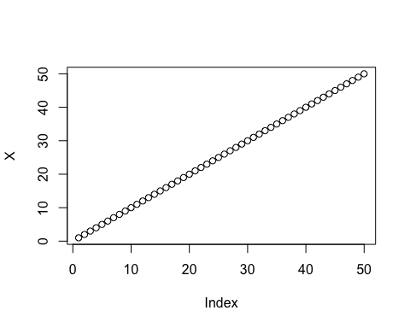
plot(X,sin(X))
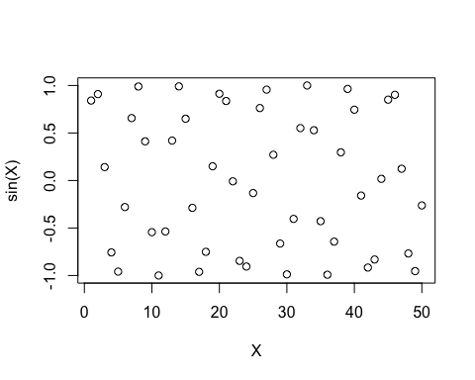
plot(X,sin(X), typ="o", col="pink", lwd=3, xlab="Is it Lunch Time Yet?")
