

**Rangeland Data Processing Exercise**

**with Pix4D AND ArcGIS Pro**

This exercise will introduce you to a variety of GIS tools that are frequently necessary to make your drone data collections more meaningful. In this exercise you will:

* Explore Pix4D tools,
* Combine image sets to render geopositioned orthomosaics and DEMs
* Explore common drone data specific GIS functions
* Conduct simple land cover classifications, and
* Export a map.

The data you will be using for this exercise will be provided in a .zip file at the workshop. **Please unzip this file on your C:\ drive** for the file contents to function correctly.



These are important points that you should read before you go any further!

These are informative tips that may help you in the future!

Metadata (data about the data) is very important, and fortunately is partially generated during the early stages of most mosaic processes with the Pix4D software application, in the form of a report. Additional information that might be important, such as flight location, elevation, time and date, camera type, data type, etc. can be included as part of your file and directory naming conventions. Please keep this in mind as you process and organize your data.

This exercise will be conducted in the Universal Transverse Mercator, Zone 10, coordinate system (using the WGS 84 datum). The files that you will be using have already been saved in this coordinate system to avoid potential confusion.

You will be using imagery that was collected as part of a Rustici funded research project for developing best practices and protocols for rangeland monitoring. The primary files you will use were collected on April 25, 2017 and consist of:

**DJI_X5 - DJI Zenmuse X5, 16mp, RGB, Orthomosaic Image and Digital Surface Model**, (TIFF - raster format). These files were generated from a collection of 407 images collected at 120m above ground level (AGL) with an 80% overlap, at the Yanci Ranch in Yolo County, situated in a mixed oak woodland and grassland. The spatial resolution of these images is approximately 1.39 in, and covers approximately 132 acres under the footprint of the flightlines.

A smaller set of 61 images from this dataset have been prepared and pre-processed in Pix4D for you, because the original 407 image Pix4D project was too large for a workshop setting (~33.4GB).

Pix4D

## Add Data

* Open Pix4D from the desktop icon, or by going to ***Start*** *->* ***All Programs*** *->* ***Pix4D*** *->* ***Pix4Dmapper Pro***   
  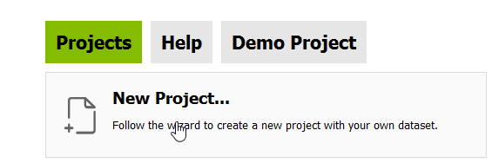
* Create a new project  
  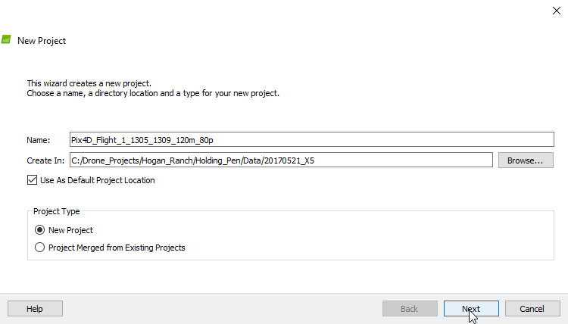
* Use the project wizard  
  to select a workspace for  
  your Pix4D project



Please refer to the Drone Data   
Management handout that was   
provided at this workshop to   
better understand how to arrange  
your data directories.

Without some foresight your data   
can quickly get out of control.

* Follow the prompts (clicking **Next**) to select images for your project.
* Open the file browser to:   
    
  **C:\DroneCamp\Drone_Projects\Rangeland\Rustici\Data\20170425_X5\Flight_2_1311_1323_400ft_80p**  
    
  Select all of the images and drag them over into the Select Images window, and click **Next**.  
    
  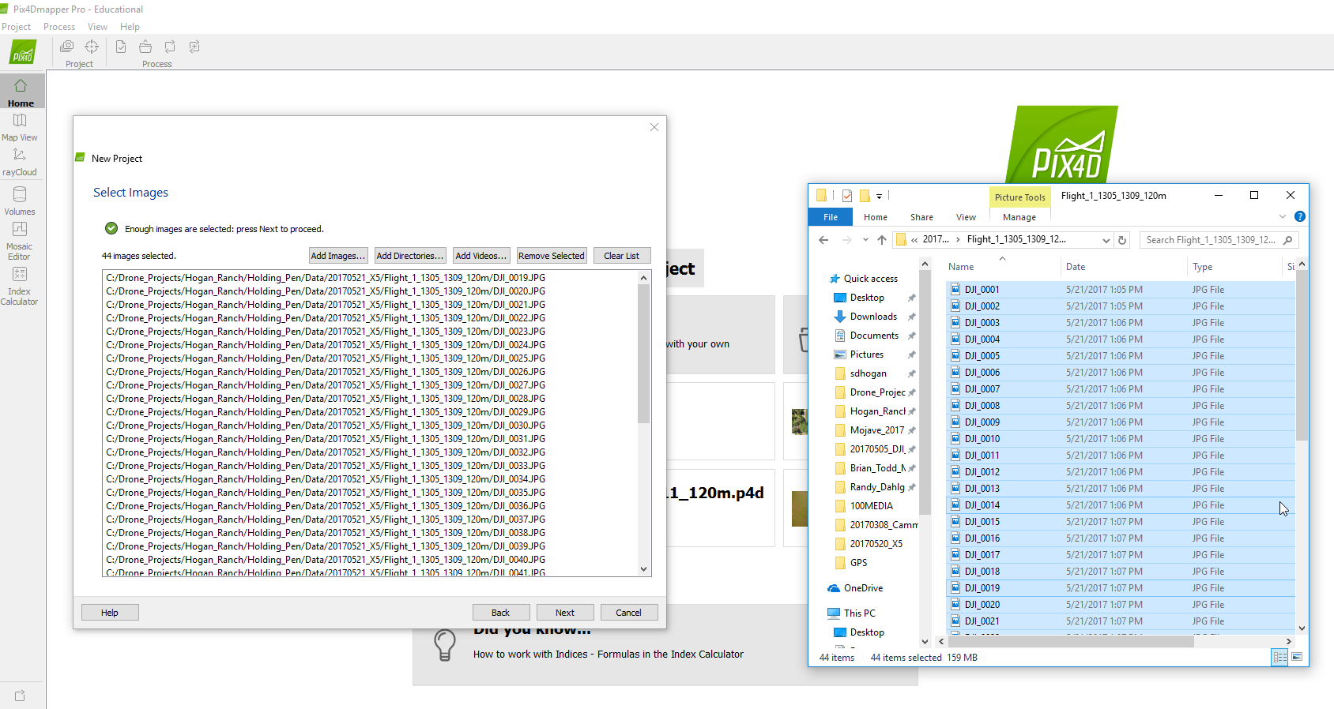
* Click the **To File…** option on the pop up window to export the drone image geotags to a .csv file. You can use this file later to identify the footprint of the flight pattern. Click **OK** and **Next**.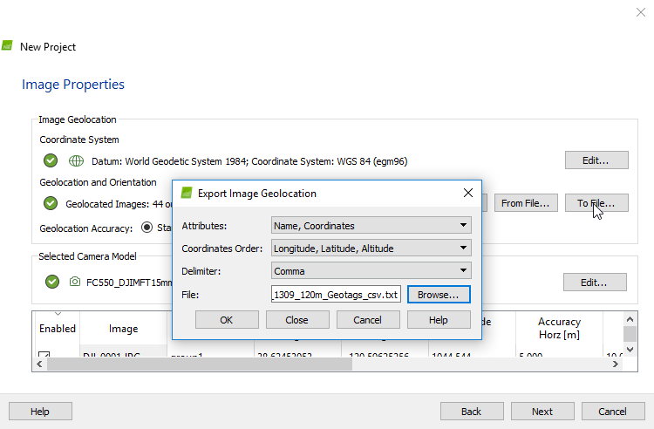
* Accept the default Coordinate system
* Select **3D Maps** (if you have a fast computer) or **3D Maps – Rapid/Low Res** (if you have a medium to slow computer)  
    
  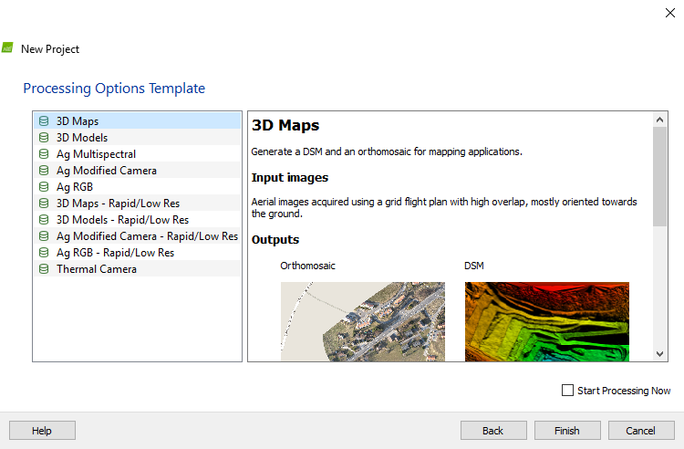
* **Do Not** check the Start Processing Now   
  button
* Click **Finish**
* Click the **Processing Options** button, and explore the various tools that are available
* Under **3. DSM, Orthomosaic and Index** -> **Additional Outputs,** check the box for **LAS**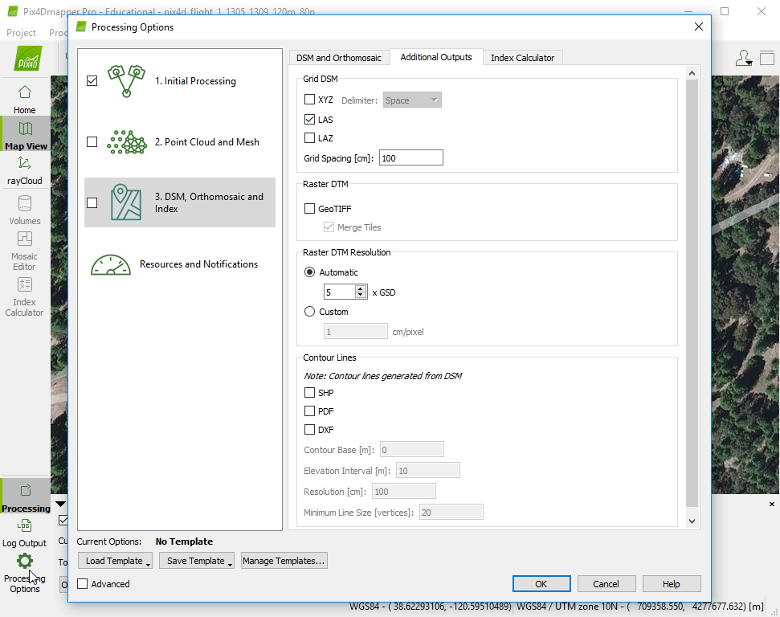
* Also check the box under   
  **Raster DTM -> GeoTIFF**
* Click **OK**
* On the bottom portion of your screen, **uncheck ‘**2. Point Cloud and Mesh and 3. DSM, Orthomosaic and Index’, leaving **only** the **1.** **Initial Processing** button checked (not steps 2 and 3), and click **Start**  
    
  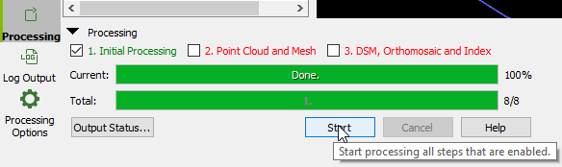
* When the Initial Processing is done, click the rayCloud option (on the left) and click the trackball navigation mode on the top of the screen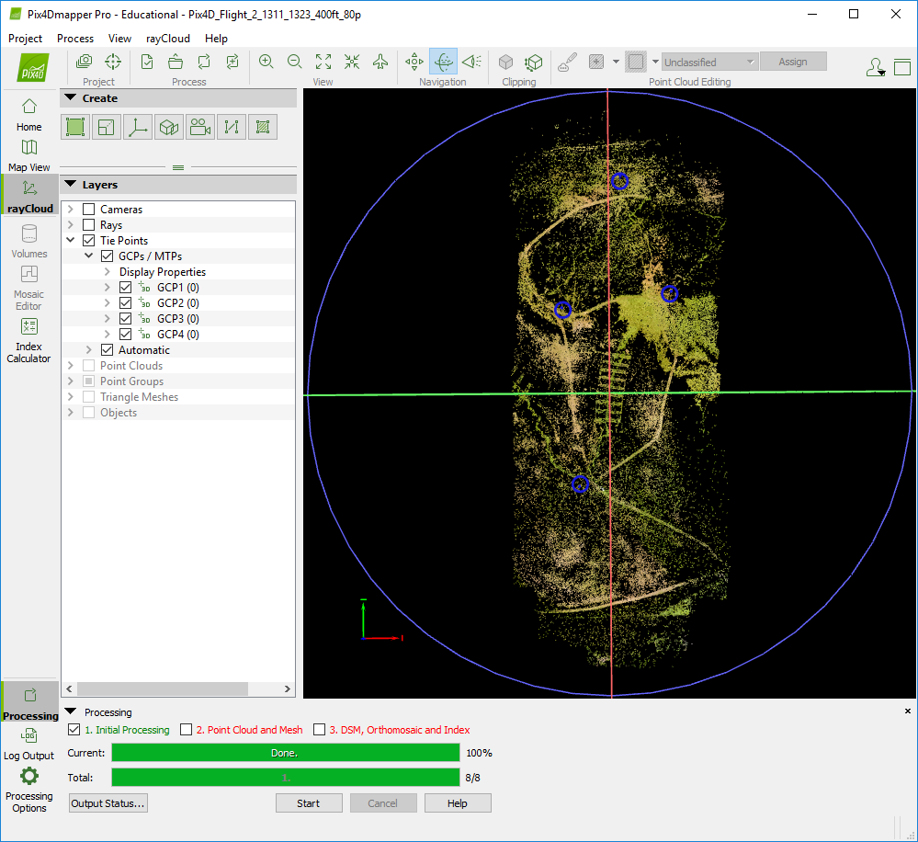
* Unclick the Cameras and Rays boxes
* Swivel the image around (clicking and dragging) until you are looking straight down on the point cloud

See example ->

* Click on the Ground Control Point (GCP)/Manual Tie Points (MTP) Manager button at the top left of the screen  
    
  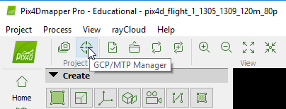

* Click **Import GCPs**
* Navigate to the following directory to find a set of GCPs for processing your imagery - **C:\DroneCamp\Drone_Projects\Rangeland\Rustici\GPS\  
  Trimble_GCPs_csv**
* Click **OK** and **OK** again
* Expand the **GCPs/MTPs** in the layers window and click the various GCPs  
  (Note – The GCP’s will turn a lighter shade of blue when selected, and the selection will pop up in the window to the right)
* If the Selection doesn’t pop up on the right, click the box on the top right side to expand the selection properties window.  
    
  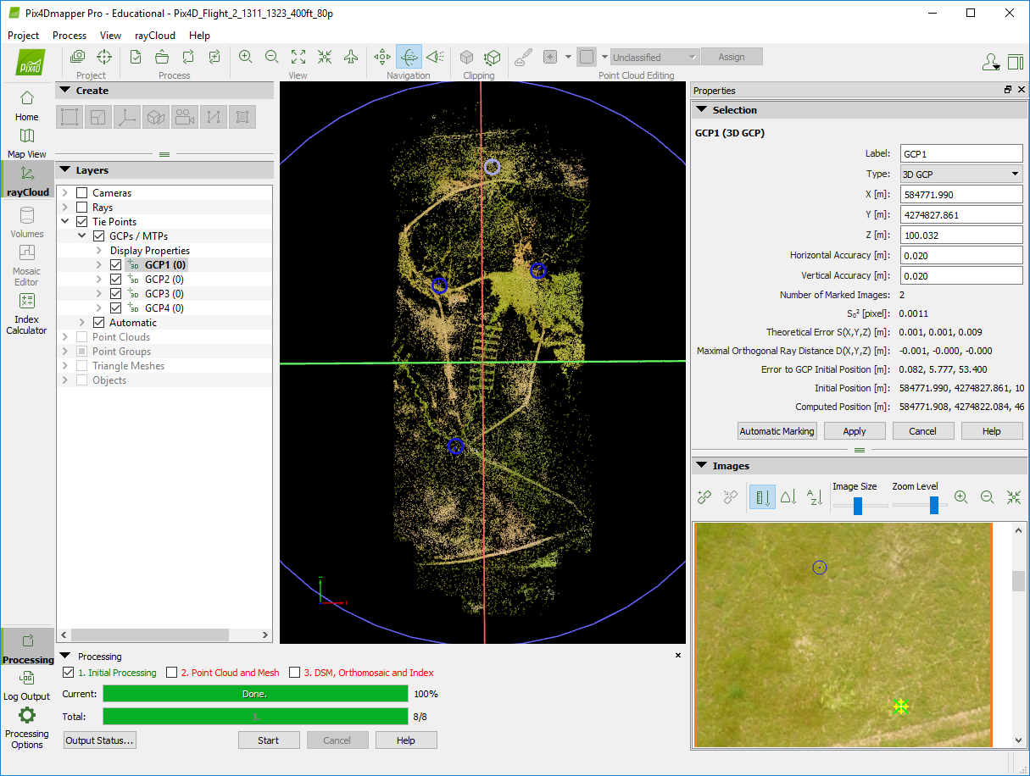

* Zoom in and out on the Image window and try to spot an unusually white dot in the area of the small blue circle. When you find this white dot (being the actual GCP marker in the field) click the center of the dot and a yellow circle should appear around the GCP.  
  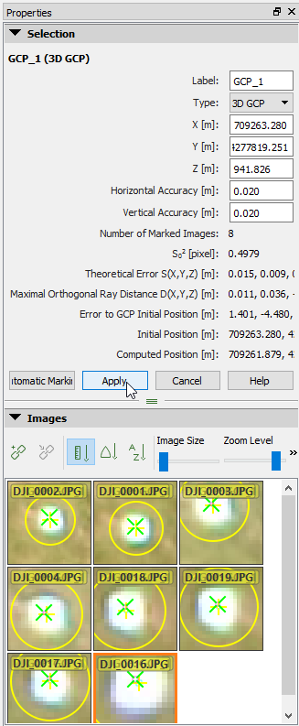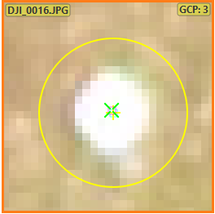
* Scroll down through the Images using the slider bar to the right to select the center of 3 more white GCP dots. When you have selected 4 images points, for tie points, click **Apply**.
* Repeat this for all four of the GCPs (finding 2-5 image dots to tie to 4 total GCPs)
* When you are done, right click the remaining GCPs in the Layers window, and delete these GCPs, which do not have any tie points to the images.

The next steps for processing will take too long for most laptop computers, therefore this processing has already been done for you. However if you were to complete this processing on your own, you would:

* Click the **Reoptimize** button at the top of the window and click **OK** for the warning  
    
  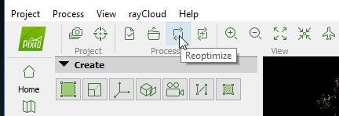
* Click Dismiss when it is done.
* Check steps 2 and 3 (Point Cloud and Mesh, and DSM, Orthomosaic and Index) and click Start.  
    
  This will take about 15 minutes on the fastest of Laptops, and 40+ minutes on average laptops.
* Close this session of Pix4D and open the pre-processed Pix4D project file located at  
  **C:\DroneCamp\Drone_Projects\Rangeland\Rustici\Data\20170425_X5\  
  Pix4D_Flight_2_1311_1323_400ft_80p.P4D**
* Explore the project that you just created

ArcGIS Pro

## Add Data

* Open ArcGIS Pro from the desktop icon, or by going to ***Start*** *->* ***All Programs*** *->* ***ArcGIS*** *->* ***ArcGIS Pro*..**
* Select ***Blank*** under “***Create a New Project***” and give your project an appropriate name
* Click the ***New Map*** button 
* Click the ***Add Data*** button  , go to the following directory in the DroneCamp folder to add the Orthomosaic and elevation data that was created through the last steps.

**Orthomosaic:**  
C:\DroneCamp\Drone_Projects\Rangeland\Rustici\Data\20170425_X5\  
Pix4D_Flight_2_1311_1323_400ft_80p\3_dsm_ortho\2_mosaic\  
Pix4D_Flight_2_1311_1323_400ft_80p_transparent_mosaic_group1

The set of images that you used in the previous exercise session were part of a larger project

* Download the complete orthomosaic at:

C:\DroneCamp\Drone_Projects\Rangeland\Rustici\Data\20170425_X5\  
Pix4D_1252_1340_400ft_80p_complete\3_dsm_ortho\2_mosaic\  
pix4d_1252_1340_400ft_80p_transparent_mosaic_group1  
  
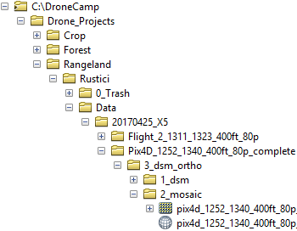

and the corresponding surface model (**DSM**) at:

C:\DroneCamp\Drone_Projects\  
Rangeland\Rustici\Data\20170425_X5\  
Pix4D_1252_1340_400ft_80p_complete\  
3_dsm_ortho\1_dsm\  
pix4d_1252_1340_400ft_80p_dsm

**Explore the Main Menu drop down options.**

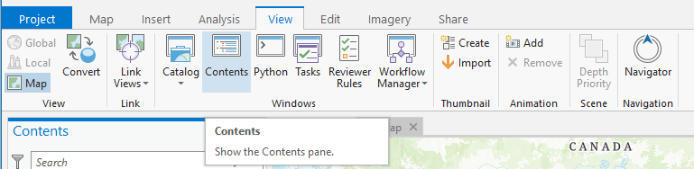

Occasionally the Contents pane will accidentally get closed. It can be restored by clicking the *View* tab and then selecting *Contents* from the Windows options.



* Click the Analysis tab and the Tools icon , and type “***Extract by Mask***” in the Geoprocessing search bar. By the time   
  you get to “Extract by” the *Extract by Mask* tool should   
  appear in your Search Reults window.
* Right click and choose “*Add To Analysis Gallery”*.

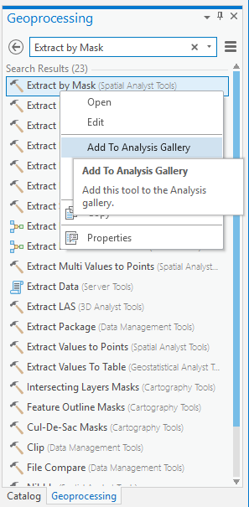

* You will have the opportunity to use the ***Extract by Mask* **tool in one of the next steps of the exercise.

The previous method for customizing your toolbars can save you a lot of time in the long run, if you find that you are repeatedly using the same tool over and over again.

Drone imagery commonly includes a considerable amount of data that is collected from outside of the footprint underneath the drone’s flight lines. This data usually has the greatest amount of spectral and spatial distortion, which can decrease the quality of later map products. For this reason, you may wish to remove the distorted portions of the mosaic and DSM products.

* Again, click the **Add** button  , and add the Flight Geotags into your ArcGIS Pro session from:  
    
  C:\DroneCamp\Drone_Projects\Rangeland\Rustici\GIS\Vector\Geotags\GeoTags1
* Turn these files on and off in your table of contents, and rearrange the files by clicking and dragging them on top of each other. Compare the file outputs from each of the sensors.
* Right click the flies to see their properties, including their source pathways.
* Slowly click them twice to rename the files; so that you don’t lose track of which file is associated with each sensor.

**Create a Shapefile from Scratch**

* Click the Tools  icon and type “***Create Feature Class***” into the Geoprocessing search bar. Under “*Feature Class Location*” navigate to your DroneCamp folder and select the ***Boundary*** folder.
* 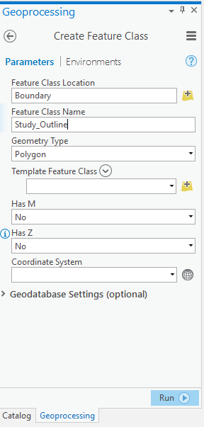Name the file ***Study_Outline*** and select   
  **Polygon** as the Geometry Type.

Designate a coordinate system for the shapefile:

* Click ***Select coordinate system*** 
* Navigate through the folders: Projected   
  Coordinate Systems -> UTM ->WGS 1984 -> Northern Hemisphere and select:   
  **WGS 1984 UTM Zone 10N**
* Click **OK** and **Run**

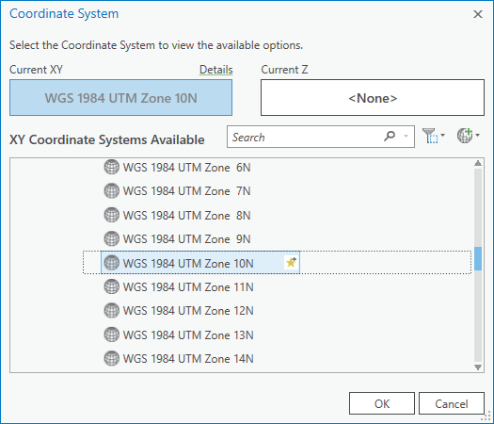

You have now created a shapefile, however this file does not yet have any spatial features within it.

* Click the Edit tab, then click the Create icon  to begin creating the shape of the shapefile (see image on the next page).
* Click ***Study_Outline*** in the   
  *Create Features* window, and   
  select ***Polygon***.

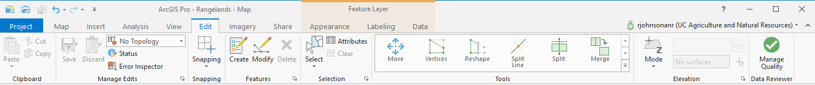

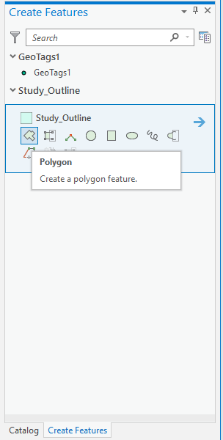

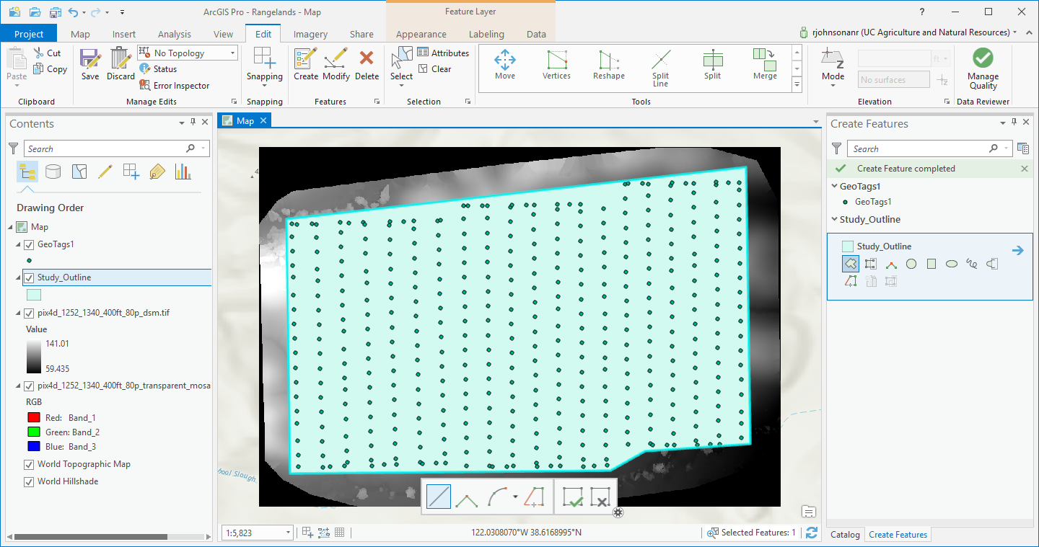

* Click around the edge of the   
  **GeoTags1**, so that it only covers the footprint under the cameras
* Under the Editor tab, click **Save Edits.**

You have now created a shape file, which can be used to clip or extract data from other files, or be used to compute zonal statistics.

**Clip Raster Images**

* Click on the **Analysis** tab and then the **Tools** icon.
* Type “**Extract by Mask**” in the Geoprocessing window, and click tool. Alternatively, you can simply click the tool icon that you previously added to your tool gallery.
* Select the **Complete RGB** orthomosaic (**pix4d_1252_1340_400ft_80p_transparent_mosaic_group1**) from the first drop down arrow
* Select your ***Study_Outline*** area, from the second drop down arrow, and

Select an appropriate location in your DroneCamp GIS folder where you can save a clipped mosaic image, and then **stop**. The processing time to complete this function will take several minutes and it is not essential right now. However, because this is one of the most common geoprocessing tools needed for drone data, these directions are included.

Note – Sometimes the *Extract by Mask* tool doesn’t work. If so, there is an alternative method to do the same thing. Simply use the *ArcToolBox -> Data Management Tools -> Raster -> Raster Processing -> Clip* function instead. Then use the *Study_Area* as the *Output Extent,* and be sure to click the *Use Input Feature for Clipping Geometry* box. 

**Raster Math and Topographic Modeling**

Pix4D produces its output layers with all pixels in alignment. Sometimes you will want to shift or warp these output layers at a later time (called georegistration or geocorrection), but you do not want to lose this important alignment between the layers in doing so. Therefore, it is usually a good idea to conduct all of your raster math and elevation modeling (e.g. for aspect, slope and hillshade) on the original files, and then create a single composite stack of the layers before you proceed.

**Topographic Visualization**

* Use the Search function to look up and apply a Hillshade function to the DSM file. Be sure save the output files to an appropriate location in your GIS folder. Slope and aspect layers can be created in the same way. For this exercise please use the defaults for these tools, these are for visualizations only.
* When the Hillshade appears in the Contents pane -> click it -> select **Appearance** under the “Raster Layer” section of the toolbar-> adjust the transparency slider to 50%.

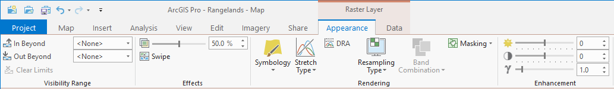

* Place this on top of the DSM in the TOC, for design effect.



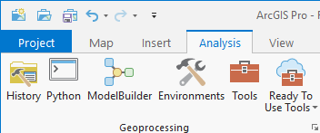**Bonus Exercise - Stream Delineation**(for more advanced users)

**New GIS users, please skip to after the boxed in text areas**

* Click the Model Builder tool at the top of the screen under **Analysis**.

Unless you have an extremely fast computer for this exercise you will probably want to use the smaller dataset that you processed in the Pix4D at the beginning of the exercise. Browse through the following folder using the file structure knowledge that you have developed over the course of this session:   
  
C:\DroneCamp\Drone_Projects\Rangeland\Rustici\Data\20170425_X5\  
Pix4D_Flight_2_1311_1323_400ft_80p

* Click and drag the DSM or DTM from the TOC into the Model Builder window at the top left.
* Use the Search tool to look up ‘**Fill**’, and then drag and drop the Fill function into the Model Builder, right after the DSM bubble.
* Click and hold the DSM, drag the arrow to Fill, and click **Input Service Raster**
* In a chain search for and connect **Flow Direction** -> **Flow Accumulation** -> and **Set Null**



A diagram of this model can be found on the next page

* Double click the first green circle in the series of function outputs -> select an appropriate place in your directory to send this file output (e.g. a trash folder - these files won’t be used again) -> then repeat this for each of the other green bubbles.
* Run the model by clicking the Run arrow arow.png on the toolbar. This step was taken to prepare the model for the final processing steps.
* 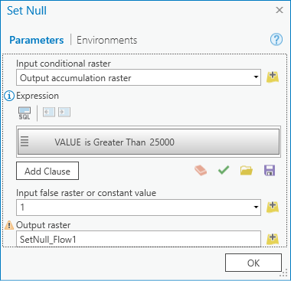Now add **Stream to Feature** to the end of the model tools.
* Double click on **Set Null**-> change the SQL expression to **VALUE > 25000**
* Set the constant value to  **1**
* 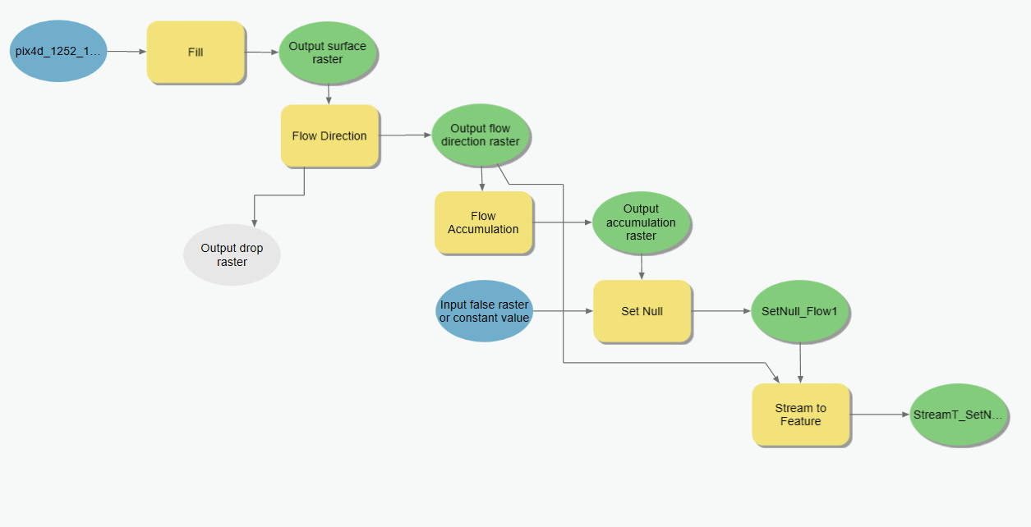Click the Run Button arow.pngagain and when it finishes running, load the new stream network file into your ArcGIS session.

**Composite Bands**

* For the sake of processing time in the next steps, load the reduced size **DSM** and **DTM** files from the directory created in the first Pix4D section of this exercise:   
    
  C:\DroneCamp\Drone_Projects\Rangeland\Rustici\Data\20170425_X5\  
  Pix4D_Flight_2_1311_1323_400ft_80p

**Hint** - In your windows file browser, you can use the search box at the top right corner of the browser (or control+F) to look up the DSM and/or DTM files. The **.tif** files found in the windows browser can then be dragged and dropped into the ArcGIS Pro Contents pane.

* Using the ArcGIS search function, type **Composite Bands**, and click the Composite Bands (Data Management) (Tool) option.
* Add your reduced size **orthomosaic**, **DSM**, **DTM**, as well as the **Hillshade**, **Slope**, Aspect any other layers from the larger dataset as Input Rasters

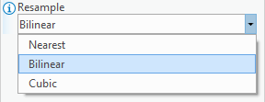If you suspect that you might ever want to conduct further analysis using your DSM or DTM files again, there is an extra step that you need to take here. 

* Click the *Environments…* tab at the top of the *Composite Bands* window, at the bottom of the list under *Resample* select BILINEAR.

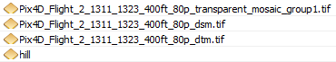

Before you run the Band Composite tool, you may want to write down the order of your layers, or take a screen capture of the file order for future reference.

* Enter an appropriate output location for your ‘Layer_Stack’ and don’t forget the extension (i.e. .tif).
* Click the Environments tab at the top of the Composite Bands window and from the dropdown under Extent, select **Same as** ‘your orthomosaic image’
* Then under Snap Raster, select the orthomosaic file again.
* Click **Run** to execute the Band Composite tool.

These steps will ensure that your raster pixels will be in perfect alignment in the output layer stack.

The layer stack will show up in your Contents pane, but will have a strange color composite of the three input layers. Right click the file in the *Contents pane* -> select *Symbology* -> Stretched→ Pick a color → Apply Stretch Type → Percent Clip

**Classification**

Classification is a powerful tool for automatically symbolizing land cover characteristics, that can then be displayed on a map for a desired impact. For this we will use ArcGIS Pro’s ***Image Classification*** tools.

* Click ***Classification Tools*** under the Imagery tab and select ***Training Samples Manager*** from the drop down menu.
* Use the Zoom and Pan tools to focus on different areas in your Layer_Stack that have relatively uniform examples of **bright vegetation (yellow star thistle), dark vegetation (grass), and stressed vegetation/bare earth**
* Within the ***Training Samples Manager*** window, select Create New Schema 
* 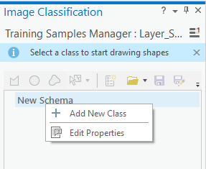Right click the “New Schema” heading and select Add New Class
* Give your new class a name (Yellow Star Thistle) and a value (1)

Frequently this type of classification training data would be collected in the field using a GPS, however we will conduct “heads up digitization” (i.e. traced outlines of the land cover sample sites). For this just use your best judgement as to the color and brightness of the RGB imagery.

* Select your new class in the ***Training Samples Manager*** and click the ***Polygon*** icon .
* Begin clicking on the map window to select/outline three **bright vegetation** regions of interest (ROI), double click when you are ready to finish the sketch.
* 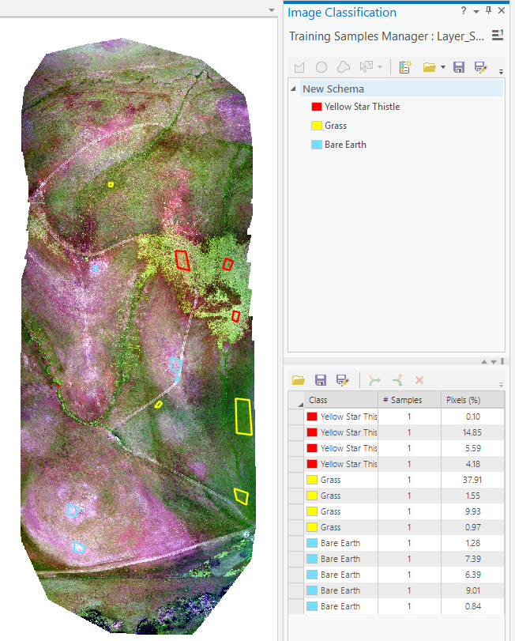Repeat the above steps to next collect 3 ROIs for each of the following types of land cover: **dark vegetation, and stressed vegetation/bare earth**.

Don’t rush while using the Image Classification tools, and save your work frequently. The classification tools are sometimes touchy and can cause ArcGIS to crash.

* In the Training Samples Manager window, click ***Save*** and save your training samples to your working directory, with a name of your choosing.
* In the Imagery tab click the ***Classification Tools*** and ***Classify*** and select **Maximum Likelihood Classification** as your classification method.
* 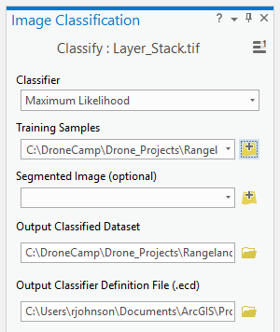Track down and select the ***Training Samples***   
  file that you just created
* Select an appropriate location to save your   
  ***Output classified dataset*** and call it ***LC_Classes***
* Leave all the other default setting as they are, and click ***Run***
* It may take a couple minutes, but eventually a classified image of your study area should appear.

**Create a map**  ____________

Within the Insert tab, select ***New Layout*** and then select “Letter” under ANSI Portrait.

* Insert Text (a **Title**), a **Legend**, a **North Arrow**, **etc.** from the ***Insert*** menu tab drop down list.

Note: ArcMap places your map elements in the center of your map at first, and you have to move them to where you want. Look carefully when you’ve added an element – sometimes it’s hard to see them in front of your map!

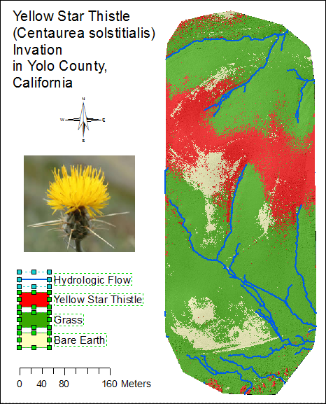

The legend is automatically linked to the layer names and displayed symbology. Sometimes you will wish to change the layout of the legend.

* Right click the legend and Convert it to Graphics, then Ungroup the legend until you can access the specific text or elements that you want to change (by double clicking them).

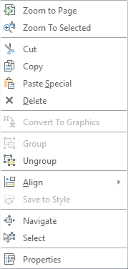

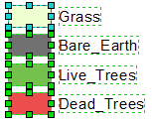

**Export your map**

* 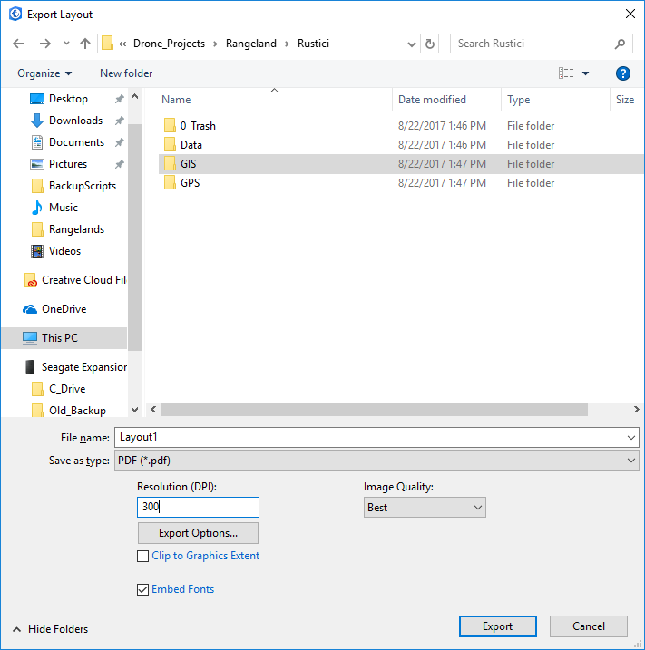Go to the ***Share* tab** *→* ***Export Layout****...* and change the “***Save as type***” to **PDF**. Use a unique name, with your name in the name.
* Change the output resolution. 300dpi is a high quality output resolution for printing (below).

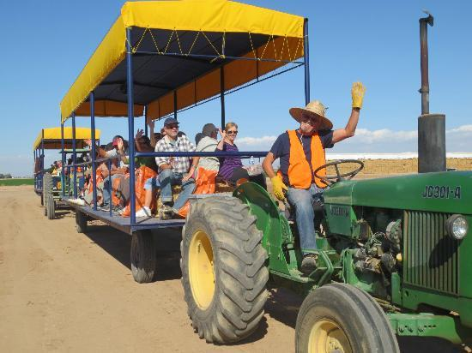

Thank you for attending the first IGIS DroneCamp!