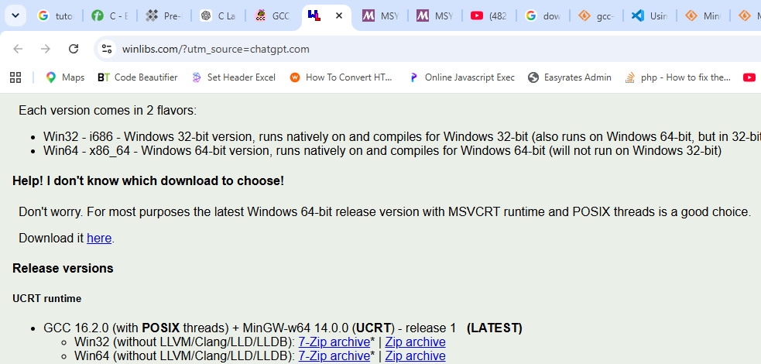
Goto url and download zip archive
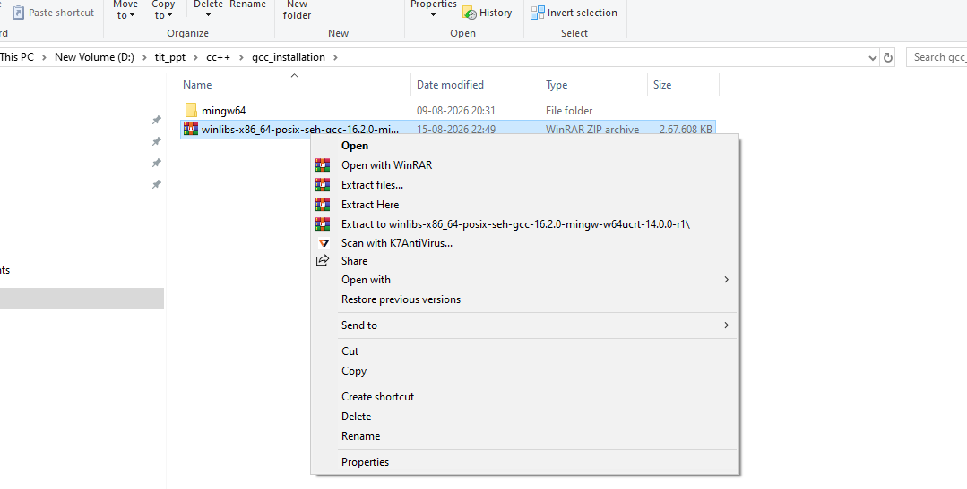
Extract files and you will get folder of mingw64
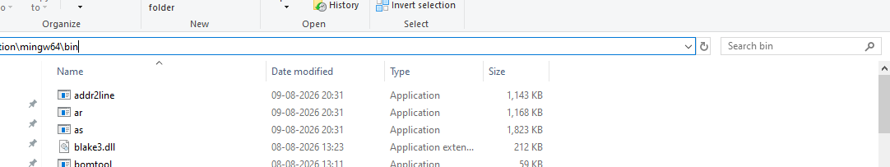
Go to bin folder and copy its path
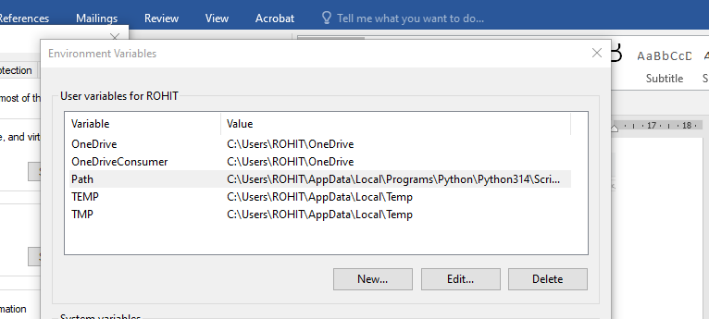
Click Edit
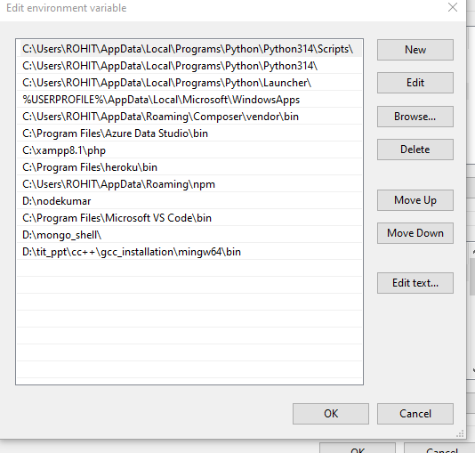
Add path of bin folder then click ok
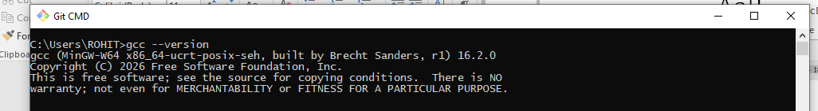
Then from terminal execute the command and you should get something like this it means gcc setup is correct

Execute commands [ sudo apt install gcc ] for linux and command [xcode-select --install] and
For Linux it will compile and execute like this
gcc hello.c -o hello
./hello

For Macos it will execute like this
clang hello.c -o hello
./hello

If this not run then do the setup accordingly

