The ‘StratiPHOLIAGE’ canopy model and program

The StratiPHOLIAGE model (Stratified Photosynthesis Light Absorption Generic model) has been developed at the department of Plant Ecology of Utrecht University, The Netherlands, initially together with the Biological Institute, Graduate School of Science of Tohoku University, Japan. The model program was written by Roelof Oomen, department of Plant Ecology of Utrecht University.

The total daily (24h) photosynthesis P_{i} (in μmol⋅d⁻¹) for layer i is calculated by integrating the photosynthesis speed p (in μmol⋅m⁻²s⁻¹) at a certain time t (in hours, hence the conversion factor 3600 s⋅h⁻¹) over one day (sunrise to sunset, twilight is not taken into account) and subtracting the nightly respiration 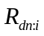. The division by the layer F_{i} is because of the integration to F (over the layers’ F_{cum} ranges) in equation 2.

(1) 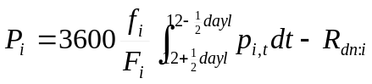

(1b) 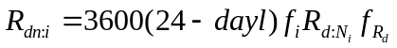

Where dayl is the day length at the given date (in h) and latitude, f_{i} is the leaf area of the plant in layer i (in m²),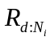is the night respiration speed in the layer (in μmol⋅m⁻²s⁻¹),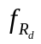the factor by which to lower the measured day dark respiration speed during the night, F_{i} the vegetation LAI in the layer (in m²m⁻²) and p the photosynthesis speed for layer i at time t, which is calculated by integrating between the cumulative LAI (F_{cum}) boundaries of the layer

(2)

Where p_{l} (in μmol⋅m⁻²s⁻¹) is the net leaf photosynthesis speed for a certain amount of radiation and a certain leaf nitrogen content, I_{dir}, I_{scat} and I_{dif} are the direct, scattered and diffuse components of the incoming radiation (in μmol⋅ m⁻²s⁻¹) and f_{sl} is the fraction of sunlit leaves at a certain depth in the canopy. Left and right of the plus sign are respectively the photosynthesis calculation for sunlit and shadowed parts of the leaves in the layer.

(3) 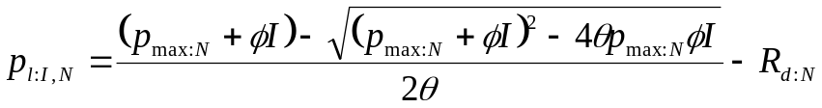
Where p_{max} and R_{d} are respectively the max photosynthesis and the night respiration of the plant (both in μmol⋅m⁻²s⁻¹), while φ and θ are respectively the quantum yield and the curvature of the photosynthesis curve.
For calculating the light absorption the following equations are used:

(4) 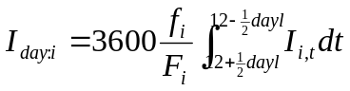
(5) 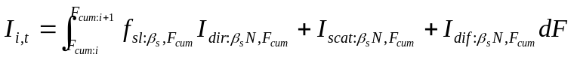

Where I_{day} is the total day PPFD absorption of layer i and I is the PPFD absorbed at a certain time t in layer i.
(6) 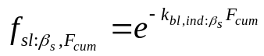

(7) 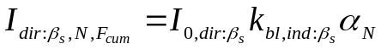

(8)

(9)

The square root of alpha “is used to model the effects of leaf reflectance and transmittance on the light climate in the canopy according to Goudriaan (1977).” (Anten & Hirose, 1999).
Extinction coefficient k_{veg} can either be a value specified in the input data (for example calculated from light measurements) or can be calculated:

(10) 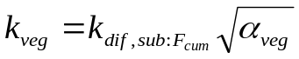

If calculations are made for an overcast day I_{o,dif} will be a fixed value throughout the day and I_{0,dir} will be 0. Where I_{0,dir} and I_{0,dif} are the direct and diffuse radiation components above the vegetation (in μmol⋅ m⁻²s⁻¹), k_{bl} is the extinction coefficient of non-scattering, hypothetically black leaves, k_{dif} is the extinction coefficient of the vegetation for diffuse light, ρ is the canopy reflection coefficient and α is the leaf light absorption coefficient for a certain leaf nitrogen content N (in mmol⋅m⁻²):

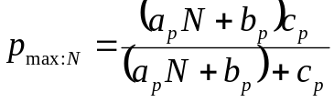 if p_{max} is set to be hyperbolic
(11) or
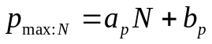 if p_{max} is set to be linear

(12) 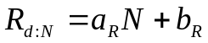

(13) 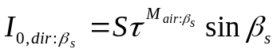

(14) 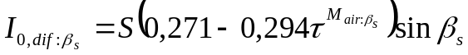

(15) 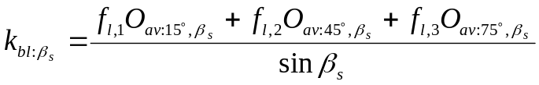

(16) 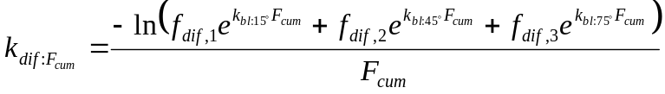

(17) 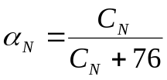

Where f_{dif} are the fractions of diffuse light coming from each sky zone, S is the sun constant, i.e. the total amount of light outside the atmosphere, τ is the atmosperic transmittance, M_{air} is the mass of air the incoming radiation from outside the atmosphere has to pass through, O_{av} is the average projection of a leaf with angle β_{l} in radiation of angle β_{s}, C is the chlorophyll content of a leaf (in μmol⋅ m⁻²).

(18) 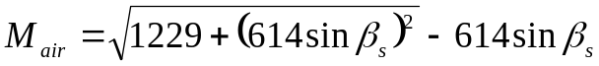

(19) 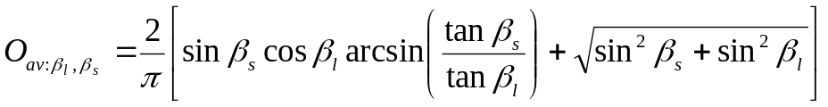 if β_{s} <β_{l}
and
(20) 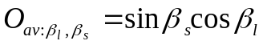 if β_{s} >β_{l}

(21) 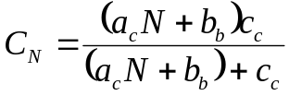

The day length dayl required for integration over the day is calculated as follows:

(22) 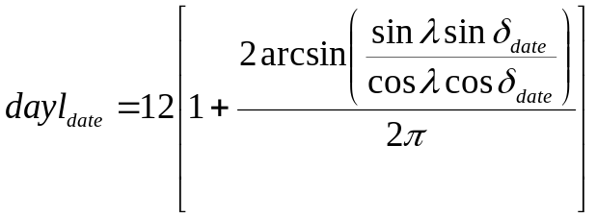

Where δ is the declination of the sun at a certain date and λ is the latitude of the plot location.

(23) 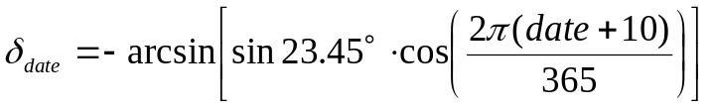

And the inclination of the sun β_{s} at a certain date date and time t is

(24) 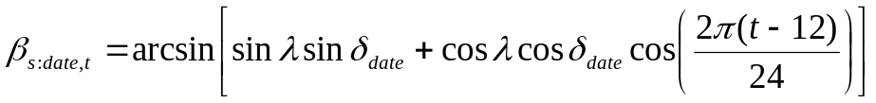

Notes:
The F_{cum} is both used as a parameter determining the k_{bl}, but also as a depth parameter, indicating how deep we are in the vegetation, as seen from the top (F_{cum} = 0) to the bottom (F_{cum} = vegetation F). This last application eliminates the need for knowing the vegetation, plant and layer height. This leads, however, to the simplifying assumption that the plant’s top layer has the same thickness as the corresponding vegetation layer.

Program notes
-The α_{N} (leaf light absorption coefficient) of an individual has a minimum value set to 0.2, in case the leaf nitrogen content is very low. This was done to prevent very low α_{N} values.
-Constants: S (sun constant) = 3190, τ (atmosperic transmittance) = 0.6, f_{dif} (1, 2, 3) = (0.2, 0.3, 0.5).
-P and I results are divided by 1,000,000 to get mol/day.
-Possible read errors
- Not enough sheets in workbook
- Error reading plot data
- Error reading species data
- Error reading subplot data
- Error reading individual data
-A ‘Hash table collision’ in the output file indicates either species/subplots/individuals with the same name or an (unlikely) occasion of two names resulting in the same hash value. Solution: change the name of the problematic species/subplot/individual.

References
Formulas:
1) ?
1b) ?
2) Anten and Hirose, 2001. Formula 10
3) Anten and Hirose, 2001. Formula 7
6) Anten and Hirose, 2001. Formula 11
7) Anten and Hirose, 2001. Formula 4, but with 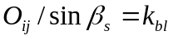 and the shade component
omitted.
8) Anten and Hirose, 2001. Formula 3
9) Anten and Hirose, 2001. Formula 2
10) ?
11) Anten and Hirose, 2001. Formula 8
12) Anten and Hirose, 2001. Formula 9
13) Gates, 1980.
14) Gates, 1980.
15) Goudriaan, 1988. ?
16) Goudriaan, 1988. ? Anten, 1997.?
17) Anten and Hirose, 2001. Formula 5

Literature
-Anten, N.P.R. and Hirose, T. 1999. Interspecific differences in above-ground growth patterns result in spatial and temporal partitioning of light among species in a tall-grass meadow. Journal of Ecology 87: 583-597.
-Anten, N.P.R. and Hirose, T. 2001. Limitations on photosynthesis of competing individuals in stands and the consequences for canopy structure. Oecologia 129:186-196
-Goudriaan, J. 1988. The bare bones of leaf-angle distribution in radiation models for canopy photosynthesis and energy exchange. Agricultural and Forest Meteorology, 43: 155-169
-Anten, N.P.R. 1997. ?
-Gates, D.M. 1980. Biophysical Ecology. Springer Verlag, New York.

