1)-

CREATE EXTERNAL TABLE IF NOT EXISTS weather

(WBANNO int, LST_DATE DATE, CRX_VN FLOAT, LONGITUDE FLOAT,LATITUDE FLOAT,T_DAILY_MAX FLOAT,T_DAILY_MIN FLOAT,T_DAILY_MEAN FLOAT, T_DAILY_AVG FLOAT,P_DAILY_CALC FLOAT, SOLARAD_DAILY String, SUR_TEMP_DAILY_TYPE FLOAT, SUR_TEMP_DAILY_MAX FLOAT, SUR_TEMP_DAILY_MIN FLOAT,SUR_TEMP_DAILY_AVG FLOAT,RH_DAILY_MAX FLOAT, RH_DAILY_MIN FLOAT,RH_DAILY_AVG FLOAT,SOIL_MOISTURE_5_DAILY FLOAT,SOIL_MOISTURE_10_DAILY FLOAT, SOIL_MOISTURE_20_DAILY FLOAT, SOIL_MOISTURE_50_DAILY FLOAT, SOIL_MOISTURE_100_DAILY FLOAT,SOIL_TEMP_5_DAILY FLOAT, SOIL_TEMP_10_DAILY FLOAT, SOIL_TEMP_20_DAILY FLOAT, SOIL_TEMP_50_DAILY FLOAT, SOIL_TEMP_100_DAILY FLOAT)

COMMENT 'Weather Details'

ROW FORMAT DELIMITED

FIELDS TERMINATED BY ','

LINES TERMINATED BY '\n'

STORED AS TEXTFILE;

2)-

LOAD DATA LOCAL INPATH '/home/tech/weather_updated.txt' OVERWRITE INTO TABLE weather;

3)-

select * from weather limit 5;

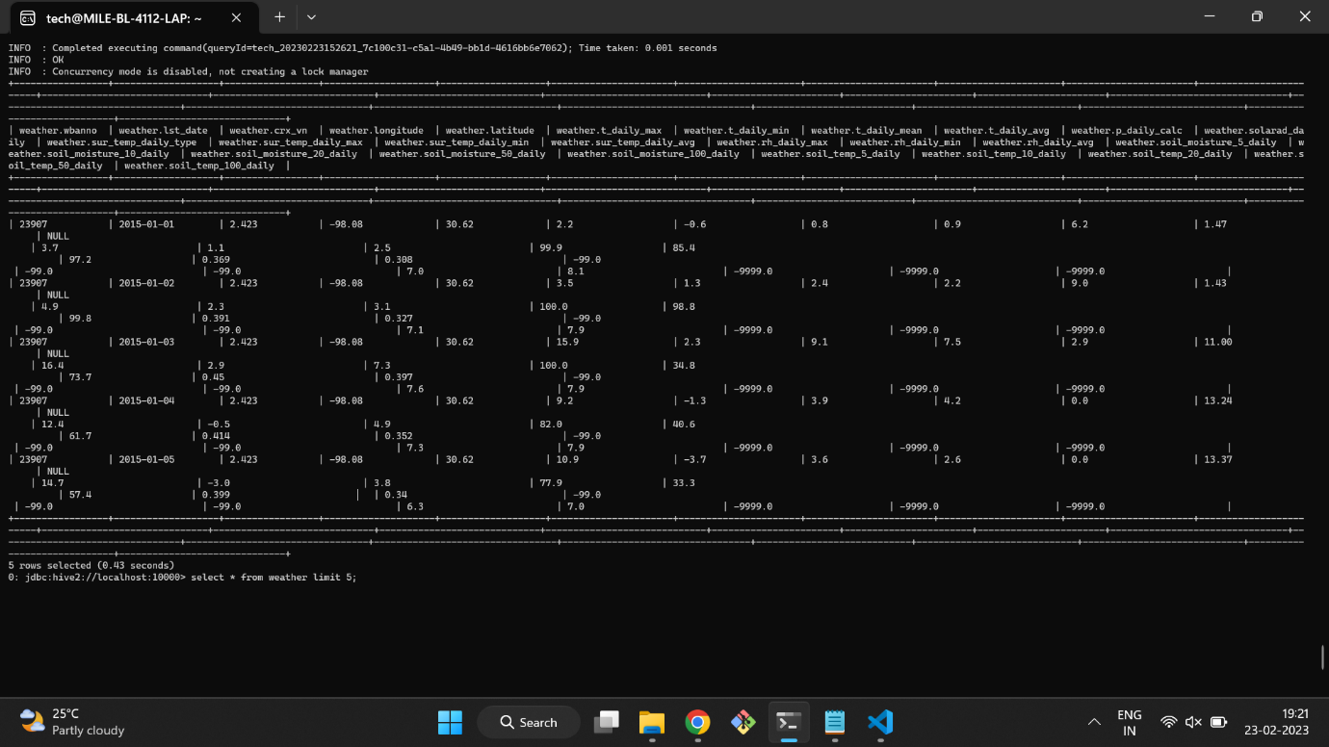

4)-

select min(t_daily_min), max(t_daily_max) from weather ;

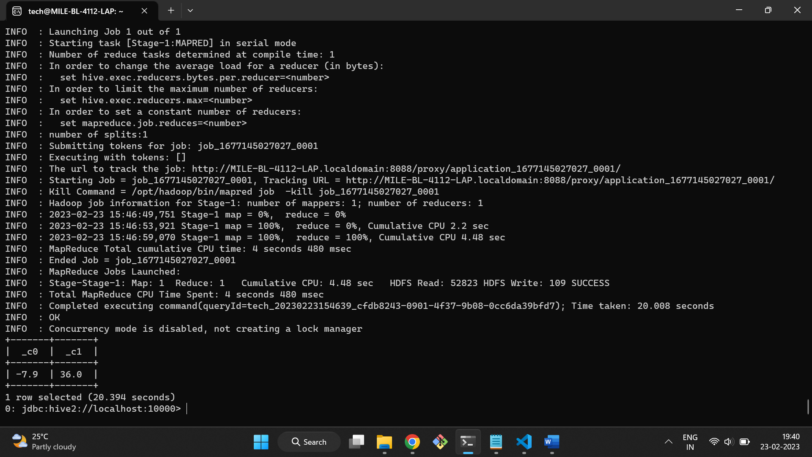

5)-

select month(lst_date),min(t_daily_min), max(t_daily_max) from weather group by month(lst_date);

