Assignment #3:

Create "customers" and "transactions" tables

Load the data from ~/futurence_hadoop-pyspark/labs/dataset/retail

Perform the analysis mentioned below

1) No of transactions by customer

2) Total transaction amount by customer

3) Get top 3 customers by transaction amount

4) No of transactions by customer and mode of payment

5) Get top 3 cities which has more transactions

6) Get month wise highest transaction

7) Get sample transactions

CREATE TABLE Customers(cust_id int,last_name String,first_name String,age int,profession String)

comment "Customer details"

ROW FORMAT DELIMITED

FIELDS TERMINATED BY ","

LINES TERMINATED BY "\n"

STORED AS TEXTFILE;

load data local inpath '/home/tech/futurense_hadoop-pyspark/labs/dataset/retail/customers.txt' overwrite into table customers;

CREATE TABLE Transactions (trans_id int,trans_date String, cust_id int, amount double,category String,desc String,city String,state String,pymt_mode String)

comment "Transactions details"

ROW FORMAT DELIMITED

FIELDS TERMINATED BY ","

LINES TERMINATED BY "\n"

STORED AS TEXTFILE;

load data local inpath '/home/tech/futurense_hadoop-pyspark/labs/dataset/retail/transactions.txt' overwrite into table transactions;

1) No of transactions by customer

SELECT c.cust_id,count(t.trans_id) FROM customers c join transactions t on c.cust_id = t.cust_id GROUP BY c.cust_id;

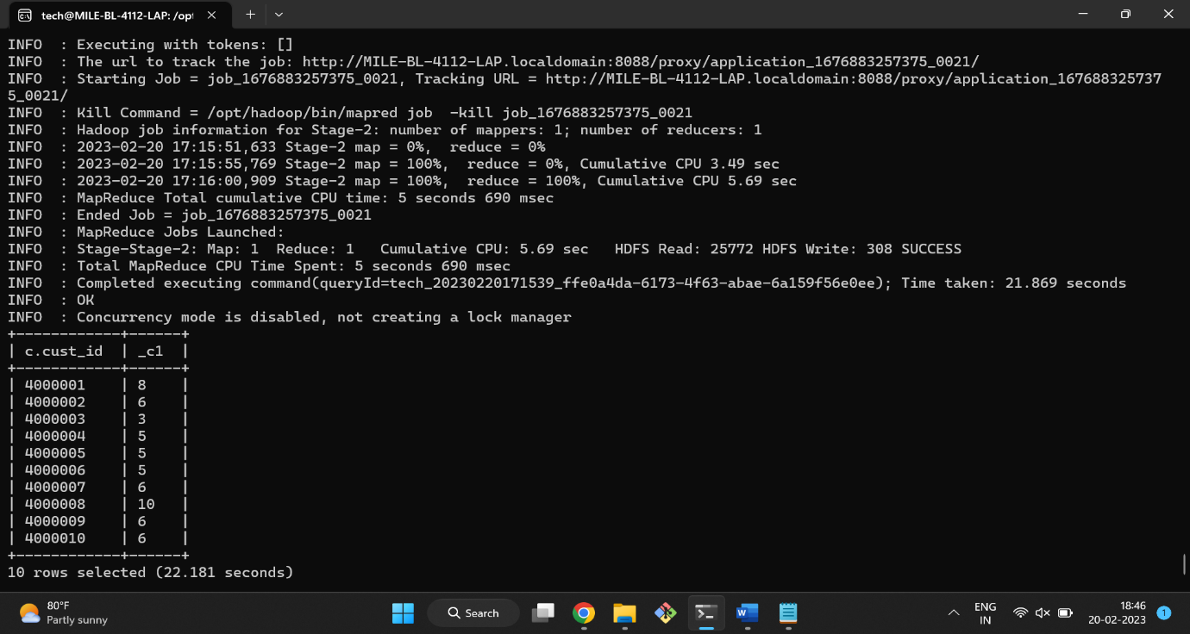

2) Total transaction amount by customer

SELECT c.cust_id, SUM(t.amount)

FROM Customers c

JOIN Transactions t

ON c.cust_id = t.cust_id

GROUP BY c.cust_id;

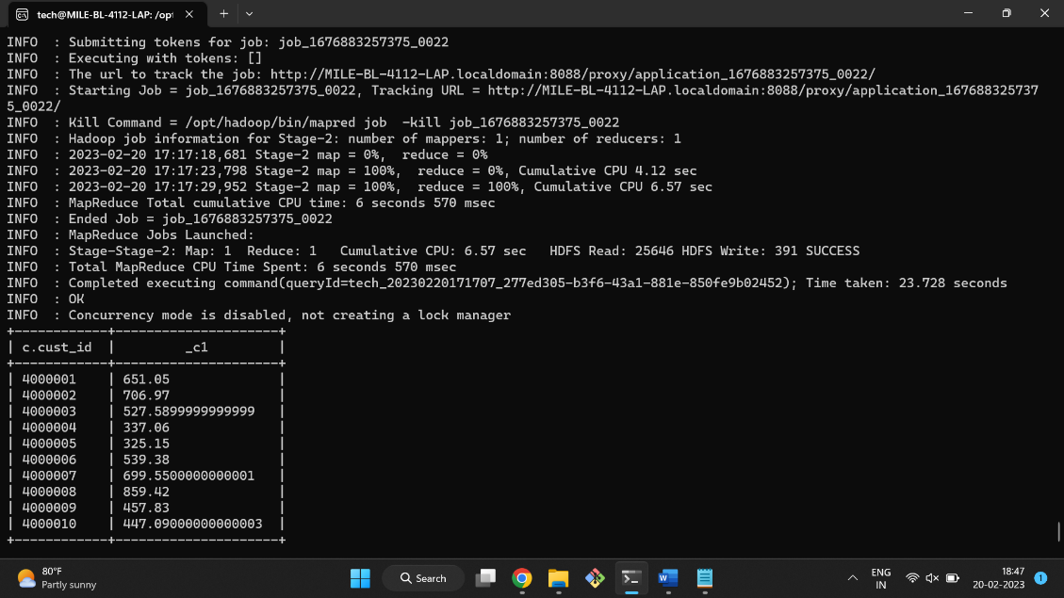

3) Get top 3 customers by transaction amount

SELECT c.cust_id, SUM(t.amount) AS Total_Amount

FROM Customers c

INNER JOIN Transactions t

ON c.cust_id = t.cust_id

GROUP BY c.cust_id

ORDER BY Total_Amount DESC

LIMIT 3;

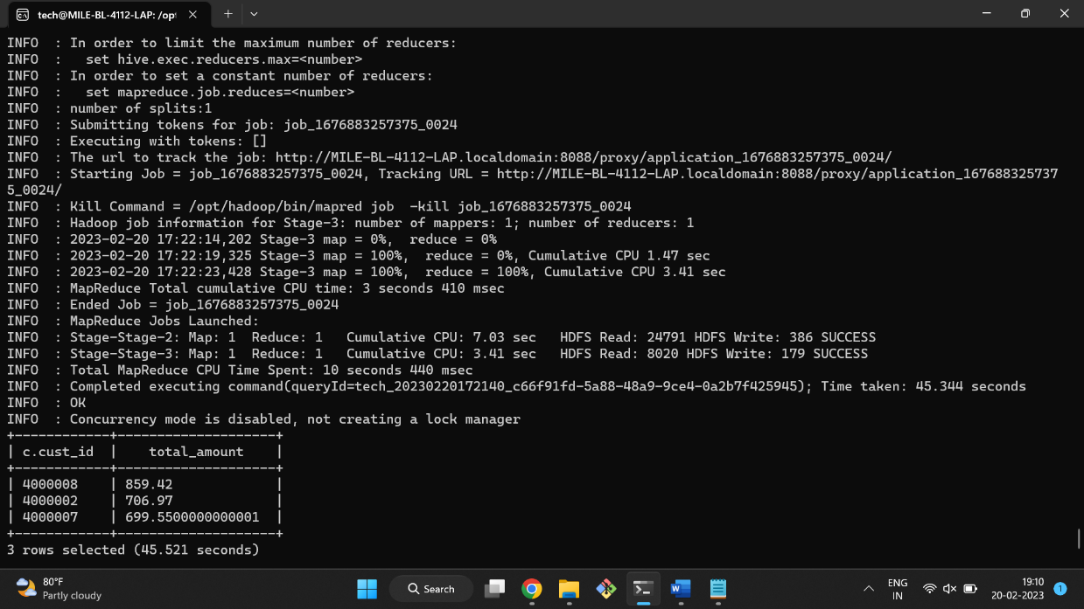

4) No of transactions by customer and mode of payment

SELECT cust_id, pymt_mode, COUNT(*) AS No_of_transactions

FROM Transactions

GROUP BY cust_id, pymt_mode;

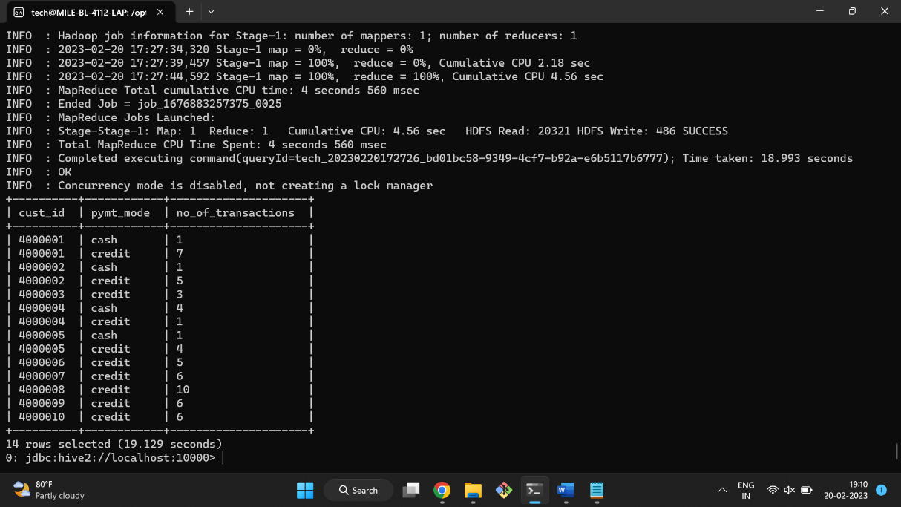

5) Get top 3 cities which has more transactions

SELECT city, count(trans_id) as Transactions

FROM Transactions

GROUP BY city ORDER BY Transactions DESC LIMIT 3;

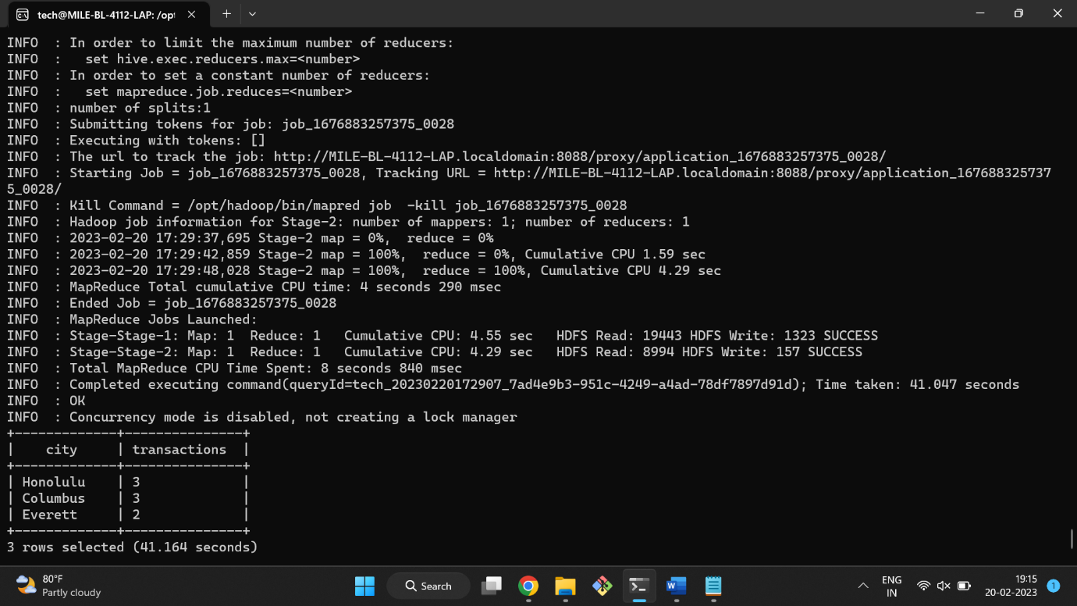

6) Get month wise highest transaction

CREATE TABLE new_time(trans_id int, trans_date date);

INSERT INTO TABLE new_time SELECT trans_id, from_unixtime(unix_timestamp(trans_date, 'MM-dd-yyyy')) FROM Transactions;

SELECT MONTH(n.trans_date), max(amount)

FROM transactions t JOIN new_time n ON t.trans_id = n.trans_id

GROUP BY MONTH(n.trans_date);

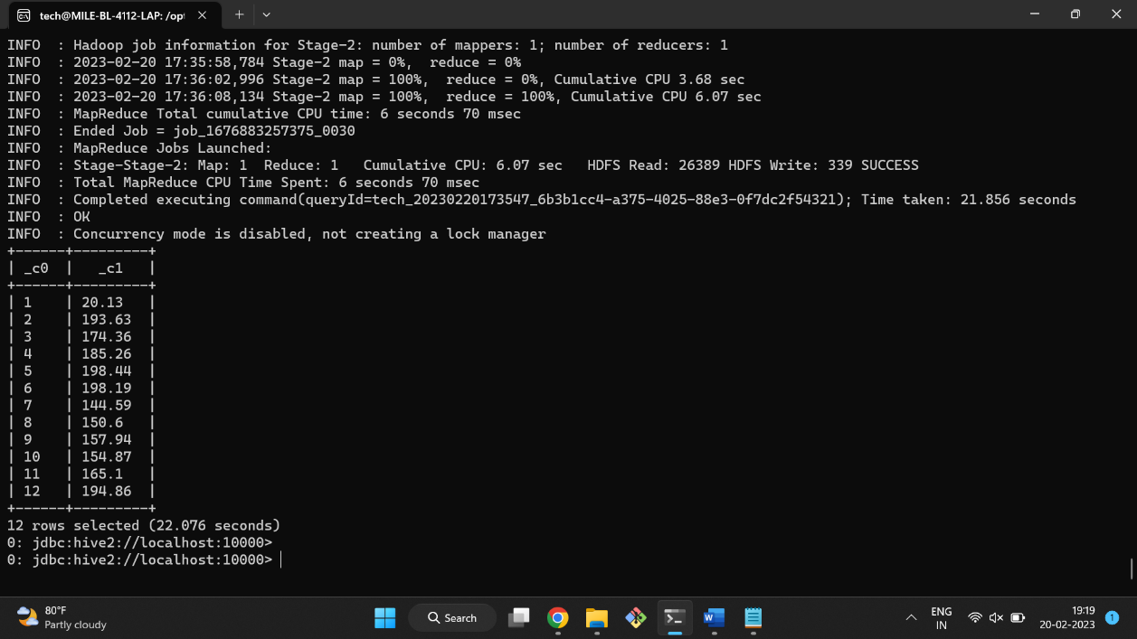

7) Get sample transactions

SELECT * FROM transactions ORDER BY RAND() LIMIT 10;

