Hi there! To get started, let’s cover what you will need to install for viewing this website. I would recommend downloading the latest version(7.2.1 as I write this) of [XAMPP](https://www.apachefriends.org/download.html); choose the one for your operating system. Make sure during installation that you have at least Apache and MySQL selected. It should place a file called xampp-control.exe (or similar depending on OS) on your desktop. If it doesn’t, then go to your File Explorer and browse to the root folder where you installed XAMPP and you will find it there. Make sure to right click it and run as administrator for ease of use. When the control-panel window opens, under the Actions column, click Start next to Apache as well as MySQL. The result should look like below:

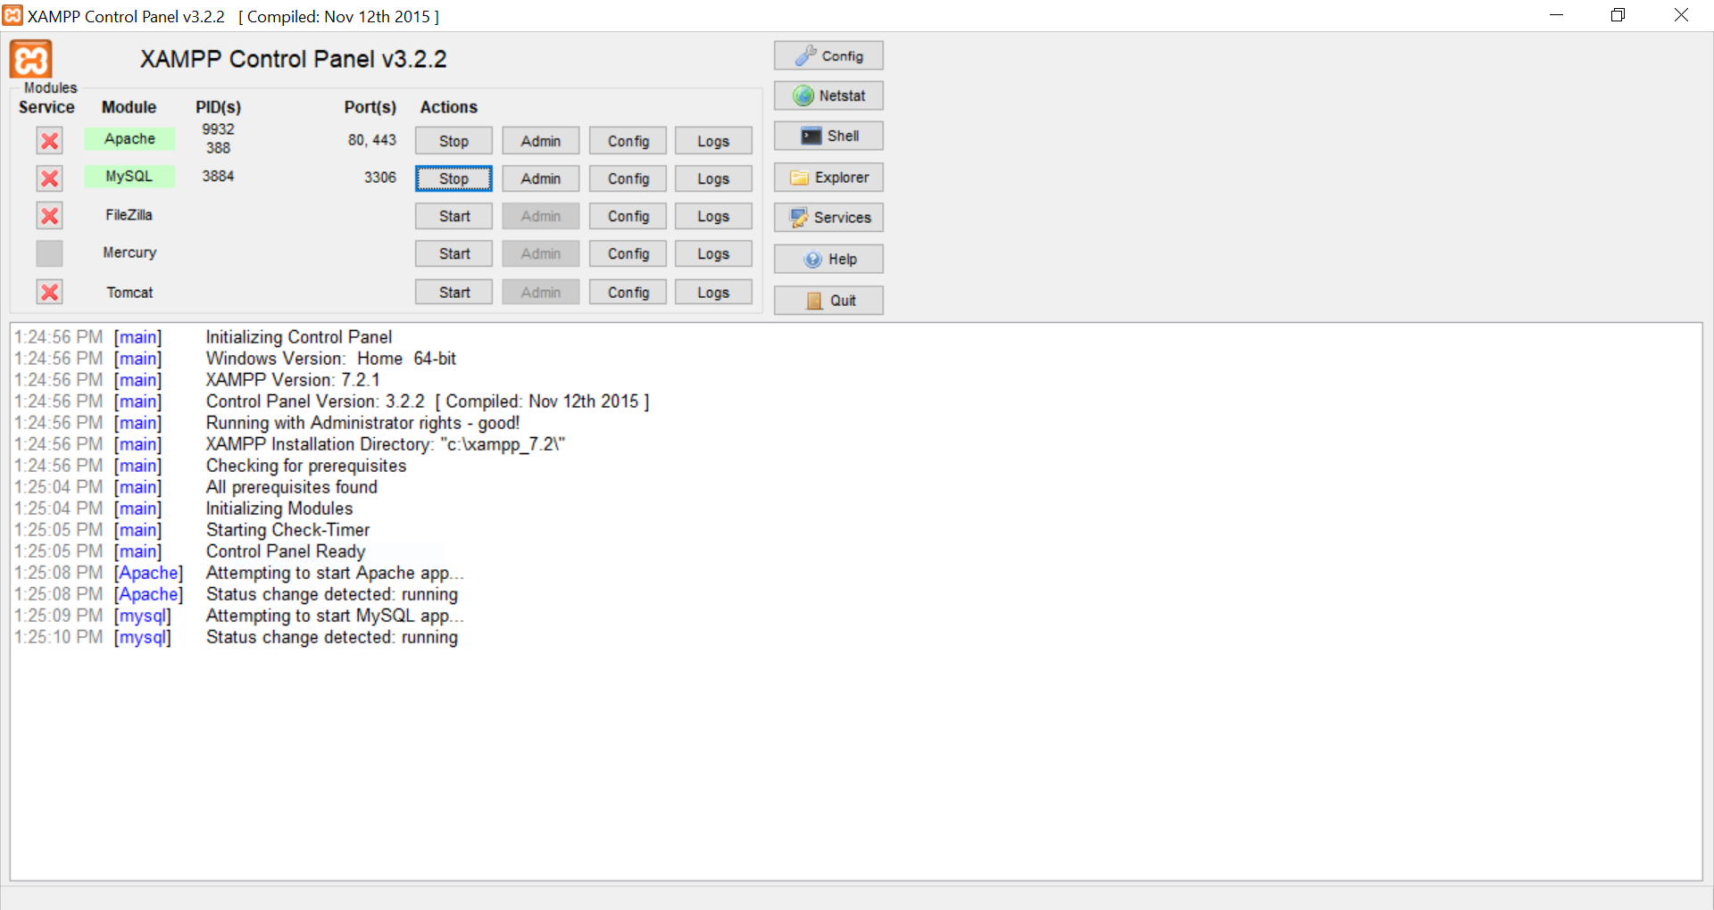

Now, let’s get the database ready to go. Open an internet browser and go to <http://localhost/phpmyadmin/> . In the resulting window, click the Databases tab at the top of the page, found here:

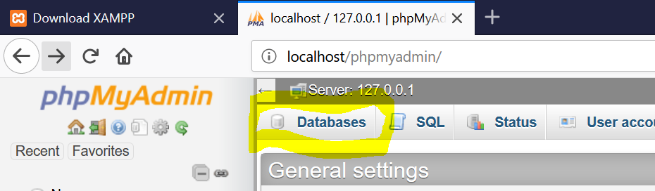

For the database name, type in joyr_cs340 and click create. It should now appear in a list of databases on the left side of the page:

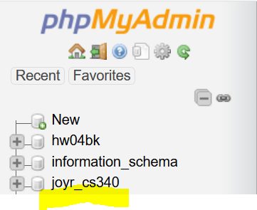

Now click on the new database. On the resulting page, click the Import button in the navigation bar:

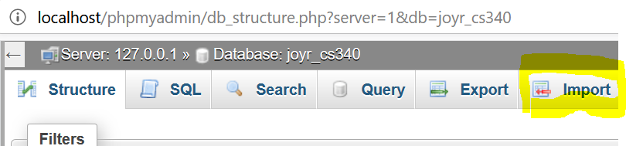

On this page, browse to where you extracted this project, click on the misc folder, and select to open videogames.sql:

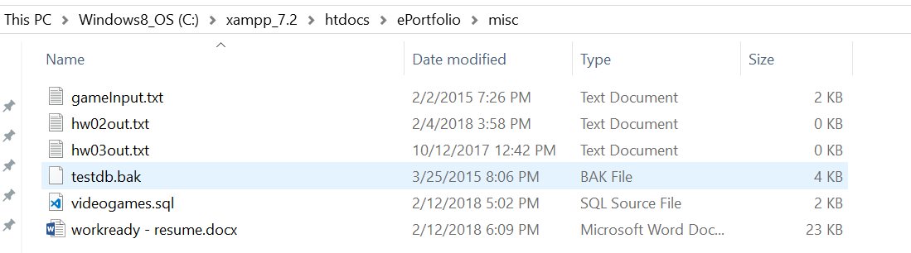

Now, if you click the plus sign next to joyr_c340, you will see the videogames table is ready to go.

With XAMPP installed and the database setup done, let’s view the site! If it is not already, copy this project to the htdocs folder where you installed XAMPP (i.e. C:/xampp/htdocs/Ryan’s PHP Site/). In your internet browser, type in localhost/Ryan’s PHP Site/content/home.php. This should bring you to my home page, as shown below:

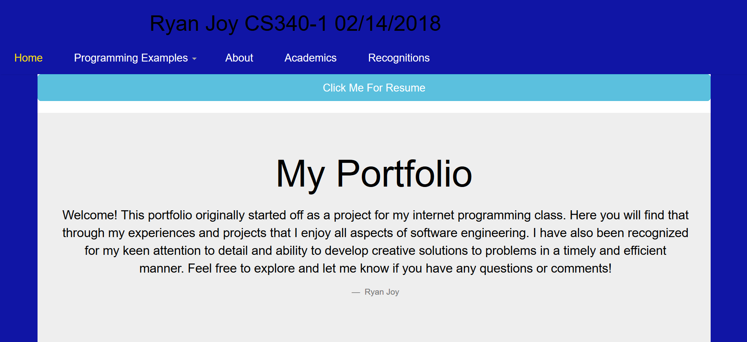

Note that this website is still a work in progress. I hope you like what I have written so far though! Also, please feel free to leave me any comments or feedback at [ryanjoy508@gmail.com](mailto:ryanjoy508@gmail.com). Thank you for visiting my website!

Ryan