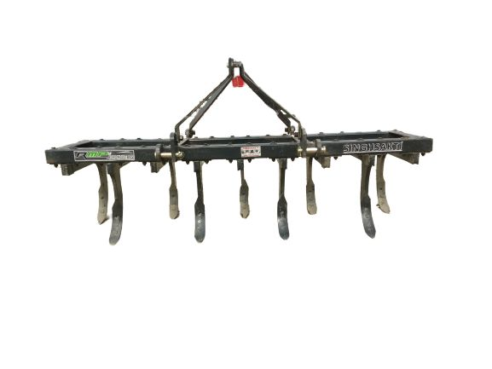 **Cultivator(Heavy Duty)**

Features & Benefits:

* SINGHSAKTI Heavy Duty Rigid tillers have a sturdy construction design and are capable of withstanding tough working conditions of hard soils.
* These can break up hard soil efficiently and perfectly.
* They uproot stubbles and weeds to leave the ground perfectly worked.
* These tillers are suitable to work in root and stone free land.
* Tines are mounted on heavy duty angle box frame thus making this a virtually maintenance free implement.
* Ideal for fitting seeding or seed cum fertilizer attachments.
* Comes with high quality reversible steel shovels.

