Assembly / Re-Assembly Work Log

Project: **GRAMS** Board: **COLD TPC SiPM Bias Board** Date: **25-March-2025**

**Information:**

1. I do not have an LVDS driver to be able to turn the device on the board on and off. These instructions will remove U3 (LVDS Receiver) and tie the output directly to an external pin.

**Description of needed assembly work:**

* Please remove U3 (See diagram)

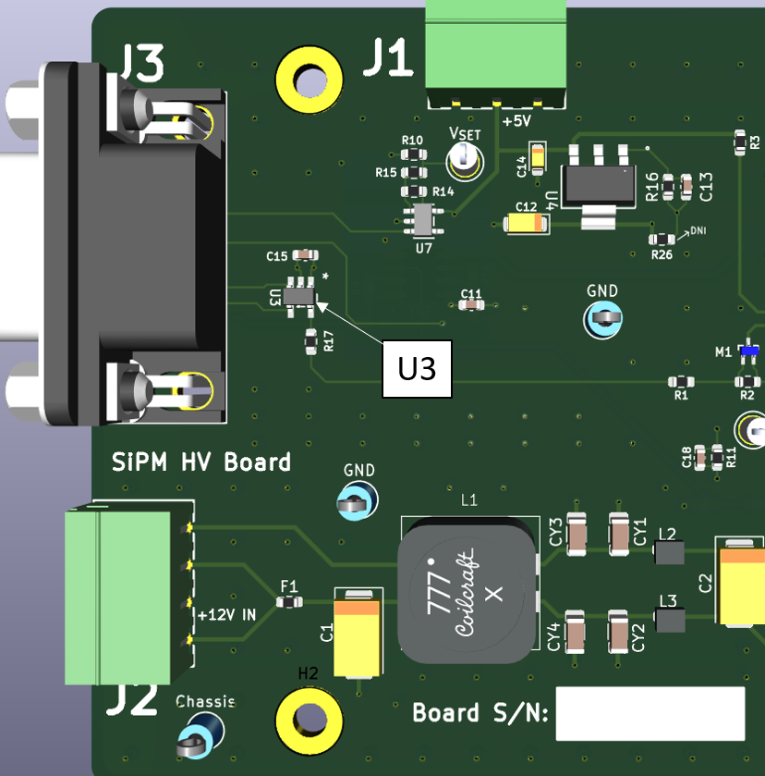

* Short Pins 4 and 5 together:

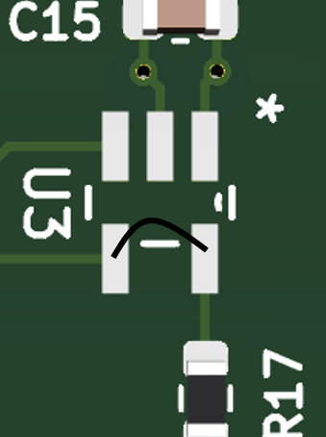

* Turn the board over, please remove R12:

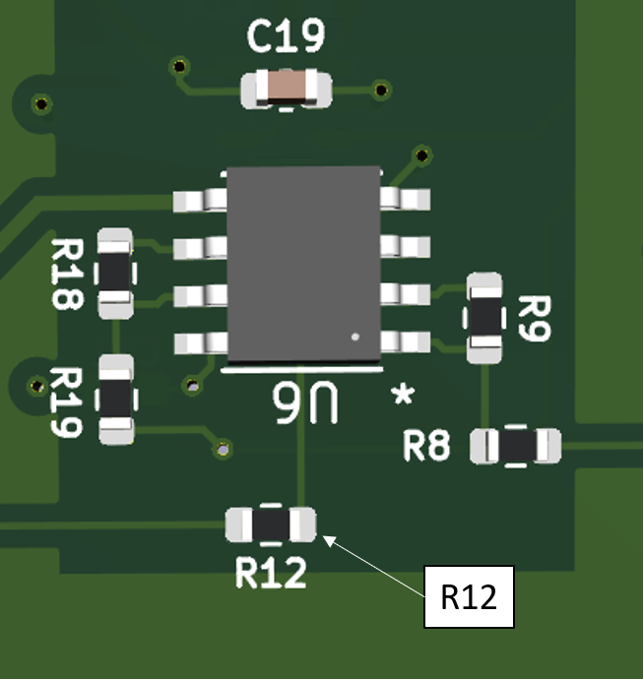

* Connect the pad shown from R12 to the nearest ground:

