Assembly / Re-Assembly Work Log

Project: **GRAMS** Board: **LED-Indicator Lights** Date: **7-APRIL-2025**

**Information:**

1. I need to have the connectors installed onto the LED Indicator Lights for the PS testing.

**Description of needed assembly work:**

* Please do the following:
  + Install the A30499-ND pins into the A30525-ND connectors (x4 of them)
  + Solder 4” of wire from the connectors
    - Use black wire for 2.
    - Use white wire for the other 2.

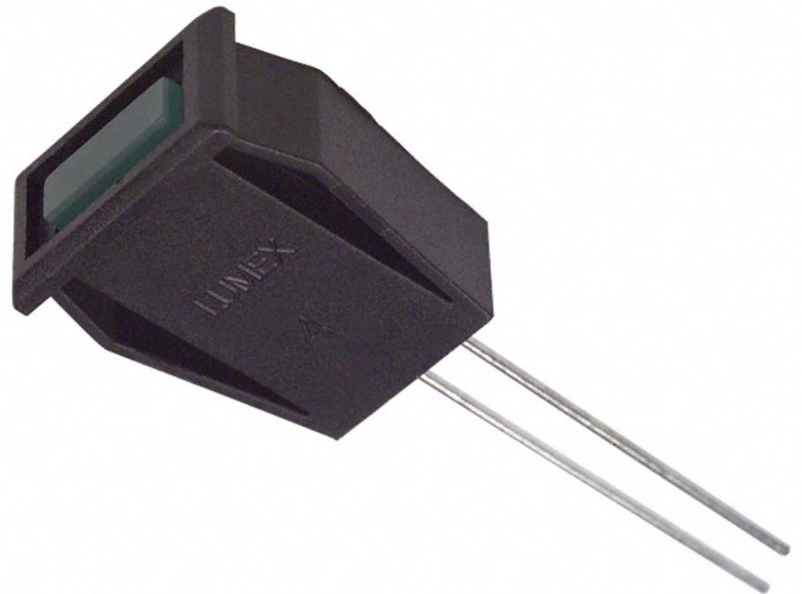

* When soldering the LED onto the wires, please ensure shrink tubing is covering all exposed wire.
  + The Anode is the longer lead. Please solder the longer lead onto the Orange Wires
  + The Cathode is the shorter lead. Please solder the shorter lead onto the Yellow Wires.