Introduction

This document describes the form, fit, and function of the Power Distribution Unit (PDU) for the Gamma Ray and Anti-Matter Survey (GRAMS) Balloon mission. The PDU is servicing several different loads, this document is broken up into sections that describe each section as it pertains to the instrument.

This document will describe the requirements of each load along with the schematics and layouts of each board with descriptions of the design philosophy in mind during design. Finally, this document will also describe how to interface to the PDU’s telemetry SPI network. This is a large design; requirements were defined for some sub-systems but not all.

# Warm TPC PDU

## SiPM Power Unit

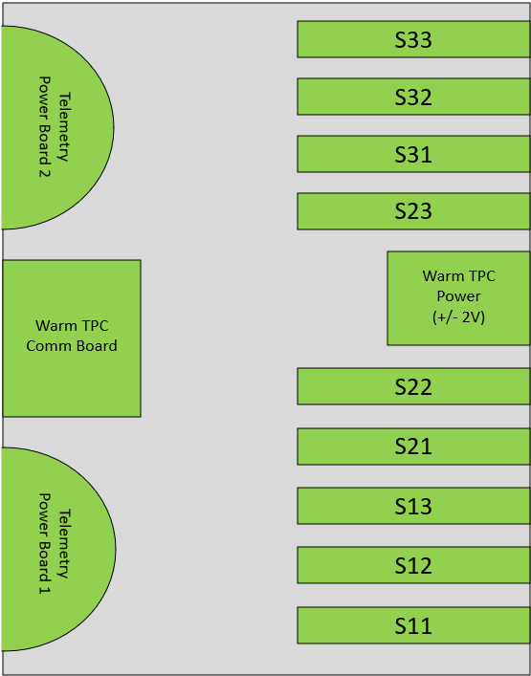

## Telemetry Power Boards

The telemetry power boards provide +5V to each of the boards within the Warm TPC SiPM box for both the telemetry blocks (3-Pos Terminals) as well as the input voltages for the DC-DC converters. (4-Pos Terminals)

### Telemetry Power Boards 1 & 2

The telemetry board 1 services the SiPM’s S11 through S22.

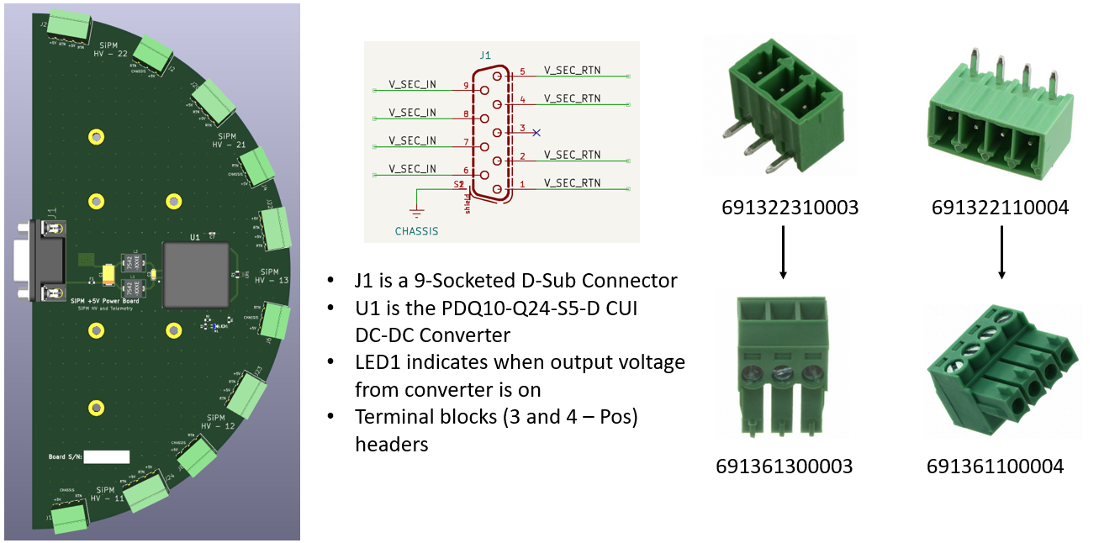

Chose to use a semi-circular configuration to maximize space for the interconnect between this board and the various loads. The second telemetry board is the same size and shape as the first board, however it is providing power to the remaining SiPM HV boards as well as the Comms board and Warm TPC +/- 2V Power.

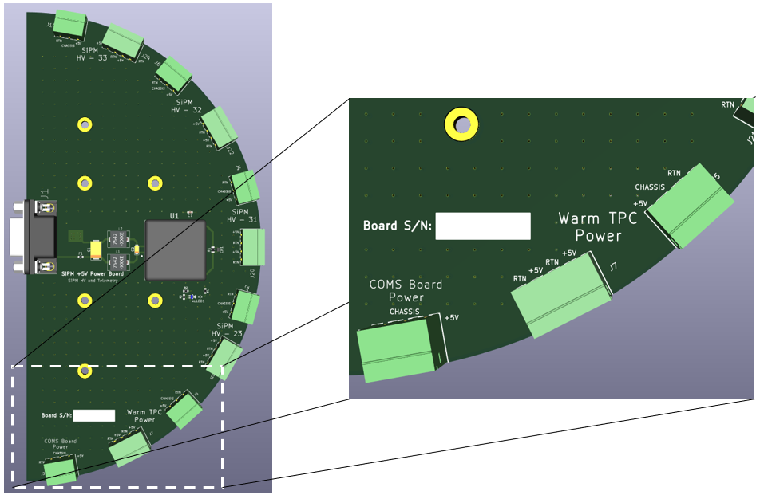

The configuration between harnessing:

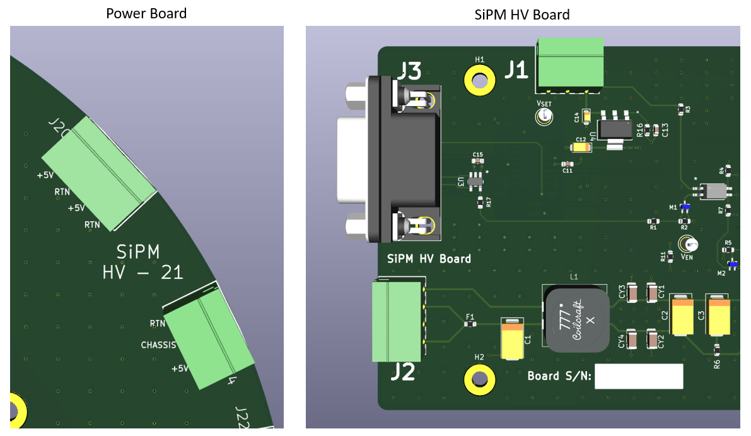

### Warm TPC SiPM HV Communication Board

The comms board provides the ability to set the HV level of each SiPM supply, as well as readout all of the telemetry values from the boards within this box.

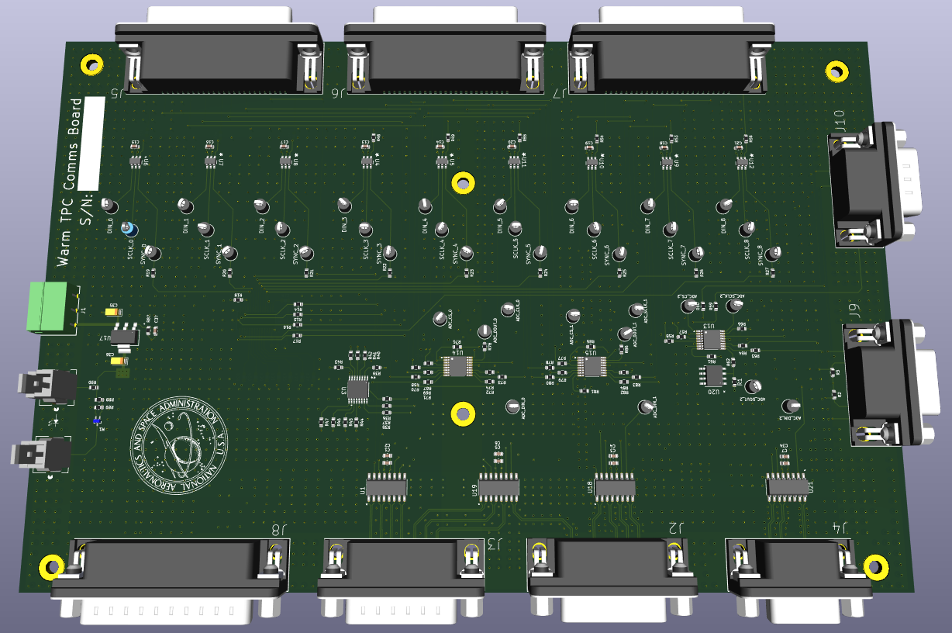

The communication board houses 3 ADC’s and 9 DAC’s that are controlled over SPI. The ADC and DAC are both manufactured by Texas Instruments.

|  |  |  |  |
| --- | --- | --- | --- |
| Desc. | Man. Part Number | Digi-Key PN | QTY |
| ADC | ADC128S102 | ADC128S102CIMT/NOPB | 3 |
| DAC | DAC121S101 | DAC121S101CIMKX/NOPB | 9 |

In total, there are 24 telemetry points that are read out of this board.

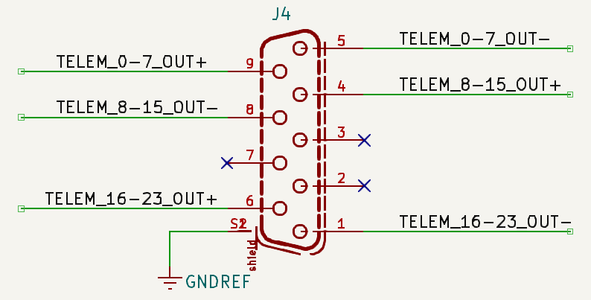

|  |  |  |  |  |  |  |
| --- | --- | --- | --- | --- | --- | --- |
| Telem # | Telemetry Description | Conversion Equation |  | Telem # | Telemetry Description | Conversion Equation |
| 1 | SiPM 11 Voltage Monitor |  | 13 | SiPM 31 Voltage Monitor |  |
| 2 | SiPM 11 Current Monitor |  | 14 | SiPM 31 Current Monitor |  |
| 3 | SiPM 12 Voltage Monitor |  | 15 | SiPM 32 Voltage Monitor |  |
| 4 | SiPM 12 Current Monitor |  | 16 | SiPM 32 Current Monitor |  |
| 5 | SiPM 13 Voltage Monitor |  | 17 | SiPM 33 Voltage Monitor |  |
| 6 | SiPM 13 Current Monitor |  | 18 | SiPM 33 Current Monitor |  |
| 7 | SiPM 21 Voltage Monitor |  | 19 | Positive 2V Monitor |  |
| 8 | SiPM 21 Current Monitor |  | 20 | Negative 2V Monitor |  |
| 9 | SiPM 22 Voltage Monitor |  | 21 | TPC Warm +/- 2V Temp Mon |  |
| 10 | SiPM 22 Current Monitor |  | 22 | Comms Temp Monitor |  |
| 11 | SiPM 23 Voltage Monitor |  | 23 | Box Temp Mon 1 |  |
| 12 | SiPM 23 Current Monitor |  | 24 | Box Temp Mon 2 |  |

The table below describes each telemetry point, with the conversion equations.

The ADC and DAC SPI Control Logic are input on the J2 connector:

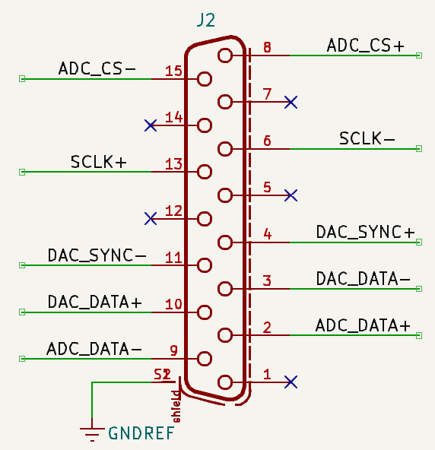

All of the ADC’s and DAC’s on the com board share the same serial clock. I’ve used these devices before, 10MHz is generally the best frequency to set this clock at.