GAMMA-Ray and Anti-Matter Survey (GRAMS) Balloon Mission Power Distribution Unit (PDU) Interface Control Document (ICD)

Contents

List of Figures 1

List of Tables 2

Introduction 1

Note on DC-DC converter Efficiency and Thermal Handling 1

SCOPE 4

Primary and Secondary Power 4

COLD Time-Projection-Chamber (TPC) PDU Section 6

High Voltage Board 6

Telemetry Equations for HV PDU Board: 8

Charge Pre-Amp PDU Board 9

Telemetry Equations for Charge Pre-Amp PDU: 11

SiPM Pre-Amp PDU Board 12

Telemetry Equations for SiPM Pre-Amp PDU Board: 14

SiPM Bias PDU Board 14

Telemetry Equations for SiPM Bias PDU: 15

# List of Figures

Figure 1: High Level Block Diagram of PDU 1

Figure 2: Efficiency of DC-DC Converter Graph 2

Figure 3: Thermal Time Constant Graph 3

Figure 4: RC Time Graph for Thermal Heating (Example) 3

Figure 5: Primary (+28V) and Secondary (+12V) Power 4

Figure 6: Pinout Configuration of Secondary Power from Main DC-DC Converter 4

Figure 7: Secondary Power Harnessing from Main DC-DC Converter Board 5

Figure 8: Harness Construction Materials (Cu-Braid, metal Backshell, and Expando 5

Figure 9: Cold TPC HV PDU Board 6

Figure 10: Cold TPC Charge Pre-Amp PDU 9

Figure 11: PDQ30-Q24-S5-D Power Efficiency 9

Figure 12: Cold TPC SiPM Pre-Amp PDU Board 12

Figure 13: Cold TPC SiPM Bias PDU Board 14

# List of Tables

Table 1: Input Power Calculations (Cold TPC PDU Section) 16

# Introduction

This document captures the interfaces between each of the sub-systems within the Power Distribution Unit (PDU). The figure below describes the PDU’s configuration within the instrument at a very high level.

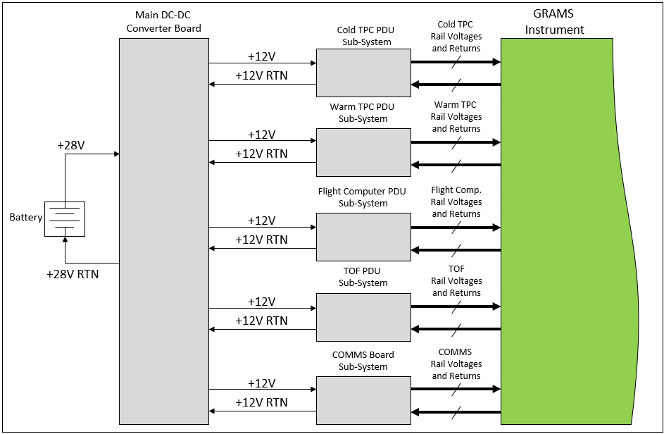

Figure 1: High Level Block Diagram of PDU

The Main DC-DC Converter board’s only functions are to receive the +28V from the on-board battery (nominally 28V), convert down to +12V and distribute to the different sub-systems of the PDU. The design of this board has to meet the power needs of the PDU system and the loads each subsystem has to drive. This power number needs to be calculated and finalized before this board can be designed. Typically, efficiency curves are provided for most DC-DC converters, if one is not readily available efforts should be made to get it from the manufacturer as this is important information.

## Note on DC-DC converter Efficiency and Thermal Handling

The graph below describes the efficiency for the PDQ30-Q24-S5-D converter, which is used in many places throughout this design. This converter has a peak output power capability of 30-watts. Doing quick math, at 5V this converter can supply a maximum of 6 amps. As seen from the graph, at lower power draws, the converter is not as efficient as it could be, this is why you sometimes see load resistors included to bring the efficiency up.

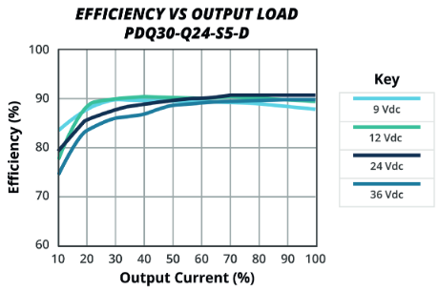

Figure 2: Efficiency of DC-DC Converter Graph

To accurately predict the input current, you’ll need to know something about the load and how much current it will need to draw. As an example:

The power consumed by the load is 15W, examining the curve above we see that this is 50% of the maximum current, and with an input of 12V to the converter it will be about 90% efficient.

With an input of 12V the input current needed is 1.39 amps. While the 15 watts will be consumed by the load, the 1.67 watts left over will be dissipated as heat. This converter was also used extensively on the COM-PAIR balloon flight, given that experience and the compact design of this converter (1” x 1” x 0.4”), a conservative estimate for its thermal resistance (qTH) is on the order of 20C/W.

Assuming that there is no path for the heat to escape, at ambient temperature this device will heat up to a temperature of 25C + 33.4C = 58.4C

How quickly the converter rises to this level will depend on the thermal capacitance (or thermal mass) of the converter itself. For small converters, such as this one, we can assume 10 to 20 Joules per degree C. This temperature will rise exponentially (RC time constant) towards the final steady state temperature. The graph below describes how this will behave.

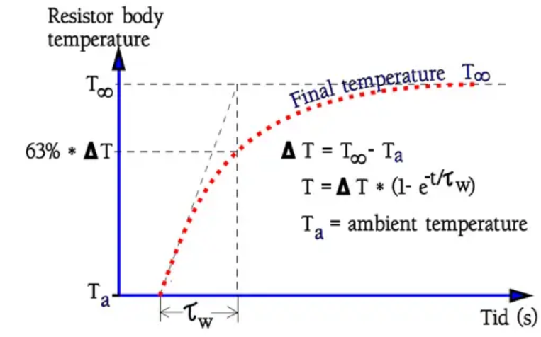

Figure 3: Thermal Time Constant Graph

The thermal time constant (t) is the thermal resistance multiplied by the thermal capacitance.

It will take this unit approximately 400 seconds (6.67 minutes) to reach 46 degrees C.

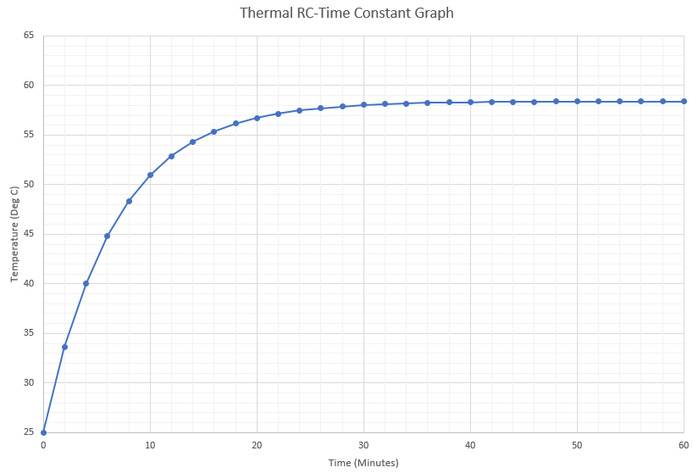

Figure 4: RC Time Graph for Thermal Heating (Example)

This graph is simply made by evaluating the RC Time-Constant formula:

This type of analysis is exceptionally useful when trying to determine how much power and heat dissipation the PDU will need.

# SCOPE

This document will be describing the interfaces within the PDU only, which will pertain to the harness details, power and thermal needs, and voltage levels at each level. This document **will not** address any of the designs within the main instrument unless it is needed to describe aspects of the PDU itself.

# Primary and Secondary Power

The primary power delivered from the batteries on the gondola is 28V, power will be calculated once we have final current values. (updates coming) The secondary voltage provided by the main DC-DC Converter board will be 12V.

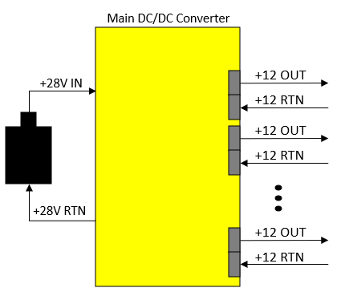

Figure 5: Primary (+28V) and Secondary (+12V) Power

Each of the +12V out and +12V return will be delivered on harnesses with the exact same configurations.

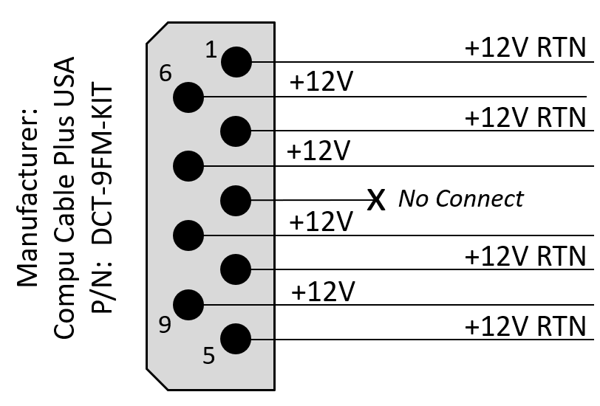

Figure 6: Pinout Configuration of Secondary Power from Main DC-DC Converter

The harness diagram is described in the figure below:

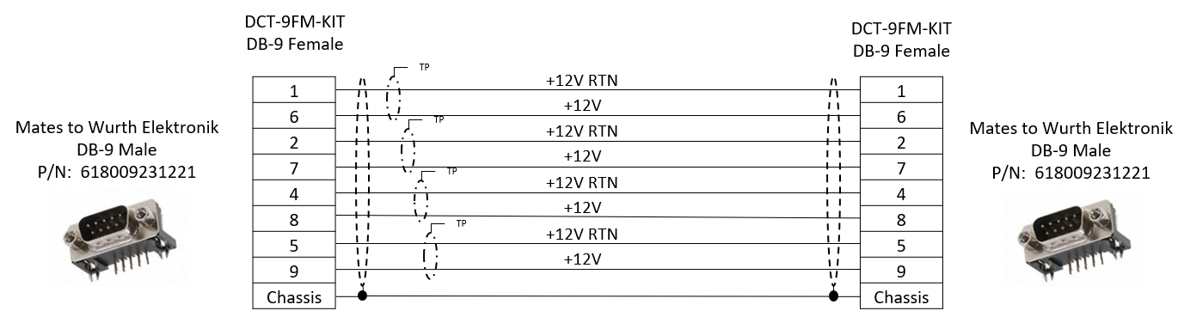

Figure 7: Secondary Power Harnessing from Main DC-DC Converter Board

Recall from the previous figure that the pin location 3 is a no-connect. This is true for every 9-position power connector within the PDU. The orientation of the connections makes it easy to twist the appropriate lines together, as shown above. The last thing of note is how the chassis is connected from board to board. In the grounding diagram, the chassis and signal grounds are AC coupled, there is no direct tie between the two. However, the chasses of each box will be shared via the harnessing as well as from the structure.

The chassis connection is shared via ground braid that is also used in the construction of the harness.

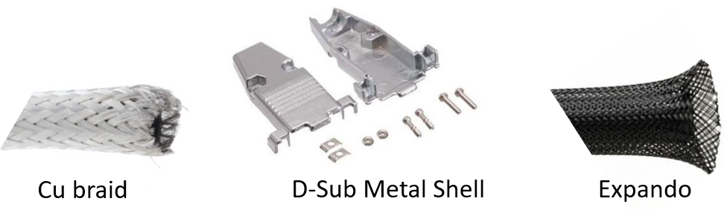

Figure 8: Harness Construction Materials (Cu-Braid, metal Backshell, and Expando)

The Cu braid material provides the shielding and chassis connection between the back shells of the harnessing, the back shells themselves connect the Cu braid to the chassis of the board, and the Expando material makes the harnesses easy to handle.

# COLD Time-Projection-Chamber (TPC) PDU Section

The Cold TPC section of the PDU is providing power to the following sub-systems:

|  |  |  |  |  |
| --- | --- | --- | --- | --- |
| GRAMS Sub-System | Prescribed Current Draw | Power Rail(s) | Power Calc | |
| High Voltage for | < 50nA | 0 to -10kV | 0.5 | mW |
| Charge Pre-Amp | 2A Max for each rail | +5V/-5V | 20 | Watts |
| SiPM Pre-Amp | 0.55A for each rail | +2.5V / -5V | 4.125 | Watts |
| SiPM Bias | 8mA Bias for each SiPM | Up to 60V | 0.48 | Watts |

Telemetry is gathered from each board, which includes the voltage levels being delivered to the sub-systems, the current consumption, as well as temperatures on the board. (*NOTE: The temperature measurements are measuring the ambient temps, not the temperature of the DC-DC converters*).

## High Voltage Board

A 3D image of the high voltage board is shown below:

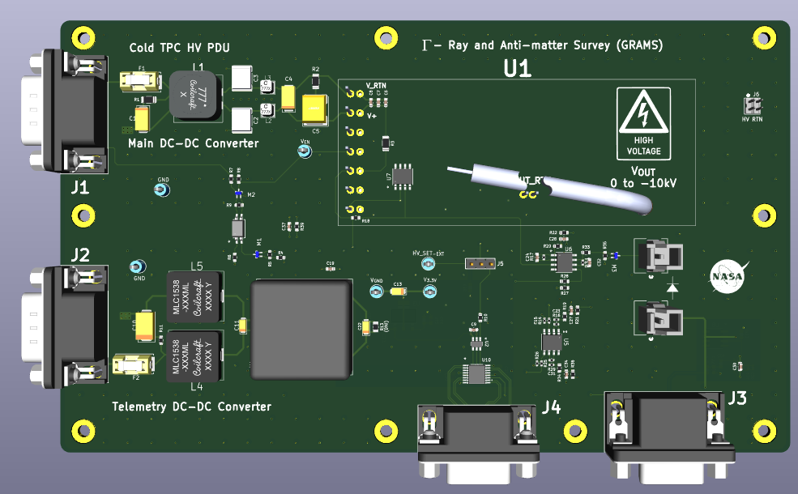

Figure 9: Cold TPC HV PDU Board

The following tables describe the input connectors and the pin-outs for each.

As can be seen from the image above, there are four connections, J1 – J4. They are each described below:

|  |  |  |  |  |
| --- | --- | --- | --- | --- |
| Designator | Connector | Pin / Socket Location | | Notes |
| J1 | 9-Pin D-Sub (Male) | 1 | Secondary Power Return | This connector delivers secondary power (+12V) and provides a return path to/from the main DC-DC converter board that services the HV DC-DC converter on this board. |
| 2 | Secondary Power Return |
| 3 | No Connect |
| 4 | Secondary Power Return |
| 5 | Secondary Power Return |
| 6 | Secondary Power Input |
| 7 | Secondary Power Input |
| 8 | Secondary Power Input |
| 9 | Secondary Power Input |

|  |  |  |  |  |
| --- | --- | --- | --- | --- |
| Designator | Connector | Pin / Socket Location | | Notes |
| J2 | 9-Pin D-Sub (Male) | 1 | Secondary Power Return | This connector delivers secondary power (+12V) and provides a return path to/from the main DC-DC converter board that services the Telemetry Circuitry on the HV Board. |
| 2 | Secondary Power Return |
| 3 | No Connect |
| 4 | Secondary Power Return |
| 5 | Secondary Power Return |
| 6 | Secondary Power Input |
| 7 | Secondary Power Input |
| 8 | Secondary Power Input |
| 9 | Secondary Power Input |

|  |  |  |  |  |
| --- | --- | --- | --- | --- |
| Designator | Connector | Pin / Socket Location | | Notes |
| J4 | 9-socketed D-Sub (Female) | 1 | SYNC_n+ | This connector is providing the Enable signal for the main DC/DC converter, and the SPI Control Signals for the DAC on board. |
| 2 | Enable - |
| 3 | No Connect |
| 4 | SCLK+ |
| 5 | DATA_IN- |
| 6 | SYNC_n- |
| 7 | Enable + |
| 8 | SCLK- |
| 9 | DATA_IN+ |

|  |  |  |  |  |
| --- | --- | --- | --- | --- |
| Designator | Connector | Pin / Socket Location | | Notes |
| J3 | 15-Socket D-Sub (Female) | 1 | Temperature Telem | The connector delivers the telemetry to the COMMS board within the PDU Sub-System. |
| 2 | Temperature Telem |
| 3 | No Connect |
| 4 | HV Current Telemetry |
| 5 | HV Voltage Telemetry |
| 6 | Telemetry Return |
| 7 | Telemetry Return |
| 8 | Telemetry Return |
| 9 | Telemetry Return |
| 10 | Telemetry Return |
| 11 | No Connect |
| 12 | No Connect |
| 13 | No Connect |
| 14 | No Connect |
| 15 | No Connect |

### Telemetry Equations for HV PDU Board:

Temperature Measurements are provided by the AD590 temperature transducers. On the HV Board, the output is terminated by an 8.06k resistor.

The High Voltage Current and Voltage telemetry are buffered from this board to the COMMS board and are on a scale of 0 to 3.3V.

Note: The maximum voltage and current that this converter can supply are -10kV and 400uA respectively.

## Charge Pre-Amp PDU Board

A 3D model of this board is shown below:

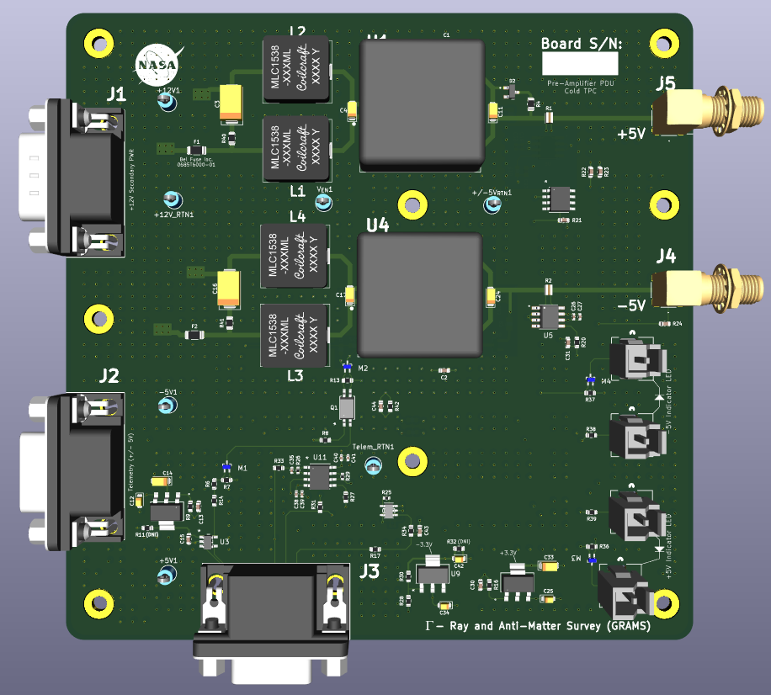

Figure 10: Cold TPC Charge Pre-Amp PDU

The DC-DC converters delivering the +/- 5V to the sub-system are PDQ30-Q24-S5-D, which are each capable of supplying 30Watts to the load. Each of the rails are expected to drive a maximum of 2A. The efficiency of this converter is described by the graph below:

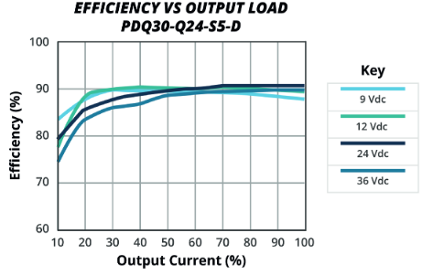

Figure 11: PDQ30-Q24-S5-D Power Efficiency

Driving 2A will be 33.33% of what this converter can supply, the 12VDC graph is what we are interested in, which provides 90% efficiency.

At 12V input, the current draw will be ~ 925mA.

With 10-Watts going to the load, 1.1W will be dissipated as heat.

This means that after about 30 minutes of continuous use, the case will rise 22 degrees above the ambient conditions. (This assumes you’re not in a vacuum environment) The datasheet reports that this device can operate up to 110 Degrees Celsius before its internal circuitry will shut it down.

The connectors on the board are described below:

|  |  |  |  |  |
| --- | --- | --- | --- | --- |
| Designator | Connector | Pin / Socket Location | | Notes |
| J1 | 9-Pin D-Sub (Male) | 1 | Secondary Power Return | This connector delivers secondary power (+12V) and provides a return path to/from the main DC-DC converter board that services this board. |
| 2 | Secondary Power Return |
| 3 | No Connect |
| 4 | Secondary Power Return |
| 5 | Secondary Power Return |
| 6 | Secondary Power Input |
| 7 | Secondary Power Input |
| 8 | Secondary Power Input |
| 9 | Secondary Power Input |

|  |  |  |  |  |
| --- | --- | --- | --- | --- |
| Designator | Connector | Pin / Socket Location | | Notes |
| J2 | 9-socketed D-Sub (Female) | 1 | Telemetry Return | This brings the telemetry voltage on board from the telemetry power board located in the Cold TPC PDU Box |
| 2 | Telemetry Return |
| 3 | No Connect |
| 4 | Telemetry Return |
| 5 | Telemetry Return |
| 6 | +5V Telemetry Power |
| 7 | +5V Telemetry Power |
| 8 | -5V Telemetry Power |
| 9 | -5V Telemetry Power |

|  |  |  |  |  |
| --- | --- | --- | --- | --- |
| Designator | Connector | Pin / Socket Location | | Notes |
| J3 | 15-Socket D-Sub (Female) | 1 | Temperature Telem | The connector delivers the telemetry to the COMMS board within the PDU Sub-System, and also provides the Enable Signal to the Main Converters. |
| 2 | -5V Voltage Monitor |
| 3 | +5V Voltage Monitor |
| 4 | -5V Current Monitor |
| 5 | +5V Current Monitor |
| 6 | Telemetry Return |
| 7 | Telemetry Return |
| 8 | Telemetry Return |
| 9 | Telemetry Return |
| 10 | Telemetry Return |
| 11 | No Connect |
| 12 | No Connect |
| 13 | No Connect |
| 14 | Enable + |
| 15 | Enable - |

### Telemetry Equations for Charge Pre-Amp PDU:

Temperature Measurements are provided by the AD590 temperature transducers. On the HV Board, the output is terminated by an 8.06k resistor.

## SiPM Pre-Amp PDU Board

A 3D model of the board is shown below:

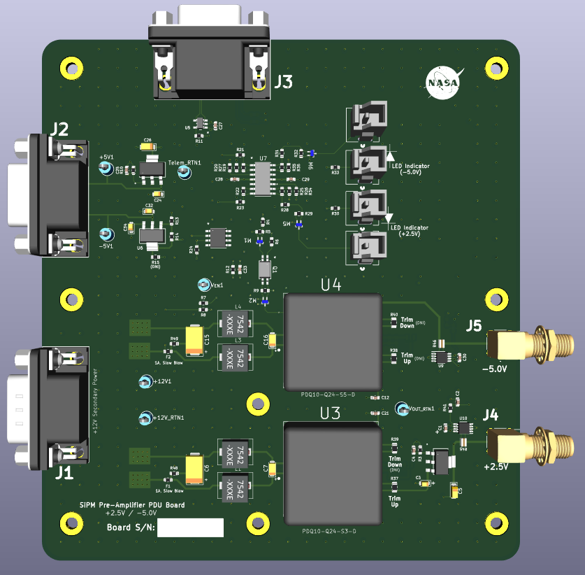

Figure 12: Cold TPC SiPM Pre-Amp PDU Board

In this case, there are two different regulators being used. The PDQ30-Q24-S5-D and the PDQ30-Q24-S3-D, these both supply 5V and 3.3V respectively and will provide a maximum of 30 watts to the load. The prescribed current draw for each rail is 550mA which is 1.82W for the 3.3V Rail, and 2.75W for the 5V rail. These will both be approximately 80 to 85% efficient at these load values.

Calculating the input power for each rail reveals:

The connectors on this board are described in the tables on the next page.

|  |  |  |  |  |
| --- | --- | --- | --- | --- |
| Designator | Connector | Pin / Socket Location | | Notes |
| J1 | 9-Pin D-Sub (Male) | 1 | Secondary Power Return | This connector delivers secondary power (+12V) and provides a return path to/from the main DC-DC converter board that services this board. |
| 2 | Secondary Power Return |
| 3 | No Connect |
| 4 | Secondary Power Return |
| 5 | Secondary Power Return |
| 6 | Secondary Power Input |
| 7 | Secondary Power Input |
| 8 | Secondary Power Input |
| 9 | Secondary Power Input |

|  |  |  |  |  |
| --- | --- | --- | --- | --- |
| Designator | Connector | Pin / Socket Location | | Notes |
| J2 | 9-socketed D-Sub (Female) | 1 | Telemetry Return | This brings the telemetry voltage on board from the telemetry power board located in the Cold TPC PDU Box |
| 2 | Telemetry Return |
| 3 | No Connect |
| 4 | Telemetry Return |
| 5 | Telemetry Return |
| 6 | +5V Telemetry Power |
| 7 | +5V Telemetry Power |
| 8 | -5V Telemetry Power |
| 9 | -5V Telemetry Power |

|  |  |  |  |  |
| --- | --- | --- | --- | --- |
| Designator | Connector | Pin / Socket Location | | Notes |
| J3 | 15-Socket D-Sub (Female) | 1 | Enable - | The connector delivers the telemetry to the COMMS board within the PDU Sub-System, and also provides the Enable Signal to the Main Converters. |
| 2 | Enable + |
| 3 | +2.5V Voltage Monitor |
| 4 | -5V Voltage Monitor |
| 5 | +2.5V Current Monitor |
| 6 | Telemetry Return |
| 7 | Telemetry Return |
| 8 | Telemetry Return |
| 9 | Telemetry Return |
| 10 | Telemetry Return |
| 11 | Temperature Monitor |
| 12 | Telemetry Return |
| 13 | Telemetry Return |
| 14 | Telemetry Return |
| 15 | -5V Current Monitor |

### Telemetry Equations for SiPM Pre-Amp PDU Board:

## SiPM Bias PDU Board

The figure below describes a 3D model of the SiPM Bias Board:

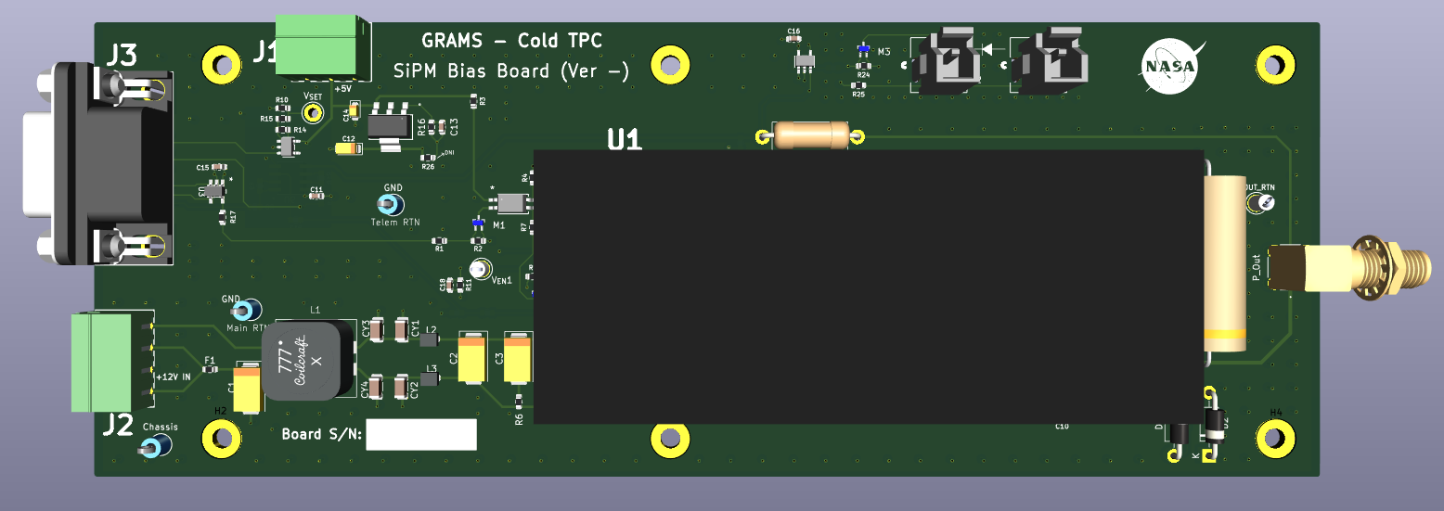

Figure 13: Cold TPC SiPM Bias PDU Board

The SiPM Bias PDU Board is a programmable voltage. The DCDC converter housed on this board is the 1/16A12-P4-I5 manufactured by Ultravolt. It is able to provide 0V to 62V at the output and provide a maximum of 4 Watts at the output.

The nominal voltage identified by the project team is ~ 54V, and 8mA. The converter is being driven by +12V, and according to the manufacturer we can expect an efficiency of 80% at the worst case.

The nominal power at 8mA is ~ 430mW. With an 80% efficiency this corresponds to an input power of 540mW. As there are 6 of these boards, we can estimate 3.24 watts total at the worst case. Each converter will be producing about 110mW of heat, which is negligible.

The connectors that service this board are descried in the tables below:

|  |  |  |  |  |
| --- | --- | --- | --- | --- |
| Designator | Connector | Pin / Socket Location | | Notes |
| J1 | 3 pos term header | 1 | Telemetry Return | This header provides +5V and +5V Return to power the telemetry circuitry on this board. |
| 2 | Telemetry Power |
| 3 | Telemetry Return |

|  |  |  |  |  |
| --- | --- | --- | --- | --- |
| Designator | Connector | Pin / Socket Location | | Notes |
| J2 | 4 pos term header | 1 | Secondary Power Return | This header provides the +12V and +12V Return to power the 1/16A12-P4-I5 Converter on this board |
| 2 | Secondary Power |
| 3 | Secondary Power Return |
| 4 | Secondary Power |

|  |  |  |  |  |
| --- | --- | --- | --- | --- |
| Designator | Connector | Pin / Socket Location | | Notes |
| J3 | 9-socketed D-Sub (Female) | 1 | Current Monitor | This connector provides the command-and-control functions for the 1/16A12-P4-I5 Converter, along with the telemetry on the board. |
| 2 | Enable + |
| 3 | No Connect |
| 4 | Telemetry Return |
| 5 | Telemetry Return |
| 6 | Telemetry Return |
| 7 | Enable - |
| 8 | Voltage Monitor |
| 9 | Voltage Set Point |

### Telemetry Equations for SiPM Bias PDU:

The current monitor for the 1/16A12-P4-I5 converter provides the following equations:

Each volt at the output represents approximately 1mA. This is divided by ten before it is applied to the telemetry section of the board.

The voltage set point has an input range from 0 to 5V, which covers the maximum output range from 0V to 65V at the output. This is a linear scale. The table on the next page describes how much power the Cold TPC PDU section will consume. This is only for the converters providing power to the sub-systems. The telemetry circuitry will also require some analysis.

|  |  |  |  |
| --- | --- | --- | --- |
| Input Power Calculations (Cold TPC Section) | | | |
| Board Name | Output Power | Efficiency | Input Power |
| HV Board | Negligible | | |
| Charge Pre-Amp PDU Board | 20W | 0.9 | 22.2W |
| SiPM Pre-Amp PDU Board | 4.57W | 0.8 | 5.72W |
| SiPM Bias Board (x6) | 2.58W | 0.8 | 3.24W |
|  | | Total: | 31.16W |

Table 1: Input Power Calculations (Cold TPC PDU Section)

The telemetry circuitry within the Cold-TPC section has several OPAMPs and switches. The amplifiers used for the buffering telemetry are primarily the LTC2050, 2051, and 2052 devices. These come in single, dual, and quad packages. The datasheets estimate 75mA for their current draw as an average. The table below describes the current draw for the telemetry on the boards listed in Table 1.

|  |  |  |  |
| --- | --- | --- | --- |
| Input Power Calculations (Cold TPC Section) - Telemetry | | | |
| Board Name | Output Power | Efficiency | Input Power |
| HV Board (Telem) | 2W | 0.9 | 2.1W |
| Charge Pre-Amp PDU Board (Telem) | 2W | 0.9 | 2.1W |
| SiPM Pre-Amp PDU Board (Telem) | 2.25W | 0.8 | 2.8W |
| SiPM Bias Board (Telem) (x6) | 3.47W | 0.9 | 3.85W |
|  | | Total: | 10.85W |

Table 2: Input Power Calculations (Cold TPC PDU - Telemetry)

The total power draw for the cold-TPC section of the PDU is ~ **42Watts**.

# COLD Time-Projection-Chamber (TPC) PDU Box Design

The cold TPC PDU Box design is comprised of three boxes.

|  |  |
| --- | --- |
| Box Design for COLD TPC PDU | |
| Box 1 | Houses the SiPM Bias Boards and Telemetry Power Board |
| Box 2 | Houses the SiPM and Charge Pre-amplifier PDU boards and Telemetry Power Board |
| Box 3 | Houses the High Voltage board (-10kV) |

Table 3: COLD TPC PDU Box Level Design

In the figures below, the box designs are laid out in detail with the harness designators called out. Each harness is detailed below the box configuration figures.

## The Box 1 configuration of Cold TPC PDU

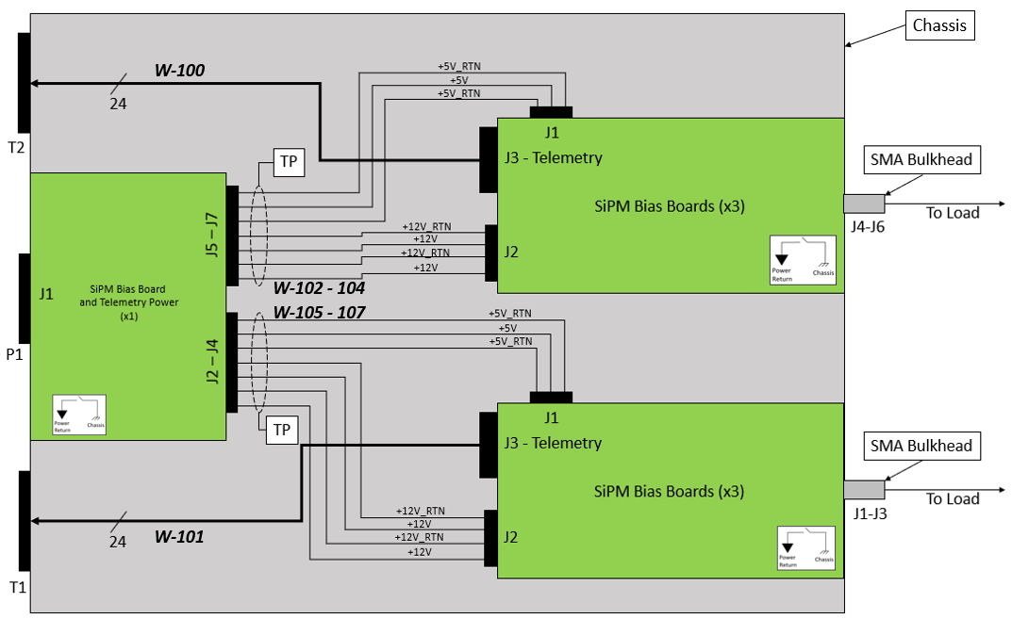

Table 4: Cold-TPC PDU SiPM Bias Box Diagram

The Telemetry Power Board shown above is described in the figure below.

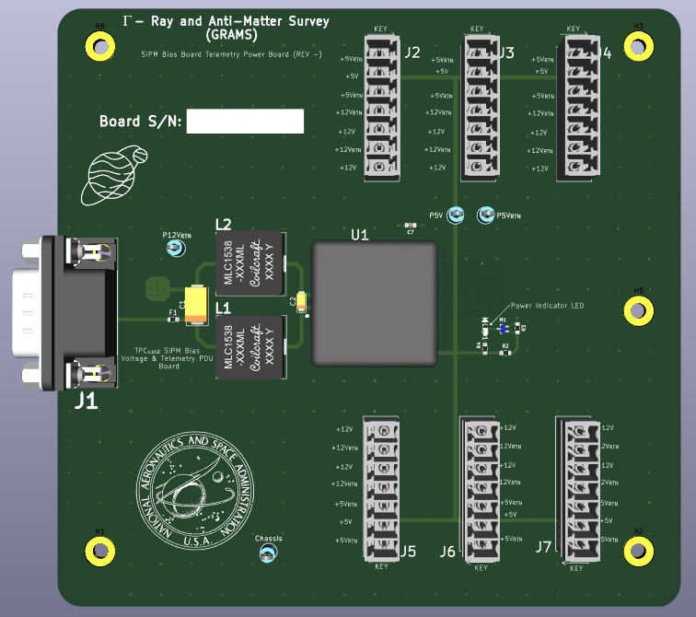

Figure 14: Telemetry Power Board (TPC Cold Box 1)

The J1 connector is receiving secondary power from the Main PDU Board and converting down to +5V that provides power to the telemetry circuitry on the SiPM Bias Boards. The J2 – J7 connectors are Phoenix Contacts (P/N: 1803471) in the above figure deliver +12V and +5V to each SiPM Bias board.

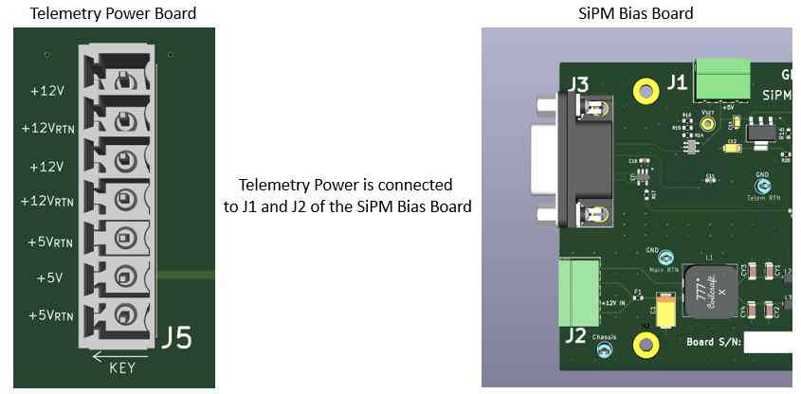

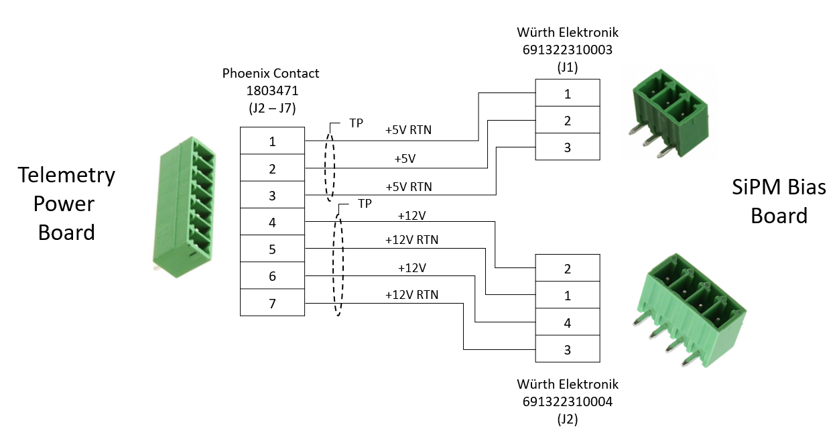

Figure 15: SiPM Bias Board Telemetry Power Harness

*Note the pin configuration with the J2 connector on the SiPM Bias Board!!*

The harnesses called out above are W-100 through W-107. *It is important to remember that there are 6 SiPM Bias Boards Total*.

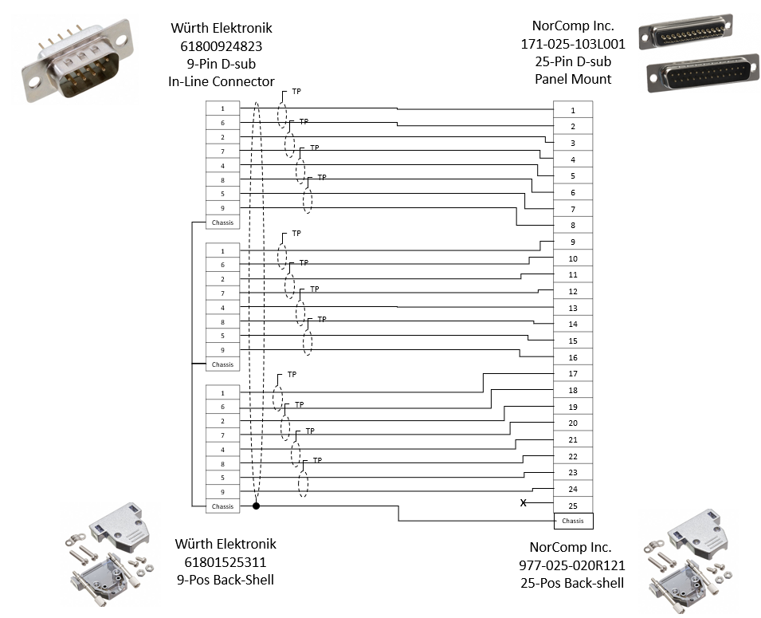

Figure 16: W-100 & W101 Harness Configuration

## The Box 2 configuration of Cold TPC PDU

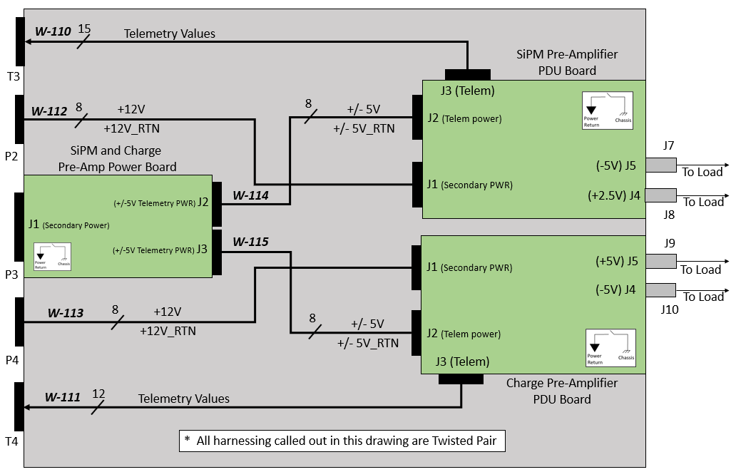

Figure 17: Cold TPC SiPM and Charge Pre-Amp PDU box Diagram

The SiPM and Charge Pre-Amp Power Board shown above is supplying +/-5V to each PDU board for the telemetry circuitry.

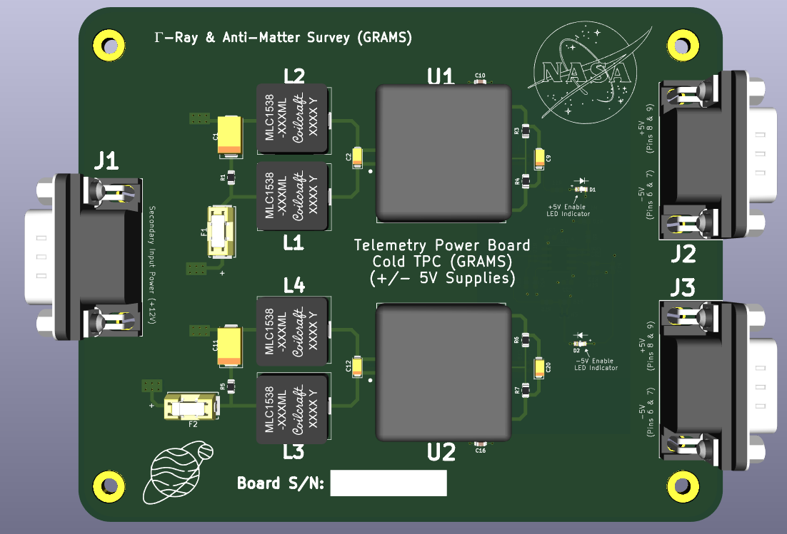

Figure 18: Telemetry Power Board for SiPM and Charge Pre-Amp PDU Boards

The J1 connector is receiving secondary power from the Main PDU board, J2 and J3 are providing the +/- 5V power to the SiPM and Charge Pre-Amplifier PDU boards for the telemetry circuitry. The figure below describes the W-114 and W-115 harnessing.

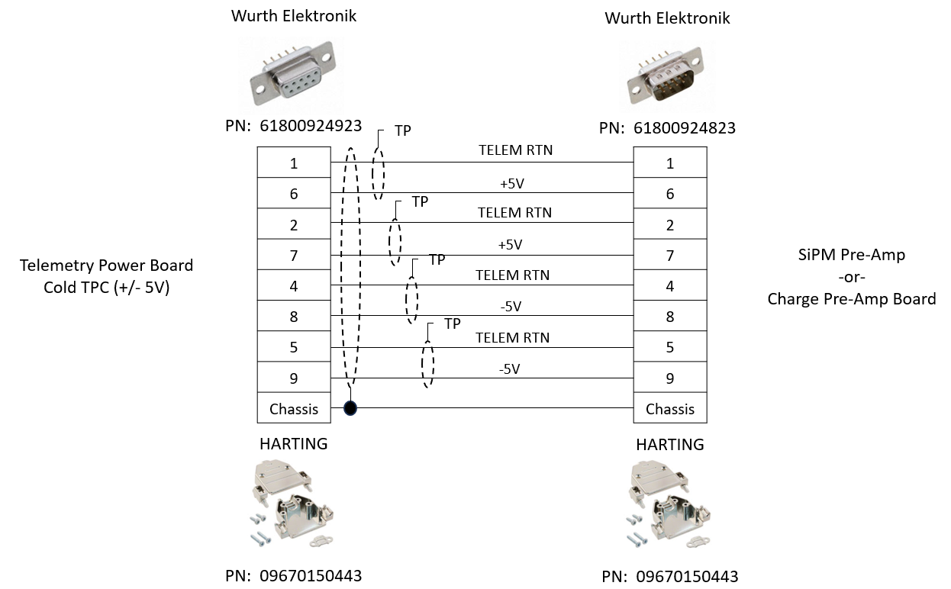

Figure 19: W-114 and W-115 Harness Drawing

The W-112 and W-113 are power harnesses.

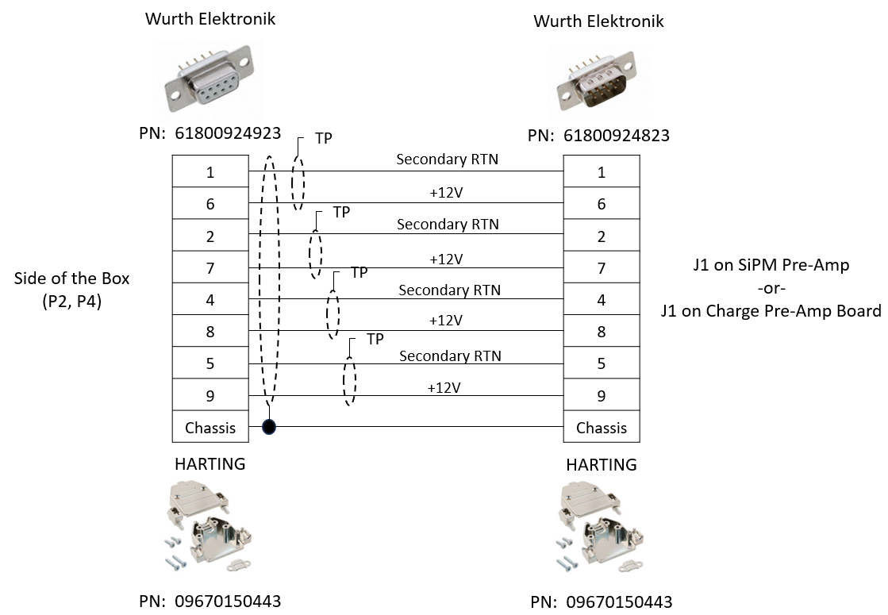

Figure 20: W-112 and W-113 Harness Drawing

The J3 connector on the SiPM Pre-Amplifier PDU carries the CMD/CTRL and Telemetry.

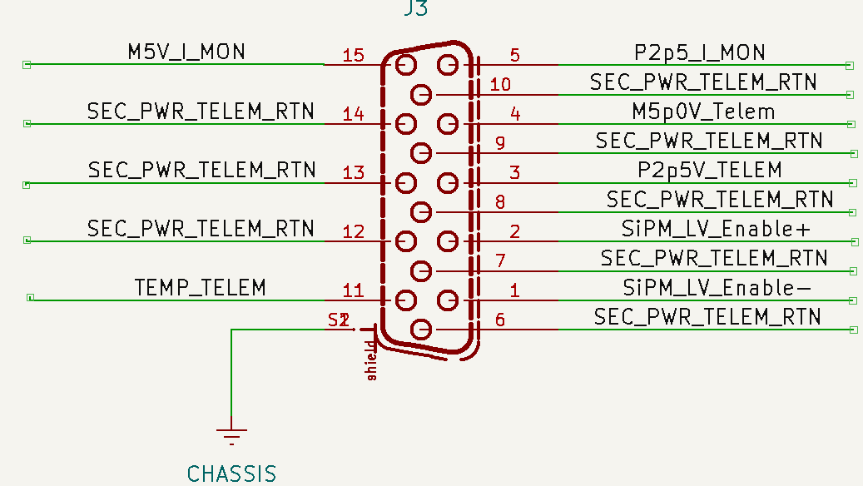

Figure 21: Cold TPC SiPM Pre-Amp PDU J3 Telemetry Connector

This is fed to the T3 connector on the box.

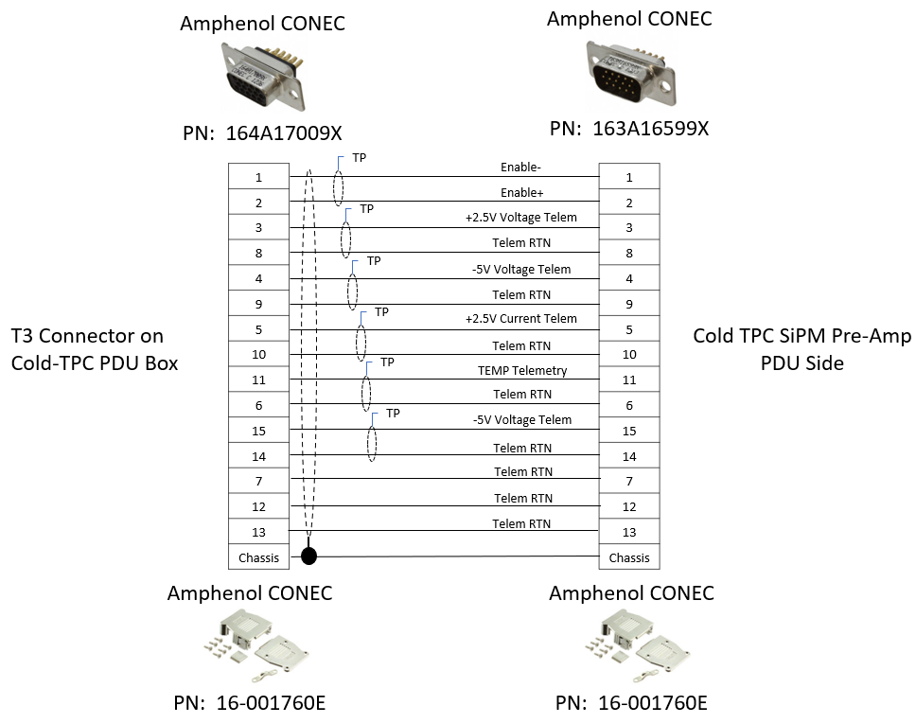

Figure 22: Cold TPC SiPM Pre-AMP W-110 Harness Drawing

The J3 connector on the Charge Pre-Amplifier is shown below:

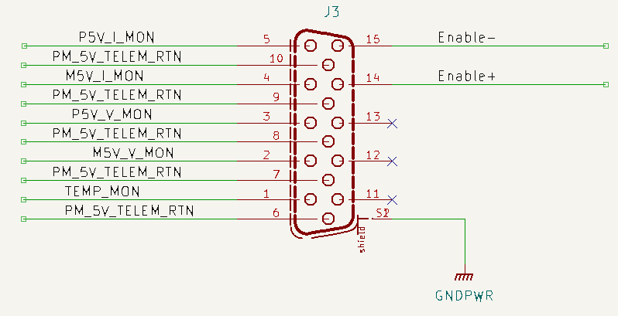

Figure 23: Cold TPC Charge Pre-Amp PDU J3 Telemetry Connector

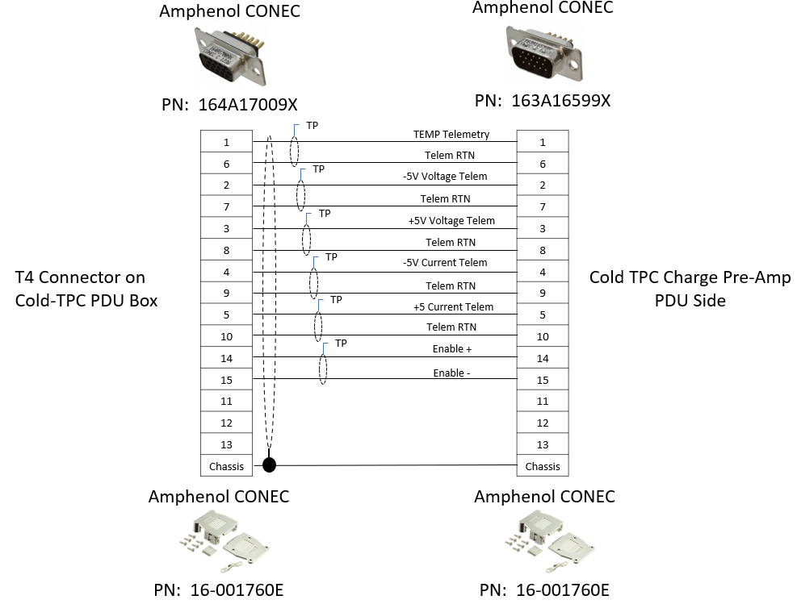

Figure 24: Cold TPC Charge Pre-AMP W-111 Harness Drawing