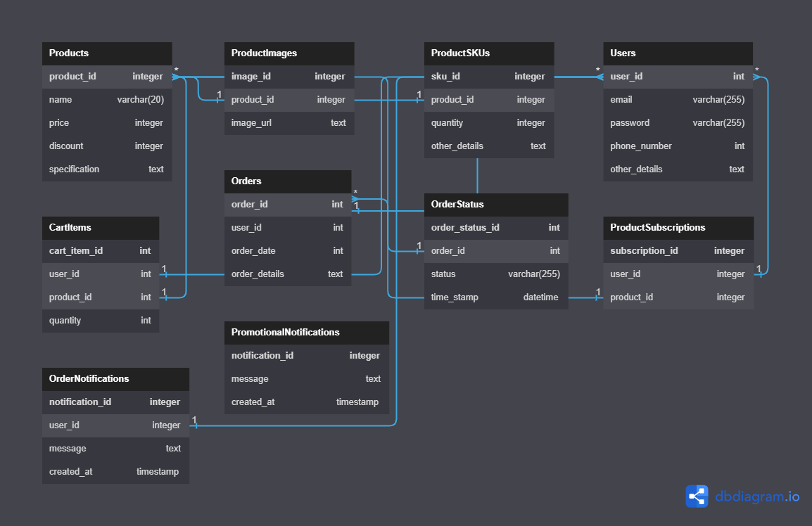

1. Physical Entity Relationship diagram of database.

2. Explain about searching performance. How will you handle replication in SQL for searching & Reporting?

Ans-

Searching performance should be very good to enhance e-commerce websites as we search for a product from lakhs of products.

SQL Server replication is a technology for copying and distributing data and database objects from one database to another and then synchronizing between databases to maintain consistency and integrity of the data.

3. Explain what major factors are taken into consideration for performance.?

Ans-

There are five major factors that influence database performance:

1. workload

2. throughput

3. resources

4. optimization

5. contention

4. Mention about Indexing, Normalization and Denormalization?

Ans-

* Indexing: Creating indexes on columns that are frequently used for searching and joining tables improves query performance by allowing the database to quickly locate the desired data.
* Normalization: Breaking down data into smaller, related tables to eliminate redundancy and maintain data integrity.
* Denormalization: Introducing redundancy by combining tables or adding redundant columns to improve query performance by reducing the number of joins and data retrieval operations.

5. How will you handle scaling, if required at any point of time?

Ans-

Scaling can be achieved through techniques such as vertical scaling (increasing server resources) or horizontal scaling (distributing the load across multiple servers).

6. Mention all the assumptions you are taking for solutions?

Ans-

* The database design assumes a relational database management system (RDBMS) like MySQL.
* The solutions assume the implementation of basic authentication and authorization mechanisms, allowing users (buyers and sellers) to log in using email/password or phone number with OTP (one-time password). It also assumes the availability of a "Forgot Password" feature for user account recovery.
* The solutions assume the existence of a notification system to send notifications to buyers regarding product availability, order updates, and promotional offers. The actual implementation of the notification system may vary, utilizing technologies such as email, SMS, or push notifications.
* The solutions consider the need for efficient searching and reporting capabilities. Indexing, query optimization, and proper database schema design are considered to enhance performance.
* The solutions assume the need for scalability to handle increasing traffic and user load. Scaling can be achieved through techniques such as vertical scaling (increasing server resources) or horizontal scaling (distributing the load across multiple servers). Caching mechanisms, like Redis or Memcached, can be utilized to improve performance and handle increased traffic.
* Additional tables and fields may be required based on specific requirements not mentioned in the scope.
* The database design does not cover payment processing or shipping details, as they are not mentioned in the provided scope.