library(moin)  
  
  
testdata <- sf::st_read("../vignettes/data/OldenburgerGraben/Placenames.shp")

## Reading layer `Placenames' from data source `C:\Users\der-w\Documents\GitHub\moin\vignettes\data\OldenburgerGraben\Placenames.shp' using driver `ESRI Shapefile'  
## Simple feature collection with 175 features and 3 fields  
## geometry type: POINT  
## dimension: XY  
## bbox: xmin: 606598.4 ymin: 5992757 xmax: 635643.1 ymax: 6026986  
## epsg (SRID): 32632  
## proj4string: +proj=utm +zone=32 +datum=WGS84 +units=m +no_defs

# MDM - Maximum Distance Modell  
mdm <- modelgraph(testdata,  
 "mdm",  
 4000)  
  
spatgraph_transform(x=mdm,output="tidygraph")

## # A tbl_graph: 175 nodes and 928 edges  
## #  
## # An undirected simple graph with 1 component  
## #  
## # Node Data: 175 x 0 (active)  
## #  
## # Edge Data: 928 x 2  
## from to  
## <int> <int>  
## 1 1 2  
## 2 1 3  
## 3 1 10  
## # ... with 925 more rows

# PPA - Proximal Point Analysis  
ppa <- modelgraph(testdata,  
 "ppa",  
 5)  
  
spatgraph_transform(x=ppa,output="tidygraph")

## # A tbl_graph: 175 nodes and 437 edges  
## #  
## # An undirected multigraph with 1 component  
## #  
## # Node Data: 175 x 0 (active)  
## #  
## # Edge Data: 437 x 2  
## from to  
## <int> <int>  
## 1 1 2  
## 2 1 48  
## 3 1 13  
## # ... with 434 more rows

############  
  
dista <- sf::st_distance(x = testdata,   
 y = testdata)  
  
dista2 <- as.dist(dista)  
  
clustertree <- hclust(dista2, method = "single")  
plot(clustertree, hang = -1)

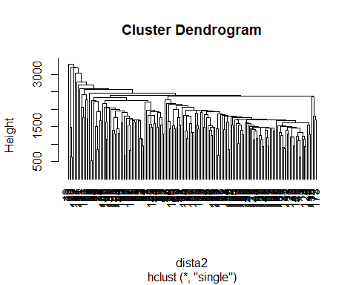

memb <- cutree(clustertree, h = 2500)  
  
testdata$Membership <- memb  
  
mapview::mapview(testdata["Membership"])