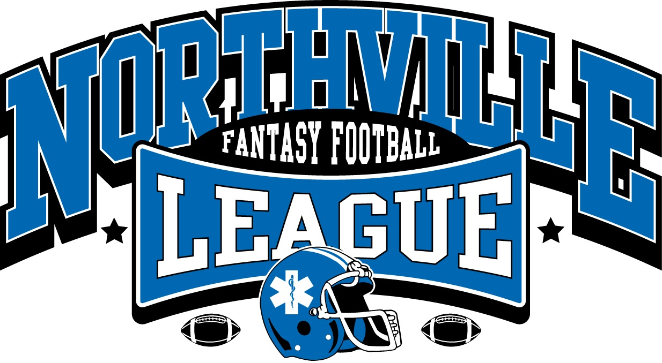

2015

Commissioner R.J. Robinson

email: [robertj.robinson@gmail.com](mailto:robertj.robinson@gmail.com) phone: 908-566-6628

**[1.1 Executive Committee]**

The executive committee for the Northville Fantasy Football League (NFFL) for 2013 consists of:

• Commissioner R.J. Robinson 908-566-6628

• First Chair TBD

• Second Chair TBD

The Executive Committee will be responsible for resolving all disputes that are not expressly covered by this constitution. If a committee member is involved in the dispute, that member will excuse himself or herself from the decision process. While all owners are encouraged to submit suggestions to the committee, the committee's decision on all matters is final.

**[1.2 Living Constitution]**

It is important to note that this is a living, breathing constitution that will change and evolve over the lifetime of this league. Changes will happen between seasons as often as possible and will be effective from that point moving forward. If you have suggestions for changes, please submit them to one of the executive committee members.

**[1.3 Membership]**

New membership to the NFFL is by invitation only. If you were a participant in the previous year, then an invitation will automatically be extended to you. If you fail to respond within 3 weeks of the season’s welcome letter, you will be put on reserve status

Reserve status means that you are on a waiting list, based on seniority, for the next available slot in the league. If there is a conflict with 2 members who have the same status, the dispute will be ruled on the opinion of the executive committee.

If you wish to join the league, or would like to recommend someone to join, there must be a spot open. An active member must also sponsor you. If you have a sponsor, and there is no team spot open, you will be placed on reserve status.

**[2.0 League Financing]**

The league fee for NFFL will be charged to each team owner and committee member, payable to www.leaguesafe.com on or before the deadline given, usually 7- 10 days before the night of the draft. If a team owner does not have the appropriate entry fee, the executive committee may make other arrangements for payment before the season starts at their discretion.

**[2.1 League Fee]**

The NFFL league fee for the 2015 season will be $100.00 from each owner. This fee consists of $100 entry fee plus $0.00 from each owner to cover the cost of the league dues. Also, at this time all trades and waiver wire transactions are free.

The company League Safe shall hold all of the league money. The site is very simple to use, and at the end of the season we will be able to quickly pay the winners. Note that if you opt to pay with credit card verses an e-check, there is a 3% fee charged.

[2.2 Prize Money]

League prize money will be paid out within seven days of the completion of the NFFL Super Bowl. Money will be held in at www.leaguesafe.com and will be paid out in the following manner:

• League Champion $ 800.00

• League Runner-Up $ 300.00

• League Second Runner- Up $ 100.00

**[2.3 Late Fee]**

If you have not paid by kick off of the first game in the season, there will be a penalty imposed.

**[3.0 League Setup and Competition]**

The NFFL will consist of 12 different teams and will be broken into two divisions of six teams each. The schedule will be randomly generated, with each team playing every other team at least once in head-to-head match-up. The schedule is generated by yahoo.com/fantasy, but the executive committee reserves the right to change match ups prior to the draft. After the draft the schedule will be locked 24 hours before draft day.

**[3.0.1 Division Rankings]**

Divisions will be locked from the 2014 season on. Meaning if you play in D1 in 2013, you will be in D1 in 2014. Division 1 and two owners shall agree upon a division name. ; Preferably a theme for the team names, but the division names will be locked throughout the season.

**[3.1 Division Rankings]**

Teams will be ranked within each division based on the following criteria:

• Overall Winning Percentage in Division

• Overall Ranking Throughout League

**[3.2 Playoffs]**

After the completion of the regular season, division leaders will make the playoffs. All division winners will be awarded a playoff spot and the highest-ranking non-division winner from each conference will be awarded a wildcard spot. Www.yahoo.com will take care of this. The website will also show you your overall ranking in the league. We have Fantasy football games through week 16. We do not use week 17 simply for the fact that NFL teams may sit their star players during that time.

**[4.0 Rosters, Lineups & Keeper Rules]**

Rosters in NFFL consist of 16 active players and optional two IR reserve spots, from any NFL team. Position limits are as follows:

|  |  |  |  |
| --- | --- | --- | --- |
| POSITION | MIN | MAX |  |
| QB | 1 | 3 |  |
| RB | 2 | 5 | FLEX |
| WR | 2 | 5 | FLEX |
| TE | 1 | 3 | FLEX |
| PK | 1 | 3 |  |
| DEF | 1 | 3 |  |

Only players from the active roster may be used as part of a team's starting lineup.

Comments: In keeper or dynasty leagues, you may also want to add a section about injured reserve or taxi squad where owners may designate players who are not active, but still available for protection for next season.

**[4.1 The Draft]**

The commissioner will designate a draft night each season. Owners are expected to attend the draft in person, and must have all league fees paid before the draft. The draft order will be determined by a random draw NLT 1 week before the draft. Draft position will be determined by random draw from the executive committee. The draft will be a serpentine order, where the person with the first pick in Round 1 will have the last pick in Round 2 and the first pick in Round 3. When it is the owner's turn to draft, they will have 2 minutes 30 seconds to make their pick. The commissioner will designate a timekeeper and when the timer expires, the next owner may make their selection. The skipped owner will then have another 30 seconds to make their pick, or the next owner will be on the clock. If you are skipped 2 times in the same round, you will not be able to secure that position until the end of 16th round.

**[4.2 Trades]**

Trading is allowed and encouraged in NFFL, and may be conducted between any owners. Trades may include multiple players from any position, as well as draft picks. Trades must include the same number of players or draft picks from each side to avoid any roster limit conflicts. If the roster allows for an uneven trade (This is for a 2 for 1 type situation) that is allowed; as long as there are no roster conflicts before, during or after the trade is complete. Owners may not make trades during any given week once the first NFL game has been played. Owners are free to trade once the final NFL game of the week is complete. No trades will be allowed after Week 12 of the fantasy football season. Please see Anti-tanking / anti-dumping rules.

**[4.2.1 Trade Veto]**

The executive committee reserves the right to reverse any trade that they deem inconsistent with league competition and fair-play standards. This veto will only be invoked in extreme cases where it is obvious that one owner is trying to give another owner an unfair advantage or disadvantage. The owners in question may offer reasons why the trade should be allowed, but the decision of the executive committee is final once it has been rendered. If the trade involves a committee member, they may offer reasons for the trade to be allowed but will not have a say in the final committee decision.

**[4.4 Starting Lineups]**

Starting lineups in NFFL will consist as follows:

1 QB

2 RBs

2 WRs

1 TE

1 Flex (RB, WR, TE)

1 PK

1 Defense

Owners must submit their starting lineup each week, even if the lineup does not change from the previous week. Players may be added or removed from the starting lineup up until the start of the first NFL game. On weeks where the NFL has a Thursday game, owners may make changes to their lineups up to the start of the second NFL game, but may not change a player that has already played. For example, if you started your quarterback on Thursday night and he has a bad game, you cannot switch him out for a quarterback who has not played. Also, if you did not start a wide receiver that played on Thursday night and he scored three touchdowns, you cannot add him to your lineup on Friday. Once the Thursday game begins, players from that game may not be started or benched.

**[4.4.1 Position Designations]**

From time to time, the NFL may change their designation of a particular player from one position to another or a player may line up in multiple positions throughout the game. For example, a wide receiver may be switched to a tight end and vice versa. For the purposes of NFFL, a player may have only one official designation; the executive committee, using the official distinctions on NFL.com as a guide, will resolve any disputed designations. Players may only start and score points based on their NFFL distinction. See the League Scoring section for more details.

**[4.5 Bye-week Penalties]**

Any owner who starts a player that is on a bye week, regardless of intention, the player will remain in the starting lineup and receive 0 points for not playing. It is each owner's responsibility to watch their starting lineup, and know when players are on their bye weeks. No exceptions will be made on this rule.

**[4.6 Active Ownership Requirements]**

Each owner is expected to actively manage their team each week, even if they are eliminated from any playoff consideration. If an owner does not submit a lineup for two consecutive weeks after week 5, the executive committee will have the right to assume control of the team and manage it for the rest of the season. A committee run team will not make any trades, sign any free agents and is only allowed to add or drop players if the team cannot field a legal starting lineup due to injury or bye weeks. Any prize money won by a committee run team will be dispersed evenly to the other active owners in the league. If a team becomes inactive in the first 4 weeks of the fantasy season, the executive committee will offer an invitation to someone on the reserve roster and that player will assume control of that team for the rest of the season. If no one is willing or no one is able to take control, the executive committee will go back and make all scores from previous games NULL (for said team) and will bench all players for the rest of the season. This will make whoever played this team in the first 4 weeks an automatic win. The inactive team will have a zero score for the end of the season. That owner may not be invited to play again at the decision of the executive committee.

**[4.7 Anti-Tanking / Anti- Dumping Provision]**

NFFL is a competitive league, created for the league owners to have fun playing fantasy football. While the competition may be fierce, this is not considered a cutthroat league. In the spirit of competition and league fairness, owners are not allowed to intentionally create a legal starting lineup that gives the opposing team a clear advantage. The executive committee reserves the right to step in and adjust the starting lineup of a team that is clearly trying to intentionally lose a game. If the committee must adjust a team's lineup in two consecutive weeks or for three or more weeks in any one season, the team will be considered inactive and the executive committee may assume ownership of the team as detailed in the active ownership requirements section.

**[4.8 Keeper League Rules]**

**** Note: This is only invoked should a keeper league be declared. ***

A Keeper league is where at the end of the season, you get to keep a total of 4 players. You must notify the E-Board within 48 hours of the next year’s draft. You can do so as early as week 13, but these players must remain on your roster throughout the end of the season

Eligible keepers must be drafted, after the second round and must have been on the retaining team’s roster at the conclusion of last season. Once you notify the E-Board of your keepers list, YOU CANNOT CHANGE IT. You may make trades after the draft is complete.

Each franchise can keep a maximum of four players from the previous year’s roster, but is not required to “keeper” any players.

The first keeper will take the place of the franchises 3rd round pick in the current year’s draft. The second keeper will take the place of the franchises 4th round pick in the current year’s draft. And son on until the 4th Keeper has been kept, if applicable.

Three of the four players can be kept for a maximum of 2 seasons, including the season in which the player was drafted, with the choice of keeping 1 player for 3 seasons.

Any new franchise has the option to “adopt” an existing and unclaimed franchise’s roster and retain eligible keepers for the new season. The new player will draw a name from a hat if more then one franchise is available.

Keepers must be officially announced 48 hours before the schedule draft time.

Any revisions to the keeper rules will not apply retroactively to players currently in “keeper” status.

Any player that is placed on an owners IR list MUST notify the E-Board. This play will be placed on inactive reserve, and will not be allowed to play in the rest of the season. This player will be able to trade or drop.

**[5.0 Scoring System]**

Scoring in NFFL will be computed to two decimal places. This will allow points to be awarded or deducted for every positive or negative yard and will dramatically reduce the chance of a tie game. Players are awarded fantasy points for each week that they are included in the team's starting lineup. The scoring system can be located at the yahoo.com site

If there are any questions regarding the points, please contact a member of the executive committee

**[5.1 Point Totals and Final Scores]**

NFFL will be hosted at yahoo fantasy sports. Head to head scoring will be determined each week by the stats from that website. From time to time, the NFL may go back and change the scoring of certain plays later in the week. http://www.nfl.com/fantasy gives the commissioner the option to make these scores retroactive. However, to maintain a sense of fairness and avoid confusion in the league, all head-to-head scoring will be resolved as of Tuesday at noon Eastern. Any scoring changes that come out from the NFL after that time will not be applied to the league.

**[6.0 Offseason Activities]**

Owners are strongly encouraged to maintain their current contact information as part of the league software. Please make sure to include your name, phone number and email address in the event that we need to reach you during the off-season. You should expect to be contacted in July with information about next year's draft. Thanks and welcome to Northville Fantasy Football League 2013 season!

**[X.0 Updates / Change log]**

7/12/15 -- Updated formatting.

-- Added change log on github.com

--

6/12/15 –- Changed dates

-- Reapplied yahoo.com as the tracker.

-- Increased fee to $100

-- Placed note about the $15 late fee.

7/12/14 -– Changed dates

-- Added Keeper rules and statuses.