/*---------------------------------------------------------------------------
Program : Readwriter.c
Author : Prof. Joseph NG (COMP, HKBU)
Description: This program investigates the Readers/Writers problem.
It will spawn 4 processes (2 Readers & 2 Writers)
To compile : gcc -o Readwriter Readwriter.c -lm
To run : Readwriter
Note : You should use "script" to capture the run time message.
----------------------------------------------------------------------------*/
#include <stdio.h>
#include <stdlib.h>
#include <sys/types.h>
#include <unistd.h>
#include <math.h>
#include "sem_pack.h"

#define SEMKEY1 ((key_t) 23456L)
#define SEMKEY2 ((key_t) 23457L)
#define SEMKEY3 ((key_t) 23458L)

double random_fun(double alpha);
void reader(int);
void writer(int);

FILE *wptr;
FILE *rptr;
FILE *rshptr;
FILE *fptr;

int x, wsem, aok;

int main(int argc, char *argv[])
{
int pid, numberdone;
int parent = 0; /* you can use this flag to identify the parent */
int finish = 0;

if ((x = sem_create(SEMKEY1, 1)) < 0) printf("can't open semaphore");
if ((wsem = sem_create(SEMKEY2, 1)) < 0) printf("can't open semaphore");
if ((aok = sem_create(SEMKEY3, 1)) < 0) printf("can't open semaphore");

fptr = fopen("SharedFile", "w");
fprintf(fptr, "0");
fclose(fptr);

fptr = fopen("ReadCount", "w");
fprintf(fptr, "0");
fclose(fptr);

fptr = fopen("ProcessDone", "w");
fprintf(fptr, "0");
fclose(fptr);

srand(time(NULL));

/* Spawn the Readers and Writers */

if ((pid = fork()) == 0){ /* Readers */
if ((pid = fork()) == 0){ /* Reader1 */
reader(1);
}else{ /* Reader2 */
reader(2);
}
}else{ /* Writers */
if ((pid = fork()) == 0){ /* Writer1 */
writer(1);
}else{ /* Writer2 */
writer(2);
parent = 1; /* set this flag to indicate this process is the parent */
}

}

if (parent){ /* if it is the parent, we can do something special here */
while (!finish){
sem_wait(aok);
fptr = fopen("ProcessDone", "r");
fscanf(fptr, "%d", &numberdone);
fclose(fptr);
if (numberdone == 3) finish = 1;
sem_signal(aok);
}
sem_close(x);
sem_close(wsem);
sem_close(aok);
}else{
sem_wait(aok);
fptr = fopen("ProcessDone", "r");
fscanf(fptr, "%d", &numberdone);
fclose(fptr);
numberdone++;
fptr = fopen("ProcessDone", "w");
fprintf(fptr, "%d", numberdone);
fclose(fptr);
sem_signal(aok);
}

}

double random_fun(double alpha)
{
return ((1 + rand()%2048)/2048.0) * alpha * 2.0;
}

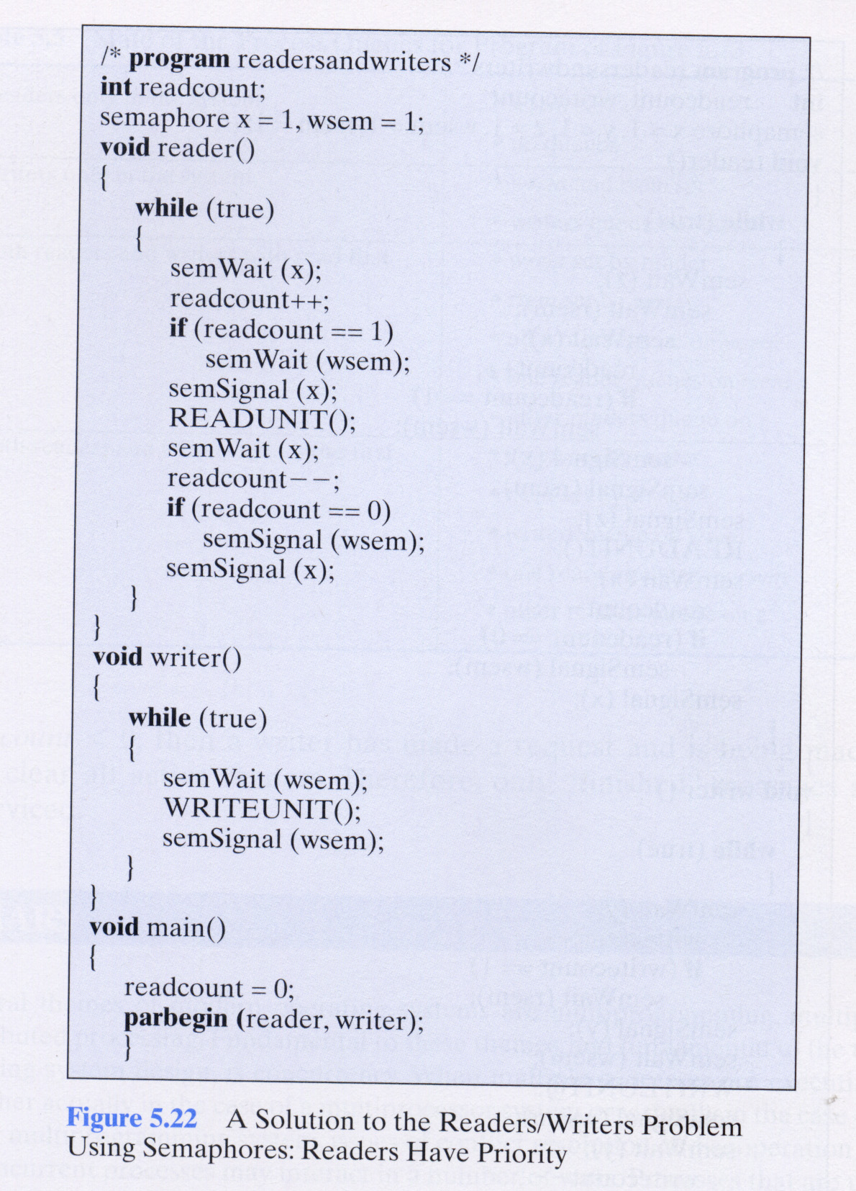
void reader(int id)
{
int i, shnumber, readcount;
double duration;

for (i = 0; i < 20; i++){
sem_wait(x);
rptr = fopen("ReadCount", "r");
fscanf(rptr, "%d", &readcount);
fclose(rptr);
readcount++;
rptr = fopen("ReadCount", "w");
fprintf(rptr, "%d", readcount);
fclose(rptr);
if (readcount == 1) sem_wait(wsem);
sem_signal(x);

rshptr = fopen("SharedFile", "r");
fscanf(rshptr, "%d", &shnumber);
fclose(rshptr);
if (id == 1){}else{rand();}
duration = random_fun(50.0) + 100.0;
printf("Reader%d: pid=%d duration=%f msec SharedFile: %d\n",
id, getpid(), duration, shnumber);

sem_wait(x);
rptr = fopen("ReadCount", "r");
fscanf(rptr, "%d", &readcount);
fclose(rptr);
readcount--;
rptr = fopen("ReadCount", "w");
fprintf(rptr, "%d", readcount);
fclose(rptr);
if (readcount == 0) sem_signal(wsem);
sem_signal(x);

usleep(random_fun(50.0)+100.0);
}
}

void writer(int id)
{
int i, num, shnumber;
double duration;

for (i = 0; i < 20; i++){
sem_wait(wsem);
wptr = fopen("SharedFile", "r");
fscanf(wptr, "%d", &shnumber);
fclose(wptr);
if (id == 1){rand(); rand();}else{rand(); rand(); rand();}
//num = (int)(random_fun(3.0)+1.0);
num = 1 + rand()%6;
shnumber = shnumber + num;
duration = random_fun(50.0)+100.0;
usleep(duration);
wptr = fopen("SharedFile", "w");
fprintf(wptr, "%d", shnumber);
fclose(wptr);
printf("Writer%d: pid=%d duration=%f msec SharedFile: %d + %d = %d\n",
id, getpid(), duration, shnumber-num, num, shnumber);
sem_signal(wsem);
usleep(random_fun(150.0)+100.0);
}
}

