Uploading Invoices and POD’s

- When a carrier sends over a POD, make sure if it is a JPEG to crop anything out around the actual POD itself to make it look as if it was scanned.

- Save the attachment to your designated desktop file and title it as the load number.

- Go to the OneDrive and upload it into the folder titled “PRODUCTION – Approved PODs Only.”

- The same process for invoices. When an invoice is received;

  - Open the attachment, and pull that load up in Salesforce to make sure the dollar amount matches.
  - Make sure the invoice also includes the POD. Even if we already have a POD uploaded, Accounting needs the POD attached to the invoice that is uploaded.

- Once everything is confirmed for invoices, upload to the OneDrive under the folder titled “PRODUCTION – Approved Invoices with PODs Only”

Updating the Spreadsheet

After the POD and/or invoice is uploaded to the OneDrive, we also need to make sure the Excel spreadsheet we keep is updated. The spreadsheet is how we keep track of what has and has not been received, located on the OneDrive in the folder titled “MISC. DOCUMENTS to SHARE”. The Excel spreadsheet is titled “Invoices and PODs.xlsx”.

Once opened, you will see three primary tabs on the bottom titled, “NEW PODS”, “NEW OLD PODS” and then the current year 2023, that we use. See below:

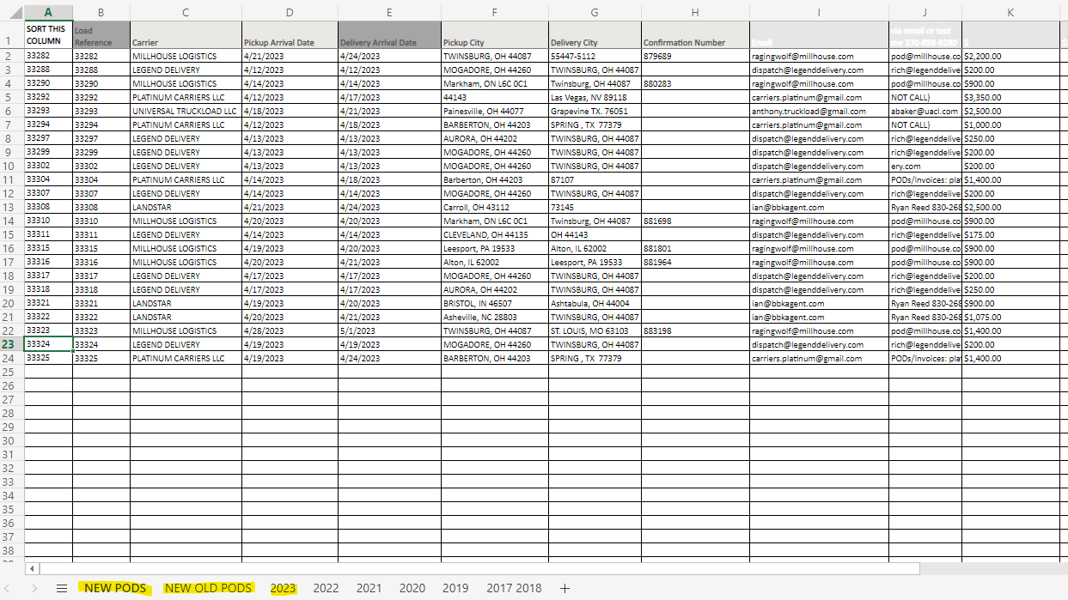

The loads listed under the tab “NEW PODS” are loads that we have yet to receive either Invoice or POD. Once a POD has been received from the carrier, that load should be listed. When received, find the column titled “Load Reference,” under column B, select the cell with the matching load number and fill it in with yellow, see below for example.

From there, find column N and insert the date the POD was received, you will just need to type in month/day and press enter and it will fill in the year. Then select the row from column B through column O and copy it and move it over to the “NEW OLD PODS” tab.
- The “NEW OLD PODS” tab will be a list of all loads that we received a POD for but not an invoice.
Once we’ve received an invoice for a load, you will have to find that load in either the “NEW PODS” or “NEW OLD PODS” and follow the same process for the date the invoice was received but you will type that date into the “Invoice Date” column. Once an Invoice and POD are received, you will copy that load and move it to the “2023” tab or the current year the load was delivered in.

NEVER FILE ANYTHING INTO A “COMPLETE” FOLDER!! – FOR ACCOUNTING USE ONLY!!

