<http://qgis.spatialthoughts.com/2012/02/tutorial-styling-vector-data-in-qgis.html>

Classify three different using three classification system:

Natural break (jenks)

Quantile

Equal Interval

All should be in one html script

Natual break

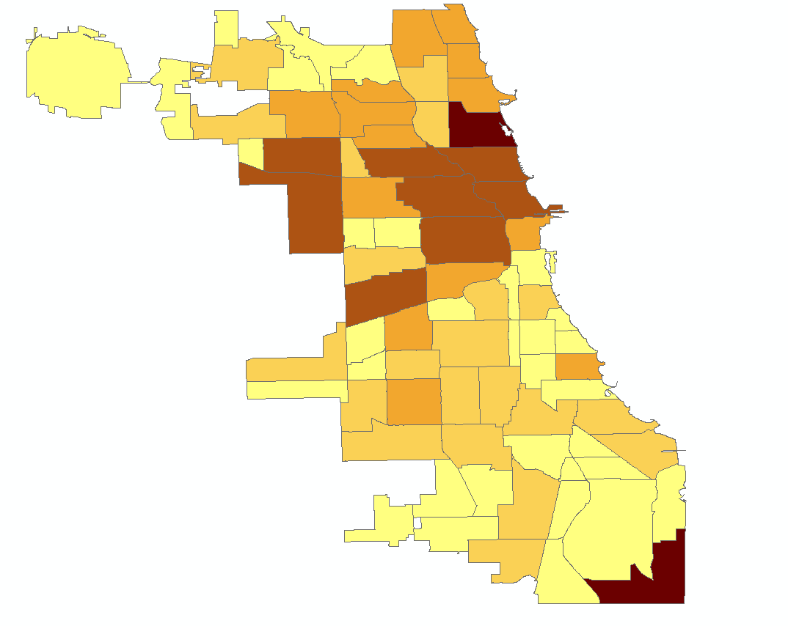

Equal Interval

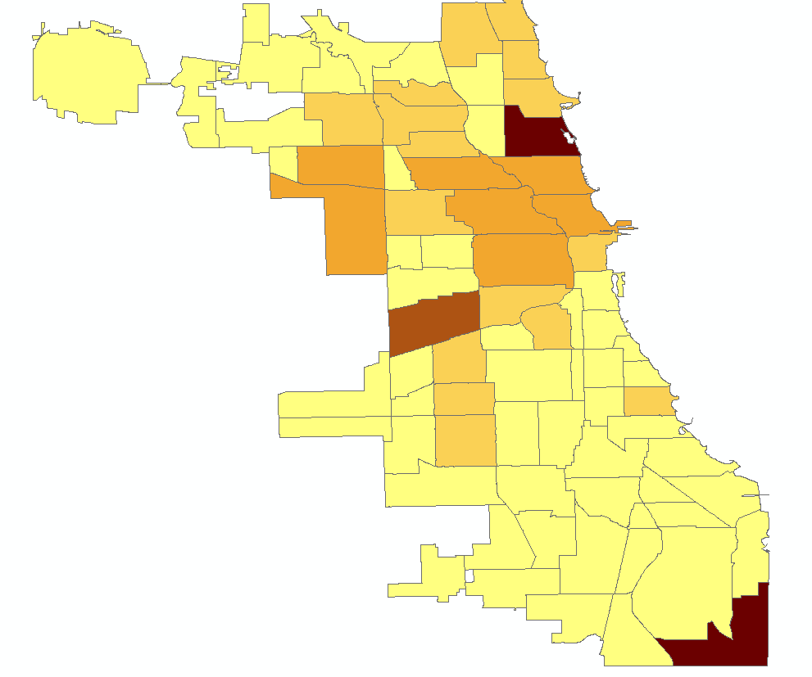

Quantile:

