Embedded System :

An **embedded system** is a computer system—a combination of a [computer processor](https://en.wikipedia.org/wiki/Computer_processor), [computer memory](https://en.wikipedia.org/wiki/Computer_memory), and [input/output](https://en.wikipedia.org/wiki/Input/output) peripheral devices—that has a dedicated function within a larger mechanical or electrical system.

Modern embedded systems are often based on [microcontrollers](https://en.wikipedia.org/wiki/Microcontroller).

Embedded systems range from portable devices such as [digital watches](https://en.wikipedia.org/wiki/Digital_watch) and [MP3 players](https://en.wikipedia.org/wiki/MP3_player), to large stationary installations like [traffic light controllers](https://en.wikipedia.org/wiki/Traffic_light_control_and_coordination), [programmable logic controllers](https://en.wikipedia.org/wiki/Programmable_logic_controller), and large complex systems like [hybrid vehicles](https://en.wikipedia.org/wiki/Hybrid_vehicles), [medical imaging](https://en.wikipedia.org/wiki/Medical_imaging) systems, and [avionics](https://en.wikipedia.org/wiki/Avionics). Complexity varies from low, with a single microcontroller chip, to very high with multiple units, [peripherals](https://en.wikipedia.org/wiki/Peripheral) and networks mounted inside a large [equipment rack](https://en.wikipedia.org/wiki/Equipment_rack).

**LM35 Temperature Sensor:**

* LM35 is a precession Integrated circuit Temperature sensor.
* Whose output voltage varies, based on the temperature around it.
* It is a small and cheap IC which can be used to measure temperature anywhere between -55°C to 150°C.
* It can easily be interfaced with any Microcontroller that has ADC function or any development platform like Arduino.

### DC Motors

* a two wire continuous rotation motor and the two wires are power and ground.
* When the supply is applied, a DC motor will start rotating
* examples are; fans being used in computers for cooling or car wheels controlled by a radio.
* The DC motor speed can be controlled by using PWM (pulse width modulation) technique

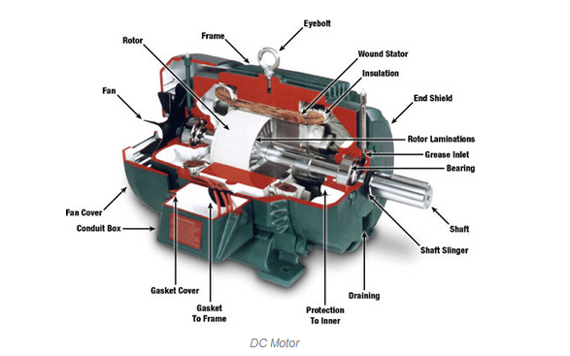

### Servo Motors

* an association of four things, namely a DC motor, a control circuit, a gearing set, and also a potentiometer usually a position sensor.
* exampe - moving a robotic arm or controlling the rudder on a boat or robot leg within a particular range.
* These motors do not alternate easily like a standard DC motor. In its place, the rotation angle is partial to 1800.

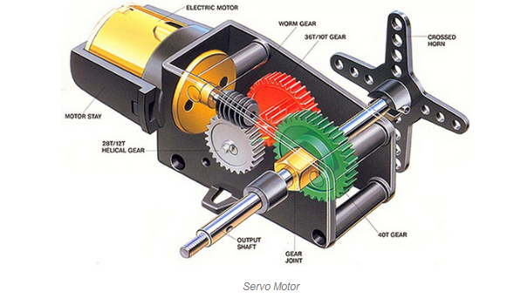

### Stepper Motors

* stepper motor is fundamentally a servo motor that uses a different method of motorization.
* a motor includes a continuous rotation DC motor and combined controller circuit, stepper motors utilizes multiple notched electromagnets arranged around a central equipment to describe the position.

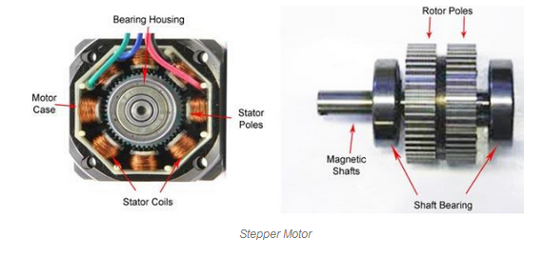

### ESP Module

### wifi module

### a very user friendly and low cost device to provide internet connectivity to your projects

### it can easily fetch data and upload it to the internet making Internet of Things

### A Gyroscope

### a device used for measuring or maintaining [orientation](https://en.wikipedia.org/wiki/Orientation_(geometry)) and [angular velocity](https://en.wikipedia.org/wiki/Angular_velocity).

### a spinning wheel or disc in which the axis of rotation (spin axis) is free to assume any orientation by itself

# **GSM**

GSM is a mobile communication modem; it is stands for global system for mobile communication (GSM)