**Bachelor of Science in Computer Science and Engineering**

**An Efficient Link Layer Handoff Procedure in Infrastructure Wireless Mesh Nerwork**

**Md. Hasanuzzaman Noor**

**ID-0904110**

**November, 2014**

**Department of Computer Science & Engineering**

**Chittagong University of Engineering & Technology**

**Chittagong-4349, Bangladesh.**

**An Efficient Link Layer Handoff Procedure in Infrastructure Wireless Mesh Nerwork**



This thesis is submitted in partial fulfillment of the requirement for the degree of Bachelor of Science in Computer Science & Engineering.

Md. Hasanuzzaman Noor

ID: 0904110

Supervised by

Mir Md. Saki Kowsar

Assistant Professor

Department of Computer Science & Engineering (CSE)

Chittagong University of Engineering & Technology (CUET)

**Department of Computer Science & Engineering**

**Chittagong University of Engineering & Technology**

**Chittagong-4349, Bangladesh.**

The thesis titled **“An Efficient Link Layer Handoff Procedure in Infrastructure Wireless Mesh Nerwork”** submitted by Roll No. 0904012, Session 2012-2013 has been accepted as satisfactory in fulfillment of the requirement for the degree of Bachelor of Science in Computer Science & Engineering (CSE) as B.Sc. Engineering to be awarded by the Chittagong University of Engineering & Technology (CUET).

**Board of Examiners**

1. Chairman

Dr. Mohammed Moshiul Hoque

Associate Professor

Department of Computer Science & Engineering (CSE)

Chittagong University of Engineering & Technology (CUET)

2. Member

Professor Dr. Kaushik Deb (Ex-officio)

Head

Department of Computer Science & Engineering (CSE)

Chittagong University of Engineering & Technology (CUET)

3. Member

Dr. Mohammad Shamsul Arefin (External)

Associate Professor

Department of Computer Science & Engineering (CSE)

Chittagong University of Engineering & Technology (CUET)

**Statement of Originality**

It is hereby declared that the contents of this project is original and any part of it has not been submitted elsewhere for the award if any degree or diploma.

------------------------------------ ------------------------------------

**Signature of the Supervisor Signature of the Candidate**

**Date: Date:**

**Acknowledgment**

First and foremost, I would like to thank God Almighty for giving me the strength to finish this work. The satisfaction that accompanies the successful completion of this thesis would be incomplete without the mention of people whose ceaseless cooperation made it possible, whose constant guidance and encouragement crown all efforts with success. I am grateful to my honorable project Supervisor Mir Md. Saki Kowsar, Assistant Professor, Department of Computer Science and Engineering, Chittagong University of Engineering and Technology, for the guidance, inspiration and constructive suggestions which were helpful in the preparation of this project. I also convey special thanks and gratitude to Professor Dr. Kaushik Deb, honorable head of the Department of Computer Science and Engineering and Dr. Mohammad Shamsul Arefin, Associate Professor,Department of Computer Science and Engineering, Chittagong University of Engineering and Technology,for their kind advice.I would also like to extend my gratitude to all of my teachers for their valuable guidance in every step of mine during the four years of learning stage. Finally I would like to thank my friends, senior, juniors and the staffs of the department for their valuable suggestion and assistance that has helped in successful completion of the project.

**Abstract**

Wireless Mesh Networks (WMN) usually provides internet access to a large area, which is from university campus to city scale. In order to provide an uninterrupted internet experience to a mobile client, a process called handoff is required to maintain the network connection. Ideally, handoff should be completely transparent to mobile users. A critical application like VoIP will require a handoff capability that transfers a call from one mesh node (MN) to another in less than 50 msec. However the current IEEE 802.11 standards do not address the handoff well. Studies have revealed that standard handoff on IEEE 802.11 WLANs incurs a latency of the order of hundreds of milliseconds to several seconds. Moreover, the discovery step in the handoff process accounts for more than 99% of this latency. The study addresses the latency in the discovery step by introducing an efficient and powerful client-side scan technique which optimizes the discovery step with an efficient method. The feasibility of the proposed scheme to support fast handoff in WMNs has been demonstrated through computer simulations under some conditions. The results from the simulations show that the latency associated with handoff can be reduced by using this technique.

Table of Contents

Chapter 1 : Introduction 1

1.1 Handoff in Wireless Mesh Network 1

1.2 Motivation of the Work 2

1.3 Challenges 3

1.4 Contribution of the Work 3

1.5 Organization of the Thesis 4

Chapter 2 : Literature Review 5

2.1 Efficient Handoff 5

2.2 Wireless Mesh Network 6

2.3 802.11 Wireless Local Area Network Standards Overview 8

2.3.1PHY Layer 6

2.3.2 MAC Layer 8

2.3.3MAC Management Frames in Handoff Process 6

2.4Handoff in 802.11 WMN 8

2.4.1Discovery 9

2.4.1 Authentication 9

2.4.2 Association/Reassociation 11

2.4.3 Handoff Procedure and Delay 9

2.6 Previous Work 9

2.6.1 Link Layer Handoff 9

2.6.2 Network Layer Handoff 11

2.7Chapter Summary 11

Chapter 3 : Methodology 14

3.1 Existing Approaches 14

3.2 Arichitecture of the Proposed System 15

3.3 Chapter Summary 28

Chapter 4 : Implementation 34

4.1 Implementation Tools 35

4.2 Implementation Details 35

4.3Chapter Summary 37

Chapter 5 : Experimental Results and Analysis 42

5.1 IEEE 802.11 Handoff Analysis 42

5.1.1 Discovery Phase……………………………………………………………………….43

5.1.2Execution Phase 42

5.1.3 Analysis Summary…………………………………………………………………....43

5.2Proposed Scheme Simulation 57

5.2.1 Handoff Latency by Using Passive Scanning 57

5.2.2 Handoff Latency by Using Active Scanning 57

5.2.3Handoff Latency by Using Proposed Scheme 57

5.2.4 Simulation Summary 57

5.3Prototype Experiments 57

5.3.1 Comparison between Proposed scheme and existing system 58

5.3.2Performance Test of the Proposed Scheme 63

5.3.3Experiment Summary 65

5.4 Chapter Summary 67

Chapter 6 : Conclusion and Future Work 68

6.1 Findings of this work 68

6.2 Future work 69

Bibliography 70

Appendices 72

Appendix A: Source Code 77

**List of Figures**

Figure 1.2: General Framework for Expressive Agent 2

Figure 2.1: Face reference points 7

Figure 2.3: Emoticons used in Yahoo! Messenger 8

Figure 2.4.1 (a): EveR-4 H33 9

Figure 2.4.1 (b): Yuppy the Robot 10

Figure 3.3.1(c): Interface of Blender 19

Figure 3.3.1(d): Taxonomy of 3-D models 19

Figure 3.3.1(e): Cloth Panels Used for Cloth Simulation 20

Figure 3.3.3.7(a): Manipulation of shape keys to generate Irony 30

Figure 3.3.3.8(b): Frames used to generate Determined 31

Figure 3.4(a): Manipulation of shape keys for Eye Blink 32

Figure 3.4(b): Frames used to generate Eye Blink 32

Figure 3.4(c):Blender Interface to generate to Head Movement 32

Figure 3.4(d): Frames use to generate to Head Movement 33

Figure 4.4: Communication between users and server 36

Figure 4.5.1: Login Window 38

Figure 5.3.2.2(a): Participant interacting with Proposed System 64

Figure 5.3.2.2(b): Users communicating through Existing Emoticon based System 64

Figure 5.3.2.2(c): Users communicating through Proposed System 65

Figure 5.3.2.2(d): Results of questionnaire assessment based on the Subjective Evaluation 66

Figure A1: Starting the Server 72

Figure A2: User connected to the Server 72

Figure A3: System Interface showing the Expression Disgust 73

Figure A4: System Interface showing the Expression Angry 73

Figure A5: System Interface showing the Expression Fear 74

Figure A6: System Interface showing the Expression Irony 74

Figure A7: System Interface showing the Expression Sad 75

Figure A8 System Interface showing the Expression Determined 75

Figure A9: System Interface showing the Expression Surprise 76

**List of Tables**

Table 2.1: Control Parameters 7

Table 3.3(a): Characteristics of 3D Models 17

Table 3.3(b): Facial Parameters to express Six Basic Emotions 21

Table 4.4: Database table user_info 37

Table 5.1: Comparison between normal face and expressive face 42

Table 5.2(a): Input texts and their corresponding output expressions 46

Table 5.2(b) Data Table to determine accuracy 56

Table 5.3.2.1: Summarized results of analysis of female and male agents’ expressions 63

Table 5.3.2.2: Comparative analysis based on the subjective evaluation between the proposed and emoticon based approaches 66

**Abbreviations and Acronyms**

ACK Acknowledgment

AID Association ID

AP Access Point

BSS Basic Service Sets

BSSID Basic Service Sets Identification

CoA Care-of-Address

CRC Cyclic Redundancy Check

CW Contention Window

DA Destination Address

DCF Distributed Coordination Function

DIFS DCF Interframe Space

DSSS Direct Sequence Spread Spectrum

EMA Exponential Moving Average

ESS Extended Service Set

FA Foreign Agent

FCS Frame Check Sequence

FT Fast BSS Transition mechanism

FHSS Frequency Hopping Spread Spectrum

HA Home Agent

HAL Hardware Abstraction Layer

HR/DSSS High Rate Direct Sequence Spread Spectrum

IBSS Independent Basic Service Set

IEEE Institute of Electrical and electronic Engineers

IR Infrared

MAC Medium Access Control

MCL Mesh Connectivity Layer

MIMO Multiple-Input and Multiple-Output

MN Mesh Node

MSDU MAC Service Data Unit

NIC Network Interface Cards

NS3 Network Simulator Version 3

PLCP Physical Layer Convergence Protocol

RSSI Received Signal Strength Indicator

RTT Round Trip Time

SA Source Address

STA Station

TU Time Unit

PCF Point Coordination Function

PHY Physical

QAM Quadrature Amplitude Modulation

QoS Quality of Service

VoIP Voice over Internet Protocol

WEP Wired Equivalent Privacy

WLAN Wireless Local Area Network

WMNs Wireless Mesh Networks

Wi-Fi Wireless Fidelity

# : Introduction

An infrastructure Wireless Mesh Network is composed of a combination of static mesh routers (MRs) and mobile mesh nodes (MNs). In a typical WMN, MRs form a wireless multi-hop backbone network. Some MRs serve as the wireless access points (APs) to provide wireless mesh backbone entries to MNs. Some MRs, called gateway MRs (GW), are connected to the Internet via wired links and serve as the Internet entry points to other MRs via multi-hop wireless links. MNs can move freely in WMNs when communicating with correspondent nodes (CNs) by means of handoffs between different APs.This chapter contains some introductory information on handoff in wireless mesh network, motivation of our work, challenges of implementing our work and our objectives.

## 1.1Handoff in Wireless Mesh Network

One of the main characteristics of mesh networks isthat they have only a few wireless gateways (GWs)connected to a wired network while the wireless routers(MR) provide Network access to mobile. Within therange of a given wireless router, the client may movefreely, but as it moves away from the wireless routerand closer to another, it should handover all its openconnections to the new one to preserve networkconnectivity [1]. Ideally the handover should becompletely transparent to mobile clients with nointerruption, loss of connectivity, or degradation ofvoice quality if VoIP communications are involved.Handover is the essential component for dealing withthe mobility of clients. It guarantees the continuity ofthe wireless services when the client moves across theboundaries.There are four different types of handovers inWireless Mesh Network [1]. They are:

(1) Intra-system HO: occurs within one system. Itcan be further divided into Intra-frequency HO andInter-frequency HO. Intra-frequency occurs betweencells belonging to the same Wireless Mesh Networkcarrier, while Inter-frequency occurs between cellsoperate on different Wireless Mesh Network carriers.

(2) Inter-system HO: takes places between cellsbelonging to two different Radio Access Technologies(RAT) or different Radio Access Modes (RAM).

(3) Hard HO: is a category of HO procedures inwhich all the old radio links of a mobile are releasedbefore the new radio links are established. Hardhandover can take place as intra or inter-frequencyhandover.

(4) Soft HO: During soft handover, a mobilesimultaneously communicates with two (2-way SHO)or more cells belonging to different APs of the samewireless gateway (intra-WG) or different wirelessgateway (inter-WG). Soft handover is only possiblewithin one carrier frequency and therefore, it isintra-frequency handover processes.

## 1.2 Motivation of the Work

Much of the work to date[2-4] in the area of handoff in IEEE 802.11 wireless networkshas been concerned with essentially trying to duplicate the successful handoff mechanismsthat already exist in cell phone networks when a mobile device roams between base stations.A cell phone handoff must be quick enough to support full-duplex voice communicationwithout a perceivable gap in either voice stream.Previous studies on seamless mobility in wireless mesh networks can be divided intotwo different categories: MAC layer handoff and network layer handoff. MAC layerhandoff is often referred to as micro-mobility while network layer handoff is referred to asmacro-mobility. Surveys addressing all of these areas are reviewed by Akyildiz et al. in [5]. Improvements have been shown in the previous studies [3-4, 6-7], but most ofthem are not specifically focused on WMNs or only address centrally controlled solutionswhich are expensive to deploy.

## 1.3 Challenges

Wireless Mesh Networks (WMNs) are a new architecture intended to provide a cost effective high-bandwidth network over a large coverage area. In recent years, WMNs have emerged as a promising solution to provide low cost access networks that extend Internet access and other networking services. A significant application for WMNs is VoIP. Wireless VoIP applications are beginning to emerge in the business market and IP Telephony revenues will more than double by 2013, compared to 2008, according to research from In-Stat [8]. Voice users are far more mobile than data users and will require a handoff capability that can transfer a call from one mesh node (MN) to another in less than 50 msec. [9]. Handoff introduces temporary variation in the delay – more appropriate to consider as jitter rather than delay. According to the IEEE 802.11 standard, the handoff process can take from a few hundred milliseconds to several seconds which is unacceptable for VoIP users. Ideally, handoff should be completely transparent to mobile VoIP users, however the current IEEE 802.11 standard does not address this issue properly. In July 2008, the IEEE published the final specification for the IEEE 802.11r-2008 standard [10], also known as Fast Basic Service Set Transition which is an amendment to the

IEEE 802.11 standard that supports fast handoff between access points by introducing the Fast BSS Transition (FT) mechanism. The FT mechanism addresses two classes of network 2 infrastructures from a QoS perspective, but it still does not address the core questions of when and where a station (STA) will handoff to.

## 1.4 Contribution of the Work

The objective of this thesis is to develop a MAC layer handoff scheme to provide fasthandoff in WMNs. After a study and analysis of the IEEE 802.11 standard handoffprocedure, the handoff process was divided into two phases: discovery phase (discoverylatency) which is used to discover the available APs/MNs and the execution phase whichincludes two authentication and (re)association phases. A fast handoff management schemehave been developed to provide a novel use of the channelscanning technique by employing open system authentication in both Passive Handoff andActive Handoff. This handoff schememay be implemented by upgrading the software on the client side, no hardware upgrade is required. NS-3 simulations were used in order to verify the feasibility of the proposed scheme.The results presented in chapter 5 indicate that the latency associated with handoff canbe reduced by using the proposed technique. The performance of the proposed scheme was also analyzed under different network conditions. The results showthat the scheme continued to successfully operate under different network conditions.

## 1.5 Organization of the Thesis

The remainder of the report is organized as follows. In the next chapter, an overview of our project related terminologies and contains brief discussion on previous works that is already implemented with their limitations. Chapter three describes the working procedure of our proposed system. In Chapter 4, we have illustrated our implementation of the project in details. Chapter 5 focuses on the experimental result of the proposed system. The thesis concludes with a summary of research contributions and future plan of our work in chapter 6. This thesis contains two appendices intended for persons who wish to explore certain topics in greater depth. Appendix A presents description of ns-3 modules and appendix B contains the source code of the project.

# : Literature Review

Handoff support is an essential issue toensure continuous communications in wireless mesh networks (WMNs). The handoff performance inWMNs can be largely degraded by the long queueing delay andmedium access delay at each mesh router, especially when the backbone traffic volume is high. In this chapter we present studies on the terminologies related to the project which are important to understand. This chapter also contains brief discussion on previous works that is already implemented, their limitations.

## 2.1 Efficient Handoff

## Handoff which is a significant challenge for wireless networks, especially for real-time applications, has not been well addressed in wireless network standards. Specifically, the handoff mechanism defined under the IEEE 802.11 standard adopts a hard handoff approach which requires that a station has to first break its connection with its old Access Point (AP) before connecting to a new AP. This can result in long handoff latencies. Researchers in this area have found that the handoff procedure in IEEE 802.11 WLANs typically takes hundreds of milliseconds and that almost 99% of the handoff delay arises from the process of searching for a new AP to associate with. With the growing demand for Wi-Fi devices running real time applications, e.g. Wi-Fi phones running VoIP applications such as Skype, the latency associated with handoff is becoming unacceptable. Therefore a new handoff scheme which provides for a fast handoff ability needs to be developed for the next generation of wireless networks which aims to complete the handoff process in less than 50 ms. Handoff introduces temporary variation in the delay that impacts on jitter. The target of 50 ms represents the recommended maximum jitter for acceptable VoIP quality [9], therefore the maximum handoff latency needs to be much less than 50 ms. In this thesis, a practical fast handoff management scheme is presented for IEEE 802.11 WMNs.

## 2.2 Wireless Mesh Network

The Wireless Mesh Network (WMN) [11] is a new architecture for wireless networkingthat incorporates existing and new radio technologies defining the overall structure,components and the inter-relationships between devices in the network. This means thatmesh networking technology can be applied to practically any radio scheme, effectivelyallowing the best radio technology to fit the desired application: Personal area networks (i.e.Bluetooth, UWB), local area networks (i.e. Wi-Fi), and wide area networks (i.e. WiMaxand cellular). WMN is set to become the predominant wireless network technology for nextgeneration networks as it has many advantages compared to traditional wireless networks:

• Self Organizing - each node determines the routing paths for itself, saving time andeffort in administration.

• Wide Coverage - multi-hop networks extend the communications coverage aroundobstacles and over greater distances.

• Scalable – The size of the network may be increased by simply adding more nodes.

The routing configuration is automatic, and there is no exponential rise incomplexity as the network grows.

• Network Resilience - The self-organizing functions run continuously, so whenchanges occur in connections and reception (i.e. when the network topologychanges) the mesh will automatically re-route around blockages in real time.

• Cost effective – Less cabling need compare to traditional wireless networks.

A WMN is a collection of wireless devices, typically operating as APs that utilizespecial routing algorithms to dynamically adapt to changes in the network. These changesmay be triggered by factors such as environmental changes, movement of the Mesh Nodes(MNs) or even failure of the MNs due to loss of electrical power. This project isparticularly interested in WMNs based on the IEEE 802.11 standards where at least oneMN has a wired Internet connection to act as a network gateway. The other MNs connect tothe gateway MN in order to gain access to the backbone network. An example of an IEEE802.11 mesh network is illustrated below in Figure.2.1 [11].

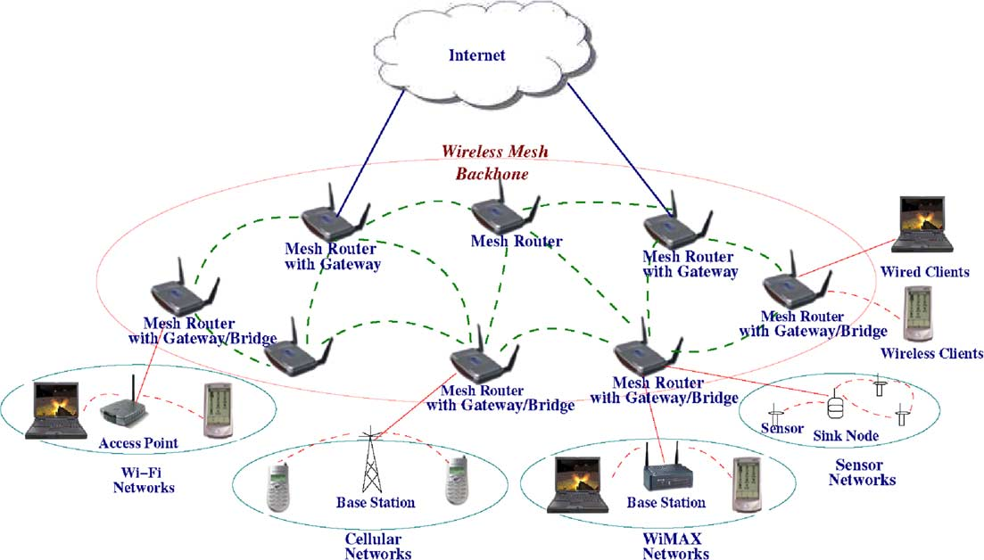

**Figure 2.1: A Typical Infrastructure Based Wireless Mesh Network (WMN)**

All of the MNs individually create Basic Service Sets (BSS) or hotspots and collectively create an Extended Service Set (ESS) or network coverage area. Usually, there will be a degree of overlap between the hotspots of different MNs. Mobile users roaming within the network coverage area will have to undergo handoff from one MN to another in order to preserve their network connectivity. The reason why user wants to use WMN compare to telecom network (i.e. EDGE, 3G, upcoming 4G) for VoIP calls is because 802.11 based WMN is cheaper to use and in most of the case is free of charge.

## 2.3 Applications

WMN is the first to introduce the concept of a peer-to-peer mesh topology with wireless communication between mesh routers. Many of today’s deployment challenges have been greatly helped by this concept such as the installation of extensive Ethernet cabling and enable new deployment models. Some key application scenarios for wireless mesh networks are given below:

• WMNs can replace current 802.11 WLANs as the efficient choice for home networking

• Using WMNs in Campus environments (enterprises and universities), manufacturing, shopping centers, airports, sporting venues, etc will not only provide increased capacity but also robustness when a link fails and it will also provide network congestion.

• Wireless mesh networks can be installed quickly in the Military operations, disaster scenarios where the links of the normal communication are down.

• Mesh routers in different homes can be inter-connected thus it provides a community network with efficient applications like distributed file sharing and video streaming.

• Carrier-managed service in public areas or residential communities.

•These days U.S. military forces are using wireless mesh networking to connect their computers, mainly ruggedized laptops in field operations.

• Mesh routers can be placed anywhere such as on the rooftop of a home or on a lamppost to provide connectivity to mobile/static clients. Mesh routers can be added incrementally to improve the coverage area.

## 2.4802.11 Wireless Local Area Network Standards Overview

## The IEEE Standard 802.11 was introduced in 1997 and has been regularly amended since then [12]. The IEEE 802.11 standard provides for a standards-based WLAN networking technology. The Wi-Fi Alliance [13] provided for inter-operability certification for WLAN equipment for different vendors based upon this standard. Three fundamental network building blocks are defined:

## • Basic Service Set (BSS): Based upon the Infrastructure mode

## • Independent Basic Service Set (IBSS): Based upon the Ad-Hoc mode

## • Extended Service Set (ESS): Based upon the Infrastructure mode

There are two basic operation modes defined in the standard: Infrastructure mode and Ad Hoc mode.

• Infrastructure mode: In the infrastructure mode, the wireless network consists of at least one AP connected to the wired network infrastructure and a set of wireless end stations (STAs). All network communication takes place via the AP. The AP controls encryption on the network and may bridge or route the wireless traffic to a wired ethernet network (i.e. the Internet). APs that act as routers can also assign an IP address to a mobile device using DHCP services. APs can be compared to a base station used in cellular networks.

• Ad-Hoc Mode: The Ad-Hoc mode is a set of IEEE 802.11 STAs that communicatedirectly with each other without requiring the use of an AP. These networks are usuallyself-contained and do not have a connection to a wired network.When using IEEE 802.11 radios to establish a WMN, generally two wireless interfaces(virtually or physically) are used in each MN. One interface works in ad-hoc mode toestablish the WMN among all MNs and another interface works in infrastructure mode (i.e.it operates essentially as an AP) to provide a wireless connection to the end user. The IEEE 802.11 standard defines two network layers: Physical (PHY) and Medium Access Control (MAC) to provide for wireless connectivity for the STAs in a WLAN.

## 2.4.1 PHY Layer

## The IEEE 802.11 WLAN system uses spread-spectrum wireless technology which is a wideband radio frequency technique. This technology is the foundation for wireless communications in the Industrial, Scientific & Medical (ISM) bands at 2.4 GHz and 5 GHz. Traditional radio communications focus on occupying as narrow a frequency band as possible. Spread spectrum works by using mathematical functions to diffuse the signal power over a large range of frequencies. The receiver performs the inverse operation whereby the smeared out signal is reconstituted as a narrow band signal. This makes the data much less susceptible to electrical noise than conventional radio modulation techniques. Spread-spectrum is designed to trade off bandwidth efficiency for immunity to interference, integrity, and security.

## 2.4.2 MAC Layer

The IEEE 802.11 standard specifies a common medium access control (MAC) Layer,which provides a variety of functions that support the operation of 802.11 based wirelessLANs. The most important function of the MAC Layer is to manage and maintaincommunications between IEEE 802.11 stations (Network Interface Cards (NIC) and AccessPoints (AP)) by coordinating access to a shared radio channel and utilizing protocols thatenhance communications over a wireless medium. The IEEE 802.11 standard defines twoforms of medium access, Distributed Coordination Function (DCF) and Point CoordinationFunction (PCF) [12].The MAC address is a 48-bit unique identifier assigned to all NICs by the manufacturerfor identification and is used in the media access control protocol sublayer. The MACaddress is usually represented in hexadecimal format. For example, when all 48 bits are setto binary 1, it represents the broadcast MAC address which is FF:FF:FF:FF:FF:FF inhexadecimal format [12].Some other functionalities (e.g. scanning, authentication, association) are also providedfor in the MAC layer.

## 2.4.3 MAC Management Frames in Handoff Process

## 2.4.3.1 Beacon Frame

The beacon frame [12] is one of the more important IEEE 802.11 WLAN managementframes. Beacon frames are broadcasted periodically by the AP/MN in an infrastructure BSSto announce the presence of a WLAN. In IBSS networks, the transmission of beaconframes is distributed among the STAs.The beacon interval indicates the time interval between beacon transmissions. Thebeacon interval is expressed in TU (Time Unit) [12] which is defined as a measurement ofTimeequal to 1024μs in the IEEE 802.11 standard. It is a configurable parameter in theAP/MN and by default is configured as 100 TU (100 ms).

## 2.4.3.2 Probe Request Frame

A probe request frame [12]is sent from a STA when it requires information fromanother STA.

## 2.4.3.3 Probe Response Frame

A probe response frame [12] is sent by an AP after receiving a probe request frame andit contains capability information, supported data rates etc. The probe response framecontains the same information as the beacon frame, expect there is no TIM field in theprobe.

## 2.4.3.4 Authentication Frame

The authentication frame [12] is a management frame sent from a STA to the AP/MNthat it wishes to authenticate with. The authentication process consists of the transmissionsof two or four authentication frames which depends on the type of the authentication beingimplemented, i.e. open system or shared key respectively.

## 2.4.3.5 Association Request Frame

The association request frame [12] is sent after a successful authentication from theSTA to the AP/MN. The listen interval field is used to indicate to the AP/MN how often a STA awakes tolisten to beacon frames.

## 2.4.3.6 Reassociation Request Frame

The reassociation request frame [12] is similar to the association request frame, exceptthat the reassociation request frame is trying to maintain an old connection or transfer theold connection with an old AP/MN to the new AP/MN. Therefore there is one more field inthe reassociation request frame body than in the association request frame body.

## 2.4.3.7 Association/Reassociation Response Frame

The Association/Reassociation response frame [12] is sent from the AP/MN to the STAafter successfully receiving an association request frame. The Listen Interval field in theassociation request frame is used to indicate to the AP/MN how often an STA awakes tolisten to beacon frames. Association ID is assigned to STA by AP/MN after successfulauthentication.

## 2.4.3.8 Deauthentication Frame

The deauthentication frame [12] is sent to terminate a secure communication. Usually itis sent from an AP/MN to a STA after unsuccessful authentication between the AP/MN andSTA. The deauthentication frame body contains just one field called the reason code whichindicates the reason for the unsuccessful authentication.

* 1. **2.4.3.9Disassociation Frame**

The disassociation frame [12] is sent from either a STA or AP/MN to terminate thecurrent connection between the STA and AP/MN. An AP/MN sends a disassociation frame to a STA when it shuts down or reboots. A STA sends the disassociation frame to AP/MNbefore the STA is powered off. The AP/MN can then relinquish memory allocations andremove the STA from the association table. The disassociation frame body is same as thedeauthentication frame body and contains a reason code field.

## 2.5 Handoff in 802.11 WMN

A handoff occurs in an IEEE 802.11WMN [14] when a mobile STA moves beyond the radio range of one MN and enters another coverage area at the MAC layer (e.g. where a STA moves from one BSS to another BSS or where both BSS are belonging to same ESS.) or when a mobile STA finds another AP/MN having a stronger beacon signal than the current one. During the handoff, management frames are exchanged between the STA and the MN. Consequently, there is a latency involved in the handoff process during which the STA is unable to send or receive traffic. The original design of the IEEE 802.11 standards just considered the handoff signaling where the handoff procedure can be divided into three phases: discovery, authentication and association/reassociation [12].

## 2.5.1Discovery

Discovery is the process used to allow the STA identify the available MNs within the RF coverage range. Two methods are defined in the IEEE 802.11 standard, namely passive scanning and active scanning. In passive scanning, the STAs do not transmit any frames on the medium and instead wait and listen to each available channel for beacon frames which are broadcasted periodically by the MNs. Usually, the beacon frame transmission period is configured at 100 ms, which makes the timescale of MN discovery on the scale of a second since there are 11 available channels in United States and 13 available channels in Europe [15], and a STA must scan each channel in turn. In active scanning, in order to determine whether a MN is operating on a particular channel, a STA periodically broadcasts probe request frames on a particular channel. When an AP receives a probe request, it replies with a probe response frame. As with passive Scanning, the STA must scan all available channels in turn. The time required (or latency) to scan one channel depends on two parameters: MinChannelTime and MaxChannelTime. Both of these are measured in steps of a TU which corresponds to a time interval of 1024 microseconds. They control the duration of scanning in each channel. MinChannelTime defines the minimum time required to scan one channel to guarantee the reception of a Probe Response frame. If a STA waits during MinChannelTime without receiving any Probe Response after broadcasting a Probe Request, it assumes that there is no AP available in this channel. On the other hand, MaxChannelTime represents the time required to guarantee the reception of the Probe Response frames from multiple APs available in the same channel. If a STA receives a Probe Response during MinChannelTime after broadcasting Probe Request, it must extend its waiting time to MaxChannelTime in case more Probe Responses might arrive in the same channel. The IEEE standard does not specify their values, however typical values are suggested from previous empirical studies [16-17] as shown below:

MinChannelTime = DIFS + (aCWmin× aSlotTime)

Where aCWmin is the maximum number of slots in minimum contention window, and aSlotTime is the length of a slot. DIFS = 50μsec, aCWmin = 31μs and aSlotTime which is defined in the standard to be 20μsec in 802.11 b/g and 9μs in 802.11a. According to the analysis carried out in [16], it suggests an ideal value of this parameter lies between 1 ms [16] and 7 ms [17].

MaxChannelTime is suggested to be set to approximately 11 ms [16-17]. Another issue in the discovery phase is the channel switching delay. This overhead is a characteristic of the network interface design and reflects the time required to switch to a new frequency, resynchronize and start demodulating packets. Channel switching delay varies considerably across implementations from a maximum of 19 ms (12 ms to switch and 7 ms to resynchronize) for Intersil Prism2-based NICs to just over 5 ms for Atheros 5212-based NICs according to previous study [4]. Since this cost is per channel it adds considerable delay to the overall scanning process.

## 2.5.2 Authentication

Authentication is the phase used to verify the identities involved between a MN and aSTA and to bring the wireless link up to the assumed physical standards of a wired link.The IEEE 802.11 standard defines two authentication algorithms: open system and sharedkey authentication.Open system authentication is the default authentication algorithm and any STA thatrequests authentication with this algorithm may become authenticated if the MN uses opensystem authentication. Open system authentication involves two step authenticationtransaction. The first step is the identity assertion and request for authentication and thesecond step is the authentication result. If the result is successful, the STA is mutuallyauthenticated with MN. The minimum time required for authentication is two RTTs (RoundTrip Times) for open system authentication. RTT is the time corresponding to thetransmission time of a probe request frame and an ACK response frame between two nodes[18]. Four timestamps are required to calculate the RTT using Equation (2.1), due to thepacket process delays.

RTT = (T21-T11) + (T12-T22)

This study assumes that T11 is the timestamp of the probe request frame that istransmitted from Node A, T21 is the time that the request frame from Node A is received byNode B, T22 and T21 are similar to T11 and T21. RTT depends on anumber of factors that includes the network load, interference and contention.Shared key authentication is the same as open system authentication which allows anySTAs to establish a link connection, but only a STA who knows the shared secret key canreceive encrypted data. Shared key authentication involves a four step authenticationtransaction. The first step is identity assertion and request for authentication and the secondstep is a challenge text sent back to the STA, the third step requires the STA to sendencrypted challenge text back to the MN, and the final step is the authentication result. Ifthe encrypted challenge text is correct, the STA is mutually authenticated with MN. Theminimum time required for shared key authentication is four RTTs.

## 2.5.3 Association/Reassociation

Association is the process that follows after a successful authentication where the STA is assigned a proper association identity and the required resources by the new MN. Reassociation is a service that is invoked to move a current association from one MN to another. The minimum time required for both association and reassociation is four RTTs. Association/Reassociation represents the end of the handoff process in MAC layer.

## 2.5.4 Handoff Procedure and Delay

## Figure 2.6 and Figure 2.7 [19-20] illustrate the basic handoff procedures for bothpassive scanning and active scanning respectively. The two procedures show the relevantdelay associated with each step in the handoff procedure. The overall delay is thesummation of scanning delay, authentication delay and association/reassociation delay.

## 2.6 Previous Work

There has been a considerable amount of work carried out on wireless peer based networking. One of the first commercial mesh networks was Metricom’s Ricochet network [21] in the mid-90s. Ricochet nodes automatically route client traffic through half-duplex wireless hops until reaching a cable connection. When the IEEE 802.11 standard was ratified in the late-90s, other mesh networks started to emerge. One of these is the MIT Roofnet [22-23] project where tens of MNs with roof mounted antennas formed a mesh around campus. Roofnet’s emphasis is more on route maintainability and optimization than on handing off a client’s connection. Many other community and commercial mesh network implementations also exist, such as Rice University TAPS in Houston [24] and Urbana-Champaign Community Wireless Project [25]. Microsoft Research has also done notable work in the area of mesh networks. Their Mesh Connectivity Layer (MCL) [26] creates a wireless mesh network between Windows clients. Their approach focuses on efficient routing protocols along with the unique supported for multiple radios on each node. Adya, Bahl, Wolman, and Zhou have shown [27] that using multiple radios on a mesh node combined with smart routing algorithms [28] will dramatically improve the throughput of a wireless mesh network. Their work necessitates a specific network driver on all mesh network participants, including the clients.Existing experimental wireless mesh testbeds that support client mobility includeMeshCluster [29] and iMesh [30], both of which work with mobile clients in theinfrastructure mode. MeshCluster, which uses MIP for MAC layer handoff, shows a latencyof about 700 ms due to the delay incurred during access point re-association and MIPregistration. iMesh also offers MAC layer handoff using regular route updates or Mobile IP.Using layer-2 handoff triggers (no moving client), handoff latency in iMesh takes 50-100ms. The approach was later used in a more realistic environment for improving VoIPperformance in mesh networks, with similar results [31].

## 2.7 Link Layer Handoff

When a station moves out of range of an AP, it triggersa link layer handoff to search for and reassociate witha new AP. The exact condition that triggers a handoffis implementation specific. For example, a client caninitiate a handoff when it fails to communicate withthe AP it is currently associated with. Or, the handoffinitiation can be more proactive. For example, the clientcan continuously do signal strength measurements forthe beacon messages from APs that it is hearing on thecurrent channel. If the signal strength of the AP it iscurrently associated with falls below a threshold and thesignal strength from another AP is sufficiently higher,the client may trigger a handoff to the second AP. Thesecond condition avoids ping-ponging between two Apsdue to slight fluctuation of signal strengths.Handoff is often associated with probing. Probingproactively seeks APs to associate with instead of waitingto hear beacon signals. This is because beaconintervals can often be too high (e.g., more than 100ms). Also, there may not be any AP to associate to inthe current channel. In probing, the client broadcasts aprobe request frame. APs on the same channel respondwith probe response frames. The client waits for certainamount of time (probe-wait time) to collect all the proberesponses. Then, the client can switch to other channelsto probe. After probing a set of channels (possibly allavailable channels), the client selects one AP with thebest SINR (signal-to-noise ratio) based on the proberesponses.After probing is complete, the station authenticateswith the new AP. Following successful authentication,the station initiates reassociation with the new AP toexchange information about the connection such as transmissionrates, beacon intervals, etc. It sends a reassociationrequest frame to the AP that responds with areassociation response frame. At this point, the linklayerhandoff completes.

## 2.8 Proposed Handoff Scheme

Several research studies have investigated link layerhandoff latency in 802.11-based wireless LAN. Our work hasbenefited a lot from these experiences. It turns out thatthe major factor in the handoff delay is the time spentin probing and waiting for probe responses. Since proberesponses may come back at different times (as they gothrough backoffs in the MAC layer to avoid collisions)too small a *probe-wait time* may miss important proberesponses. So we propose an efficient handoff scheme where the AP broadcasts the beacon in the beginning. After that the station nodes send probe request and wait for the probe response. Finally if the association response is received from the AP handoff is completed.

## 2.9 Chapter Summary

This chapter has discussed what handoff is and why fast handoff is important to WMNsand also outlines some fundamental aspects of the operation of IEEE 802.11 WLANs andWMNs. A detailed description of the handoff procedure in IEEE 802.11 standards wasgiven that included the handoff related management frames and scan techniques. Thechapter ended with discussion of related works and how they compare with our proposedhandoff solution. The following chapters will further outline the technicaldetails of the proposed scheme and its implementation, as well as an analysis of itsperformance along with the comparing with the existing system.

# : Methodology

## 3.1 Existing Handoff Procedures in WMNs

Usually during the scanning phase of the handoff active scanning is used. In this system, the phase starts with probe request from the station nodes. Then it waits for the probe response. Then authentication request is sent and then wait for the authentication response. Finally association request is sent and then again wait for the association response. If association response is received from the new AP handoff is finished.

This is shown in the figure [] below:

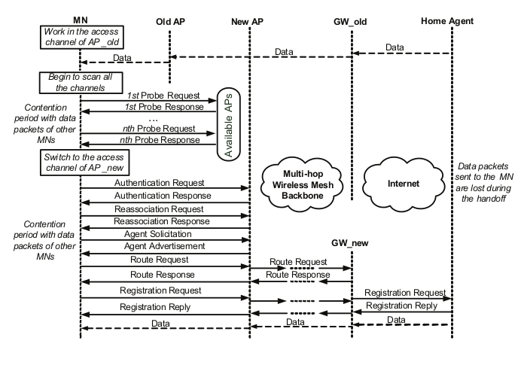

Figure: Existing Handoff procedure in WMNs

## 3.1.2 Passive Handoff

This is another handoff procedure where the station nodes wait for the beacon frame from the APs. After that they measure the signal strength. Then the station sends authentication request to the AP with most signal power. This is shown in figure below:

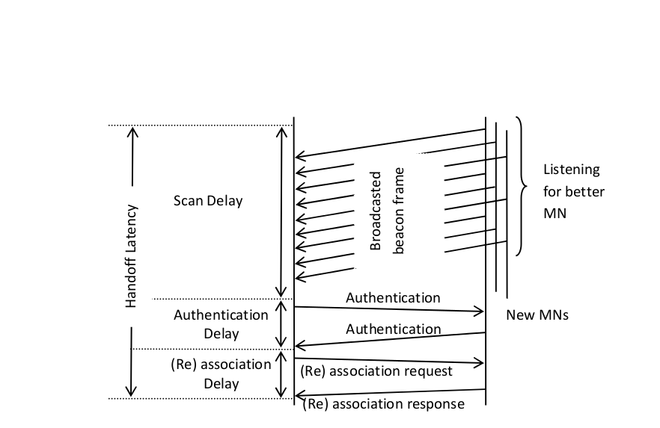

Figure: Passive scanning in WMNs

## 3.1.3 Active Handoff

This is widely used as the handoff procedure. In this method the station nodes continuously send probe request to the APs. Then it waits for the probe response. Then in the execution phase authentication and association is done and handoff is finished.

The active handoff procedure is shown in figure below:

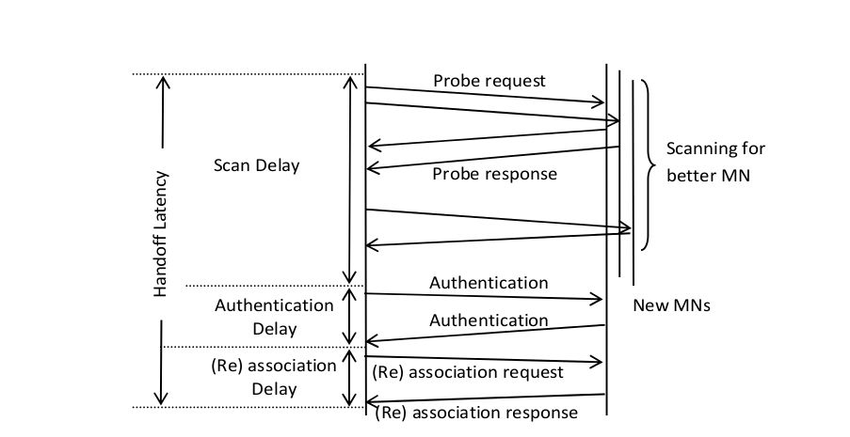

Figure: Active scanning in WMNs

## 3.2 Proposed Methodology

In the proposed system the handoff is started when the client node fails to send 3 consecutive packets to the server node which is another station node. Then the APs with more number of mobile station nodes will send beacon frame. Then the client node will send the probe request and wait for the probe response from the new AP. If the AP sends the probe response then it sends the authentication request to the AP and wait for the response again. Then if the new AP sends the authentication response the client node sends the association request to the new AP and then waits again. If the client receives the association response from the new AP the handoff is finished. On the other hand, if the AP does not have any mobile node during the configuration of the network or have less number of mobile nodes in comparison to the static nodes, active scanning procedure is followed during the scanning phase.

The methodology is shown in the figure below:

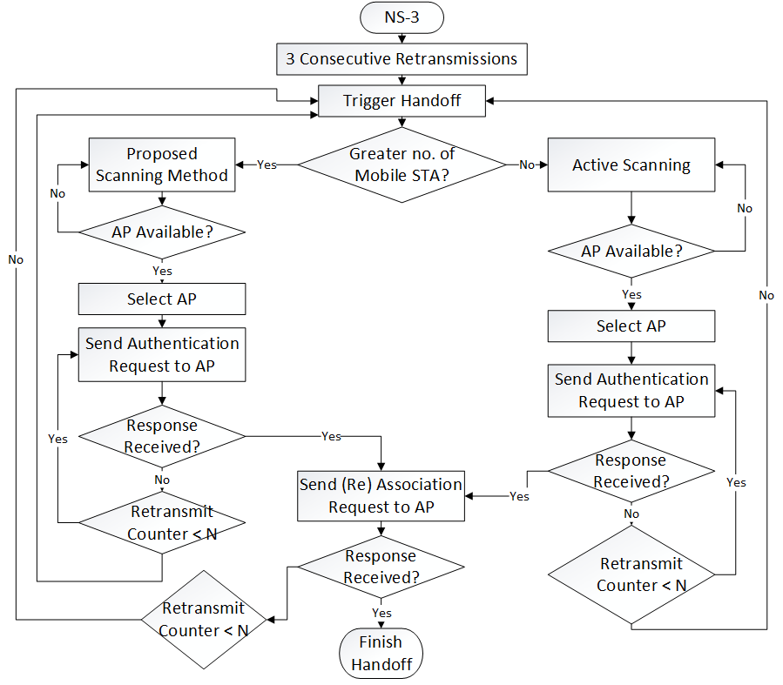

Figure: Methodology of the proposed system

Access Point

Station Node

Association Delay Latency

Handoff Latency

Beacon Frame

ScanDelay

Probe Response

Probe Request

Authentication Request

Authentication

Delay

Authentication Response

Association Request

Association Response

Fig: Scanning procedure in the proposed system

# : Implementation

## 4.1 Implementation Tools

The necessary tools to implement this system can be divided in to two categories-Hardware &

Software as illustrated below:

* **Hardware Requirements**
* Personal Computer with basic configuration
* **Software Tools**
* Operating System:Ubuntu 14.04 LTS
* Network Simulator 3 version 3.21
* NetAnim
* PyViz
* Wireshark
* Flowmonitor
* GNU Plot

## 4.2 Implementation Details

As discussed in the previous chapter, a client-side handoff scheme have been developed to provide for fast handoff. It is implemented in NS-3 in order to analyze its performance through experiments. The basis of the scheme is to decrease the total handoff duration by reducing the latency of the discovery phase. The modifications were made on NS-3 in the MAC layer where the discovery process is defined and implemented.

## 4.3Simulation Parameters

Number of Nodes: 10

Simulation Time: 100s

Mobility Model: Constant Position Mobility Model

Routing Protocol: Olsr Routing Protocol

Size of packets in UDP ping: 1024 bytes

Data Rate of Point to Point links: 100Mbps

Data Rate of CSMA connection: 100Mbps

The interval between two consecutive probe request attempts: 0.05s

The interval between two consecutive assoc. request attempts: 0.5s

Max Missed Beacons: 10

Beacon Interval: 102400 microseconds

## 4.4Simulation Visualization

For the analysis and evaluation ns-3 (network simulator 3) [] is used. For the visualization NetAnim [] and PyViz [] is used. Wireshark [] is used to analyze the signaling packet and data packets.

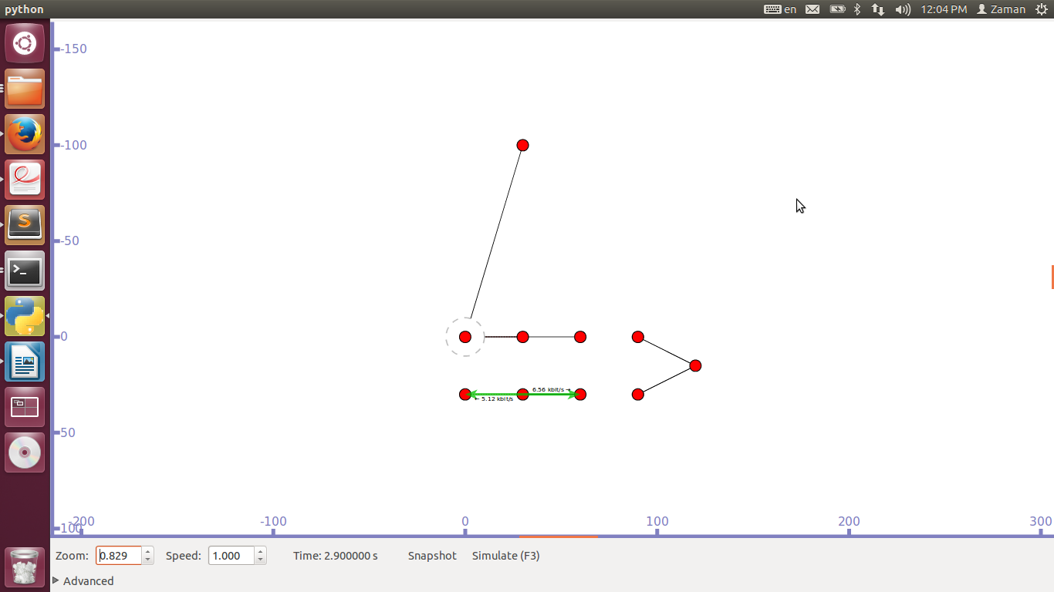

Figure: Probing in the network 2

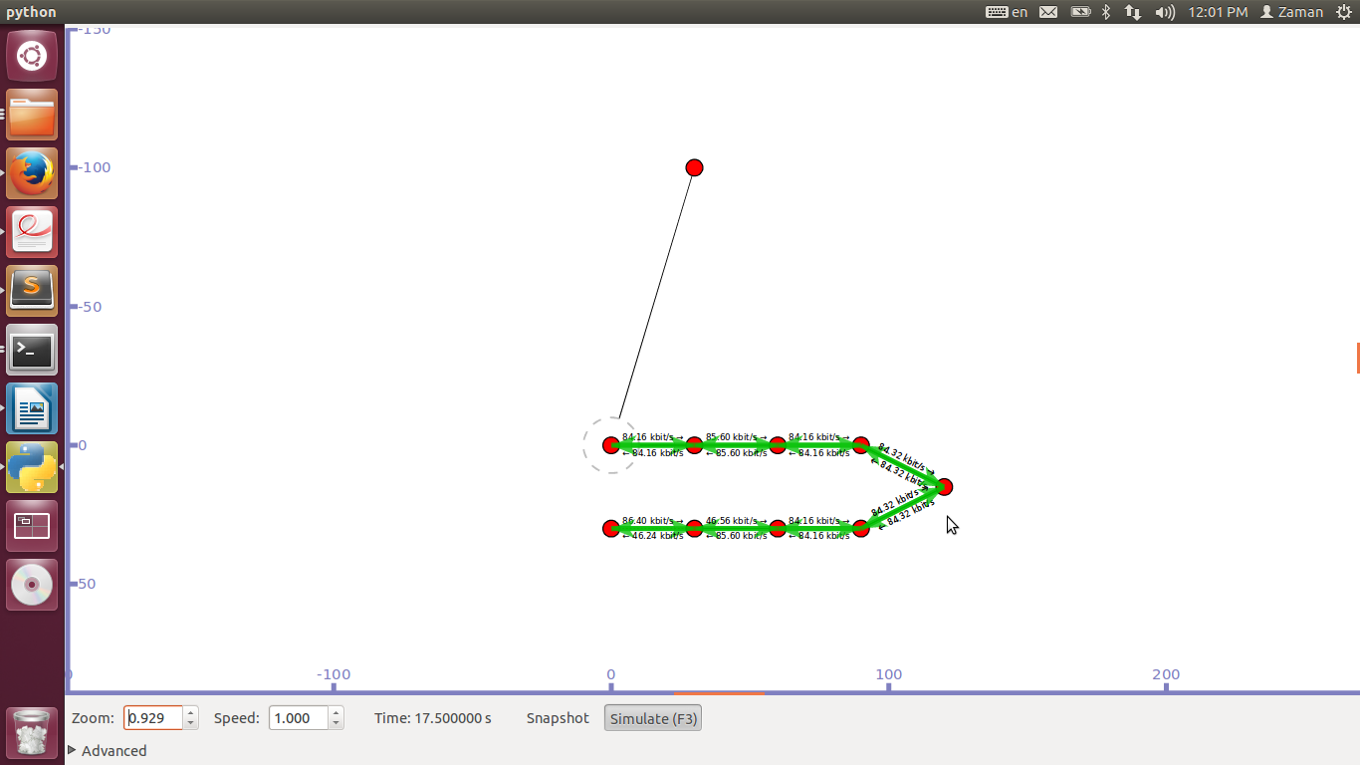

Figure: Transmission of packets

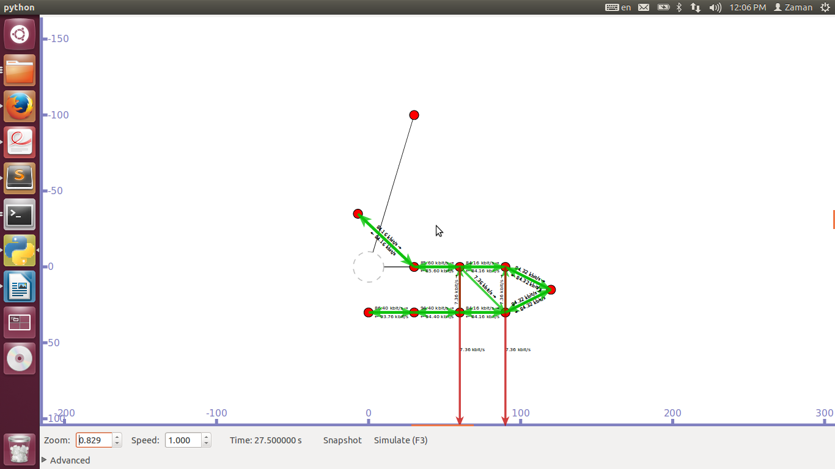

Figure: Mobility of station node

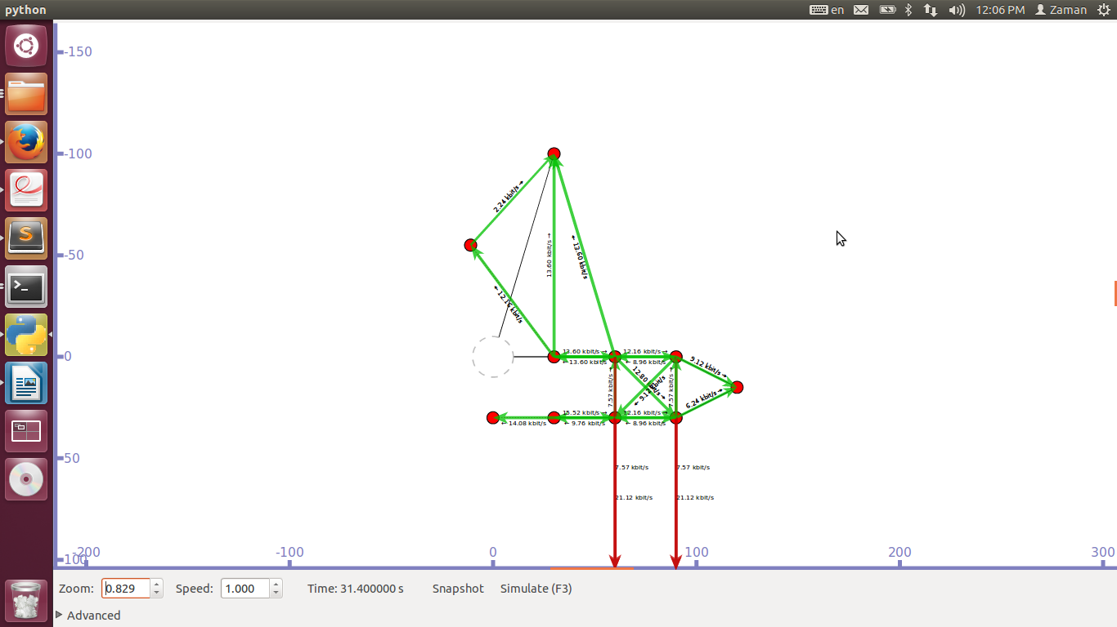

Figure: Initiating Handoff

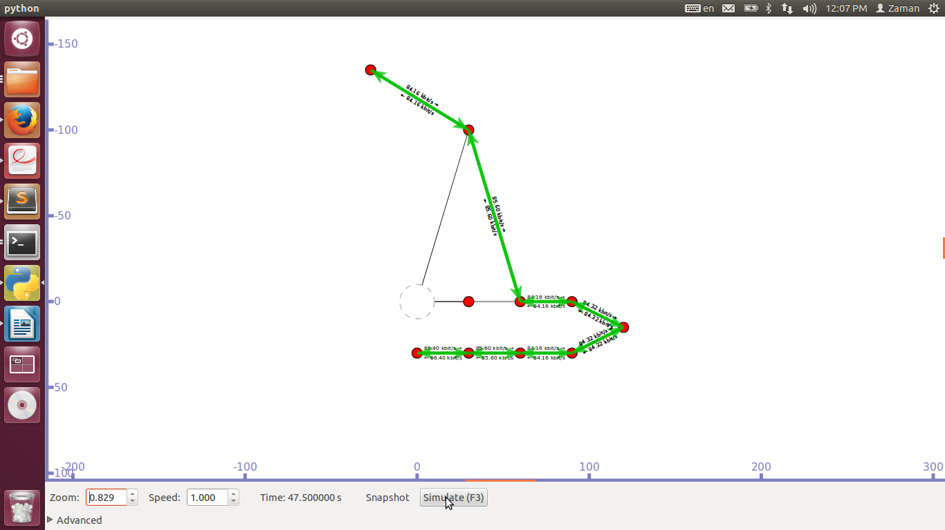

Figure: Selection of new AP

## 4.5 Chapter Summary

In this chapter, the details of the implementation of the scheme is given in NS-3. The objective of is to verify the feasibility of the proposed technique and to compare its performance with the traditional scanning techniques (passive scanning and active scanning separately) defined in the IEEE 802.11 standard.The next chapter will present the results generated from the computer simulations and experiments.

# : Simulation Results and Analysis

In this section the simulation results are presented in detail and an explanation is provided.

## 5.1 Parameters for Evaluating Simulation Model

The following parameters are needed for evaluating our simulation based

**Average throughput**: Number of bits received divided by the difference between the arrival time of the first packet and the last one.

Throughput=(total no.of bytes received *8)/(simulation time)/1024/1024 Mbps.

**Average Packet Delivery Fraction (PDF):** Number of packets received divided by the number of packets transmitted.

**Average end-to-end delay:** the sum of the delay of all received packets divided by the number of received packets.

## 5.2 Comparison with Existing System

## 5.4.1Flow vs Throughput

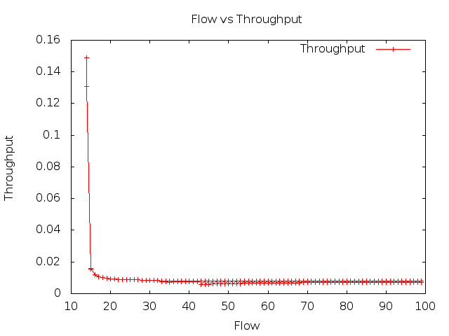

Figure: Proposed Handoff Method

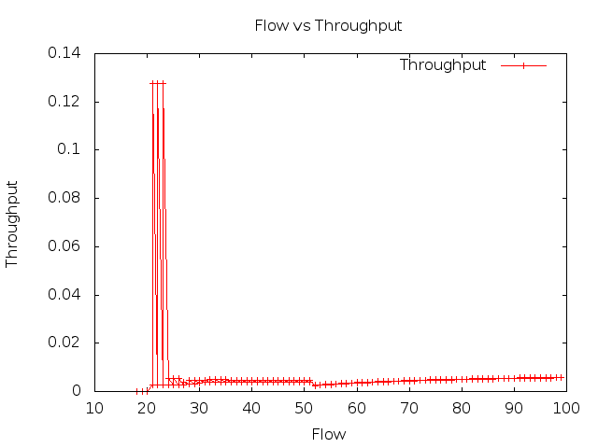

Figure: Active Handoff

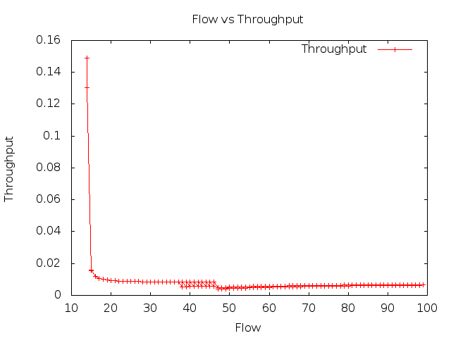

Figure: Passive Handoff

## 5.4.2 Packet delivery fraction PDF

## 5.4.3 Average Throughput

## 5.4.4 Average End to end Delay

## 

## 

## 5.3.2 Overall performance analysis

|  |  |  |  |  |  |
| --- | --- | --- | --- | --- | --- |
| Simulation Time | Parameters | Active Handoff | Passive Handoff | Proposed Handoff Method | Best performing Method |
| 20 | Packet Delivery Fraction (PDF) | 0 | 1 | 1 | Proposed and Passive Scanning |
| Throughput (Kbps) | 0 | 1 | 1 | Proposed and Passive Scanning |
| End to End Delay |  |  |  |  |
| 40 | Packet Delivery Fraction | .62 | .86 | .79 | Passive Scanning |
| Throughput (Kbps) | 4.51 | 7.19 | 7.84 | Proposed Method |
| End to End Delay |  |  |  |  |
| 60 | PDF | .76 | .92 | .95 | Proposed Method |
| Throughput (Kbps) | 3.54 | 5.47 | 7.39 | Proposed Method |
| End to End Delay |  |  |  |  |
| 80 | PDF | .87 | .95 | .96 | Proposed Method |
| Throughput (Kbps) | 5.11 | 6.32 | 7.64 | Proposed Method |
| End to End Delay |  |  |  |  |
| 100 | PDF | .91 | .96 | .97 | Proposed Method |
| Throughput (Kbps) | 5.89 | 6.76 | 7.78 | Proposed Method |
| End to End Delay |  |  |  |  |

## 

## 5.3.2.1.2 Result

## 5.4 Discussion

The objective for the simulation work was to verify the feasibility of the scheme and to compare its latency with the current standard. From the results presented above, the conclusion can be made that this scheme shows the better performance in finding the next AP for STA to associate with when handoff is required, compared to other scan techniques.

# : Conclusion and Future Works

This chapter contains an overview of the system and its limitations with future recommendations.

## 6.1 Findings of the Work

In this thesis, a practical fast handoff management scheme have been developed, to manage when handoff should be performed and which AP the client should associate with. Theoretically, this scheme can reduce the latency associated with handoff. This scheme reduces the channel scanning latency. This scheme is fully compatible with all the IEEE 802.11 standards. This scheme addresses when and where a STA will handoff to under the discovery phase. A set of simulation studies were conducted in order to investigate the performance of the scheme in an IEEE 802.11. In the computer simulations, NS-3 was used to implement the theoretical procedures of the scheme and to simulate the scheme under different network scenarios in order to verify the feasibility of the scheme.

Over the course of simulation, the effectiveness of our scheme was demonstrated by comparing it to the IEEE 802.11 standard handoff latency and other fast handoff schemes. The following main observations were made:

• Both passive scanning and active scanning can be used together for implementing the fast handoff scheme in WMNs

• This scheme can reduce the handoff delay significantly

## 6.2 Future Works

In this work a client side fast handoff scheme for WMNs has been developed and analyzed. Although this scheme has been shown to improve handoff latency in WMN, further analysis of the scheme under different network conditions could be performed. There are some limitations that should be pointed out concerning the experimental setup. All the MNs and client STA were operating in a fixed channel, under the 802.11 mode in order to realise a clean wireless medium for our experiments. Consequently, no channel switching was required during the handoff process. Further research may examine in a multi-channel (non-overlapped and overlapped) mesh testbed. In addition, the client STA need to be examined when it moves at different speeds and in different environment scenarios. Further research may also include determining the overall performance improvement when the model is combined with the recent IEEE 802.11r standard. From the technical point of view, the scheme does not concern itself with QoS in the handoff process which means that although the scheme allows a STA to quickly handoff from one MN to another, it does not guarantee the link quality. (i.e. throughput, link rate and available bandwidth etc.). Another important consideration for this scheme is that it does not relies on a list of MNs. This means the STA does not need to learn or be given the list in order that the scheme can function immediately when the STA joins new WMNs.

In conclusion, an efficient and powerful client-side technique have been developed. This technique addresses the core problem of when handoff should occur and which AP to handoff to in MAC layer. The feasibility of has been demonstrated through computer simulations. The results show that it has ability to reduce the standard latency.

### Bibliography

1. T. Hung, B. Thao and N. Binh, “*Handover in Wireless Mesh Network,”*Journal of Communication and Computer,Volume 7, No.8 (Serial No.69), August 2010.
2. Ye, Y., et al.,“*A Dual Re-Authentication Scheme for Fast Handoff in IEEE 802.11 Wireless Mesh Networks,”*in Wireless Communications and Networking Conference*, 2009. WCNC 2009.*
3. Mustafa, N., et al., “*Pre-scanning and dynamic caching for fast handoff at MAC layer in IEEE 802.11 wireless LANs*,” in Mobile Adhoc and Sensor Systems Conference, 2005. IEEE International Conference on. 2005. Washington DC, USA.
4. Ramani, I. and S. Savage, “*SyncScan: practical fast handoff for 802.11infrastructure networks*,” in INFOCOM 2005, 24th Annual Joint Conference of the IEEE Computer and Communications Societies. Proceedings IEEE. 2005. Miami, FL, USA.
5. I. F. Akyildiz, X.W., and W. Wang, *“Wireless mesh networks: a survey,”*Computer Networks (Elsevier), vol. 47, no. 4, 2005.
6. Wei, L., Z. Qing-An, and D.P. Agrawal, “*A reliable active scanning scheme for the IEEE 802.11 MAC layer handoff*,” in *Radio and Wireless Conference, 2003.*
7. Rivera, N., “*Seamless connectivity and mobility in wireless mesh networks*. 2009,”Johns Hopkins University. p. 90.
8. In-Stat. “*VoIP Penetration Forecast to Reach 79% of US Businesses by 2013*,”

Available from: http://www.in-stat.com/index.html

1. Kelly, E.B. *Quality of Service In Internet Protocol (IP) Networks*. 2002; Available from: http://www.wainhouse.com/files/papers/wr-qos-in-ip-networks.pdf. (Last checked on 28th April 2010)
2. *IEEE Standard for Information Technology- Telecommunications and Information Exchange Between Systems- Local and Metropolitan Area Networks- Specific Requirements- Part 11: Wireless LAN Medium Access Control (MAC) and Physical Layer (PHY) Specifications.* ANSI/IEEE Std 802.11, 1999 Edition (R2003), 2003: p.i-513.
3. I. F. Akyildiz, X.W., and W. Wang, Wireless mesh networks: a survey. Computer Networks, 2005. 47(4): p. 445-487.
4. *“IEEE Standard for Information Technology- Telecommunications and Information Exchange Between Systems-Local and Metropolitan Area Networks-Specific Requirements-Part 11: Wireless LAN Medium Access Control (MAC) and Physical Layer (PHY) Specifications,”*IEEE Std 802.11-1997, 1997: p. i-445.
5. *Wi-Fi Alliance*, Available from: http://www.wi-fi.org/.
6. Pathak, A., A. Mangalam Srivatsa, and X. Jiang. An Analytical Model for Handoff Overhead Analysis in Internet-Based Infrastructure Wireless Mesh Networks. In Communications, 2008. ICC '08. IEEE International Conference on. 2008. Beijing, China.
7. *IEEE Standard for Information Technology- Telecommunications and Information Exchange Between Systems- Local and Metropolitan Area Networks- Specific Requirements- Part 11: Wireless LAN Medium Access Control (MAC) and Physical Layer (PHY) Specifications.* ANSI/IEEE Std 802.11, 1999 Edition (R2003), 2003: p.i-513.
8. Velayos, H. and G. Karlsson,“*Techniques to reduce the IEEE 802.11b handoff time*,” in *Communications, 2004 IEEE International Conference on*. 2004. Paris, France.
9. Mishra, A., M. Shin and W. Arbaugh, “*An empirical analysis of the IEEE 802.11MAC layer handoff process,”* SIGCOMM Comput. Commun. Rev., 2003. **33**(2): p.93-102.
10. Xinrui. Wang, T.-F.L., Lei. Chen, “*Synchronization and Time Resolution Improvement for 802.11 WLAN OWPT Measurement,”* in Proceedings of the International MultiConference of Engineers and Computer Scientists 2009.
11. Gurpal Singh, A.P.S.A.a.B.S.S., “*Mobility Management Technique for Real Time Traffic in 802.11 Networks,”*Journal of Computer Science 2007. **3**(6): p. 390-398.
12. Shin, S., et al., *Reducing MAC layer handoff latency in IEEE 802.11 wireless LANs*, in *Proceedings of the second international workshop on Mobility management \&amp; wireless access protocols*. 2004, ACM: Philadelphia, PA, USA. p. 19-26.
13. Tang, D. and M. Baker, *Analysis of a metropolitan-area wireless network.* Wireless Networks, 2002. **8**(2/3): p. 107-120.
14. Chambers, B.,“*The grid roofnet: a rooftop ad hocwireless network*. 2002,” Available from: http://pdos.csail.mit.edu/papers/grid:bac-meng.pdf. (Last checked on 28th October 2014)
15. Bicket, J., et al., “*Architecture and evaluation of an unplanned 802.11b mesh network*, in *Proceedings of the 11th annual international conference on Mobile computing and networking*,” ACM: Cologne, Germany. p. 31-42, 2005.
16. Camp, J.D., E.W. Knightly, and W.S. Reed, *Developing and deploying multihop wireless networks for low-income communities.* Journal of Urban Technology, 2006. **13**(3): p. 129-137.
17. *The Champaign-Urbana community wireless network*. Available from: http://www.cuwin.net. (Last checked on 28th October 2014).
18. *Microsoft Research Networking Research Group* Available from: http://research.microsoft.com/mesh. (Last checked on 28th April 2010)
19. Adya, A., et al., *A Multi-Radio Unification Protocol for IEEE 802.11 Wireless Networks*, in *Proceedings of the First International Conference on Broadband Networks*. 2004, IEEE Computer Society. p. 344-354.
20. Draves, R., J. Padhye, and B. Zill, *Routing in multi-radio, multi-hop wireless mesh networks*, in *Proceedings of the 10th annual international conference on Mobile computing and networking*. 2004, ACM: Philadelphia, PA, USA. p. 114-128.
21. Ramachandran, K.N., et al., *On the design and implementation of infrastructure mesh networks*, in *IEEE Workshop on Wireless Mesh Networks*. 2005: Santa Clara, CA, USA.
22. Navda, V., A. Kashyap, and S.R. Das. *Design and evaluation of iMesh: an infrastructure-mode wireless mesh network*. in*World of Wireless Mobile and Multimedia Networks, 2005. WoWMoM 2005. Sixth IEEE International Symposium on a*. 2005. Taormina, Giardini Naxos.
23. Ganguly, S., et al., *Performance Optimizations for Deploying VoIP Services in Mesh Networks.* IEEE Selected Areas in Communications, 2006. **24**(11): p. 2147-2158.
24. H. Li and J. Xie,*“A low-cost channel scheduling design for multi-hop handoff delay reduction in Internet-based wireless mesh networks,”*in Proc. 2012 IEEE INFOCOM, pp. 307–315.
25. H. Li, J. Xie, and X. Wang, *"A channel splitting strategy for reducing handoff delay in Internet-based wireless mesh networks,"* IEEE Transactions on Vehicular Technology, vol. 1,no. 6, pp. 2740-2752, July 2012.
26. H. Li and J. Xie, “*GaS: A gateway scheduling-based handoff scheme in single-radio infrastructure wireless mesh networks*,” in Proceedings 2013 IEEE INFOCOM, pp. 1860-1868.
27. *Wireshark* Available from: https://www.wireshark.org/.(Last checked on 28th October 2014)
28. *Network Simulator 3*Available from: http://www.nsnam.org/.(Last checked on 28th October 2014)
29. K. Andreev and P. Boyko, “*IEEE 802.11 s Mesh Networking NS-3 Model*,” In Work-shop on ns3, 2010.
30. H. Li and J. Xie, “*A handoff solution in wireless mesh networks by implementing split channels*,” in Proc. IEEE GLOBECOM, 2010.
31. J. Xie and X. Wang, *“A survey of mobility management in hybrid wireless mesh networks,”*IEEE Network, vol. 22, no. 6, pp. 34–40, November/December 2008.
32. I. F. Akyildiz and W. Wang, “*Wireless Mesh Networks,*” John Wiley & Sons, Ltd., 2009.
33. I. F. Akyildiz, X.W., and W. Wang, *“Wireless mesh networks: a survey,”*Computer Networks (Elsevier), vol. 47, no. 4, 2005.
34. Ye, Y., et al.,“*A Dual Re-Authentication Scheme for Fast Handoff in IEEE 802.11 Wireless Mesh Networks,”*in Wireless Communications and Networking Conference*, 2009. WCNC 2009.*
35. Mustafa, N., et al., “*Pre-scanning and dynamic caching for fast handoff at MAC layer in IEEE 802.11 wireless LANs*,” in Mobile Adhoc and Sensor Systems Conference, 2005. IEEE International Conference on. 2005. Washington DC, USA.
36. Ramani, I. and S. Savage, “*SyncScan: practical fast handoff for 802.11infrastructure networks*,” in INFOCOM 2005, 24th Annual Joint Conference of the IEEE Computer and Communications Societies. Proceedings IEEE. 2005. Miami, FL, USA.
37. Akyildiz, I.F., X. Jiang, and S. Mohanty, “*A survey of mobility management in extgeneration all-IP-based wireless systems.*,” IEEE Wireless Communications, 2004.
38. Wei, L., Z. Qing-An, and D.P. Agrawal, “*A reliable active scanning scheme for the IEEE 802.11 MAC layer handoff*,” in *Radio and Wireless Conference, 2003.*
39. Rivera, N., “*Seamless connectivity and mobility in wireless mesh networks*. 2009,”Johns Hopkins University. p. 90.
40. In-Stat. “*VoIP Penetration Forecast to Reach 79% of US Businesses by 2013*,”

Available from: http://www.in-stat.com/index.html

1. Kelly, E.B. *Quality of Service In Internet Protocol (IP) Networks*. 2002; Available from: http://www.wainhouse.com/files/papers/wr-qos-in-ip-networks.pdf. (Last checked on 28th April 2010)
2. Jain, “A. *Handoff Delay for 802.11b Wireless LANs,”* 2003.
3. Prasita Pradhan, “Wireless Mesh Network. Project Report,” National Institute of science & technology, India, 2013.
4. *“IEEE Standard for Information Technology- Telecommunications and Information Exchange Between Systems-Local and Metropolitan Area Networks-Specific Requirements-Part 11: Wireless LAN Medium Access Control (MAC) and Physical Layer (PHY) Specifications,”*IEEE Std 802.11-1997, 1997: p. i-445.
5. *Wi-Fi Alliance*, Available from: http://www.wi-fi.org/.
6. Dhruv Gupta,“Managing Wireless Mesh Networks: A Measurement-based Approach,” Dept Computer Science, University of California, 2010.
7. W. Reilly, “*Believable social and emotional agents*,” PhD thesis, School of Computer Science, Carnegie Mellon University,Pittsburgh, PA, 2009.
8. *IEEE Standard for Information Technology- Telecommunications and Information Exchange Between Systems- Local and Metropolitan Area Networks- Specific Requirements- Part 11: Wireless LAN Medium Access Control (MAC) and Physical Layer (PHY) Specifications.* ANSI/IEEE Std 802.11, 1999 Edition (R2003), 2003: p.i-513.
9. Velayos, H. and G. Karlsson,“*Techniques to reduce the IEEE 802.11b handoff time*,” in *Communications, 2004 IEEE International Conference on*. 2004. Paris, France.
10. Mishra, A., M. Shin and W. Arbaugh, “*An empirical analysis of the IEEE 802.11MAC layer handoff process,”* SIGCOMM Comput. Commun. Rev., 2003. **33**(2): p.93-102.
11. Xinrui. Wang, T.-F.L., Lei. Chen, “*Synchronization and Time Resolution Improvement for 802.11 WLAN OWPT Measurement,”* in Proceedings of the International MultiConference of Engineers and Computer Scientists 2009.
12. Gurpal Singh, A.P.S.A.a.B.S.S., “*Mobility Management Technique for Real Time Traffic in 802.11 Networks,”*Journal of Computer Science 2007. **3**(6): p. 390-398.
13. Shin, S., et al., *Reducing MAC layer handoff latency in IEEE 802.11 wireless LANs*, in *Proceedings of the second international workshop on Mobility management \&amp; wireless access protocols*. 2004, ACM: Philadelphia, PA, USA. p. 19-26.
14. Tang, D. and M. Baker, *Analysis of a metropolitan-area wireless network.* Wireless Networks, 2002. **8**(2/3): p. 107-120.
15. Chambers, B.,“*The grid roofnet: a rooftop ad hocwireless network*. 2002,” Available from: http://pdos.csail.mit.edu/papers/grid:bac-meng.pdf. (Last checked on 28th October 2014)
16. Bicket, J., et al., “*Architecture and evaluation of an unplanned 802.11b mesh network*, in *Proceedings of the 11th annual international conference on Mobile computing and networking*,” ACM: Cologne, Germany. p. 31-42, 2005.
17. Camp, J.D., E.W. Knightly, and W.S. Reed, *Developing and deploying multihop wireless networks for low-income communities.* Journal of Urban Technology, 2006. **13**(3): p. 129-137.
18. *The Champaign-Urbana community wireless network*. Available from: http://www.cuwin.net. (Last checked on 28th October 2014).
19. *Microsoft Research Networking Research Group* Available from: http://research.microsoft.com/mesh. (Last checked on 28th April 2010)
20. Adya, A., et al., *A Multi-Radio Unification Protocol for IEEE 802.11 Wireless Networks*, in *Proceedings of the First International Conference on Broadband Networks*. 2004, IEEE Computer Society. p. 344-354.
21. Draves, R., J. Padhye, and B. Zill, *Routing in multi-radio, multi-hop wireless mesh networks*, in *Proceedings of the 10th annual international conference on Mobile computing and networking*. 2004, ACM: Philadelphia, PA, USA. p. 114-128.
22. Ramachandran, K.N., et al., *On the design and implementation of infrastructure mesh networks*, in *IEEE Workshop on Wireless Mesh Networks*. 2005: Santa Clara, CA, USA.
23. Navda, V., A. Kashyap, and S.R. Das. *Design and evaluation of iMesh: an infrastructure-mode wireless mesh network*. in*World of Wireless Mobile and Multimedia Networks, 2005. WoWMoM 2005. Sixth IEEE International Symposium on a*. 2005. Taormina, Giardini Naxos.
24. Ganguly, S., et al., *Performance Optimizations for Deploying VoIP Services in Mesh Networks.* IEEE Selected Areas in Communications, 2006. **24**(11): p. 2147-2158.

### Appendices

## Appendix A: Source Code

**/*Source code of Header File */**

**//-----------------------------------------Core Modules-------------------------------------//**

/*mesh.h*/

#include "ns3/applications-module.h"

#include "ns3/core-module.h"

using namespace ns3;

class MyApp : public Application

{

public:

MyApp ();

virtual ~MyApp();

void Setup (Ptr<Socket> socket, Address address, uint32_t packetSize, uint32_t nPackets, DataRate dataRate);

private:

virtual void StartApplication (void);

virtual void StopApplication (void);

void ScheduleTx (void);

void SendPacket (void);

Ptr<Socket> m_socket;

Address m_peer;

uint32_t m_packetSize;

uint32_t m_nPackets;

DataRate m_dataRate;

EventId m_sendEvent;

bool m_running;

uint32_t m_packetsSent;

};

MyApp::MyApp ()

: m_socket (0),

m_peer (),

m_packetSize (0),

m_nPackets (0),

m_dataRate (0),

m_sendEvent (),

m_running (false),

m_packetsSent (0)

{

}

MyApp::~MyApp()

{

m_socket = 0;

}

void

MyApp::Setup (Ptr<Socket> socket, Address address, uint32_t packetSize, uint32_t nPackets, DataRate dataRate)

{

m_socket = socket;

m_peer = address;

m_packetSize = packetSize;

m_nPackets = nPackets;

m_dataRate = dataRate;

}

void

MyApp::StartApplication (void)

{

m_running = true;

m_packetsSent = 0;

m_socket->Bind ();

m_socket->Connect (m_peer);

SendPacket ();

}

void

MyApp::StopApplication (void)

{

m_running = false;

if (m_sendEvent.IsRunning ())

{

Simulator::Cancel (m_sendEvent);

}

if (m_socket)

{

m_socket->Close ();

}

}

void

MyApp::SendPacket (void)

{

Ptr<Packet> packet = Create<Packet> (m_packetSize);

m_socket->Send (packet);

if (++m_packetsSent < m_nPackets)

{

ScheduleTx ();

}

}

void

MyApp::ScheduleTx (void)

{

if (m_running)

{

Time tNext (Seconds (m_packetSize * 8 / static_cast<double> (m_dataRate.GetBitRate ())));

m_sendEvent = Simulator::Schedule (tNext, &MyApp::SendPacket, this);

}

}

**/*Source code for Link Layer Handoff*/**

**//--------------------------------------Link Layer Handoff---------------------------------------//**

/*link-layer-handoff.cc*/

#include "ns3/core-module.h"

#include "ns3/internet-module.h"

#include "ns3/network-module.h"

#include "ns3/applications-module.h"

#include "ns3/wifi-module.h"

#include "ns3/mesh-module.h"

#include "ns3/mobility-module.h"

#include "ns3/mesh-helper.h"

#include "ns3/netanim-module.h"

#include "src/point-to-point/helper/point-to-point-helper.h"

#include "src/csma/helper/csma-helper.h"

#include "ns3/olsr-helper.h"

#include "ns3/ipv4-global-routing-helper.h"

#include "ns3/netanim-module.h"

#include "src/network/model/packet-metadata.h"

#include "mesh.h"

#include <iostream>

#include <sstream>

#include <fstream>

using namespace ns3;

NS_LOG_COMPONENT_DEFINE ("infrastructure-mesh");

// Method for setting mobility using (x,y) position for the nodes

static void

SetPosition (Ptr<Node> node, double x, double y)

{

Ptr<MobilityModel> mobility = node->GetObject<MobilityModel> ();

Vector pos = mobility->GetPosition ();

pos.x = x;

pos.y = y;

mobility->SetPosition (pos);

}

class MeshTest

{

public:

/// Init test

MeshTest ();

/// Configure test from command line arguments

void Configure (int argc, char ** argv);

/// Run test

int Run ();

private:

int m_backbone;

int m_gw;

int m_mr;

int m_ap;

int m_sta;

double m_step;

double m_randomStart;

double m_totalTime;

double m_packetInterval;

uint16_t m_packetSize;

uint32_t m_nIfaces;

bool m_chan;

bool m_pcap;

std::string m_stack;

std::string m_root;

/// NodeContainer for individual nodes

NodeContainer nc_sta1, nc_sta2;

NodeContainer nc_ap1, nc_ap2, nc_ap3;

NodeContainer nc_mr1, nc_mr2;

NodeContainer nc_gw1, nc_gw2;

NodeContainer nc_bb1;

// NodeContainer for categorical nodes

NodeContainer nc_sta, nc_ap;

// NodeContainer for connected nodes

NodeContainer nc_sta1Ap1, nc_sta2Ap2, nc_sta1Ap1Ap3;

NodeContainer nc_ap1Mr1, nc_ap2Mr2, nc_ap1Ap3Mr1;

NodeContainer nc_mr1Gw1, nc_mr2Gw2;

NodeContainer nc_gw1Bb1, nc_gw2Bb1;

// List of categorical NetDevice Container

NetDeviceContainer de_sta1, de_sta2;

NetDeviceContainer de_ap1, de_ap2, de_ap3;

// List of WiFi NetDevice Container

NetDeviceContainer de_wifi_sta1Ap1Ap3;

NetDeviceContainer de_wifi_sta2Ap2;

// List of mesh NetDevice Container

NetDeviceContainer de_mesh_mr1Gw1;

NetDeviceContainer de_mesh_mr2Gw2;

// List of CSMA NetDevice Container

NetDeviceContainer de_csma_ap1Ap3Mr1;

NetDeviceContainer de_csma_ap2Mr2;

// List of p2p NetDevice Container

NetDeviceContainer de_p2p_gw1Bb1;

NetDeviceContainer de_p2p_gw2Bb1;

// List of interface container

Ipv4InterfaceContainer if_wifi_sta1Ap1Ap3;

Ipv4InterfaceContainer if_wifi_sta2Ap2;

Ipv4InterfaceContainer if_mesh_mr1Gw1;

Ipv4InterfaceContainer if_mesh_mr2Gw2;

Ipv4InterfaceContainer if_csma_ap1Ap3Mr1;

Ipv4InterfaceContainer if_csma_ap2Mr2;

Ipv4InterfaceContainer if_p2p_gw1Bb1;

Ipv4InterfaceContainer if_p2p_gw2Bb1;

// Helper

MeshHelper meshHelper;

PointToPointHelper p2pHelper;

CsmaHelper csmaHelper;

Ipv4AddressHelper address;

private:

/// Create nodes and setup their mobility

void CreateNodes ();

/// Install internet m_stack on nodes

void InstallInternetStack ();

/// Setup mobility

void SetupMobility ();

/// Install applications

void InstallUdpApplication ();

/// Print mesh devices diagnostics

void Report ();

};

MeshTest::MeshTest () :

m_backbone (1),

m_gw (2),

m_mr (2),

m_ap (3),

m_sta (2),

m_step (30.0),

m_randomStart (0.1),

m_totalTime (50.0),

m_packetInterval (1.0),

m_packetSize (1024),

m_nIfaces (1),

m_chan (true),

m_pcap (false),

m_stack ("ns3::Dot11sStack"),

m_root ("ff:ff:ff:ff:ff:ff") { }

void

MeshTest::Configure (int argc, char *argv[])

{

CommandLine cmd;

cmd.AddValue ("step", "Size of edge in our grid, meters. [100 m]", m_step);

/*

* As soon as starting node means that it sends a beacon,

* simultaneous start is not good.

*/

cmd.AddValue ("start", "Maximum random start delay, seconds. [0.1 s]", m_randomStart);

cmd.AddValue ("time", "Simulation time, seconds [100 s]", m_totalTime);

cmd.AddValue ("packet-interval", "Interval between packets in UDP ping, seconds [0.001 s]", m_packetInterval);

cmd.AddValue ("packet-size", "Size of packets in UDP ping", m_packetSize);

cmd.AddValue ("interfaces", "Number of radio interfaces used by each mesh point. [1]", m_nIfaces);

cmd.AddValue ("channels", "Use different frequency channels for different interfaces. [0]", m_chan);

cmd.AddValue ("pcap", "Enable PCAP traces on interfaces. [0]", m_pcap);

cmd.AddValue ("stack", "Type of protocol stack. ns3::Dot11sStack by default", m_stack);

cmd.AddValue ("root", "Mac address of root mesh point in HWMP", m_root);

cmd.Parse (argc, argv);

}

void

MeshTest::CreateNodes ()

{

// Create individual nodes in their node container

nc_sta1.Create (1);

nc_sta2.Create (1);

nc_ap1.Create (1);

nc_ap2.Create (1);

nc_ap3.Create (1);

nc_mr1.Create (1);

nc_mr2.Create (1);

nc_gw1.Create (1);

nc_gw2.Create (1);

nc_bb1.Create (1);

// Create categorical Node Container

nc_sta = NodeContainer (nc_sta1, nc_sta2);

nc_ap = NodeContainer (nc_ap1, nc_ap2, nc_ap3);

// Create connected nodes in their node container

nc_sta1Ap1Ap3 = NodeContainer (nc_sta1, nc_ap1, nc_ap3);

nc_sta2Ap2 = NodeContainer (nc_sta2, nc_ap2);

nc_ap1Ap3Mr1 = NodeContainer (nc_ap1, nc_ap3, nc_mr1);

nc_ap2Mr2 = NodeContainer (nc_ap2, nc_mr2);

nc_mr1Gw1 = NodeContainer (nc_mr1, nc_gw1);

nc_mr2Gw2 = NodeContainer (nc_mr2, nc_gw2);

nc_gw1Bb1 = NodeContainer (nc_gw1, nc_bb1);

nc_gw2Bb1 = NodeContainer (nc_gw2, nc_bb1);

// Create p2p links between backbone (bb1) and gateways (gw1, gw2)

p2pHelper.SetDeviceAttribute ("DataRate", StringValue ("100Mbps"));

p2pHelper.SetChannelAttribute ("Delay", StringValue ("10ms"));

de_p2p_gw1Bb1 = p2pHelper.Install (nc_gw1Bb1);

de_p2p_gw2Bb1 = p2pHelper.Install (nc_gw2Bb1);

// Create CSMA connection between MRs (mr1, mr2) and APs (ap1, ap2)

csmaHelper.SetChannelAttribute ("DataRate", StringValue ("100Mbps"));

csmaHelper.SetChannelAttribute ("Delay", TimeValue (NanoSeconds (6560)));

de_csma_ap1Ap3Mr1 = csmaHelper.Install (nc_ap1Ap3Mr1);

de_csma_ap2Mr2 = csmaHelper.Install (nc_ap2Mr2);

// Configure YansWifiChannel

YansWifiPhyHelper wifiPhy = YansWifiPhyHelper::Default ();

YansWifiChannelHelper wifiChannel = YansWifiChannelHelper::Default ();

wifiPhy.SetChannel (wifiChannel.Create ());

// ---------------------- Setup Mesh Network-----------------------------------

/*

* Create mesh helper and set stack installer to it

* Stack installer creates all needed protocols and install them to

* mesh point device

*/

meshHelper = MeshHelper::Default ();

if (!Mac48Address (m_root.c_str ()).IsBroadcast ())

{

meshHelper.SetStackInstaller (m_stack, "Root", Mac48AddressValue (Mac48Address (m_root.c_str ())));

}

else

{

//If root is not set, we do not use "Root" attribute, because it

//is specified only for 11s

meshHelper.SetStackInstaller (m_stack);

}

if (m_chan)

{

meshHelper.SetSpreadInterfaceChannels (MeshHelper::SPREAD_CHANNELS);

}

else

{

meshHelper.SetSpreadInterfaceChannels (MeshHelper::ZERO_CHANNEL);

}

meshHelper.SetMacType ("RandomStart", TimeValue (Seconds (m_randomStart)));

// Set number of interfaces - default is single-interface mesh point

meshHelper.SetNumberOfInterfaces (m_nIfaces);

// Install protocols and return container if MeshPointDevices

de_mesh_mr1Gw1 = meshHelper.Install (wifiPhy, nc_mr1Gw1);

de_mesh_mr2Gw2 = meshHelper.Install (wifiPhy, nc_mr2Gw2);

// -------------------------Setup WiFi for network 1--------------------------------

WifiHelper wifi1 = WifiHelper::Default ();

wifi1.SetRemoteStationManager ("ns3::AarfWifiManager");

NqosWifiMacHelper mac1 = NqosWifiMacHelper::Default ();

// STA1 and AP1, AP3 are initialized for network 1

Ssid ssid1 = Ssid ("WiFi Network 1");

mac1.SetType ("ns3::StaWifiMac",

"Ssid", SsidValue (ssid1),

"ActiveProbing", BooleanValue (true));

de_sta1 = wifi1.Install (wifiPhy, mac1, nc_sta1);

// Setup AP1 and AP3 for network 1

mac1.SetType ("ns3::ApWifiMac",

"Ssid", SsidValue (ssid1));

de_ap1 = wifi1.Install (wifiPhy, mac1, nc_ap1);

de_ap3 = wifi1.Install (wifiPhy, mac1, nc_ap3);

// ---------------------------Setup WiFi for network 2-------------------------------

WifiHelper wifi2 = WifiHelper::Default ();

wifi2.SetRemoteStationManager ("ns3::AarfWifiManager");

NqosWifiMacHelper mac2 = NqosWifiMacHelper::Default ();

// STA2 and AP2 are initialized for network 2

Ssid ssid2 = Ssid ("network-2");

mac2.SetType ("ns3::StaWifiMac",

"Ssid", SsidValue (ssid2),

"ActiveProbing", BooleanValue (false));

de_sta2 = wifi2.Install (wifiPhy, mac2, nc_sta2);

// Setup AP2 for network 2

mac2.SetType ("ns3::ApWifiMac",

"Ssid", SsidValue (ssid2));

de_ap2 = wifi2.Install (wifiPhy, mac2, nc_ap2);

// Setup WiFi for network 3

WifiHelper wifi3 = WifiHelper::Default ();

wifi3.SetRemoteStationManager ("ns3::AarfWifiManager");

NqosWifiMacHelper mac3 = NqosWifiMacHelper::Default ();

// Net Device container for STA1 and AP1, AP3 in WiFi network 1

de_wifi_sta1Ap1Ap3.Add (de_sta1);

de_wifi_sta1Ap1Ap3.Add (de_ap1);

de_wifi_sta1Ap1Ap3.Add (de_ap3);

// Net Device container for STA2 and AP2 in WiFi network 2

de_wifi_sta2Ap2.Add (de_sta2);

de_wifi_sta2Ap2.Add (de_ap2);

wifiPhy.EnablePcapAll("wify-infrastructure-mesh");

}

void

MeshTest::SetupMobility ()

{

// -------------------------------Setup mobility for the nodes---------------------

MobilityHelper fixedMobility;

fixedMobility.SetPositionAllocator ("ns3::GridPositionAllocator",

"MinX", DoubleValue (0.0),

"MinY", DoubleValue (0.0),

"DeltaX", DoubleValue (m_step),

"DeltaY", DoubleValue (m_step),

"GridWidth", UintegerValue (5),

"LayoutType", StringValue ("RowFirst"));

fixedMobility.SetMobilityModel ("ns3::ConstantPositionMobilityModel");

// ------------------------Setup fixed position for the network nodes----------------

fixedMobility.Install (nc_sta1);

fixedMobility.Install (nc_ap1);

fixedMobility.Install (nc_mr1);

fixedMobility.Install (nc_gw1);

fixedMobility.Install (nc_bb1);

fixedMobility.Install (nc_sta2);

fixedMobility.Install (nc_ap2);

fixedMobility.Install (nc_mr2);

fixedMobility.Install (nc_gw2);

fixedMobility.Install (nc_ap3);

// Position for AP3 and Backbone

SetPosition (nc_ap3.Get (0), 30.0, -100.0);

SetPosition (nc_bb1.Get (0), 120.0, 15.0);

// ------------------------Setup mobility for the STA1 node--------------------------

double startTime = 20.0;

for (int sta1_x = 0, sta1_y = 0; sta1_y >= -150; sta1_x -= 1, sta1_y -= 5)

{

// Change position of STA1 after startTime

Simulator::Schedule (Seconds (startTime), &SetPosition, nc_sta1.Get (0), sta1_x, sta1_y);

// Change position of STA2 after startTime

//Simulator::Schedule (Seconds (startTime), &SetPosition, nc_sta2.Get (0), 0.0, sta2_y);

//sta2_y--;

startTime++;

}

}

void

MeshTest::InstallInternetStack ()

{

InternetStackHelper internetStackHelper;

OlsrHelper routingProtocol;

internetStackHelper.SetRoutingHelper (routingProtocol);

// ---------------------Setup internet stack on the nodes------------------------------

internetStackHelper.Install (nc_sta1);

internetStackHelper.Install (nc_sta2);

internetStackHelper.Install (nc_ap1);

internetStackHelper.Install (nc_ap2);

internetStackHelper.Install (nc_ap3);

internetStackHelper.Install (nc_mr1);

internetStackHelper.Install (nc_mr2);

internetStackHelper.Install (nc_gw1);

internetStackHelper.Install (nc_gw2);

internetStackHelper.Install (nc_bb1);

// -------------------- IP address for Network 1 (left)---------------------------

address.SetBase ("10.1.1.0", "255.255.255.0");

if_wifi_sta1Ap1Ap3 = address.Assign (de_wifi_sta1Ap1Ap3);

address.SetBase ("10.1.2.0", "255.255.255.0");

if_csma_ap1Ap3Mr1 = address.Assign (de_csma_ap1Ap3Mr1);

address.SetBase ("10.1.3.0", "255.255.255.0");

if_mesh_mr1Gw1 = address.Assign (de_mesh_mr1Gw1);

address.SetBase ("10.1.4.0", "255.255.255.0");

if_p2p_gw1Bb1 = address.Assign (de_p2p_gw1Bb1);

// -------------------- IP address for Network 2 (right)--------------------------

address.SetBase ("20.1.1.0", "255.255.255.0");

if_wifi_sta2Ap2 = address.Assign (de_wifi_sta2Ap2);

address.SetBase ("20.1.2.0", "255.255.255.0");

if_csma_ap2Mr2 = address.Assign (de_csma_ap2Mr2);

address.SetBase ("20.1.3.0", "255.255.255.0");

if_mesh_mr2Gw2 = address.Assign (de_mesh_mr2Gw2);

address.SetBase ("20.1.4.0", "255.255.255.0");

if_p2p_gw2Bb1 = address.Assign (de_p2p_gw2Bb1);

}

void

MeshTest::InstallUdpApplication ()

{

// ------------------Server is set on STA2 in network 2 (right)--------------------

UdpEchoServerHelper echoServer (9);

ApplicationContainer serverApps = echoServer.Install (nc_sta2.Get (0));

serverApps.Start (Seconds (0.0));

serverApps.Stop (Seconds (m_totalTime));

// ------------------Client is set on STA1 in network 1 (left)---------------------

UdpEchoClientHelper echoClient (if_wifi_sta2Ap2.GetAddress (0), 9);

echoClient.SetAttribute ("MaxPackets", UintegerValue ((uint32_t) (m_totalTime * (1 / m_packetInterval))));

echoClient.SetAttribute ("Interval", TimeValue (Seconds (m_packetInterval)));

echoClient.SetAttribute ("PacketSize", UintegerValue (m_packetSize));

ApplicationContainer clientApps = echoClient.Install (nc_sta1.Get (0));

clientApps.Start (Seconds (0.0));

clientApps.Stop (Seconds (m_totalTime));

}

int

MeshTest::Run ()

{

CreateNodes ();

InstallInternetStack ();

SetupMobility ();

InstallUdpApplication ();

Simulator::Stop (Seconds (m_totalTime));

// Enable graphical interface for netanim

AnimationInterface animation ("link-layer-handoff.xml");

animation.EnablePacketMetadata (false);

csmaHelper.EnablePcapAll("csma-infrastructure-mesh");

p2pHelper.EnablePcapAll("p2p-infrastructure-mesh");

//meshHelper.EnablePcapAll("mesh-infrastructure-mesh");

Simulator::Run ();

Simulator::Destroy ();

return 0;

}

int

main (int argc, char *argv[])

{

ns3::PacketMetadata::Enable ();

LogComponentEnable ("UdpEchoClientApplication", LOG_LEVEL_INFO);

LogComponentEnable ("UdpEchoServerApplication", LOG_LEVEL_INFO);

MeshTest t;

t.Configure (argc, argv);

return t.Run ();

}