# Requirements Analysis Document

Application: Civium

Date: 12/02/2020

**Index**

1. Introduction 3

1.1 Purpose of the system 3

1.2 Scope of the system 3

1.3 Objectives and success criteria of the project 3

1.4 Definitions, Acronyms, and abbreviations 3

2. System Description 4

2.1 Functional Requirements 4

2.2 Non-functional Requirements 6

3. Use Cases 7

3.1 Use Case diagram 7

3.2 Use case descriptions 8

3.2.1 Use Case Join Group 8

3.2.2 Use Case Create Project 8

3.2.3 Use Case Send Project for Funding 9

4. Mockups

# 1. Introduction

## 1.1 Purpose of the system

The proposed application is "Civium", an application that allows citizens to join and create groups for common interests and propose and support projects. This project can then be proposed to the government through an external application obtaining and approved or rejected status.

## 1.2 Scope of the system

The application must enable users to log in and once logged in, they should be able to create, join and leave groups and propose and support projects.

## 1.3 Objectives and success criteria of the project

The success of the application depends upon meeting the following core set of objectives:

* One must be able to search for, create, join and leave groups. Also, to create groups inside of other groups.
* The user must be able to search for and propose projects and support other projects. If acting as a representative, the user can also support a project on behalf of the whole group he/she represents. Also, subscribe to projects and receive notifications for those projects.
* The administrator should be able to ban and unban users, moderate created projects, act as a regular registered citizen and set a global threshold of votes for the projects.
* The application must support at least 1000 registered users and 100 groups.

## 1.4 Definitions, Acronyms, and abbreviations

GOV: Government

# 

# 2. System Description

## 2.1 Functional Requirements

**1. Users**

**1.1 Citizen**

1.1.1 **Does not require** any data.

1.1.2 The user can register.

**1.2 Registered citizen**

1.2.1 **Requires** a unique name, a unique and valid id and a password.

1.2.2 A registered citizen can:

1.2.2.1 Login, providing name or id and a password.

1.2.2.2 Create a group.

1.2.2.3 Join a group.

1.2.2.4 Can be the representative of the group if they created it.

1.2.2.5 Propose a project.

1.2.2.6 Vote a project. If they are the representative of a group, they can vote with the whole group (and subgroups). They can choose which group they wants to vote with if they are the representative of more than one.

1.2.2.7 Cannot remove the votes, unless the project was voted by the representative of a group and they leave that group, in which case the votes are updated.

1.2.2.8 Can request a similarity report between two groups they are in.

1.2.2.9 Can request popularity report of a project they already voted.

1.2.2.10 Include an empty group inside of another group if both have the same owner.

1.2.2.11 Leave a group.

1.2.2.12 Can subscribe to a project.

**1.3 Administrator**

1.3.1 **Requires** a name and a password.

1.3.2 The administrator can:

1.3.2.1 Ban users. If it is a representative, they continue to be one, but they are banned.

1.3.2.2 Set a threshold for votes.

1.3.2.3 Validate or reject newly created projects.

**1.4 Features**

1.4.1 Personal info cannot be changed.

1.4.2 Profile with a list of groups that the citizen is part of.

**2 Groups**

2.1 **Requires** a name.

2.2 Group features:

2.2.1 The creator is the representative of the group.

2.2.2 It has a tree hierarchy: father, siblings and children groups.

2.2.2.1 The children groups can only be created by the representative and can only be included as children group if they are empty.

2.2.2.2 The users can only be a part of one level of the groups (siblings). It is impossible to be a part of the parent and children group at the same time

2.2.2.3 If a parent group supports a project, all the subgroups are included.

2.3 Similarity report: projects of group 1 supported by group 2 + projects of group 2 supported by group 1 / total number of projects in the application.

**3 Projects**

3.1 **Requires** name, description, amount of money and type.

3.2 Can be created by all citizens, including representatives of a group and regular citizens.

3.3 Features

3.3.1 History of projects: ongoing, approved and rejected. Order alphabetical, date of creation and date of last support.

3.3.2 Approve or rejected by admin when created. If rejected, motivation of 50 characters communicated to the creator.

3.3.3 If there are no new votes for a month it will be marked as out of date.

3.3.4 Sent to a GOV external app (only if the threshold of votes has been surpassed). 3.3.5 Can be approved or rejected and can also be provided an amount of money. This external app will provide the project with a unique id when sent. If the project is funded, the application will notify all the subscribers for that project.

3.3.6 Popularity report: Show the number of votes. It can only be requested by a user if they already voted the project.

3.3.7 Banned users vote doesn’t count

3.3. Subscription:

3.3.7.1 User can subscribe to any project (having voted it or not).

3.3.7.2 Citizen will receive notifications if a project overcomes the threshold and if it’s accepted or rejected.

3.3.7.3 If a user proposes a project, it will be automatically subbed to it.

3.4 Types of projects and extra data required.

3.4.1 Infrastructure: Graphical scheme and a list of neighborhoods affected.

3.4.2 Social Issues: Social group name and the national or international aim.

## 2.2 Non-functional Requirements

**2.2.1 System:**

2.2.1.1 Will be run on **Windows.**

2.2.1.2 On a desktop computer.

2.2.1.3 Developed in Java.

**2.2.2 Capabilities:**

2.2.2.1 Test: 1000 users, 100 groups.

2.2.2.2 Persistent: data must be stored and loaded.

2.2.2.3 No concurrent users.

**2.2.3 Error Management:**

2.2.3.1 In case there is a communication issue with government’s app there shall be an error message to the user.

2.2.3.2 In case wrong information is specified in a project, it should be checked when submitting to government or on creation.

# 3. Use Cases

## 3.1 Use Case diagram

## 

## 3.2 Use case descriptions

## 3.2.1 Use Case: Join Group

**Primary Actor:** Registered Citizen

**Stakeholders and Goals:**

* Registered Citizen: Join a group that he/she previously sought.

**Preconditions:** The citizen is registered, has logged in and has sought a group. They have then entered the group’s page.

**Success guarantee (Post-conditions):** Thecitizen is recorded in the system as a member of the group. The votes done by the representative of the group are recalculated to reflect the new member. The profile menu for the user will also be updated to include the new group in the list of groups he/she is a part of.

**Main Success Scenario:**

1. The user selects “Join Group”.
2. The system records him as a member of the group.

**Extensions (Alternative paths):** None.

**Special Requirements:** None.

**Technology and Data Variations List:**

**Frequency:** Low, one user at a time.

**Open Issues:**

## 3.2.2 Use Case: Create Project

**Primary Actor:** Registered Citizen.

**Stakeholders and Goals:**

* Registered Citizen: Propose a project in the application.
* Administrator: Wants to approve or reject the creation of the project.

**Preconditions:** The citizen is registered and has logged in.

**Success guarantee (Post-conditions):** The project is recorded in the system; the creator is subscribed to the project and votes for it automatically as an individual user or as a representative.

**Main Success Scenario:**

1. The user selects “Create a Project”.
2. The user enters the name of the project.
3. The user enters the description of the project.
4. The user specifies the amount of money required for the project.
5. The user chooses between the two kinds of projects.
6. The system saves the project and notifies the administrator for approval.

**Extensions (Alternative paths):**

5a. The user chooses the infrastructure project.

5a.1 The user uploads a graphical scheme.

5a.2 The user specifies the list of neighborhoods affected.

5b. The user chooses the Social Issue project.

5b.1 The user enters the name of the social group.

5b.2 The user specifies the national/international aim.

**Special Requirements:** None.

**Technology and Data Variations List:** Upload graphical scheme in an image file format.

**Frequency:** Low, one user at a time.

**Open Issues:** None

## 3.2.3 Use Case: Send Project for Funding

**Primary Actor:** Registered Citizen

**Stakeholders and Goals:**

* Registered Citizen: To send a project (that he/she previously created) through the government application for funding.

**Preconditions:** The user is identified and has logged in. The user was the creator of the project. The project has already reached the threshold of votes stated by the administrator.

**Success guarantee (Post-conditions):** The project is sent to the external government application for funding and the project is recorded as sent in the application. As such, the project can’t receive more votes.

**Main Success Scenario:**

1. The user selects “send project” in the project page.
2. The application sends the project information to the external government application.

**Extensions (Alternative paths):** None.

**Special Requirements:** None.

**Technology and Data Variations List:** Connection to the external government application.

**Frequency:** Low, one user at a time.

**Open Issues:** None

# 4. Mockups

# Initial window where the user can register or log in if they have already registered. The log in process accepts either the name or the id of the citizen.

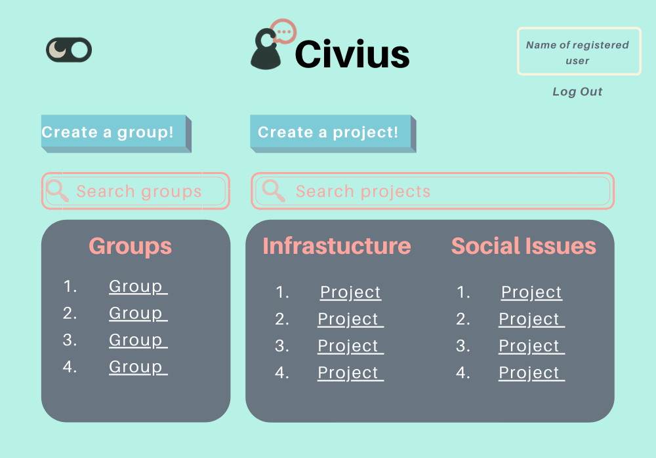

# After logging in, the user accesses the general page. Here they have several options. First, the user can visit their personal profile by clicking the top left button, where they can information about the groups, they are part of, projects voted by them, etc. Only the user has access to this page and only their own page. The user can also visit the page of any group or project by clicking in their links or by searching for the group/project. The user is also able to create their own project or group. Finally, the user can also log out and change the color scheme of the application for a darker mode.

# The “create a group” page is accessed through the general page. Here the user can give the name of the group and decide if the group will be a subgroup of another group by using the dropdown menu. Here, all the groups in which the user is a representative will appear. After clicking the confirm button, the group will be created, and the user will be redirected to the page of the group.

# Similarly, to the “create a group” page, the “create a project” page is accessed through the general page. Here the user will fill the information needed for the project and choose the category of the project (infrastructure or social issues). After that they will be redirected to the specific page for the category they chose.

# If the user chose the infrastructure category when creating a project, they will be redirected to this page. The user will have to choose which neighborhood the project affects and upload an image with the graphical scheme of the project. After clicking confirm the project will be created and the user redirected to the project’s page.

# If the user chose the social issue category when creating a project, they will be redirected to this page. The user will have to choose the social group affected and select if the aim of the project is national or international. After clicking confirm the project will be created and the user redirected to the project’s page.

# Information page for a group. Accessed by selecting the group in the general page or after creating the group. The page states the name of the group, name of the representative, parent group (if there is one) and children groups (if there are any). The user can also see the projects that have been voted by the whole group (through the representative). The user can also click the join group in order to join.

# Appearance of the group information page when the user is already a part of the group. Simply the button changes from “join” to “leave group”.

# Information page for a project. Accessed by selecting the project in the general page or after creating the project. The page states the name of the project, the information regarding the project and the current status of the project. The user can request a popularity report (if they have voted the project only). The user can also choose to vote for the project and/or subscribe to it.

# If already subscribed to the project, the button simply changes to “unsubscribe”.

# Version of the project page when it has surpassed the threshold of votes. The user can choose to submit the project for government review and ask for funding (only if the user is the creator of the project).

# Voting page. Accessed by the user through the project information page. The user can choose to vote as a regular citizen or as a representative of a group (if they are of any).

# If the user chooses to vote as a representative, a drop-down menu appears where the user can select as a representative of which group they want to vote.

# User profile page where they can access the groups they are part of and see what projects they have voted. The user can also access their notifications.

# User profile page when the notifications menu is opened.

# Administrator profile page. Here the administrator can access all their functionalities. They can choose to ban a user from the application, they can set the threshold of votes for all the projects and they can also click the “new projects” button.

# After clicking the “new projects” button a list of all new projects that require approval is shown. Here the administrator can choose to accept or reject those projects.