|  |  |  |
| --- | --- | --- |
|  | Rodrigo Juez Hernández  Daniel Mohedano Rodríguez  Silvia Sopeña Niećko | [rodrigo.juezh@estudiante.uam.es](mailto:rodrigo.juezh@estudiante.uam.es)  [*daniel.mohedano@estudiante.uam.es*](mailto:daniel.mohedano@estudiante.uam.es)  [*silvia.sopenna@estudiante.uam.es*](mailto:silvia.sopenna@estudiante.uam.es) |

TEST PLAN and test results

Application: Civium

DATE: 10-05-20

# 1. TEST CASE<PROJECT creation>

* 1. **Create a project:**

*In this case, the user creates a project in the application to which he/she automatically subscribes to.*

*We will be following the social issue project alternative while also testing the error checking of the application.*

**1.2. Test case design**(including expected inputs and outputs)**:**

**Preconditions:**

*The citizen must be registered and logged in to create the project.*

**Scenario:**

* 1. The user selects the “Create a Project” button.
  2. The user enters the name, description, and budget for the project.
  3. The user chooses to use a group he/she represents to create the group or none.
  4. The user will choose the option of “Social Issue” project.
  5. The user uses the “next” button. If the user gave any invalid information a pop up will appear indicating the error. After the errors are resolved, the user will be transported to the specific page for the information about the social issues project
  6. The user enters the social group affected and chooses the aim of the project.
  7. The user selects the confirm button. If any invalid information was given the user will be prompted. After fixing it the user will be transported to the project information page.
  8. Once the project is validated by the admin the user will be able to request a popularity report.

## 1.3. Test execution result

The application works as intended. When providing incorrect values, the application prompts the user with the error.

# 

When a name longer than 25 characters is provided the error prompt appears.

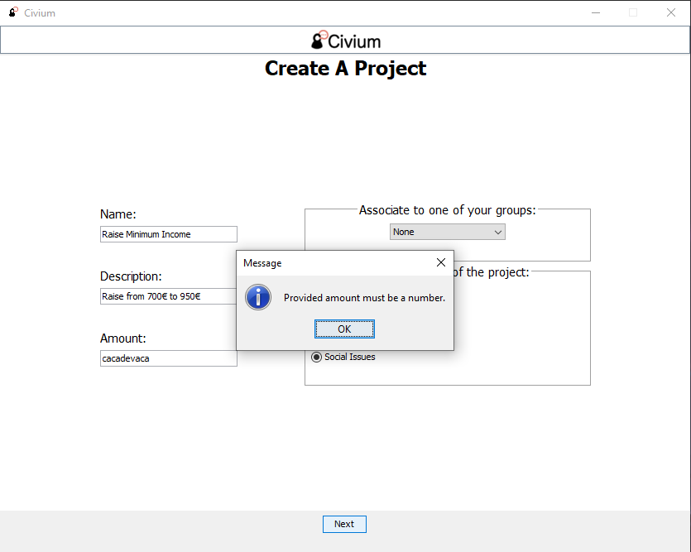

When not providing a number for the budget the error prompt appears.

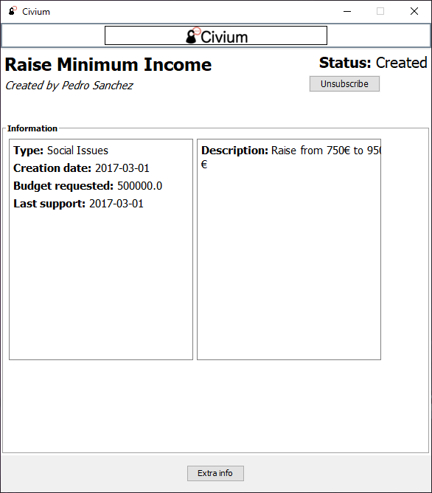

The user is transported to the project page once it is created.

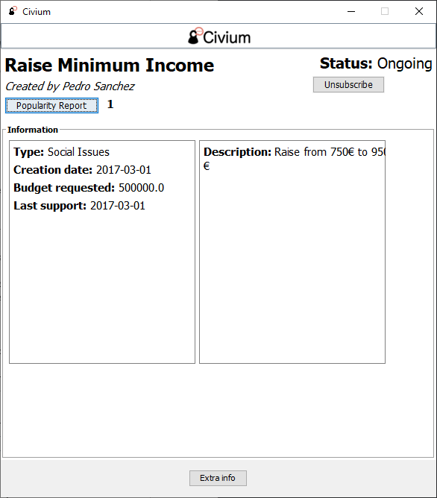

After validation from the admin the user is able to request the popularity report and unsubscribe.

# 2. TEST CASE <Join group>

**2.1 Join a Group:**

*The citizen is recorded in the system as a member of the group. The votes done by the representative of the group are recalculated to reflect the new member. The profile menu for the user will also be updated to include the new group in the list of groups he/she is a part of.*

*We will test the main path, which includes joining a group and checking if it appears on the user’s profile and is registered as member.*

**2.2 Test case design:**

**Preconditions:**

1. *The citizen is registered.*
2. *Has logged in.*
3. *Has sought a group.*
4. *They have then entered the group’s page.*

**Scenario:**

* 1. *The application main menu shows all the existing groups.*
  2. *The user can click on the group that calls his/her attention.*
  3. *After clicking on a group, the group window appears.*
  4. *To join the group, he/she only must press the Join button.*

**Note:** If steps in test case are different from those of use case, explain why

## https://cdn.discordapp.com/attachments/675724062844125216/709153958932906065/unknown.png2.3. Test execution result

The user has not joined the “Prorroga Estado Alarma” group, represented by Pedro Sanchez. To do this, he must click on the join button.

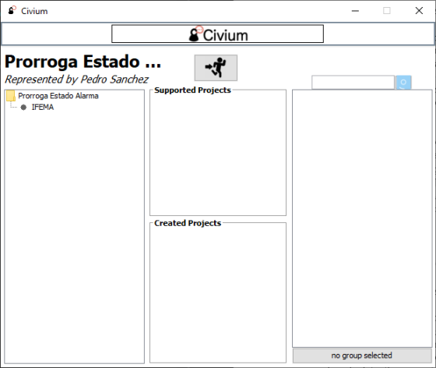The user has not joined the “Prorroga Estado Alarma” group, represented by Pedro Sanchez. To do this, he must click on the join button.

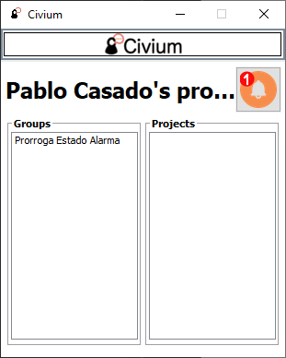

Once the registered citizen joins the group, the group is automatically added to his list of groups.