EXERCISE 3
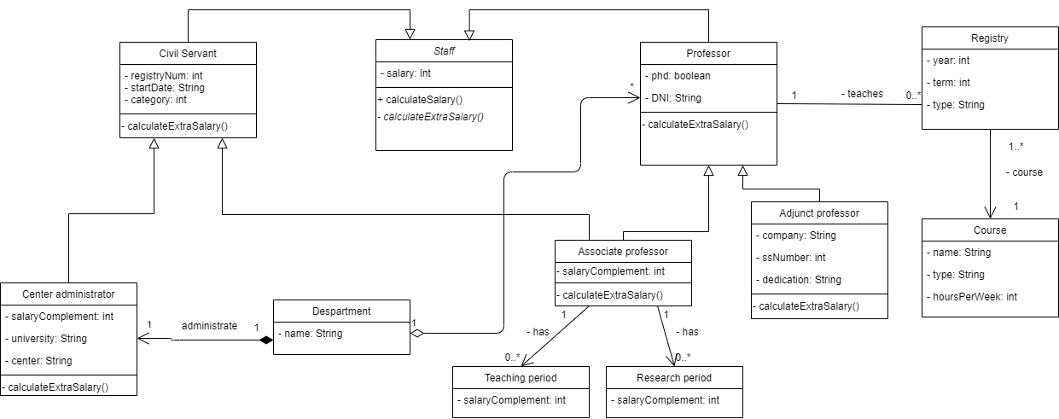
A)
In this exercise, we need to design an application for the managing of the staff of public universities. For implementing it, we created the abstract class Staff where two classes called Civil Servant and Professor are inherited. Staff contains one attribute and two methods use by its subclasses.
Then, from Civil Servant, there are inherited normal subclasses as Center administrator which administrates a department created in another class called Department, and also it is inherited the class Associate professor which is also inherited from Professor (and that will be a problem in implementation because of multiple inheritance). Associate professor will have the registry of its teaching and research periods, divided in two subclasses for adding the unique methods for calculating the salary complement of each of them.
The Professor class will be connected to another class called Registry that has all the courses in which that professor has given class, and all the information about them will be given in the Registry class by its attributes.
The method calculateExtraSalary is useful to calculate supplements from different kinds of Staff.

B)
For implementing in Java, we will need the setters and getters, and many more functions in order to make it work efficiently. Then, as java doesn't accept classes belonging to more than one class (multiple inheritance) we will have to divide in some way the class Associate professor as it belongs to Civil servant and Professor. This following design could be a good implementation, where the Associate professor class inherits from a class called Civil Servant Professor which is a copy of Civil Servant and Professor classes together and inherits directly from the Staff class, it’s also abstract as we don’t want to be able to create an object to just be that and the objects will be created by Associate Professor.

