**CAPITAL BEARDS 2015 COMPETITION AND DECEMBEARD**

Morning all

I have just returned from my travels so time for a quick update. Firstly, to those who didn’t come to our October get-together at Tapping the Admiral in Camden, you missed a good one. The Sunday Dinners there are probably the best of all the pubs we visit and their selection of beers in this very friendly back street pub is excellent so I suggest you put a note in your diary to make sure you don’t miss out next year. The date is likely to be Sunday 16 October 2016, but I shall confirm nearer the time.

Now to the big one. On Saturday 14 November we will be holding Capital Beards’ first Beard and Moustache Competition in The Hope, 48 West Street Carshalton SM5 2PR. This event will also include the local launch of Decembeard. Our very own Rodger of the Hope and Sherrill Hawker, Community Fundraiser for the South East have been busy ensuring that the day will be special. We are hoping for some special guests including the local press to come along to the event. The BBC Two health series ‘Trust Me, I’m A Doctor are also planning to come along to film a segment for a forthcoming programme. One of the guests from Beating Bowel Cancer will be the guy on the front of the Decembeard A5 leaflet which is being promoted nationally so the poster boy will be there! Sherrill’s manager will also be attending as she is really excited to see an event in play and lives nearby. She will be saying a few words at the launch.

The schedule of events is currently due to start at our usual Midday with drinks, food and socialising while the registration takes place. This is scheduled to be completed by 2 o’clock when our Beard and Moustache Competition will commence. To remind you of the categories, they are:

**Moustache Natural**

Natural shaping allowed but without aids. Facial hair is grown on the upper lip only and hairs may grow out up to 1.5 cm from the end of the upper lip  
  
**Partial Beard Natural**

This covers goatee, business class, mutton chops and 'Whaler/Amish’ but with no aids

**Full Beard Natural**  
As grown with moustache integrated without any natural or shaved gap and no aids.   
  
**Partial Beard Styled**

Includes sculptured beards.

**Moustache Styled**

Facial hair is grown on the upper lip only.  
  
**Full Beard Styled**

This takes in styled beard as well as styled moustache (with beard).

**Musketee**r

Moustache long and slender, lip hairs may grow out up to 1.5cm from end of upper lip. Beard narrow and pointed. Aids allowed.

**Freestyle**

Covers both moustaches and beards – including Wiskeriners. Anything goes!

Contestants are welcome to enter more than one category if they feel they meet the criteria.

Following, there will be the official regional launch party for Decembeard. This is an awareness-and fund-raising campaign by the Beating Bowel Cancer Charity**.** Beating Bowel Cancer is the support and campaigning charity for everyone affected by bowel cancer, they provide vital practical and emotional help – on the phone, digitally and face to face. They’re proud to run the UK’s only nurse-led specialist helpline for bowel cancer which patients call a ‘lifeline’. They bring patients together to share invaluable experience and support, through their website, social media and major events. The campaign aims to encourage non-bearded and wannabe bearded chaps to grow a beard for (at least) the month of December, and importantly to attract local financial sponsorship for a Decembeard donation while they are doing it.  
  
 Unlike Movember's after-party, there is (hopefully) no shave-down at the end of it. On the contrary, it's hoped that the beard growers will be so attached to their new beards by the end of Decembeard that they will want to keep them, and/or their previously disapproving partners and employers will be used to their beards, and agree that they can keep them afterwards. If you know any non-bearded people who are not sure whether they should grow a beard please invite them along to the Hope, so we can pass on the good word about beard-growing, grooming and the wonderful friendship and camaraderie that we've all   
 experienced since joining Beard Clubs. Customers of the pub will also be fair game!The Capital Beard are organising this event in aid of Beating Bowel Cancer, has said ‘We are thrilled to have the support of Capital Beards for our Decembeard campaign. It means a lot to us to have the backing of the local community all helping us to spread the word, helping to raise awareness of the UK’s second biggest cancer killer. We need 5,000 men to grow beards and raise £500,000 to fund Beating Bowel Cancer’s vital services Every 15 minutes someone is diagnosed with bowel cancer which is why we are asking local communities to get on board and sprout your cheek fuzz’. The pub is five minutes’ walk from Carshalton station and a significant number of buses run close by. If you fancy a bus, check out the Hope’s very helpful web site.

With these two events in one, it will be Capital Beards biggest event in our history so I hope to see you all there.

I will conclude with a picture. For those familiar with the Hope they will recognise that this is not the Hope. What is it to do with our event then? Actually nothing at all, but it is the entrance to one of my favourite pubs anywhere – the Philharmonic in Liverpool and I couldn’t resist sharing it with you. Even the Gents loos are Grade 2 listed, but I didn’t feel comfortable getting my camera out in there!

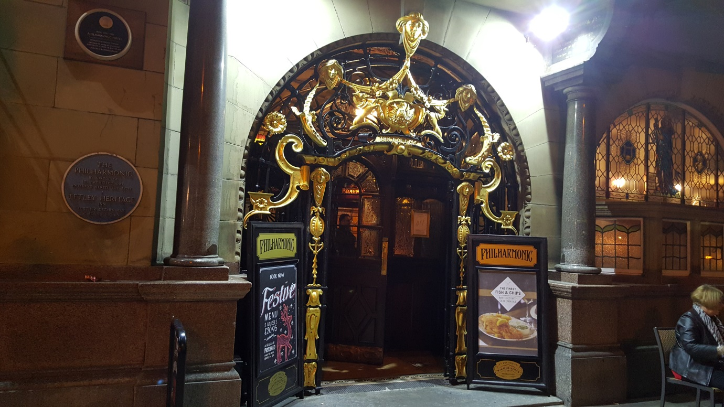

Cheers

Del Legg

Capital Beards Organiser