# Setting up BrawStats App

Setting the app up to use in this course is easy. Here are the 5 steps. They are all done in your browser. They are all free.

## 1. Make an online RStudio account (once only)

We need to make an online account in the system called RStudio.

1. Go to <https://rstudio.cloud/>   
   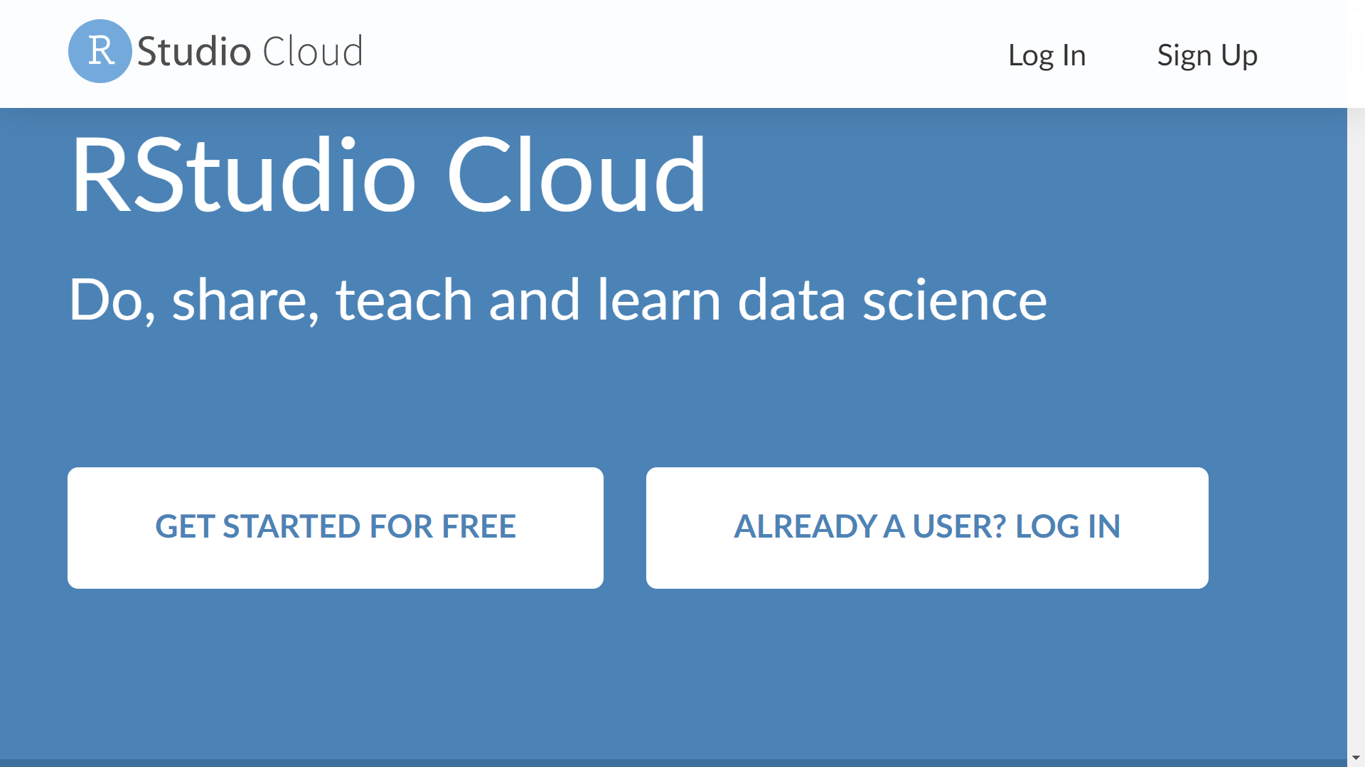

Press

1. Press the button that says “Get started for free”.
2. Press the button “Sign up” for Cloud Free. You don’t need the “plus” option so leave it switched off (as in the screenshot).   
   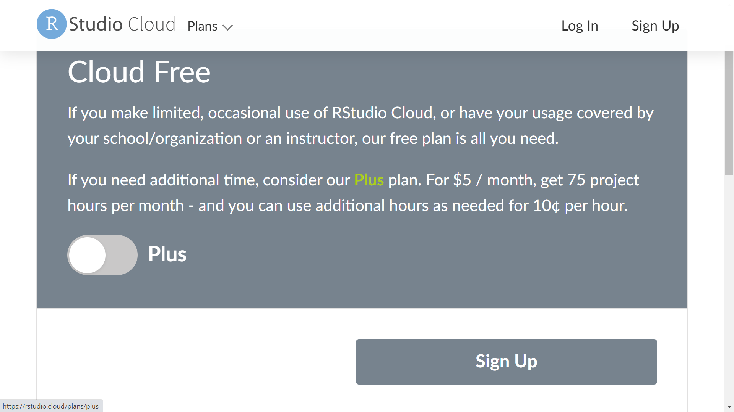

Press

1. Make an account by filling in your email address and the other details. Where it says Password it is asking you to create a password.

## 2. Log in to your RStudio Account (always)

In future, you can go directly to <https://login.rstudio.cloud/> and log in with your email address and the password you created.

1. At this point, choose “RStudio Cloud” as your destination.   
    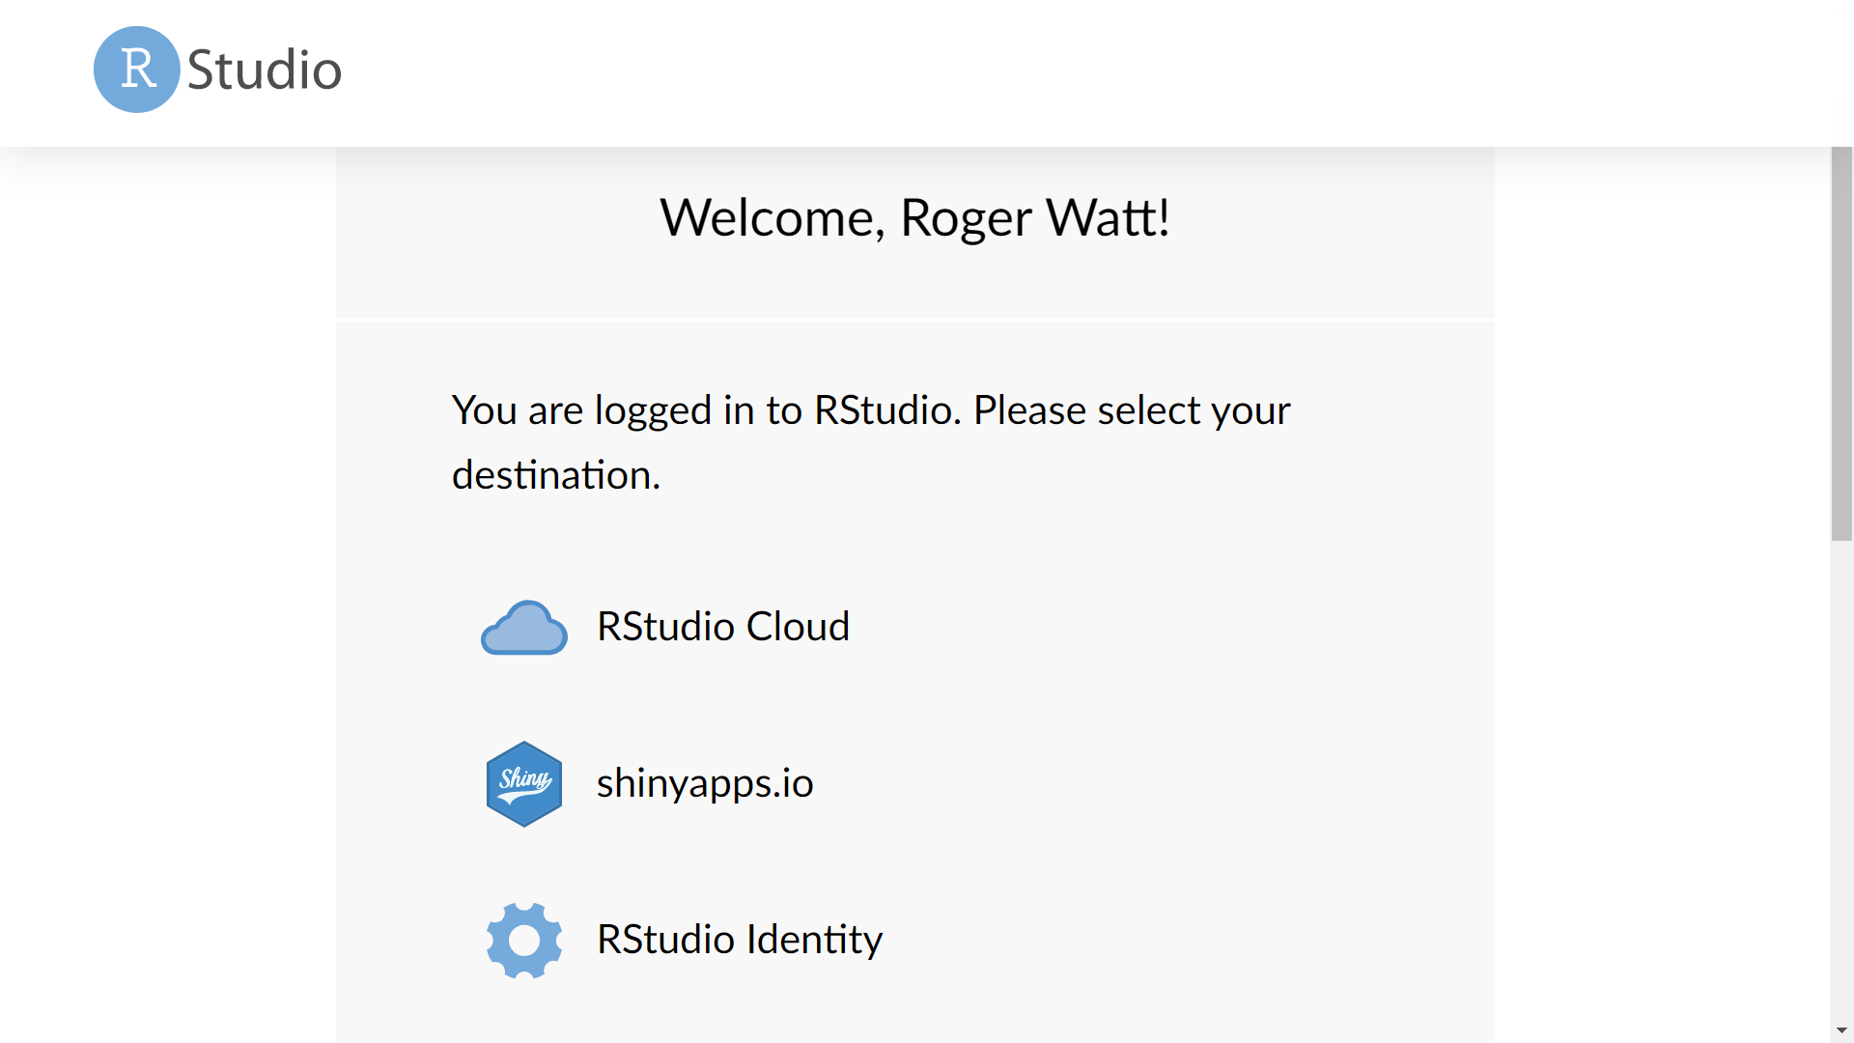

Press

## 3. Make a Project to hold the App (once only)

On the screen you will now have reached, there is a button for “New Project” in the top right.

1. Click on this and choose “new RStudio Project”.   
   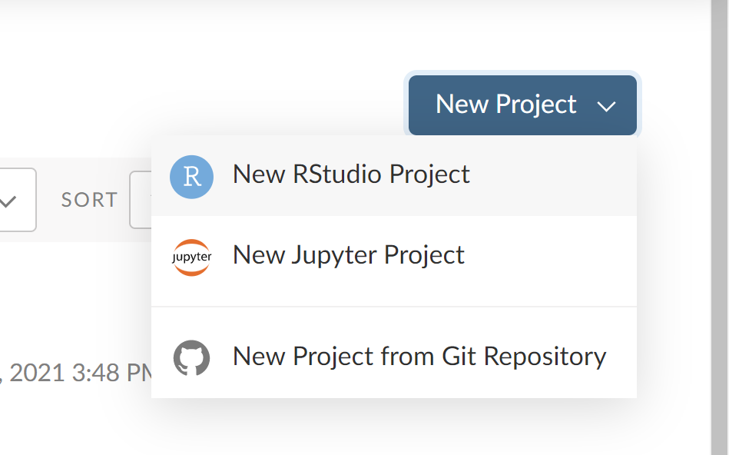
2. Wait for a few seconds while it sets everything up.
3. It is a good idea to name the project – click on the grey letters that say “Untitled Project” and choose a name for the project. In future you will use this name to load the project.

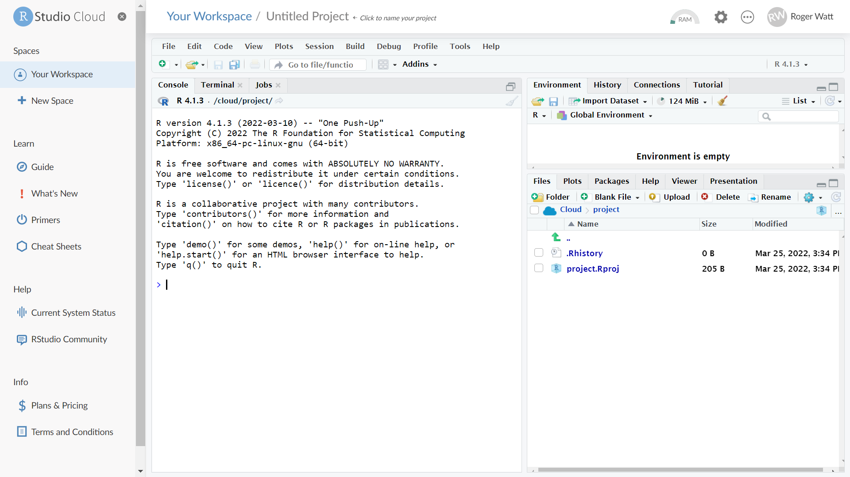

Type a project name here

Console prompt

1. Lastly, in the console, where the insert cursor is (it looks like this **>** |), type this instruction:  
   **install.packages("shiny")**

note that the " is not the fancy leaning ones that MS Word uses  
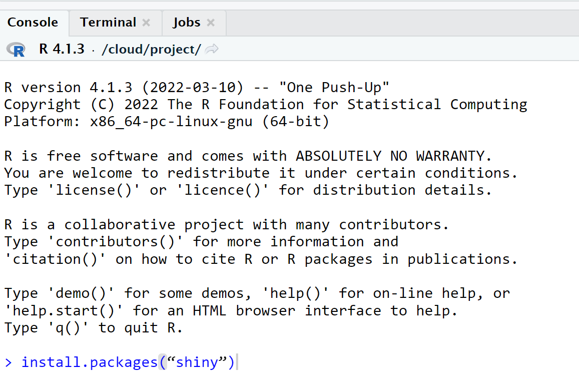

The console will now go off a do lots of things. And it fills the screen with very official looking red text. Ignore everything until the **>** | comes back.

Next time you come to this project, that won’t be needed.

## 4. Run the App (always)

Only one more thing to do.

1. Copy and paste this in the console:  
   **shiny::runGitHub(repo="BrawStats", username="rjwatt42", launch.browser=TRUE)**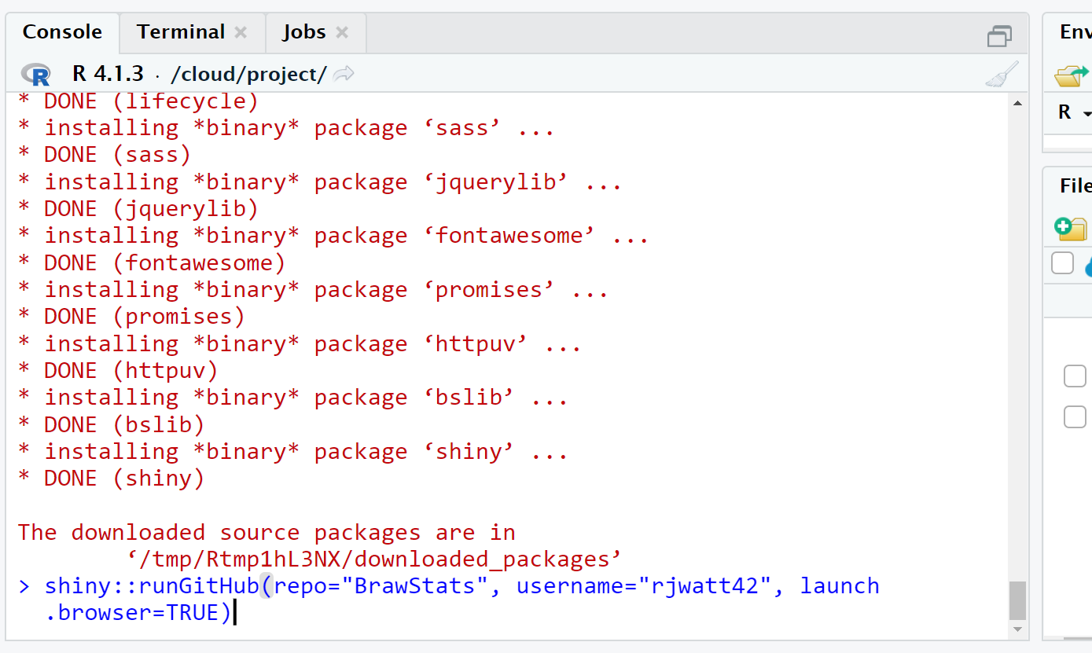

Sit back and wait for a few minutes and the app will launch in a fresh tab in your browser.

## 5. Feel smug

You are there.

# Running BrawStats App subsequently

Once that set up is completed, you can close the browser tabs involved (RStudio and the app itself any time you have finished). Here is how you would restart subsequently.

## 1. Log in to your RStudio Account

1. Follow this link <https://login.rstudio.cloud/> and log in with your email address and the password you created.
2. At this point, choose “RStudio Cloud” as your destination as before.

## 2. Select the Project you made

This takes you to “Your Workspace”. It will list all your projects (which may just be this one).

Click on the name of your project.

## 3. Run the App (always)

Only one more thing to do.

Copy and paste this in the console:

**shiny::runGitHub(repo="BrawStats", username="rjwatt42", launch.browser=TRUE)**Sit back and wait for a few moments and the app will launch in a fresh tab in your browser.

## 4. Feel smug

You are there.