# Inheritance:

# Part 1

1. Consider the following three Java Classes

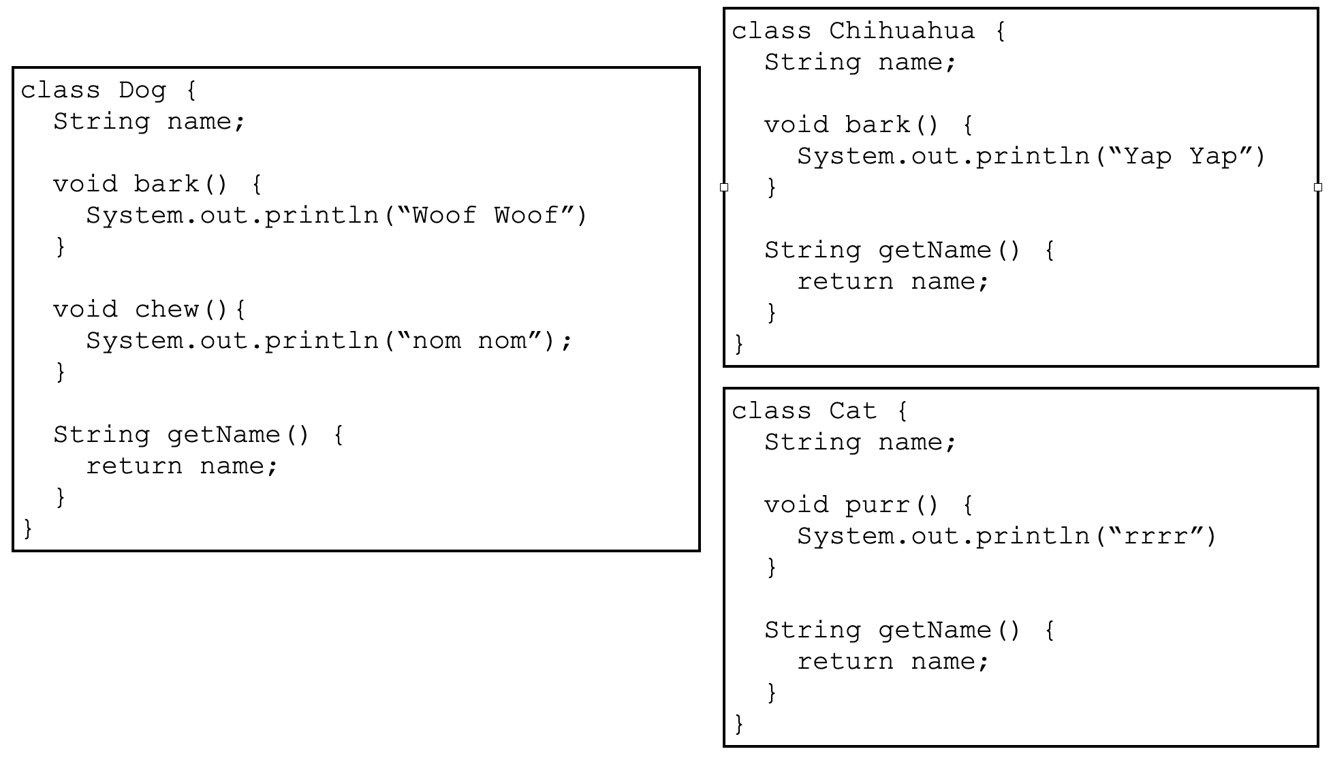

* 1. What do they have in common?
  2. How might you use inheritance to model these classes? [Hint, do they all fit into some general category?]
  3. Draw the onion diagram for the Cat Class and Chihuahua Class.

1. Why do you think we call it an onion diagram?

# 

# Part 2

For each line of code in the main method indicate **which class the method being executed comes from** and **the result of executing that method**

1. Example 1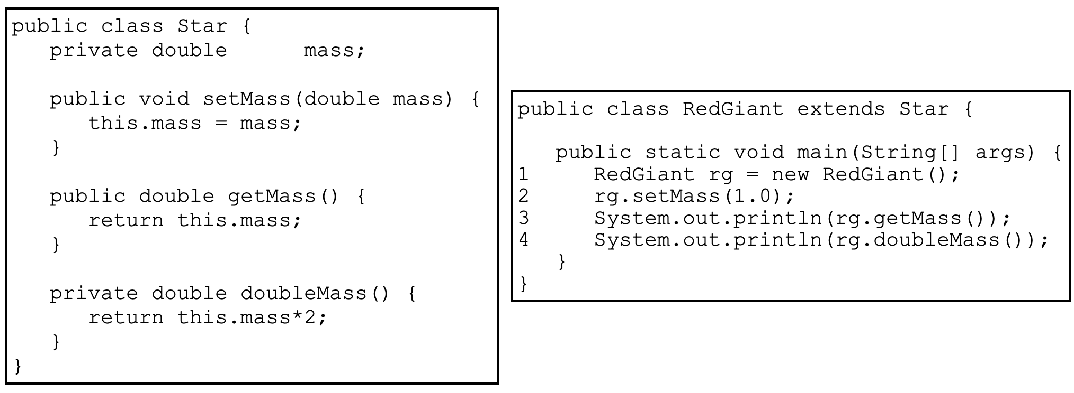
2. Example 2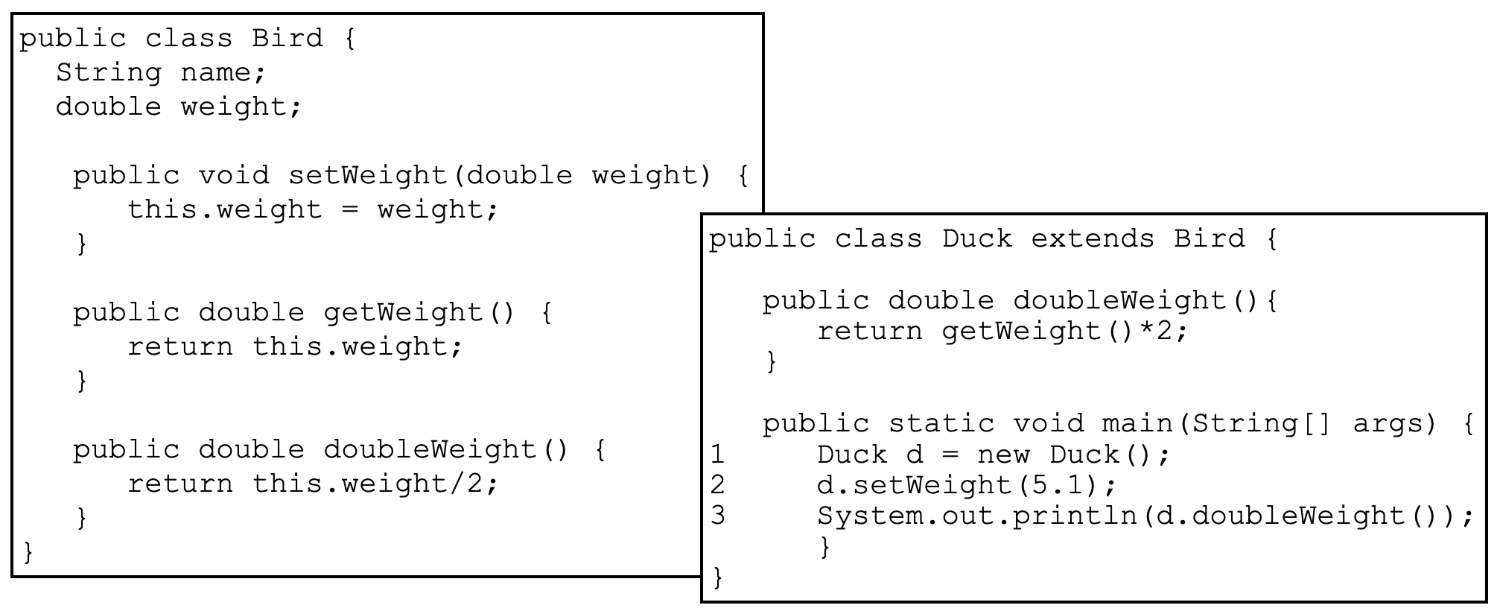
3. Example 3