Title:
AI-Based Early Alzheimer’s Detection and Cognitive Assistance
using Deep Learning
Domain:
Artificial Intelligence and Machine Learning

Motivation for the Project:
The rapidly increasing number of Alzheimer’s disease cases worldwide, especially among the aging population. Alzheimer’s is a progressive neurological disorder that affects memory, cognitive abilities, and behaviour, ultimately impacting a person’s ability to perform daily activities independently. One of the major concerns is that the disease is often diagnosed at a later stage, when symptoms become severe and irreversible. Early detection is crucial to slow down disease progression and improve the quality of life, but current healthcare systems face challenges in identifying the disease at its initial stages.
Another important factor motivating this project is the limitation of traditional diagnostic techniques. Diagnosis typically depends on expert interpretation of MRI or CT scan images, which is time-consuming and subject to human error. Subtle patterns indicating early-stage Alzheimer’s can be easily missed, leading to delayed intervention. With advancements in Artificial Intelligence and Deep Learning, particularly Convolutional Neural Networks (CNNs), it is now possible to analyze medical images more efficiently and accurately. This creates an opportunity to develop an automated system that assists doctors in making faster and more reliable diagnoses.
In addition to medical challenges, Alzheimer’s patients face significant difficulties in their day-to-day lives. They often forget medications, appointments, and routine tasks, and may even fail to recognize familiar people or places. This not only reduces their independence but also increases safety risks such as getting lost. At the same time, caregivers experience emotional, physical, and financial stress while continuously monitoring patients. Existing solutions often address only one aspect of the problem, lacking a comprehensive approach that integrates diagnosis, monitoring, and assistance.

Therefore, this project is motivated by the need to develop a holistic and intelligent system that combines early detection with continuous patient support. By integrating deep learning-based image analysis with a mobile healthcare application, the system can provide features such as medication reminders, cognitive training exercises, face recognition for identity support, GPS tracking for safety, and real-time alerts for caregivers. This integrated approach aims to enhance early diagnosis, improve patient independence, support caregivers, and contribute to more effective and accessible healthcare solutions.
Literature Survey:
No | Title | Author(s) | Description | References | Year | Limitations
1. | The Role of Artificial Intelligence in the Detection and Diagnosis of Neurocognitive Disorders | Pasqualina Perna, Alessandra Claudi, Fabrizio Stasolla, Raffaele Nappo | AI is used to detect neurocognitive disorders like Alzheimer’s and Mild Cognitive Impairment using data such as neuroimaging, EEG, biomarkers, and speech. It supports early detection, prediction, and patient monitoring. | Technologies  MDPI Journal | 2026 | Dataset heterogeneity, lack of external validation, methodological inconsistencies, challenges in clinical implementation, ethical concerns.
2. | AI-Driven Mental Health Support for Caregivers of Individuals With Alzheimer Disease | Syeda Umme Salma, Chandra Rekha Renduchintala, Isa Siddique, Evelina Sterling, Sweta Sneha | AI-based systems use NLP, machine learning, and wearable data to support caregivers of Alzheimer’s patients. They provide personalized monitoring, support,and recommendations. | JMIR Mental Health | 2026 | Lack of personalization in existing systems, limited real-time monitoring, dependency on smart devices, usability challenges, need for explainable AI.
3. | A Deep Learning Model for Early Diagnosis of Alzheimer’s Disease Combined with 3D CNN and Video Swin Transformer | Juan Zhou, Yiming Wei, Xiong Li, Weiqiang Zhou, Ruiyang Tao, Yi Hua, Hongwei Liu | A deep learning model using 3D-CNN and Video Swin Transformer model analyzes MRI images to detect Alzheimer’s. It captures key features, avoids data leakage, and ensures accurate classification. | Scientific Reports | 2025 | Requires high computational power, needs large MRI datasets, complex model architecture, longer training time, limited real-world clinical validation
4. | Facial Expression Deep Learning Algorithms in the Detection of Neurological Disorders | Shania Yoonesi, Ramila Abedi Azar, Melika Arab Bafrani, Shayan Yaghmayee, Haniye Shahavand | CNN-based deep learning analyzes facial expressions to detect neurological disorders. Expression changes act as indicators for accurate AI-based detection | BioMedical Engineering OnLine | 2025 | Limited datasets, variability in facial data, and lack of standardization reduce accuracy. Further validation is required.
5. | Enhanced Hybrid AI-Based Framework for Improving the Detection and Diagnosis of Alzheimer’s Disease | Parthasarathi Pattnayak, Tulip Das | Proposes a hybrid AI model using DenseNet and ML classifiers to detect Alzheimer’s from MRI images, achieving good accuracy on 6400 images and supporting automated diagnosis. | IEEE | 2025 | Depends on MRI data quality and size, has high complexity and computational cost, limited clinical validation, and lacks explainability.
6. | A Multi-CNN Ensemble Method for Early Diagnosis of Alzheimer’s Disease Using MRI Imaging | Ghata Mehta, Nitya Jani, Himanshu Gajera, Rajendra Choudhary | Proposes a multi-CNN ensemble model for early Alzheimer’s detection from MRI images, achieving high accuracy and supporting better early diagnosis. | International Conference on Artificial Intelligence and Machine Vision (AIMV), IEEE | 2025 | High computational complexity, depends on large high-quality MRI data, risk of overfitting, low interpretability, and requires extensive clinical validation
7. | LSTM-Based Assistance for People with Alzheimer’s Disease | Priyanka K, Vikas Benhur Chitla, Aman Aftab, Sumanth Kamath | Focuses on AI assistive tech using LSTM, apps, chatbots, and voice systems to provide reminders, tracking, and personalized care for Alzheimer’s patients | International Conference on Intelligent and Innovative Technologies in Computing, Electrical and Electronics (IITCEE), IEEE | 2025 | No unified model, multi-tech dependency, privacy concerns, integration challenges, limited deployment, needs personalization.
8. | Early Diagnosis of Alzheimer's Disease Using YOLOv11 Deep Learning Model in MRI Scans | Wided Hechkel, Rim Missaoui, Abdelhamid Helali | Uses YOLOv11 on MRI (ADNI) data to classify four Alzheimer’s stages with high accuracy for early detection. | IEEE 22nd International Multi-Conference on Systems, Signals & Devices (SSD) | 2025 | Needs large MRI dataset, high computation cost, requires clinical validation, accuracy depends on image quality.
9. | Exploring how caregivers of people with Alzheimer’s disease experience role captivity | Wenxia Zhang, Wenting Xu, Junzhi Duan, Junyu Tang, Qunli Zhu, Xifeng Pi, Jing Huang | Examines caregiver burden in Alzheimer’s, highlighting emotional stress, social and financial challenges, and reduced well-being. | International Psycho-geriatrics, Elsevier | 2025 | Small sample size, single hospital study, results may not generalize, based on interviews not experiments.
10. | An integrated deep learning model for early and multi-class diagnosis of Alzheimer's disease from MRI scans | Emanuel Raju Vinukonda & B. N. Jagadesh | Proposes a hybrid deep learning system combining IDeepLabV3+, LeNet-5, and EResNext for multi-class Alzheimer’s classification using MRI. | Scientific Reports | 2025 | Requires large datasets and is affected by class imbalance, which can reduce performance.
11. | Artificial Intelligence Technology in Alzheimer’s Disease Research | Wenli Zhang, Yifan Li, Wentao Ren, Bo Liu | Proposes a deep CNN model for Alzheimer’s detection using MRI images from the OASIS dataset with data augmentation to handle class imbalance.  The model classifies four dementia stages with ~99.6% accuracy, enabling early automated diagnosis. | Intractable & Rare Diseases Research Journal | 2025 | Requires large datasets, high computational cost, difficulty in early-stage detection, lack of standardized clinical validation, and ethical/privacy concerns.
12. | An integrated deep learning model for early and multi-class diagnosis of Alzheimer's disease from MRI scans | Emanuel Raju Vinukonda & B. N. Jagadesh | Proposes a hybrid deep learning model using IDeepLabV3+, LeNet-5, and EResNext for multi-class Alzheimer’s detection from MRI images.Classifies the stages with High accuracy (~98%) and improves early diagnosis using feature selection. | Scientific Reports | 2025 | Class Imbalance: Unbalanced datasets can negatively influence performance by shifting accuracy toward the majority class.
13. | MemorySona: Illuminating Cognitive Health with Deep Learning – A Mobile Medical App for Alzheimer’s Patients | Samah A. Z. Hassan | An AI-based Alzheimer’s support system using deep learning models (CNN, DenseNet121, ResNet50, VGG16, InceptionV3) on MRI images for diagnosis.  It also provides memory training and reminders, with DenseNet121 achieving the best performance. | 2024 6th International Conference on Computing and Informatics (ICCI), IEEE | 2024 | Accuracy depends on dataset quality, moderate performance, requires large MRI data, limited real-time clinical testing.
14. | Exploring how caregivers of people with Alzheimer’s disease experience role captivity: A qualitative study | Wenxia Zhang, Wenting Xu, Junzhi Duan, Junyu Tang, Qunli Zhu, Xifeng Pi, Jing Huang | Uses AI/ML with clinical and cognitive data to predict Alzheimer’s and MCI, where ensemble methods improve diagnostic accuracy. | International Psycho-geriatrics, Elsevier | 2024 | Small sample size, single hospital study, results may not generalize, based on interviews not experiments.
15. | AI-Based Smart Assistant System for Alzheimer Patients | Kiruthika V R, NirmalaDevi J | An AI-based smart assistant uses ML models (LSTM, Random Forest, SVM, LightGBM) to predict activities and provides app-based reminders, tracking, and monitoring to improve patient safety and reduce caregiver burden. | 2024 5th International Conference on Electronics and Sustainable Comunication Systems (ICESC), IEEE | 2024 | Depends on user interaction, raises privacy concerns (e.g., location tracking), shows variable accuracy, requires continuous data input.
16. | Deep Learning-Based Diagnosis of Alzheimer’s Disease Using Medical Imaging | Falah Sheikh, Ahmed Al Marouf, Jon George Rokne, Reda Alhajj | Uses deep learning, especially CNN models, for Alzheimer’s detection using MRI and medical imaging data.Shows high classification accuracy and supports early diagnosis with automated feature extraction. | Diagnostics Journal | 2024 | High dependency on imaging data quality, limited generalization across datasets, and need for clinical validation before real-world use.
17. | Early Detection of Alzheimer’s Disease Using Artificial Intelligence and Machine Learning: A Comprehensive Review | Subramanian Ganesan | Reviews AI and Machine Learning methods for early Alzheimer’s detection using MRI, PET, biomarkers, and deep learning models.Shows that multimodal data and hybrid models improve accuracy and support early diagnosis. | VIT University | 2024 | Requires large datasets, high computational power, lack of standardization, clinical validation still needed, ethical and privacy concerns.
18. | Deep Learning-Based Diagnosis of Alzheimer’s Disease Using MRI Images | A. Khan,  M. Usman | The model classifies patients into different stages such as Normal, Mild Cognitive Impairment, and Alzheimer’s. It demonstrates improved accuracy compared to traditional machine learning techniques and emphasizes automated feature extraction. | IEEE  Access | 2023 | .The model’s performance depends heavily on high-quality MRI datasets, requires large amounts of training data, is prone to overfitting with limited samples.
19. | AI-Based Model for Detection and Classification of Alzheimer Disease | Suraj Kumar, Narendra Pratap Singh, Banalaxmi Brahma | Uses CNN on MRI brain images for early Alzheimer’s detection with feature extraction using a pre-trained model.Compares SoftMax, SVM, and DNN classifiers and achieves very high accuracy (~99%), improving early diagnosis. | IEEE International Conference on Computer Vision and Machine Intelligence (CVMI) | 2023 | Dependence on MRI data quality, risk of overfitting due to very high accuracy, computational complexity, limited dataset diversity and lack of interpretability, and requirement.
20. | Machine Learning Techniques for Alzheimer’s Disease Diagnosis: A Review | S. Rathore, M. Habes, M. A. Iftikhar | This study explores various machine learning algorithms such as Support Vector Machines (SVM), Random Forest, and Logistic Regression for early detection of Alzheimer’s disease, comparing their performance using clinical and imaging datasets. | Elsevier (Journal of Neuroscience Methods) | 2023 | Requires manual feature extraction, is sensitive to data imbalance issues, and has limited capability in capturing complex patterns in high-dimensional data.

Problem Statement:
Alzheimer’s disease is a progressive neurological disorder that affects memory, thinking ability, and behaviour, and is one of the leading causes of dementia among older adults. In many cases, it is diagnosed only after symptoms become severe, reducing the effectiveness of treatment. Existing diagnostic methods rely on manual interpretation of medical images, which can be time-consuming and may fail to detect early-stage abnormalities. Additionally, patients require continuous support in their daily lives, as they may forget medications, appointments, or even the identity of family members, leading to safety risks and reduced independence. Current systems do not provide a unified solution that addresses both early detection and patient assistance. Therefore, there is a need to develop an integrated system that utilizes deep learning for early detection of Alzheimer’s disease, along with cognitive assistance for patients, and a doctor dashboard for effective monitoring and care.

Aim:

The aim of this project is to develop an AI-powered Alzheimer’s detection system using MRI/CT image analysis, integrated with a smart application for cognitive assistance and patient support. The system is capable of analyzing brain images to detect Alzheimer’s disease at an early stage and assist healthcare professionals in making faster, more accurate, and reliable diagnostic decisions, enabling timely intervention and treatment. By leveraging deep learning-based predictions along with continuous support mechanisms, the project aims to improve patient outcomes, enhance safety and independence, reduce caregiver burden, and contribute to more efficient and accessible healthcare systems.
Objectives:
- To develop a CNN-based AI model for analyzing MRI/CT brain images for early detection of Alzheimer’s disease.
- To design and implement a mobile healthcare application that provides features such as medication reminders, scheduling, and cognitive assistance.
- To implement face recognition and machine learning-based cognitive training modules to support memory enhancement and identity assistance.
- To develop an integrated system incorporating GPS tracking, anomaly detection, alert mechanisms, and a doctor dashboard for real-time monitoring and analytics.

System Requirements:
- Hardware Requirements

- Processor: Intel i3 / Ryzen 5 or higher
- Processor Speed: 1.2 GHz+
- RAM: Minimum of 8GB or higher
- Hard disk space: 500GB
- GPU: NVIDIA GPU with CUDA support for deep learning tasks

- Software Requirements

- Operating System: Windows 10 or higher
- IDE: Visual Studio Code, Android Studio(for mobile app)
- Deep Learning Frameworks: scikit-learn, TensorFlow, Keras
- Programming Language: Python
- Libraries: OpenCV (image processing), NumPy, Pandas
- Database: MySQL
- Data Visualization Tool: matplotlib (for displaying dashboards)

Functional Requirements:
1. Data Collection
• The system should utilize publicly available datasets (e.g., MRI/CT brain scan datasets) for Alzheimer’s detection.
• It should support integration of both structured data (patient details, medical history) and unstructured data (brain images).
2. Data Preprocessing
• The system should clean and pre-process image data, including resizing, normalization, and noise removal.
• It should perform data augmentation to improve model performance and the dataset should be split into training and testing sets for model evaluation.
3. Predictive Modelling
• The system should use a Convolutional Neural Network (CNN) for analyzing MRI/CT images.
• It should classify Alzheimer’s stages (Normal, Mild, Moderate, Severe).
• The model should output interpretable predictions such as probability scores and disease stage.
4. Cognitive Assistance System
• The system should provide reminders for medications and appointments.
• It should include memory training exercises and cognitive games and it must support face recognition to help patients identify known individuals.
5. Patient Safety and Monitoring
• The system should provide GPS tracking for real-time patient location monitoring.
• It should generate alerts for abnormal behaviour or emergency situations and It should maintain patient history for continuous monitoring.
6. Visualization and Reporting
• The system should display results in a dashboard with charts and patient health indicators.
• It should generate reports summarizing diagnosis and patient progress and those reports should be downloadable and shareable with doctors and caregivers.
7. Deployment and Accessibility
• The system should be developed as a web/mobile-based application.
• It should provide secure login and authentication for users.

Non-Functional Requirements:
1. Performance
• The system should generate prediction results within a few seconds for real-time usability.
• It should efficiently process large MRI/CT image datasets without significant delay.
2. Accuracy and Reliability
• The system should achieve high accuracy in detecting and classifying Alzheimer’s stages.
• It should provide consistent and reliable results with minimal errors.
• The system should function correctly even with noisy or incomplete input data.
3. Scalability
• The system should handle an increasing number of users and data efficiently.
• It should support future expansion, such as adding new features or larger datasets.
4. Security
• The system should ensure secure storage and transmission of patient data.
• It should implement authentication and authorization mechanisms.
• Sensitive medical information should be protected from unauthorized access.
5. Maintainability and Availability
• The system should be easy to maintain, update, and modify.
• The code should be modular and well-documented.
• The system should be available with minimal downtime and support continuous access.
6. Compatibility
• The system should be compatible with different devices such as mobile phones and desktops.
• It should support multiple operating systems and web browsers.

Methodology:
The proposed system follows a structured methodology that integrates deep learning-based disease detection with a smart healthcare application for continuous patient support. The system begins with the collection of brain MRI/CT scan datasets from reliable sources such as Kaggle and medical repositories. These datasets contain labeled images representing different stages of Alzheimer’s disease.
The collected data undergoes preprocessing, where images are resized, normalized, and enhanced to improve quality and ensure consistency. Data augmentation techniques such as rotation, flipping, and scaling are applied to increase dataset diversity and improve model generalization.
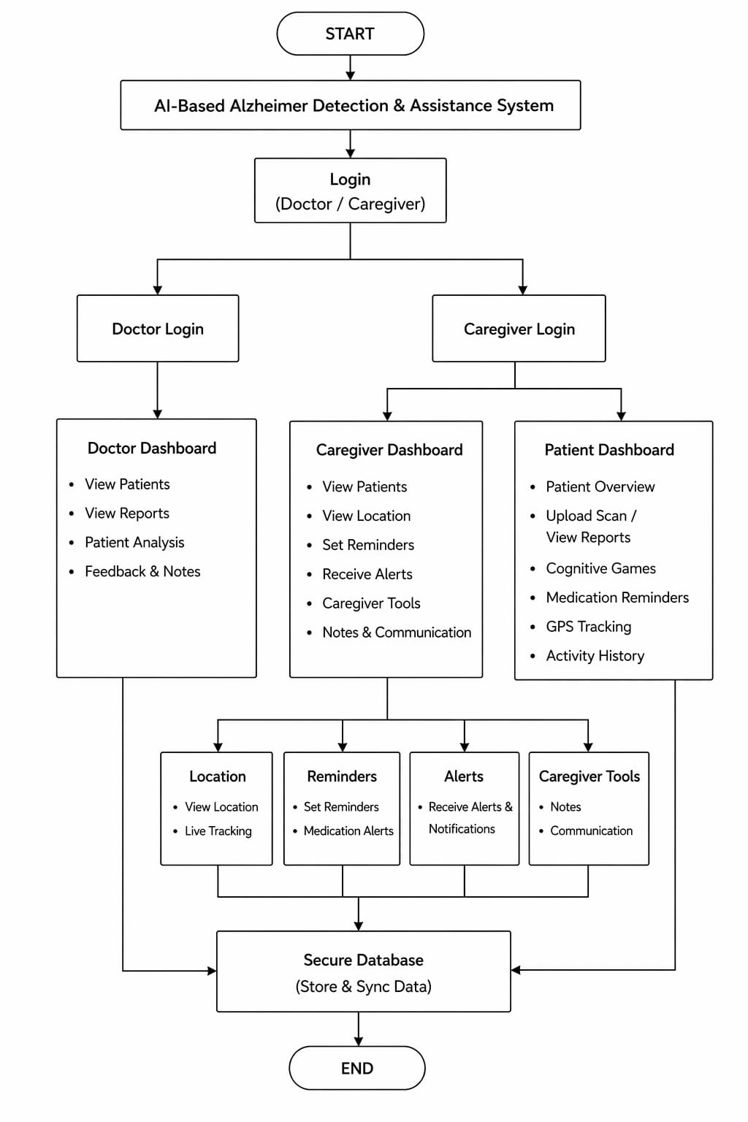
Figure: Activity Diagram

In the model development phase, a Convolutional Neural Network (CNN) is designed and trained to automatically extract features from MRI/CT images and classify them into categories such as non-demented, mild, moderate, or severe Alzheimer’s. The model is evaluated and optimized using performance metrics such as accuracy, precision, recall, and F1-score to ensure reliable predictions. Once trained, the model is integrated into the system to generate predictions based on user-uploaded brain scan images, providing interpretable outputs for medical use.
Parallel to the detection system, a mobile healthcare application is developed to support patients in their daily activities. The application includes features such as medication reminders, scheduling, and cognitive assistance modules. Face recognition technology is implemented to help patients identify known individuals, while machine learning-based cognitive training games are incorporated to improve memory and mental engagement. Additionally, GPS-based tracking is used to monitor patient location and enhance safety.
The system also includes an anomaly detection and alert mechanism that identifies unusual patterns or risks, such as missed medications or abnormal movement, and sends notifications to caregivers. A doctor dashboard is developed to provide real-time monitoring, data visualization, and analytics for effective patient management. Finally, all components are integrated into a unified system, tested for accuracy, usability, and reliability, and deployed to ensure scalability and accessibility in real-world healthcare scenarios.
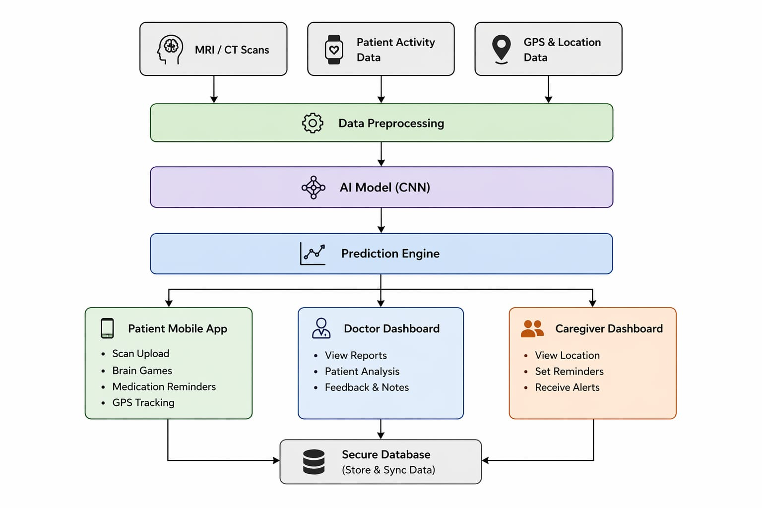
Figure: System Architecture

Expected Outcomes:
- An AI-based early diagnosis of Alzheimer’s using CNN-driven MRI/CT scan analysis for high accuracy detection.
- An intelligent mobile support system with personalized remainders for medication, appointments, and daily task management.
- A cognitive assistance module featuring memory training, pattern recognition, word-recall exercises, and face recognition for identity support.
- Real-time patient safety system using GPS tracking and automated alert notifications for caregivers.
- Centralized healthcare dashboard for doctors to monitor patient reports, imaging results, and overall progress analytics.
References:
[1] Pasqualina Perna, Alessandra Claudi, Fabrizio Stasolla, Raffaele Nappo. The Role of Artificial Intelligence in the Detection and Diagnosis of Neurocognitive Disorders. MDPI Journal, Vol. 13(1), 2026.
[2] Syeda Umme Salma, Chandra Rekha Renduchintala, Isa Siddique, Evelina Sterling, Sweta Sneha. AI-Driven Mental Health Support for Caregivers of Individuals With Alzheimer Disease. JMIR Mental Health, 2026.
[3] Juan Zhou, Yiming Wei, Xiong Li, Weiqiang Zhou, Ruiyang Tao, Yi Hua, Hongwei Liu. A Deep Learning Model for Early Diagnosis of Alzheimer’s Disease Combined with 3D CNN and Video Swin Transformer. Scientific Reports, 2025.
[4] Shania Yoonesi, Ramila Abedi Azar, Melika Arab Bafrani, Shayan Yaghmayee, Haniye Shahavand. Facial Expression Deep Learning Algorithms in the Detection of Neurological Disorders. BioMedical Engineering OnLine, 2025.
[5] Parthasarathi Pattnayak, Tulip Das. Enhanced Hybrid AI-Based Framework for Improving the Detection and Diagnosis of Alzheimer’s Disease. IEEE, 2025.
[6] Ghata Mehta, Nitya Jani, Himanshu Gajera, Rajendra Choudhary. A Multi-CNN Ensemble Method for Early Diagnosis of Alzheimer’s Disease Using MRI Imaging. International Conference on Artificial Intelligence and Machine Vision (AIMV), IEEE, 2025.
[7] Priyanka K, Vikas Benhur Chitla, Aman Aftab, Sumanth Kamath. LSTM-Based Assistance for People with Alzheimer’s Disease. International Conference on Intelligent and Innovative Technologies in Computing, Electrical and Electronics (IITCEE), IEEE, 2025.
[8] Wided Hechkel, Rim Missaoui, Abdelhamid Helali. Early Diagnosis of Alzheimer's Disease Using YOLOv11 Deep Learning Model in MRI Scans. IEEE 22nd International Multi-Conference on Systems, Signals & Devices (SSD), 2025.
[9] Wenxia Zhang, Wenting Xu, Junzhi Duan, Junyu Tang, Qunli Zhu, Xifeng Pi, Jing Huang. Exploring how caregivers of people with Alzheimer’s disease experience role captivity. International Psychogeriatrics, Elsevier, 2025.
[10] Emanuel Raju Vinukonda & B. N. Jagadesh. An integrated deep learning model for early and multi-class diagnosis of Alzheimer's disease from MRI scans. Scientific Reports, 2025.
[11] Wenli Zhang, Yifan Li, Wentao Ren, Bo Liu. Artificial Intelligence Technology in Alzheimer’s Disease Research. Intractable & Rare Diseases Research Journal, 2025.
[12] Emanuel Raju Vinukonda & B. N. Jagadesh. An integrated deep learning model for early and multi-class diagnosis of Alzheimer's disease from MRI scans. Scientific Reports, 2025.
[13] Samah A. Z. Hassan. MemorySona: Illuminating Cognitive Health with Deep Learning – A Mobile Medical App for Alzheimer’s Patients. 2024 6th International Conference on Computing and Informatics (ICCI), IEEE, 2024.
[14] Wenxia Zhang, Wenting Xu, Junzhi Duan, Junyu Tang, Qunli Zhu, Xifeng Pi, Jing Huang. Exploring how caregivers of people with Alzheimer’s disease experience role captivity: A qualitative study. International Psychogeriatrics, Elsevier, 2024.
[15] Kiruthika V R, NirmalaDevi J. AI-Based Smart Assistant System for Alzheimer Patients. 2024 5th International Conference on Electronics and Sustainable Communication Systems (ICESC), IEEE, 2024.
[16] Falah Sheikh, Ahmed Al Marouf, Jon George Rokne, Reda Alhajj. Deep Learning-Based Diagnosis of Alzheimer’s Disease Using Medical Imaging. Diagnostics Journal, 2024.
[17] Subramanian Ganesan. Early Detection of Alzheimer’s Disease Using Artificial Intelligence and Machine Learning: A Comprehensive Review. VIT University, 2024.
[18] Wenli Zhang, Yifan Li, Wentao Ren, Bo Liu. Artificial Intelligence Technology in Alzheimer’s Disease Research. Intractable & Rare Diseases Research, 2023.
[19] A. Khan, S. Hussain, M. Usman, et al., Deep Learning-Based Classification of Alzheimer’s Disease Using MRI Data, IEEE Access, 2023.
[20] S. Rathore, M. Habes, M. A. Iftikhar, Machine Learning Techniques for Alzheimer’s Disease Diagnosis: A Review, Elsevier (Journal of Neuroscience Methods), 2023.

