ENTERPRISE AI
CLINICAL ASSISTANT
Solution Feasibility Implementation Blueprint
Clinical Knowledge + Patient Summary + Governed RAG
Management Demo → Enterprise Pilot → Enterprise Rollout
Version 1.0 | 25 August 2026

Document Control
Item | Value
Title | Enterprise AI Clinical Assistant — Solution Implementation Blueprint
Version | 1.0
Date | 25 August 2026
Audience | Architecture, Engineering, Product, Clinical Safety, Security and Management
Target | Local VS Code management demo with enterprise evolution path
Prototype data | Synthetic patient data only; no real PHI
Clinical position | Clinical information / decision support; not autonomous diagnosis or treatment

Revision History
Version | Date | Change
0.1 | 25-Aug-2026 | Initial architecture baseline
1.0 | 25-Aug-2026 | Formal implementation blueprint

Critical boundary
The source recommends synthetic data for the demo and states that production clinical deployment requires additional security, clinical validation, privacy, regulatory, infrastructure, model governance, integration, disaster recovery and organizational approval. The prototype should demonstrate architectural controls, not claim production HIPAA compliance

Table of Contents
TBD

1. Executive Summary
The Enterprise AI Clinical Assistant is a governed clinical information and summarization solution intended to reduce clinician information-retrieval effort while keeping the clinician in control. The recommended first implementation is a focused vertical slice: authenticated clinician → authorized synthetic patient → structured patient context + approved clinical knowledge → governed AI response → citations, confidence and safety validation.
The source rates synthetic patient data, clinical guideline RAG, patient summarization, citation generation, RBAC, hallucination/fallback, FHIR simulation, agent orchestration and local VS Code deployment as highly feasible for the demo, while identifying real EHR/PACS/LIS integration, production compliance, large-scale concurrency and autonomous clinical decisions as later-phase concerns. fileciteturn1file0L11-L41
Executive positioning
Do not present this as “a chatbot.” Present it as a governed clinical AI architecture in which patient context and approved clinical knowledge are retrieved separately, combined under policy controls, passed to an AI model and validated before the clinician sees the response.

1.1 Primary Use Case
Clinician Patient Summary + Guideline Q&A
- Persona: physician / clinician.
- Scenario: summarize current clinical status and identify relevant guideline considerations.
- Patient context: demographics, diagnoses, medications, allergies, labs, encounters, vital signs and notes.
- Knowledge context: approved hospital guidelines, protocols, clinical pathways and medication policies.
- Output: summary, relevant findings, guideline information, evidence, confidence, missing information and safety/fallback.
- Initial system does not prescribe or make autonomous treatment decisions.

2. Scope and Solution Boundaries

2.1 In Scope
- Synthetic FHIR-like patients
- Clinical guideline/policy ingestion
- Governed hybrid RAG
- Patient Summary and Clinical Q&A
- RBAC and patient-level authorization
- PHI detection concept
- Prompt-injection protection
- Citation validation
- Evidence-based confidence
- Safe fallback
- Audit logging
- Evaluation dataset and KPI dashboard
- Five-page clinician UI

2.2 Out of Scope for First Demo
- Real EHR/PACS/LIS integration
- Real PHI
- Autonomous diagnosis/treatment
- Mobile or voice assistant
- Kubernetes / large microservice estate
- Multi-region disaster recovery
- Thousands of concurrent users
- Production regulatory certification
- Complex workflow automation

2.3 Feasibility Position
Demo feasibility is high. Production clinical deployment is a separate program requiring security, clinical validation, privacy, regulatory, infrastructure, model governance, integration, disaster recovery and organizational approval.

3. Solution Architecture

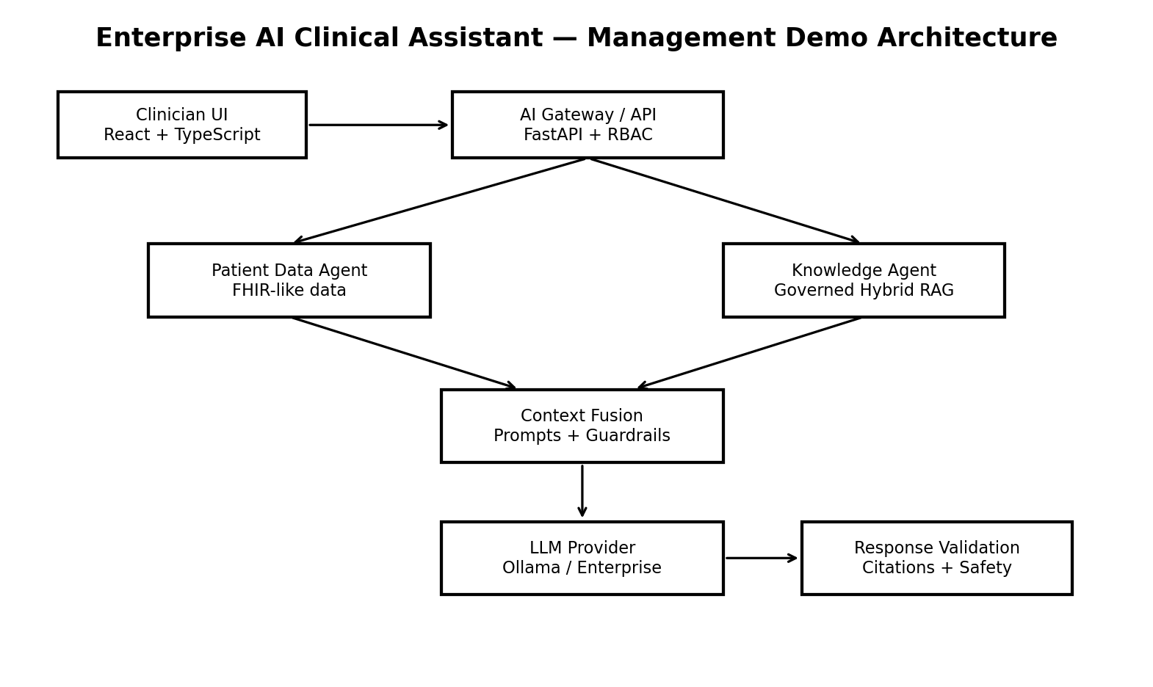
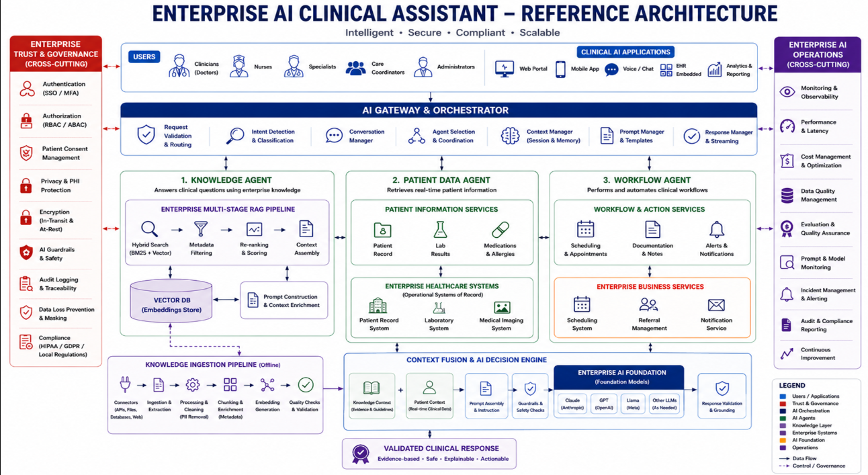
Figure 1. Recommended management-demo architecture. The source target flow is Clinician → Secure Gateway → Patient Context + Clinical Knowledge RAG → LLM → Guardrails/Validation → Cited Clinical Response
JK Question – Judge Model to improvise AI Application TBD by Harish
Knowledge agent – Hospital Policies and guidelines? ( ex: Discharge policies, Filtering, Ranking )- Figure out what else this agent can do?
Patient Agent – Patient historical data, Records, Lab results, Medications etc retervial
Workflow Agent – Scheduling appointments, Doctor notes, notifications
Self Impoving agents – Improvise AI application anomalies, issues, failed records, wrong records , system behaviour

Component | Responsibility | Implementation
Clinician UI | Login, patient view, query, evidence | React + TypeScript + Vite
AI Gateway/API | Validation, auth, RBAC, intent, routing | Python + FastAPI + Pydantic
Patient Data Agent | Controlled structured retrieval | Python + FHIR-like service
Knowledge Agent | Governed clinical retrieval | Python + hybrid RAG
Context Fusion | Combine context, question, role, policy | Python orchestration
Prompt Manager | Versioned prompts and approvals | YAML + metadata
LLM Provider | Generate grounded response | Ollama initially; enterprise provider later
Response Validation | Claims, citations, safety, fallback | Python rules + Pydantic
Audit/Monitoring | Traceability and operational metrics | PostgreSQL + OpenTelemetry

3.1 Agent Strategy
For the first demo, implement Knowledge Agent + Patient Data Agent. Add the Workflow Agent later. This avoids unnecessary agentic complexity and creates a safer, easier-to-explain architecture.

3.2 Human-in-the-Loop Workflow
Future referral/discharge workflows should generate a DRAFT, followed by Clinician Review → Approve → Submit. No external workflow action should be automatically submitted in the first demonstration.

4. Technology Stack

Refer to other Docs for Tech stack

Layer | Technology | Role
Frontend | React + TypeScript + Vite | Clinician UI
API | Python + FastAPI + Pydantic | Gateway and validation
Orchestration | LangGraph or simple Python | Agent routing
RAG | LangChain/LlamaIndex + custom retrieval | Retrieval implementation
Embeddings | Sentence Transformers | Local embeddings
Data + Vector | PostgreSQL + pgvector | Relational + vector search
LLM — demo | Ollama | Local model inference
LLM — production option | AWS Bedrock | Enterprise model provider
Authentication | Keycloak | Local identity/JWT
Authorization | RBAC + policy layer | Access control
PHI detection | Presidio + custom rules | Detection/masking concept
Healthcare format | FHIR JSON | Interoperability
Documents | PDF/DOCX/TXT | Knowledge sources
Observability | OpenTelemetry + structured logs | Tracing/metrics/logs
Testing | Pytest | Automated tests
Evaluation | RAGAS / DeepEval / custom | AI quality evaluation
Version control | Git | Source control

The source recommends PostgreSQL + pgvector for the demo because patient data, clinical documents, metadata, embeddings and audit records can remain in one database; later, retrieval can move to a dedicated search/vector platform if required.

4.1 Platform-Agnostic Architecture
Use capability labels such as AI Orchestration Layer, LLM Provider and Vector Store rather than making LangChain, Ollama or pgvector the architecture itself. This preserves platform independence.

5. Data Architecture and FHIR Model

5.1 Synthetic Patient Model
- Demographics
- Conditions
- Allergies
- Medications
- Observations
- Encounters
- Clinical notes
- Diagnostic reports

5.2 FHIR-like Examples
{
"resourceType": "Patient",
"id": "P1001",
"name": [{"family": "Synthetic", "given": ["John"]}],
"gender": "male"
}
{
"resourceType": "Observation",
"id": "OBS001",
"subject": {"reference": "Patient/P1001"},
"code": {"text": "HbA1c"},
"valueQuantity": {"value": 8.2, "unit": "%"}
}

5.3 Database Schema
Domain | Tables / entities
Identity | users, roles, permissions
Patient | patients, patient_conditions, patient_medications, patient_allergies, patient_observations, patient_encounters
Knowledge | clinical_documents, document_chunks, document_embeddings
Conversation | conversations, messages
Audit | audit_logs
AI telemetry | ai_requests, ai_responses
Evaluation | evaluation_cases

5.4 Patient Data Agent Rule
The LLM should not directly query SQL. Expose controlled tools such as get_patient(), get_conditions(), get_medications(), get_allergies(), get_observations() and get_encounters(), returning structured data. This makes access control enforceable at the tool boundary.

6. Governed Clinical Knowledge RAG

6.1 Ingestion Pipeline
- Connector / file intake
- PDF/DOCX extraction
- Cleaning
- Recursive or semantic chunking
- Embedding generation
- Quality checks
- Storage in PostgreSQL + pgvector

6.2 Metadata
Field | Example
Document ID | GUIDE-DM-002
Title | Hospital Diabetes Management Guideline
Version | 2.1
Status | APPROVED
Effective date | 2026-01-01
Expiration date | Policy controlled
Department | Endocrinology
Classification | Clinical Guideline
Page/section | Page 12 / Glycemic Management

6.3 Retrieval Policy
status = APPROVED
AND effective_date <= today
AND expiration_date > today
This is governed RAG: retrieve relevant clinical knowledge only when it is approved and current. fileciteturn1file8L1426-L1468

6.4 Hybrid Retrieval
Stage | Design
Keyword search | PostgreSQL full-text search
Vector search | pgvector similarity
Candidate merge | Combine semantic + keyword results
Metadata filter | Approved/current/department
Re-ranking | Cross-encoder or equivalent
Context assembly | Top evidence chunks with provenance

The source provides configurable demo weights such as vector similarity 60%, keyword relevance 20%, authority 10% and recency 10%; these are implementation parameters, not clinical standards.

7. AI Gateway, Agents and Prompt Design
Request
-> Validate
-> Authenticate
-> Authorize
-> Intent Classification
-> Agent Selection
-> Context Retrieval
-> Prompt Assembly
-> LLM
-> Response Validation
-> Audit
-> Response

7.1 Intent Taxonomy
Intent | Example | Agent
PATIENT_SUMMARY | Summarize P1001 | Patient + Knowledge
CLINICAL_QA | Relevant guideline considerations? | Knowledge + Patient if needed
PATIENT_LOOKUP | Show recent observations | Patient
GUIDELINE_SEARCH | Find diabetes guideline | Knowledge
WORKFLOW_REQUEST | Prepare referral summary | Future Workflow
UNSUPPORTED | Unsupported request | Fallback

7.2 System Prompt Policy
You are a clinical information assistant.
1. Use only supplied patient data.
2. Use only retrieved approved knowledge.
3. Do not invent patient facts.
4. Do not fabricate citations.
5. If evidence is insufficient, say so.
6. Do not make autonomous treatment decisions.
7. Distinguish patient facts from guideline information.
8. Cite every clinical knowledge claim.
9. Escalate uncertainty to clinician review.

7.3 Prompt Manager
Artifact | Required metadata
Prompt ID | Unique identifier
Version | Version number
Created by | Author
Created date | Timestamp
Approved by | Approver
Status | Draft / Approved / Retired

Recommended prompt files: patient_summary.yaml, clinical_qa.yaml, discharge_summary.yaml and fallback.yaml. fileciteturn1file7L1089-L1118

8. Security, Privacy and Governance

8.1 RBAC
Role | Patient data | Guidelines | Summary | Workflow | Audit/Admin
Doctors | Yes | Yes | Yes | Yes | Yes
Clinicians | Yes | Yes | Yes | No | No
Care Coordinators | Yes | Yes | Yes | No | Limited
Physician | Yes | Yes | Yes | Yes | Limited
Nurse | Limited | Yes | Yes | Limited | Limited
Administrator | No clinical data | Configuration | No | No | Yes

Access path: Identity → Role → Permission → Patient Access → AI Context.

8.2 PHI Protection Concept
User Input
->
PHI Detector
->
Policy
->
Allowed / Masked / Blocked
- Name
- DOB
- Phone
- Email
- Address
- MRN
- SSN
Synthetic records remain mandatory for the prototype. The design demonstrates that PHI protection is considered before AI processing.

8.3 Audit Events
Field | Example
user_id | Dr. Smith
role | Physician
patient_id | P1001
intent | PATIENT_SUMMARY
action | Clinical Query
result | ALLOWED / BLOCKED
reason | Permission denied / unsupported
timestamp | ISO timestamp
request_id | Correlation ID

8.4 Governance Pillars
Security | Safety | Quality
RBAC | Guardrails | Evaluation
Consent | Fallback | Grounding
Encryption | Human review | Citations
Audit | PHI controls | Accuracy

The source organizes governance around Security, Safety and Quality, with Monitoring and Continuous Improvement across them

9. Guardrails, Validation and Safe Fallback

9.1 Response Validation
- Check unsupported facts.
- Verify citations exist and map to retrieved evidence.
- Check references to unavailable patient information.
- Check safety-policy violations.
- Return PASS or FALLBACK.
- Record the result in audit logs.
This validation chain is explicitly identified in the source as a key management-demo component.

9.2 Evidence-Based Confidence
Level | Criteria
HIGH | Relevant patient data; ≥2 strong evidence chunks; approved sources; no major conflicts; no critical missing fields
MEDIUM | Some evidence; limited patient information; some uncertainty
LOW | Weak retrieval; missing information; conflicting evidence; unsupported question

Confidence is an evidence-based indicator, not an LLM probability or clinical reliability score.

9.3 Safe Fallback
Fallback example
I cannot provide a grounded answer because no approved clinical knowledge source relevant to this question was retrieved. Please consult the appropriate clinical guideline or specialist. Confidence: LOW. Action: CLINICIAN REVIEW REQUIRED.

9.4 Break-It Test Suite
Test | Scenario | Expected result
Hallucination | Ask about nonexistent ABC-999 policy | NOT FOUND / no approved evidence
Missing data | Remove HbA1c and ask for control | State unavailable; never infer
Unauthorized access | Nurse accesses restricted P2001 | ACCESS DENIED + audit
Prompt injection | Malicious instructions inside clinical note | Treat as data; block instruction
Conflicting guidelines | v1 and v2 disagree | Current approved version or explicit conflict

10. API and UI Design
Method | Endpoint | Purpose
POST | /api/auth/login | Authenticate
GET | /api/patients | Authorized patient search
GET | /api/patients/{patient_id} | Patient data
POST | /api/clinical/query | Governed clinical query
POST | /api/patient/{patient_id}/summary | Clinical summary
POST | /api/documents/ingest | Knowledge ingestion
GET | /api/audit | Audit events
GET | /api/health | Health check

10.1 Response Contract
{
"answer": "...",
"citations": [],
"confidence": "HIGH",
"grounded": true,
"safety_status": "PASS",
"fallback": false
}
The structured response contract is intended to make frontend rendering and automated validation straightforward. fileciteturn1file7L1120-L1134

10.2 Frontend Pages
Page | Capabilities
Login | Username/password; demo identities
Dashboard | Patients, recent queries, safety/system status
Patient View | Demographics, conditions, medications, allergies, labs, encounters
AI Assistant | Question, summary, evidence, confidence, safety
Governance Dashboard | Requests, grounded responses, citations, fallbacks, blocked requests, latency, evaluation

11. Requirements
Category | Requirements
Functional | FR-001 Login; FR-002 Patient search; FR-003 Patient summary; FR-004 Clinical Q&A; FR-005 Guideline retrieval; FR-006 Citations; FR-007 Confidence; FR-008 Fallback; FR-009 Audit; FR-010 RBAC
Security | SR-001 Authentication; SR-002 Authorization; SR-003 Patient access; SR-004 Encryption; SR-005 Audit; SR-006 PHI detection; SR-007 Session management
AI | AI-001 Grounded generation; AI-002 Citations; AI-003 Retrieval filtering; AI-004 Prompt versioning; AI-005 Hallucination mitigation; AI-006 Prompt injection protection; AI-007 Human oversight
Performance | PERF-001 Target response latency; PERF-002 Retrieval latency; PERF-003 Concurrent requests; PERF-004 Timeout handling
Compliance | COMP-001 Auditability; COMP-002 Data minimization; COMP-003 Access control; COMP-004 Retention; COMP-005 Traceability
UX | UX-001 Simple workflow; UX-002 Evidence visibility; UX-003 Clear confidence; UX-004 Safety warnings; UX-005 Minimal clicks

Requirement categories and identifiers follow the source blueprint.

12. Evaluation and KPIs

12.1 Evaluation Set
- 10 patient summary questions
- 10 guideline questions
- 5 missing-data questions
- 5 hallucination questions
- 5 unauthorized-access tests
- 5 prompt-injection tests

12.2 Metrics
Dimension | Metrics
Retrieval | Precision@K, Recall@K, MRR
Generation | Citation correctness, citation completeness, groundedness, answer relevance
Safety | Unauthorized access blocked %, hallucination fallback %, prompt injection blocked %, unsupported-question refusal %
Performance | Average latency, P95 latency, token usage, cost/request

The source recommends 30–50 test questions and these retrieval, generation, safety and performance measures. fileciteturn1file3L540-L579

12.3 Business KPIs
Business objective | Pilot KPI
Reduce chart review time | Time to summary
Faster guideline access | Search-to-answer time
Improve trust | Citation coverage
Reduce hallucination | Unsupported-answer refusal rate
Protect PHI | Unauthorized request block rate
Improve productivity | Clinician task completion time
Improve consistency | Guideline-grounded response rate

These should be treated as pilot-validation KPIs, not claims of clinical improvement from the prototype

13. Observability and Governance Dashboard
Telemetry | Purpose
request_id | End-to-end correlation
user_id | Actor traceability
patient_id | Patient traceability
intent | Routing analytics
retrieval_time | RAG performance
LLM_time | Model performance
total_time | User-perceived latency
retrieved_documents | Evidence traceability
model | Provider/version
token_count | Usage/cost
confidence | Evidence quality
fallback | Safety behavior
safety_result | Governance outcome

OpenTelemetry is recommended as a standards-based option for traces, metrics and logs. fileciteturn1file7L1157-L1178
Dashboard metric | Illustrative demo value
Requests | 127
Successful responses | 121
Fallback responses | 6
Grounded responses | 96%
Citation coverage | 98%
Unauthorized requests | 4
Blocked requests | 4
Average latency | 2.4 sec
Hallucination test score | 94%

Illustrative figures above are demo values and must be labeled as such.

14. Local Implementation and Project Structure
clinical-ai-assistant/
├── frontend/src/{components,pages,services,types}
├── backend/app/
│ ├── api/{auth,patients,clinical,governance}.py
│ ├── agents/{knowledge_agent,patient_agent,workflow_agent}.py
│ ├── rag/{ingestion,chunking,embeddings,retrieval,reranking}.py
│ ├── llm/{model,prompts}.py
│ ├── security/{rbac,phi,guardrails}.py
│ ├── patients/{fhir,synthetic_data}.py
│ ├── evaluation/{test_cases,metrics}.py
│ └── audit/logger.py
├── data/{patients,guidelines,policies}
├── database/{schema.sql,seed.sql}
├── tests/
├── docker-compose.yml
├── .env.example
└── README.md
Service | Local target
Frontend | localhost:5173
FastAPI | localhost:8000
PostgreSQL + pgvector | Local
Keycloak | Local
Ollama | Host-local

The source proposes Docker Compose for PostgreSQL and Keycloak, with Ollama running separately on the host for the local demo.

15. Implementation Roadmap
Phase | Duration | Deliverables
0 — Architecture | 1–2 days | Architecture, use case, requirements, data model, technology choices
1 — Synthetic Data | 2–3 days | 5–10 patients with conditions, medications, allergies, labs, encounters, notes
2 — Knowledge Ingestion | 2–3 days | PDF → text → chunks → embeddings → pgvector
3 — RAG | 2–3 days | Query → retrieval → re-ranking → context → LLM
4 — Patient Summary | 2–3 days | Patient Agent → context → LLM → summary
5 — Security | 2–3 days | Login, RBAC, patient access, audit, PHI detection
6 — Safety | 2–3 days | Fallback, citations, prompt injection, missing data, unauthorized access
7 — UI | 2–4 days | Login, dashboard, patient, assistant, governance
8 — Evaluation | 2–3 days | 30–50 test cases + dashboard

The phase sequence is designed to build a working vertical slice incrementally instead of creating an oversized platform before the core use case works

15.1 Delivery Gates
Gate | Exit criteria
G1 | Architecture/use case/data model approved
G2 | Synthetic patient set validated
G3 | Approved/current knowledge retrieval with citations
G4 | Patient summary works end-to-end
G5 | RBAC, patient access and audit pass
G6 | Safety/fallback tests pass
G7 | Five-page UI + management demo complete
G8 | Evaluation baseline and limitations documented

16. Management Demo Runbook
- Explain the business problem: clinicians review multiple patient data sources and guidelines.
- Login as Dr. Smith / Physician and show authentication + authorization.
- Select synthetic Patient P1001.
- Show conditions, medications, labs, allergies and recent encounters.
- Generate Clinical Summary.
- Show Patient Agent → Knowledge Agent → RAG → Context Fusion → LLM → Validation → Response.
- Open View Evidence and show guideline version/page and patient evidence.
- Ask an unsupported question and demonstrate safe refusal.
- Attempt unauthorized patient access and show ACCESS DENIED + audit event.
- Remove a critical lab and demonstrate no inference.
- Inject malicious instructions in a clinical note and demonstrate prompt-injection blocking.
- Open Governance Dashboard and show demo KPIs.
- Close with the management message and enterprise roadmap.

16.1 Management Takeaway
Closing statement
We built a governed clinical AI architecture where patient context and approved clinical knowledge are retrieved separately, combined under policy controls, passed to an AI model, and validated before a clinician sees the response. fileciteturn1file1L332-L342

17. Enterprise Evolution

Level 1 — Management Demo
- Synthetic Patients
- Clinical Guidelines
- RAG
- Patient Summary
- Citations
- RBAC
- Fallback
- Audit

Level 2 — Enterprise Pilot
- FHIR
- EHR
- Enterprise IAM
- Production vector/search
- Model gateway
- Monitoring
- Clinical evaluation
- Security testing

Level 3 — Enterprise Rollout
- Multi-hospital / clinic scale
- Thousands of users
- Multi-region HA
- Disaster Recovery
- Enterprise SIEM
- AI Governance
- Clinical Safety Program
- Continuous Evaluation
Load Balancer
-> API Gateway
-> Multiple FastAPI instances
-> Session / Cache
-> Agent Services
-> PostgreSQL Cluster
-> Vector / Search Cluster
-> Model Gateway
-> LLM Infrastructure
- Horizontal scaling
- Caching
- Async processing
- Queueing
- Connection pooling
- Read replicas
- Vector indexing
- Model routing
The source describes these as future enterprise scaling mechanisms and notes HNSW plus PostgreSQL replication/partitioning strategies as possible pgvector scaling approaches depending on workload

18. Risks, Assumptions and Mitigations
Risk | Impact | Mitigation
Prototype mistaken for production | High | Explicit boundaries; synthetic data; clinician-review language
Clinical hallucination | High | Governed RAG, citation validation, fallback, evaluation
Outdated guideline | High | Approved/current metadata filtering
Unauthorized patient access | High | RBAC + patient-level authorization + audit
Prompt injection in notes | High | Treat retrieved text as data; validation and blocking
Missing critical patient data | High | Explicit missing-data response; never infer
Provider lock-in | Medium | LLM provider abstraction
Vector infrastructure complexity | Medium | PostgreSQL + pgvector initially
Laptop performance | Medium | Local baseline + measured latency
Evaluation gaps | Medium | 30–50 structured cases

18.1 Assumptions
- All patient data is synthetic.
- Clinical knowledge documents are synthetic/fictitious demonstration sources.
- The assistant is a clinical information and summarization aid.
- Production vendors and controls are selected during the enterprise pilot.
- Evaluation thresholds are pilot parameters, not clinical standards.

19. Final Deliverables and Acceptance Criteria
# | Deliverable | Acceptance outcome
1 | Feasibility Study | Scope and boundaries validated
2 | Business & Clinical Use Case | Clear clinician problem/value
3 | Requirements | Traceable implementation backlog
4 | Solution Architecture | End-to-end component/data flow
5 | Technology Mapping | Platform-agnostic choices
6 | Synthetic Patient Dataset | FHIR-like demo data
7 | Clinical Knowledge / RAG | Governed evidence retrieval
8 | Working Local Application | React + FastAPI + PostgreSQL + LLM
9 | AI Safety & Governance Suite | Break-it tests + evaluation
10 | Management Demo + KPI Dashboard | Executive-ready demonstration

19.1 Recommended Build Order
- Synthetic patients
- Clinical guideline ingestion
- PostgreSQL + pgvector RAG
- Patient Summary
- Citations/evidence
- RBAC
- Safety/fallback
- Clinician UI
- Governance dashboard
- Evaluation + management demo
This follows the source recommendation to formalize the blueprint first and then build incrementally from synthetic patients through guideline ingestion, RAG, patient summary, citations, RBAC, safety/fallback and UI

Appendix A — Reference Architecture Mapping
Capability | Demo | Production candidate
Users / Portal | React | Enterprise web portal
Authentication | Keycloak | Enterprise IAM / SSO / MFA
Authorization | RBAC middleware | RBAC + ABAC / policy engine
Consent | Mock consent table | Enterprise consent service
PHI protection | Presidio + rules | Enterprise DLP
Encryption | HTTPS + DB encryption concept | TLS + KMS + encrypted storage
AI Guardrails | Python rules | Enterprise AI safety
Audit | PostgreSQL/logs | SIEM
AI Gateway | FastAPI | API Gateway + AI Gateway
Knowledge Agent | Python + RAG | Agent platform
Hybrid Search | pgvector + FTS | Search/vector platform
Patient Agent | Python | FHIR service
Patient record | FHIR JSON | EHR/FHIR server
Workflow Agent | Draft generation | Workflow engine
Knowledge ingestion | Local files | ETL/data platform
Embeddings | Sentence Transformers | Enterprise embedding model
Model | Ollama | Enterprise model platform
Response validation | Pydantic + rules | AI validation service
Monitoring | Structured logs | OpenTelemetry + enterprise monitoring
Evaluation | Test dataset | Enterprise AI evaluation

Appendix B — Clinical Safety Position
Safety position
The assistant supports clinical information retrieval and summarization. It is not an autonomous diagnostic or treatment engine. Clinician review remains required for clinical interpretation and decisions.

Appendix C — Source Basis
This document is based on the uploaded Clinical AI Assistant solution material, which covers feasibility, use case, architecture, technology, synthetic FHIR-like data, governed RAG, agents, security, guardrails, evaluation, observability, implementation phases and management demonstration. fileciteturn1file5L866-L887

