SWIGGY BUILDERS CLUB
Household Daemons
Concept, architecture, and build plan — for review

What this is A record of the idea-generation process, the direction we landed on, the proposed architecture and phased build plan, and an honest answer to where machine learning fits. Written to be handed to a few people for a reality check before any code is written.
Ask Sanity-check the direction (§4), the architecture (§5), and the ML scoping (§8). Specific questions for reviewers are collected in §11.
Context Built on Swiggy’s Builders Club MCP access — three servers (Food, Instamart, Dineout), 48 tools, read + write. Compiled 24 August 2026.

Contents

1. Executive summary
Every Swiggy MCP project we could find — published or in the whitelist queue — is a new surface for placing an order: a terminal, a voice call, a WhatsApp thread, a smart-home add-on. None of them remember anything between sessions, and none of them act unless someone opens the app and asks.
The proposal here is the piece nobody has built: a system that holds state about a household — what it usually eats, what it has committed to, what it is running low on — and runs small scheduled processes ("daemons") against that state, each one ending in a real Swiggy transaction rather than a suggestion.

The core design rule
The agent decides WHAT. Code decides WHETHER and WHEN. Reasoning about food, inventory, and timing is genuinely agentic (LLM-driven). Whether a transaction is allowed to fire, and when, is deterministic code with no model in the loop.

Three daemons, one substrate
Daemon | Vertical | Terminal action
Standing Plans | Dineout | Books a recurring social commitment autonomously — only free reservations, so nothing is spent without a human.
Kitchen Entropy | Instamart | Tracks pantry depletion and spoilage risk; proposes a restock cart, one tap to place.
Dead Man's Switch | Food | Orders to someone else’s address when their own ordering activity goes quiet — framed as a nudge to call, not an alarm.

2. What is already being built on Swiggy MCP
Surveyed via the public manifest repo, its whitelist-request issues, and published write-ups, as of August 2026.

Project | What it is
consolestore.in | Terminal + TUI ordering client. Well-engineered (OAuth+PKCE, kitty graphics, MCP skills) but unshipped — 0 installs, page marked preview-only.
RecipeCart | Recipe (video or text) → Instamart cart, pantry-aware, "missing ingredients only." One-directional: recipe to cart, never touches Food or Dineout.
rish106 household orchestrator | Multi-agent planner across all three verticals for a single occasion (e.g. a birthday) — flowers timed before cake, offer stacking. Single-shot: plans one event, then stops.
Voice / phone / WhatsApp agents | Several independent builds putting a conversational layer over Food ordering via SIP or WhatsApp.
Home Assistant integration | Order groceries via smart-home voice commands.
Third-party platforms | General-purpose agent platforms requesting production whitelisting to add Swiggy as one of many integrations.

The pattern
Every project above is a surface — a new place to type or speak an order. None persist state between sessions. None run anything when the user is not actively present.
The field is competing on where you type. Nobody is competing on what the system knows, or what it does unprompted.

3. What the API actually allows
Several early ideas were reshaped or dropped after checking them against the real tool contracts rather than assumptions. Worth stating plainly, since it explains some of the choices later in this document.

Constraint | Consequence
No dish-level ratings anywhere | Cannot rank or filter items within a menu by quality. Any "these are the six good dishes" feature is not buildable on this API.
Dineout has no menus or item prices | Dine-in cost is only ever an estimate: costForTwo × deal%. No dish-level price comparison against delivery.
No cross-vertical restaurant join | Matching the same restaurant across Food and Dineout means fuzzy name+coordinate matching — no guaranteed coverage.
book_table: free reservations only | Paid Dineout deals are rejected outright. Turns out to be useful: it is the fact that makes autonomous booking safe (see §6).
₹1000 cap on place_food_order | Any Food order at or above ₹1000 is rejected — the MCP surface is explicitly scoped for beta use.
Instamart coupons gated; Food coupons are not | Discount logic cannot be assumed symmetric across servers.
48 tools, near-identical verbs across 3 servers | A single agent holding all tools at once loses track of which server it is calling — a documented failure mode in a public build report (§5.3).

4. Ideas explored
The brainstorm ran in two passes. The first pass produced grounded product ideas and is included briefly for completeness. The second pass, at your request, pushed for something "only a crazy person would think of" — ten ideas, evaluated against a single test: does it end in a real transaction, or does it end in an opinion?

4.1 First pass — considered and set aside
Idea | Why set aside
Honest menu (surface only the good dishes) | Killed outright — requires dish-level ratings, which do not exist on any tool.
Cook-vs-order arbitrage with pack-size amortisation | Survives the API, but self-terminating: teach the heuristic twice and the user no longer needs the tool.
Three doors, one meal (Food vs Instamart vs Dineout price comparison) | Wounded, not dead — Dineout’s missing item prices force meal-level rather than dish-level comparison.

4.2 Second pass — ten unconventional ideas
# | Idea | What it does | Type
1 | Ghost Kitchen Detector | Cross-reference menus, prices, and coordinates to expose which "restaurants" are one kitchen operating six brands. | Sensor
2 | Congestion Map | Poll ETA over time as a proxy for kitchen load — infer when a restaurant is rushed (and likely cooking worse). | Sensor
3 | Dead Man's Switch | Order food to a distant family member when their ordering activity goes quiet — a nudge to call, food as the softener. | Actuator
4 | Long-Distance Dinner | Two accounts, two cities — orders timed to land together so people eat "together" apart. | Actuator
5 | Price Archaeology | Track menu prices daily; expose delivery markup, silent price creep, and portion shrinkflation over time. | Sensor
6 | CI → Chai | A failed build orders chai; a Friday deploy orders samosas. Food as a physical notification channel. | Actuator (stunt)
7 | Kitchen Entropy Engine | Model the pantry as decaying inventory; surface a spoilage countdown that resolves into a restock order. | Actuator
8 | Food Autobiography | Order history read back as a diary — life events have legible food signatures. | Sensor
9 | 3AM Atlas | A verified map of what is genuinely open in the dead hours, for night-shift workers and insomniacs. | Sensor
10 | Pay It Forward | Buy a meal for someone who is not the user and not known to them — a shelter, a guard, a site crew. | Actuator

The filter that mattered most
Swiggy’s own framing for this program is transactional — agents that place orders, book tables, buy groceries. A submission that only observes and never acts is off-thesis, however clever.
Sorted against that filter: the four "Sensor" ideas (1, 2, 5, 8, 9) don’t end in a transaction on their own. They are not dropped — they become inputs that make the Actuator daemons smarter, rather than standalone products. See §6.

5. Proposed direction: Household Daemons
Not a router that dispatches a prompt to the right Swiggy vertical — that pattern is already crowded (it’s rish106’s build, a published multi-agent write-up, and Swiggy’s own starter recipe, "Plan my evening"). Instead: a persistence layer plus a scheduler, with small autonomous processes running on top of it.

Why "daemon," specifically
An operating system is not defined by having a router. It’s defined by three things nothing in the current field has: a filesystem (state that survives the session), daemons (processes that run without being asked), and a scheduler (things that fire on time or event, not on prompt). Every one of the ten ideas that felt genuinely novel turned out to need exactly this substrate — which is a strong signal it’s the right foundation rather than a coincidence.

The two-tier consent model
This is the piece that makes autonomy safe rather than reckless, and it falls directly out of a constraint we initially read as a limitation:
- Tier A — autonomous. Free Dineout reservations only (book_table rejects paid deals anyway). Nothing is ever spent without a human, so nothing needs approval.
- Tier B — consent required. Anything that spends money (Food, Instamart) generates a proposal, pauses, and waits for a single tap. This also matches the tool contract directly: place_food_order’s own description mandates explicit confirmation before it is called.

Why this beats being one more surface
A surface has to be summoned — you have to remember it exists, open it, and type. That is not a habit, it is a chore with better UX.
A daemon shows up. It earns its place by acting during the time nobody was thinking about it. The transactions still happen — they are simply initiated by the system noticing something, not by a person remembering to ask.

6. Architecture
Six domains, split along what has to be uniform (spine, consent, safety) versus what is allowed to vary (individual daemon logic).

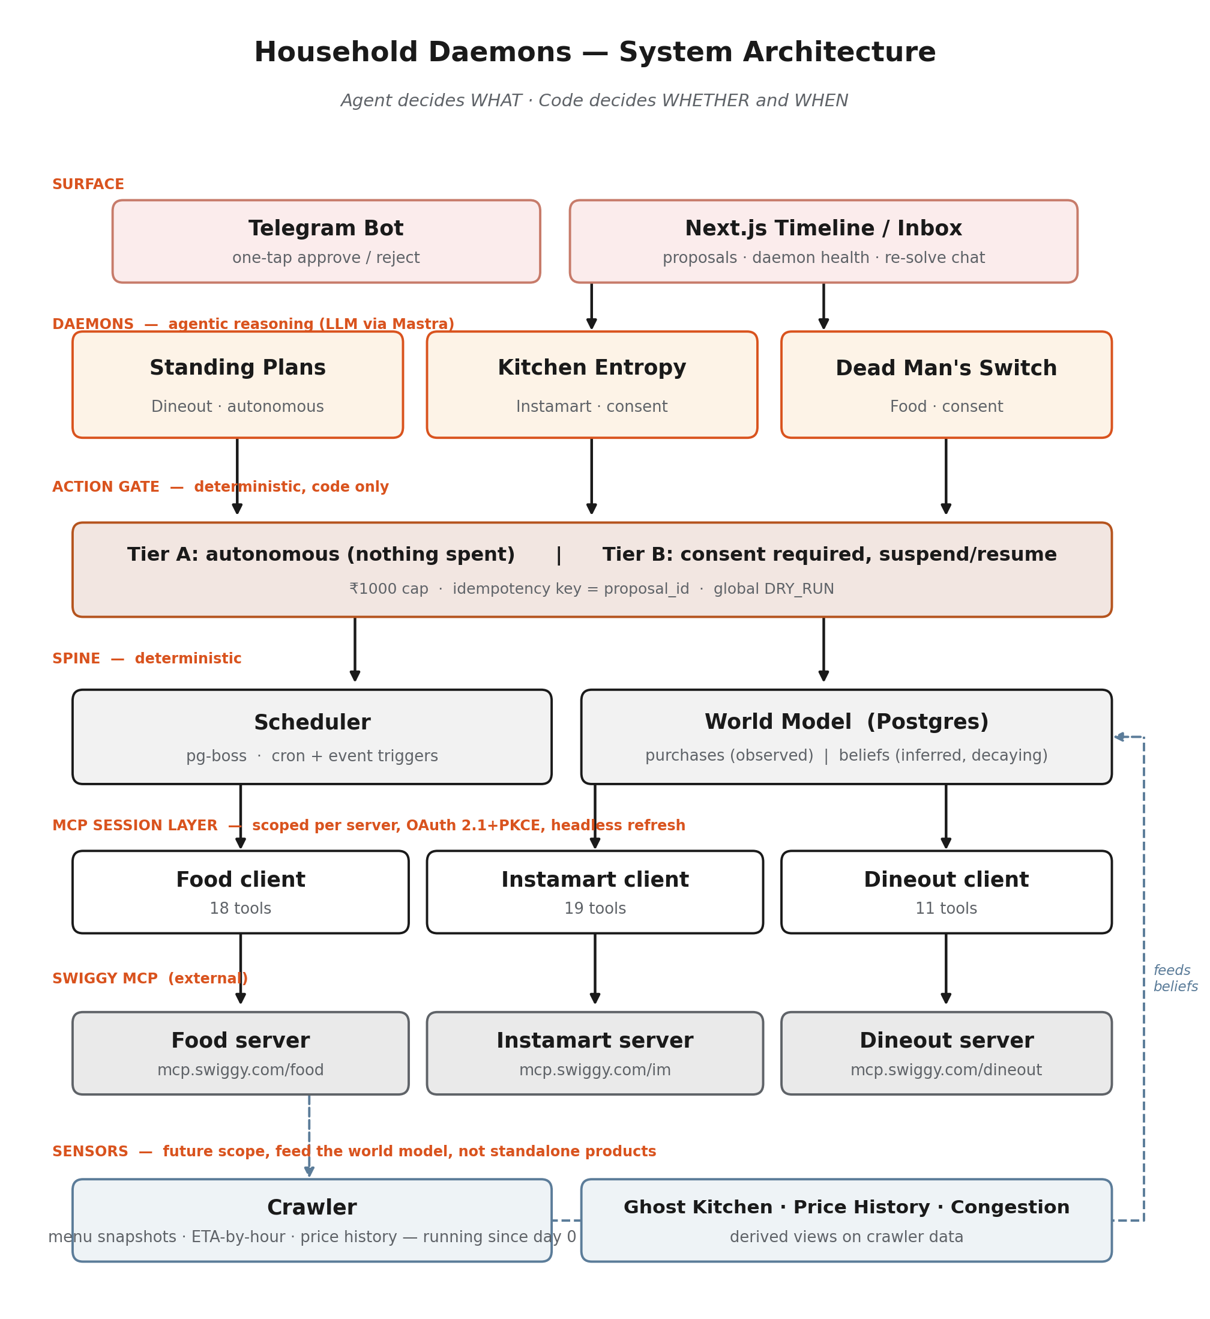

Domain | Owns | The hard part
MCP session layer | OAuth+PKCE, refresh, three separate per-server clients | A daemon firing at 3am cannot do a browser handoff — headless refresh has to actually work, persisted to the DB.
Scheduler | Cron + event triggers, run history, idempotency | place_food_order is not idempotent. A retried job that double-orders is the worst class of bug this system can ship.
World model | Pantry beliefs, commitments, people, addresses | Nothing is directly observed. Purchases are seen; consumption is inferred, and that inference has to carry honest uncertainty.
Action gate | The single mutation path — both tiers, dry-run mode | Every daemon must go through it. If mutation logic leaks into individual daemons, the safety model stops being true.
Daemons | Trigger → proposal → terminal action | Deliberately the easy part, once the four domains above exist. Pluggable by design.
Surface | Timeline, one-tap confirm, notifications | Kept deliberately thin and built last, so it never becomes the thing the differentiation rests on.

A structural side-benefit
The 48-tool attention-collapse problem — documented publicly, where a single agent holding every tool called the wrong server and hallucinated a cart ID — doesn’t apply here by construction. Every daemon-path agent is scoped to exactly one server’s tools (at most 19), because the daemon already knows which vertical it belongs to. A router across all three only appears on the small interactive path (e.g. "I’m not cooking tonight, re-plan"), not on the daemon path.

7. Build plan
Five phases. The spine is built crude-but-real first, proven on the cheapest possible daemon, then stress-tested by a second daemon whose state is genuinely harder — deliberately, to find where the first abstraction breaks while there is still only one thing to fix.

Phase 0 — Ground
- Repo, Postgres, migrations.
- MCP session layer: OAuth 2.1+PKCE, tokens persisted, headless refresh proven across a process restart. The single most load-bearing task in the whole plan.
- Crawler running from day one — menu snapshots, ETA-by-hour, price history. The only component whose value is a pure function of elapsed time; a month started today can’t be replicated by someone starting next month.
- Simulation harness — a fake clock plus recorded MCP responses, so a weekly daemon can be iterated on in minutes, not days.

Phase 1 — Spine + first daemon
- Scheduler (pg-boss): cron + event triggers, run history, retries.
- Action gate: both consent tiers, ₹1000 cap check, idempotency keyed on proposal_id, global dry-run flag.
- World model, minimal — commitments only, no pantry yet.
- Daemon: Standing Plans (Dineout) — smallest possible state, exercises the full spine including the autonomous path, and every mistake here is free since no money moves.
- Telegram bot for notify + one-tap confirm.

Phase 2 — The abstraction test
- Daemon: Kitchen Entropy (Instamart) — full probabilistic pantry, pack-size amortisation, the first real Tier-B consent flow.
Expect Phase 1’s interfaces to not quite fit here. That’s the point of sequencing it second: better to find the wrong abstraction with one daemon built than with two.

Phase 3 — Third daemon + interactive path
- Daemon: Dead Man's Switch (Food) — ordering to another address, triggered by absence rather than presence.
- Interactive re-solve — the one place a router across all three servers appears, kept deliberately small.

Phase 4 — Surface and demo
- Timeline, proposal inbox, daemon health — thin, and last on purpose.
- Demo spine: show several daemons already running — price history accumulating, a spoilage countdown ticking, a booking that happened overnight. Visibly a different category of object than a chat window that orders faster.

8. Where does ML / AI / DL fit — and is it needed?
Short answer
Generative AI (an LLM) is already load-bearing and central to the design — it does the reasoning in the world model and the daemon proposals. That is genuinely agentic AI, not a bolt-on.
Classical trained ML/DL is NOT needed for the scoped v1. The honest reason: those models need historical data to train on, and this system is what generates that data. Training one on day one means training on nothing.
There are 2–3 specific places where a trained model would legitimately outperform the LLM later, once real usage history exists. Those are listed below as deliberate future scope, not omissions.

8.1 What is AI already, in the v1 design
Where | What kind of AI, and why it has to be there
World-model inference | Given three months of purchases, household size, and today’s date — what is probably depleted, what is about to spoil. This is open-ended reasoning over unstructured signal, not a formula. LLM-appropriate.
Daemon proposal construction | Multi-step, tool-using, error-recovering: search products, compare pack-size variants, compute amortised cost, check cart, apply coupons. Genuinely agentic — this is what "agentic framework at the core" means in this design.
Interactive re-solve | Free-text input ("not cooking tonight") reshaping a plan across constraints. Needs language understanding and multi-step tool use.

8.2 Why not add trained ML/DL now
- Cold start is fatal for training: a model needs the very usage history this system hasn’t generated yet. An LLM with heuristics degrades gracefully with no data; a trained model without data doesn’t run at all.
- The heuristic version is honestly probably good enough for v1 — exponential decay curves for shelf life, rule-based confidence — and is far easier to explain in a demo than a model’s internals.
- Every hour spent on a training pipeline before Phase 2 exists is an hour not spent proving the spine works, which is the actual differentiation.

8.3 Legitimate future scope — after the spine is proven
Capability | Model type | Why it waits
Depletion / shelf-life prediction | Time-series or survival model per product per household | Needs months of real purchase intervals per household to beat a hand-set decay curve. Exactly the data Phase 0’s crawler and Phase 1–2’s usage generate.
Deal / price forecasting | Gradient-boosted trees on day-of-week, time-of-day features | Same — needs the crawler’s accumulated history (§4.1, "Price Archaeology") to have any signal to fit.
ETA / congestion forecasting | Time-series on crawler observations | Same dependency — this is "Congestion Map" (§4.2) formalised as a trained model instead of a heuristic.
Ghost Kitchen clustering | Text/price embedding similarity — lightweight deep learning | The one exception that could start early: clustering doesn’t need historical training data, just a snapshot of menus at a point in time. Reasonable to prototype alongside Phase 0 if it’s of interest, kept separate from the core spine.
Cross-household personalization | Collaborative filtering / recommendation | Meaningless with one household’s data. Only becomes real at multi-tenant scale — well past this scoped build.

The instrumentation decision to make now, even though the models come later
Log every proposal, every confidence score, every accept/reject, from Phase 1 onward — even though nothing consumes it yet. That log is the training set for everything in §8.3. Skipping this now means re-collecting months of data later, at exactly the moment you’d want to start training.

9. Why this direction — pros
Point | Detail
Genuine differentiation | Every other Swiggy MCP project surveyed is stateless. Persistent state plus unattended action is not incremental — it is a different category of object next to a chat client.
Sidesteps a documented failure mode | Daemon-scoped agents (≤19 tools each) avoid the 48-tool attention collapse a public build report ran into. This is a structural property, not a mitigation bolted on afterward.
A constraint becomes a safety feature | Dineout’s "free bookings only" restriction, initially read as a limitation, is exactly what makes Tier-A autonomy safe: a daemon can act alone because it structurally cannot spend money.
A compounding, hard-to-copy asset | The crawler’s time-series data (menus, prices, ETAs) only grows more valuable the earlier it starts. A competitor starting later can never backfill the history.
On-thesis for the program | Terminates in real transactions across all three verticals, matching Swiggy’s own transactional framing for the Builders Club — not just an assistant that talks about food.
Complementary rather than competitive | The voice agent, the Home Assistant add-on, the terminal client are all stateless. This could sit underneath them as the memory layer rather than competing with them as another front end.
A demo that shows, not tells | The pitch is: several processes already running, visibly, unattended — a spoilage countdown ticking, a table booked overnight. Harder to fake, and more memorable than "watch me order faster."
Safety is designed in, not retrofitted | Two-tier consent, an idempotency key on every mutation, a global dry-run flag, and a hard spend cap — all decided before a single daemon was built, not patched in after an incident.

10. Open risks
Risk | Mitigation already designed in
Headless token refresh fails | Made the very first Phase 0 task, proven before any daemon logic is written.
Double-ordering on a retried job | actions.proposal_id is a unique constraint; the action gate is the only mutation path; dry-run mode for testing.
The system becomes nagware | Proposals expire silently rather than re-notifying. Ignore rate tracked as a first-class metric from day one.
Cold start — day-one emptiness | Seeded from get_orders and your_go_to_items on connect; the surface says plainly that it’s guessing until real data accumulates.
Phase 1’s abstractions don’t generalise to Phase 2 | Expected, not a failure mode — it’s the explicit reason Kitchen Entropy is sequenced second rather than third.
Trust story for holding household food data | Persistence is the moat and the burden simultaneously. Privacy posture needs deciding before the surface is built, not after.
Autonomous booking still feels risky to a reviewer | Worth stress-testing directly — see question 3 in §11.

11. Questions for reviewers
Specific rather than "thoughts?" — these are the calls most likely to be wrong and most expensive to discover late.
- Does the daemon framing land, or does it read as three separate small apps wearing one name? (§5)
- Is the two-tier consent model — autonomous only where nothing can be spent — actually reassuring, or does "autonomous" raise a flag regardless of the spend guarantee? (§5, §10)
- Sequencing: Standing Plans → Kitchen Entropy → Dead Man’s Switch. Does starting with the least useful daemon (to de-risk the spine) make sense, or should the most impressive daemon come first even at higher build risk? (§7)
- The four "sensor" ideas (Ghost Kitchen, Congestion Map, Price Archaeology, Food Autobiography) are demoted to future-scope inputs rather than products. Agree, or does one of them deserve to be a headline feature on its own? (§4.2, §6)
- The ML section argues against training models for v1 and for instrumenting now to train later. Does that read as disciplined scoping, or as underselling the "AI" in the pitch? (§8)
- Is there a Swiggy MCP project already known to any reviewer that overlaps with this — closer than the ones surveyed in §2?

12. Sources
https://mcp.swiggy.com/builders/llms.txt
https://mcp.swiggy.com/builders/docs/reference/
https://github.com/Swiggy/swiggy-mcp-server-manifest
https://consolestore.in
https://www.recipecart.shop

Compiled 24 August 2026, from a working session covering ideation, a competitive scan, API verification against live docs, and architecture scoping. Companion reference: Swiggy MCP Working Reference (tool-level documentation for coding-agent sessions).

