Ramakrishna Mahankali

rk.ramamca@gmail.com

Linux commands

Information about Linux commands

1. A *shell* is any user interface that interprets a user's commands, either through a command-line interface (CLI) or a graphical user interface (GUI). You can think of a shell (visualized in the figure) as a software layer meant to execute all appropriately formatted commands using the underlying kernel and hardware system resources. In other words, it's the way you talk to your computer.

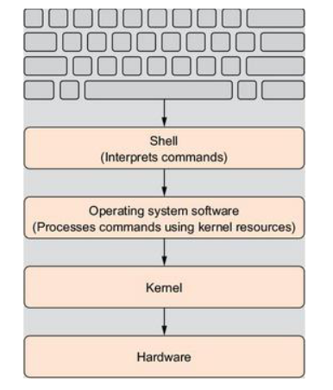

1. **BASH** is default command line tool in Linux, whereas **sh** is default command line tool in Unix. Other popular command line tools are **C shell, Z shell [Z sh]**
2. Use below command to find out the shells installed in Linux

**cat /etc/shells**

1. Most Linux distributions include an online manual for looking up information on shell commands.
2. The **man** command provides access to the manual pages stored on the Linux system. Entering the man command followed by a specific command name provides that utility's manual

**Example:** man pwd

Below screenshot shows above command output

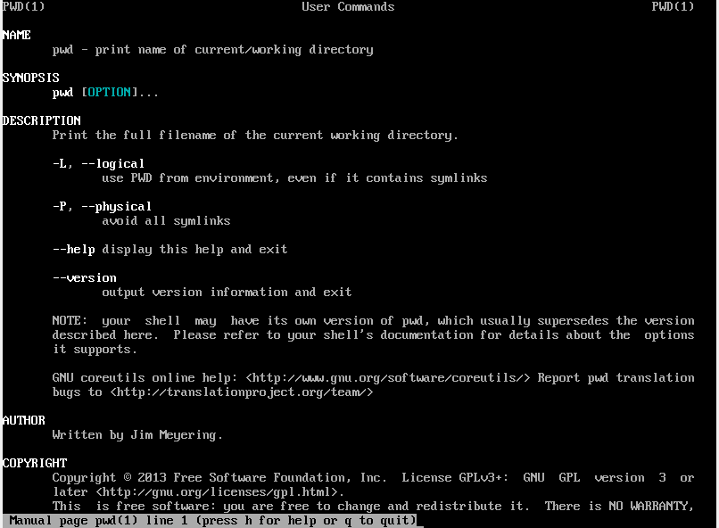

1. The bash manual is not a step-by-step guide, but instead a quick reference.

##### Tip:

The bash manual even has reference information on itself. Type man man to see manual pages concerning the man pages.

1. The manual page divides information about a command into separate sections. Each section has a conventional naming standard as shown in below table

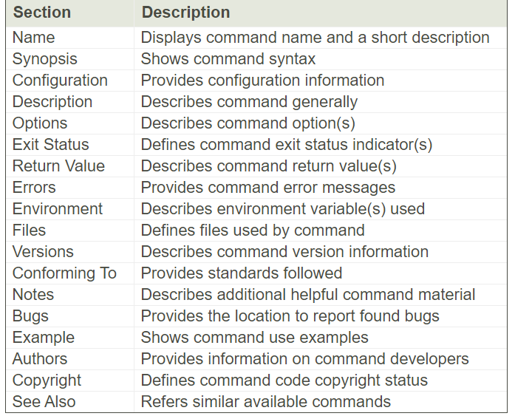

##### Tip:

Not every command's man page has all the section names described in above table. Also, some commands have section names that are not listed in the conventional standard.

##### Tip:

What if you can't remember the command name? You can search the man pages using keywords. The syntax is **man -k keyword**. For example, to find commands dealing with the terminals, you type man -k terminal.

1. In addition to the conventionally named sections for a man page, there are man page section areas. Each section area has an assigned number, starting at 1 and going to 9; they are listed in below table.

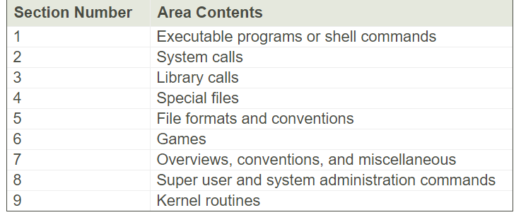

1. For example, screenshot shown on point-5. Notice that in the upper-left and upper-right display corners, the word PWD is followed by a number in parentheses, (1). This means the man pages displayed are coming from content area 1 (executable programs or shell commands).