POSTMAN is API client

Used to develop, test, share, document APIs

Create API request

New->Request

Sample rest API: https://reqres.in/

--request/ endpoint : api/users/2 : inside it data is stored

e.g.:

on running https://reqres.in/api/users/2

we get

{"data":{"id":2,"email":"janet.weaver@reqres.in","first_name":"Janet","last_name":"Weaver","avatar":"https://s3.amazonaws.com/uifaces/faces/twitter/josephstein/128.jpg"},"ad":{"company":"StatusCode Weekly","url":"http://statuscode.org/","text":"A weekly newsletter focusing on software development, infrastructure, the server, performance, and the stack end of things."}}

New->Request-> CreateCollection/UseExistingCollection -> enter API reqquest ( https://reqres.in/api/users/2 ) -> send

We will receive data from server i.e. from https://reqres.in/

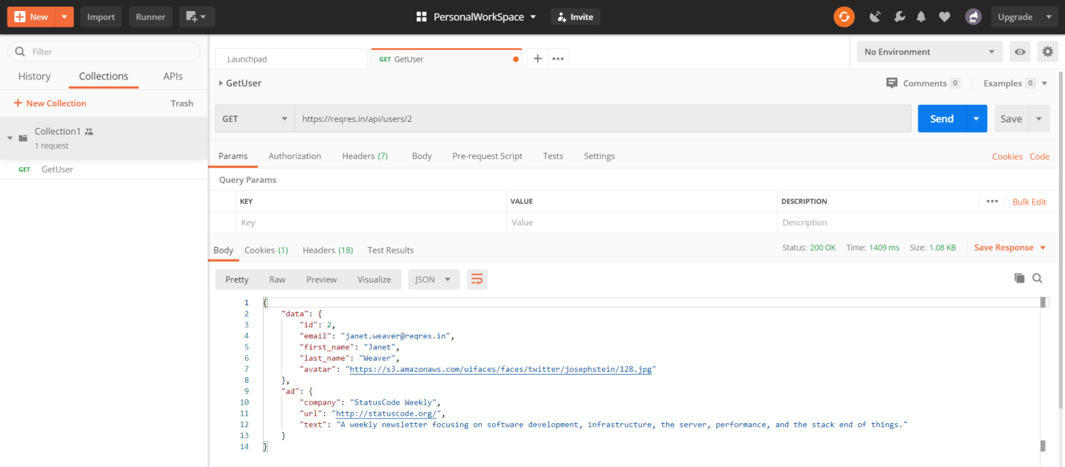

Collection: Group of API requests

New -> Collection

Inside collection we can have multiple folders

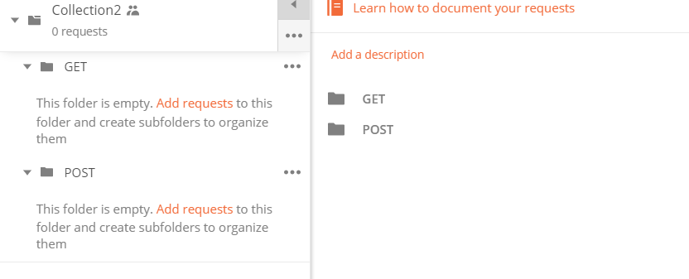

Run Collection:

Collection -> Run ->Run Folder or collection which we want

Variables:

Elements to store value

Collection -> 3 dots-> edit

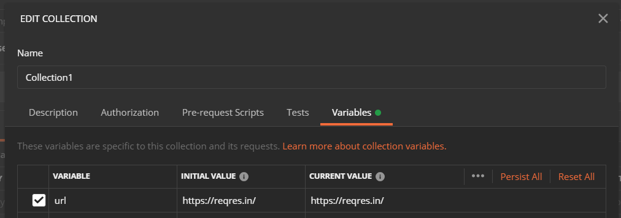



Environments:

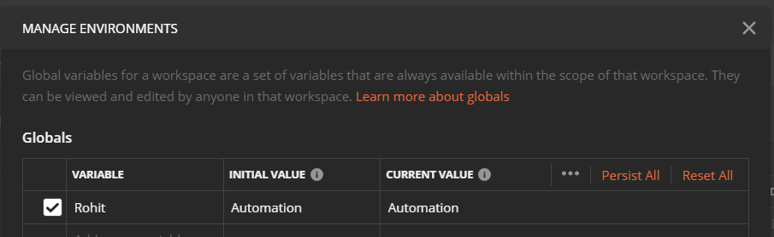

Postman Console:

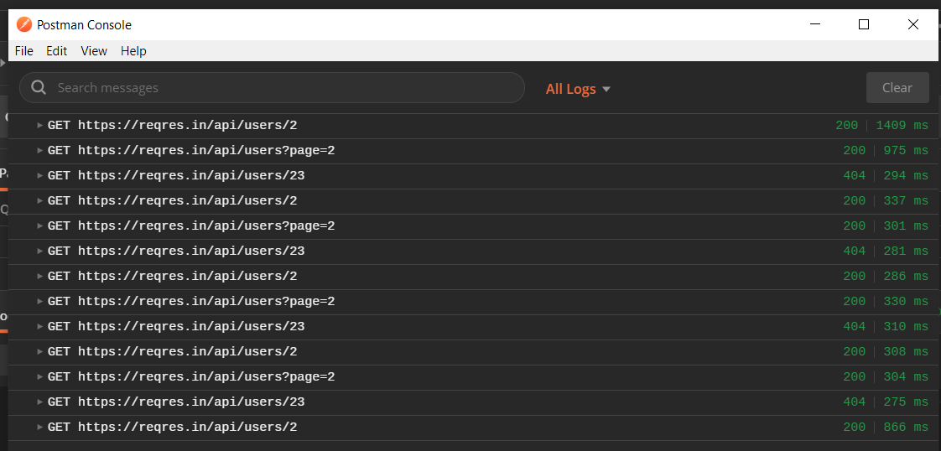

How to SET and GET variables through scripts:

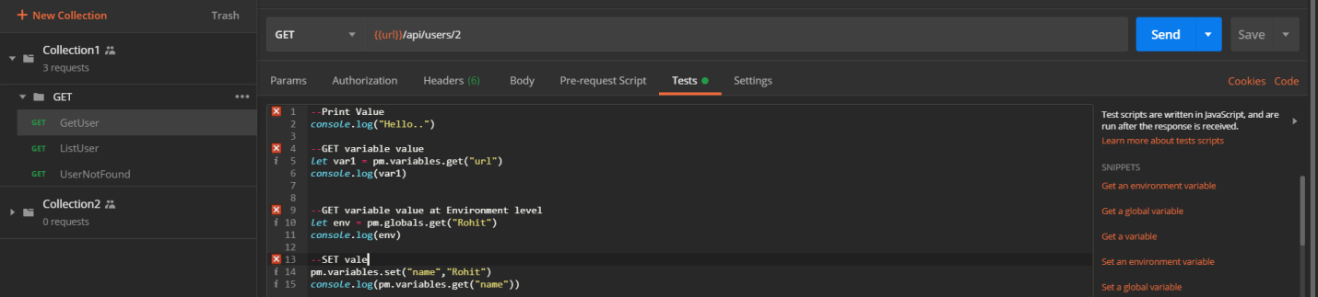

SET value at environment level

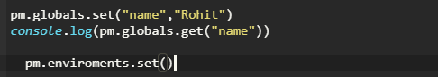

We can add these scripts at pre requisite, then it will run everytime.

ENVIRONMENT:

Set of key value pair.

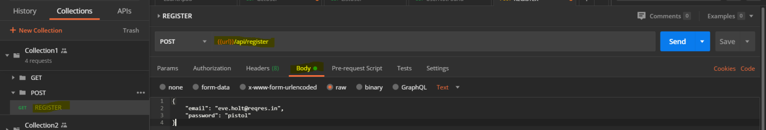

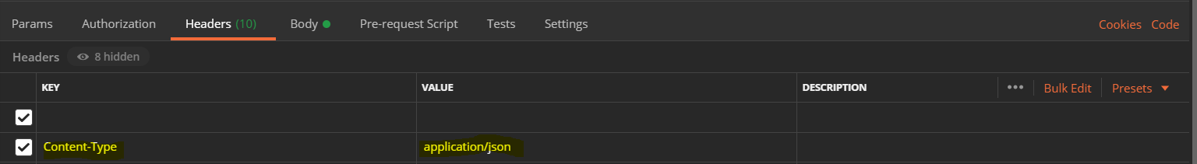

Set of value that do not change can be grouped together and place in different environment.

e.g.: here endpoint, email and password are variables whose value changes in different environment.

So we create two environment QA and PreProd and test our code

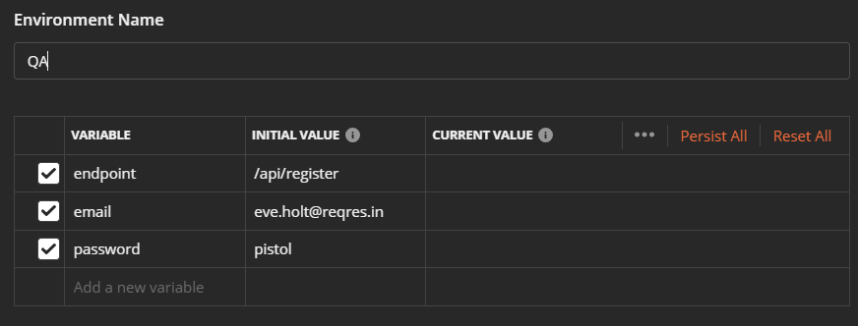

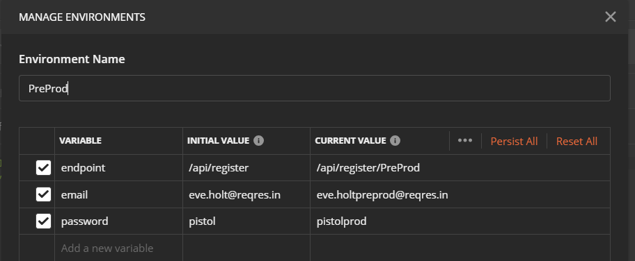

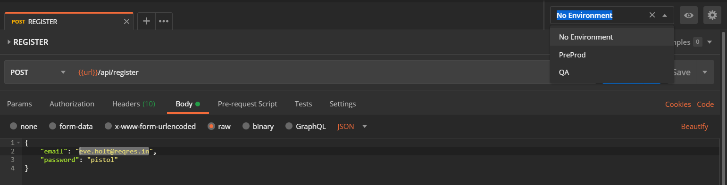

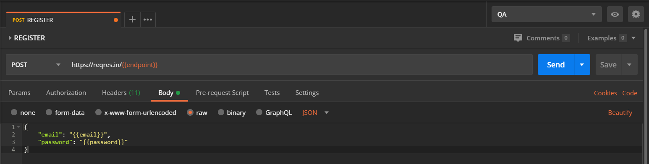

Test Script Creation:

Script creation using Snippet template

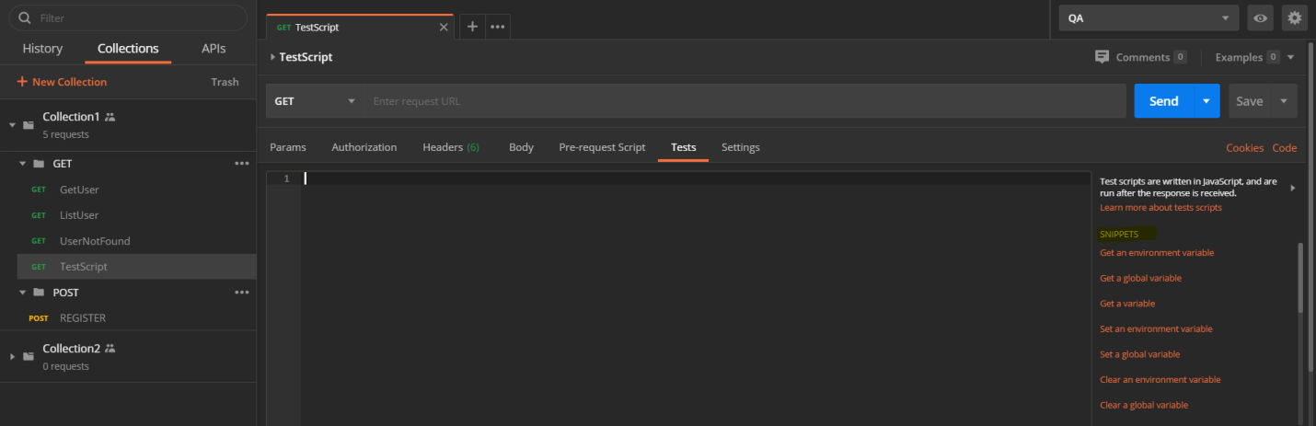

**Postman test are javascript code which runs after receiving response from Server

Pre-request runs before sending request

Test scripts runs after receiving request

Test Scripts can be created at collection, folder, request level.

