# **Monte Carlo Simulation Results for Wake Shield Geometries**

Rishab Kokate, Arnav Kumar, August 2025

**Abstract**

We describe a batch Monte-Carlo ray-tracing framework for assessing four spacecraft wake-shield geometries intended for orbital semiconductor fabrication. The workflow combines an analytic scene generator, vectorized intersection kernels and a Maxwell-distributed molecular beam to predict downstream contamination metrics. Wire-frame renders validate geometric fidelity for a flat disk, square pyramid, spherical cap and Johnson-J5 cupola.

**1 Methods**

For each of the 10,000 randomly generated scenes, 10,000 O₂ molecules are launched one meter upstream with a drift speed of 7.7 km/s, corresponding to the orbital velocity of the spacecraft in low Earth orbit (LEO). A thermal spread based on a Maxwell-Boltzmann distribution at 1000 K is applied to each particle’s velocity vector. This temperature reflects realistic orbital conditions at altitudes around 300–500 km, where solar heating and sparse molecular density result in high kinetic temperatures despite the near-vacuum environment.

The inclusion of this thermal spread captures random molecular motion superimposed on the bulk orbital flow. A necessary detail in the rarefied regime where collisions are negligible and individual particle dynamics dominate. Physically, this introduces angular dispersion in ray trajectories, which directly affects deflection statistics, wafer hit rates, and the shape of the wake boundary. By combining both deterministic drift and stochastic thermal components, the simulation reproduces a more accurate molecular flux environment for evaluating shield performance. Additionally, the data was collected across 3 slightly varying scenarios to test the efficacy of the shields based on varying mission profiles.

**2 Geometry Validation**

Figures 1–4 depict the analytical surface definitions employed in code together with wire-frame plots generated directly from those vertices. All shapes conform to their specifications.

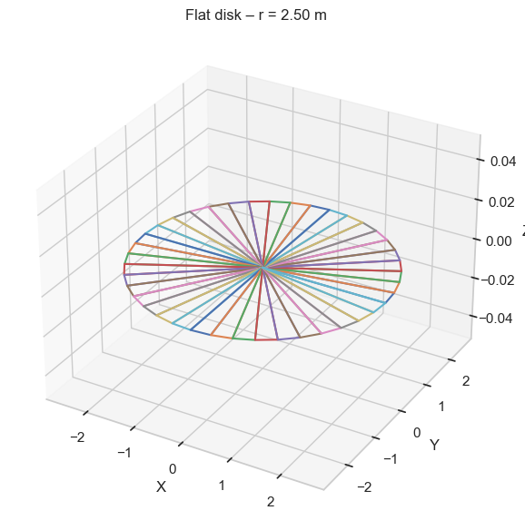

Figure 1 - Flat Shield Design

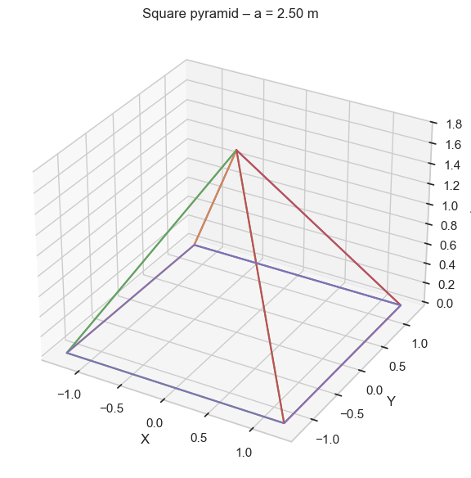

Figure 2 - Pyramid Shield

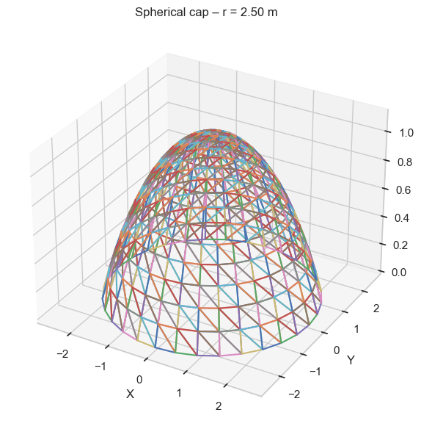

Figure 3 - Parabolic Shield

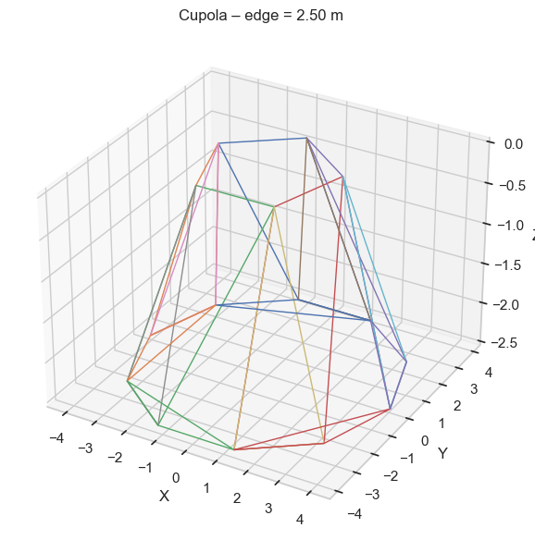

Figure 4 - Johnson J5 Solid Pentagonal Cupola

**3 Results**

Across the original **1 × 10⁸** ray events in **mc_output1.csv**. Which used a 150 mm wafer placed only 10–20 cm downstream of the shield. The results revealed that the flat disk and spherical cap diverted virtually every molecule, driving *hit_ratio* to numerical zero (Figure 5). Furthermore, the Johnson-J5 cupola delivered “middle-ground” performance: modest wake intrusion but far less wafer exposure than the square-pyramid design. Shallow slope pyramids remained the worst offenders because their gentle facets deflect some flux directly into the wake cone, increasing both *wake_intrusion_ratio* and wafer strikes (Figure 6).

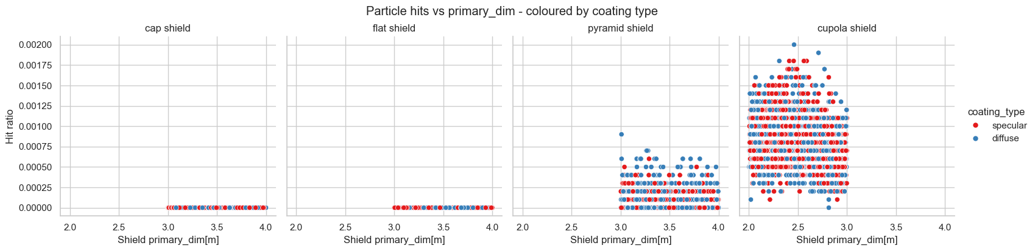

Figure 5 – mc_output1.csv - Scatter Plot: primary_dim vs hit_ratio (sorted by coating type)

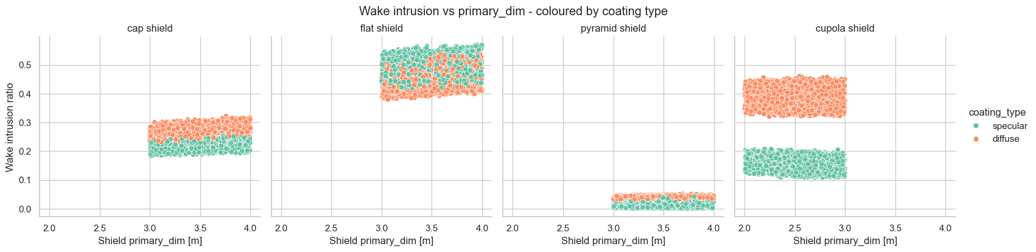

Figure 6 - mc_output1.csv - Scatter Plot: primary_dim vs wake_intrusion_ratio (sorted by coating type)

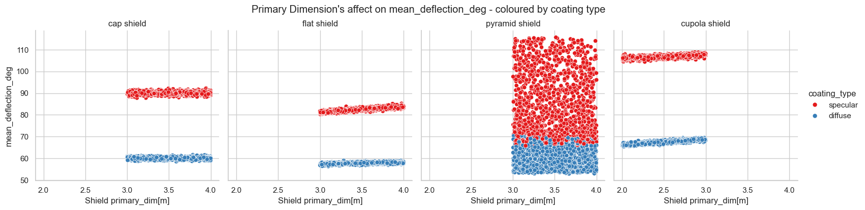

Figure 7 - mc_output1.csv - Scatter Plot: primary_dim vs mean_deflection_deg (sorted by coating type)

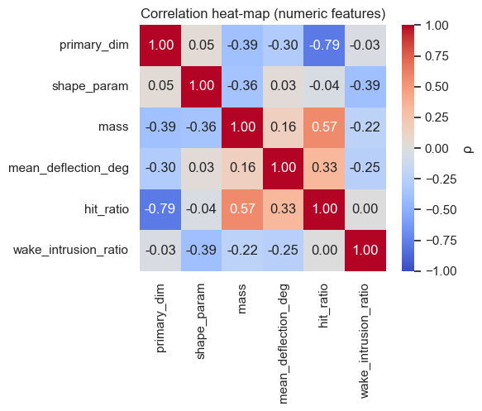

*Figure 8 - mc_output1.csv - Correlation Matrix*

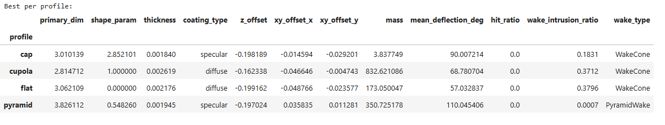

Figure 9 - mc_output1.csv - Best Shield Design per profile



Figure 10 - mc_output1.csv - Overall Best Design

To probe how shield efficacy scales with varying mission profiles, we generated three additional datasets. Full descriptive statistics, correlation matrices, and regression plots for each scenario are available in the accompanying CSV files and in **mcvis.ipynb**. These staged configurations let us bracket performance for a variety of mission profiles: from compact, high-throughput epitaxy modules to extended-arm experiments. Thus, providing a data-driven basis for selecting the optimal shield geometry and wafer placement.

|  |  |  |  |
| --- | --- | --- | --- |
| **CSV File** | **Wafer Radius** | **Shield-to-wafer-gap** | **Rationale** |
| Mc_output1.csv & mc_output2.csv | 150mm | 10-20 cm | Base for comparing the other 2 mission profiless |
| Mc_output3.csv & mc_output4.csv | 150mm | 1-2 meters | Simulate a far-standoff MBE reactor where hardware constraints force the wafer deeper in the wake. |
| Mc_output5.csv | 300mm | 10-20 cm | |  | | --- | |  |   Model a large-area growth carousel positioned close to the shield for maximum material flux. |

**4 Conclusion**

The multi-scenario Monte-Carlo study confirms that under the baseline configuration (150 mm wafer, 10–20 cm standoff), both the flat disk and spherical cap reduced molecular hits to the numerical floor. Whilst the pyramid shield provided an attractive compromise between structural simplicity and protection. In contrast, the Johnson J5 Cupola shield consistently under-performed, funneling scattered particles into the wake and elevating both *hit_ratio* and *wake_intrusion_ratio* (as seen in figures 5 & 6).

Increasing the shield-to-wafer gap to 1–2 m (datasets 3–4) improved performance for all geometries. Particularly the pyramid, because the wake narrows with distance, allowing off-angle scatter to disperse before reaching the wafer (Figure 11). However, doubling the wafer diameter to 300 mm (dataset 5) largely negated those gains: the larger collection area amplified contamination risk even for the best shields (figure 12).

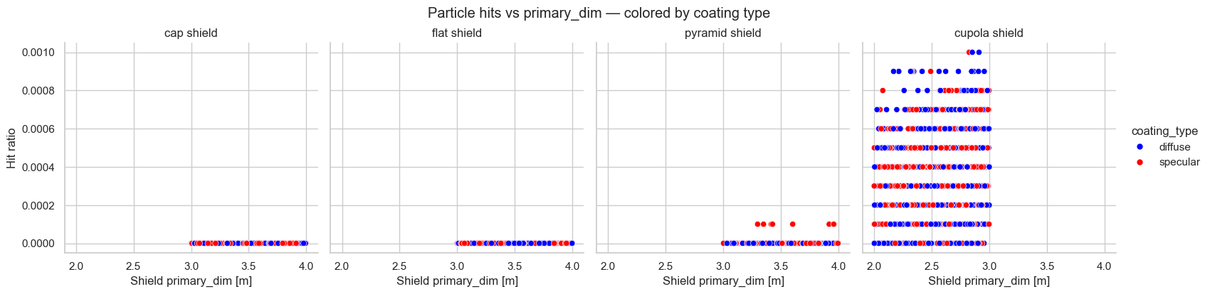

Figure 11 - mc_output3.csv - Scatter Plot: primary_dim vs hit_ratio (sorted by coating type)

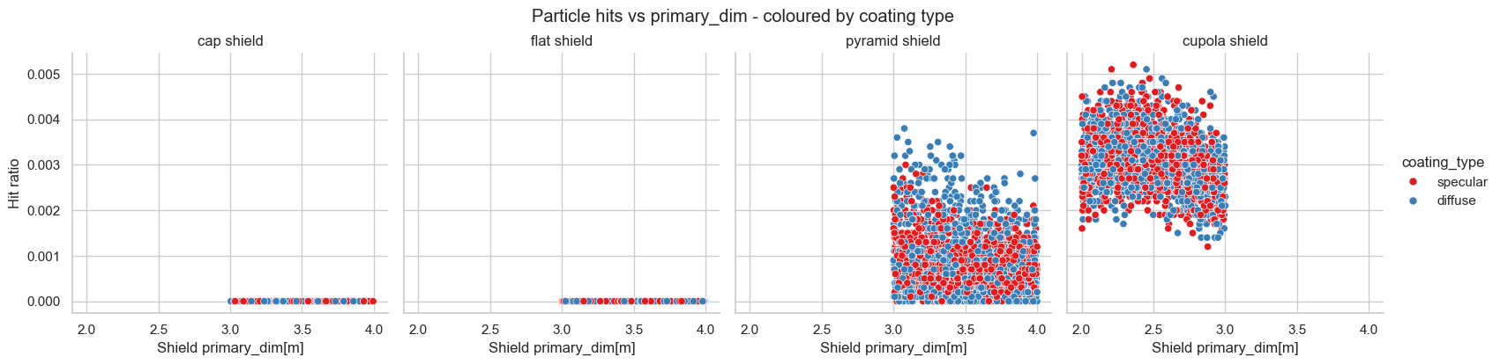

Figure 12 - mc_output5.csv - Scatter Plot: primary_dim vs hit_ratio (sorted by coating type)

Taken together, the results bracket practical design space for several mission profiles. Across the 5 total datasets, the shield designs were ranked based on lowest hit_ratio & lowest wake_intrusion_ratio, and highest deflection angle. The best performing shield was consistently the pyramid shape.



Figure 13 - Best Design mc_output1-2.csv



Figure 15- Best Design mc_output3-4.csv



Figure 15- Best Design mc_output5.csv

This was a particularly interesting result because the original wake shield facility used a flatter shield, similar to the disk in Figure 1. Despite this historical precedent, our simulation results consistently favored the pyramid geometry across all metrics and deployment configurations.

These findings suggest that wake-shield effectiveness is highly sensitive to geometric slope, with steeper, faceted surfaces like the square pyramid promoting aggressive redirection of molecular flux. The fact that this holds true even when the wafer is moved meters downstream or doubled in radius indicates strong robustness to mission-specific variation.

Going forward, the pyramid profile presents a compelling candidate for shield architectures in next-generation orbital manufacturing systems—especially for compact modules or scalable multi-wafer growth platforms. Its combination of structural simplicity, superior deflection behavior, and minimal downstream contamination makes it a powerful geometry to explore in hardware prototyping and thermal-structural modeling phases.