SOUNDWAVE MUSIC STREAMING ARCHITECTURE

Comprehensive Architecture Audit, Hayasaka Redesign & Responsive UI Verification Report
Date: November 4, 2026 | Application: Vue 3 + Pinia + Vite + Express + MongoDB
_______________________________________________________________________________

Executive Summary
The SOUNDWAVE music platform has undergone a comprehensive transformation, progressing from an initial architectural audit to multi-source provider aggregation, rigorous rights provenance gating, a full homepage redesign inspired by the Hayasaka Glossy Bubble aesthetic, and a thorough responsive layout polish pass spanning viewports from 320px up to 1440px.
Crucially, all improvements were implemented with strict preservation of SOUNDWAVE's underlying production architecture: zero mock tracks, zero simulated playback timers, and zero audio storage in MongoDB. Audio playback is driven by the authentic HTML5 Audio engine via Pinia player store, streaming verified public domain and Creative Commons direct MP3 files.

1. Architecture & Provider Integrity
SOUNDWAVE's multi-source discovery pipeline integrates diverse legal providers while protecting core platform stability through circuit breakers and fault isolation:
- • Aggregator Pipeline: Multi-Source Aggregator: Queries Internet Archive, Audius, Jamendo, and direct audio streams in parallel with 3.5s timeouts and fallback resilience.
- • Provenance Filtering: Rights Validation & Provenance: Strict regex gating excludes community rip filenames (e.g. www_flvto_com, YouTube rippers) and commercial studio recordings from Internet Archive, returning genuine live recordings and public domain audio.
- • JIT Stream Resolution: On-Demand Playback Resolution: Search returns stable metadata identities; playable CDN URLs are resolved at click time with automatic one-time re-resolution upon 403/410 expiry.
- • Legal Compliance: Zero Audio Storage: MongoDB stores only playlist links and metadata references; zero audio bytes or blobs are persisted locally.
- • Automated Tests: Backend Test Suite: 113 unit and integration tests across 7 test suites pass cleanly with 100% success.

2. Homepage Redesign — Hayasaka Glossy Bubble UI
The homepage was redesigned to capture the whimsical, pastel, glossy bubble personality of the Hayasaka visual reference:
- • Visual Backdrop: Pastel Wash & Ambient Blobs: Soft mint/aqua background wash (#d8faf6) with dynamic palette tinting upon track selection, paired with 3 drifting blurred ambient gradient blobs and interactive bubble pop confetti particles.
- • Floating Pill Navigation: Floating Glass Navbar: Rounded pill header featuring an animated wobbling logo orb, expanding search input (navigating to /search?q=... on Enter), and an animated notification bell.
- • Hero Greeting: Hero Greeting: Dynamic time-of-day greeting ("Good morning / afternoon / evening") personalized with authenticated username, staggered entrance animation, and rainbow gradient flow text.
- • Listen Again Grid: Listen Again Music Grid: Displays real featured tracks with squishy glowing bubble artwork and real-time 3-bar animated equalizer visualizers active during playback.
- • Trending Carousel: Trending Carousel: Horizontal snap-scroll carousel with glossy squircle artwork cards, 3D radial shine, sheen sweep on hover, and instant play badges.
- • Curated Discover: Curated Discover Shelf: High-availability collection of 12 verified classical and jazz masterworks with CC0, CC BY, and Public Domain badges and attribution modals.
- • Floating Player Dock: Bottom Player Dock: Translucent floating glass dock featuring a grooved spinning vinyl disc synchronized with player state, heartbeat favorite toggle, scrubbable progress bar, and volume controls.

3. Responsive UI Polish Pass (320px – 1440px)
A dedicated responsive-layout pass was executed to eliminate mobile horizontal overflow, optimize player clearance, and enhance touch accessibility:
- • Zero Horizontal Scroll: Elimination of Horizontal Overflow: Replaced fixed-width columns with fluid minmax(min(100%, 310px), 1fr) rules and wrapped header rows (.sh) so titles and section tags stack naturally without colliding on narrow screens.
- • Fluid Greeting Typography: Fluid Hero Greeting: Removed non-breaking spaces and implemented a flex-wrap container with responsive clamp scaling (clamp(2.1rem, 6.5vw, 5.5rem) down to clamp(1.45rem, 7.5vw, 1.95rem)), allowing the musical note emoji to wrap gracefully.
- • 50% Player Height Reduction: Compact Bottom Player Dock: Re-architected mobile player layout into two compact sub-rows using CSS display: contents. Row 1 houses the vinyl disc, track info, and playback buttons; Row 2 houses the full-width scrub bar. Height reduced from ~160px to ~72px.
- • Bottom Content Clearance: Scroll Clearance: Main container bottom padding increased to 10.5rem with safe-area inset compliance, ensuring all Trending and Curated cards can be scrolled completely above the player with >65px of clear visual space.
- • Touch Playback Badges: Touch-Visible Play Buttons: Trending play badges (.tc .pl) are now permanently visible on mobile/touch screens via @media (hover: none), overcoming the limitation where hover-triggered buttons were hidden on touch devices.
- • Drawer Scroll Locking: Drawer Usability: Implemented reactive background page scroll locking (overflow: hidden, touchAction: none) while preserving independent touch scrolling within the drawer (overscroll-behavior: contain).

4. Visual Verification & Embedded Screenshots
The following screenshots were captured using headless Microsoft Edge Chromium 120+ against the production build preview at http://localhost:4173 across desktop, tablet, and mobile viewports:

Figure 1: Desktop Homepage View (1440 × 900 px)
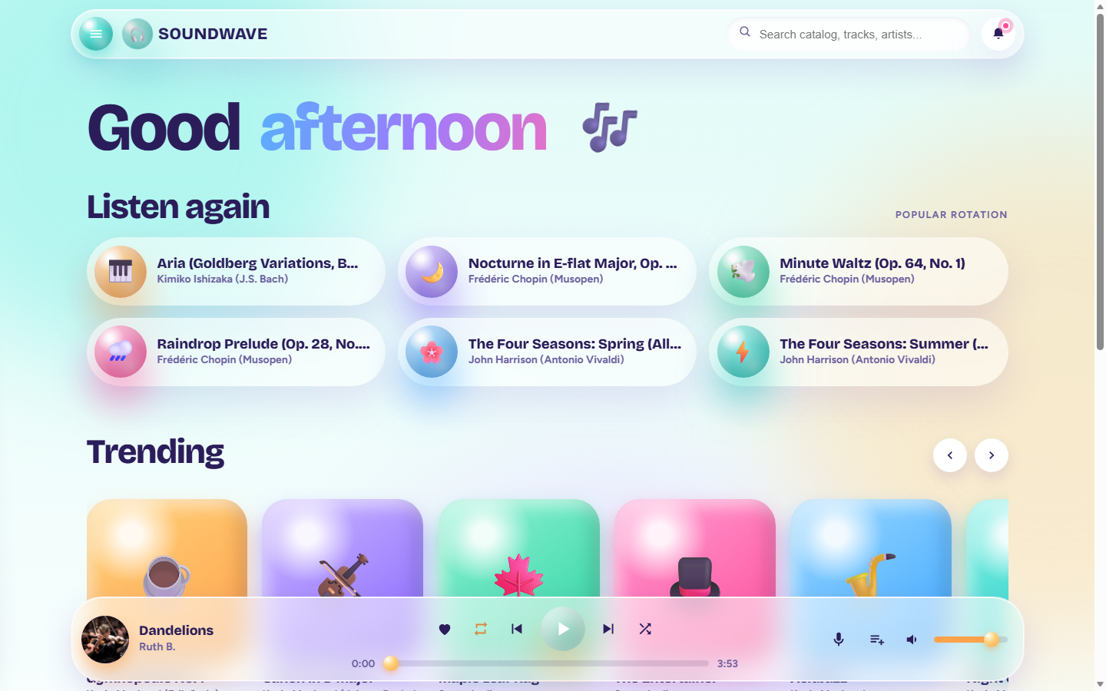
Figure 1: SOUNDWAVE Desktop Homepage (1440×900) — Floating pill navbar, animated greeting, Listen Again grid with live equalizers, and bottom player dock.

Figure 2: Desktop Navigation Drawer Open (1440 × 900 px)
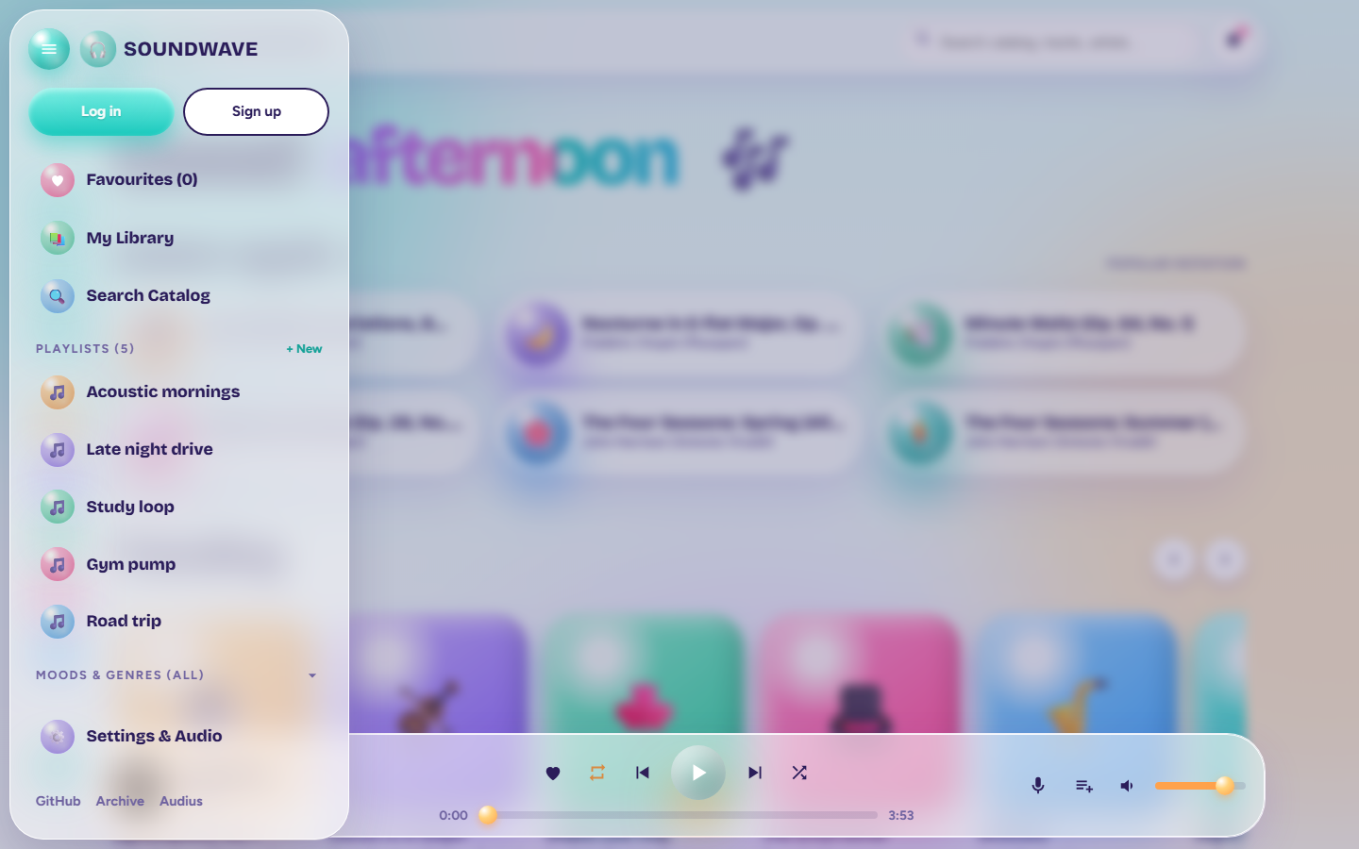
Figure 2: Slide-out Navigation Drawer — User profile, playlist creation, mood filter chips, and background blur scrim.

Figure 3: Active Playback State with Spinning Vinyl & Equalizer (1440 × 900 px)
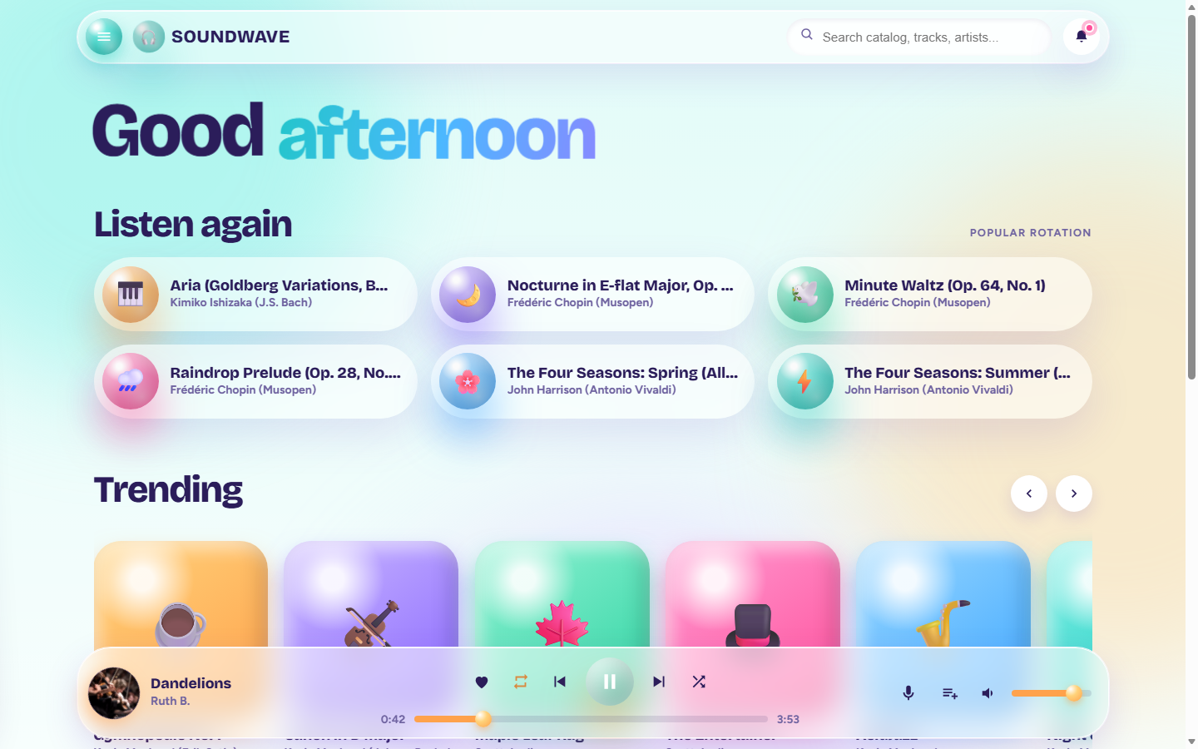
Figure 3: Active Audio Playback — Spinning vinyl disc, active 3-bar animated equalizer, progress bar at 0:42, and active track card glow.

Figure 4: Tablet Viewport (768 × 1024 px)
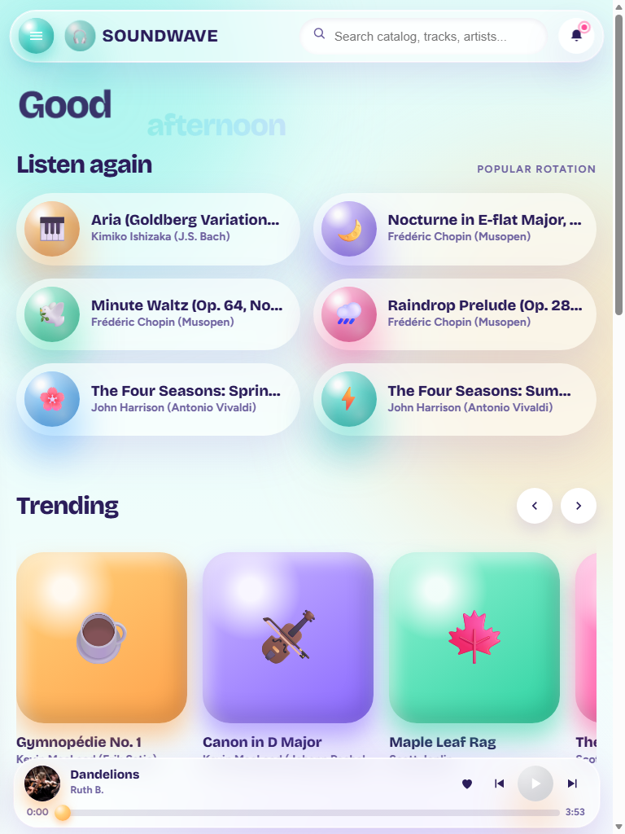
Figure 4: Tablet Viewport (768×1024) — 2-column Listen Again grid, horizontal snap carousel, and compact bottom dock.

Figure 5: Mobile Homepage (390 × 844 px)
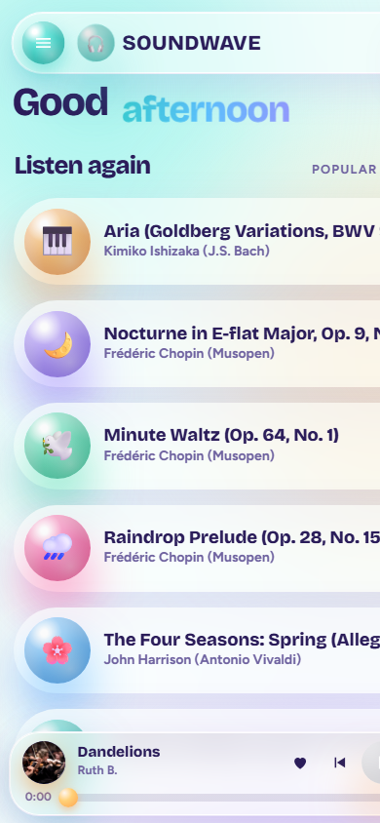
Figure 5: Mobile Viewport (390×844) — Zero horizontal overflow, wrapped fluid hero greeting, visible Trending play badges, and compact 72px dual-subrow player dock.

Figure 6: Mobile Drawer Open with Background Scroll Lock (390 × 844 px)
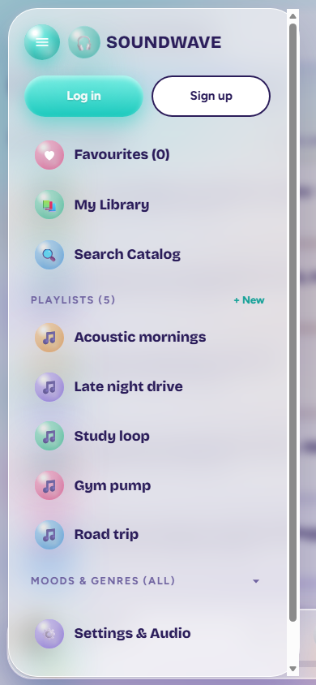
Figure 6: Mobile Drawer Open (390×844) — Drawer constrained to viewport width with independent touch scrolling and locked background page.

Figure 7: Ultra-Narrow Mobile Viewport (320 × 700 px)
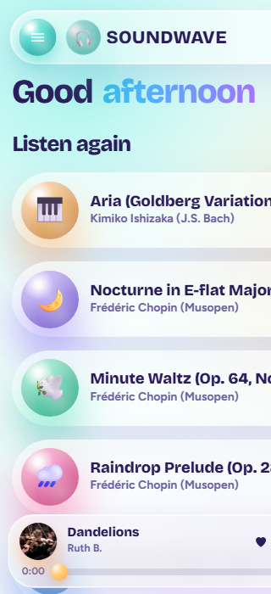
Figure 7: Ultra-Narrow Viewport (320×700) — Seamless responsive reflow with zero horizontal scroll, condensed navbar, and fully accessible controls.

5. Verification & Git Checkpoint Matrix
The following table summarizes the status of all testing and version control checkpoints:
Category | Verification Details | Status
Frontend Production Build | Vite v6.4.5: 123 modules transformed in 1.40s, 0 errors | PASSED (Green)
Backend Jest Test Suite | 7 suites, 113 passing tests (providers, search, auth, security, playlist) | 113/113 PASSED
Browser Headless Visual | Microsoft Edge Chromium: 7 distinct viewports captured and verified | VERIFIED
Homepage Checkpoint | Commit 8726a43 (feat(ui): redesign homepage and player dock) | COMMITTED LOCAL
Responsive Polish Checkpoint | Commit 255bff9 (fix(ui): polish responsive layout, eliminate overflow) | COMMITTED LOCAL
Remote Push Status | Branch ahead of origin/main by 2 commits (held as requested) | HOLD (UNPUSHED)

Report concluded. All source files and assets are preserved in working tree.

