**Recruitment website**

**Follow:**

[**www.crowdstaffing.com**](http://www.crowdstaffing.com)

[**www.traveltriangle.com**](http://www.traveltriangle.com)

[**www.policybazaar.com(For**](http://www.policybazaar.com(For) client)

**Goal: Development of a lead generation & client management Platform**

app

Website

**Website Design:**

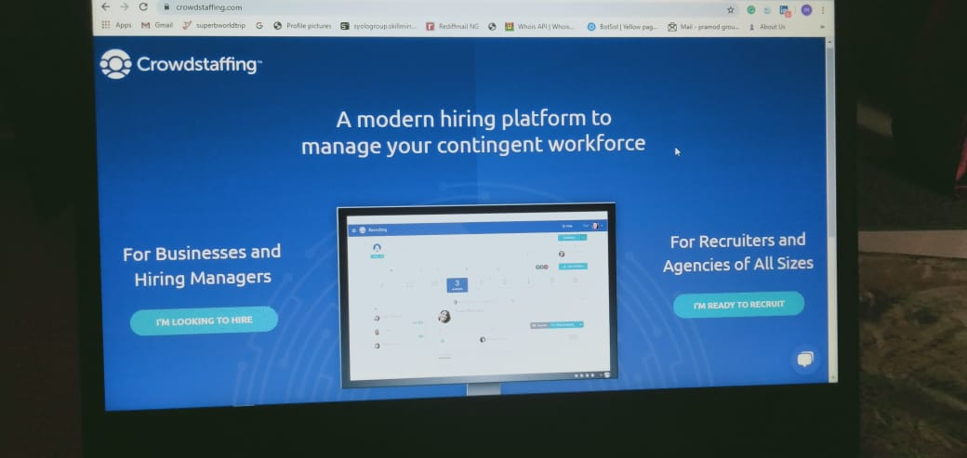

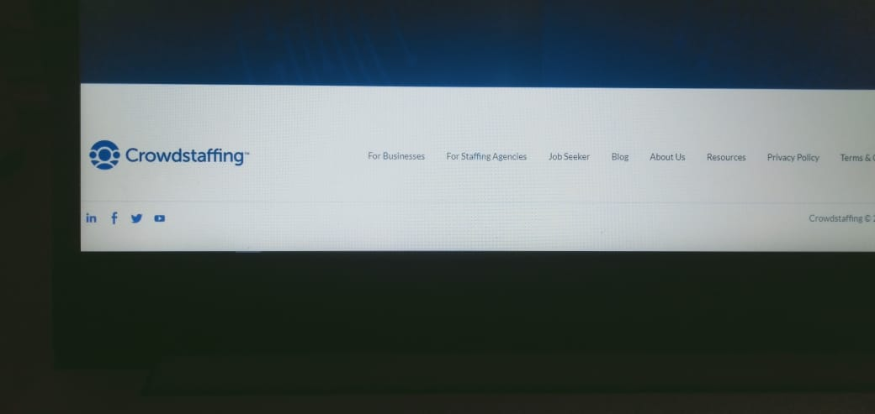

**1)Candidate Dashboard(Job Seeker)**



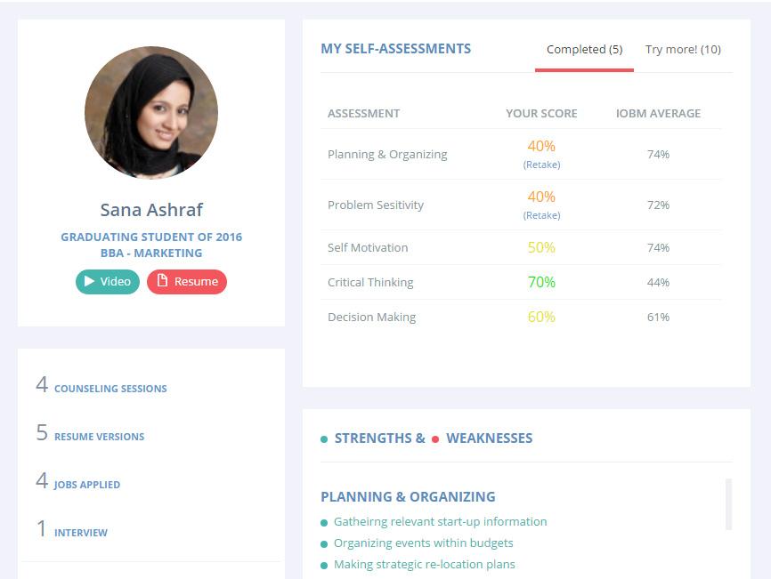

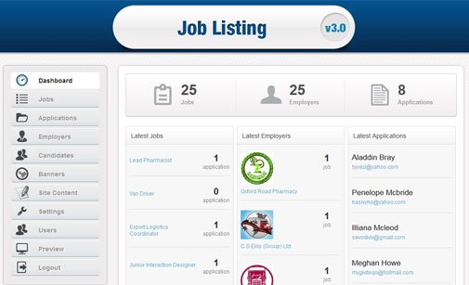

**2)Dashboard(For Businesses):**

**Video <iframe title="vimeo-player" src="https://player.vimeo.com/video/398905372" width="640" height="360" frameborder="0" allowfullscreen></iframe>**

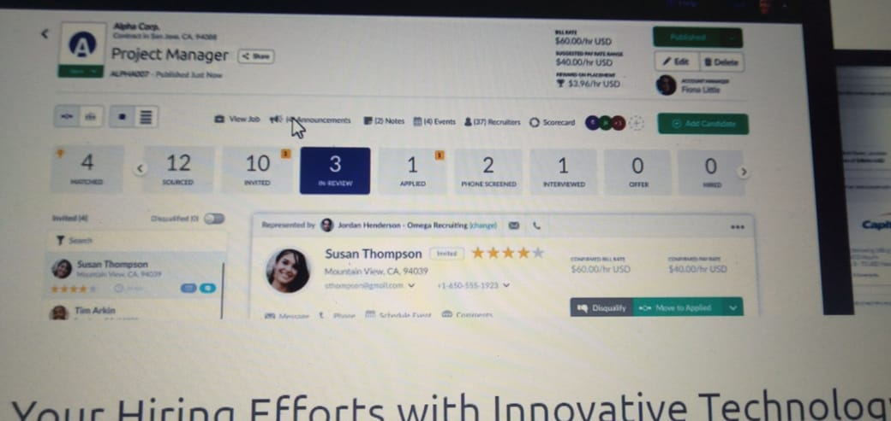

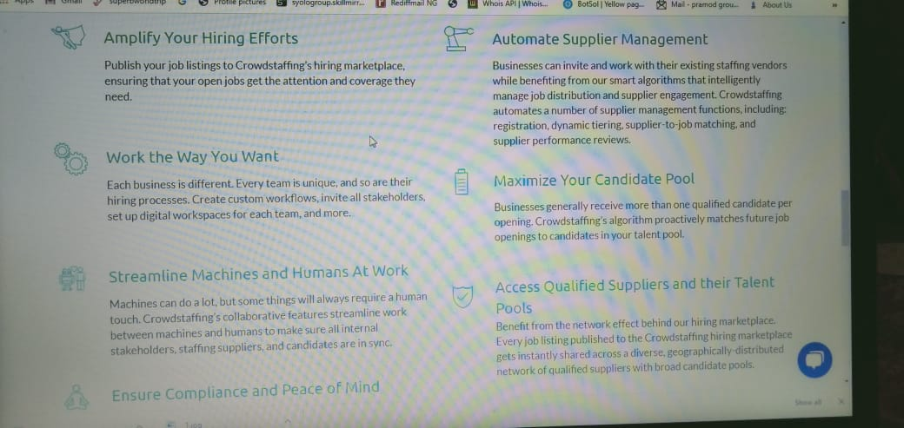

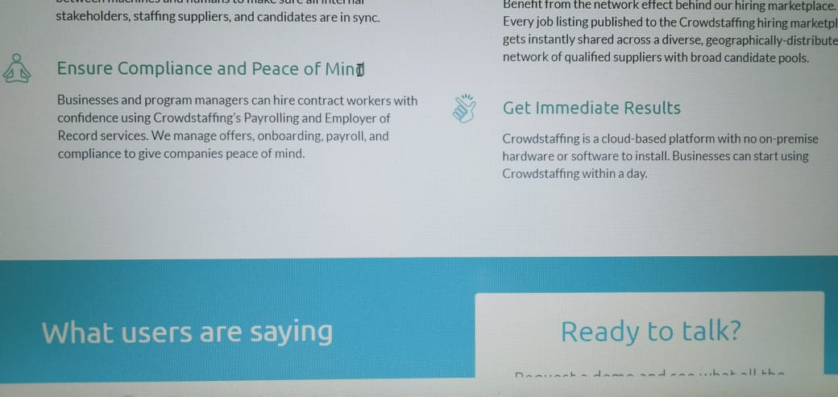

**3)For Staffing Agencies: Features☺**