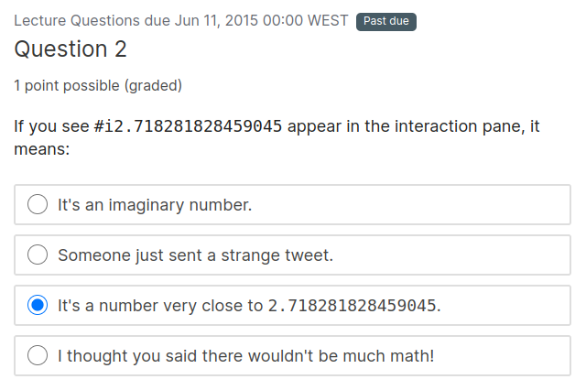
Explanation

Because computers are finite, DrRacket displays irrational numbers as inexact numbers by adding #i to the front.
+1

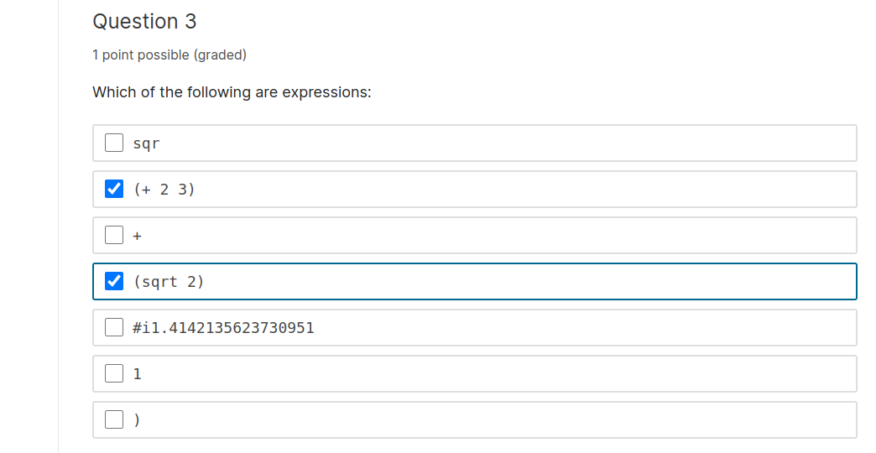

Explanation

At this point in the course an expression is either a value, or of the form (<primitive> <expression> ...).

We will shortly add to our vocabulary of expressions.

+1

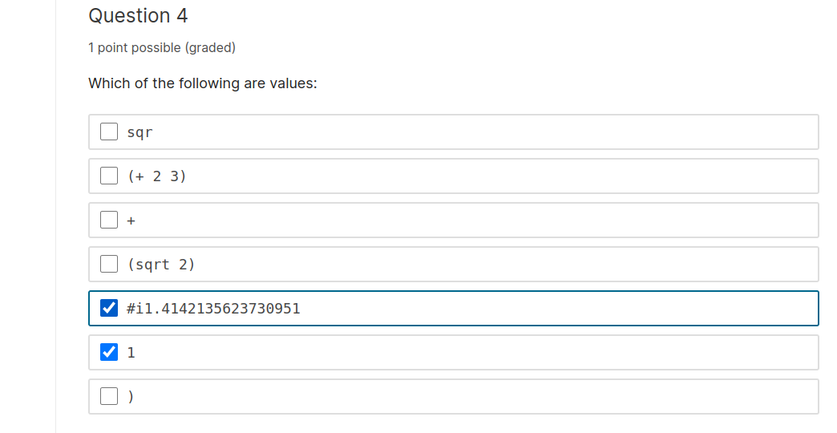

Explanation

Examples of values are numbers, strings, and images. Consult the language tab for more information on values and how to form expressions.
+1

Explanation

Evaluating (* 2 3) produces 6, and evaluating (- 3 1) produces 2. 6 divided by 2 is 3.

+1

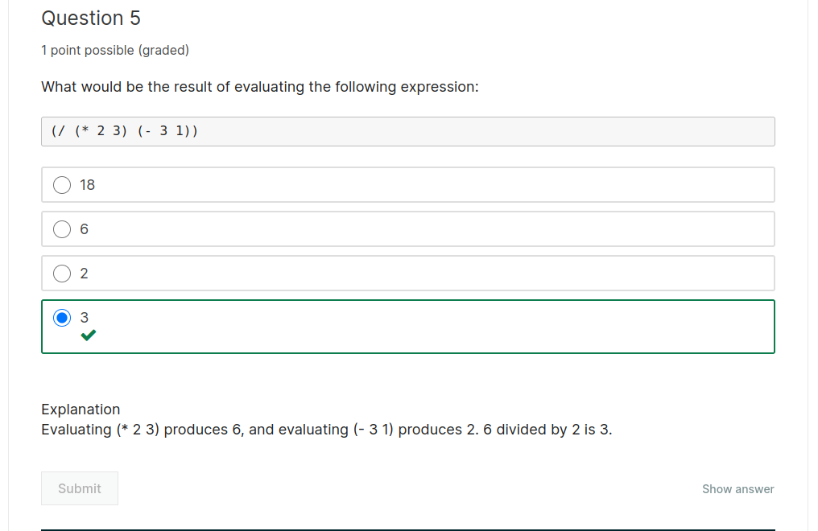

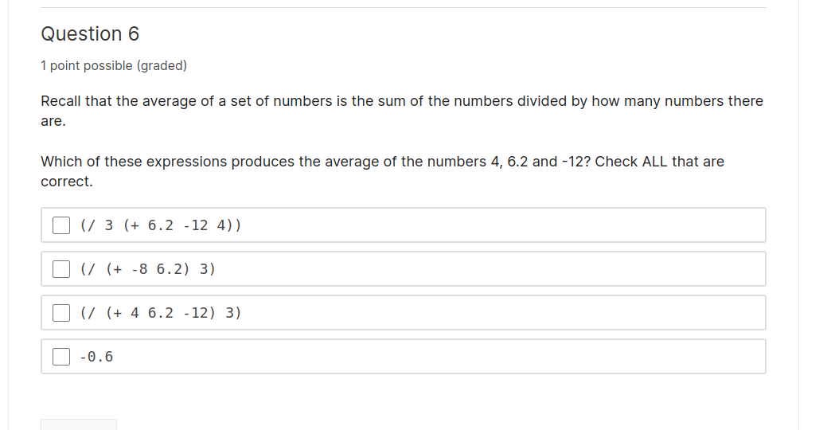
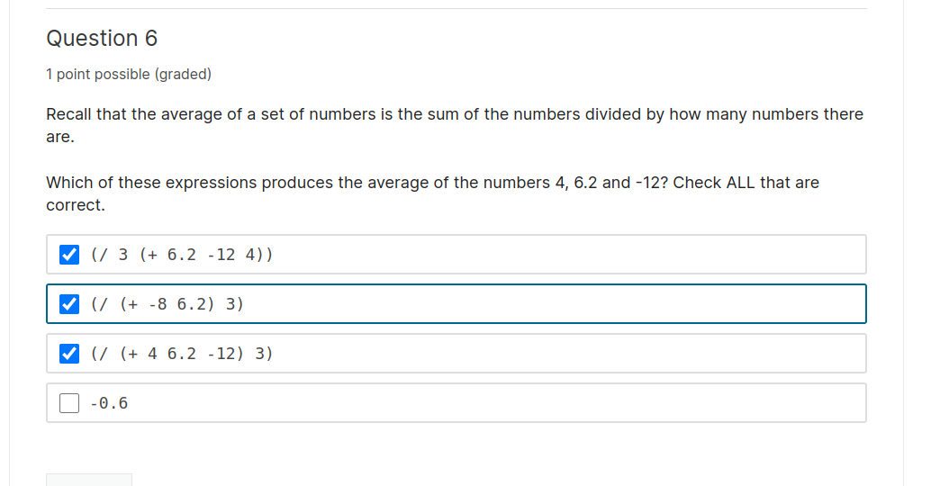

5/6

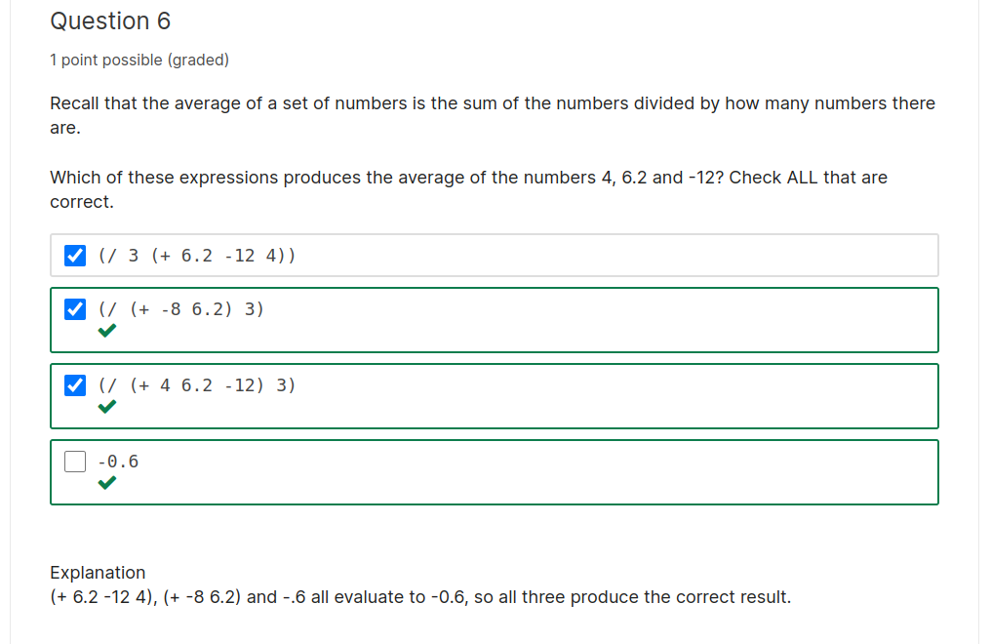
Evaluation
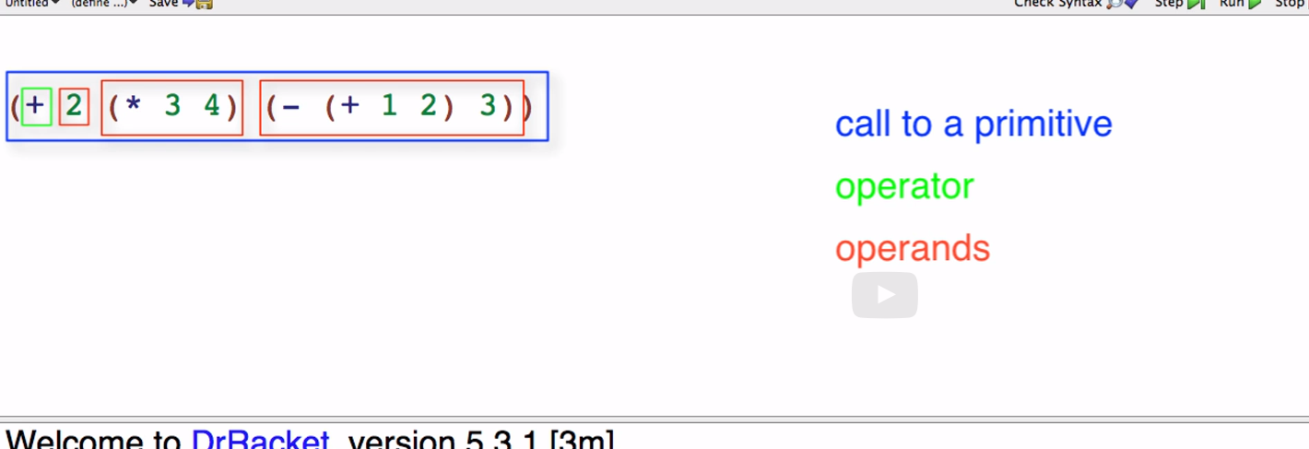

Question 1 to 3

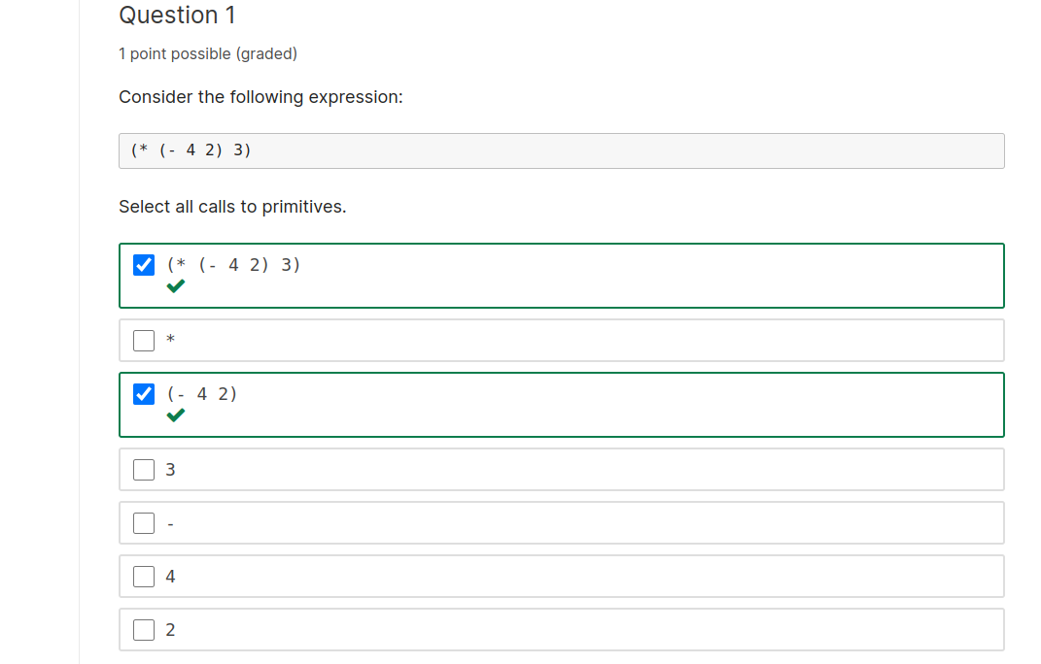

Explanation

(* (- 4 2) 3) and (- 4 2) are primitive calls because they are expressions that start with open parenthesis and the name of a primitive operation

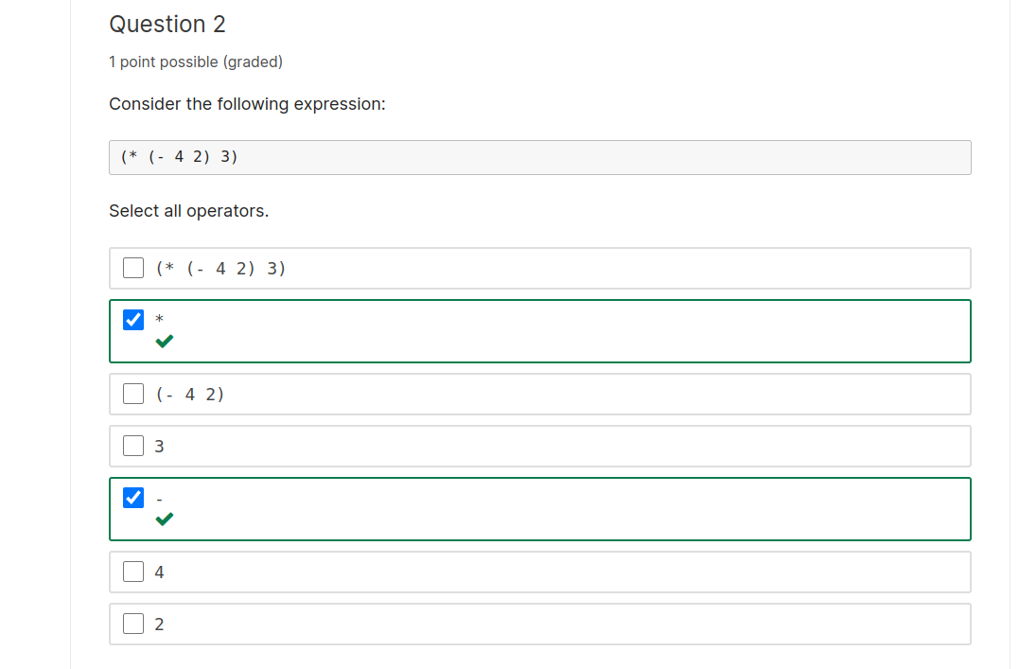

Explanation

* is the operator in the primitive call (* (- 4 2) 3), and - is the operator in the primitive call (- 4 2).

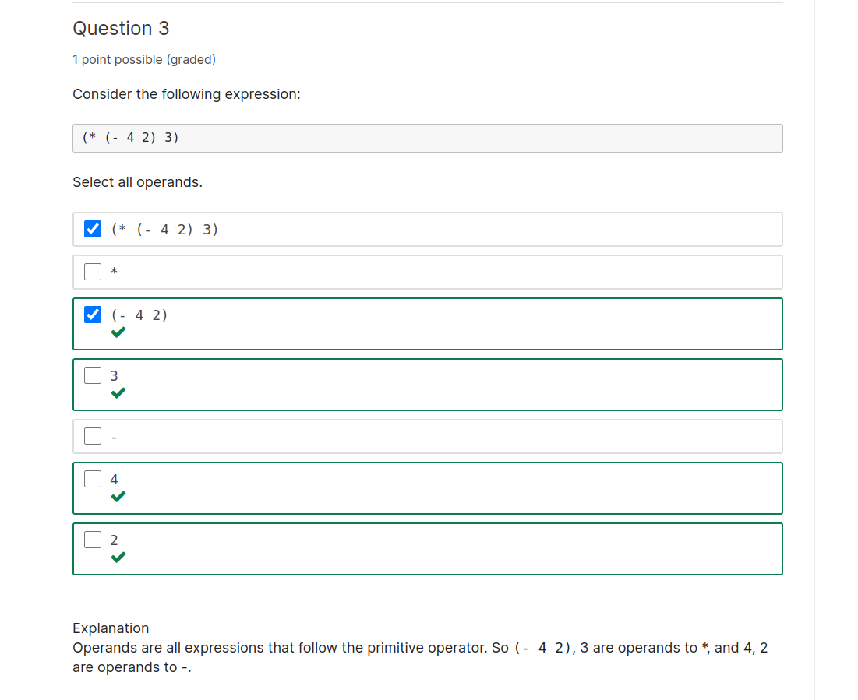

2/3

Explanation

Operands are all expressions that follow the primitive operator. So (- 4 2), 3 are operands to *, and 4, 2 are operands to -.

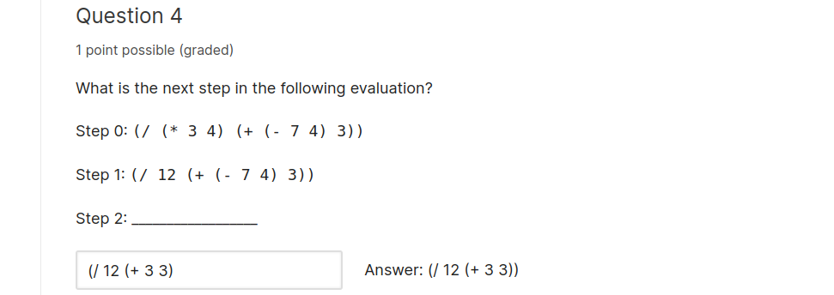

Explanation

The second operand to / is an expression, so it must be evaluated. And the first operand to + is an expression, so it must be evaluated. All of the operands to - are values, so - can be called with 7 and 4 as arguments. This replaces the - call expression with 3.

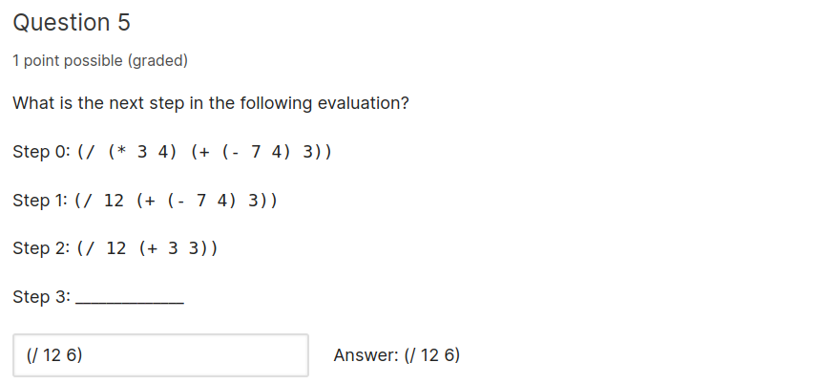

Explanation:

All of the operands to + have been evaluated, so + can be called with the arguments 3 and 3.

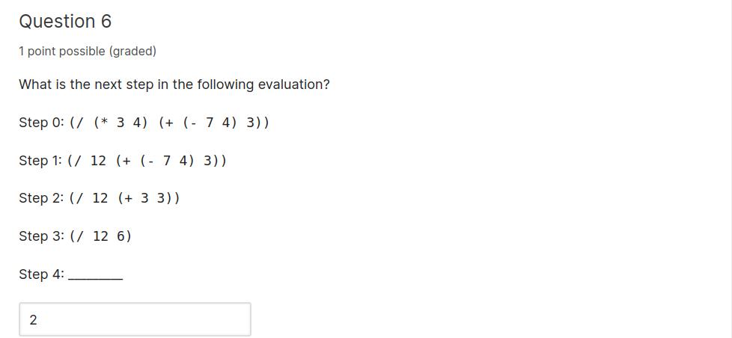

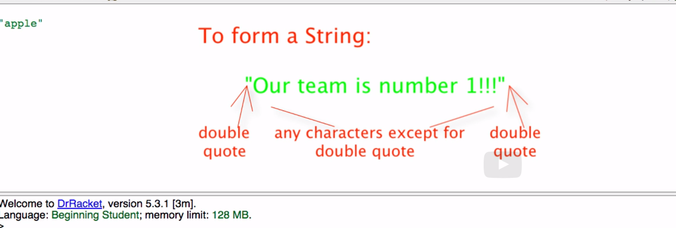

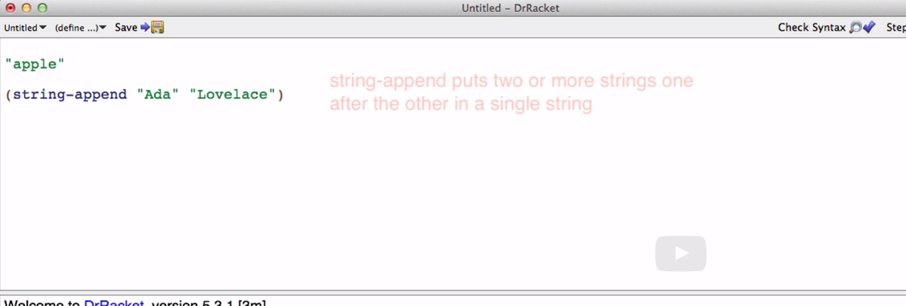

Substring

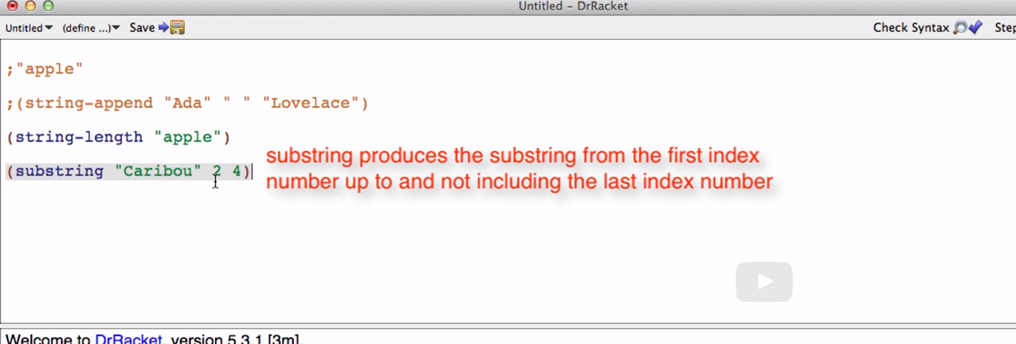

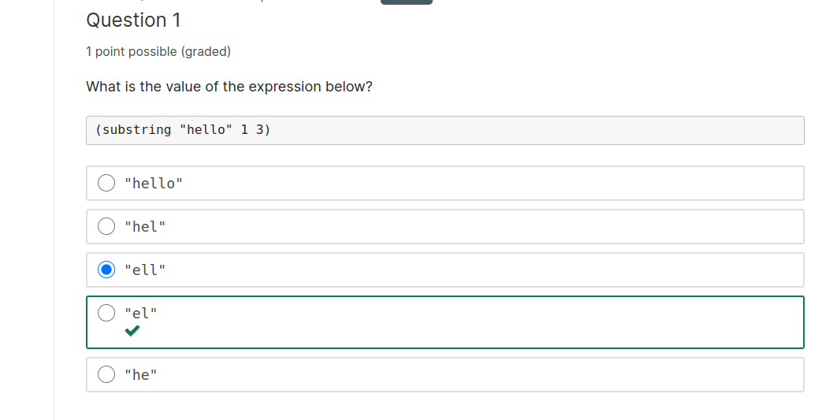

Explanation

Remember strings use zero-based indexing. The first number represents the character to start at. In this case, 1. The second number represents the character to go up to but not including. As shown below, 1 is the the 'e', and 3 is the second 'l'. Since substring starts at 'e' and goes up to but not include the second 'l' the answer is "el".

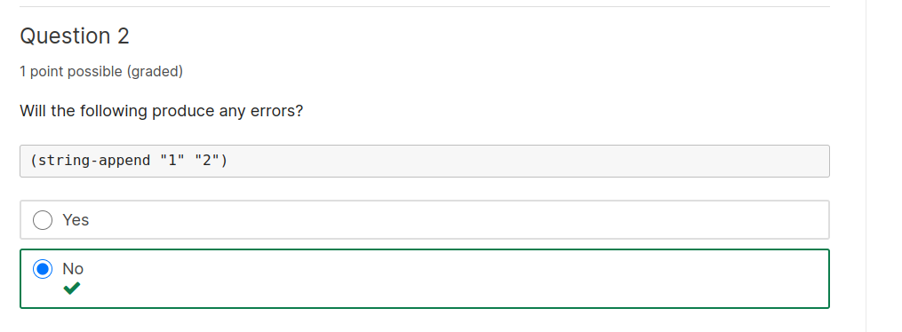

Explanation

"1" and "2" are both strings, so the expression above will not produce any errors. Just because inside the "" looks like a number doesn't mean that "1" is a number. It is a string. 1 is a number.

Don't hesitate to try different things like this in DrRacket in case you have similar questions. If you get an error, just read the error message and try to fix it.

Strings and Images, pt 2

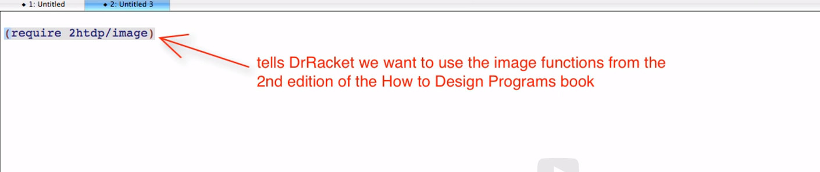

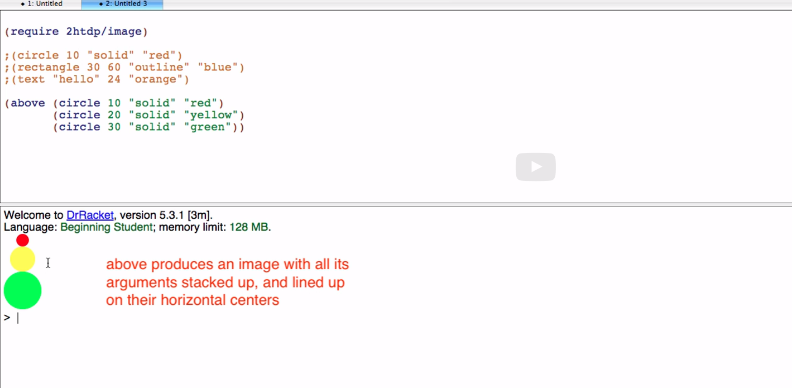

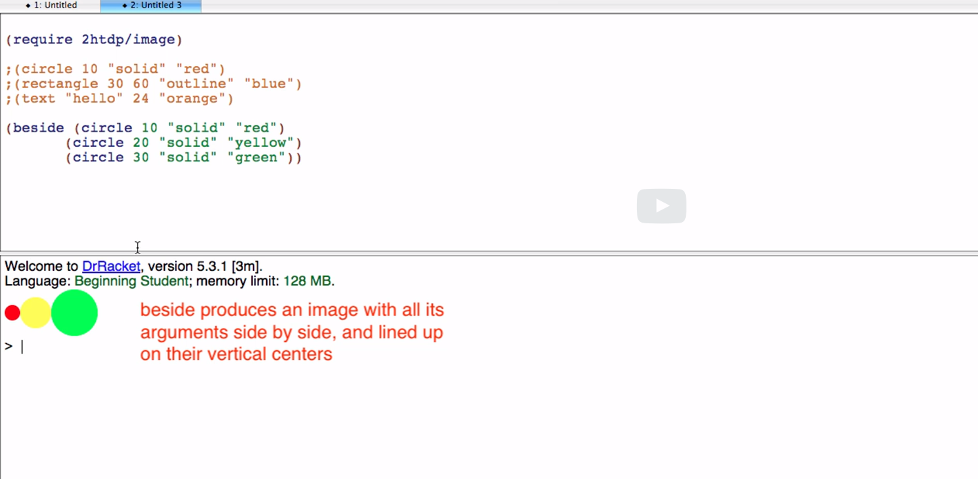

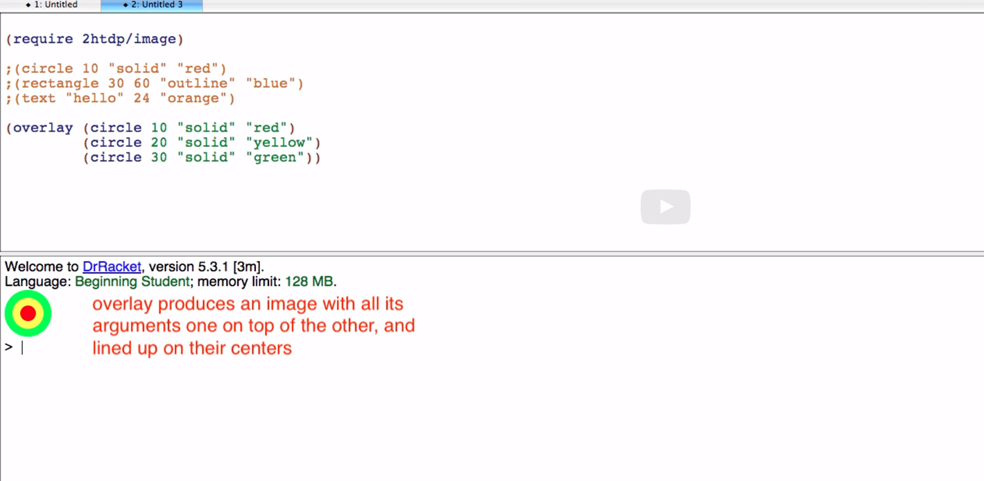

Questions

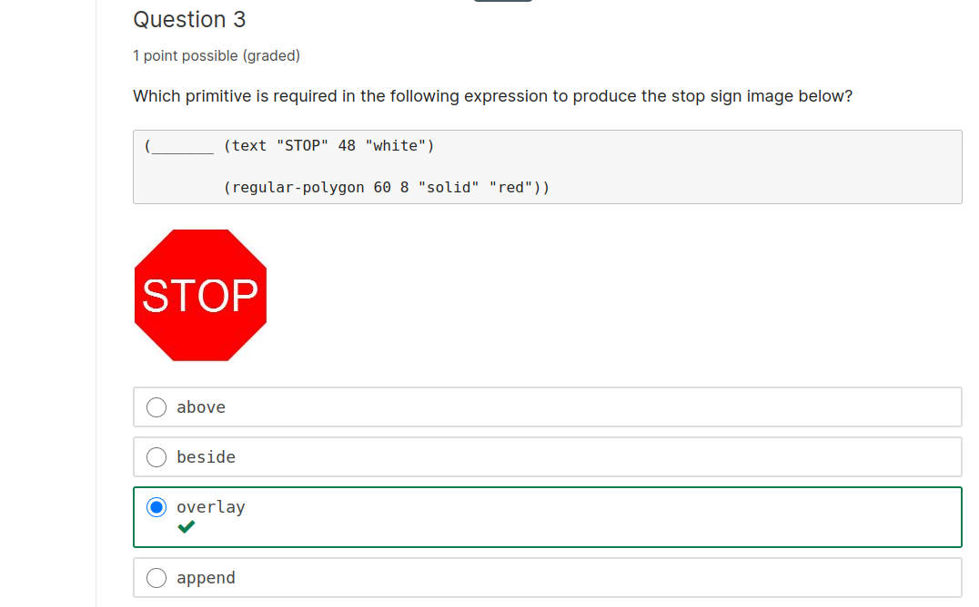

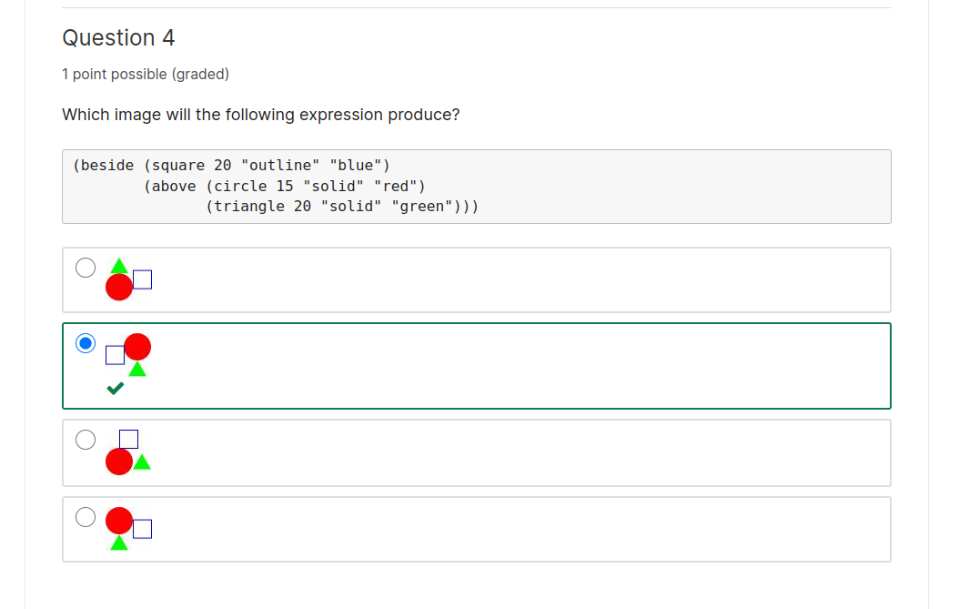

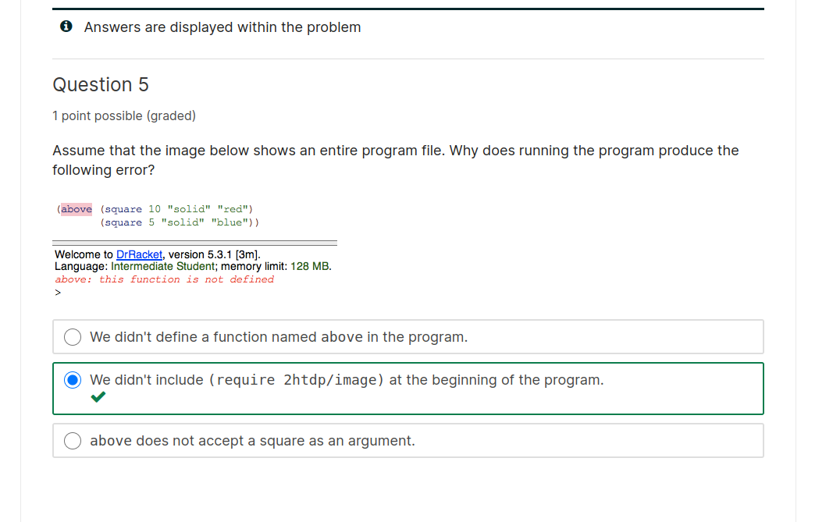

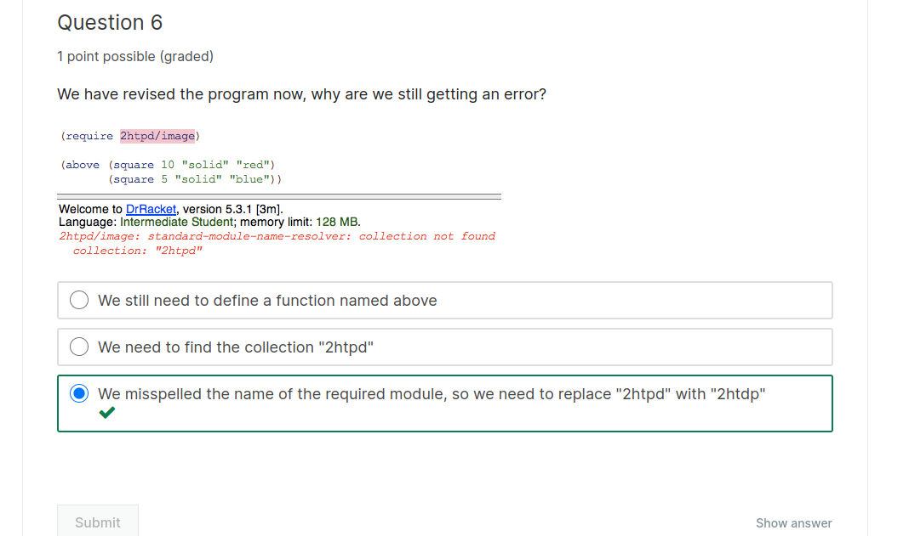

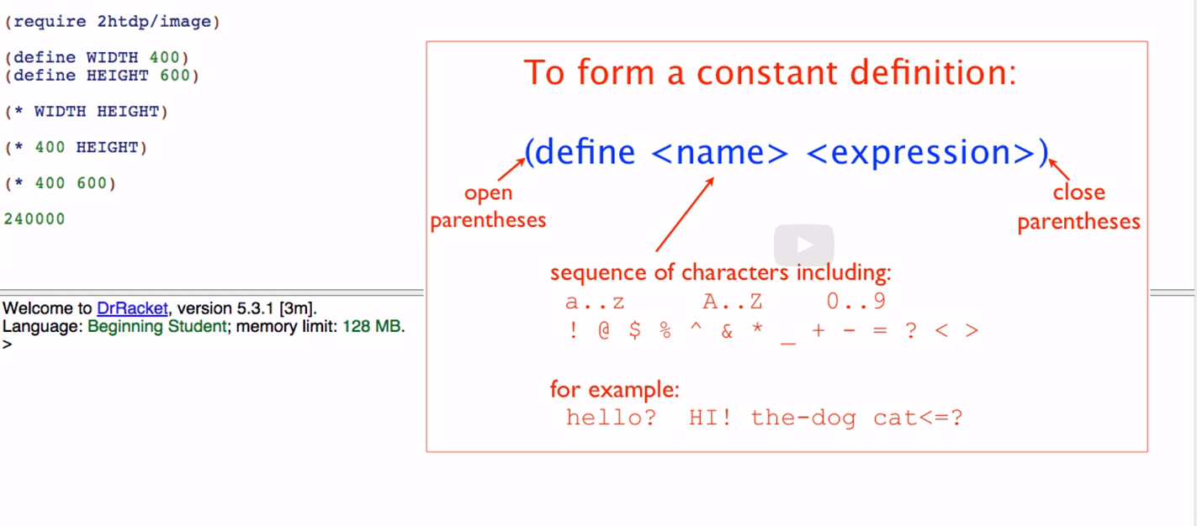

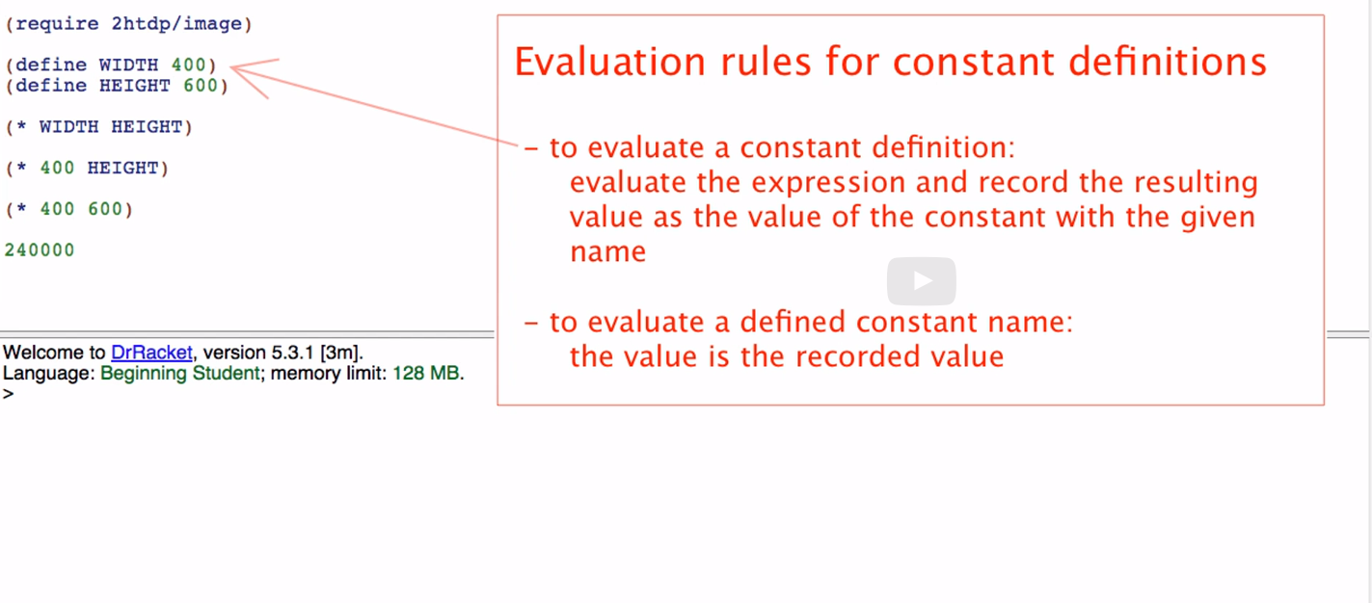
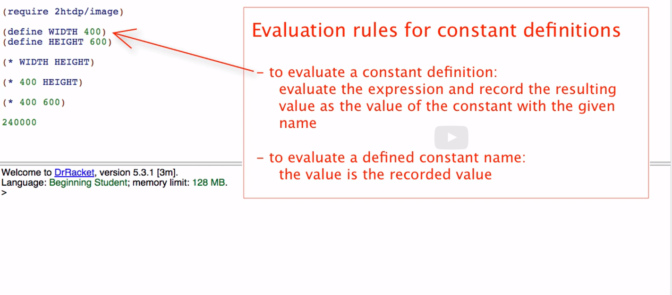
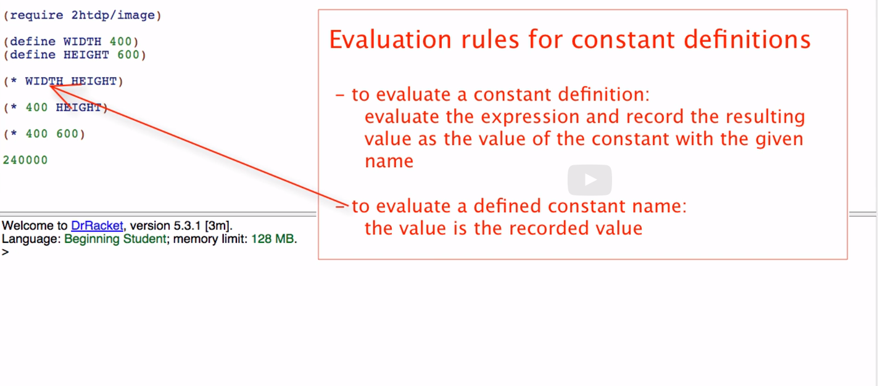
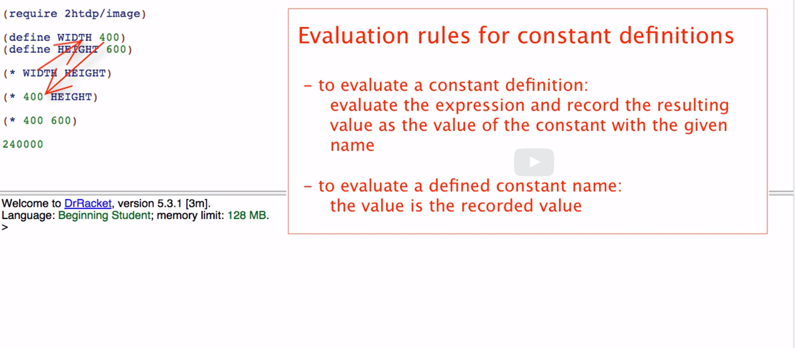

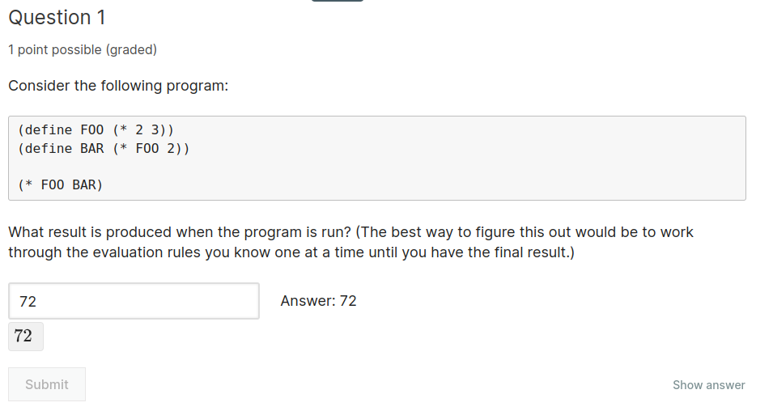

(define FOO (* 2 3))
(define BAR (* FOO 2))

(* FOO BAR)
(* (* 2 3) BAR)
(* 6 BAR)
(* 6 (* 6 2))
(* 6 12)
Question 2
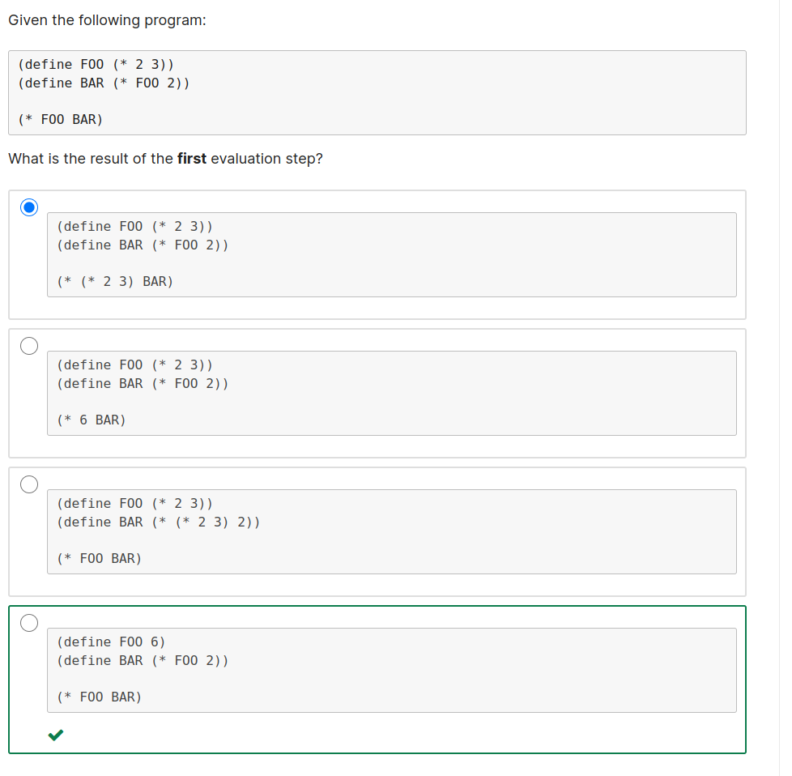

Function definitons, pt. 1

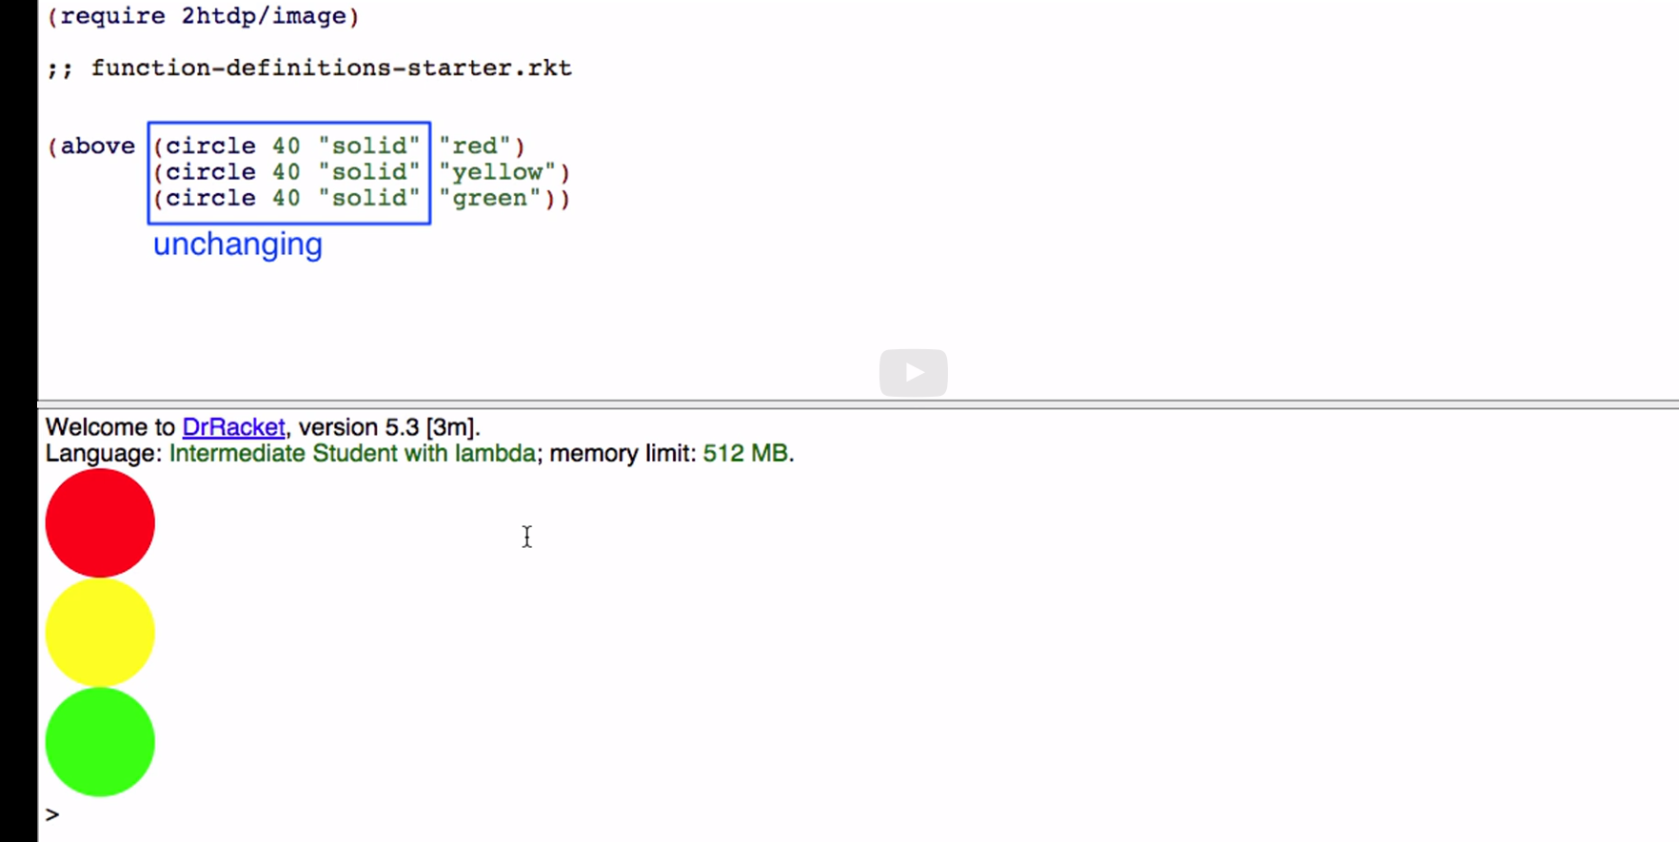
unchanging parts

varying parts

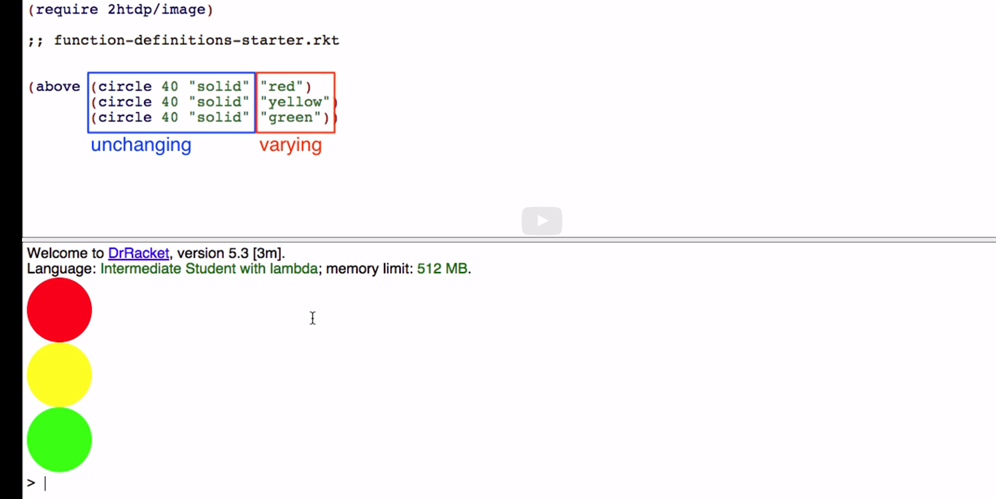

Remember function definitions and how they work

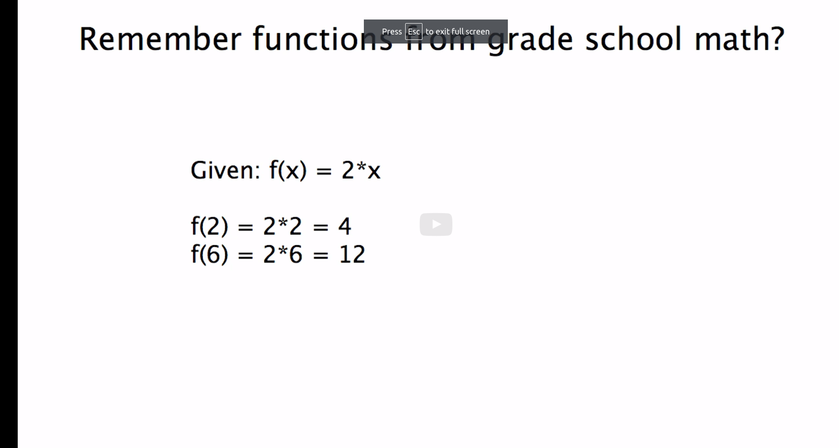

parameter stands for varying value

function can be used repeatedly, with any value each time

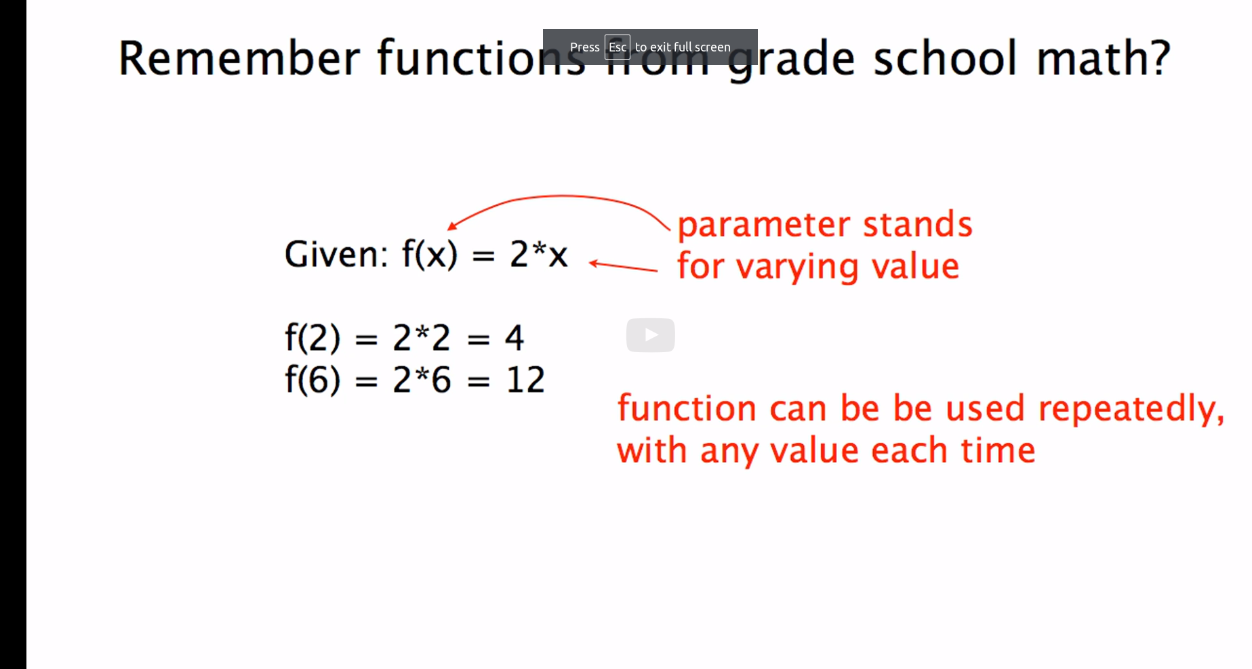

Parameter stands for changing value

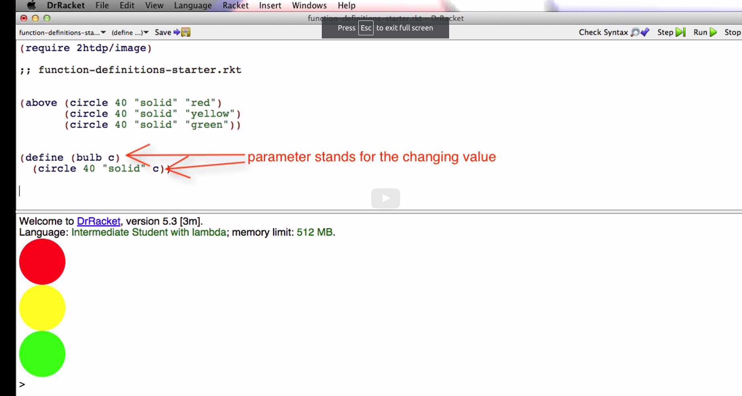

making code concise

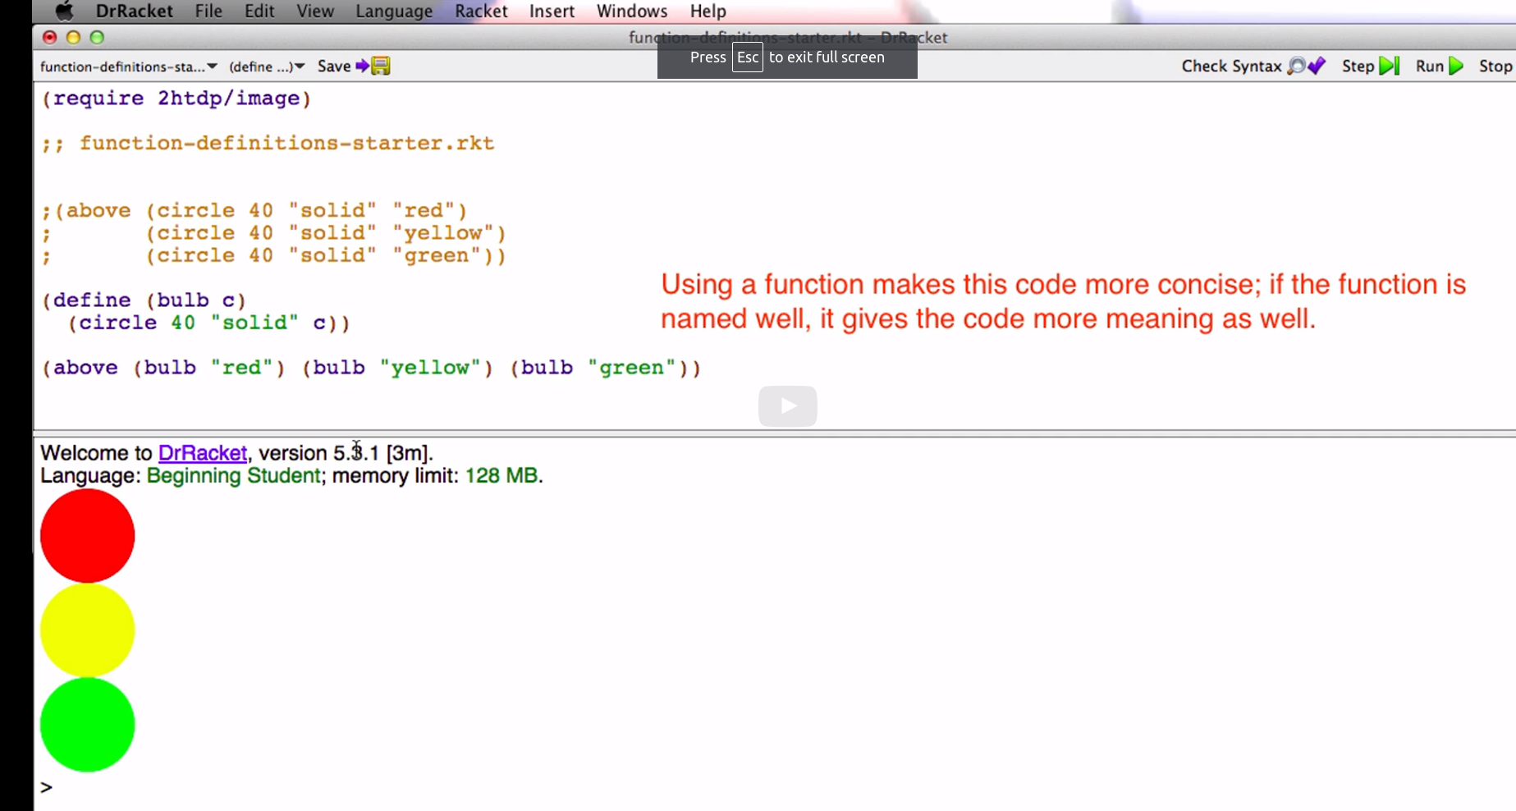

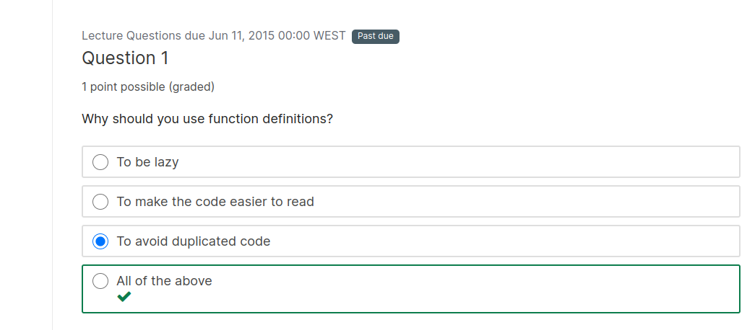

Explanation

All of these are good reasons because we would like to avoid redundancy and duplicate code as programs get big, mainly so we can easily understand and navigate the code.

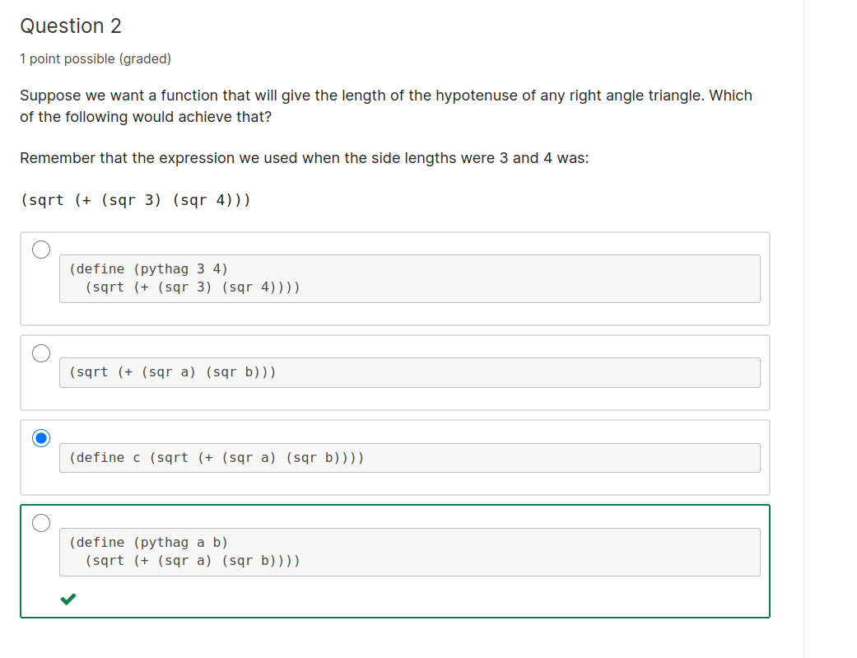

Explanation

The side lengths of the right angle triangle can vary, so we can write the following function:

(define (pythag a b)
(sqrt (+ (sqr a) (sqr b))))

Where parameters a and b stand for the changing values.

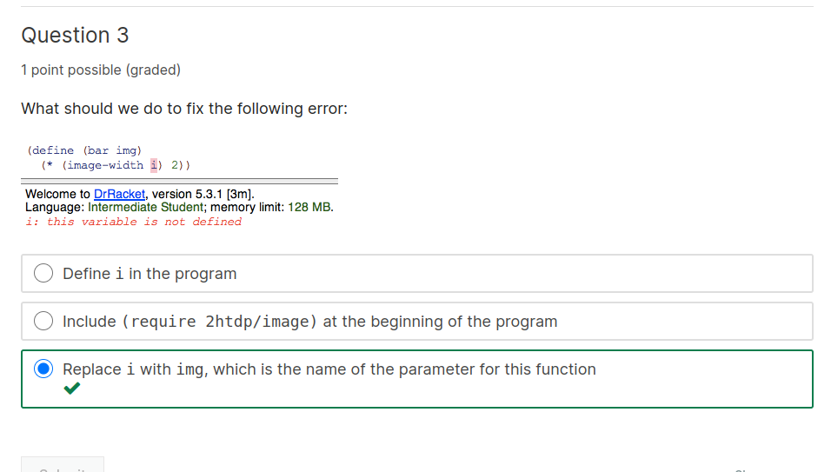

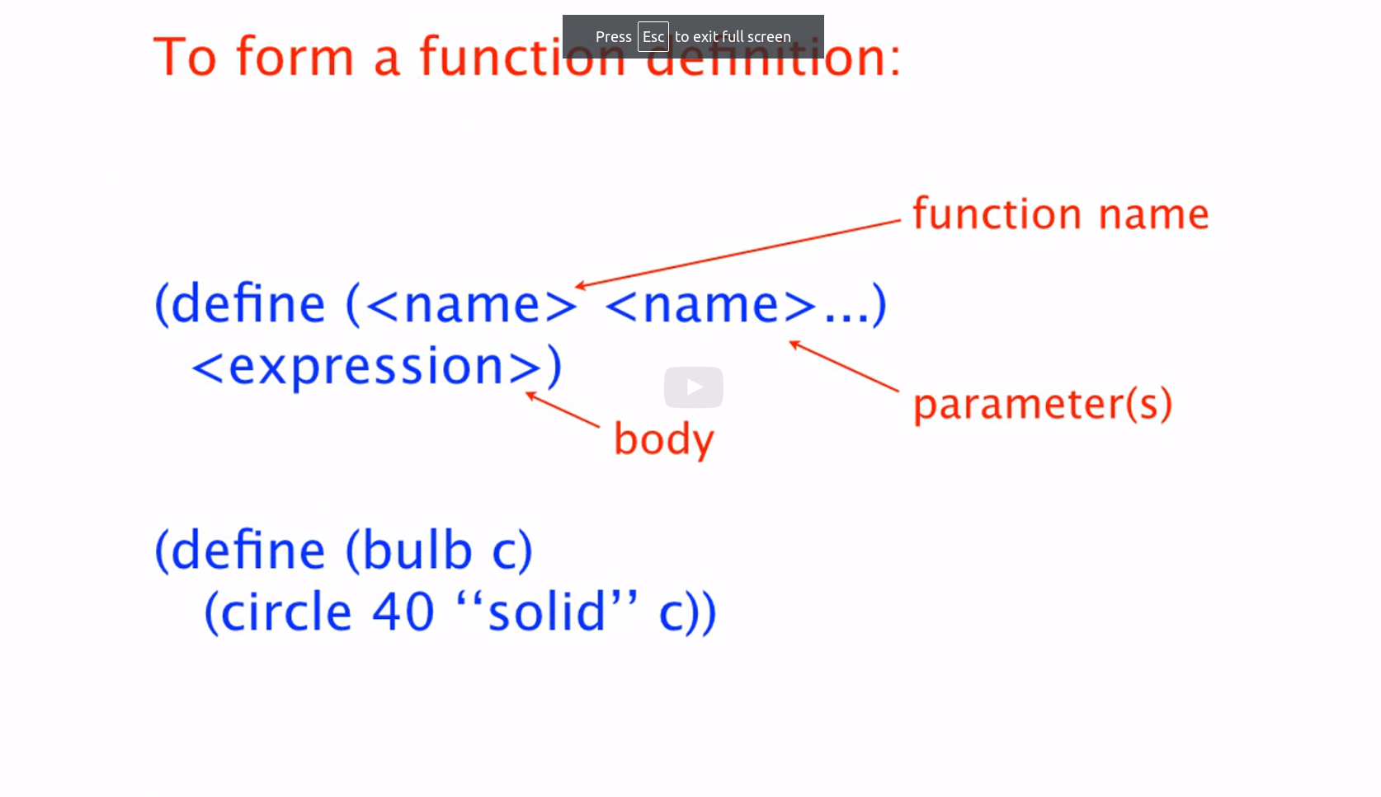

To form a function call expression

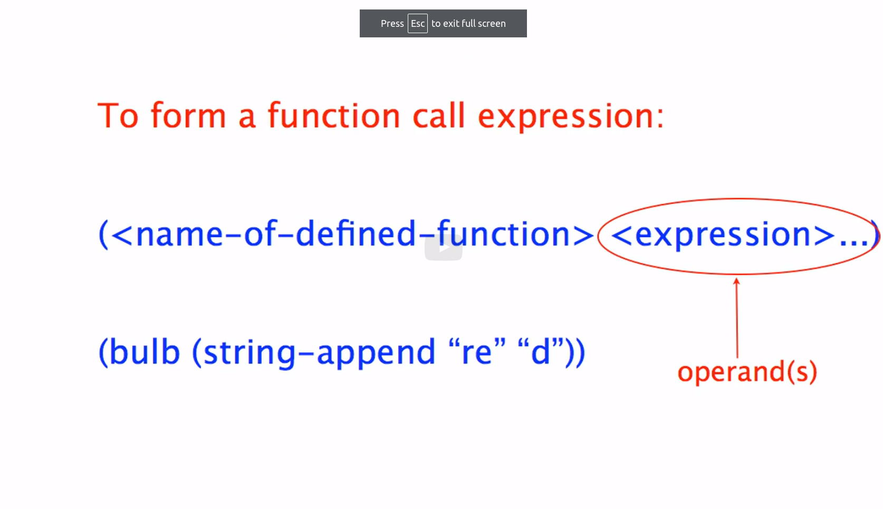

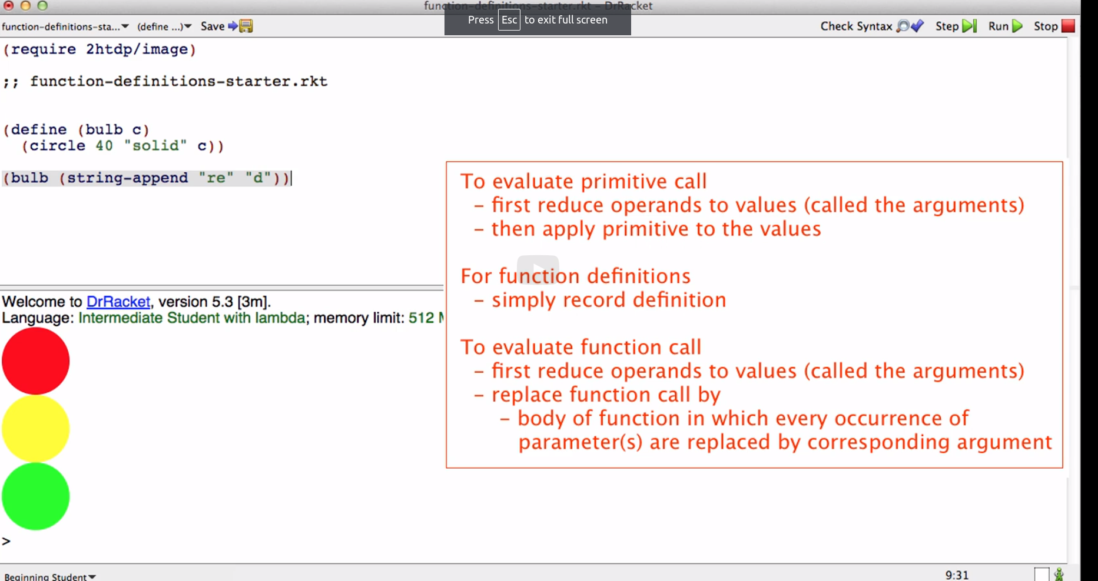

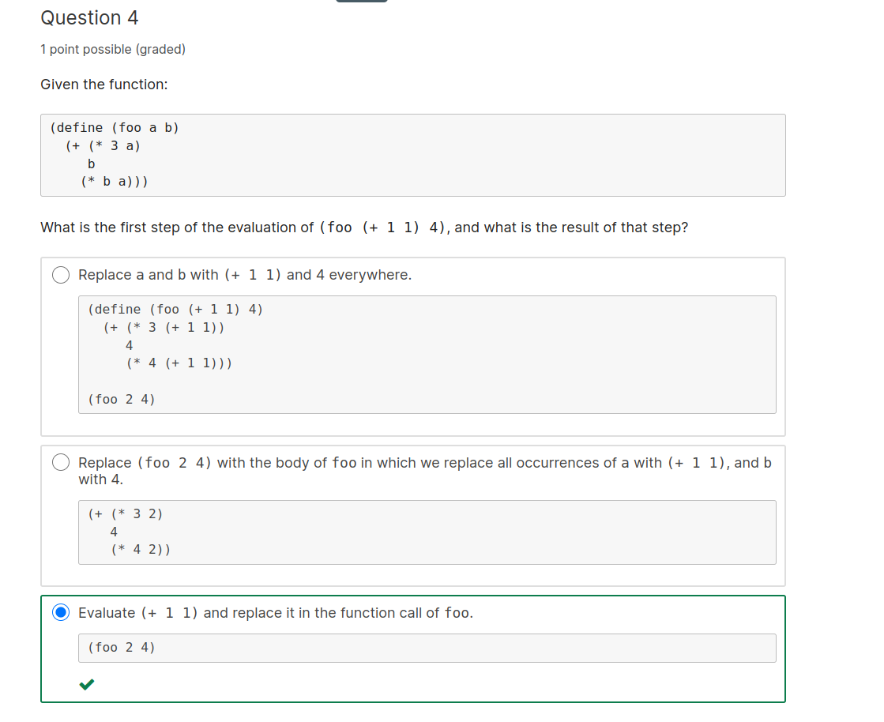

Explanation

Because (+ 1 1) is an expression, not a value, it is first evaluated to 2 before moving on with the evaluation of foo.

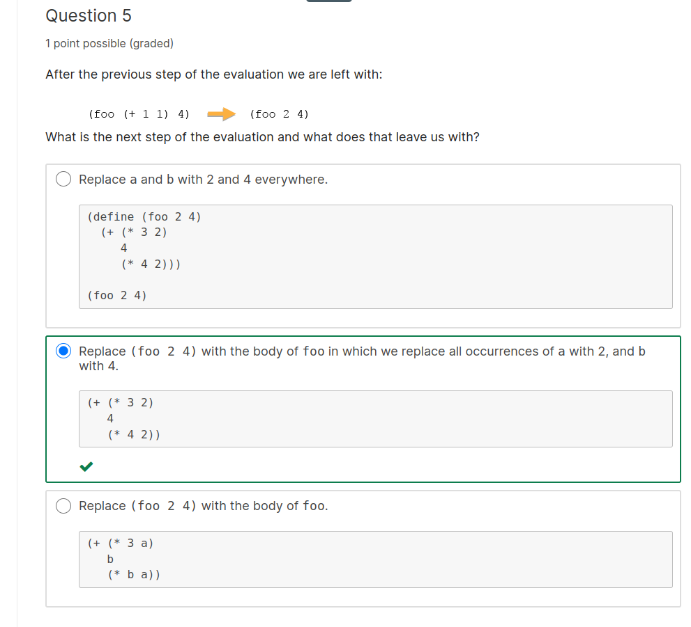

Explanation

According to the rules for evaluating function calls, the first step is to replace the function call by the body of the function in which every occurrence of the parameters a and b are replaced by the corresponding arguments 2 and 4.

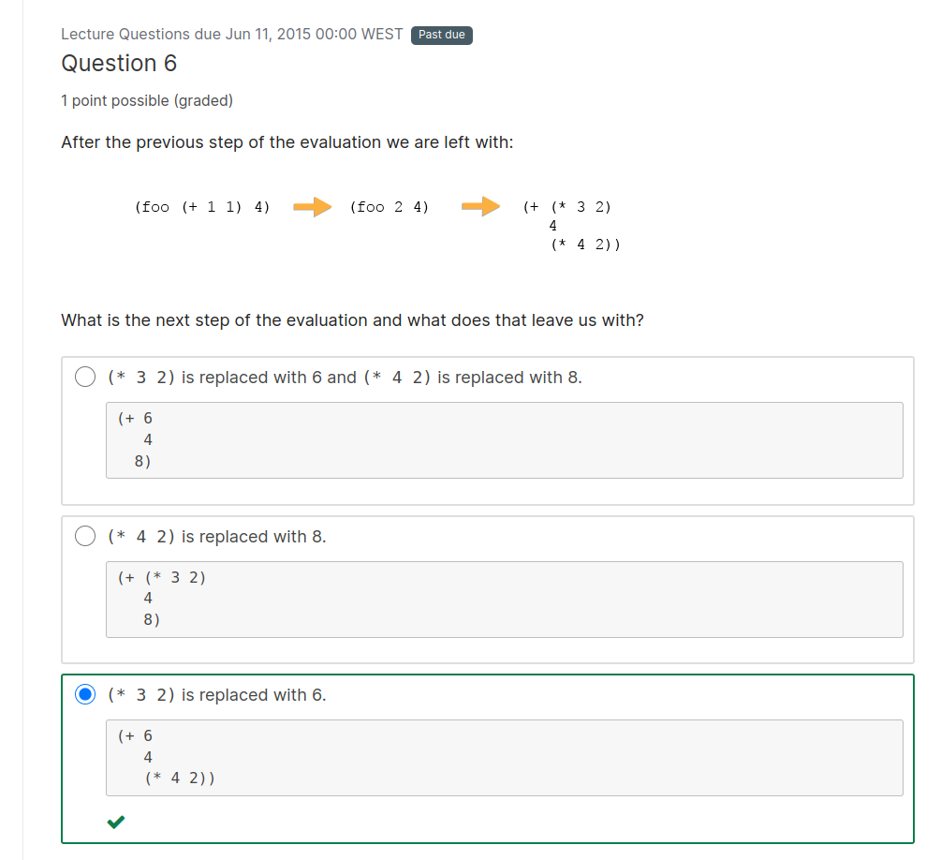

Explanation

We now simply evaluate the expression (+ (* 3 2) 4 (* 4 2)) in left to right, inside to outside order, so (* 3 2) evaluates to 6.

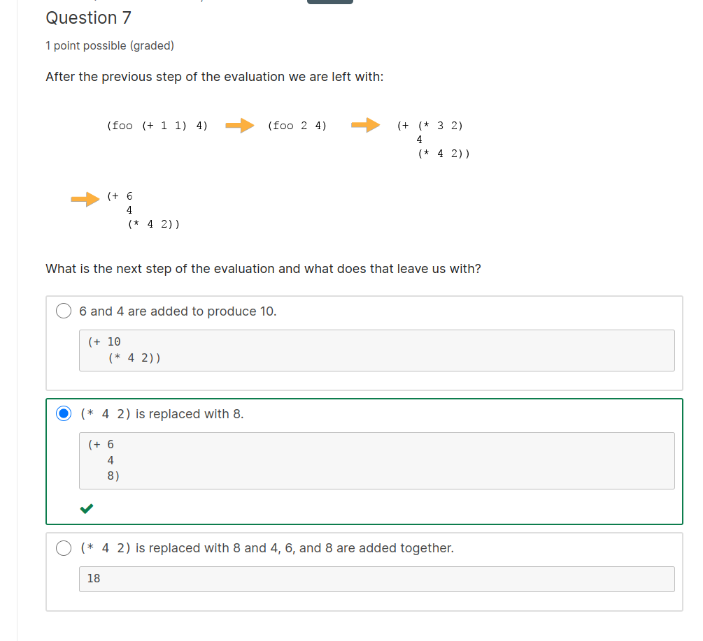

Explanation

Next, the expression (* 4 2) evaluates to 8.

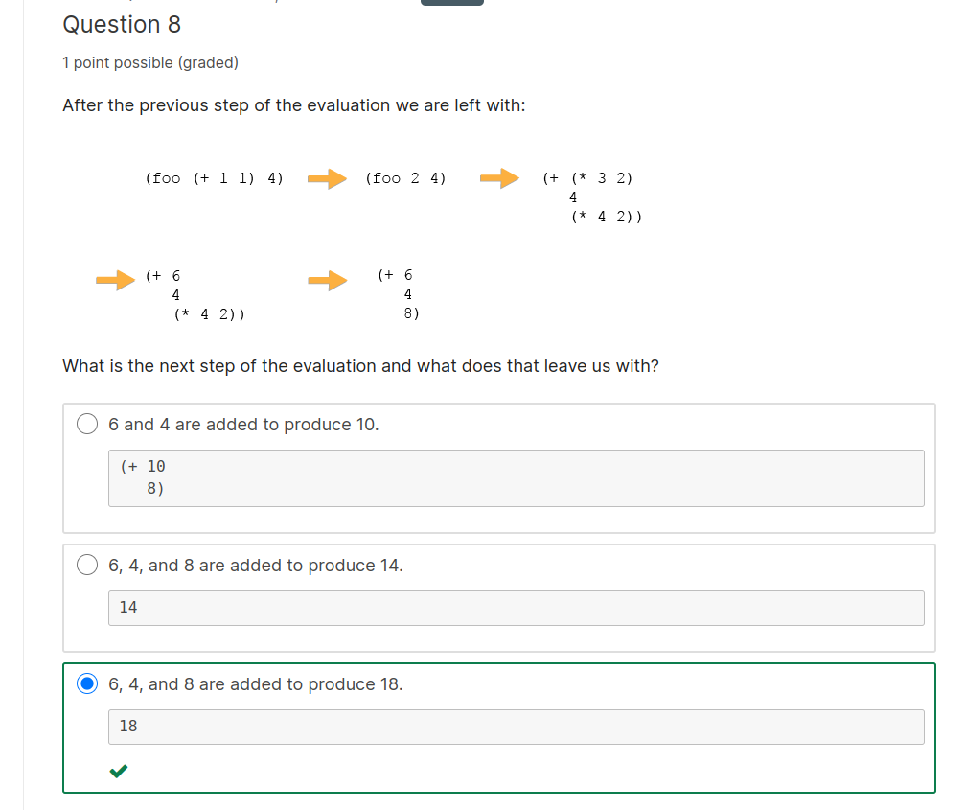
Explanation

Finally, the expression (+ 6 4 8) evaluates to 18.

Once you have all the values use the operation

Booleans and if Expressions, pt 1

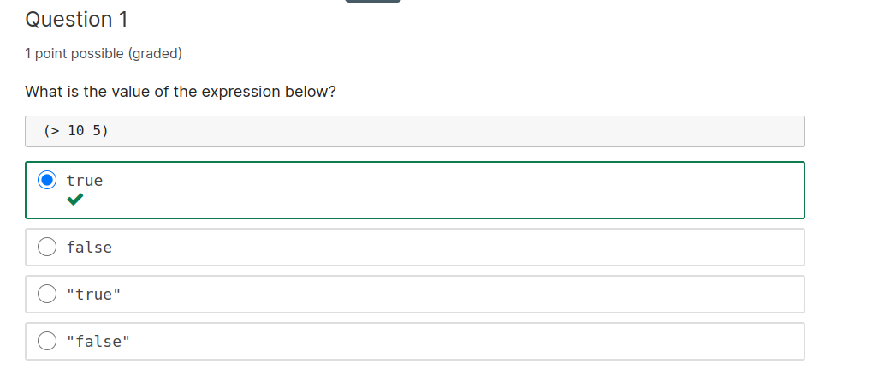

Explanation

10 is greater than 5 so the answer is true. Remember boolean values are not strings and are case sensitive.

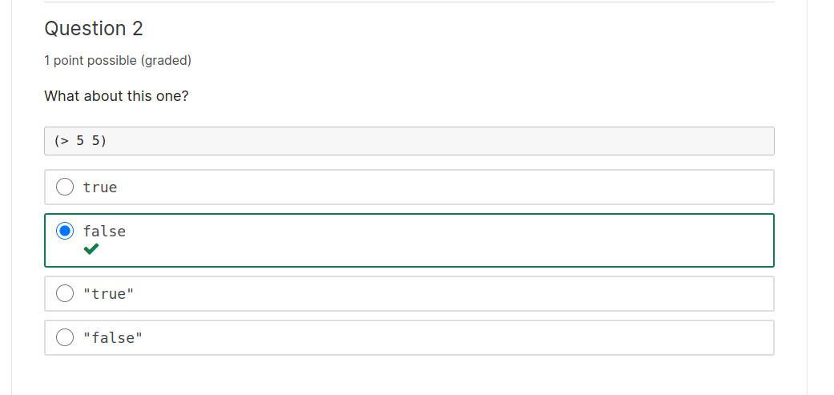
Explanation

5 is not greater than 5 so the answer is false. Again, remember boolean values are not strings and are case sensitive

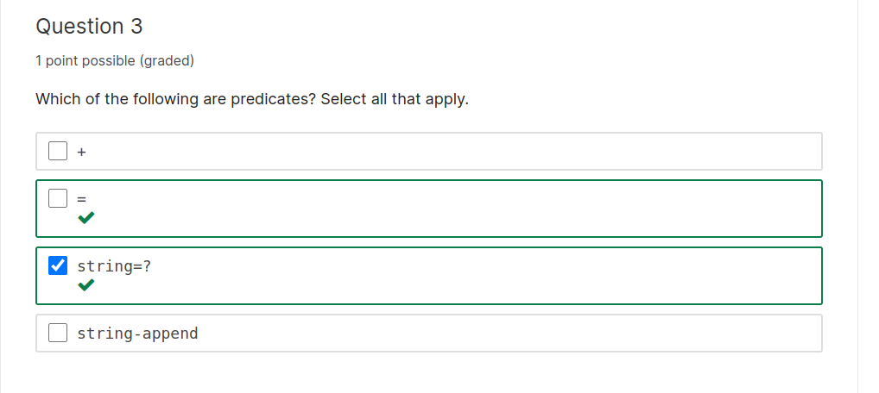

Explanation

Predicates are primitives or functions that produce a boolean value, so = and string=? are examples of predicates.

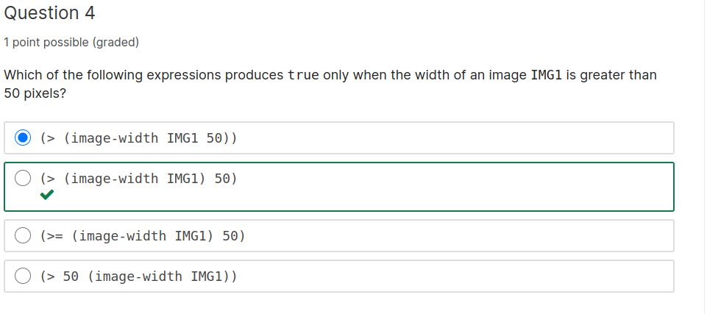

Don’t forget the brackets here

Explanation

The expression that compares whether (image-width IMG1) is greater than 50 is:

(> (image-width IMG1) 50)

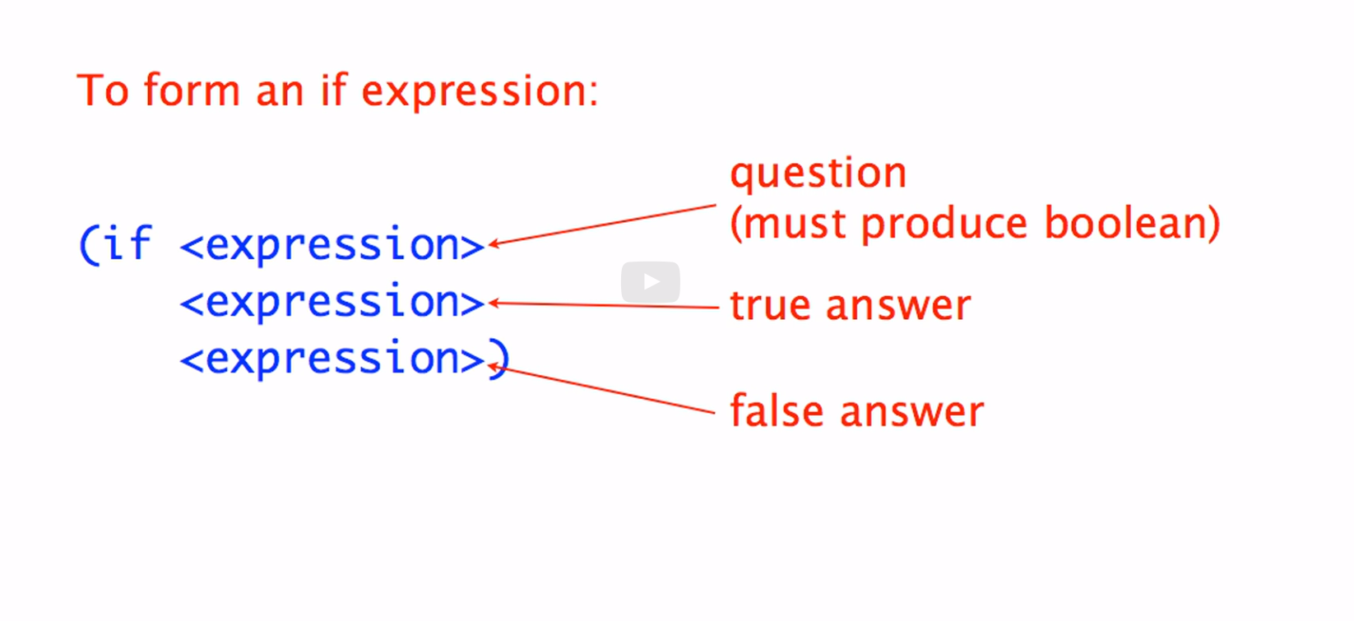

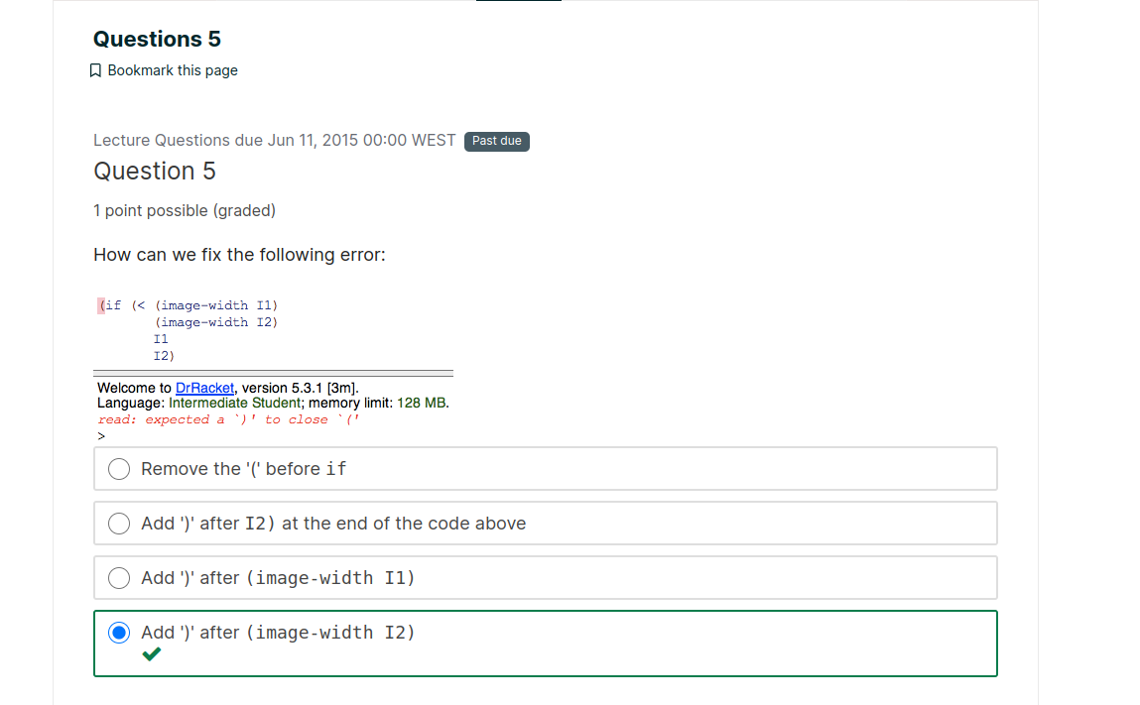

Explanation

We know that if expressions have three parts: the question, the true answer and the false answer. Reading what we have here it looks like I1 and I2 are intended to be the true and false answers. So the < needs to be the question. We have to add a close paren after the second operand to <. Note that after we do that we should push CMD-I or CTL-I to fix the indentation of this code.

Booleans and if Expressions, pt 3
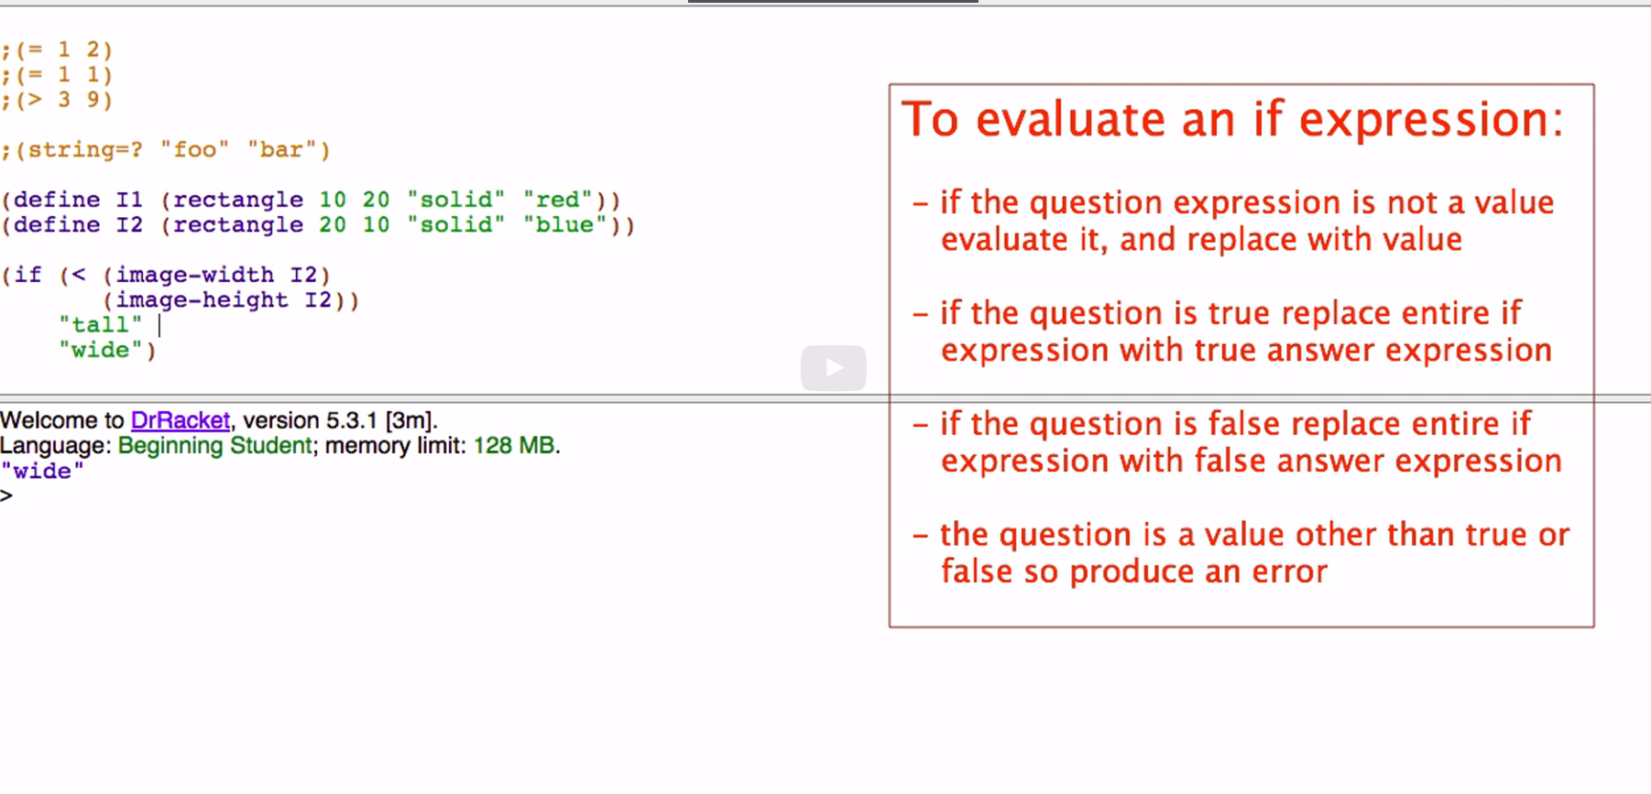

Key to evaluating if is that
first you evaluate the question and depending on the result of the question
you replace the entire if with either the true answer or the false answer
and then just keep evaluating.

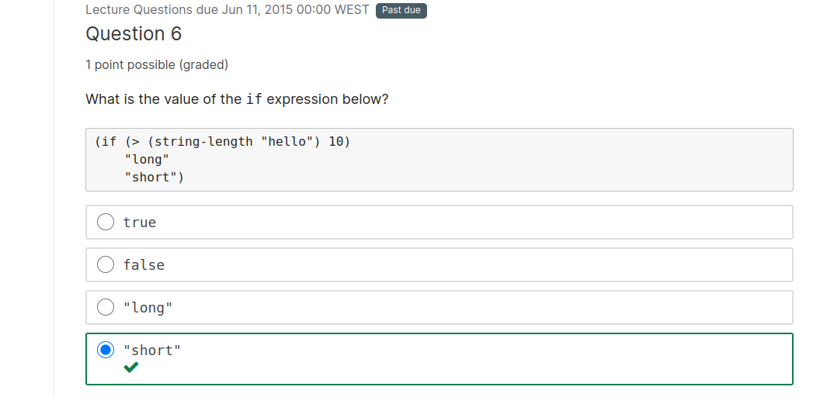

Explanation

The question in the if expression is not a value, so we evaluate it and replace it with false. Since the question is false, we replace the entire if expression with the false-answer expression, which is just the value "short".

To form and

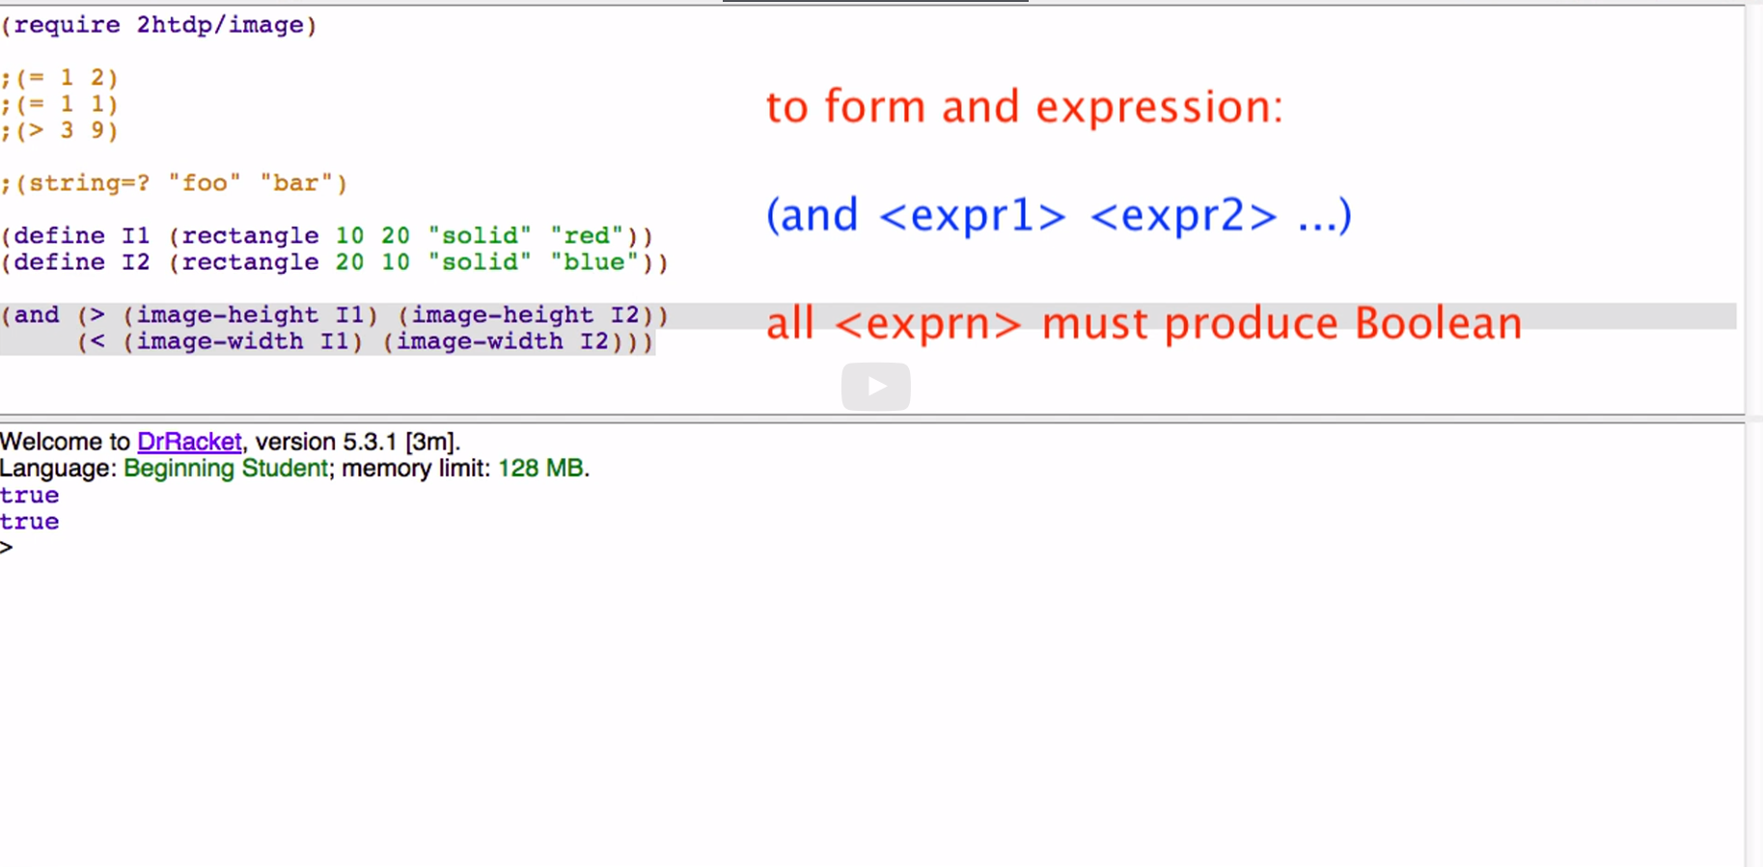

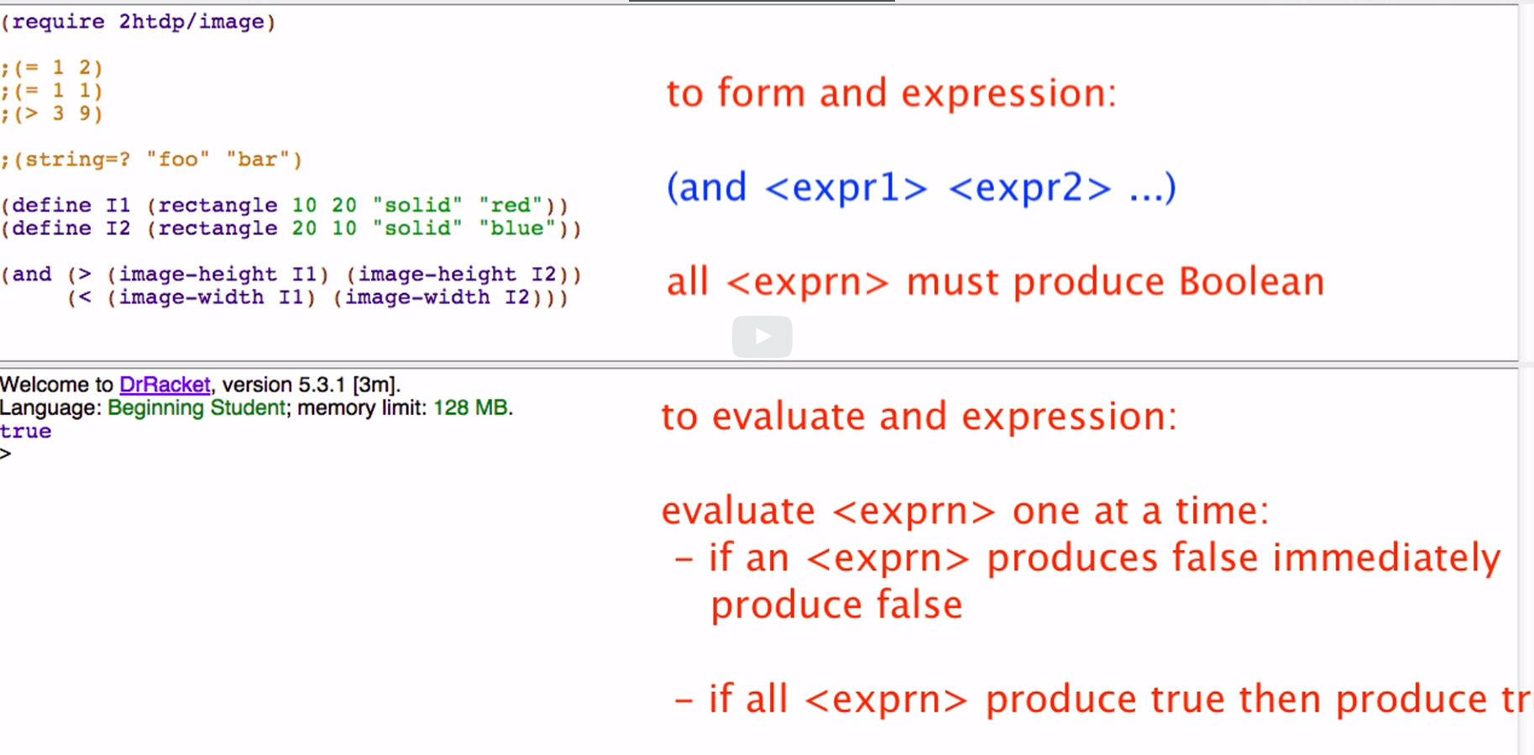

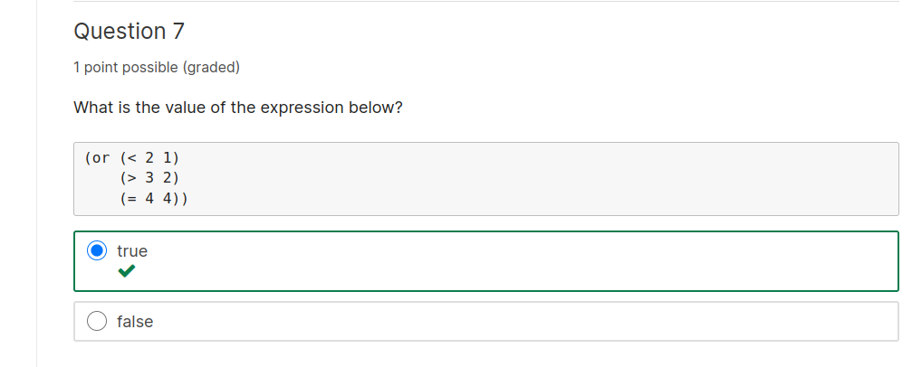

or stops evaluating só it does not go to 4 = 4

Explanation

According to the help desk, an or expression: (or <expr1> <expr2> …) evaluates to true as soon as one <exprn> evaluates to true.

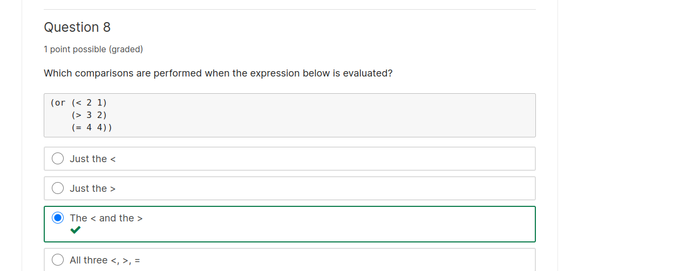

Explanation

The help desk also explains that as soon as an expression produces true, in this case the expression is (> 3 2), other expressions to the right of it are not evaluated and or immediately produces true.

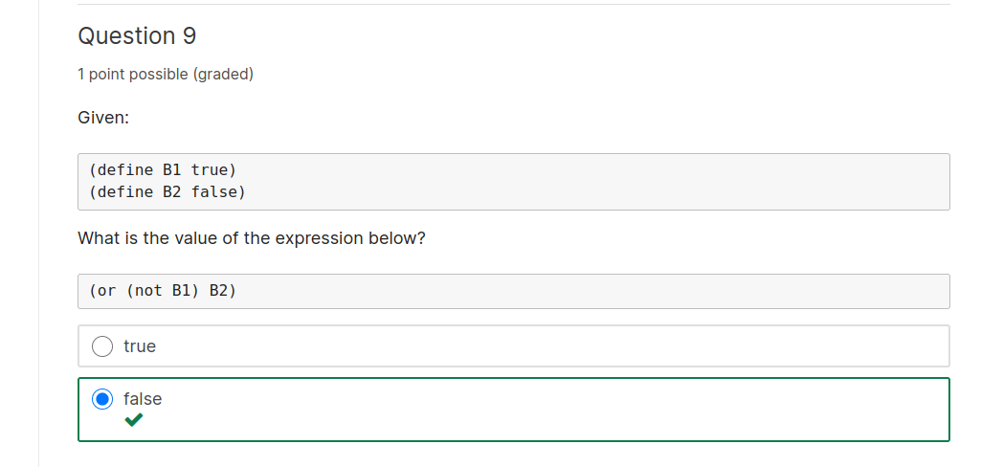
Explanation

(not B1) is false. (or false false) is false.

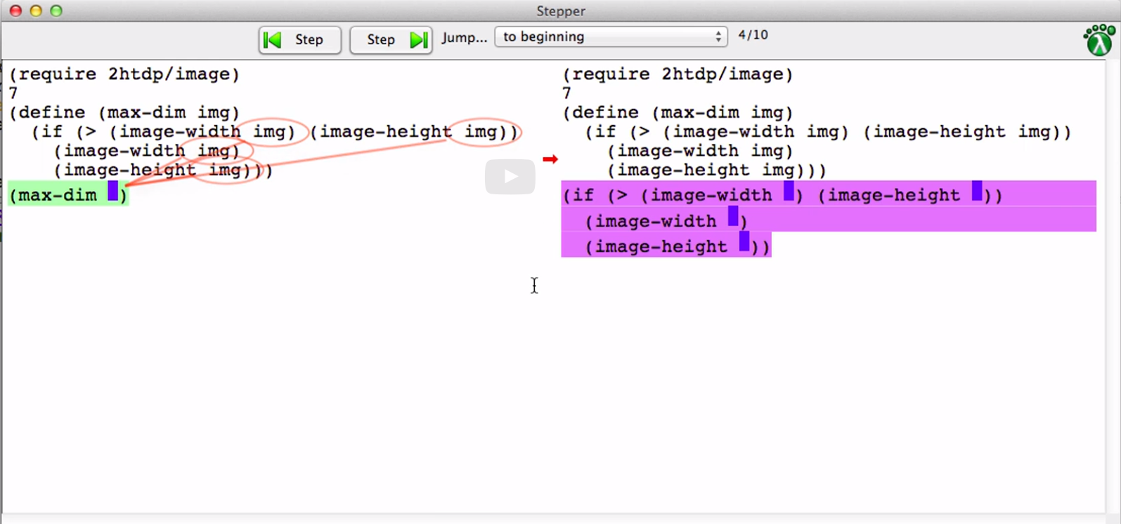

arguments become value

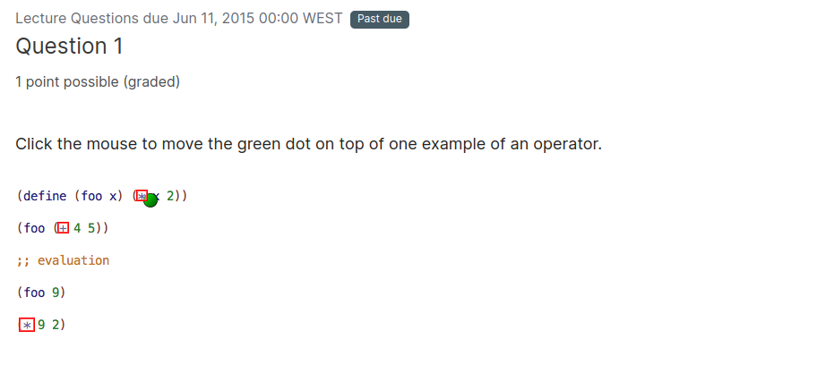

Explanation

Operators are primitives built into BSL that consume primitive data and produce results. Examples include +, *, -, / and many more.



