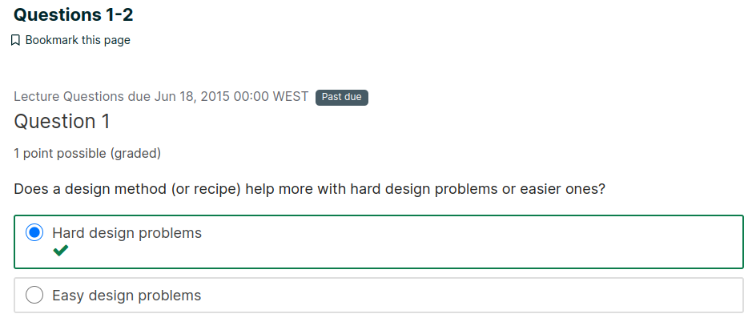

Explanation

A design recipe makes hard problems easier, as it breaks the problem down.

But breaking down easy problems might make them more cumbersome.

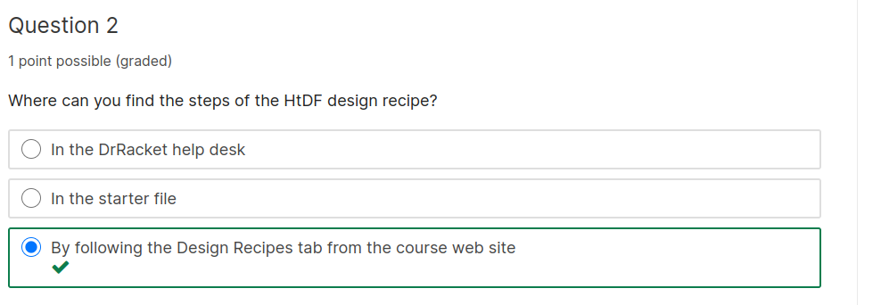

Explanation

Go to the top of any course page and click on the Design Recipes tab.

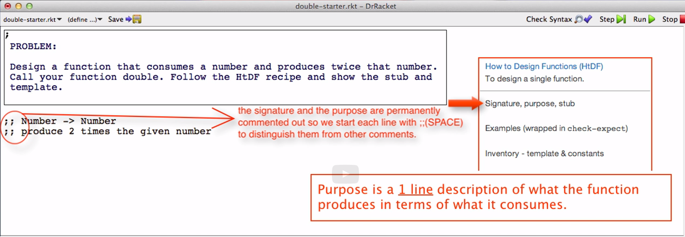

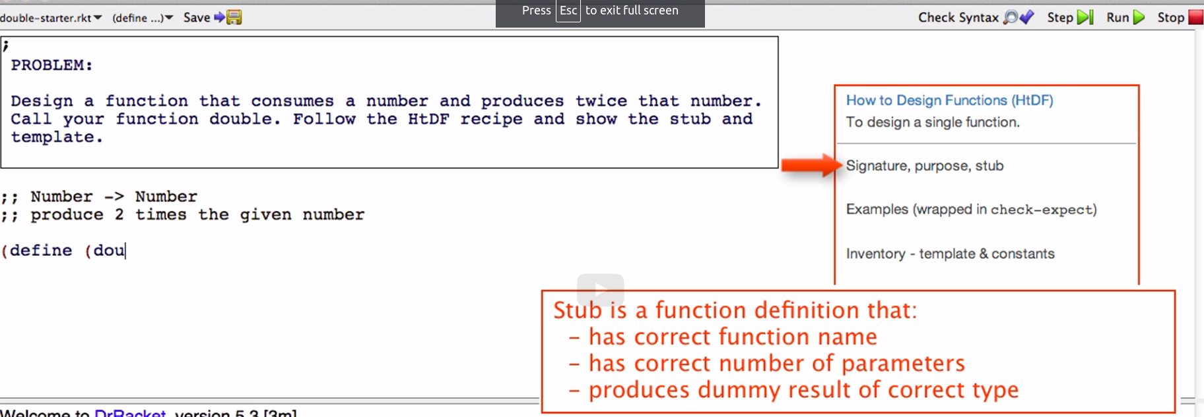

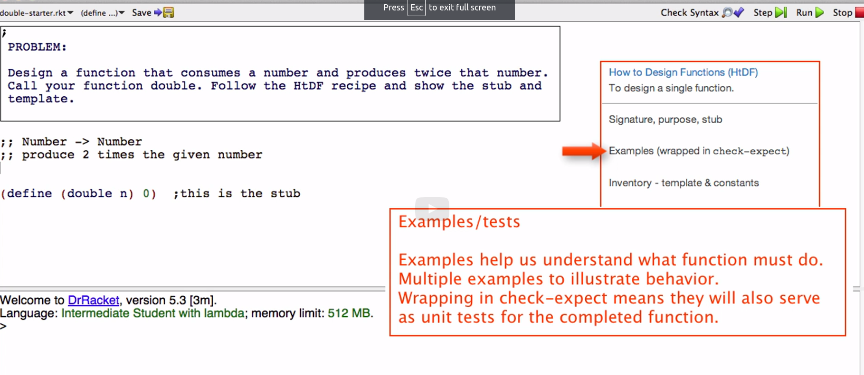

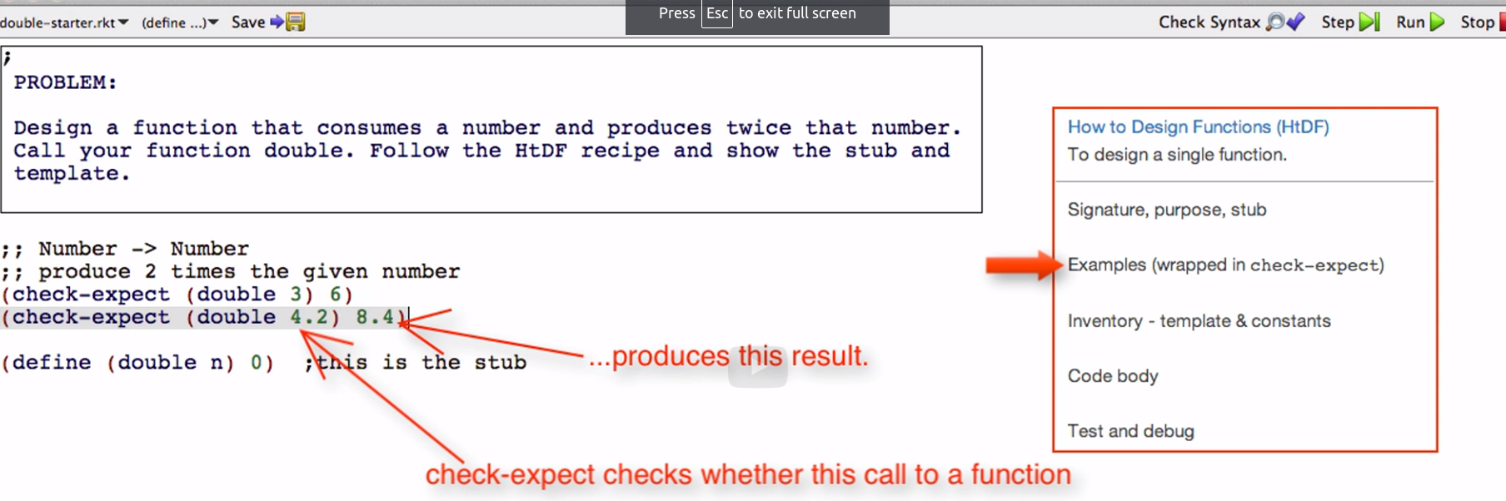

Every step of the recipe helps with the steps after it!

Signature helps us write purpose and stub

Signature helps to write check expects
Signature tells me to put a number

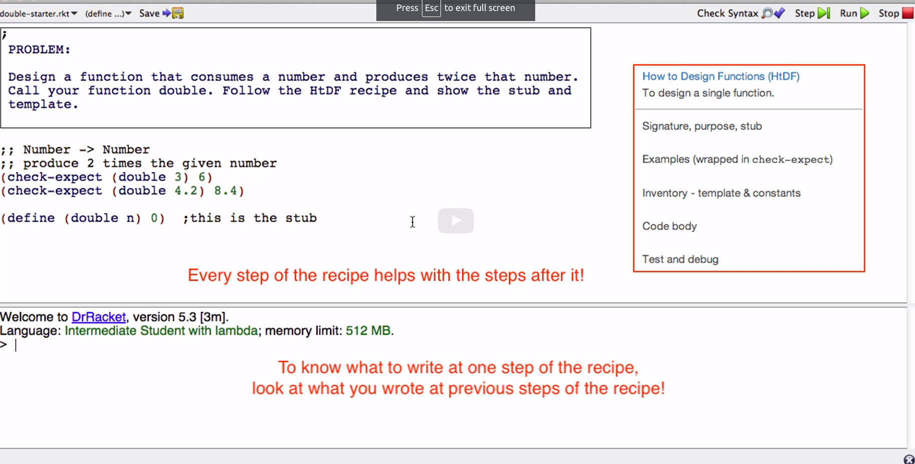

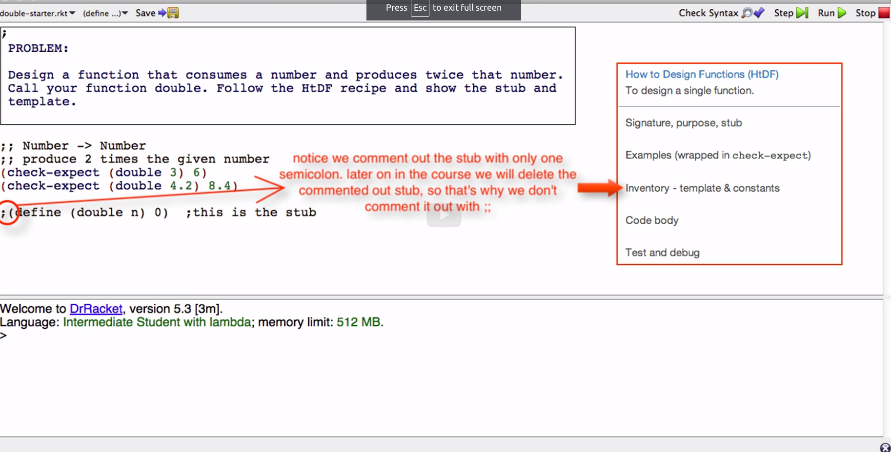

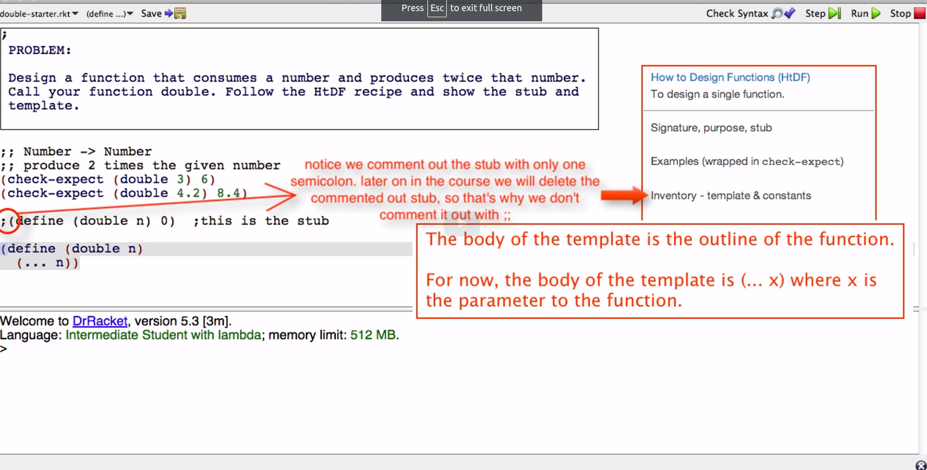

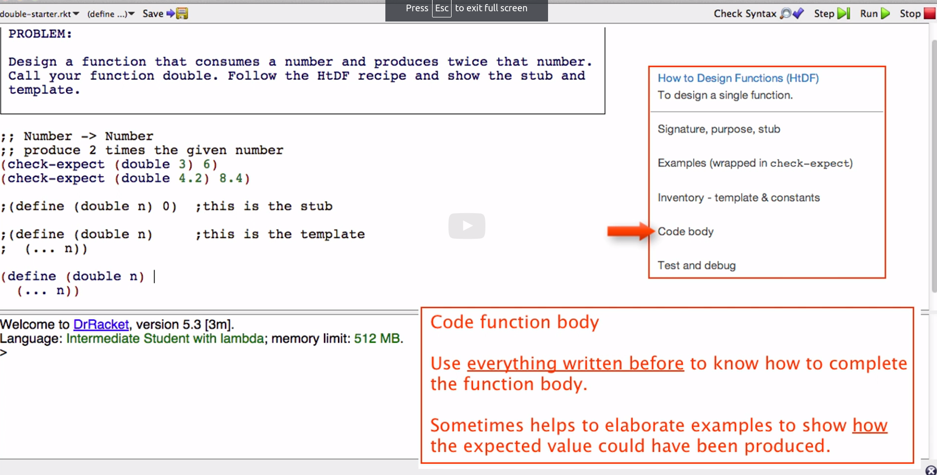

Keep this in mind

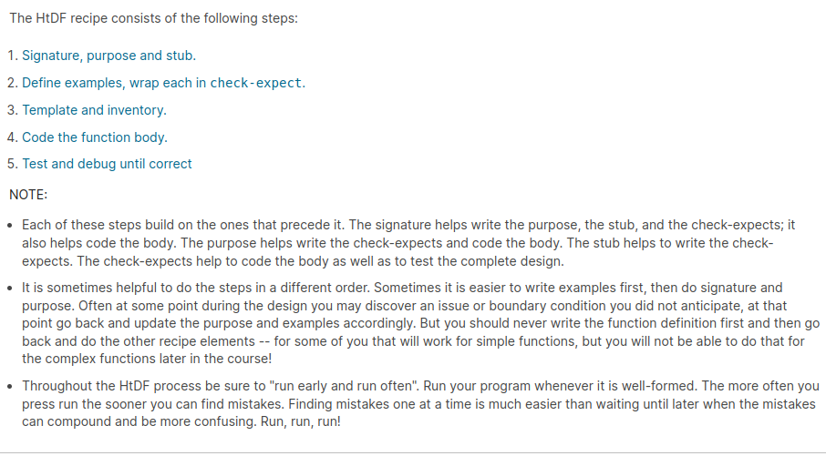

Problem: Design a function that pluralizes a given word. (Pluralize means to convert the word to its plural form.) For simplicity you may assume that just adding s is enough to pluralize a word.

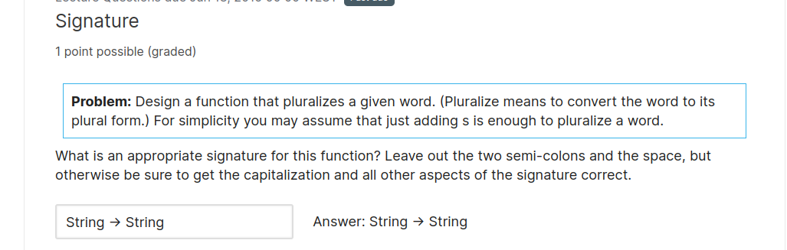

Explanation

The most appropriate way to represent a word is with a string, so the primitive type the function should consume and produce is String. This means the signature line, including the semi-colons, is:

1/1

wrong in code, right here

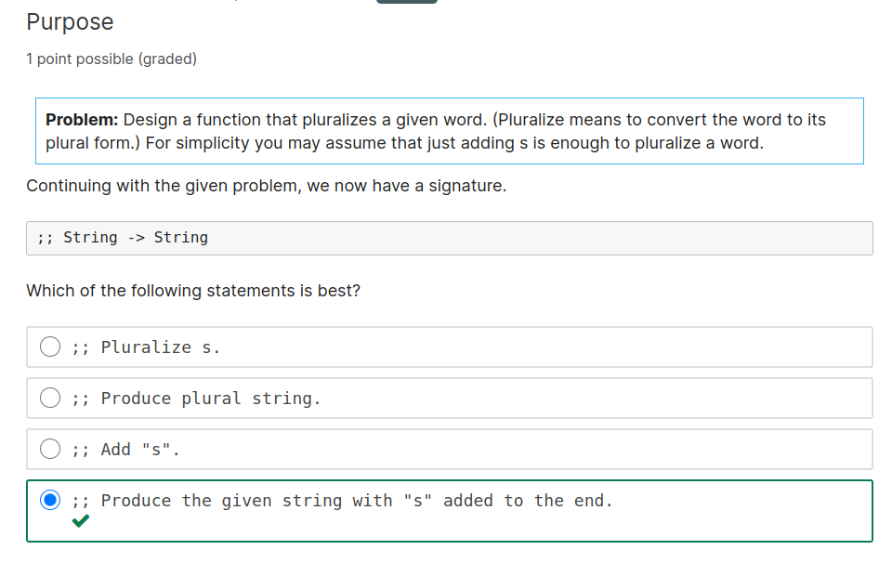

Explanation

A purpose statement should describe what result is produced and how that is based on the argument(s). The first choice says no more than the signature, so it adds no value. The second choice says not much more than the function name. The third choice is unclear about what "s" is added to and what is produced. The fourth choice is best because it makes it clear exactly what is produced from the given string.

0/1

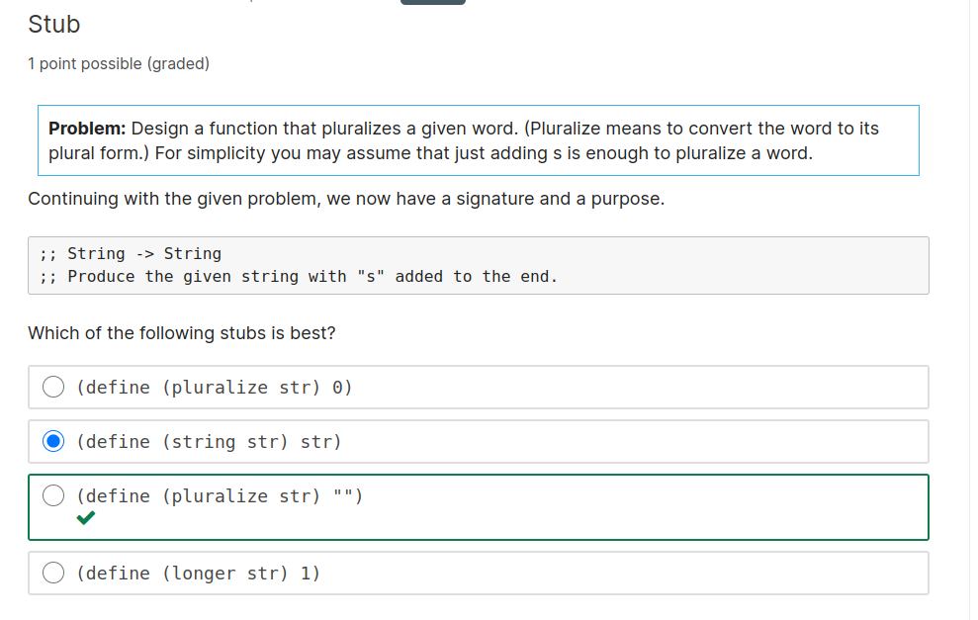

1/1

Explanation

A stub must have the correct function name, the correct number of parameters, and produce a value of the correct type. As part of writing the stub we end up deciding on a good name for the function. The name should say what the function produces when it is called, not necessarily how it does that internally. Of the choices above, the 1st and 3rd have good function names. All accept the correct number of parameters. Only the 2nd and 3rd produce a value of the correct type. So only the 3rd option is a good stub for this problem.

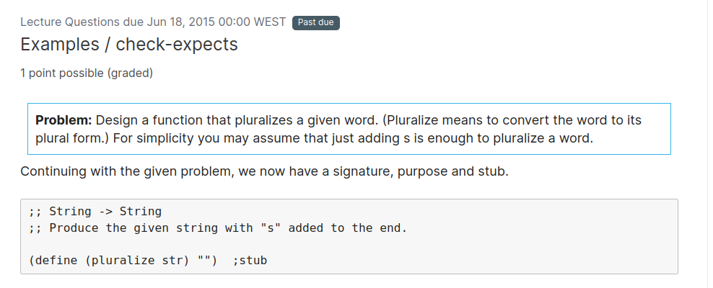

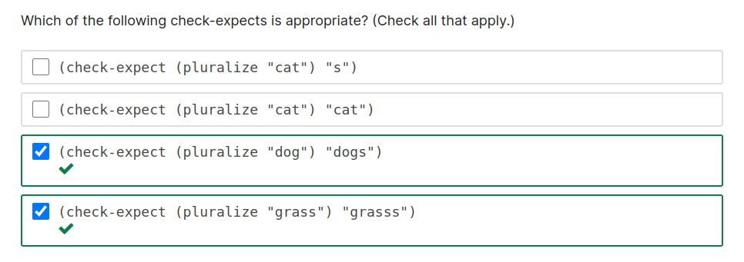

Explanation

Given "cat" this function should add "s" to produce "cats". So the first and second tests are incorrect. The third test is correct. So is the fourth, since adding "s" to "grass" should produce "grasss". Which just goes to show that this is not a very good pluralize function! But that's OK for now. The design method at least has made that clear to us.

1/1

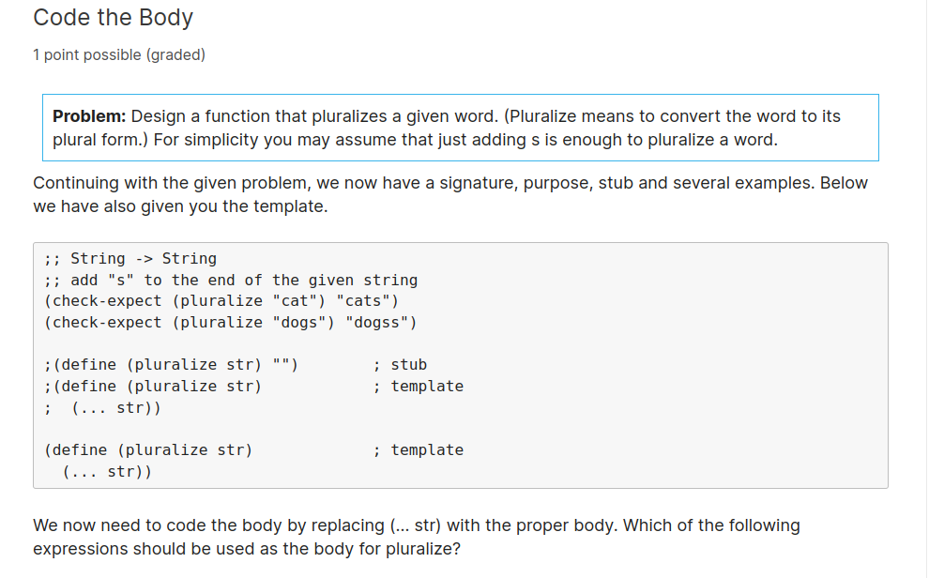

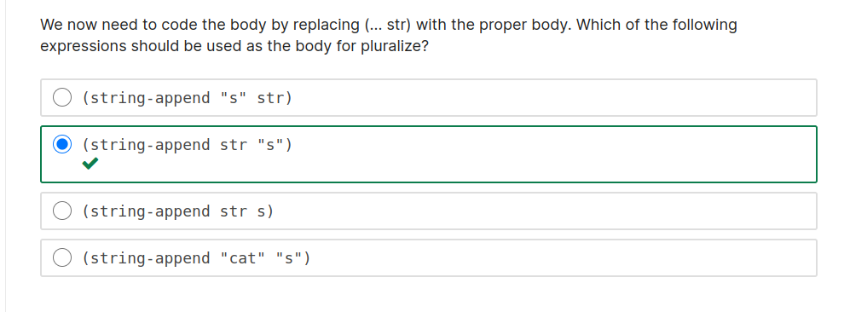

Explanation

The first option puts the "s" before the string instead of after it. The second option is correct. The third option is missing the " " around s, so it will cause an error message that there is no parameter or constant named s. The fourth option always produces "cats" no matter what arguments the function is called with, because it is failing to use the parameter s.

1/1

4/5

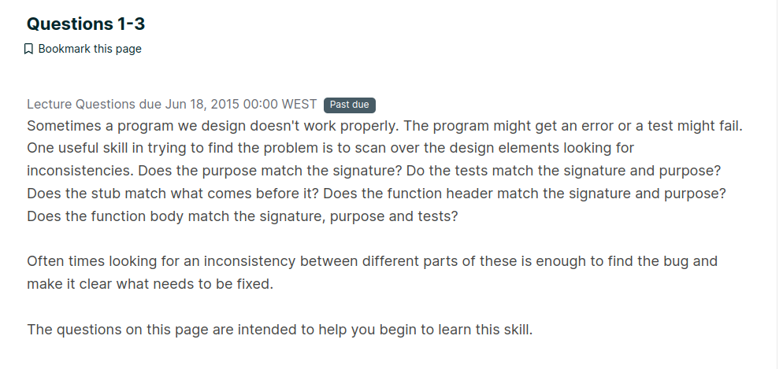

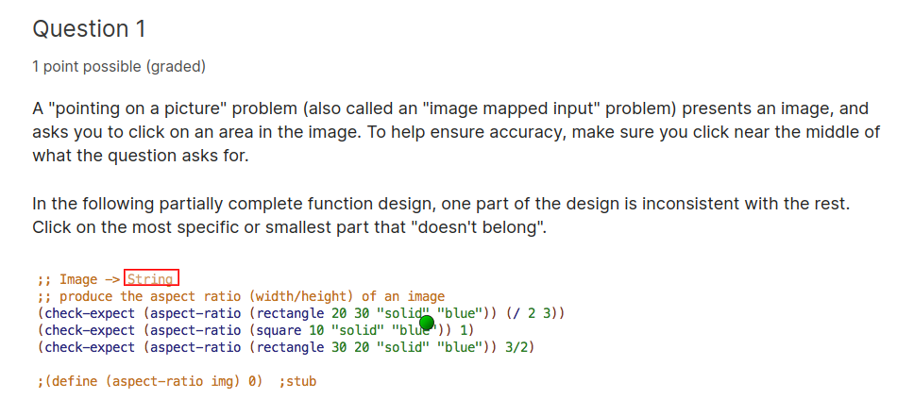

Explanation

The signature shows the function as producing String. But this doesn't match the purpose, the check-expects or the stub, all of which have the function producing Number.

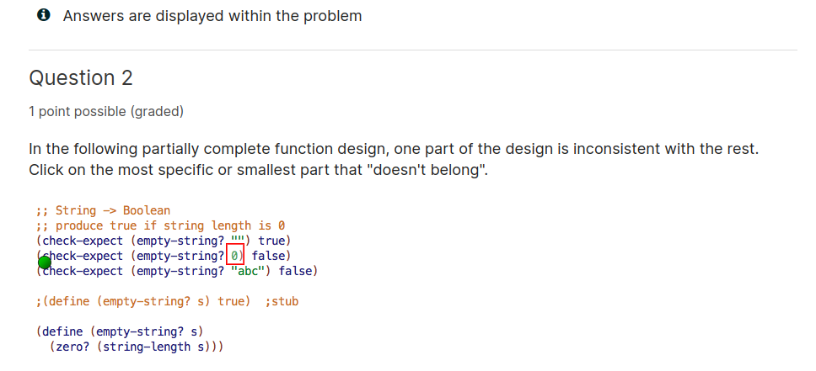

Explanation

In the second check-expect, the operand in the call to empty-string? is 0. But 0 is a number, the signature says the function must consume String, and all the other parts of the design have the function consuming String.

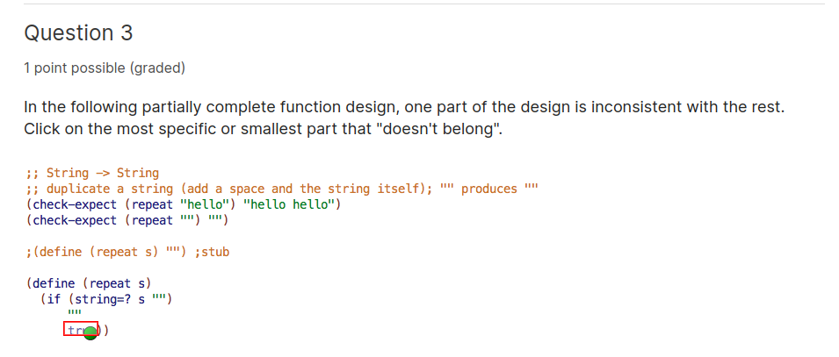

Explanation

The false answer in the if expression produces true. But true is a boolean, which does not match the signature, purpose or any of the check-expects.

An inefficient session I need to do an hour of deep work

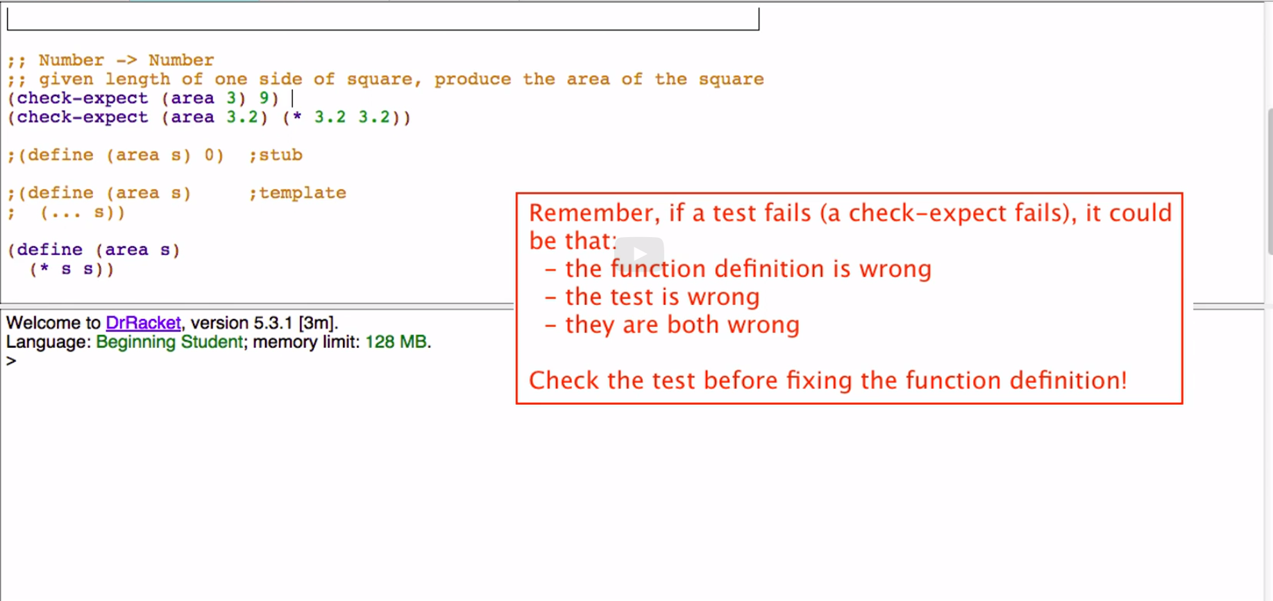

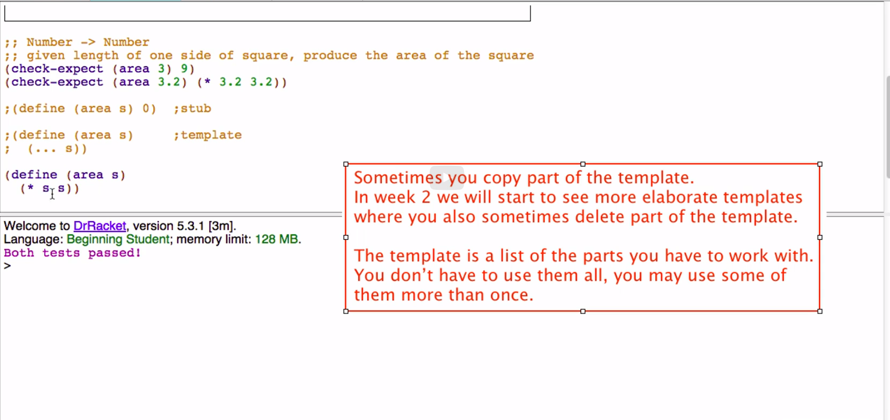

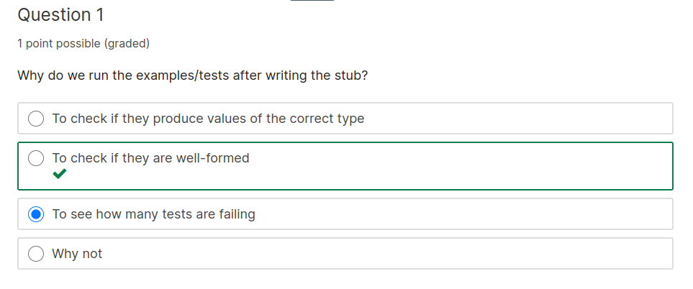

Explanation

The stub helps us make sure the tests are well-formed. Running the tests when we have the stub finds errors like unbalanced parentheses or string quotes, calls to non-existent functions and other violations of the well-formedness rules. But we should not expect all the tests to pass since the stub is returning the same result every time it is called. Similarly we should not expect that our stub is "correct" if all our tests do happen to pass.

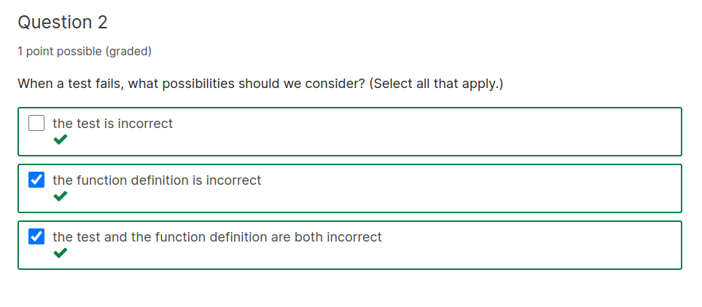
Explanation

When a test fails our first thought is likely to be that the function definition is incorrect. But if the function definition looks correct we should consider the possibility that the test itself is incorrect and carefully check the test against the signature and purpose. In some cases both the test and function definition may be incorrect! If you suspect that you want to carefully walk through the entire design checking it.

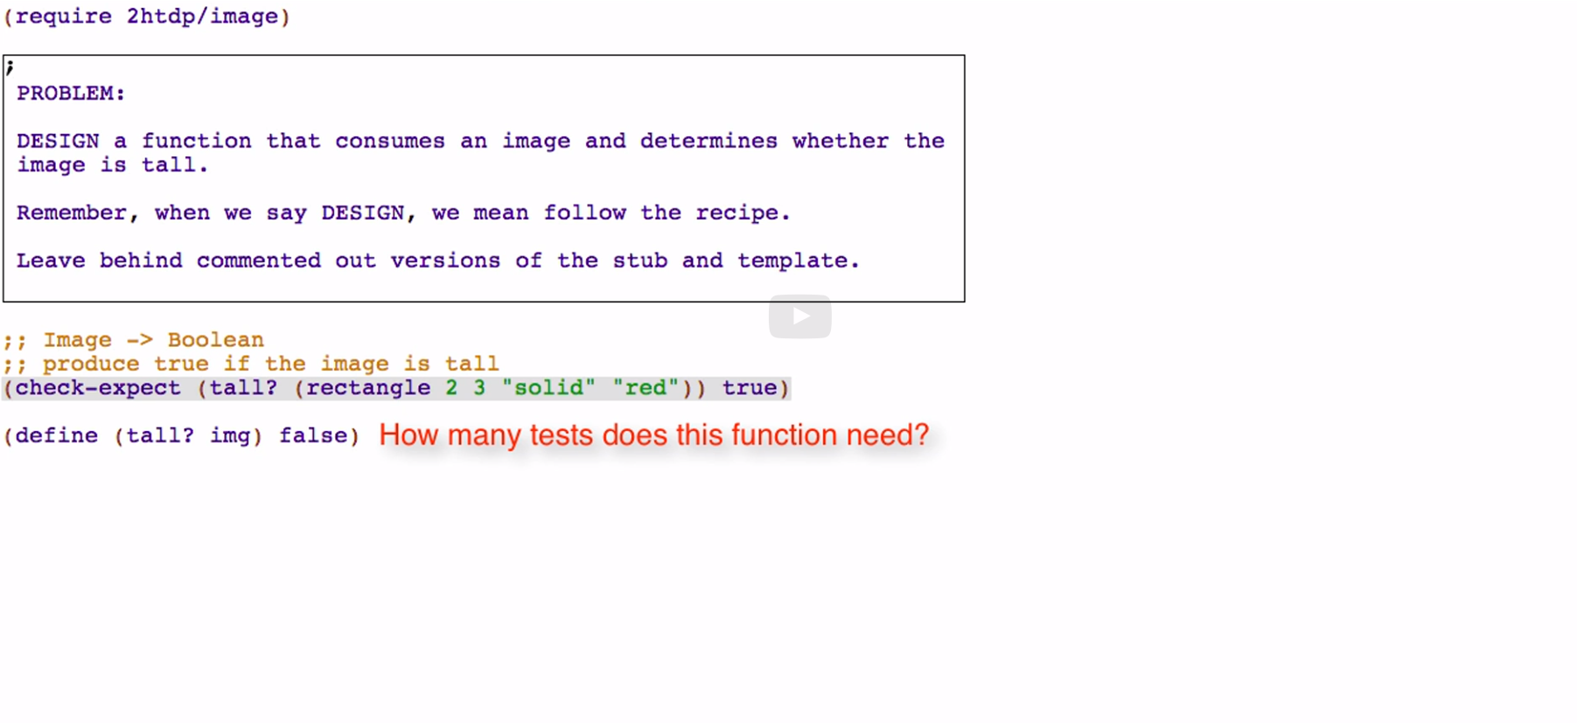

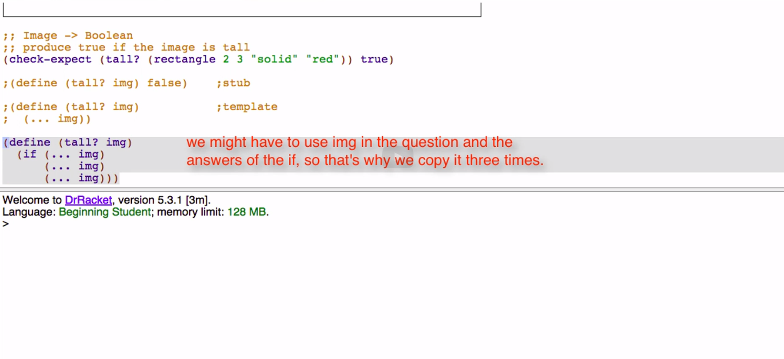
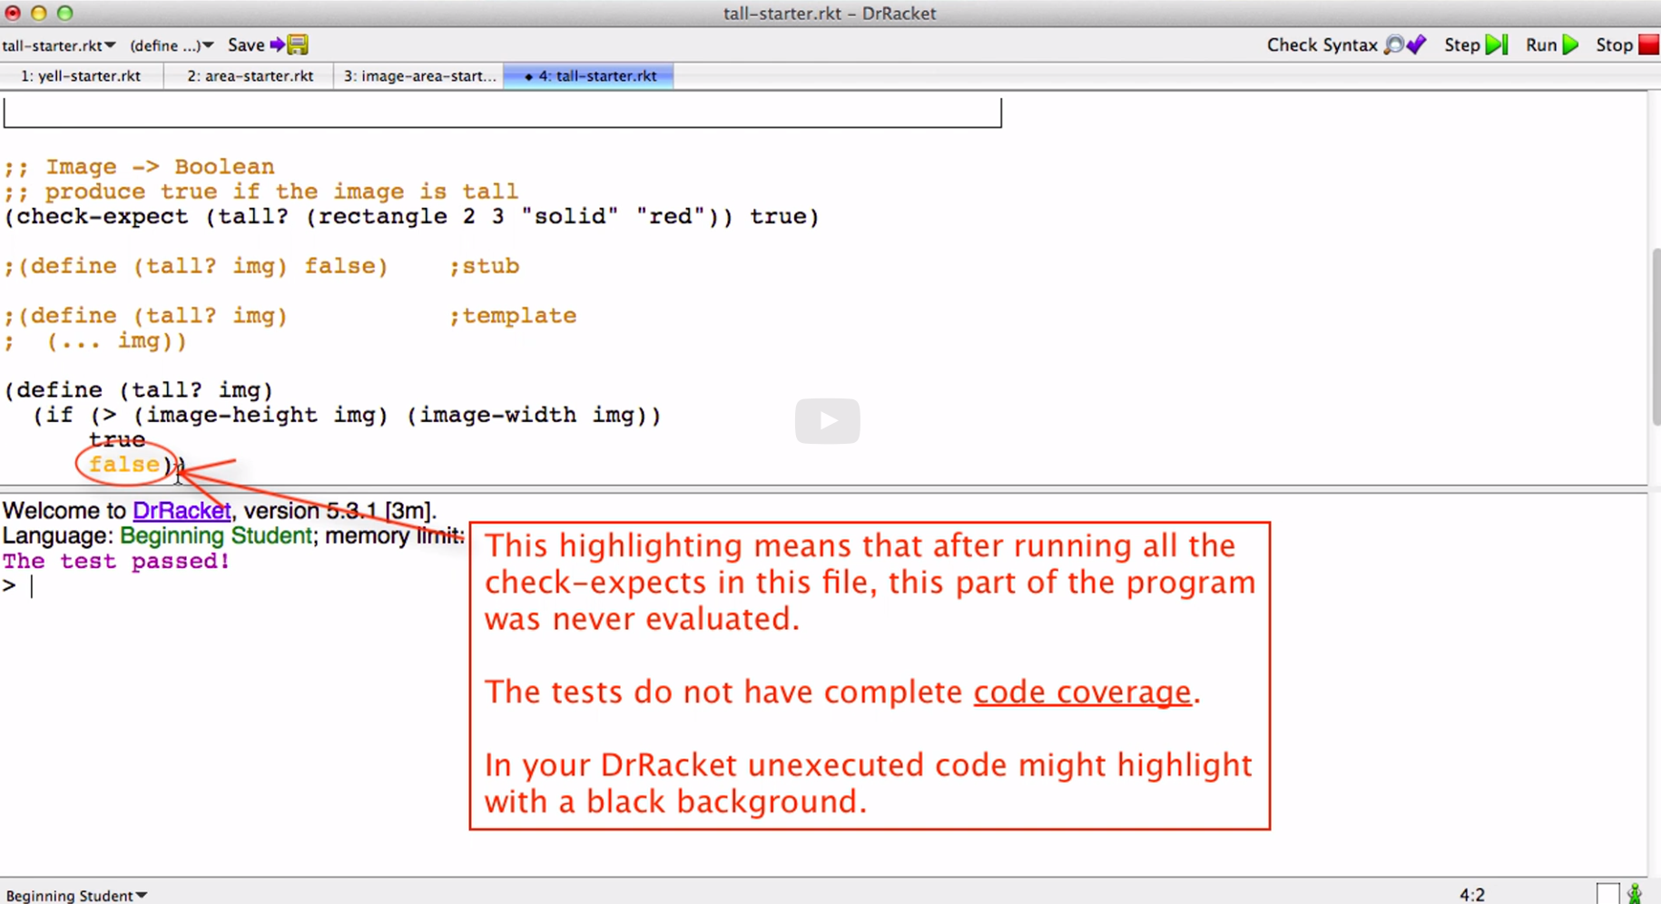

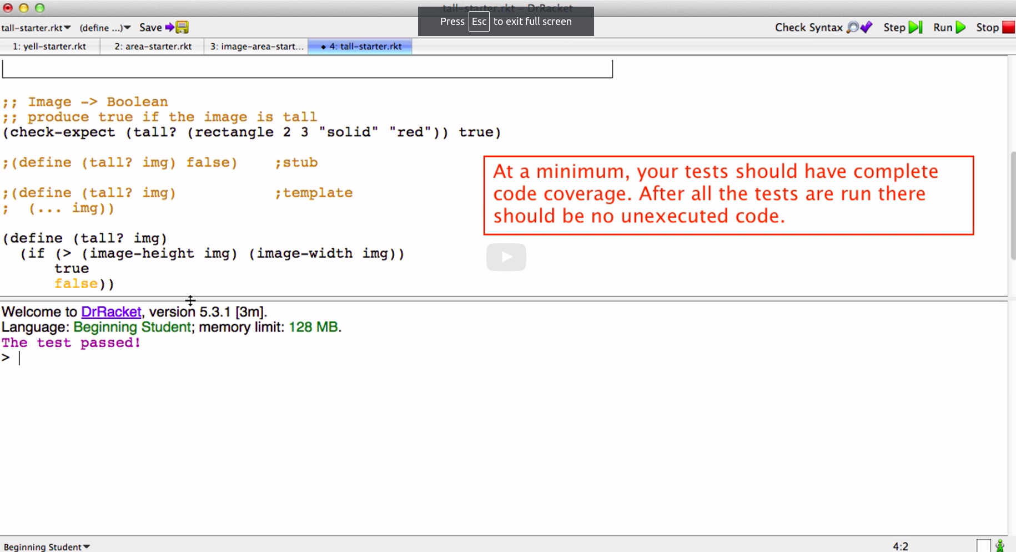

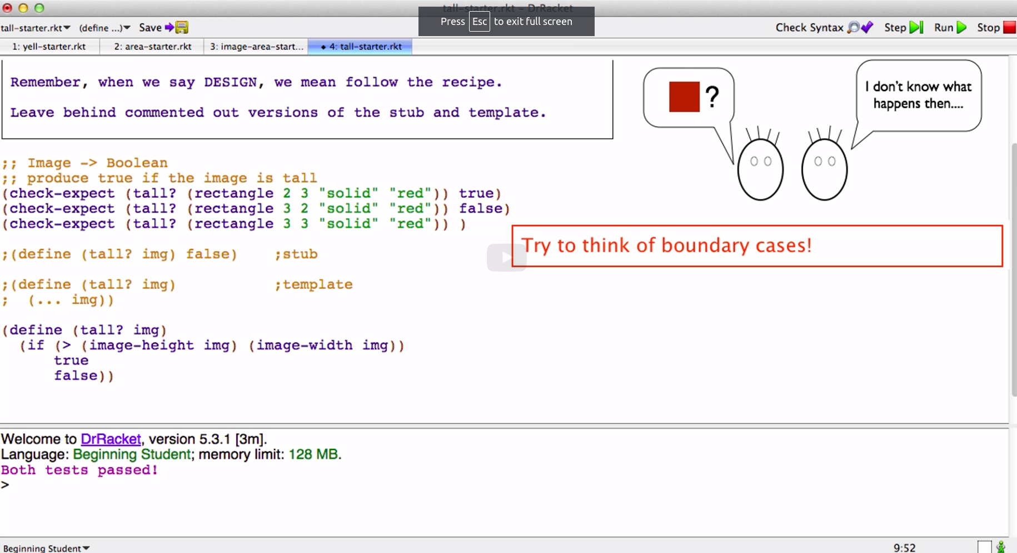

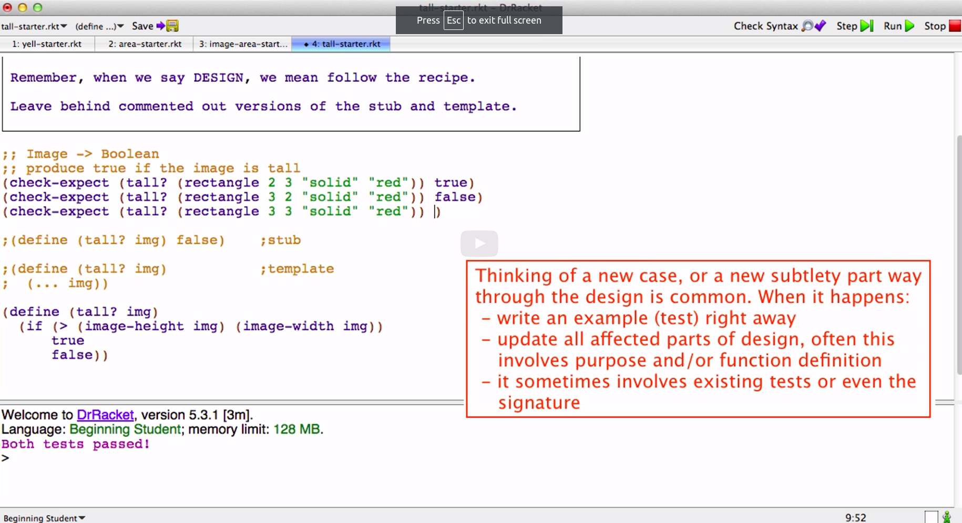

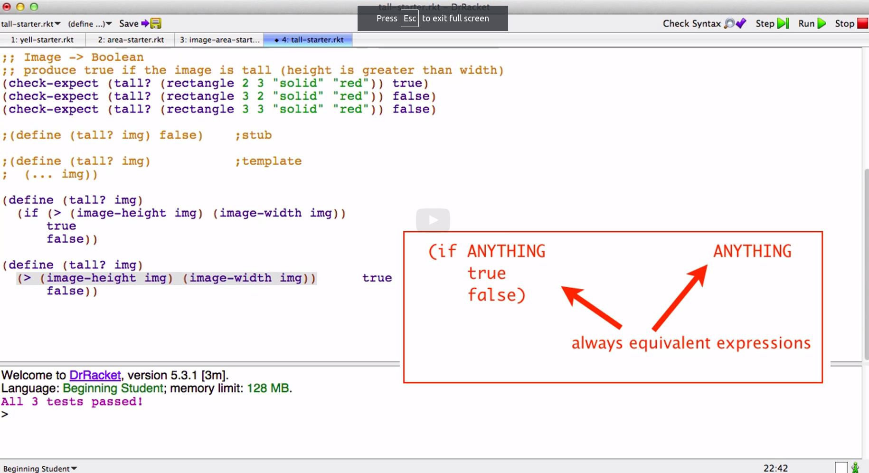

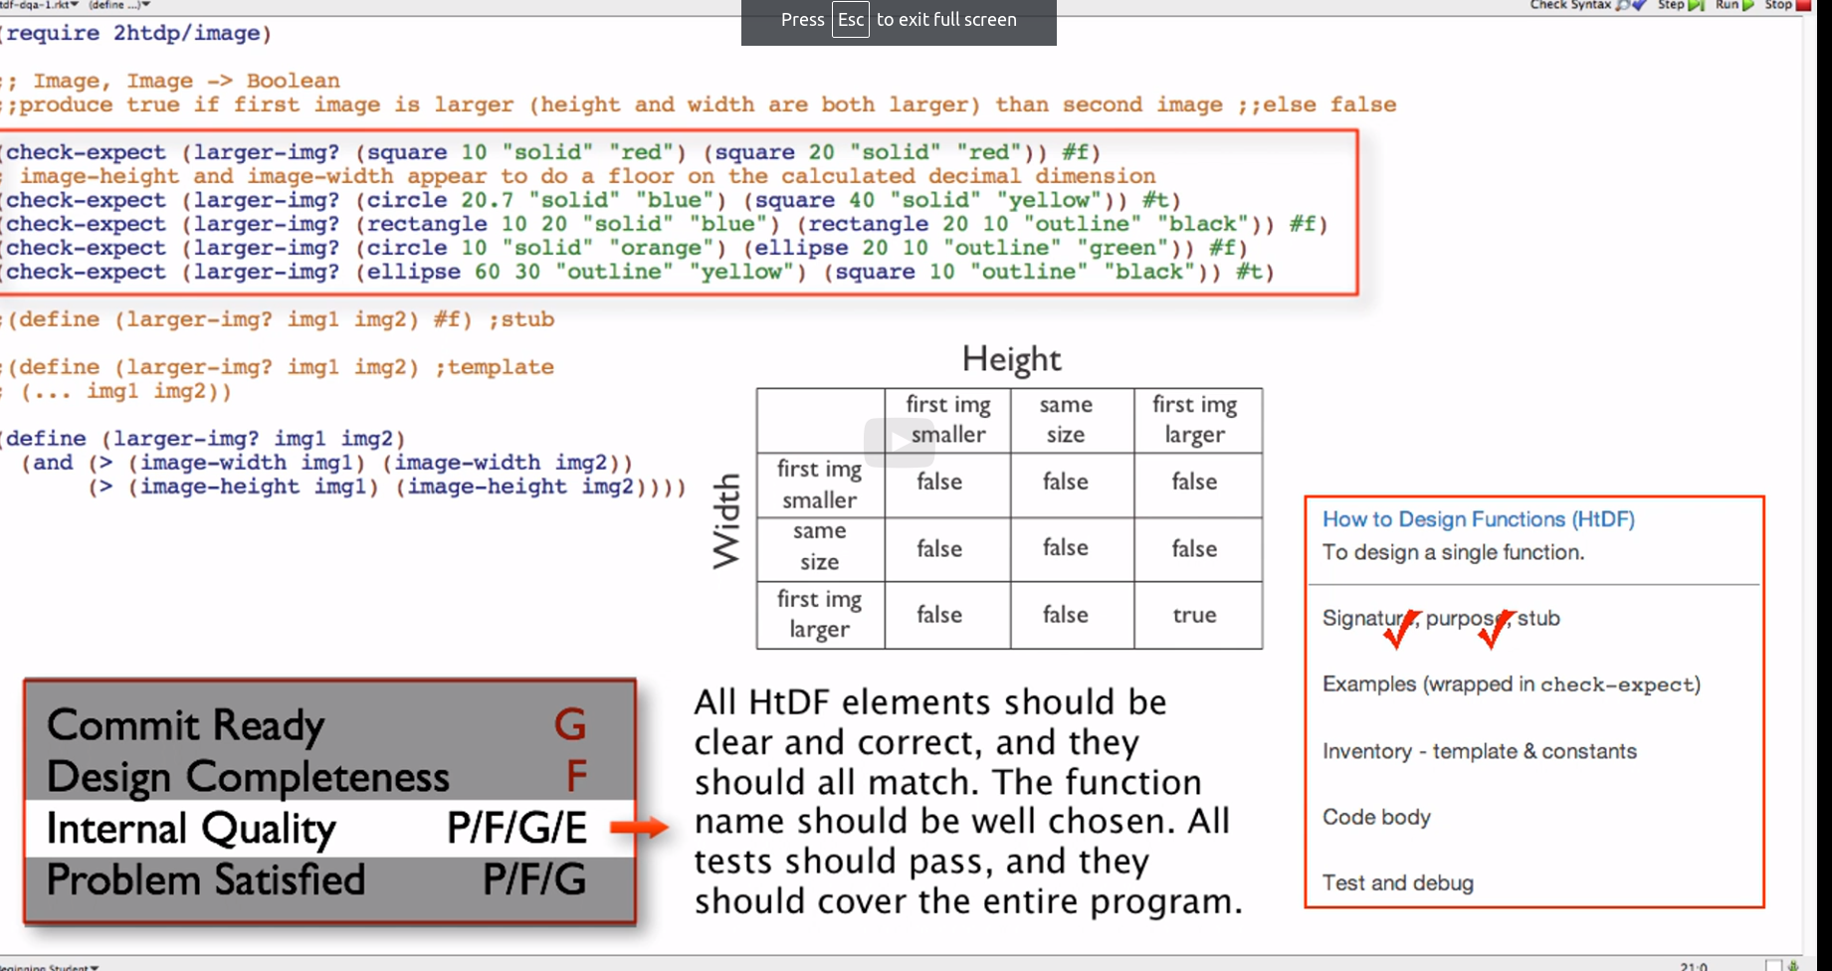

I only have 5 tests need 9

