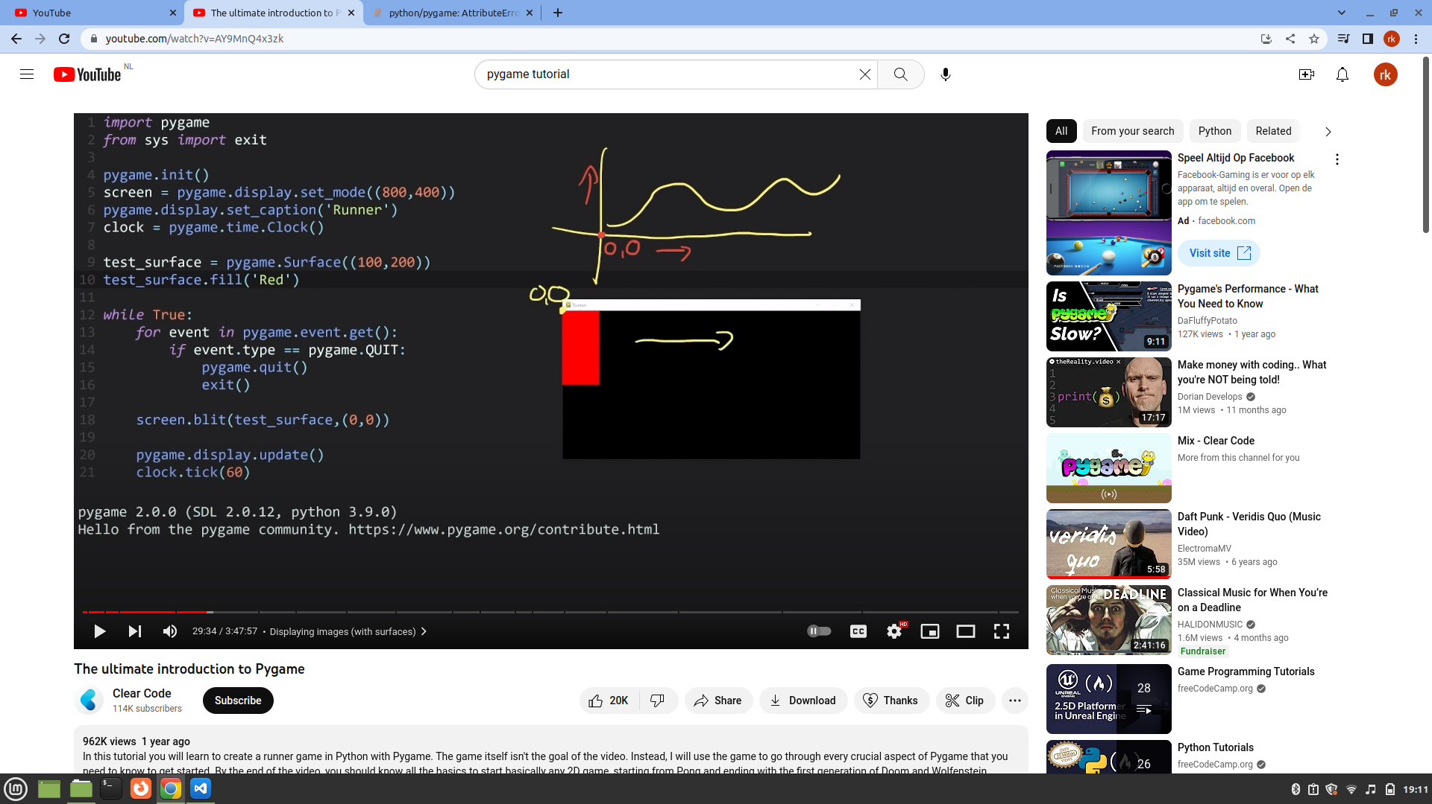
pygame starting coordinate is on top left

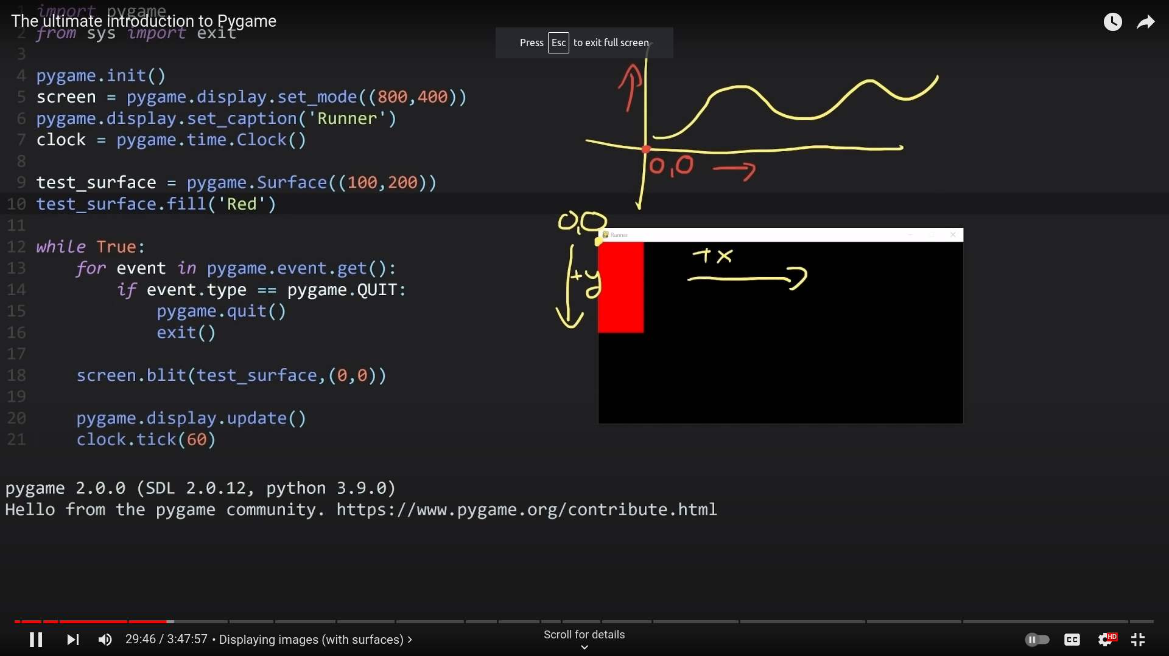
if you want to go downwards you have to decrease y

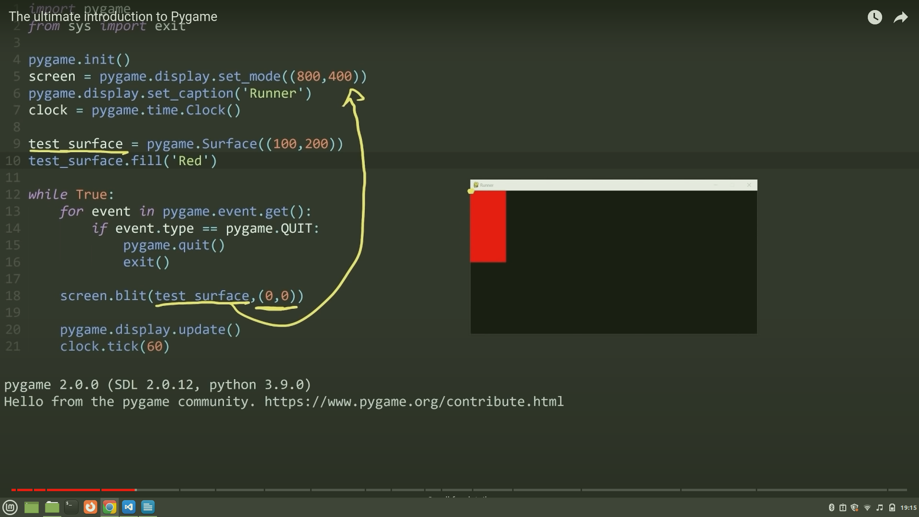

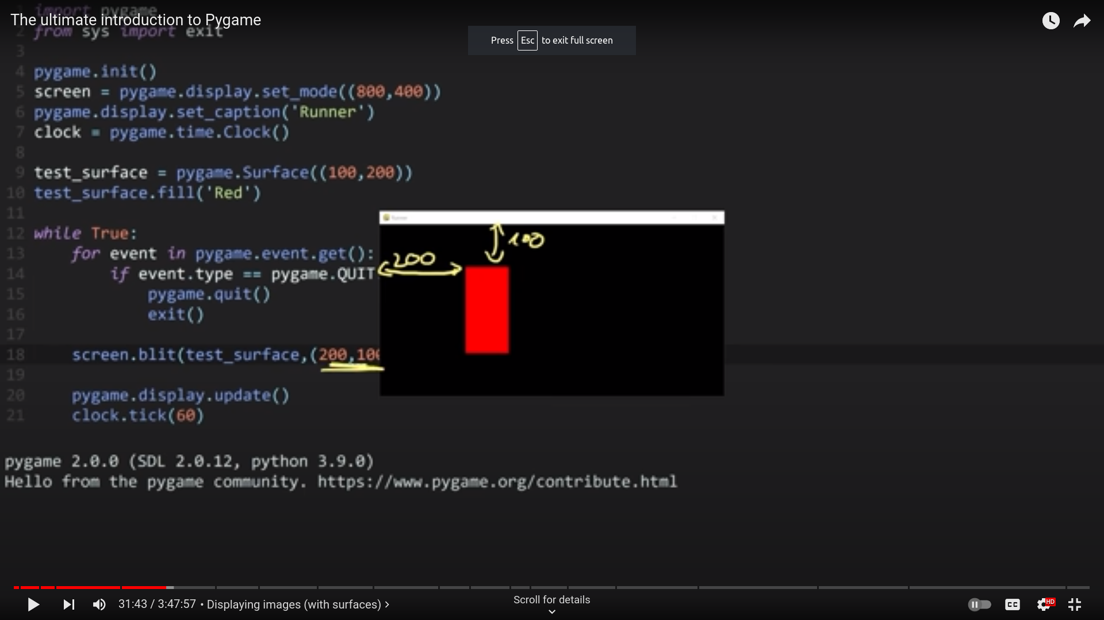

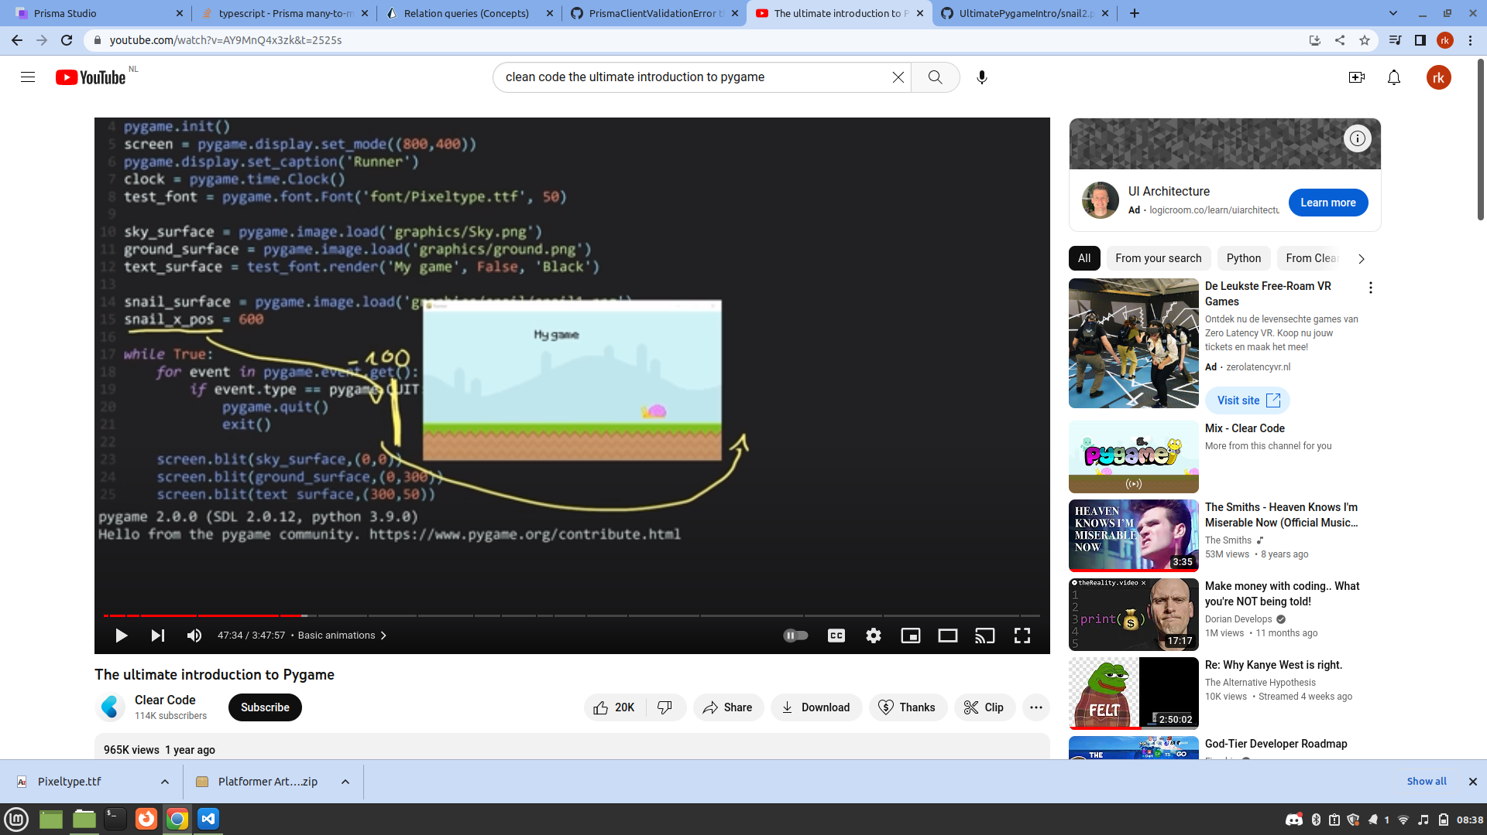
The above looks like it is looping, but really, it is just updating its position

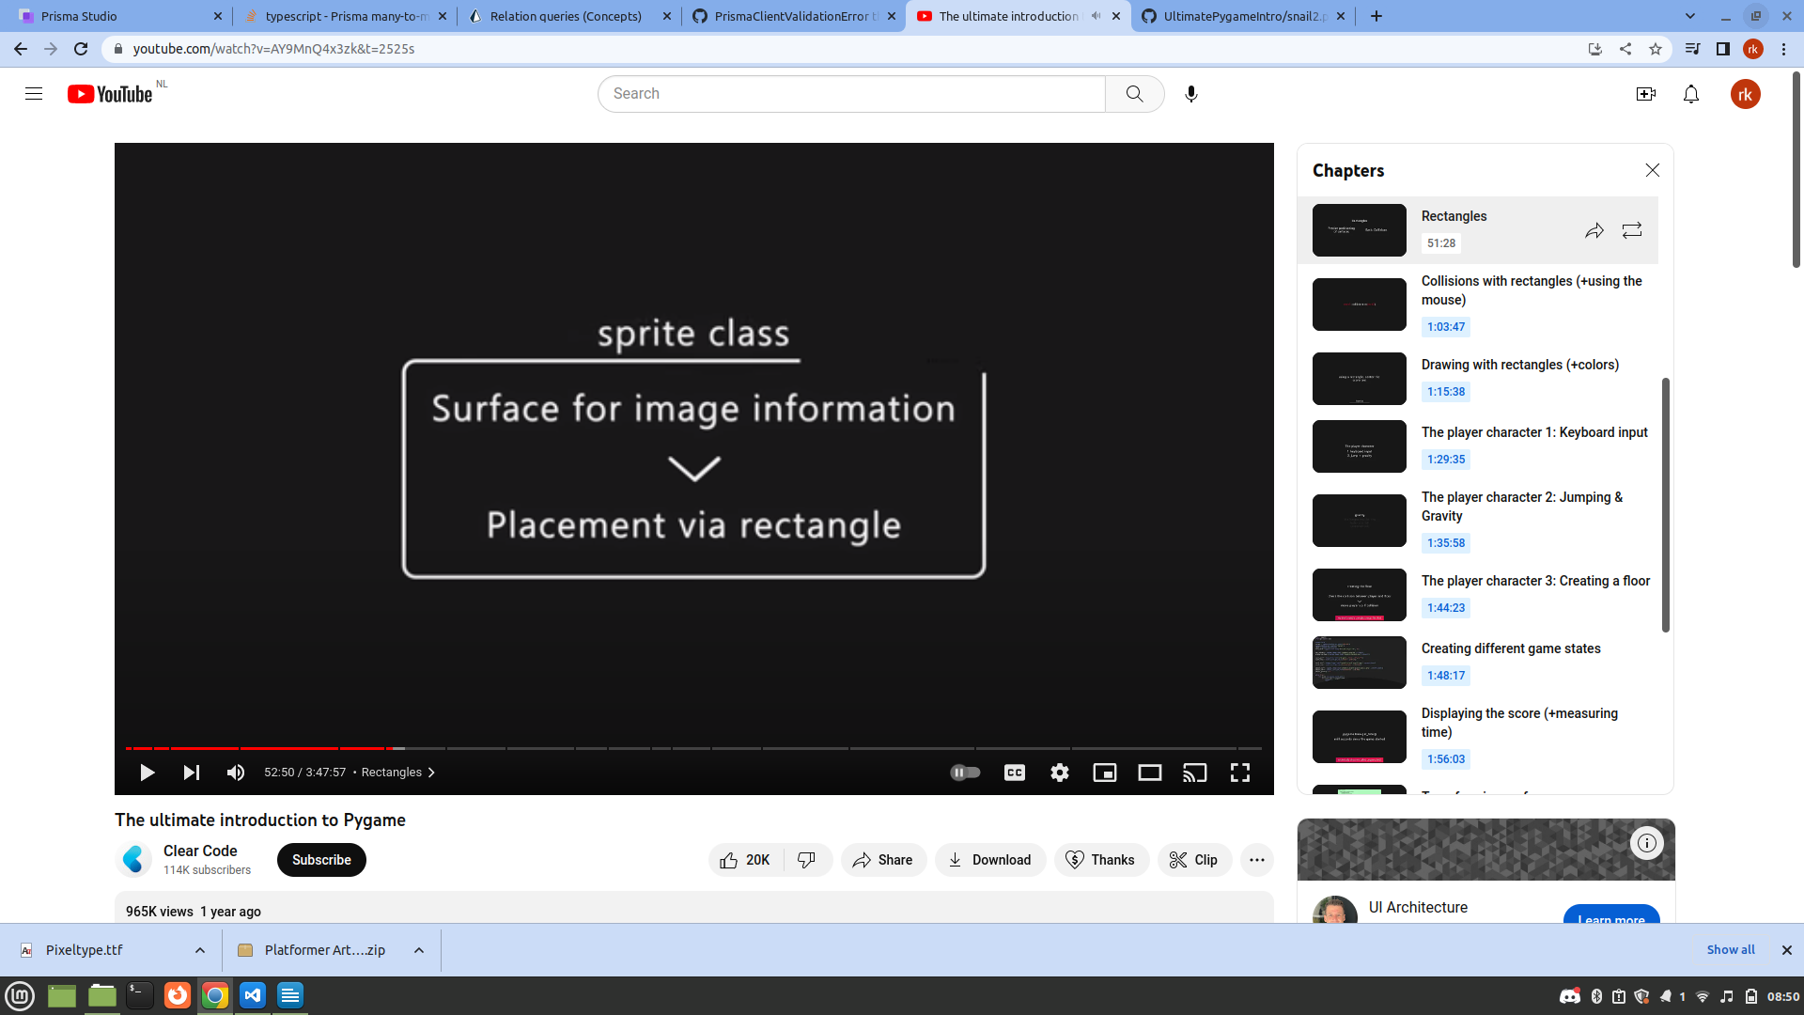

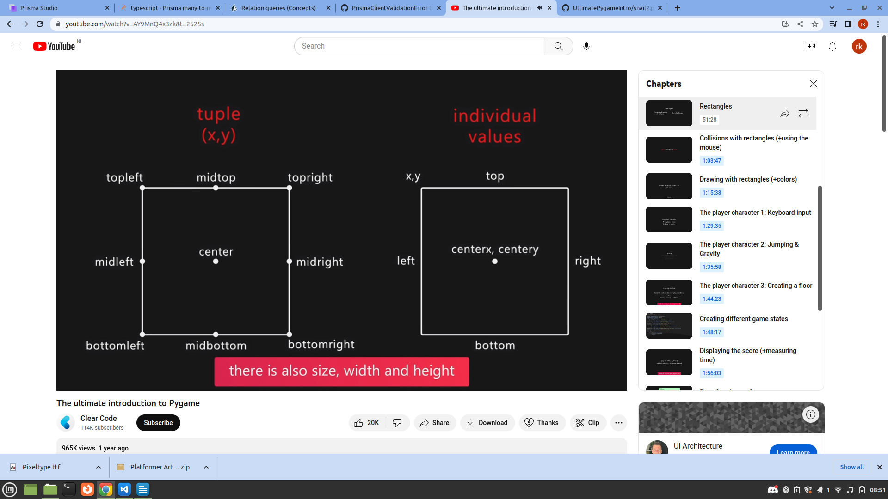

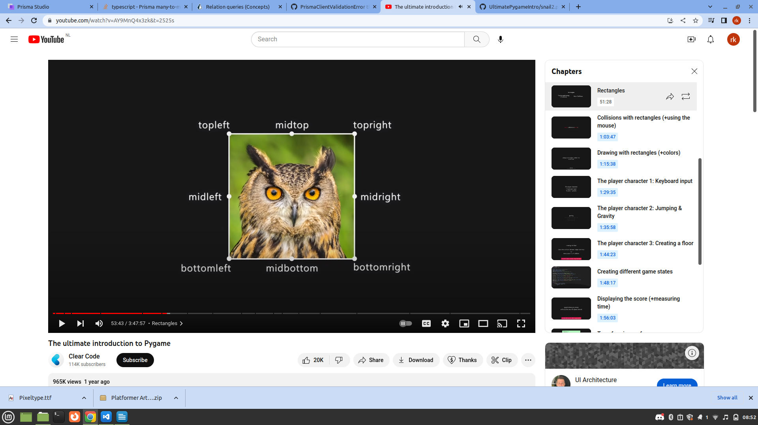

our surface in the rectangle

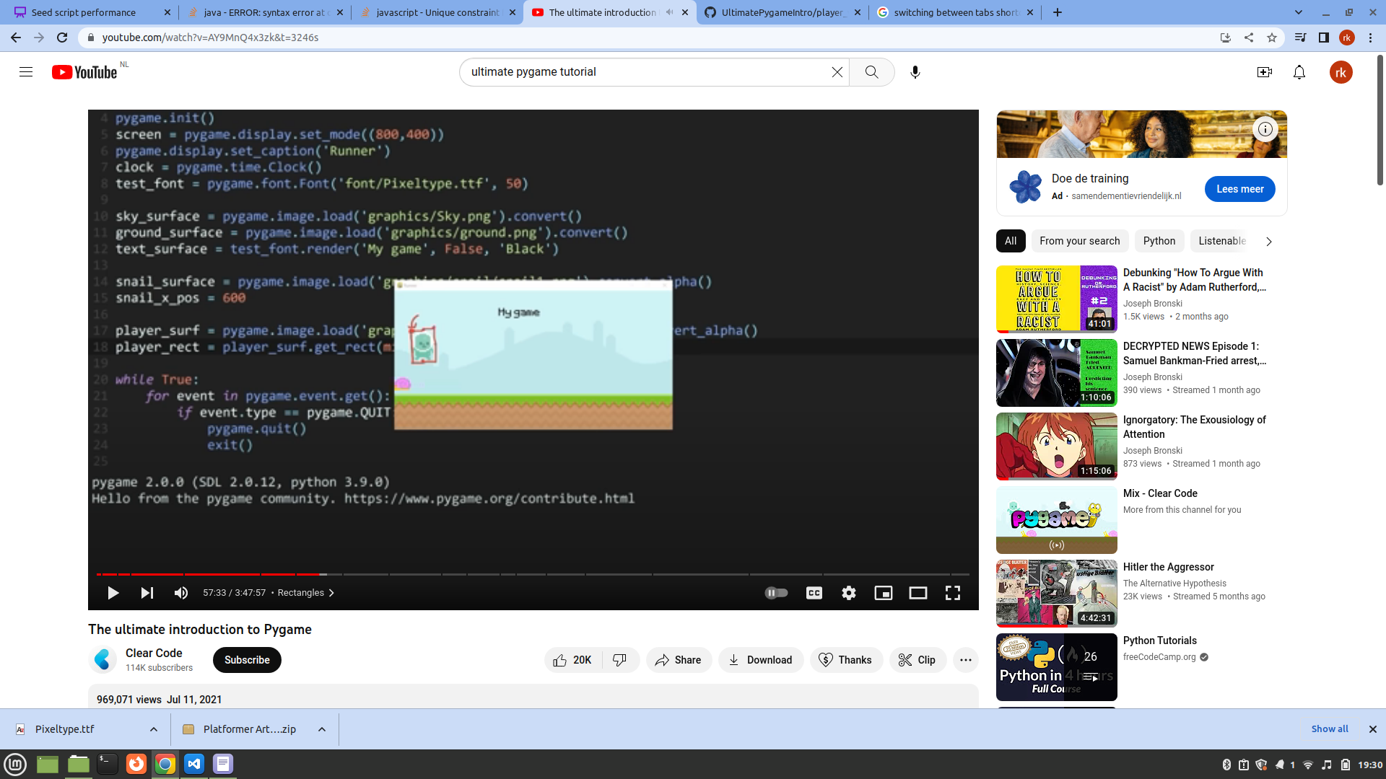

for surface we always grab the point on top
for rectangle we can grab any point in the rectangle
and we use it to put pleyr on bo0ttom

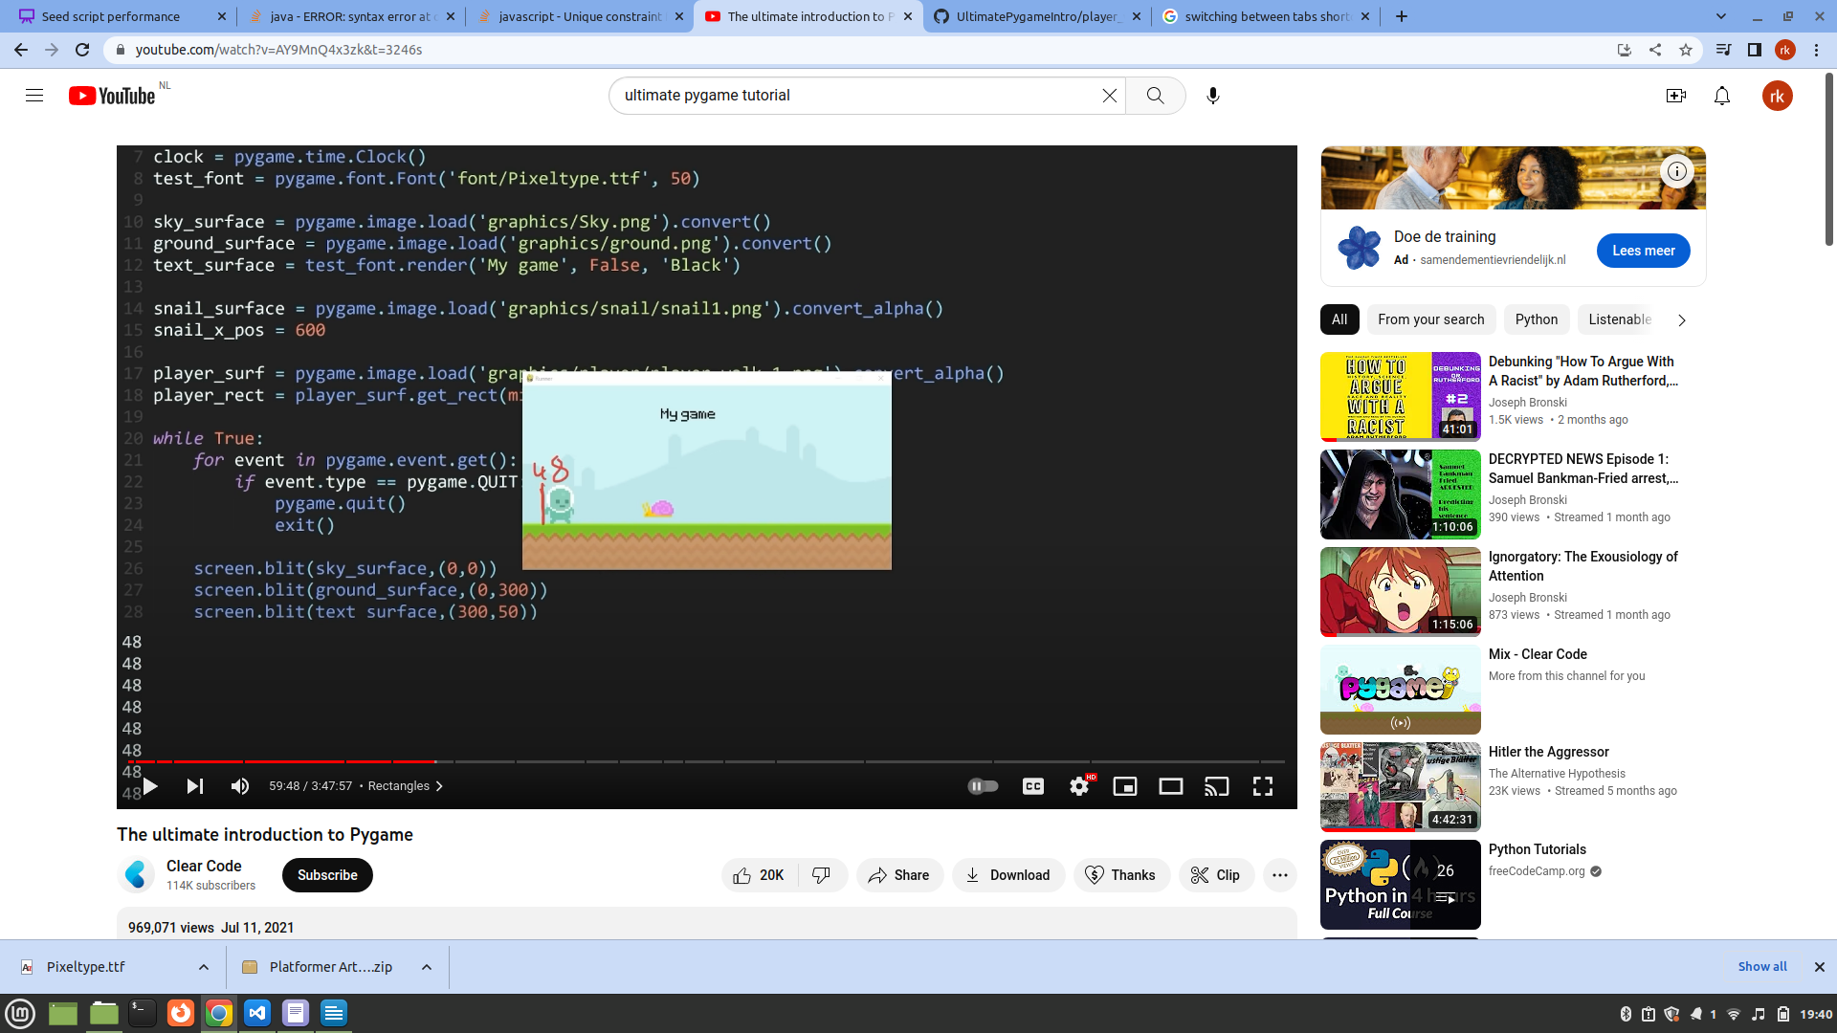

printing the position of player rectangle

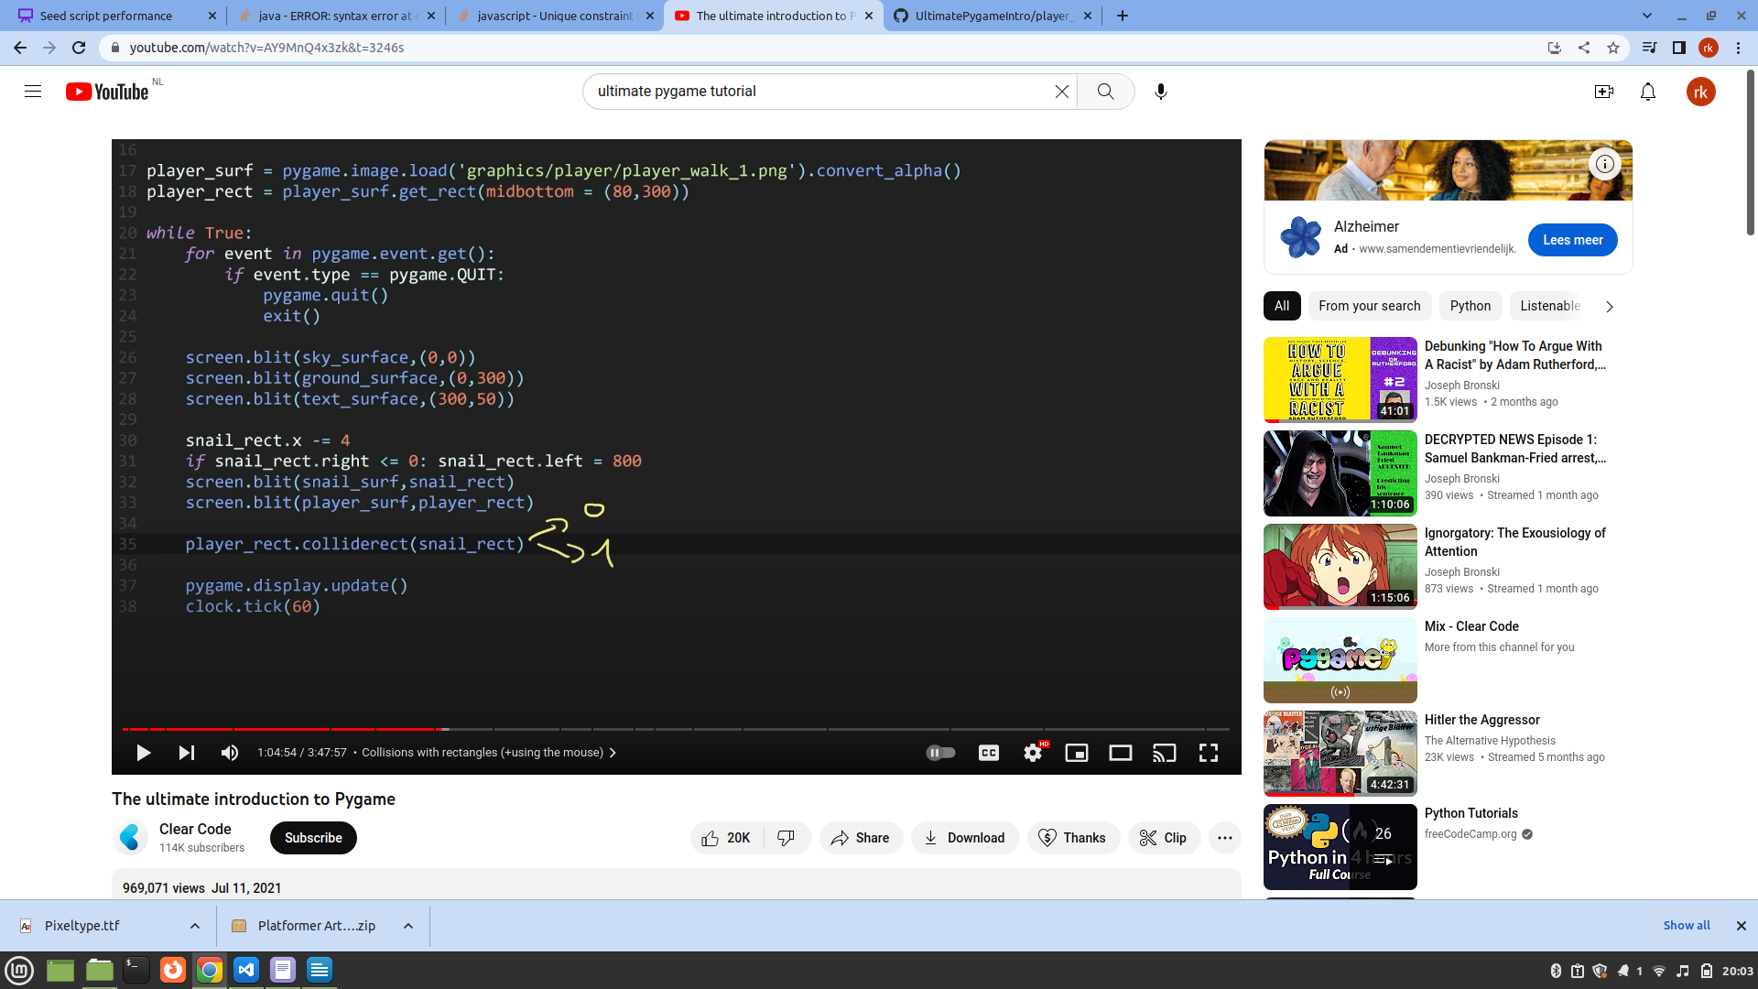

check player rect colliding with snail rect , and method returns 0 or 1

if there is collision then 1 otherwise 0

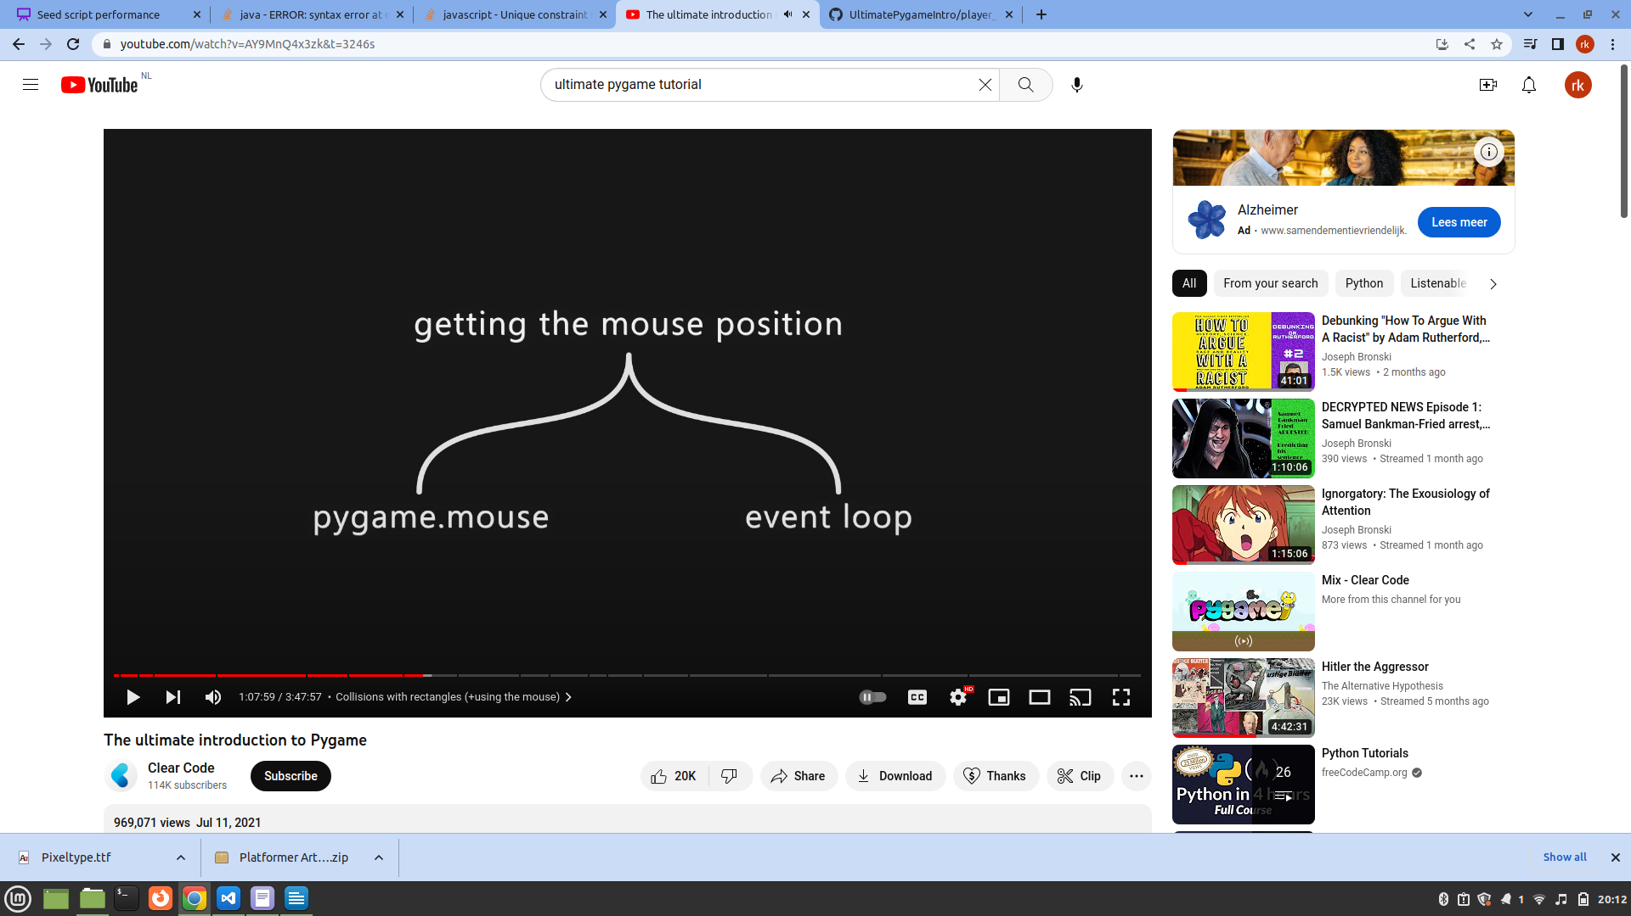

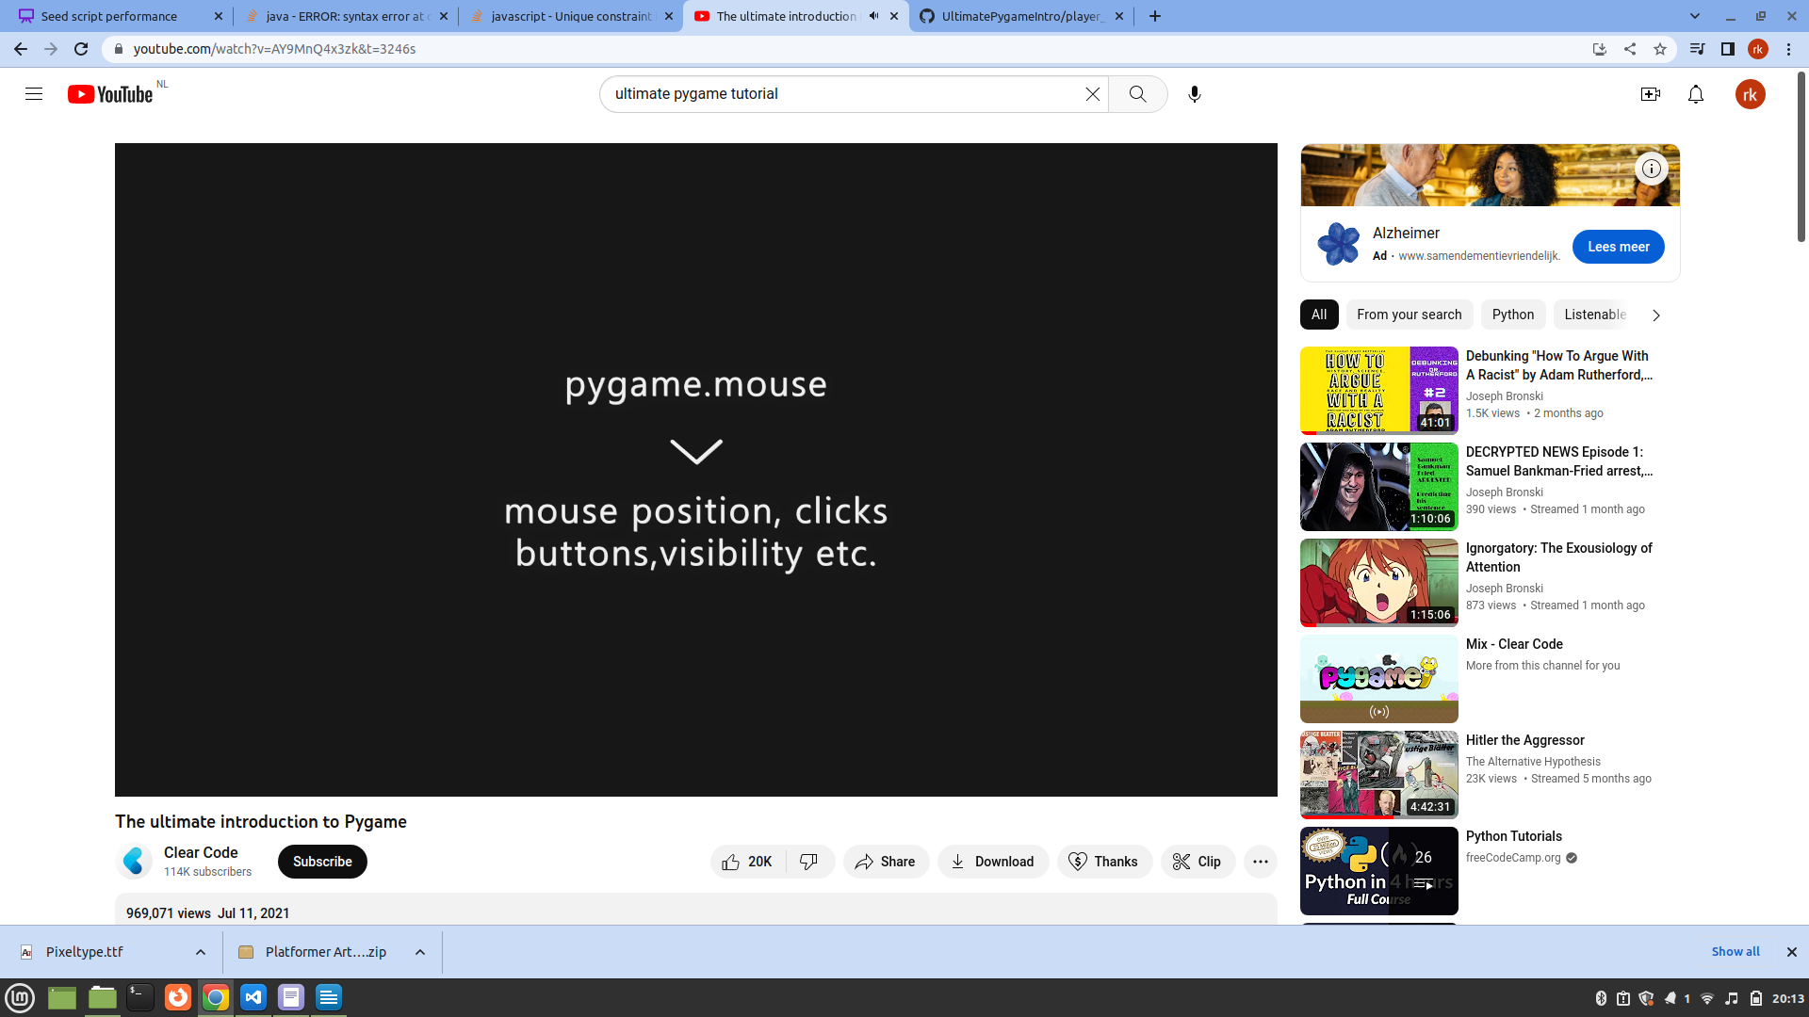

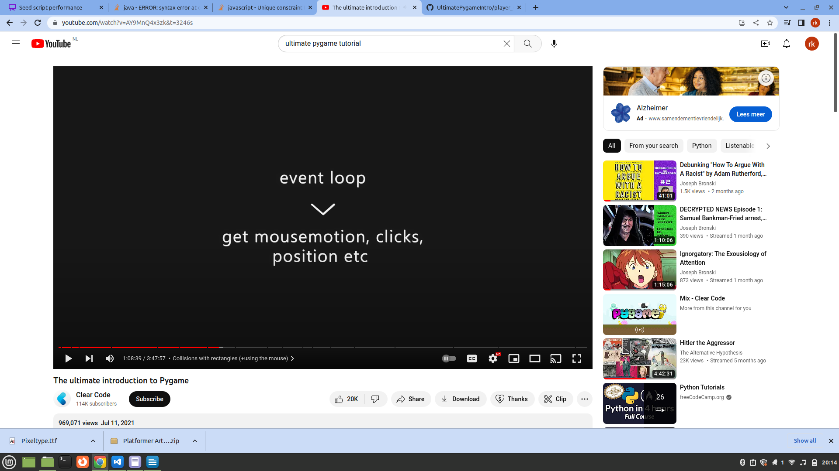

Drawing with rectangles

using a rectangle, center the score text

we have used rectangles for positioning and collisions + drawing with pygame.draw

pygame.draw

draw rectangles, circles, lines. Points, ellipses

adding a background to score text

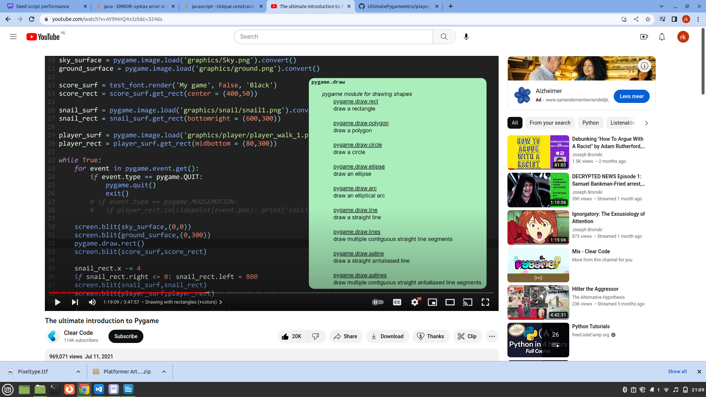
the doc shows that you can draw many shapes other than the rectangle

colors: rgb and hexadecimal

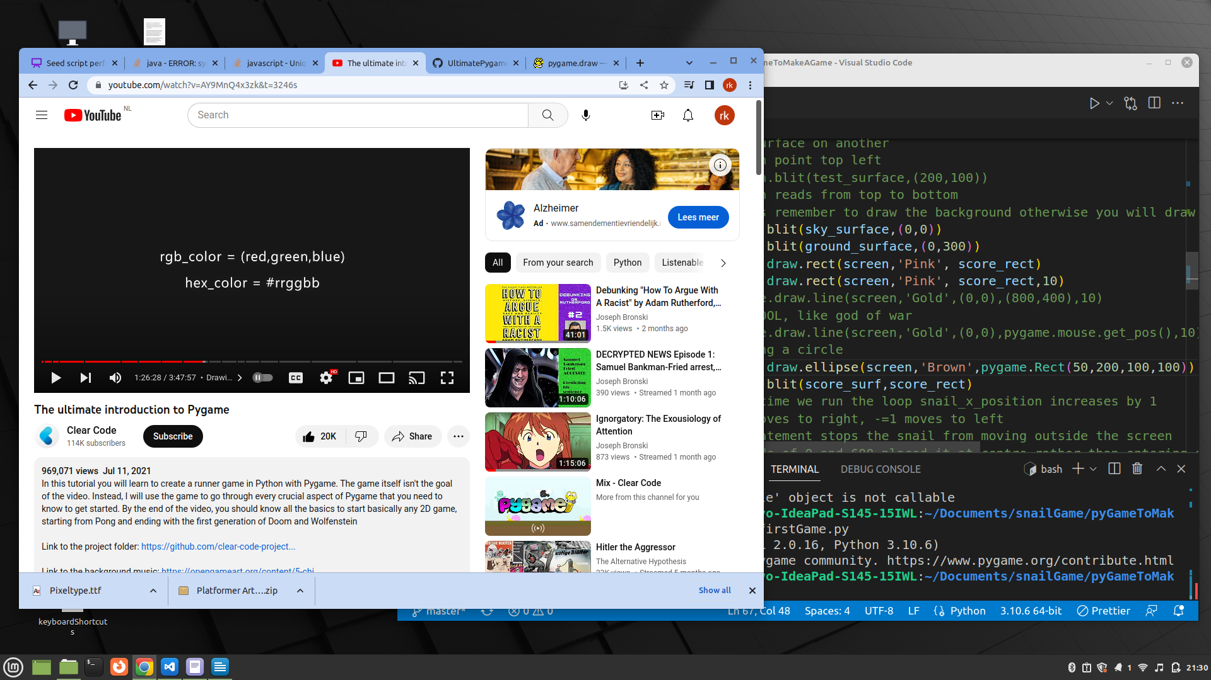

our good old friends rgb and hexadecimal

for colors you will rely on photoshop or someone else’s code

we need color for text and box

The player character needs:
1) keyboard input
2) jump+ gravity
3) creating a floor (or else it will jump into nothingness)

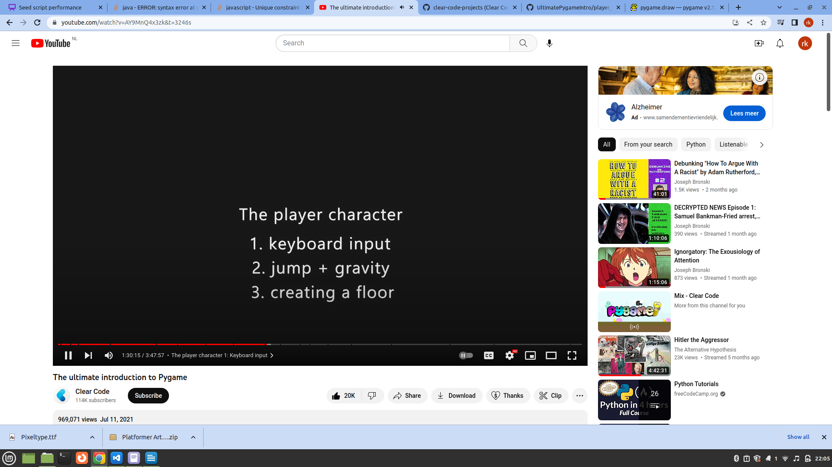

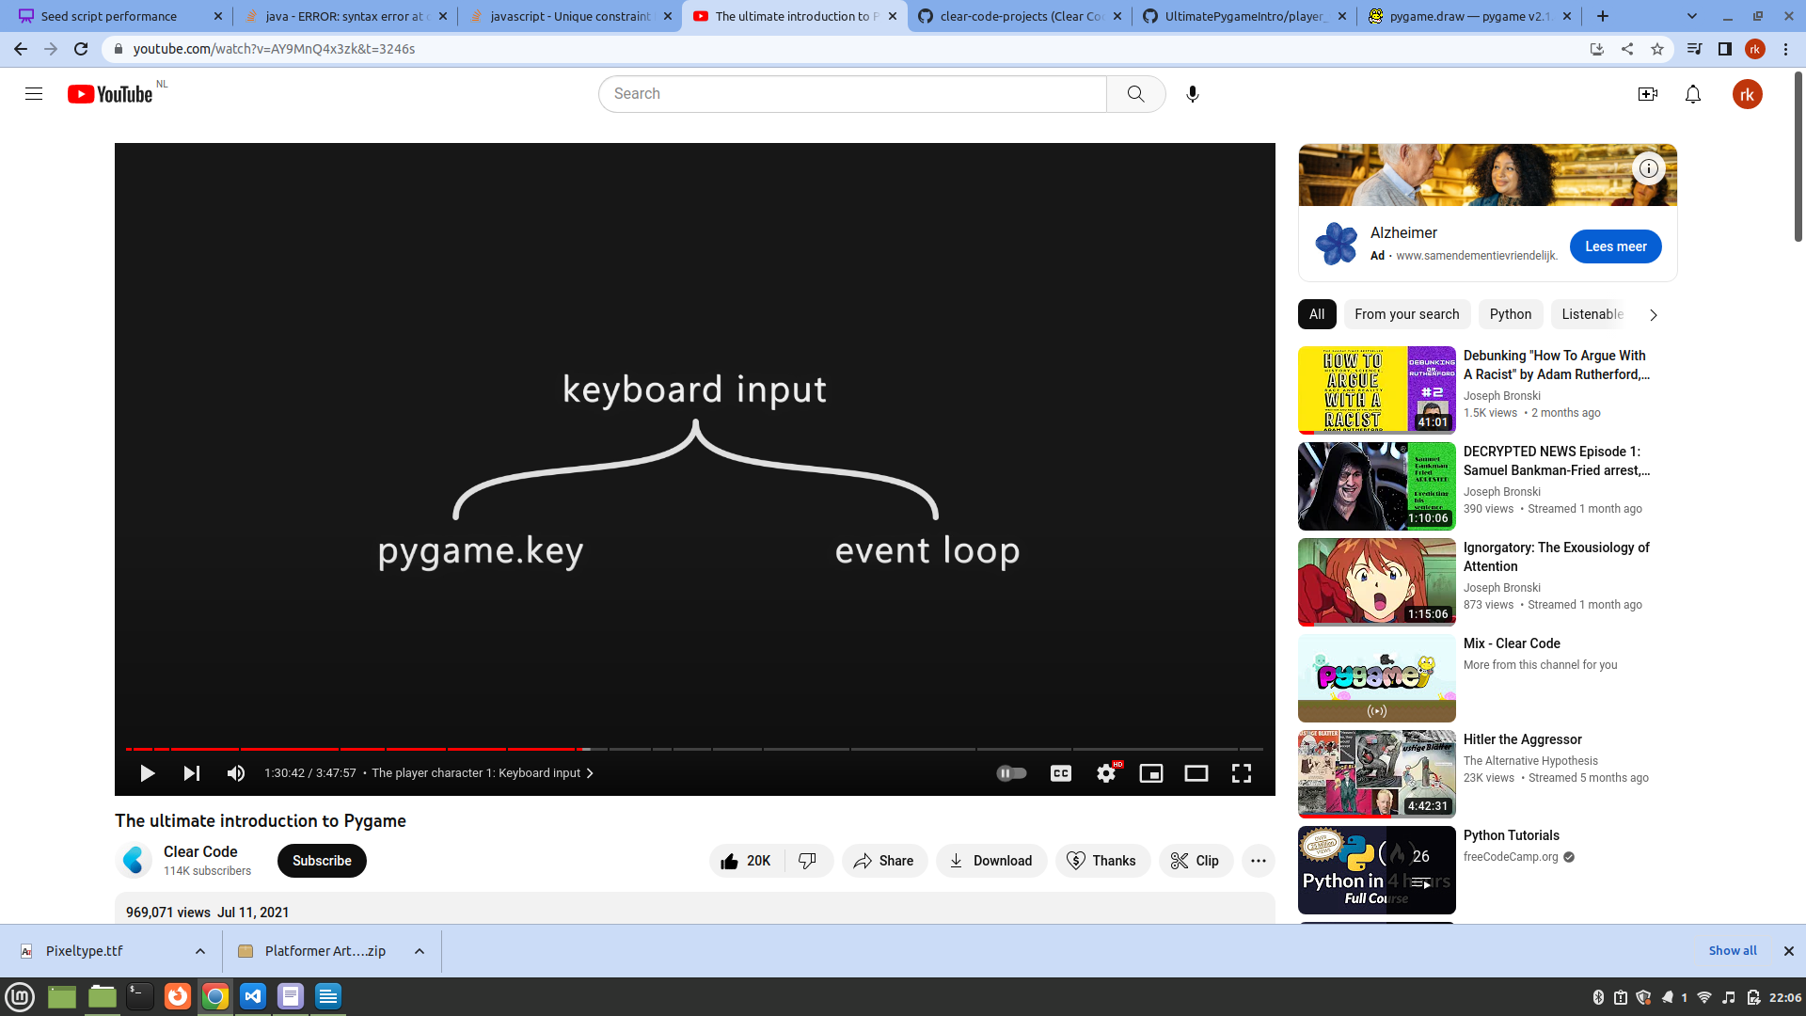

Keyboard input in the event loop
1) Check if any button was pressed
2) Work with a specific key

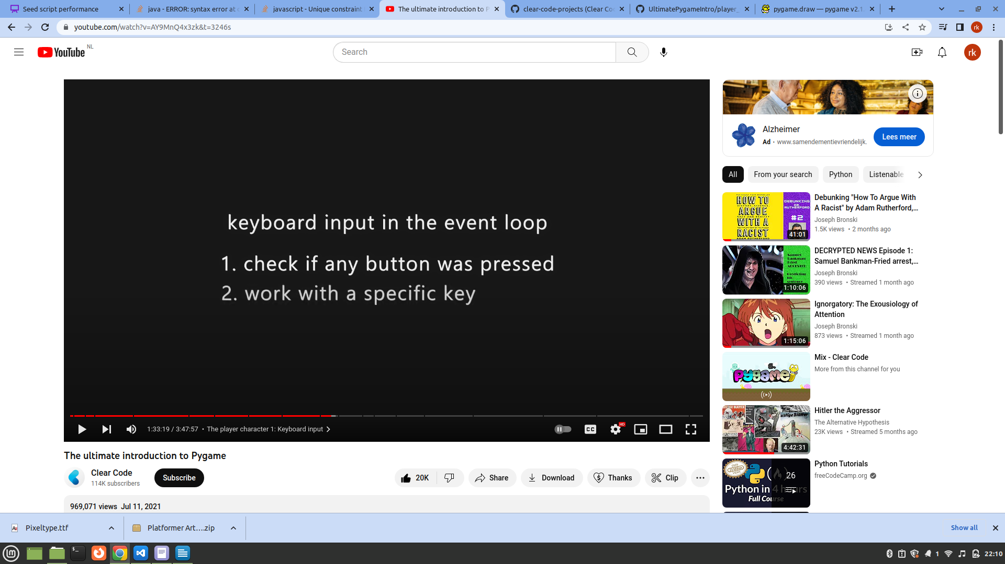

why are there two methods to get input?
When using clases you want to controls inside the relevant class pygame.mouse and pygame.keys are great for that.

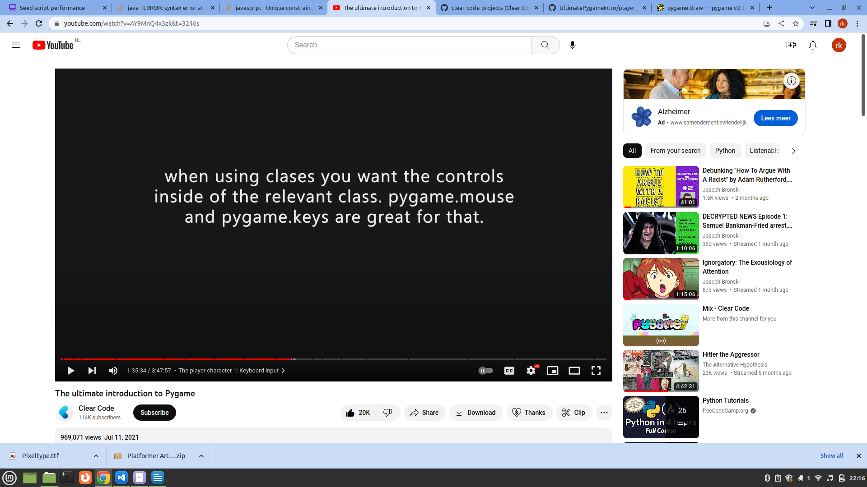

Jumping and falling

we need gravity for that
gravity: the longer you fall the faster you fall (exponential), otherwise you feel like flying in space

gravity += some value
player.y += gravity

accurate pysics < fun or ease of programming

game developers do not really care so much about physics as long as it feels good and easy to code

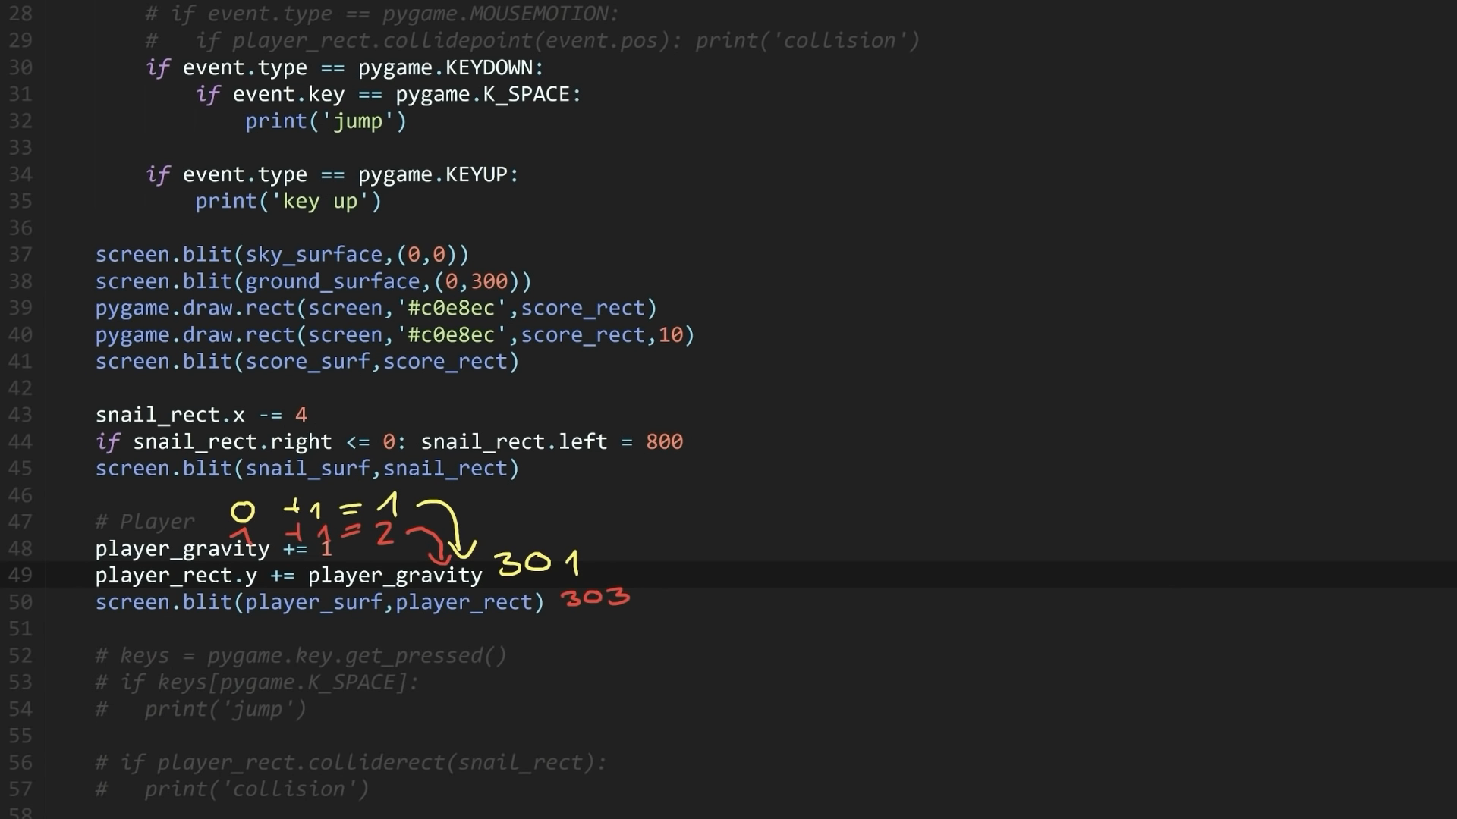

You see exponential increase as player falls down

This looks like player is falling but it is not

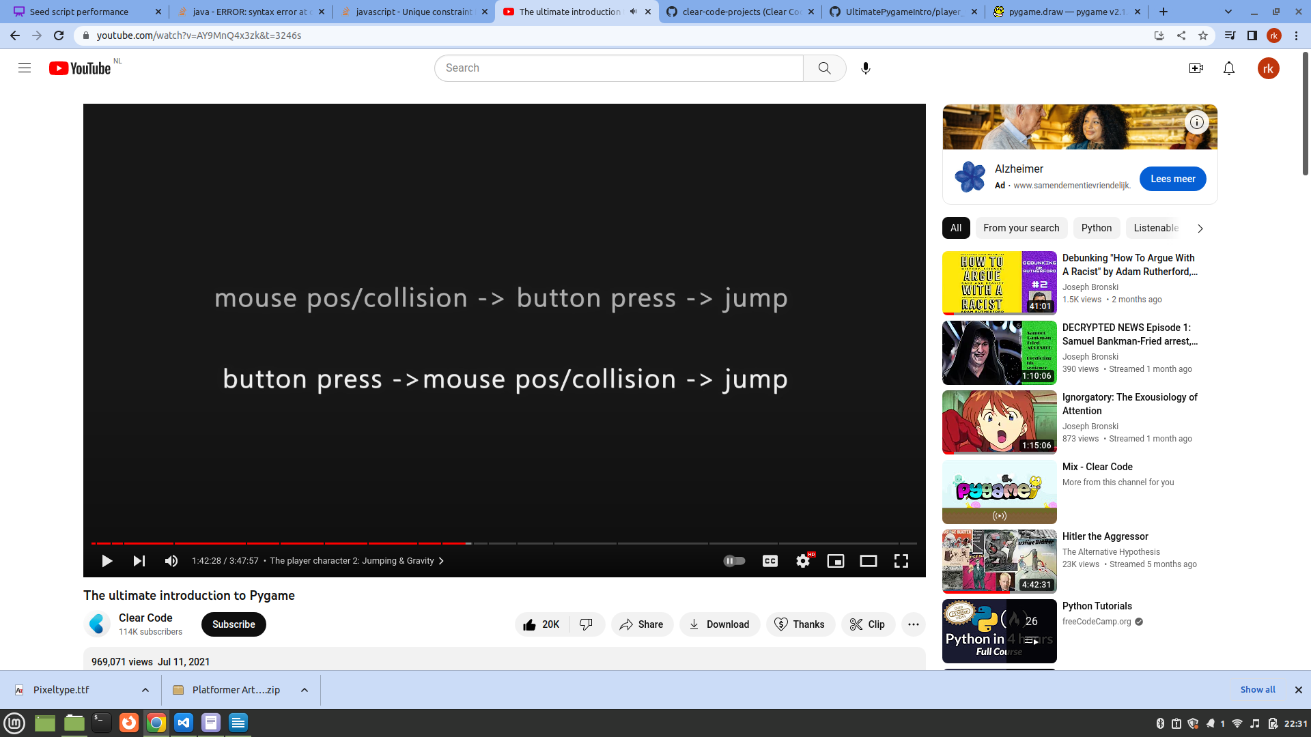

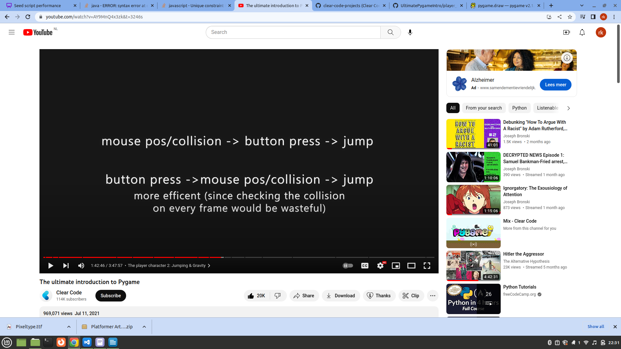

the latter option is more efficient

Creating the floor

Check the collision between player and floor

move player up if collision

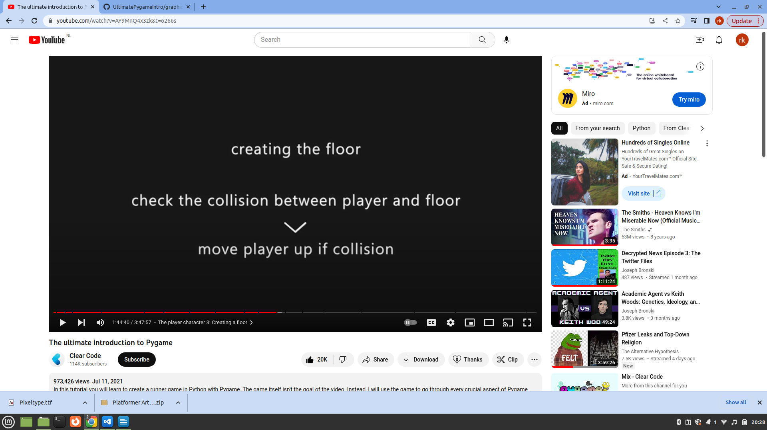

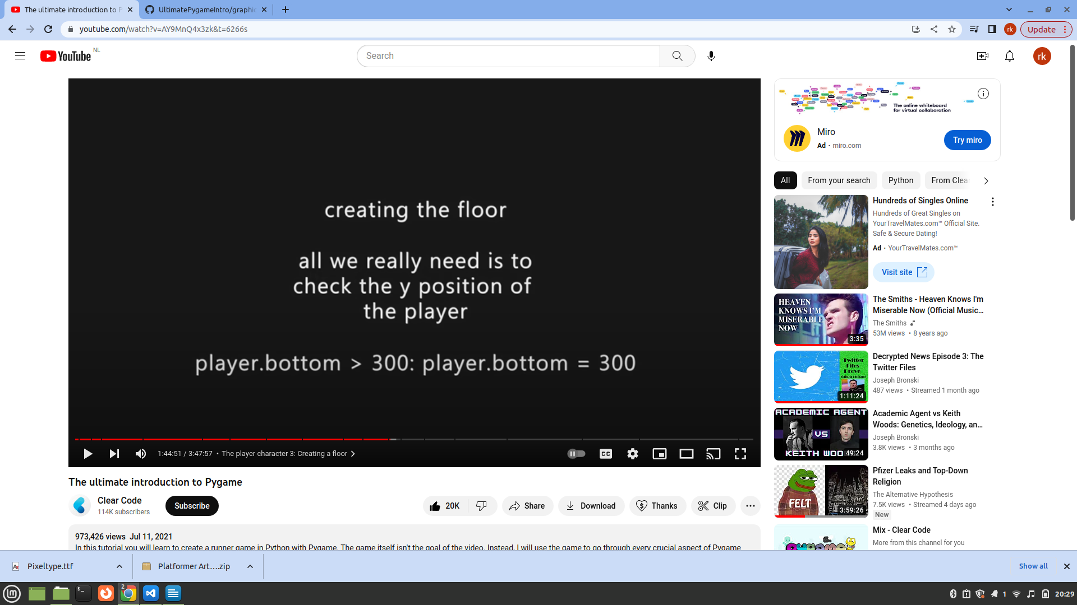

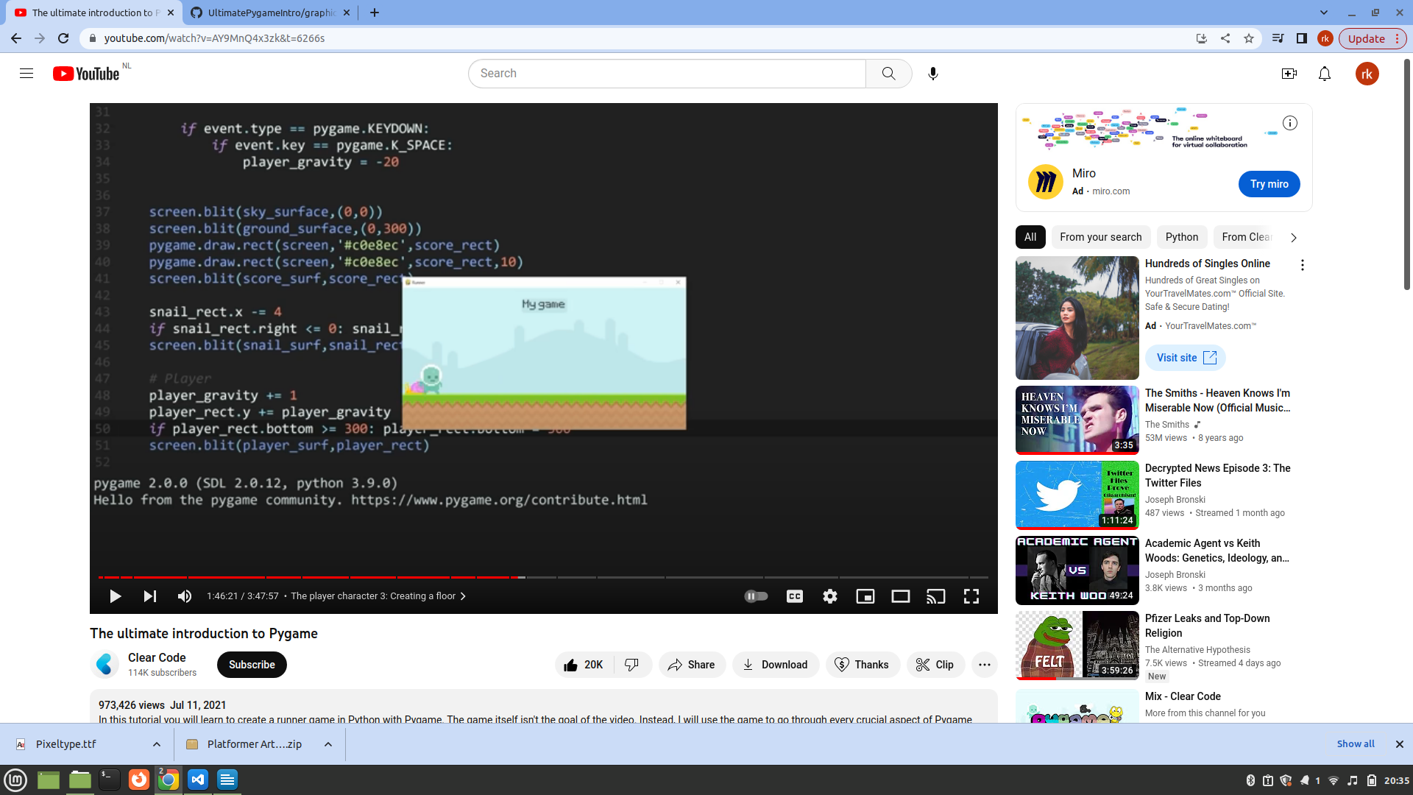
It looks like there is a collision but in reality there isn’t

And in video games we are just simulating what looks real to us, but it is not really real

if game_active:
current game
else:
game over

If game active is set to false at the end game stops because we have stopped drawing at the top of the screen.

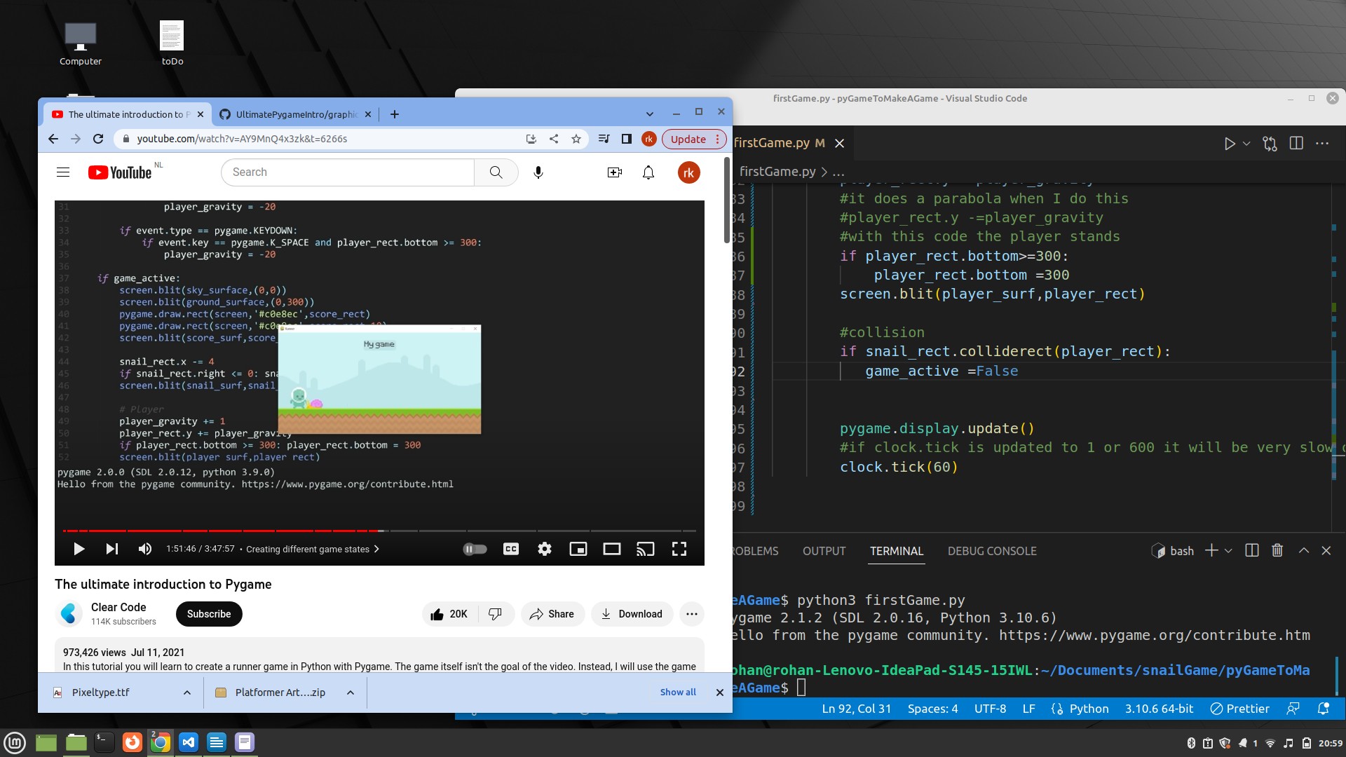

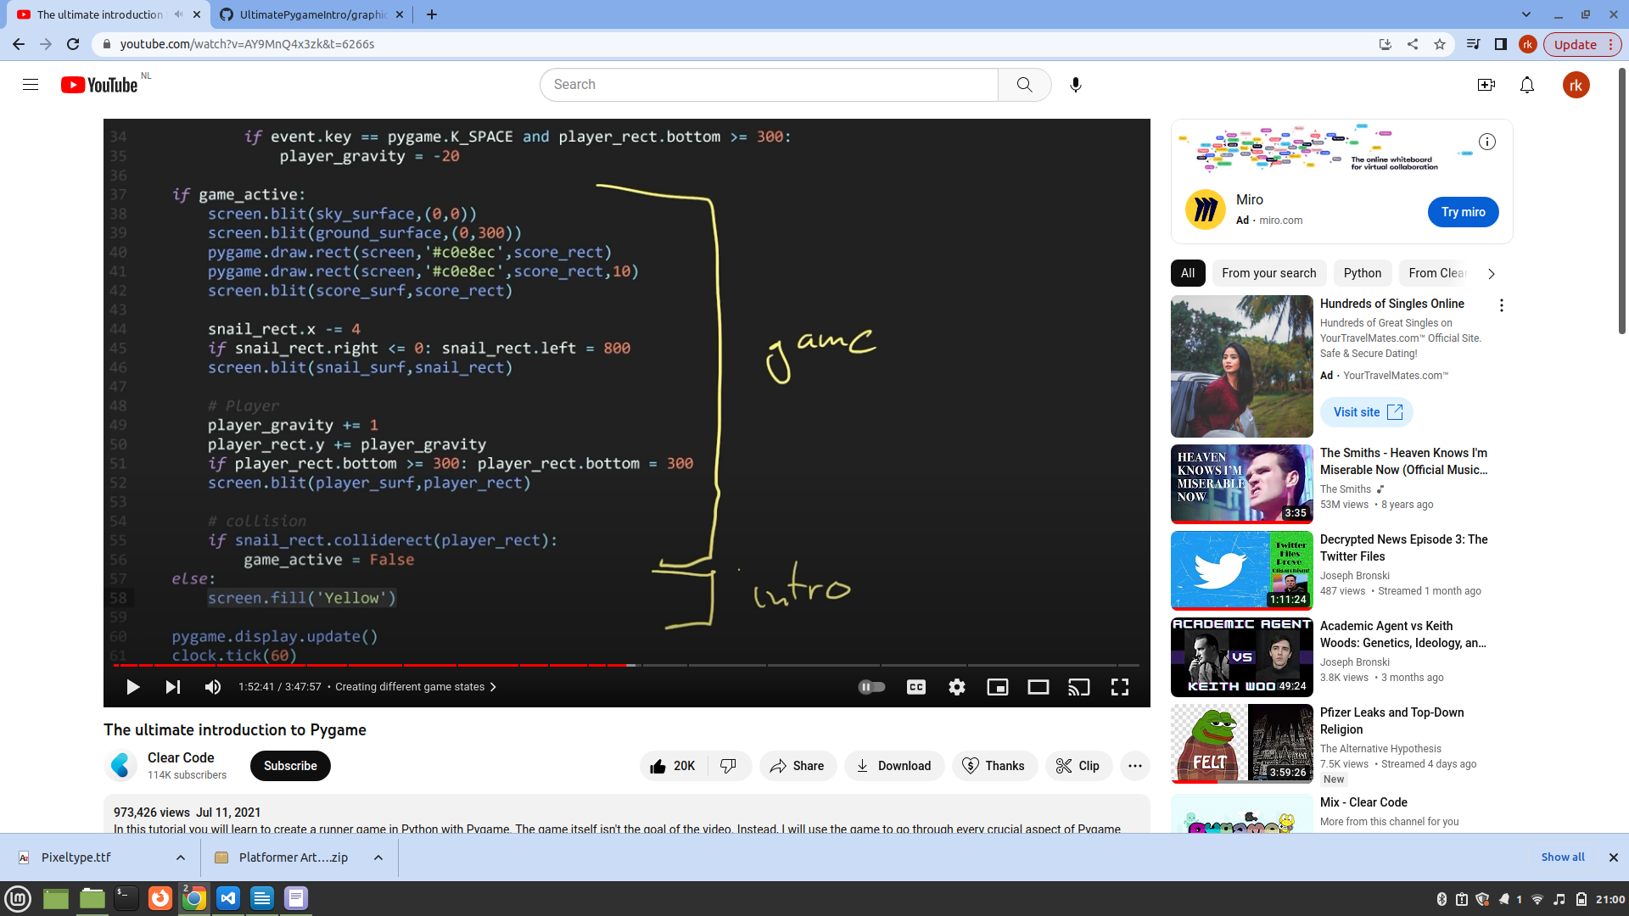

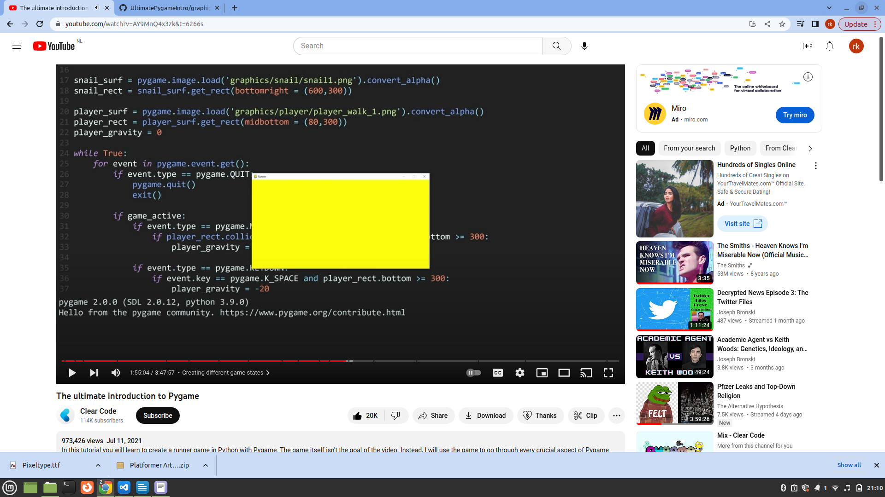
Here the problem is that our snail overlaps with the player and so only if the snail moves does the game work.

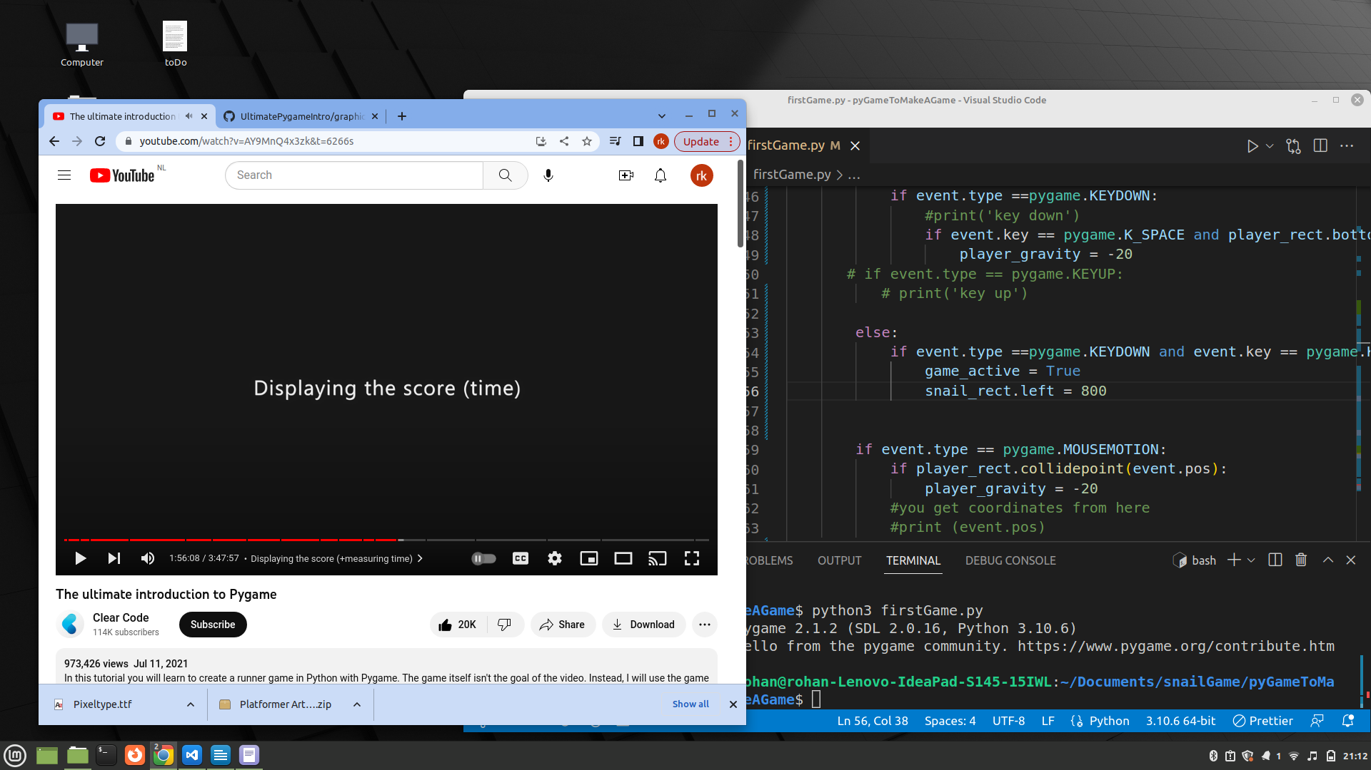

Displaying score

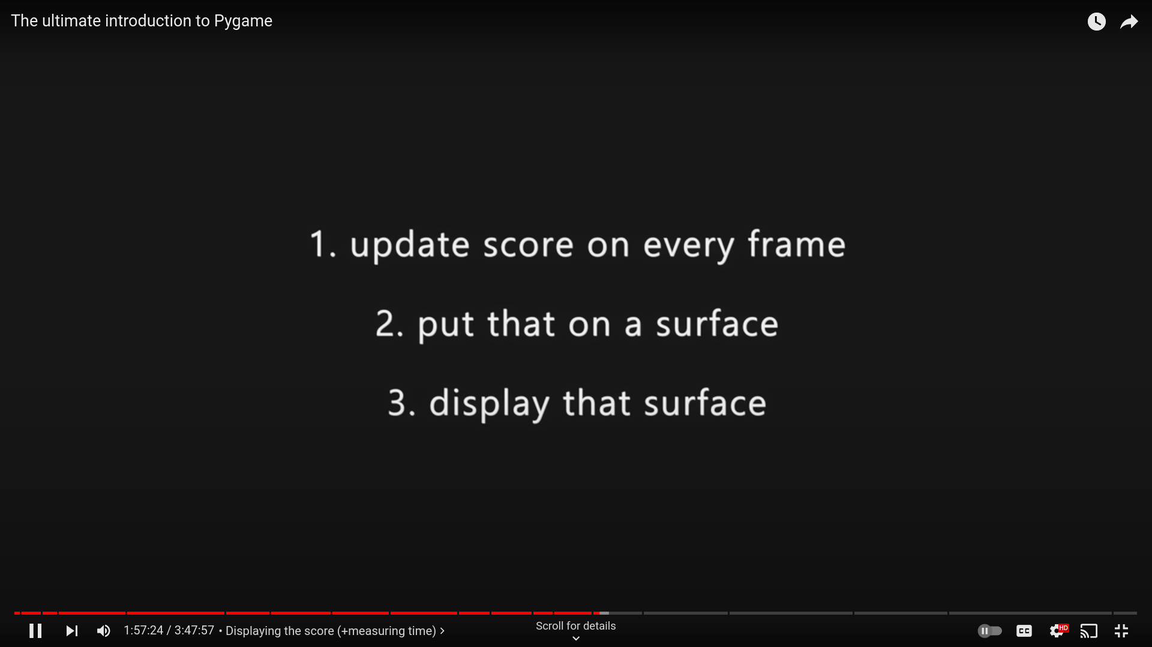

All three in the same function

current_time = pygame.time.get_ticks()

the function above could be used for my snail game to see how much time it takes for snail to complete something.

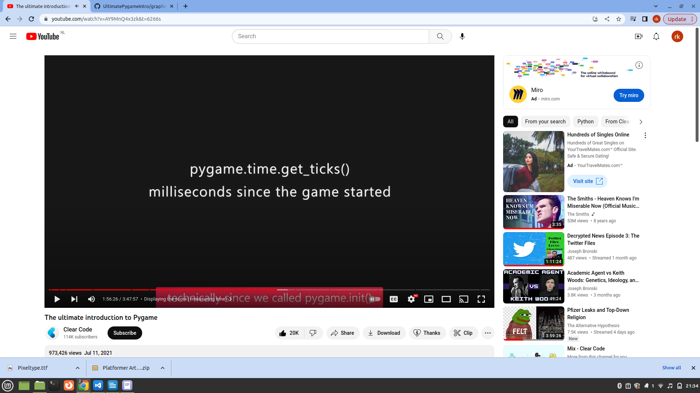

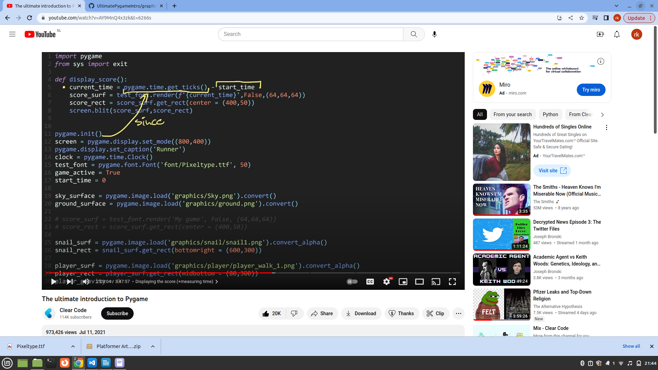
when the function runs its value is same as the total time pygame has run, because function running corresponds to pygame running.

