Minor Project Report
NOTESNAP
Project Category: University Based Project
Projexa Team Id- 26E3084

Submitted in partial fulfilment of the requirement of the degree of
BACHELORS OF TECHNOLOGY
in
COMPUTER SCIENCE ENGINEERING (Section -E)
to
K.R Mangalam University
by
Rishit Garg (2301010334) Lakshay (201010306)
Sagar (2301010312) Yash Chauhan (2301010308)
Yash Singh (2301010339)
Under the supervision of

Mr. Shahjad

Department of Computer Science and Engineering School of Engineering and Technology
K.R Mangalam University, Gurugram- 122001, India January 2026

INDEX

1. | Abstract | Page No.
2. | Introduction (description of broad topic) | 4
3. | Motivation | 5
4. | Literature Review | 7
5. | Gap Analysis | 9
6. | Problem Statement | 10
7. | Objectives | 11
8. | Tools/platform Used | 12
9. | Methodology | 14
10. | References | 17

ABSTRACT

We are all aware of the importance of academic notes, textbooks, and PDF study materials in a student’s learning journey. One of the most significant challenges faced by students today is not only studying and revising large volumes of content in limited time, but also finding good-quality notes for difficult topics. Many students depend on friends, WhatsApp groups, or random online sources to collect notes, but these resources are often unorganized, unreliable, and time-consuming to search. Due to the increasing syllabus load and tight exam schedules, students struggle to read lengthy documents, identify important points, and revise effectively. Traditional methods of learning involve manually reading notes and preparing summaries, which consumes a lot of time and reduces productivity. Even though digital learning platforms exist, most of them do not provide a complete solution that supports note sharing, organization, quality checking, and quick summarization in one place.
Hence, in this project, we propose an AI-Based Smart Notes Sharing and Summarization Platform for Academic Learning. The system allows students to upload and share their study notes, organize them subject-wise or topic-wise, and search for required notes easily. To ensure quality and usefulness, students can also provide ratings, feedback, and save useful notes for future reference. Along with this, the system includes an AI feature that converts long academic documents into short and meaningful summaries with key bullet points, making revision faster and more efficient. The uploaded notes and generated summaries are stored securely in a PostgreSQL database, allowing students to access them anytime without repeating the process. This project improves learning efficiency, encourages collaborative learning through note sharing, saves time during revision, and supports better understanding of academic content. With the rapid growth of AI and Natural Language Processing, such smart educational platforms are becoming more useful in modern learning environments, as they reduce information overload and help students focus on essential concepts. In the future, this system can be extended with advanced features such as handwritten note support using OCR, multilingual summarization, and AI-based question-answer generation to further enhance student learning outcomes.

INTRODUCTION

In today’s academic environment, students are expected to learn and revise a large amount of information in a limited time. With the rapid growth of digital education, most study materials are available in the form of PDF notes, e-books, research papers, and online documents. Although these resources provide detailed knowledge, they also create a major challenge for students because reading long documents continuously becomes time-consuming and mentally exhausting. In addition, due to increasing syllabus load, frequent assessments, and competitive exams, students often face pressure to complete multiple subjects within short deadlines. This leads to stress, lack of proper revision, and difficulty in remembering key concepts during examinations.
Not only this, but many students also struggle with identifying the most important points from lengthy academic content. Often, learners waste time reading unnecessary details or repeatedly searching for key definitions, formulas, and explanations. Manual note-making and summarization is a traditional method, but it requires a lot of effort and consistency, which is difficult to maintain in daily academic life. As a result, students may lose productivity and fail to revise effectively. Even though online learning platforms and digital tools are increasing day by day, most systems do not provide a smart and automatic way to summarize study materials into short, easy-to-understand notes that are suitable for quick revision.
To overcome these issues, an AI-based Smart Notes Summarizer can play an important role in improving the learning process. By using Artificial Intelligence and Natural Language Processing (NLP), the system can automatically analyze long academic documents and generate concise summaries along with key bullet points. This helps students understand the topic faster and revise more efficiently before exams. It also reduces the time required for manual reading and note preparation. Moreover, storing these summaries in a PostgreSQL database allows students to maintain a history of summarized notes, making it easy to access and revise important topics anytime. Therefore, the proposed system provides a practical solution to modern academic challenges by making learning faster, more organized, and more effective.

MOTIVATION

In recent years, there have been many reasons contributing to the increasing difficulty faced by students in managing academic studies. The rapid growth of digital education, availability of online resources, increasing syllabus load, frequent assessments, and competitive examinations have made learning more demanding than ever. Students are required to study from large volumes of notes, textbooks, PDFs, and reference materials within limited time. Moreover, due to busy schedules, stress, and lack of proper revision time, many students struggle to maintain consistency in learning and often find it difficult to identify the most important points from lengthy content. This results in reduced productivity, poor time management, and weak exam preparation.
Even though students try their best to revise properly, manual reading and note-making takes a lot of time and effort. Many learners spend hours reading long chapters and preparing short notes, which becomes repetitive and tiring. In most cases, students only need key concepts, definitions, and important points for revision, but they are forced to go through the entire content to extract them. This creates a need for a smart system that can reduce the burden of manual summarization and provide structured study material automatically. With the help of Artificial Intelligence and Natural Language Processing (NLP), it is possible to analyze long academic documents and generate meaningful summaries and key points, which can save time and improve learning efficiency.
In today’s world, AI-based tools are growing rapidly and are being adopted in various fields, including education. Many students already use AI chatbots and online tools for learning support, but these tools often do not provide a proper academic workflow such as uploading notes, generating summaries in a structured format, and storing them for later revision. The motivation behind this project is to build a student-friendly platform where users can upload academic PDFs and instantly receive a short summary and key bullet points that are easy to understand. This reduces the effort required for manual note preparation and helps students revise quickly before examinations.
The main goal of this project is to improve the learning process by providing an AI-based Smart Notes Summarizer that is simple, efficient, and useful for academic revision. The system focuses on generating concise summaries, extracting important points, and storing the results in a PostgreSQL database for

future access. This ensures that students can maintain a revision history, access summarized notes anytime, and prepare more effectively. In the future, the project can also be extended with features like OCR support for handwritten notes, multilingual summarization, and question-answer generation, making it even more helpful for modern education.

LITERATURE REVIEW

AI-POWERED SUMMARIZATION TOOLS IN EDUCATION:
There has been increasing research on the use of AI-based summarization tools in education, especially for improving reading comprehension and supporting note-taking. The study “A Study on AI-Powered Summarization Tools in Supporting Reading Comprehension and Note-Taking among Intermediate EFL Learners in High Schools” focuses on how AI summarization tools can help learners understand lengthy content more easily and improve learning outcomes. The research compares a group using AI summarization tools with a group using traditional summarization methods. The study highlights that AI tools can improve comprehension, reduce effort in manual note preparation, and increase student motivation. This work supports the idea that AI summarization can be beneficial in academic environments where students need quick and effective revision material.

ARTIFICIAL INTELLIGENCE FOR AUTOMATIC TEXT SUMMARIZATION:
Automatic text summarization is a widely explored topic in the field of Artificial Intelligence and Natural Language Processing. The IEEE research paper “Artificial Intelligence for Automatic Text Summarization” discusses the importance of AI techniques in converting long documents into shorter summaries while preserving the key meaning of the content. The study emphasizes that summarization is useful for handling large amounts of information and making content easier to understand in less time. This research shows that AI-based summarization is not only a useful concept but also an active research area, which proves the technical relevance of our Smart Notes Summarizer project.

DOCSNAP.AI – ADVANCED DOCUMENT SUMMARIZATION TOOL USING GENERATIVE AI:
Recent advancements in generative AI have made document summarization more accurate and more practical for real-world usage. The SSRN paper “DOCSNAP.AI — an Advanced Document Summarization Tool” presents a system that uses large language models such as GPT-based architectures to generate concise summaries from documents. The paper highlights how generative AI can be used to summarize documents efficiently and also discusses additional features such as question answering and information extraction. This research shows that AI-powered summarization tools are highly useful for saving time and improving understanding, and it strongly supports the concept of our project. It also provides direction for future improvements, such as adding advanced features beyond basic summarization.

CONCLUSION FROM LITERATURE REVIEW:
From the above studies, it is observed that AI-based summarization is a useful and effective approach for reducing the effort required to read long documents. The literature proves that automatic summarization improves learning efficiency, supports better comprehension, and provides practical benefits in academic environments. Therefore, the proposed AI-Based Smart Notes Summarizer for Academic Learning is strongly supported by existing research and has a valuable real-world application for students.

Table: Sample of Literature Review Table

Author (Year) | Sample / Dataset | Title | Source | Findings / Contribution
SER Journal (2025) | Intermediate EFL learners (students) | AI-Powered Summarization Tools in Supporting Reading Comprehension and Note-Taking | All Social Science Journal | AI summarization improves comprehension, supports note-taking, and reduces time spent on long reading materials.allsocialsciencejournal​
IEEE (2018) | Long documents and text data | Artificial Intelligence for Automatic Text Summarization | IEEE Xplore | Automatic summarization helps reduce information overload and provides quick access to key ideas from large documents.tabletoimage​
DOCSNAP.AI (Recent) | PDFs, documents, study notes | Advanced Document Summarization Tool using Generative AI | SSRN | Generative AI can create concise summaries and key points, making it useful for students and academic learning.scisummary​
NLP Research (General) | News articles / text corpora | Extractive vs Abstractive Summarization Methods | NLP Studies | Extractive summarization selects important sentences, while abstractive summarization generates new sentences with meaning preservation.tabletoimage​

GAP ANALYSIS
With the rapid growth of digital education, students and learners now depend heavily on online resources such as PDF notes, e-books, research papers, lecture slides, and web articles. Due to this, there has been a significant increase in the amount of study material available, which often becomes difficult to manage in limited time. Many research works and tools have been developed in the field of Natural Language Processing (NLP) and Artificial Intelligence (AI) to summarize documents and extract important information. These systems aim to reduce reading time and improve understanding by generating concise summaries.
However, after reviewing multiple existing approaches and research papers, it is observed that many solutions are either too generic, not student-focused, or do not provide an integrated academic workflow. Several tools can summarize text, but they often fail to deliver structured academic output such as key points, short notes, topic-wise summaries, and revision-friendly formats. Some summarizers generate summaries that may miss important concepts, contain irrelevant lines, or provide results that are not easy to store and reuse.
Another major gap found is that many summarization systems work only as a one-time output generator, meaning they provide a summary but do not maintain proper storage of previous summaries, document history, and user data. As a result, students are unable to track their learning progress, re-open past summaries, or build a personal collection of summarized notes for revision. Also, many existing systems do not provide proper database support for managing documents efficiently.
To overcome these limitations, our project Smart Notes Summarizer using AI for Academic Learning focuses on building a complete academic assistant system that not only summarizes content but also supports storage and easy access. Our project bridges the gap by providing:
- AI-based summarization of long academic notes and PDFs
- Extraction of key points and important highlights for quick revision
- Student-friendly summarized output that is clear and easy to understand
- Database support using PostgreSQL to store summaries, documents, and user history
- Fast retrieval of saved summaries for future revision and repeated learning

PROBLEM STATEMENT

In today’s academic environment, students often face difficulty in finding good-quality study notes, especially for subjects and topics that are complex and hard to understand. Although many students prepare their own notes, these notes are usually scattered, unorganized, and not easily accessible to others who may need them. As a result, students spend a lot of time searching for the right resources, which affects their learning speed and exam preparation.
Traditional studying methods depend heavily on manually collecting notes from friends, WhatsApp groups, or random online sources. However, these sources are not always reliable, and students cannot easily verify the quality of the notes. In addition, even when notes are available, they are often lengthy and require extra time to read and extract important points, making revision difficult during exams.
Although some digital platforms provide study material, most of them do not offer a proper system for uploading, organizing, searching, and rating notes in a student-friendly way. Also, existing summarization tools work separately and do not integrate with a note-sharing platform, which reduces their usefulness for academic revision.
Therefore, there is a strong need for a centralized platform where students can upload, share, and search notes subject-wise or topic-wise, while also ensuring the notes are useful through features like ratings, feedback, and saving favorite resources. To make the learning process even faster and more effective, the system should also include an AI-based summarization feature that can convert long notes into short summaries and key points for quick understanding and revision.
This motivates the development of a Smart Notes Sharing and Summarization Platform, which helps students learn collaboratively, access quality study notes easily, and revise faster using AI-generated summaries.

OBJECTIVES

Sample Objectives

- To design and develop an AI-based Smart Notes Summarizer system that can generate concise and meaningful summaries from long academic documents such as PDFs, lecture notes, and study materials.
- To implement Natural Language Processing (NLP) techniques for extracting important information like key points, headings, and main concepts to support faster learning and quick revision.
- To provide a user-friendly interface (GUI/Web Interface) that allows students to upload documents, view generated summaries, and access extracted key points in an easy and organized manner.
- To integrate PostgreSQL as the database system for storing user details, uploaded documents, generated summaries, and summary history for future reference and repeated revision.
- To ensure efficiency and accuracy of summarization by testing the system on different types of academic content and evaluating results based on clarity, relevance, and time reduction for learners.

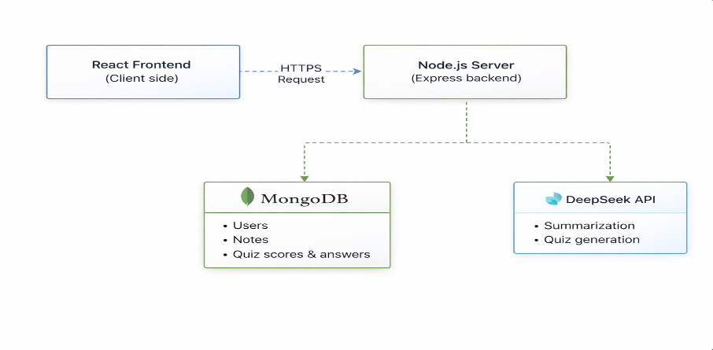

The main objective of this project is to overcome the limitations of manual note-making and basic summarization tools by building a smart academic assistant. This system helps students save time, improve understanding, and maintain a structured collection of summarized notes. By combining AI-based summarization with database storage using PostgreSQL, the project provides an effective solution for academic learning and revision.

Tools/Technologies Used

For this project, we have used various modern technologies which are evaluated in this chapter with complete details of why each one is used. Since our project is based on AI-powered academic text summarization and storing summaries for future revision, we selected a technology stack that is efficient, scalable, and easy to implement.

BACKEND: NODE.JS AND EXPRESS.JS

We have used Node.js to develop the backend of the Smart Notes Summarizer system. Node.js is an open-source JavaScript runtime environment that allows server-side programming using JavaScript. It is fast and efficient because it follows a non-blocking and event-driven architecture, which helps in handling multiple user requests smoothly.

Reasons for Selecting Node.js and Express
- Fast and efficient performance
- Easy API development and routing
- Scalable backend structure
- Suitable for real-world web applications

FRONTEND: EJS (EMBEDDED JAVASCRIPT)

For the frontend of our project, we have used EJS (Embedded JavaScript Templates). EJS helps in creating dynamic and interactive web pages by allowing JavaScript logic inside HTML templates. It makes the project simple because it works directly with Express and does not require complex frontend frameworks.

Reasons for Selecting EJS
- Easy to learn and implement
- Works smoothly with Express.js
- Supports dynamic page rendering
- Lightweight and beginner-friendly

DATABASE: MongoDB
We have used MongoDB as the database system for storing uploaded notes, generated summaries, key points, and related user information. MongoDB is an open-source, powerful, and scalable NoSQL database that stores data in the form of JSON-like documents (BSON format). It is highly suitable for our Smart Notes Summarizer project because academic notes and AI-generated summaries can vary in length and structure. MongoDB allows flexible storage, fast retrieval, and efficient management of user history and summarized content in an organized way.
MongoDB ensures high performance, easy integration with Node.js/Express, and supports quick access to saved summaries for future revision.

Reasons for Selecting MongoDB
- Flexible NoSQL database (stores data in document format)
- Handles unstructured and long text data easily (notes and summaries)
- Fast searching and retrieval using indexing and queries
- Scalable and efficient for storing multiple users’ notes and summary history
- Easy integration with web applications using Node.js and Mongoose

GENERATIVE AI API FOR TEXT SUMMARIZATION

To generate summaries automatically, we have used a Generative AI API specifically for text summarization. This AI technique understands large academic content and produces a short, meaningful summary along with important key points. It reduces the need for manual reading and helps students revise faster.

Reasons for Using Generative AI Summarization
- Produces meaningful and accurate summaries
- Saves students’ time and effort
- Extracts key points for quick revision
- Works well with large academic documents

METHODOLOGY

This chapter explains the working methodology of our project in a step-by-step manner. The proposed system follows a structured pipeline where the user uploads academic material, the backend extracts text, the AI generates a summary, and the results are stored for future access. The overall methodology ensures that the system is simple to use, fast in execution, and effective for student revision.

1. DOCUMENT UPLOAD AND INPUT HANDLING
The first step of the system is to take input from the user. The user can upload academic documents such as PDF files or text-based notes through a simple web interface created using EJS.
Once the document is uploaded, the backend validates the file type and size to ensure that only supported academic documents are processed.
This step is important because it ensures smooth user interaction and prevents unsupported or corrupted files from breaking the system.

2. TEXT EXTRACTION FROM DOCUMENT
After the document is uploaded successfully, the backend extracts the textual content from the file.
For typed and digital PDFs, the system reads the document and converts it into plain text format. This extracted text becomes the main input for the summarization module.
If the document contains too much unnecessary formatting or extra spaces, the system performs basic preprocessing such as:
- Removing extra line breaks
- Cleaning unwanted symbols
- Converting content into a readable text format
This step ensures the AI receives clean and meaningful input for better summarization results.

3. AI-BASED TEXT SUMMARIZATION
Once the text is extracted, the system sends the content to a Generative AI API for summarization. This is the core functionality of the project. The AI analyzes the academic text and produces:

- A short summary (easy to understand)
- Key points / bullet points for quick revision
The AI is guided using a structured prompt so that the output remains academic-focused, clear, and not too lengthy. This makes the summarizer suitable for exam preparation and quick learning.

4. RESULT FORMATTING AND PRESENTATION
After receiving the AI-generated summary, the backend formats the result properly and sends it to the frontend. The summary and key points are displayed on the result page using EJS templates.
This makes the output:
- Clean and readable
- Properly structured
- Easy to revise in less time
The system also provides options like viewing past summaries and re-checking important notes.

5. STORING DATA IN POSTGRESQL DATABASE
To make the system more useful, the generated summary is stored in PostgreSQL. The database stores information such as:
- Document title / file name
- Extracted summary
- Key points
- Date and time of summarization
Storing this data helps the user access summary history anytime without uploading the same document again. It also makes the project more complete and practical for real-world academic use.

6. SUMMARY HISTORY AND RETRIEVAL
The stored summaries can be retrieved from the PostgreSQL database whenever required. Users can view previously summarized notes, which helps in:
- Fast revision before exams
- Maintaining an organized study record
- Saving time and effort
This feature improves the usability of the system and adds value compared to one-time summarization tools.

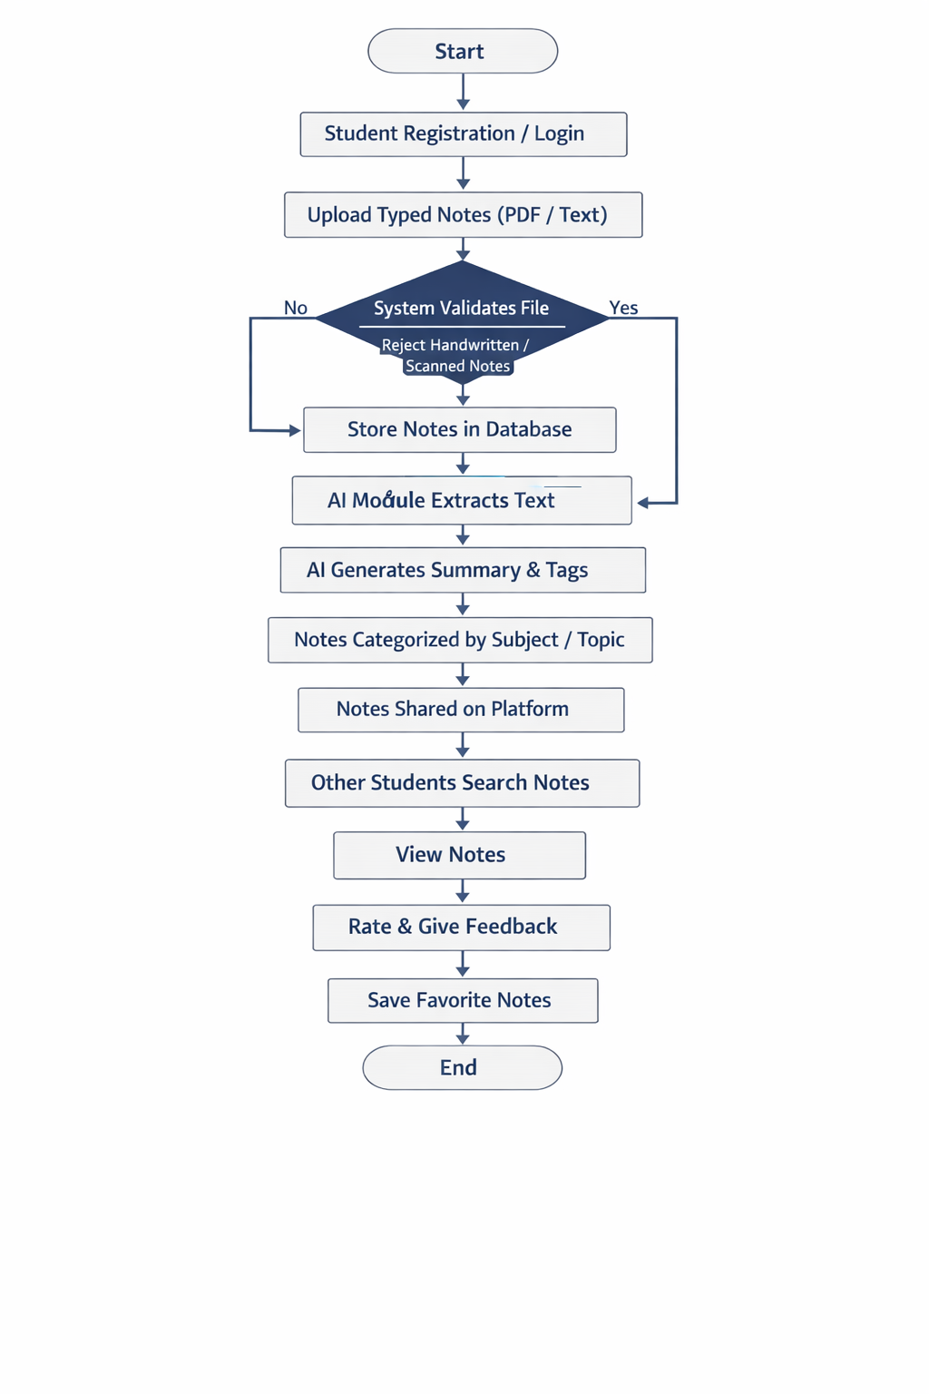

Figure 2: Architectural Diagram ( Mandatory)

9. Planning

Key features such as user authentication, note uploading, AI summarization, quiz generation, and performance tracking were outlined. A feasibility analysis was carried out to evaluate the available resources and tools, leading to the selection of the DeepSeek API for AI-related tasks and a full-stack development framework comprising React, Node.js, Express, and Mongo DB. This phase also included breaking down the project into manageable tasks that could be implemented over several Agile sprints.

The Login Page is the entry point of the application and plays a crucial role in ensuring secure access to the system. It authenticates users based on their registered email ID and grants access only to authorized individuals. The login module is integrated within the overall system architecture, where the React frontend communicates with the Node.js backend for verification.

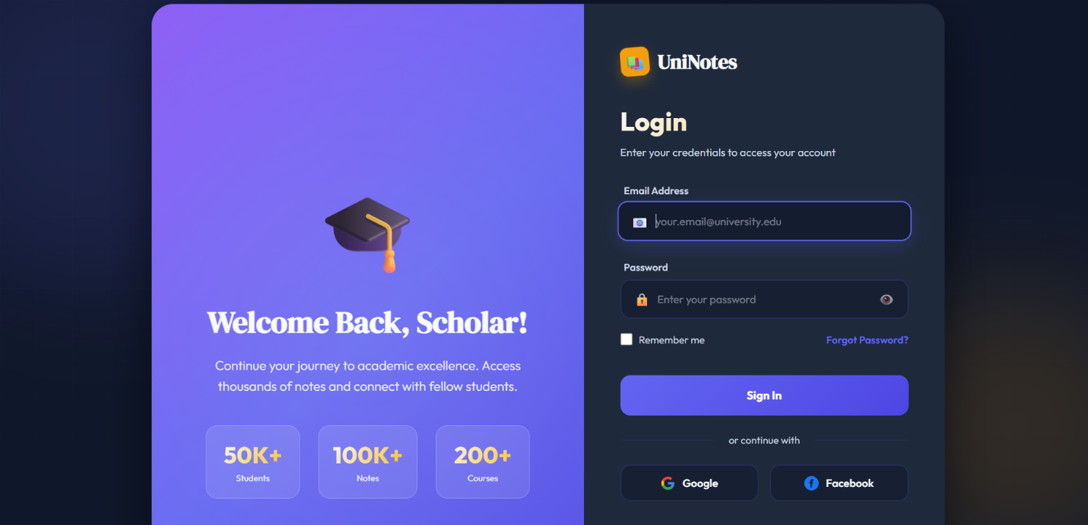
Fig: login page with authentication

UI wireframes were created to visualize the layout of major components, including the dashboard, upload section, summary viewer, and quiz page. During this stage, the backend was also designed, encompassing the design of the database schema and the design of key components such as file upload, generated summaries, and quiz management. API endpoints were outlined to ensure smooth interaction between the frontend, backend, and AI services. The design stage ensured that every module was logically structured and ready for incremental development. Fig. 2(a) displays the upload notes interface. User needs to press the “Choose file” button to upload a file from their devices. The system then generates a summary of the notes and displays it on the summary preview page as illustrated in Fig. 2(b). The left panel displays the original uploaded content, while the right panel presents the generated summary content. Additionally, “Save” and “Copy” buttons are provided, which allow users to save the summary in their personal database or copy the summarized text for external use.

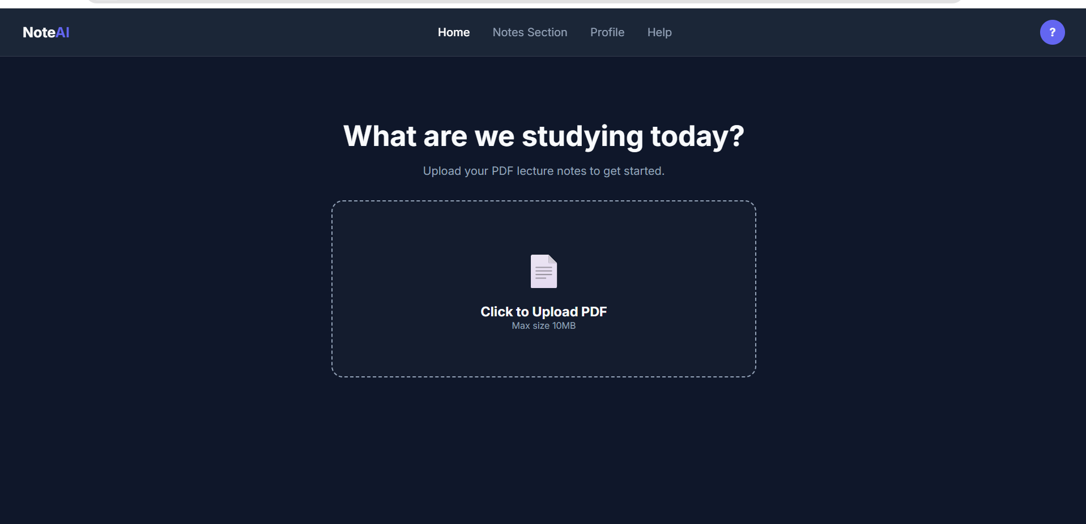

Fig: Fig. 2 (a) Upload Notes



Fig: (b) Summary Preview

Evaluation:

Testing was conducted throughout the development to verify the accuracy and reliability of system functions. Black box testing was applied to both frontend and backend components. AI-generated summaries and quizzes were reviewed for relevance and clarity. Performance tracking features were also tested to evaluate system responsiveness and processing efficiency. This continuous testing helped reduce errors and enhance the user experience. Finally, a user acceptance test (UAT) was conducted to ensure that the system not only functions correctly but also meet the educational needs of its target audience. The testing process was divided into two main phases:

1. Developer-led functional and performance testing: Conducted by the developer to validate technical correctness.

2. End-user acceptance testing: Conducted by participants to assess usability and learning value.
Literature Review Summary

In modern academic environments, students must process large volumes of text from notes, textbooks, and research papers, making timely revision challenging. To address this, numerous studies have explored automatic text summarization to help users extract meaningful information from long documents with minimal manual effort.
Automatic summarization systems are designed to reduce reading time by identifying key ideas and presenting them in a concise format. AI-based summarization tools have been shown to assist learners in comprehension and note-taking, providing condensed versions of long texts and highlighting important points [1]. Although these studies demonstrate the effectiveness of summarization in reducing cognitive load, they mainly focus on algorithmic outcomes rather than complete applications that store, organize, and manage summarized content for user access.
Research into summarization techniques distinguishes between extractive and abstractive methods. Extractive approaches select significant sentences or phrases directly from source text to form a summary, whereas abstractive methods generate new sentences that capture the overall meaning in a more human-like manner [2]. Transformer-based models and deep learning architectures have further improved summarization quality by enhancing semantic understanding. Despite these advancements, many systems remain research prototypes without practical user-oriented features such as document upload interfaces, persistent storage, or personalized revision tools.
Furthermore, studies addressing long academic documents highlight the challenges of handling complex terminology and dense information frequently found in research texts. This complexity complicates the summarization process and demands advanced AI models capable of contextual interpretation [3]. However, existing research often overlooks the integration of summarization systems into web platforms tailored for students, leaving a gap between theoretical summarization performance and real-world utility.
Research Gap and Contribution
The reviewed literature identifies a gap in the development of comprehensive systems that not only summarize content accurately but also provide a student-centric platform with features like PDF upload, storage of summarizations, note management, and intuitive user interaction. To address these limitations, the proposed “Smart Notes Summarizer” integrates generative AI for text summarization into a web-based application with persistent storage (MongoDB). Users can upload academic content in PDF or text form, receive concise summaries and key bullet points generated by AI, and save results for later revision, thereby improving learning efficiency and productivity.

REFERENCES

- [1] All Social Science Journal. (2025). Research on AI-based text summarization for academic learning and content understanding. Retrieved January 29, 2026, from https://www.allsocialsciencejournal.com/uploads/archives/20250217123600_SER-2025-1-055.1.pdf
- [2] IEEE Xplore. (2018). A study on automatic text summarization techniques and NLP-based approaches. Retrieved January 29, 2026, from https://ieeexplore.ieee.org/abstract/document/8424747
- [3] SSRN. (2024). Generative AI and modern summarization methods for document processing and knowledge extraction. Retrieved January 29, 2026, from https://download.ssrn.com/2024/7/8/4888165.pdf?abstractId=4888165

