**Edureka Project Setup :-**

1. **Jenkins Installation**

**Install Java**

Jenkins is a java-based software, so the first step is to install Java. The java version that compatible with Jenkins is 8 and 11, but some Jenkins plugins may not be compatible anymore with Java 8.

$ sudo yum update  
$ sudo yum install java-11-openjdk-devel

**Install Jenkins**

Add the Jenkins repository and download the repo file, then import the GPG key:

$ sudo wget -O /etc/yum.repos.d/jenkins.repo <http://pkg.jenkins-ci.org/redhat-stable/jenkins.repo>

$ sudo rpm --import https://pkg.jenkins.io/redhat-stable/jenkins.io.key

Install the latest stable version of the Jenkins

$ sudo yum install jenkins

if the installation process has been finished, start and enable the Jenkins service

$ sudo systemctl start jenkins  
$ sudo systemctl enable jenkins

Check the service status

$ sudo systemctl status jenkins

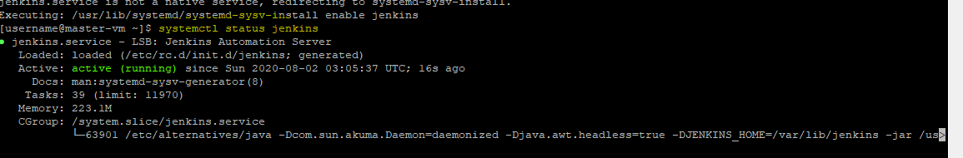

1. **Ansible Installation –**

**Step 1:** Set**EPEL** Repository

yum install epel-release

**Step 2:** Install Ansible

**yum install ansible -y**

**ansible –version**

**Step 3:** Generate SSH key on the Ansible Control Machine. In order to do that, use the command below:

**ssh-keygen**

**Step 4:** After the key is generated, the next task is to copy public key of Ansible server to its nodes. Use the command below:

ssh-copy-id username@ 40.65.216.211

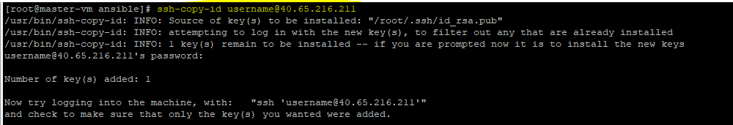

**Step 5**: Create inventory file for nodes

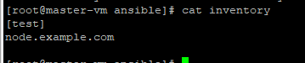

**Step 6**: add this inventory in ansible.cfg file

**Step 7**: ping the node

ansible test -m ping

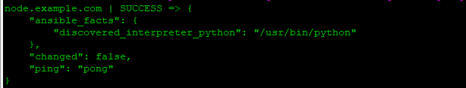

**3. Configure Jenkins Node to Master -**

1. On your master machine go to **Manage Jenkins** > **Manage Nodes**.



1. New Node
2. Enter Node Name
3. Select Permanent Agent
4. Press OK.
5. Fill out the Following:-

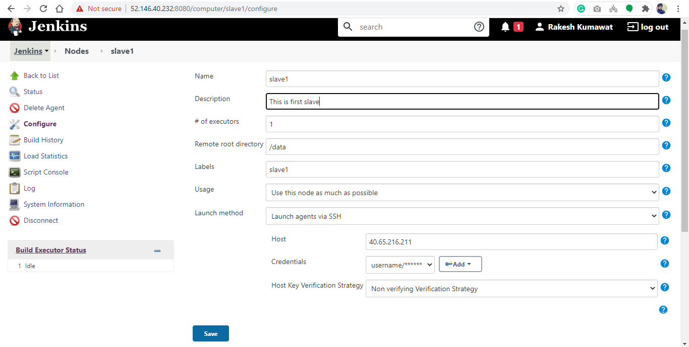

1. Click on Save Button.

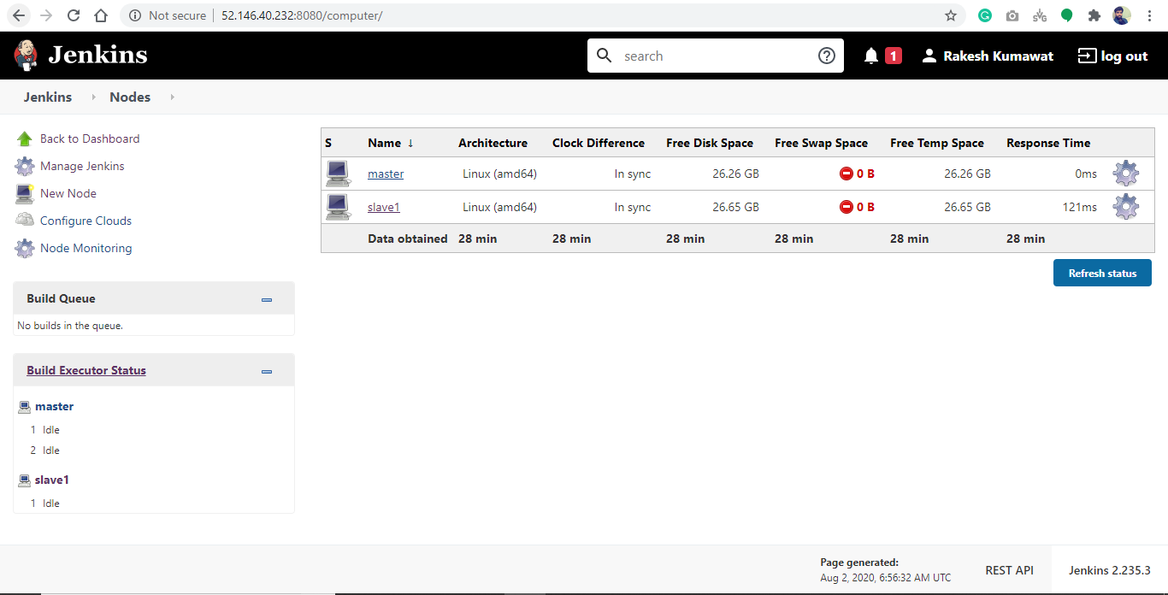

1. **Set up the necessary tools such as git on the slave node through Ansible**
2. **Git**

ad-hoc command for install git on slave

ansible test -m apt -a 'name=git state=present purge=yes' --become

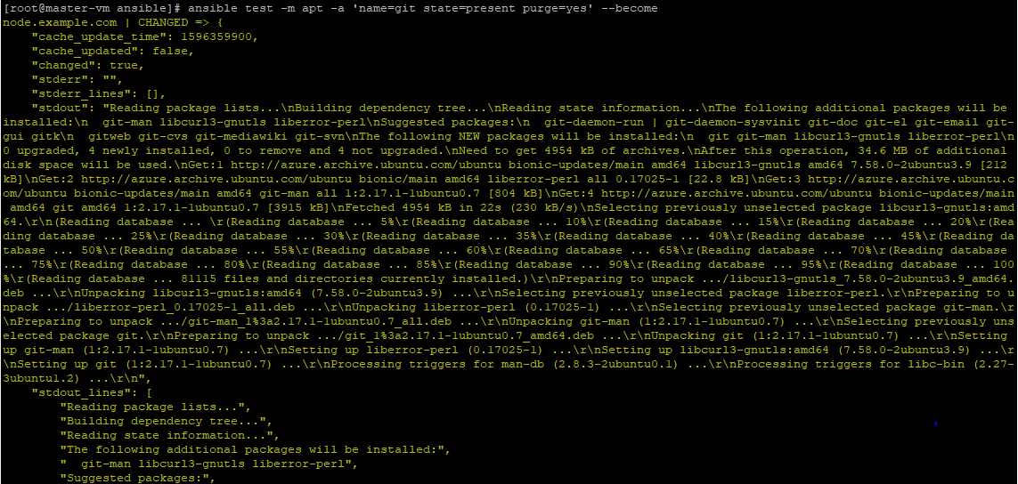

1. **Change the IP address of the VMs accordingly**
2. **Master machine**

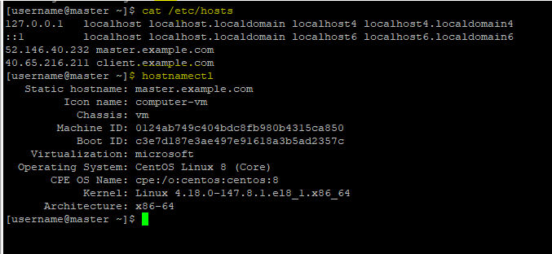

1. **Ubuntu VM (i.e. Jenkins agent, puppet-agent)**

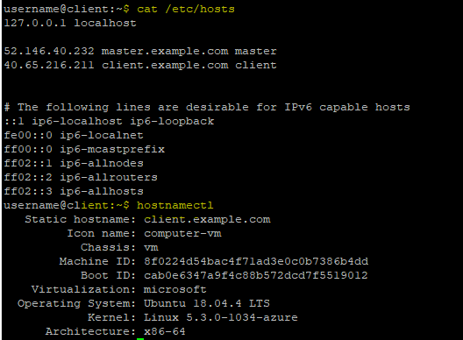

1. **Git Branches –**

Git URL - <https://github.com/rk23597/projectCert.git>

Branches – a) Master (act as Prod)

b) Staging (act as Pre-Prod)

c) Dev (development)

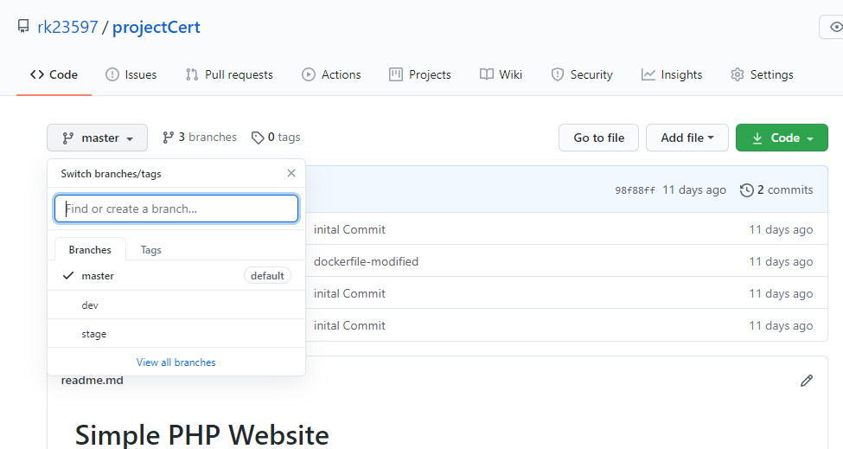

Azure VM Configuration –

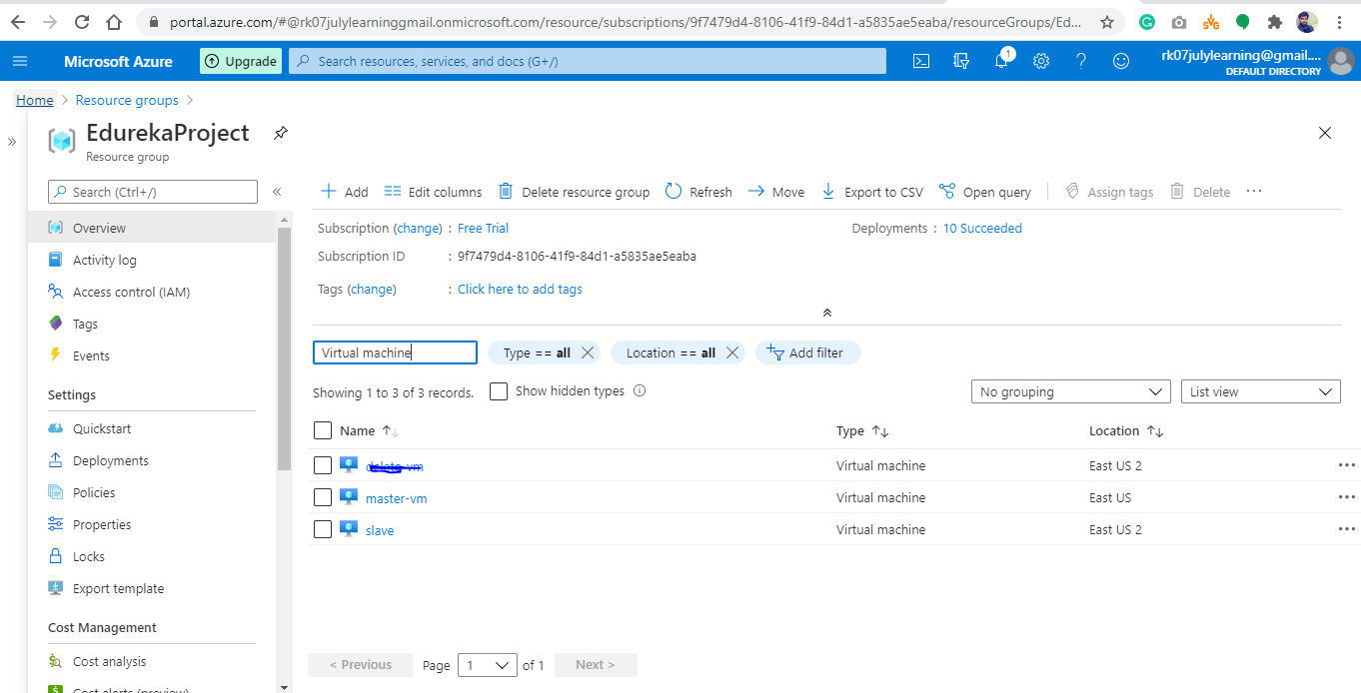

Created 2 Virtual Machines –

1. Master-vm : act as master

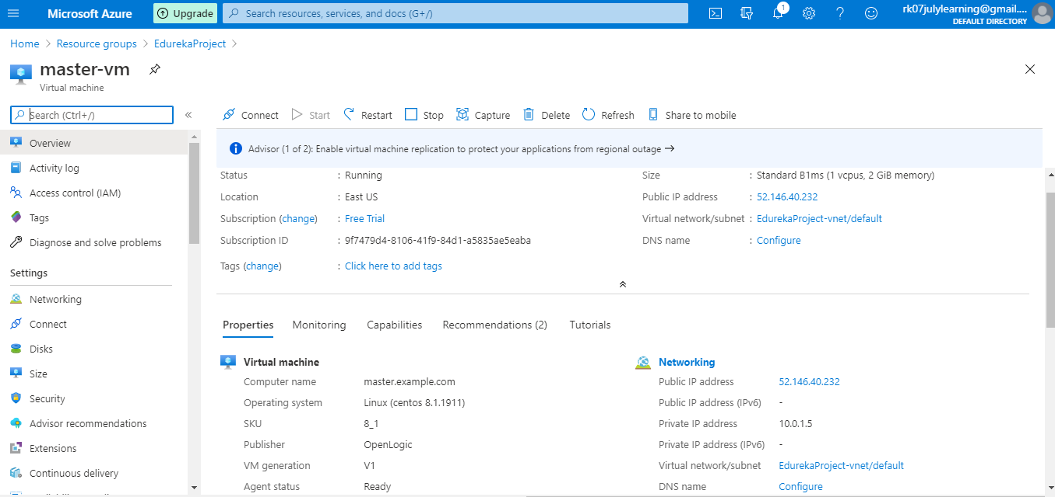

1. Slave – act as Jenkins agent, puppet agent (Fresh Ubuntu Machine )

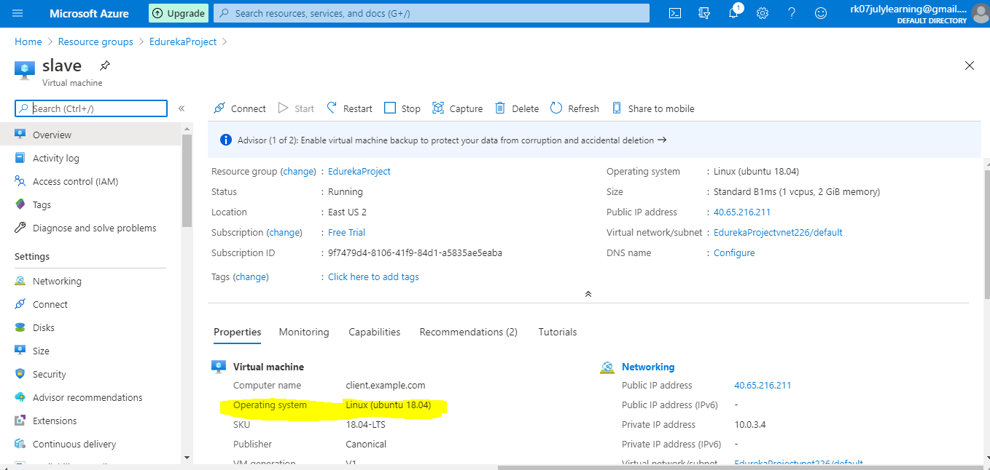

Port whitelisting in Azure -

