**STUDENT ID :- 22062263**

**NAME :- RUCHITABEN SHAILESHBHAI KABARIYA**

**TOPIC : - ASSIGNMENT 1 (VISUALISATION)**

**REPORT OF ASSIGNMENT 1**

**Visualisation 1: Population of 5 countries (India, Afghanistan, Costa Rica, Somalia, China) between 2015 to 2019.**

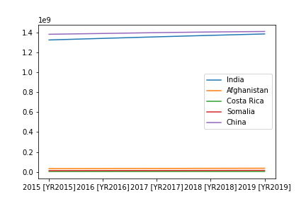

Line chart is better way to show the changes between population of five different countries from 2015 to 2019.

As in shown in the above graph, there is no vast increase in number of populations in countries like Costa Rica, Somalia, Afghanistan. It is remained same till the end of the year that is 2019. However, the graph line between China and India increases gradually. But, if we compare the graph lines between India, China and Costa Rica, Somalia, Afghanistan then the population rate in other three countries is very low compare to India and China as well as it remained low till the end of the year. On the other hand, the population rate in India and China is very high from the start period year (2015) and it increases gradually.

**LINK OF DATASET OF ABOVE LINE GRAPH: -**

[**https://data.worldbank.org/indicator/SP.POP.TOTL?locations=IN-AF-CR-SO-CN**](https://data.worldbank.org/indicator/SP.POP.TOTL?locations=IN-AF-CR-SO-CN)

**Visualisation 2: Evolution of population rate between five different countries which is India, China, Afghanistan, Somalia, and Costa Rica.**

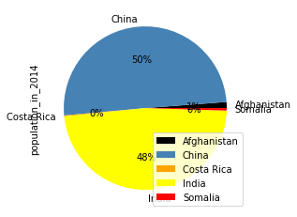

A pie chart is good visualisation method for evolution of dataset which is represent in percentage.

In the above pie chart of year 2014, the data of population of India is slightly lower than the data of population of China. China has highest population rate in percentage as compare to other four countries.

On the other hand, the increase population rate of Somalia and Afghanistan in the year of 2014 is very less. However, the changes in data of population in Costa Rica is zero which is nullable.

**LINK OF DATA SET OF ABOVE PIE CHART: -**

[**https://data.worldbank.org/indicator/SP.POP.TOTL?locations=IN-AF-CR-SO-CN**](https://data.worldbank.org/indicator/SP.POP.TOTL?locations=IN-AF-CR-SO-CN)

# Visualisation 3: Evolution of mortality of under age of 5 between five countries in year 2021.

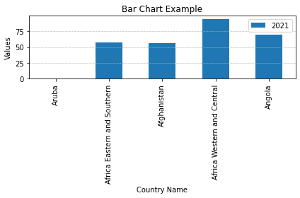

A bar chart is good for distribution data set and can easily compare other groups against each other and show which subgroups is highest and lowest.

In the above bar graph, the data set is about mortality rate of under age 5 person of year 2021. The highest rate is in Africa Western and Central than other three countries. How ever, the two countries which is Afghanistan and Africa Eastern and Southern has common bar graph with same values of mortality rate in the year 2021. On the other hand, there is no data of country Aruba. Although, Angola has slightly higher mortality rate than Africa Eastern and Southern country and Afghanistan but lower than Africa Western and Central country in the year 2021.

**LINK OF DATA SET OF ABOVE BAR CHART: -**

<https://data.worldbank.org/indicator/SH.DYN.MORT?end=2021&locations=AL-IN-AT-BW&start=2021&view=bar>