**CHANGES IN URBAN ENVIRONMENT BASED ON WORLD BANK DATA**

**By Ruchitaben Kabariya**

**Student id: 22062263**

**Abstract**

The analysis phase about access of electricity in urban and rural area from oil and coal sources has taken by using of different country with some specific timeline.

**Git hub link**

[**https://github.com/rk23aae/DHV_assignment2.git**](https://github.com/rk23aae/DHV_assignment2.git)

**Dataset**

Data taken from world bank data

**Electricity changes in rural and urban data analysis based on World Bank data**

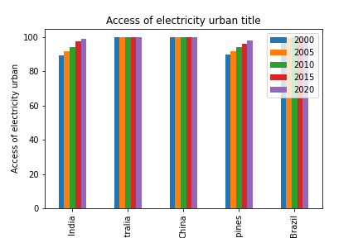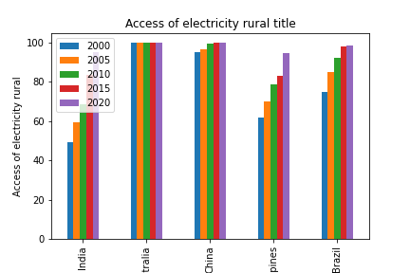Five nations from various continents were chosen for this analysis, and the relationships between the following variables and changes in electricity were examined: Access to electricity in rural areas (percentage of population), in urban areas (percentage of population), and in terms of electricity generated from coal and oil sources.

The data available from 2000 to 2020, in five-year increments, was used to create the bar graph above on the availability of electricity in rural and urban areas by country. The largest nations with the most availability to electricity in both rural and urban areas are China and Australia. They continue to trend upward through the end of the year. But Brazil also has an upward trend in its metropolitan areas, with a steadily increasing graph in its rural areas. India's metropolitan areas consume more electricity than its rural areas do, with the Philippines showing a similar trend from 2000 to 2020. However, India's rural trend is less than its urban trend. In 2020, the Indian graph reaches its maximum point.

China, on the other hand, uses more power in its cities than it does in its rural areas, albeit the difference is not as great in the first year.

However, in the period of time Australia has same graph for both rural and urban area.

[Access to electricity, rural (% of rural population) | Data (worldbank.org)](https://data.worldbank.org/indicator/EG.ELC.ACCS.RU.ZS)

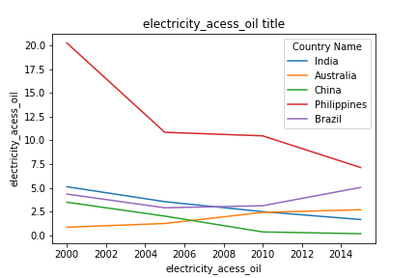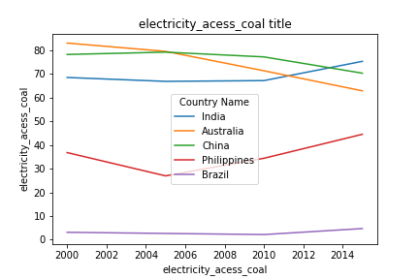

The association between five distinct countries' availability to power from coal and oil between 2000 and 2020 is depicted in a line graph. The Philippines' electricity access graph illustrates the main shifts: electricity from oil starts at peak and declines in 2004, then stabilises until 2010, at which point it gradually declines until the end of the year. In contrast, the country's coal-based electricity access graph exhibits an upward trend until the end of the year.

However, Brazil's trend from 2000 to 2020 in the coal and oil datasets is the same.

Meanwhile, Australia shows totally opposite trend in both data set. The graph which illustrates the electricity access of oil sources in that Australia has significantly upward trend but the graph which shows the electricity access from coal in that Australia has decreasing trend which become lower gradually.

In India, the power consumption from oil has reducing flow from the 2000 year to 2020 year.

Nevertheless, the power access from oil has constant flow from 2000 to 2010 and then there is sudden increase till the end of the period.

China’s trend starting from decreasing flow till 2010 and become constant in the end of the year for electricity produced oil.

In the dataset which show the power access from coal for China begin with constant flow till 2008 and immediate low flow from 2008 to 2020.

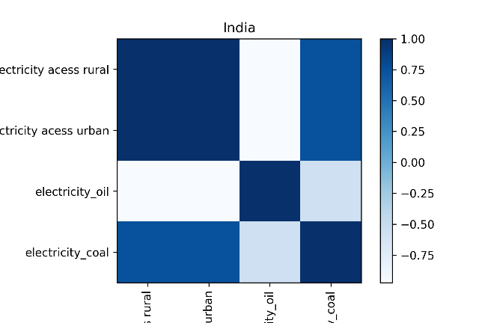

The heat map above illustrates the visualisation of four distinct datasets based on the availability of power in rural and urban areas, as well as the availability of electricity from coal and oil sources in India, a single nation. It demonstrates how widely access to power is in both rural and urban areas when oil is used. However, the trends in power from coal sources and rural areas are comparable.

Meanwhile, the power usage from oil is very less in urban area which do not affect the climate so much.

The heatmap clearly show that the electricity produced from oil is obviously less then energy produced from coal but urban population access more power from oil.