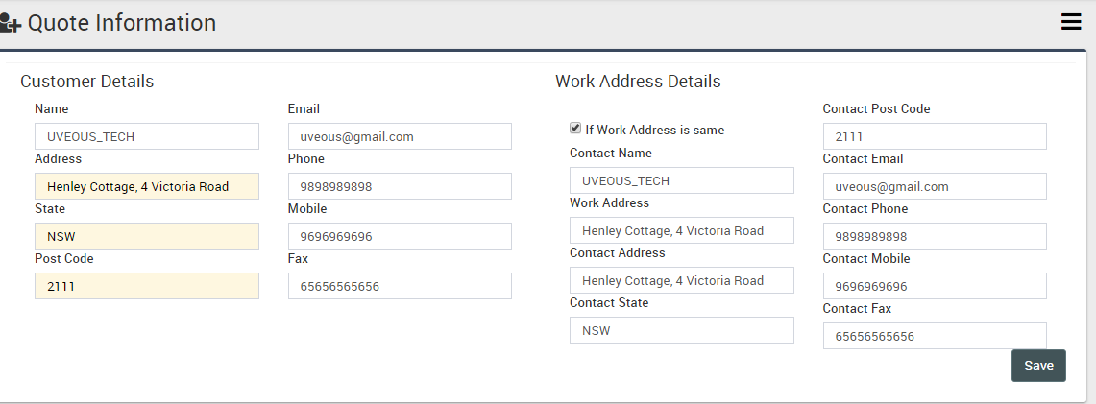

**After Pressing SAVE Button the Bellow Part Reflected**

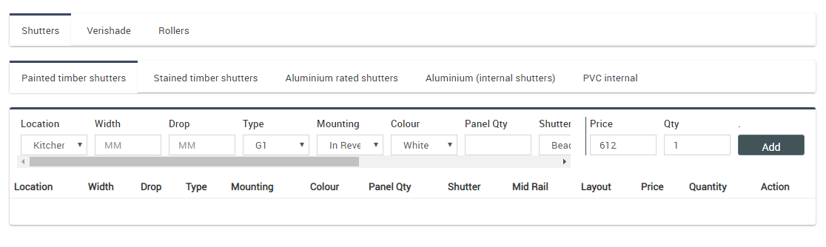

**After Press ADD Button Bellow Part is Reflected With Data**

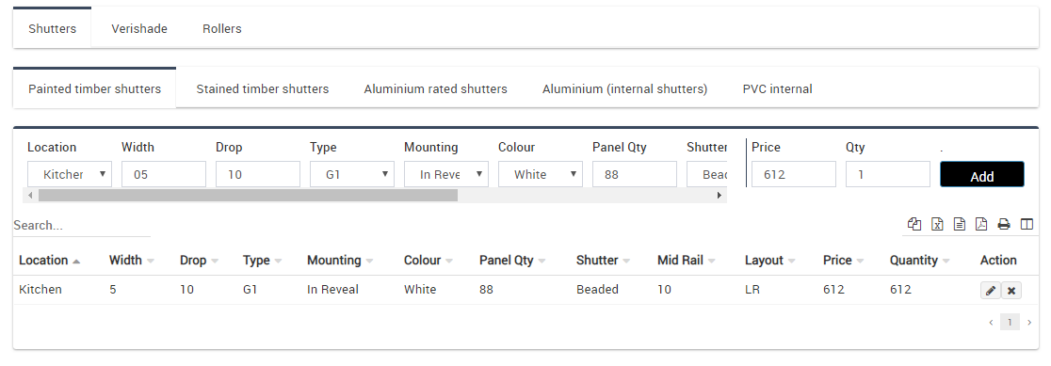

**Press on Pencil Action Icon Bellow Pop-Up will come out like as**

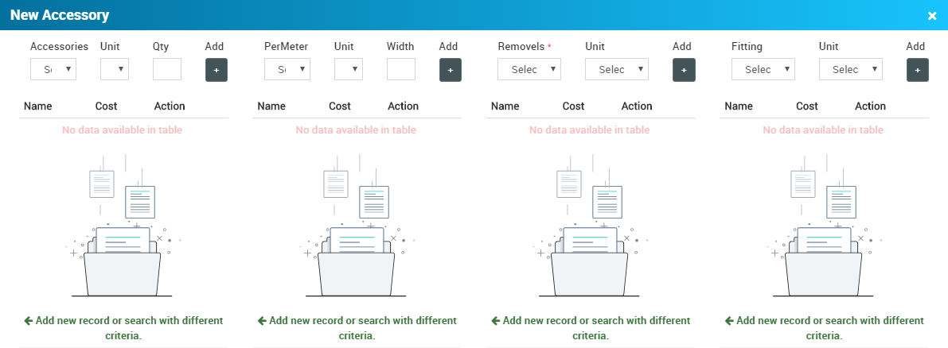

**We can Add as per our requirement like Accessory , Per meter , fitting and removal by pressing + Icon Button and Data will show like tabular structure as show bellow .**

