***DASHBOARD***

**Listing Page of the Currency :-**

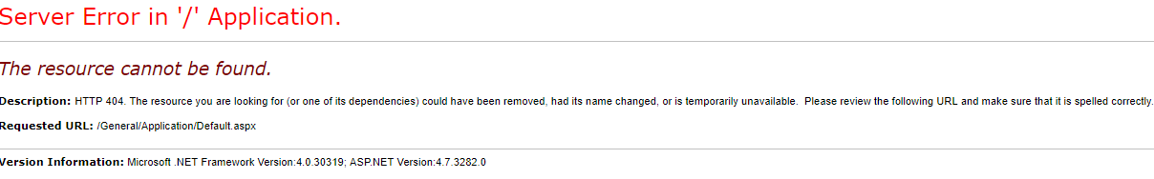

**Issues: -** (1) Dashboard Page gives Error message.

(2) On the Dashboard Page, there is HOME word in the title bar that is giving Error Page.

______________________________________________________________________________________________________________________________________________________________________

***CURRENCY***

**Listing Page of the Currency :-**

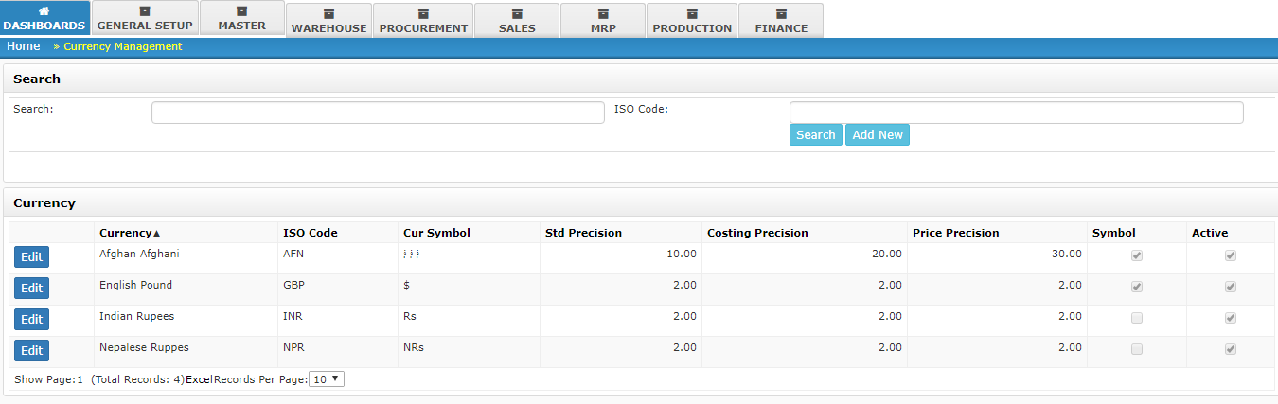

**Issues: -** (1) When I am going for searching any data in the Search box and ISO Code Box then hit the ENTER Button, it’s comes back on the Login Page.

**Add Page of the Currency :-**

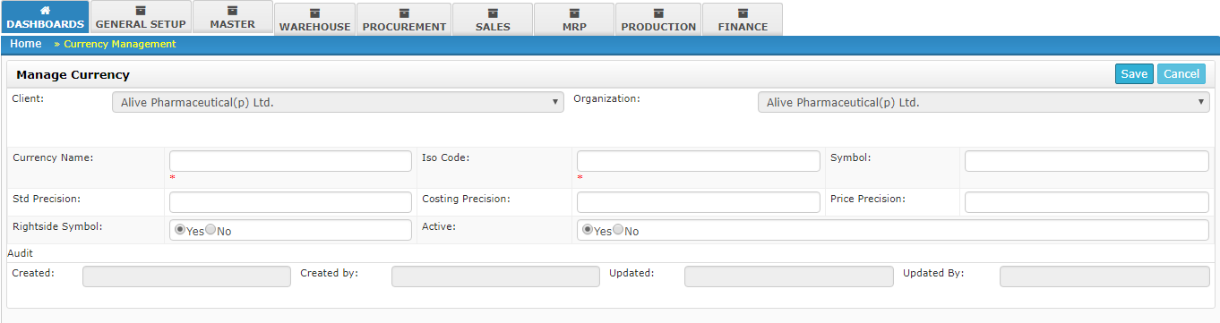 **Issues: -** (1) Validation message should be in a correct Format of Currency Name and ISO Code.

(2) Description Field is missing according to the Documentation.

(3) Duplicate value should be protected.

**Edit Page of the Currency :-**

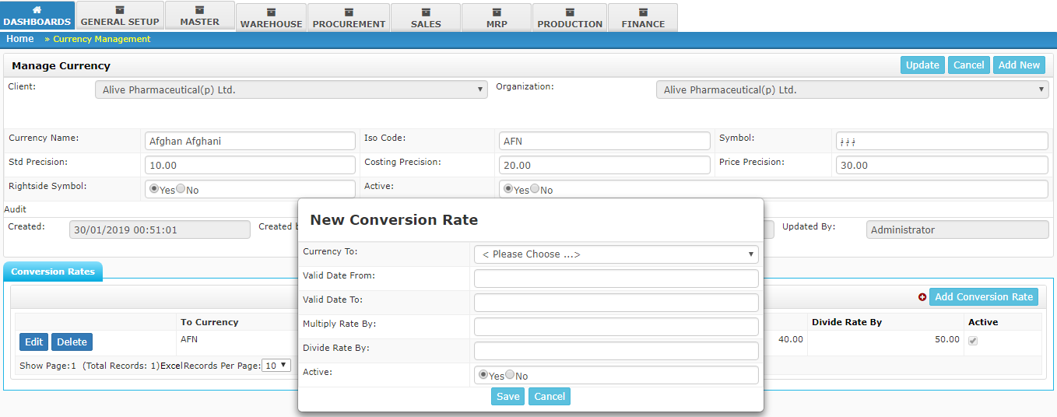 **Issues: -** (1) In the New Conversion Rate Pop-up, there is Multiply Rate By field that should be Multiple Rate By according to the Documentation.

(2) Duplicate value should be protected.

______________________________________________________________________________________________________________________________________________________________________

***CONVERSION RATE***

**Listing Page of the Conversion Rate :-**

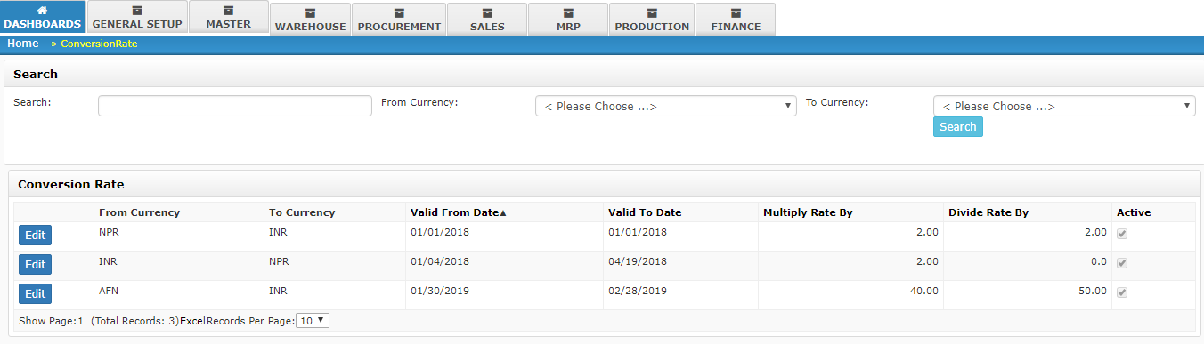

**Issues: -** (1) When I am going for searching any data in the Search box and hit the ENTER Button, it’s comes back on the Login Page.

(2) Column Name Multiply Rate By should be Multiple Rate By.

______________________________________________________________________________________________________________________________________________________________________

***COUNTRY AND REGION***

**Listing Page of the Country and Region :-**

***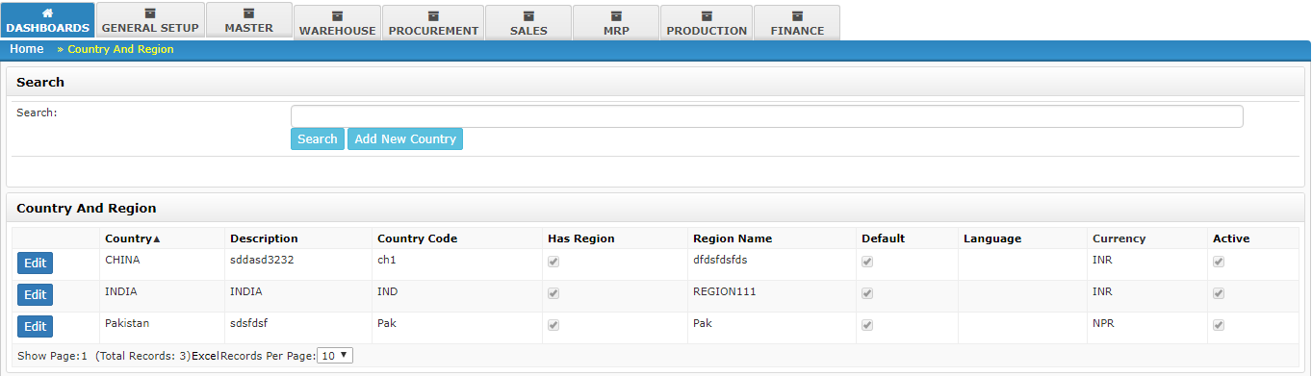*Issues: -** (1) When I am going for searching any data in the Search box and hit the ENTER Button, it’s comes back on the Login Page.

**Add Page of the Country and Region :-**

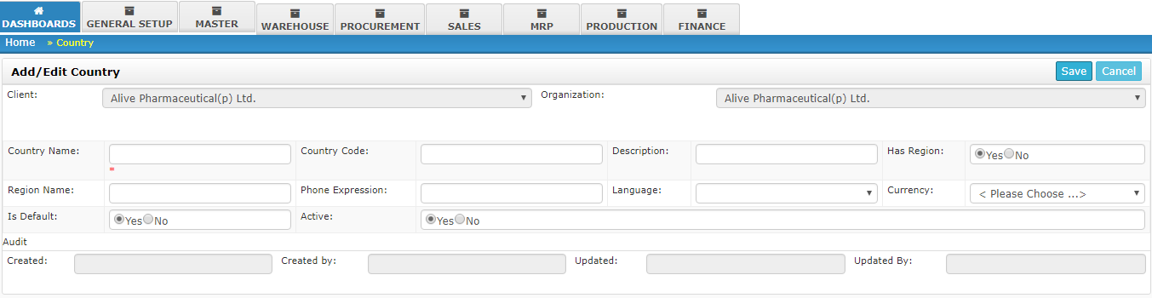

**Issues: -** (1) Validation message should be in a correct Format of Country Name Field.

(2) At the time of checking the validation of the ADD page, firstly I hitting the SAVE button then its shows a Star mark on the Country Field after fill the data in the Country name then again I Clicked on the SAVE button then neither shows any validation nor save the data.

(3) **ISO Country Code, IBAN Code, IBAN length, Postal code Format** fields are missing according to the Documentation.

(4) Duplicate value should be protected.

**Edit Page of the Country and Region :-**

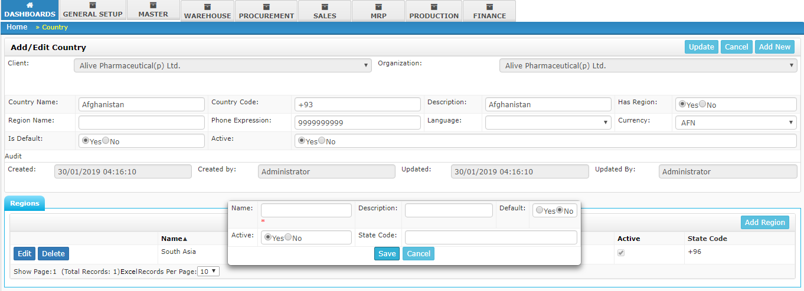 **Issues: -** (1) In the Region Section, Validation of the Name field should be in correct format.

(2) If ‘**Has Region**’ field have NO then Region should not be added.

(3) At the time of the Click on the DELETE Button at least it should show a confirmation Message.

(4) Duplicate value should be protected.

______________________________________________________________________________________________________________________________________________________________________

***PREFERENCE***

**Listing Page of the Preference :-**

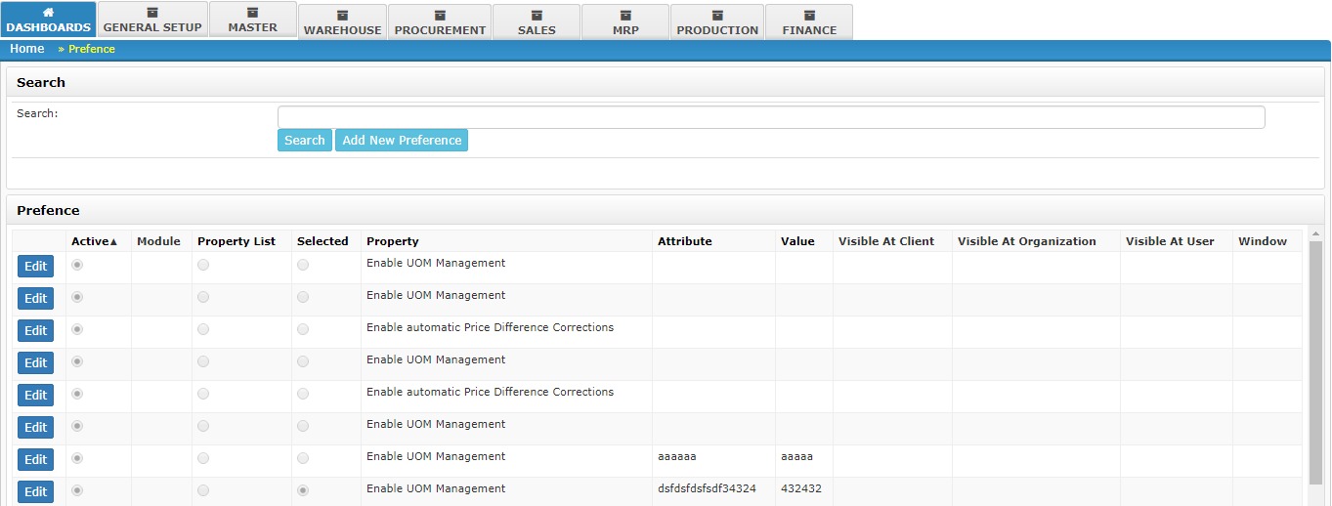 **Issues: -** (1) Searching is not working using Search Button.

(2) When I am going for searching any data in the Search box and hit the ENTER Button, it’s comes back on the Login Page.

(3) Spelling of **Prefence** should be correct in the tittle Bar.

**Add Page of the Preference :-**

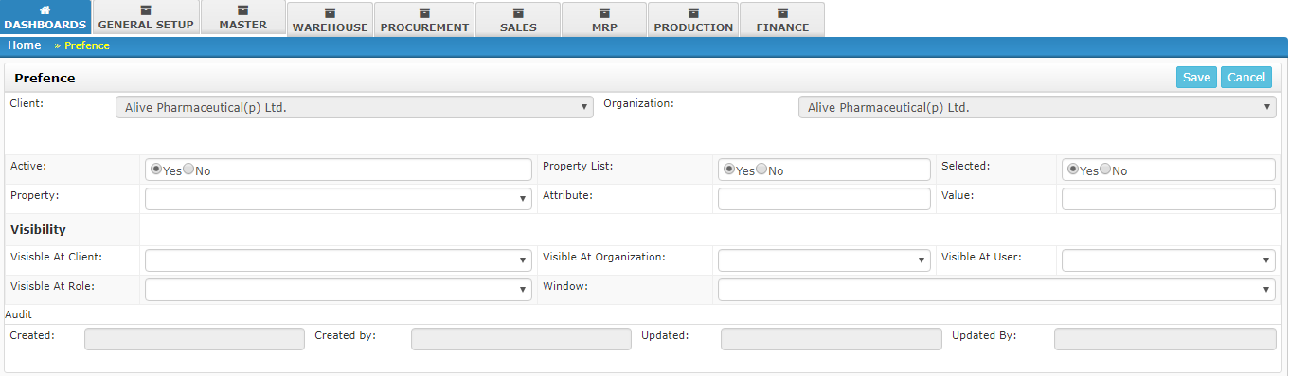**Issues: -** (1) Searching is not working using Search Button.

(2) When I am going for searching any data in the Search box and hit the ENTER Button, it’s comes back on the Login Page.

(3) Spelling of **Prefence** should be correct in the tittle Bar.