7COM1079-0901-2025 - Team Research and Development Project

Final report title: The relation between GPA and IQ

Group ID: A85

Dataset number: DS 136

Prepared by: Rahul Kolupoti – 24164879,
Brahmateja Aduru – 24160067,
Manohar Amaram – 24122536,
Abhinay Reddy Induru - 24158654,
Chandu Thanneeru - 24177993

University of Hertfordshire
Hatfield, 2025

Table of Contents
- Introduction
  - Problem statement and research motivation
  - The data set
  - Research question
  - Null hypothesis and alternative hypothesis (H0/H1)

- Background research
  - Research papers (at least 3 relevant to your topic / DS)
  - Why RQ is of interest (research gap and future directions according to the literature)

- Visualisation
  - Appropriate plot for the RQ output of an R script (NOT a screenshot) and required supplementary graph/table
  - Useful information for the data understanding

- Analysis
  - Statistical test used to test the hypotheses and output
  - The null hypothesis is rejected based on the p-value

- Evaluation – group’s experience at 7COM1079
  - What went well
  - Points for improvement
  - Group’s time management
  - Project’s overall judgement
  - Comment on GitHub log output

- Conclusions
  - Results explained.
  - Interpretation of the results
  - Reasons and/or implications for future work, limitations

- Reference list
- Appendices
- R code used for analysis and visualisation.
- GitHub log output.

1. Introduction

  - Problem statement and research motivation (100 words)
Academic achievement is often measured using Grade Point Average (GPA) and the intelligence of a person as Intelligent Quotient (IQ). There is a widespread assumption that higher intelligence leads to better academic outcomes. This has a significant impact on educational assessment, admission criteria, and student’s prospects. However, the empirical findings in existing research works vary, which suggests that intelligence alone is not enough to fully explain academic success.

This study aims to examine the relationship between GPA and IQ using a student dataset and testing for correlation using Pearson’s correlation. This report aims to determine whether IQ can be considered as a proper predictor of a student’s academic performance.

  - The data set (75 words)
The dataset, gpa_iq.csv, contains a list of students GPAS as well as their IQ. The dataset contains 74 unique entries containing information about the student’s GPA, IQ and gender. The dataset lists 29 values as gender 1 and 45 values as gender 2. The highest values of GPA and IQ are 9.999 and 136, whereas the lowest values are 0.53 and 72 respectively. The mean of the GPA’s listed is 7.279 whereas the mean of the IQ’s listed is 108.067.

  - Research question (50 words).

Is there a correlation between GPA (Grade Point Average) and IQ (Intelligent Quotient)?

  - Null hypothesis and alternative hypothesis (H0/H1) (100 words)

Null hypothesis (H0): There is no correlation between GPA and IQ.

Alt hypothesis (H1): There is a correlation between GPA and IQ.

- Background research
  - Research papers (at least 3 relevant to your topic / DS) (200 words)
(Rakhmanov & Dane, 2020) studied the correlation between GPA and other parameters (IQ, Short-term and Long-term visual memory). In the study, 125 first year students were selected and were asked to complete a full IQ test (The Wonderlic Personnel Test Quicktest) and Rey–Osterrieth Complex Figure Test (ROCF) and the scores were tested against GPA using Pearson Correlation. The results showed an overall positive Pearson correlation between GPA and the other parameters.

(Iqbal, et al., 2021) sought to find out if there was a correlation between intelligence and academic success of MBBS students (Bachelor of Medicine, Surgery) and if the correlation differs between male and female students. The data was analysed using Spearman’s correlation, independent t test and Mann Whitney U test. The results showed no significant correlation between GPA and IQ. There was also no significant difference in the correlation between male and female students.

(Heaven & Ciarrochi, 2012) aimed to assess the interactive effects of intelligence and personality on school performance. 768 high school students were enlisted for this study. Their intelligence (measured in their 1st year of high school (Grade 7) by the Department of Education and Training) was tested with their total grade scores from Grade 10 using t-test and a Bonferroni correction. The results showed Intelligence to be the strongest predictor of academic performance individually.

  - Why RQ is of interest (research gap and future directions according to the literature) (100 words)
The Research question focuses on finding out if there is a connection/correlation between a person’s IQ and their academic achievements. Following this, more research can be conducted to figure out which factors can be used to predict student’s academic performance. The literature reviews done here propose multiple additional factors like Short-term and Long-term visual memory (Rakhmanov & Dane, 2020), gender (Iqbal, et al., 2021) and extraversion, openness/intellect, agreeableness, conscientiousness, and neuroticism (Heaven & Ciarrochi, 2012). But most of these factors fall into moderate positive correlation. Any future directions must focus on finding alternative factors which have higher correlation.

- Visualisation
  - Appropriate graphs for the RQ (50 words)
A Scatterplot was chosen for our study because it helps us visualize the relationship between GPA and IQ. They are ideal for examining relationships between two variables, detect outliers, visualize linearity and check assumptions for correlation analysis.
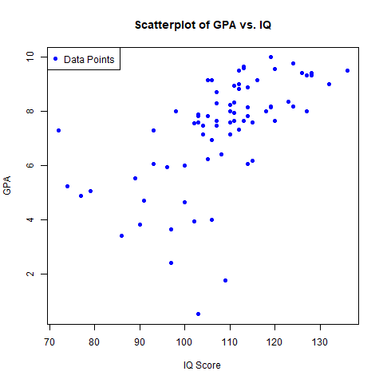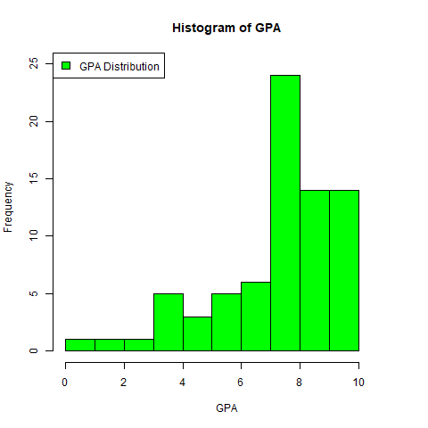
  - Useful information for the data understanding (50 words)
Based on the scatterplot, we can summarise a positive correlation between GPA and IQ. Students with higher IQ tend to get higher GPA. But there are still some outliers, either with high IQ and low GPA or low IQ and high GPA. The histogram of GPA indicates that most student’s GPA lies between 7-8.

- Analysis
  - Statistical test used to test the hypotheses and output (75 words)
Pearson’s correlation test was conducted to test for relationship between GPA and IQ. The null hypothesis states that there is no correlation between GPA and IQ, while the alternative hypothesis states that there is a correlation. Output of the test is:

Pearson's product-moment correlation

data: gpa_iq$gpa and gpa_iq$iq
t = 6.3058, df = 72, p-value = 2.048e-08
alternative hypothesis: true correlation is not equal to 0
95 percent confidence interval:
0.4260418 0.7260206
sample estimates:
cor
0.5964738

  - The null hypothesis is rejected based on the p-value (100 words)
For the null hypothesis to be rejected, the p-value must be less than the significance value which is usually set at 0.05. In our analysis, the p-value produced by the Pearson correlation test is 2.048e-08 (0.00000002048) which is far smaller than 0.05. This extremely small p-value provides very strong evidence against the null hypothesis. Therefore, we reject the null hypothesis (which suggests of no correlation) and conclude that there is a statistically significant correlation between GPA and IQ, supporting the alternative hypothesis.

- Evaluation – group’s experience at 7COM1079
  - What went well (75 words)
The dataset was simple and easy to understand which allowed us to form a proper research question based on a thought which is commonly debated over, ‘does a high IQ guarantee a high GPA’. Moreover, having teammates who are used to working together and having a similar mindset allowed us to quickly complete the work on our self-afflicted time crunch. Though the R code feels a bit simple, it fits all the criteria and has low time complexity and storage requirements.

  - Points for improvement (75 words)
A tougher/complex question could’ve been chosen. The dataset, while simple, has greater aspects which would have been nice to study like the difference in correlation between males and females. A more thorough literature review prior to selecting the dataset would’ve also been beneficial. Better time management must be maintained and allow ample time for each person to complete their part of the work. The flow of the report could’ve been better.

  - Group’s time management (50 words)
This was the biggest issue faced. Due to the simplicity of the dataset and research question, we grew complacent. After splitting our work, we, regretfully, didn’t start working until later. Though we were able to coordinate well in the end, it would’ve saved us a lot of time and energy if we started working early.

  - Project’s overall judgement (50 words)
Although our report doesn’t contain any new discoveries, we feel happy to have studied this topic and worked with fellow students to show our understanding of the dataset. The past research about this topic is also very stimulating and interesting to study. It was also nice to work with R Studio and Git.

  - Comment on the GitHub log output (50 words)
Please comment on the GitHub log output, and refer to it as being placed into Appendix B.
From your Git log, select three most significant commits during this project and include the following for each:
- Commit Message: [Insert Commit Message] Brief explanation of the broader impact of the change
- Commit Message: [Insert Commit Message] Brief explanation of the broader impact of the change
- Commit Message: [Insert Commit Message] Brief explanation of the broader impact of the change

- Conclusions
  - Results explained (75 words)
Statistical analysis after cleaning up the data showed the GPA values up to 10 and IQ from 70 to 140. The Pearson correlation test shows a moderate-to-strong positive correlation between GPA and IQ (r = 0.5965, p < 0.05). The 95% confidence interval shows that the true population correlation is positive and between 0.426 and 0.726. The Scatterplot and histogram confirmed the positive trend and reasonable distribution of data. These results indicate a significant correlation between student’s GPA and their IQ.
  - Interpretation of the results (75 words)
These findings suggest that students with higher IQ tend to achieve higher GPAs, but it is not always a guarantee. Additional factors such as hard work, socioeconomic status, willingness to study also play a major role in determining a student's GPA. It is important to note that Correlation does not mean Causation and that just because someone has a high IQ does not mean their GPA will be high.
  - Reasons and/or implications for future work, limitations of your study (50 words)
Although the study shows a positive correlation between GPA and IQ, several limitations must also be acknowledged. The sample size is very small to begin with and can’t represent the wider population. External factors must also be considered. Future research could use larger, more diverse data including other sources that may affect a student’s performance.

- Reference list

Heaven, P. C. & Ciarrochi, J., 2012. When IQ is not everything: Intelligence, personality and academic performance at school. Personality and Individual Differences, 53(4), pp. 518-522.

Iqbal, K. et al., 2021. Relationship between IQ and academic performance of medical students.. The Professional Medical Journal, 28(2), pp. 242-246.

Rakhmanov, O. & Dane, S., 2020. Correlations Among IQ, Visual Memory Assessed by ROCF Test and GPA in University Students. Journal of Research in Medical and Dental Science, Volume 8, pp. 1-5.

- Appendices
- R code used for analysis and visualisation analysis. R code with the appropriate statistics to test the hypotheses.

#Load Dataset
gpa_iq<- read.csv("gpa_iq.csv", stringsAsFactors = FALSE)

#Clean Dataset
gpa_iq <- gpa_iq[gpa_iq$gpa <= 10.0,]
write.csv(gpa_iq,"gpa_iq.csv", row.names = FALSE)
num <- nrow(gpa_iq)
gpa_iq$obs <- 1:num

#Statistical analysis
max(gpa_iq$gpa)
max(gpa_iq$iq)

min(gpa_iq$gpa)
min(gpa_iq$iq)

mean(gpa_iq$gpa)
mean(gpa_iq$iq)

length(which(gpa_iq$gender==1))
length(which(gpa_iq$gender==2))

mean(gpa_iq$gpa)
sd(gpa_iq$gpa)

mean(gpa_iq$iq)
sd(gpa_iq$iq)

#Pearson Test with significance

print(cor.test(gpa_iq$gpa,gpa_iq$iq, method = "pearson"))

#Plotting Scatterplot graph

png("Scatterplot.png")

plot(x = gpa_iq$iq, y = gpa_iq$gpa,
main = "Scatterplot of GPA vs. IQ",
xlab = "IQ Score",
ylab = "GPA",
pch = 19,
col = "blue")

legend("topleft",
legend = "Data Points",
col = "blue",
pch = 19)

dev.off()

#Plotting Histogram for GPA

png("GPA_Hist.png")

hist(gpa_iq$gpa,
main = "Histogram of GPA",
xlab = "GPA",
ylab = "Frequency",
xlim = c(0,11),
ylim = c(0,25),
col="green")

legend("topleft",
legend = "GPA Distribution",
fill = "green")

dev.off()

- GitHub log output.

