Theia Mobile

User Manual
LagZilla
Getting Started
When first opening the app, you are presented with a building list. Select a building to get started.

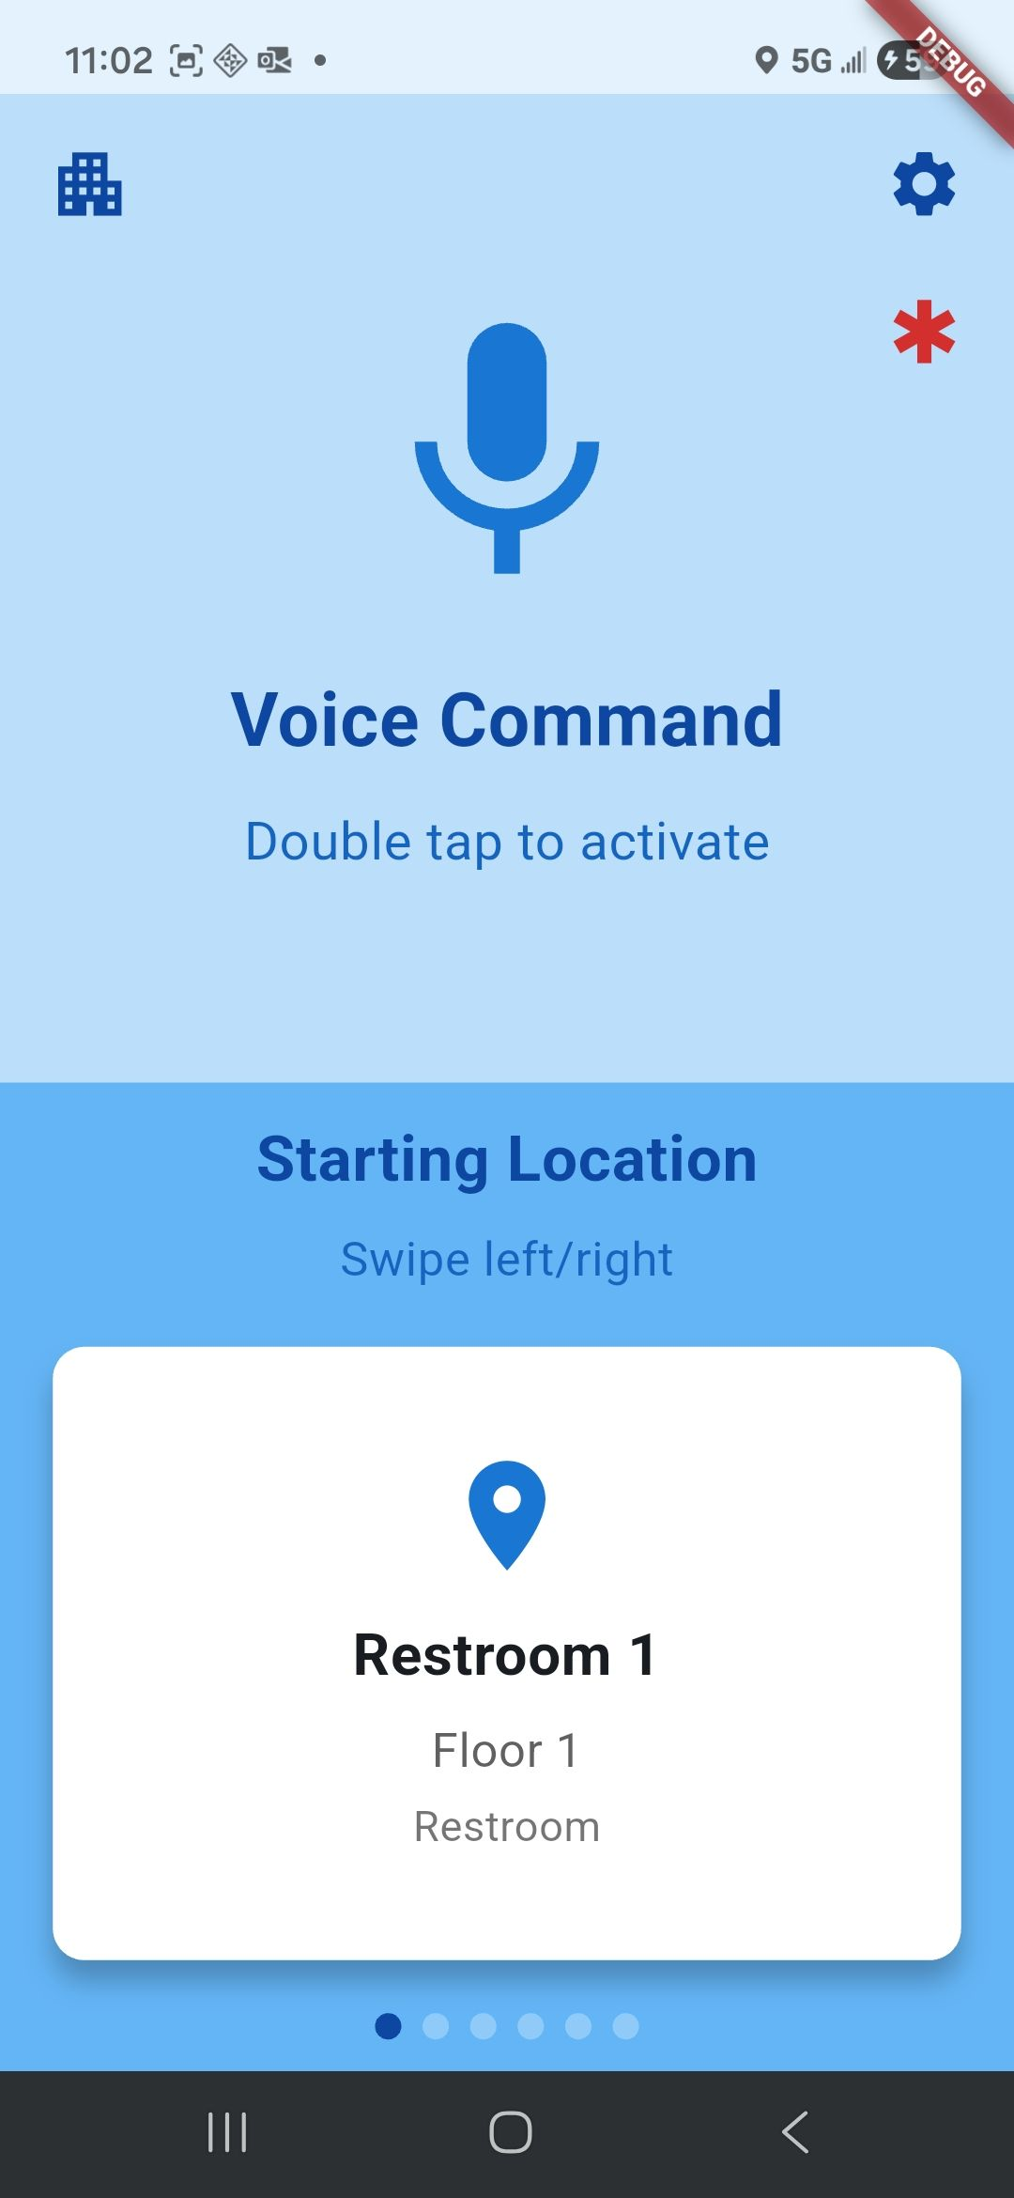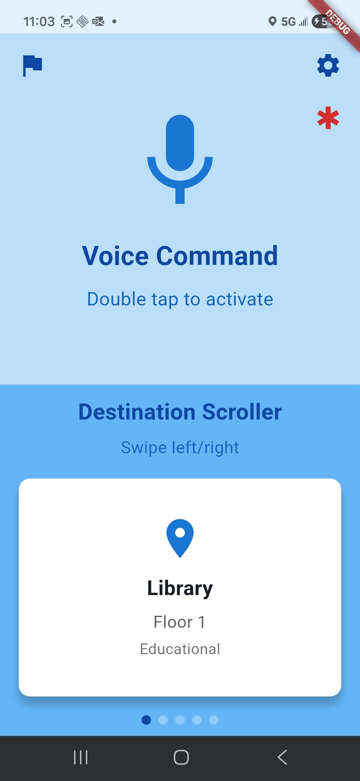
Location Selection
The next screen is the location selection screen. The top half is a big button for voice command. The bottom half is a destination scroller.

Voice Commands
Double tapping the top half of the screen will activate voice command mode, which allows you to give the system commands. A TTS will notify that it is "Listening for a start location...". Speak into your phone and give it a location within the building. The system will attempt to match a voice command to one of the possible destinations in the building, and then ask for confirmation. Double tap the voice command button to confirm your destination. The system will move the destination scroller to the selected destination.

Destination Scroller
The bottom half of the screen contains a destination scroller, containing a list of all locations in the building. Swiping left and right will switch destinations. Double tapping a destination on the bottom will move the system into navigation mode.

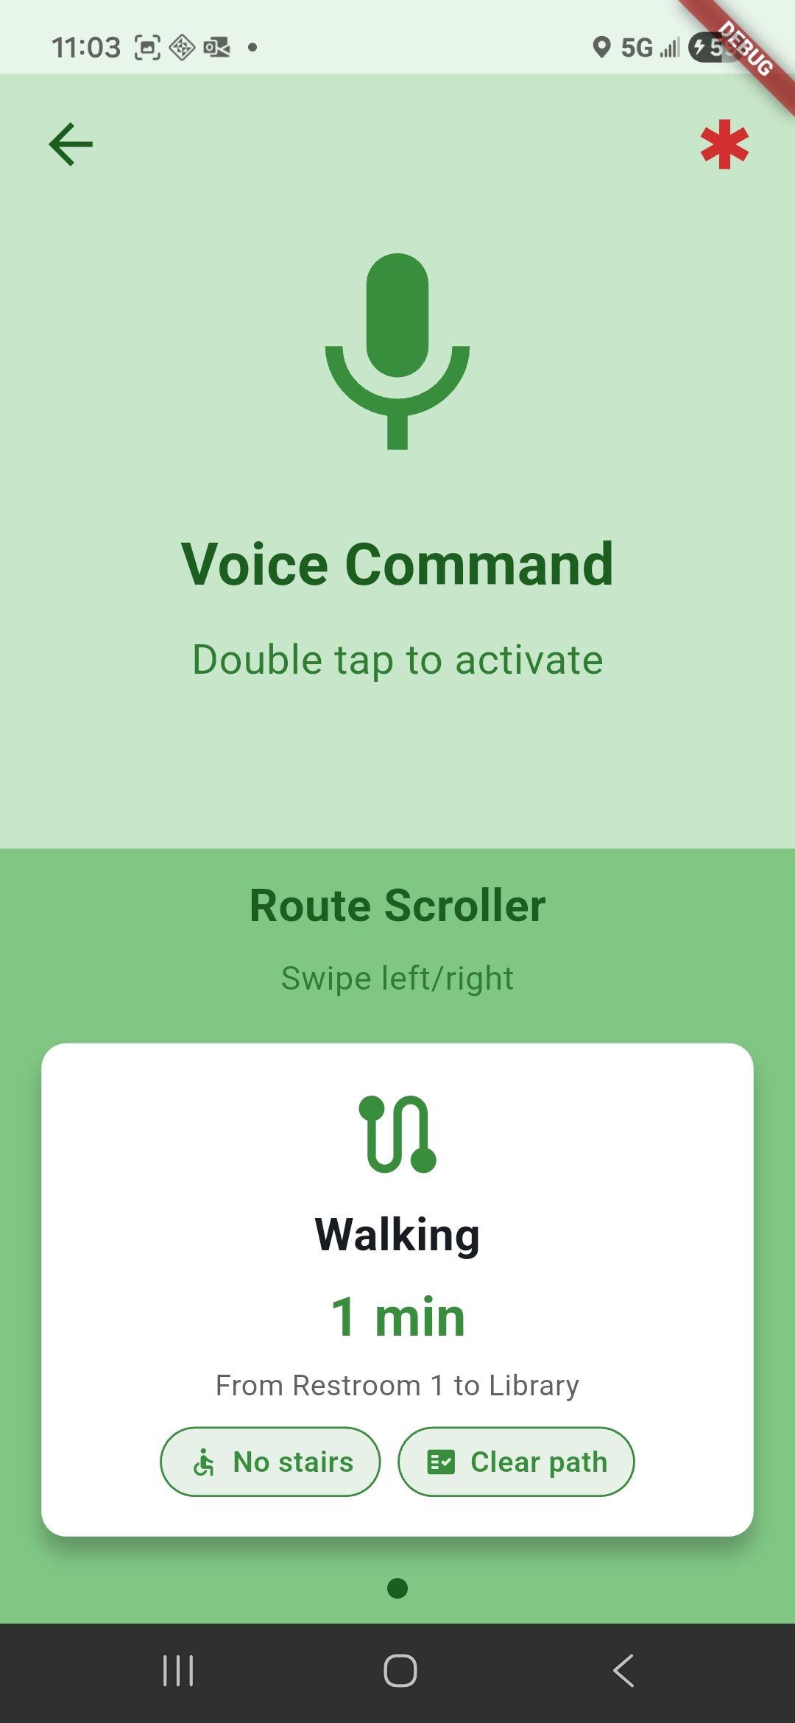
Route Selection
Once a destination is selected, the screen will change to green. The destination scroller is replaced by a route scroller.

Route Scroller
The route scroller allows you to select different possible routes to reach your destination. Double tapping a route from the route scroller moves the system into route navigation mode.

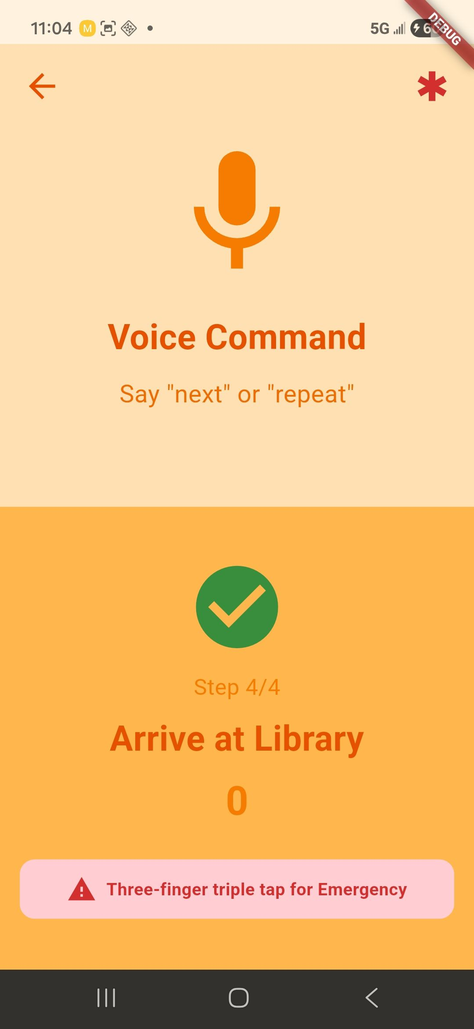
Navigation Mode
The screen will change to yellow. The system will now guide you through the route you selected. It will utilize TTS to tell you the instructions on a route.

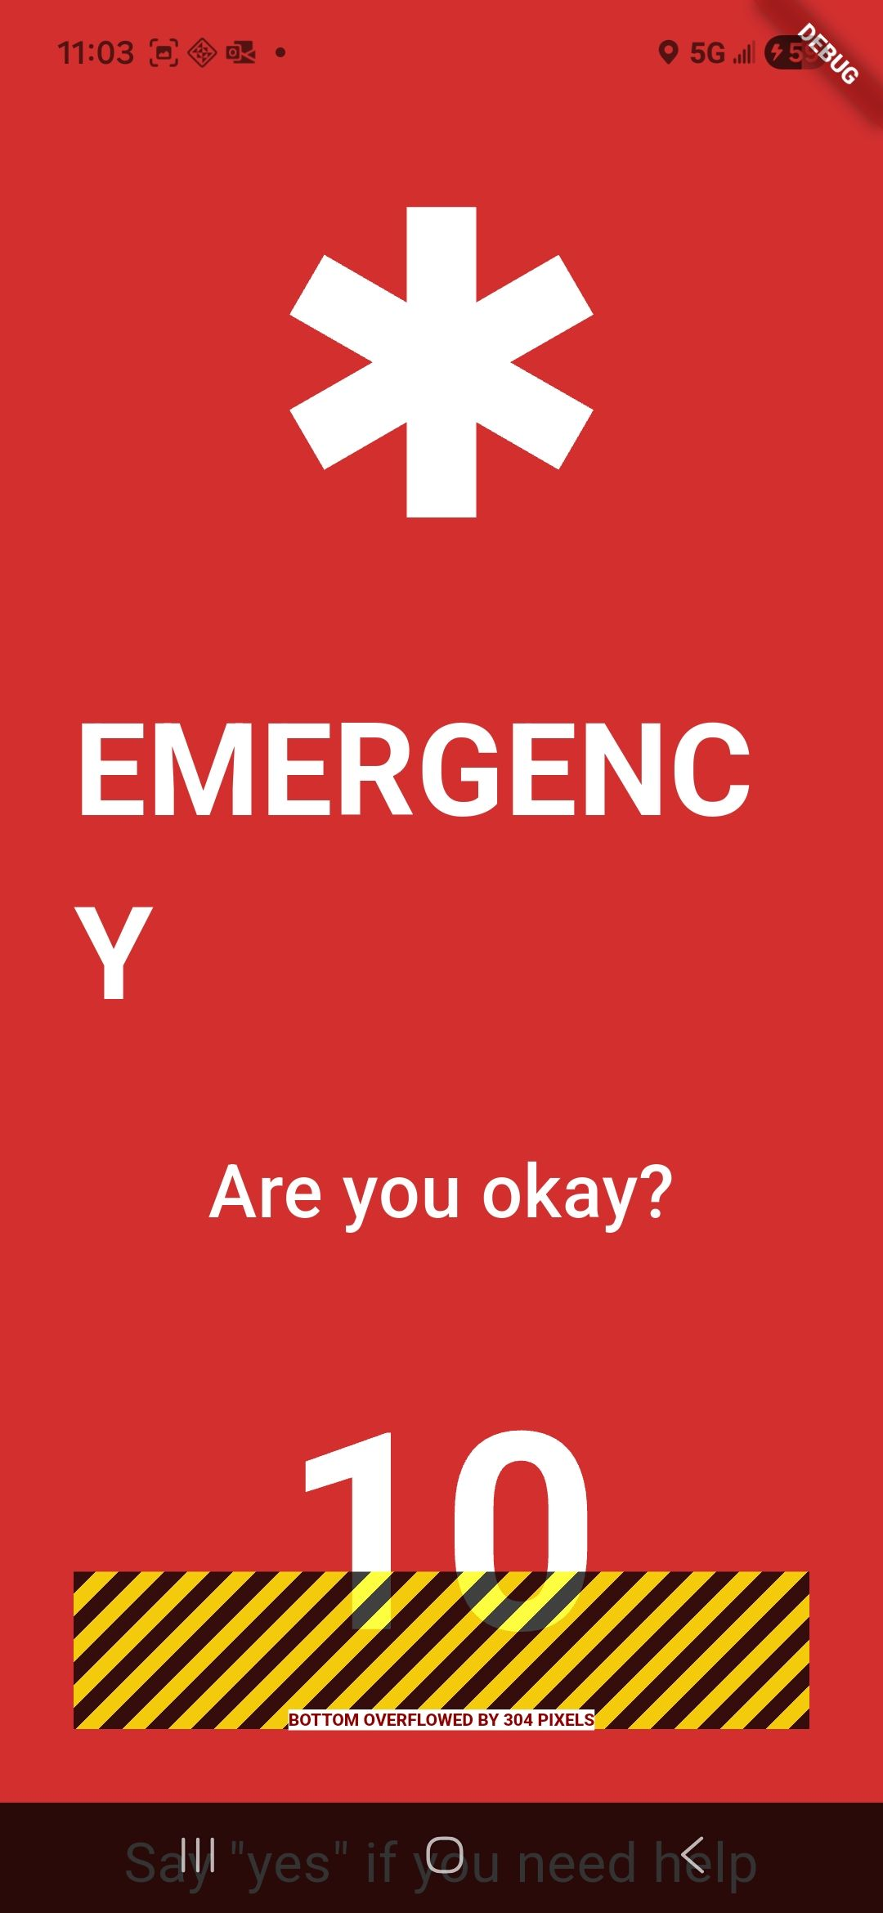
Emergency Mode
Triple tapping the screen moves the system into emergency mode. The system will also automatically enter emergency mode if a fall is detected from the phone's collision detection. Emergency mode has a red screen. First, TTS will ask for voice confirmation that you are in need of assistance. It will have a 10 second countdown before it automatically calls your emergency contact, which is configured in settings.

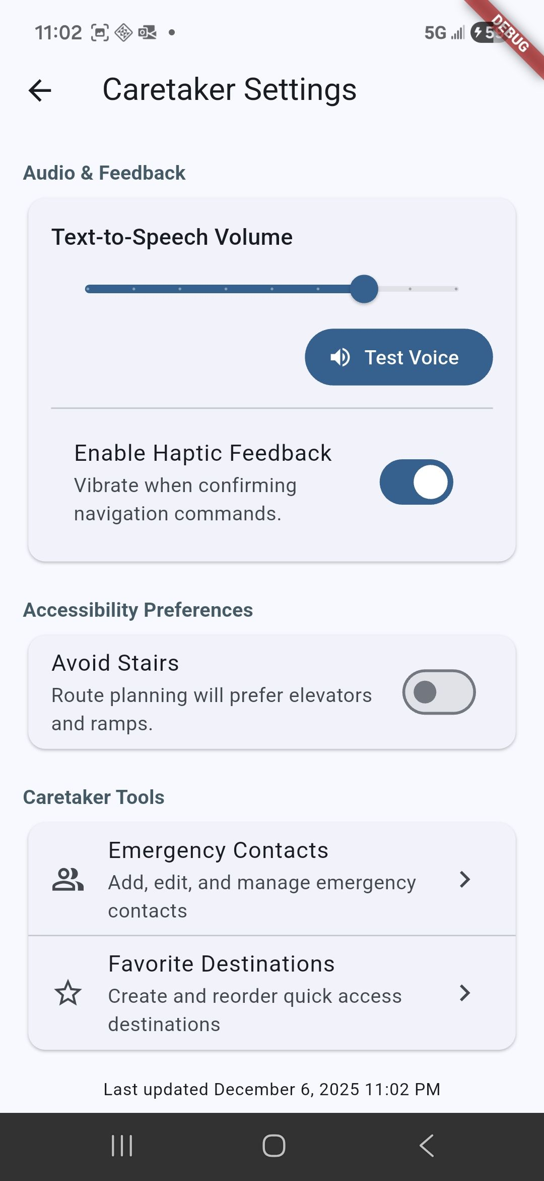
Configuration
Configuration settings can be accessed by pressing the gear icon on the top right of the location selection screen. The available options are:
- Audio & Feedback
  - TTS volume: a slider for controlling the Text-to-Speech volume
  - Enable/Disable Haptic Feedback: a toggle for turning on or off vibration
- Accessibility Preferences
  - Avoid Stairs: a toggle to avoid stairs on all routes
- Caretaker Tools
  - Emergency Contacts: a customizable list of emergency contact numbers that are called in emergency mode
  - Favorite Destinations: a customizable list of destinations that will appear in the destination scroller first

