AWS EC2 & EBS INFRASTRUCTURE REPORT
Status: Volume successfully created

1. EBS Volume Creation Settings
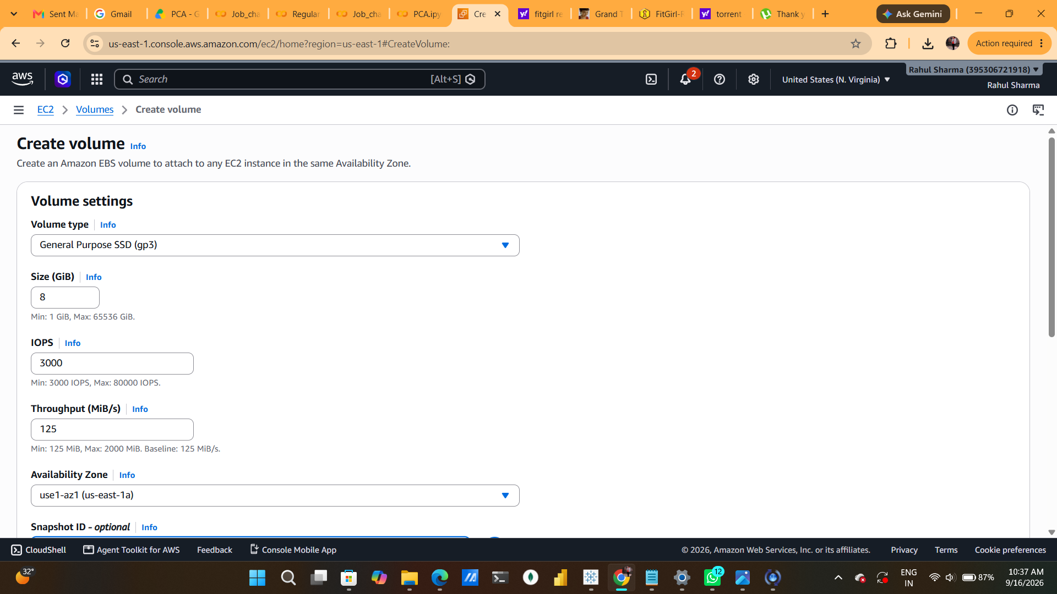

Summary: The first screenshot shows the main EBS configuration page: gp3, 8 GiB, 3,000 IOPS, 125 MiB/s throughput, and Availability Zone use1-az1 (us-east-1a)

2. Snapshot, Encryption, Tags and Creation
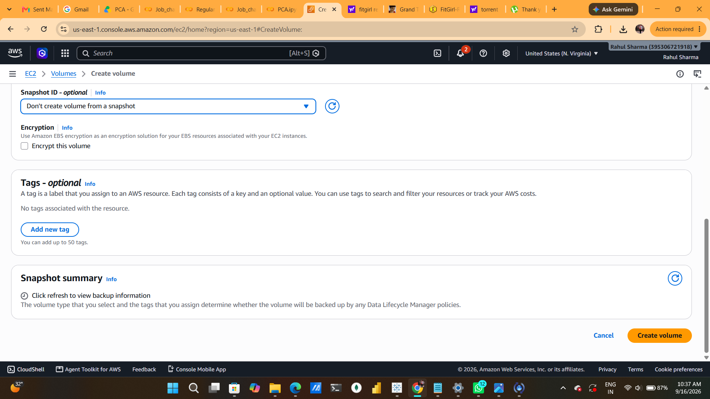

Summary: The second screenshot shows the lower creation form. No snapshot is selected, encryption is unchecked, and no tags are associated

3. Successful EBS Volume Creation
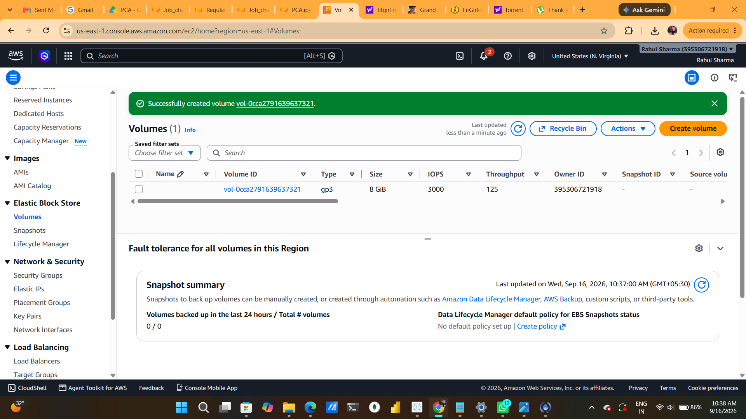

Summary: The final screenshot verifies successful creation and displays the new volume in the EC2 Volumes list

4. Conclusion
The screenshots document successful provisioning of an 8 GiB gp3 EBS volume in us-east-1 / use1-az1, configured for 3,000 IOPS and 125 MiB/s throughput. The main governance items to review are encryption, tagging, backup policy, and attachment/configuration for the intended workload.

